Curriculum Management System
Change Management PLAN
Version 1.0
19/03/2019

VERSION HISTORY

Version  # | Implemented  By | Revision  Date | Approved  By | Approval  Date | Reason
1.0 | Prashant | 19/03/2019
UP Template Version: 11/30/06

TABLE OF CONTENTS
1 Introduction 5
1.1 Purpose of The Change Management Plan 5
2 Change management Process 5
2.1 Change Request Process Flow Requirements 5
2.2 Change Request Form and Change Management Log 6
2.3 Evaluating and Authorizing Change Requests 6
2.3.1 Change Control Board 7
3 Responsibilities 7
Appendix A: Change Management Plan Approval 8
Appendix B: References 9
Appendix C: Key Terms 10
Appendix D: Change Request Form Example 11
Appendix E: Change Management Log Template 12

Introduction

Purpose of The Change Management Plan
The Change Management Plan documents and tacks the necessary information required to effectively manage project change from project inception to delivery.
The Change Management Plan is created during the Planning Phase of the project. Its intended audience is the project manager, project team, project sponsor and any senior leaders whose support is needed to carry out the plan.

Change management Process
The Change Management process establishes an orderly and effective procedure for tracking the submission, coordination, review, evaluation, categorization, and approval for release of all changes to the project’s baselines.

Change Request Process Flow Requirements

Step | Description
Generate CR | A submitter completes a CR Form and sends the completed form to the Change Manager
Log CR Status | The Change Manager enters the CR into the CR Log. The CR’s status is updated throughout the CR process as needed.
Evaluate CR | Project personnel review the CR and provide an estimated level of effort to process, and develop a proposed solution for the suggested change
Authorize | Approval to move forward with incorporating the suggested change into the project/product
Implement | If approved, make the necessary adjustments to carry out the requested change and communicate CR status to the submitter and other stakeholders
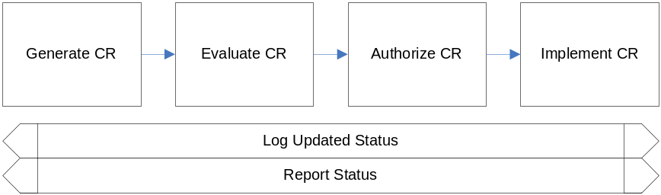

Change Request Form and Change Management Log

Element | Description
Date | The date the CR was created
CR# | Assigned by the Change Manager
Title | A brief description of the change request
Description | Description of the desired change, the impact, or benefits of a change should also be described
Submitter | Name of the person completing the CR Form and who can answer questions regarding the suggested change
Phone | Phone number of the submitter
E-Mail | Email of the submitter
Product | The product that the suggested change is for
Version | The product version that the suggested change is for
Priority | A code that provides a recommended categorization of the urgency of the requested change (High, Medium, Low)

Evaluating and Authorizing Change Requests
Change requests are evaluated using the following priority criteria:
Priority | Description
High | Change requests that effect the proper working of the product
Medium | Change requests that improve functionality or reduces effort
Low | Change requests that involve good to have features

Change requests are evaluated and assigned one or more of the following change types:
Type | Description
Scope | Change affecting scope
Time | Change affecting time
Duration | Change affecting duration
Cost | Change affecting cost
Resources | Change affecting resources
Deliverables | Change affecting deliverables
Product | Change affecting product
Processes | Change affecting process
Quality | Change affecting quality

Change requests are evaluated and assigned one of the following status types:
Status | Description
Open | Entered/Open but not yet approved or assigned
Work in Progress | CR approved, assigned, and work is progressing
In Review | CR work is completed and in final review prior to testing
Testing | CR work has been reviewed and is being tested
Closed | CR work is complete, has passed all tests, and updates have been released.

Change Control Board

Role | Name | Contact | Description
[Insert Role] | [Insert Name] | [Insert Contact #] | [Insert Role Description]

Responsibilities

Role | Name | Contact | Description
Project Manager
Change Manager
Appendix A: Change Management Plan Approval
The undersigned acknowledge they have reviewed the Curriculum Management System Change Management Plan and agree with the approach it presents. Changes to this Change Management Plan will be coordinated with and approved by the undersigned or their designated representatives.

Signature: |  | Date:
Print Name:
Title:
Role:

Signature: |  | Date:
Print Name:
Title:
Role:

Signature: |  | Date:
Print Name:
Title:
Role:

Appendix B: References
The following table summarizes the documents referenced in this document.
Document Name and Version | Description | Location

Appendix C: Key Terms
The following table provides definitions for terms relevant to this document.
Term | Definition

Appendix D: Change Request Form Example
The example Change Request From attached below can be used to submit changes during the life of the project.
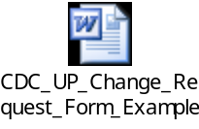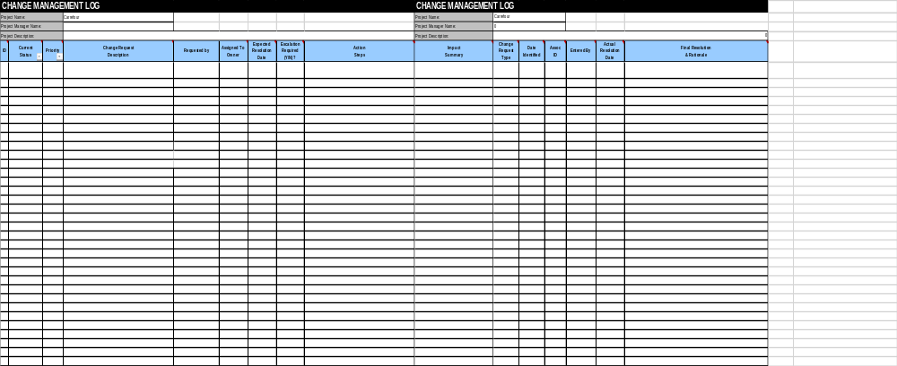

Appendix E: Change Management Log Template
The detailed Change Management Log template attached below can be used to track and manage requested changes during the life of the project.
