**Step1:-create the new virtual machine**

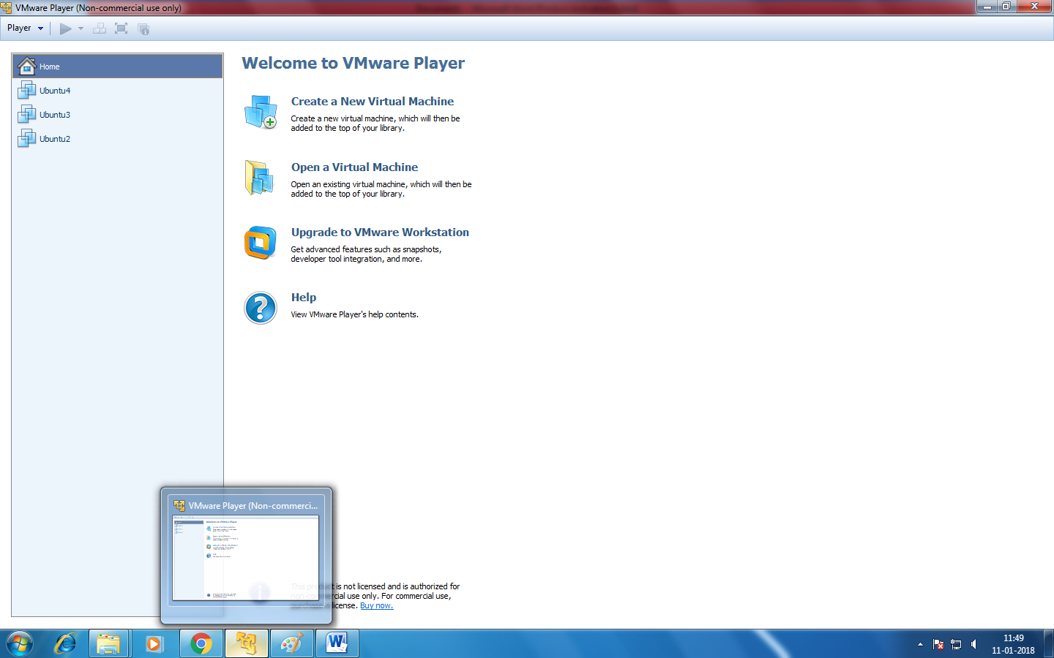

**Step2:Select the any option to install.**

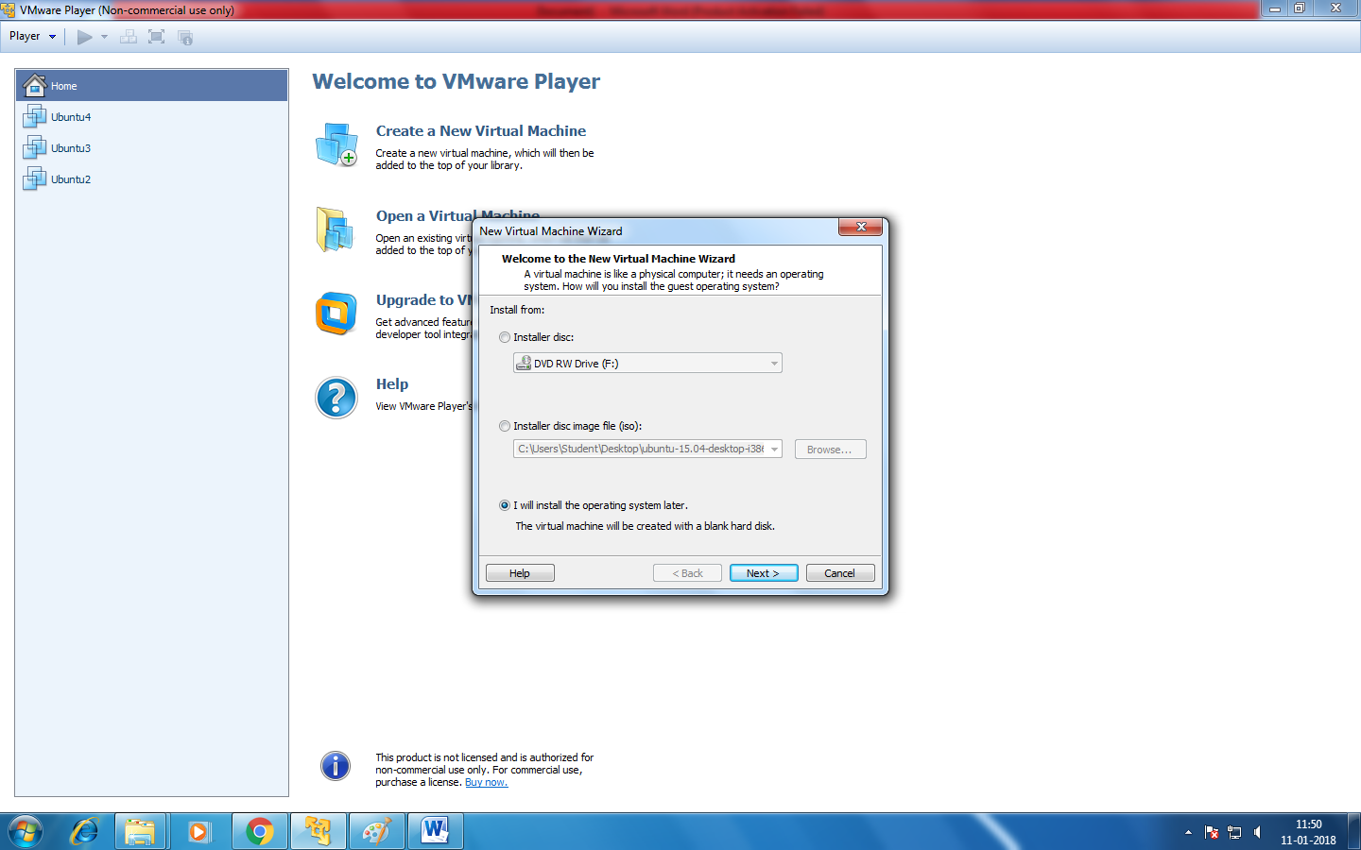

**Step3:Select the guest operating system and click next.**

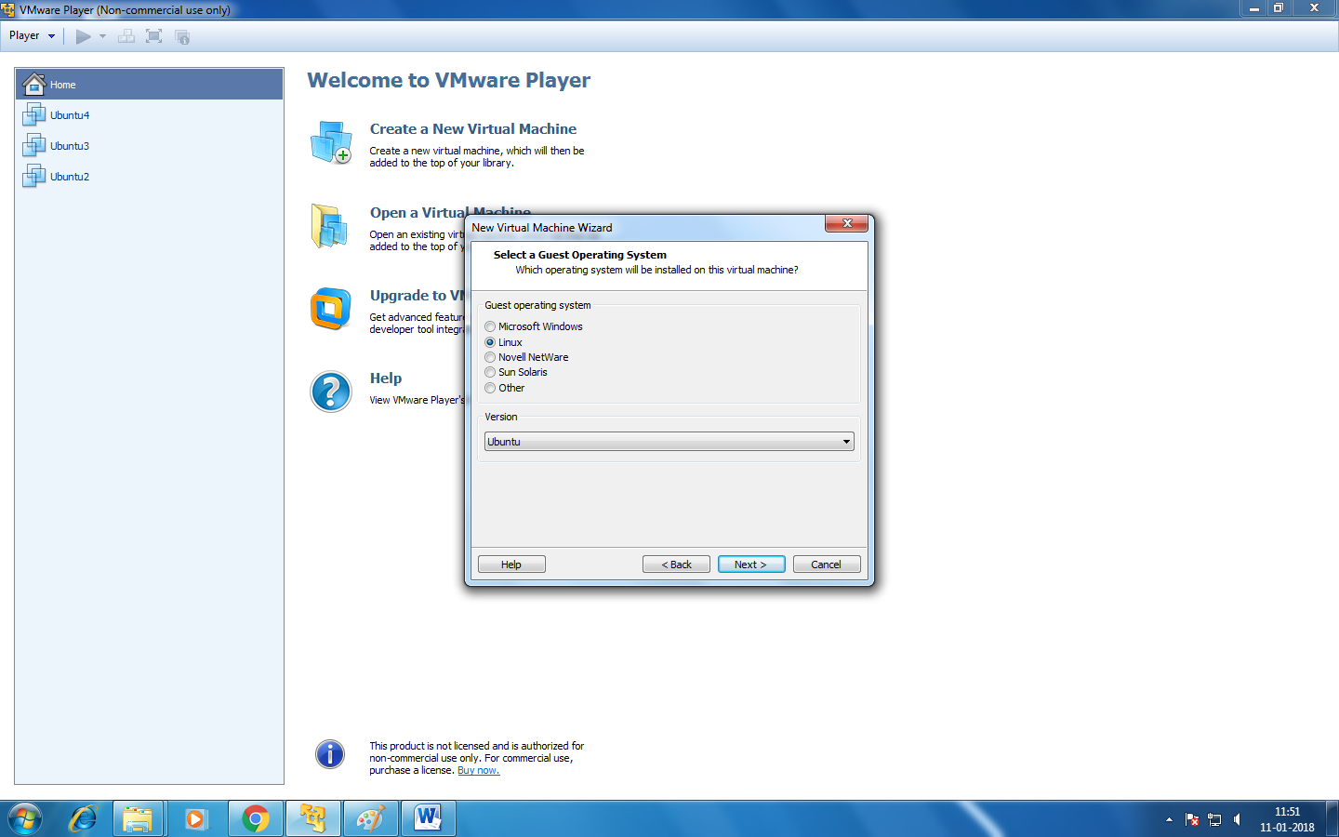

**Step4: Give the name to Virtual machine.**

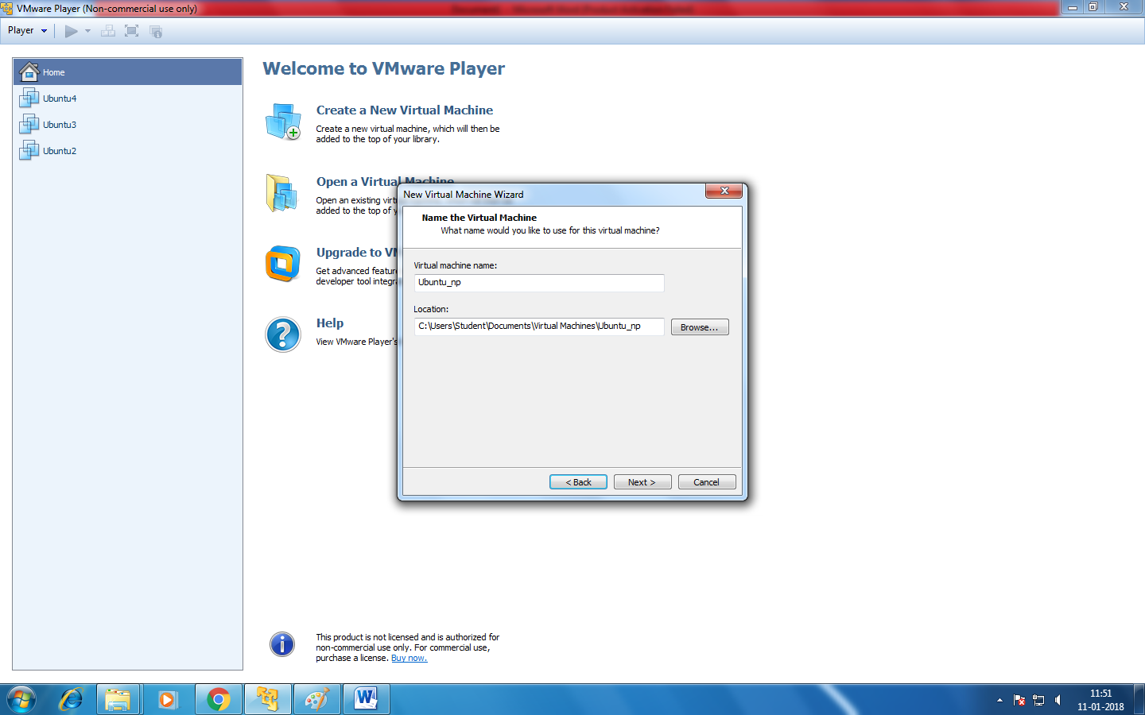

**Step5:In this step it will show the max disk capacity and choose option accordingly.**

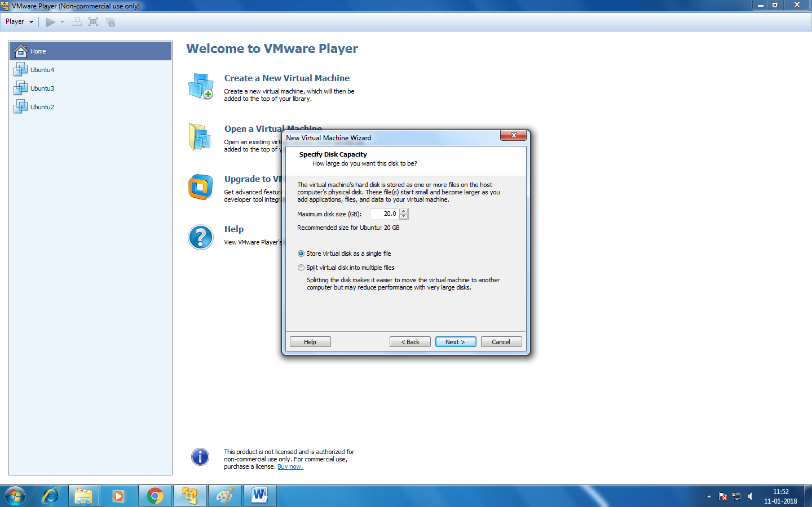

**Step6:Select the path of iso file to install the os.**

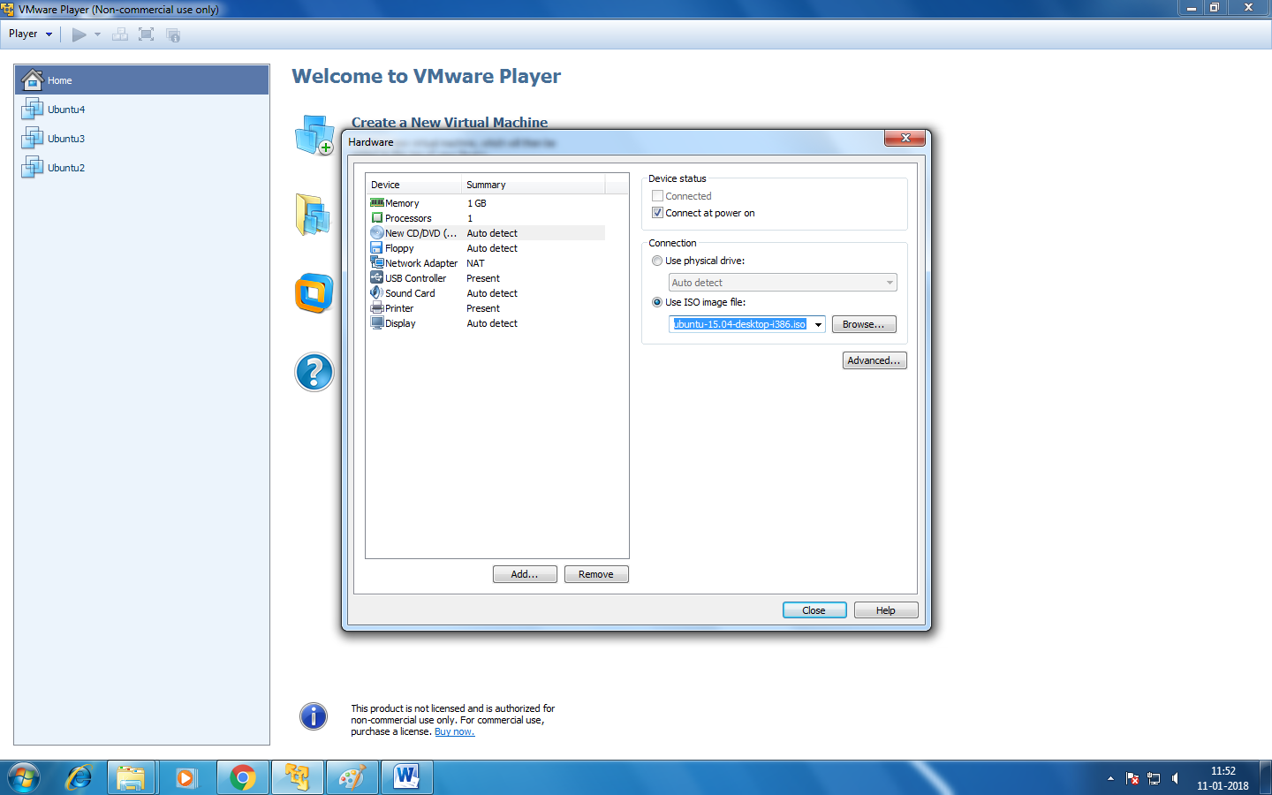

**Step7:After creating new machine then click play virtual machine option for further installation.**

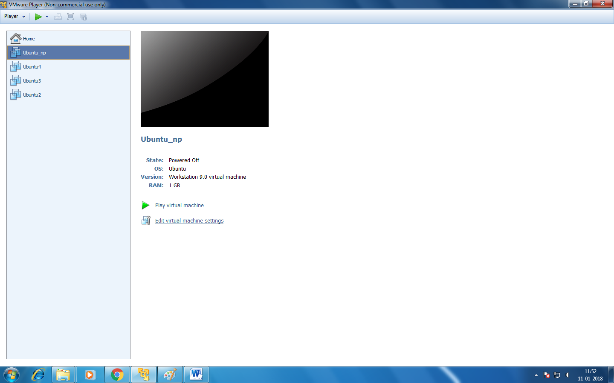

**Step8:select install Ubuntu option.**

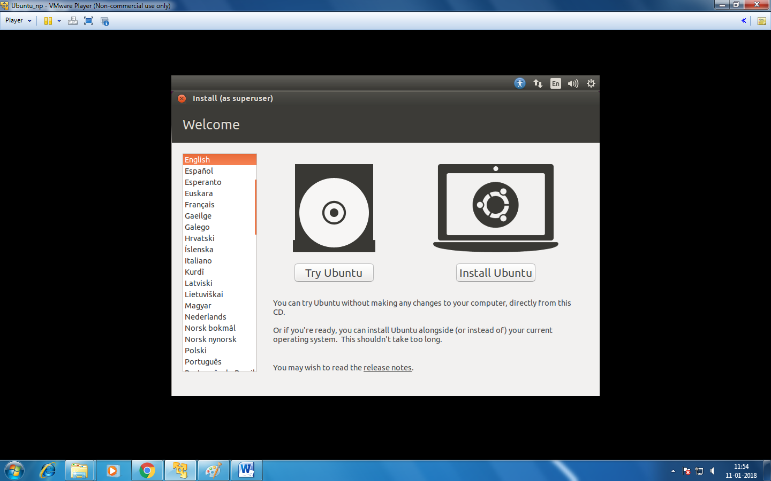

**Step9:click first option for manual portioning it will erase all the data and install os accordingly.**

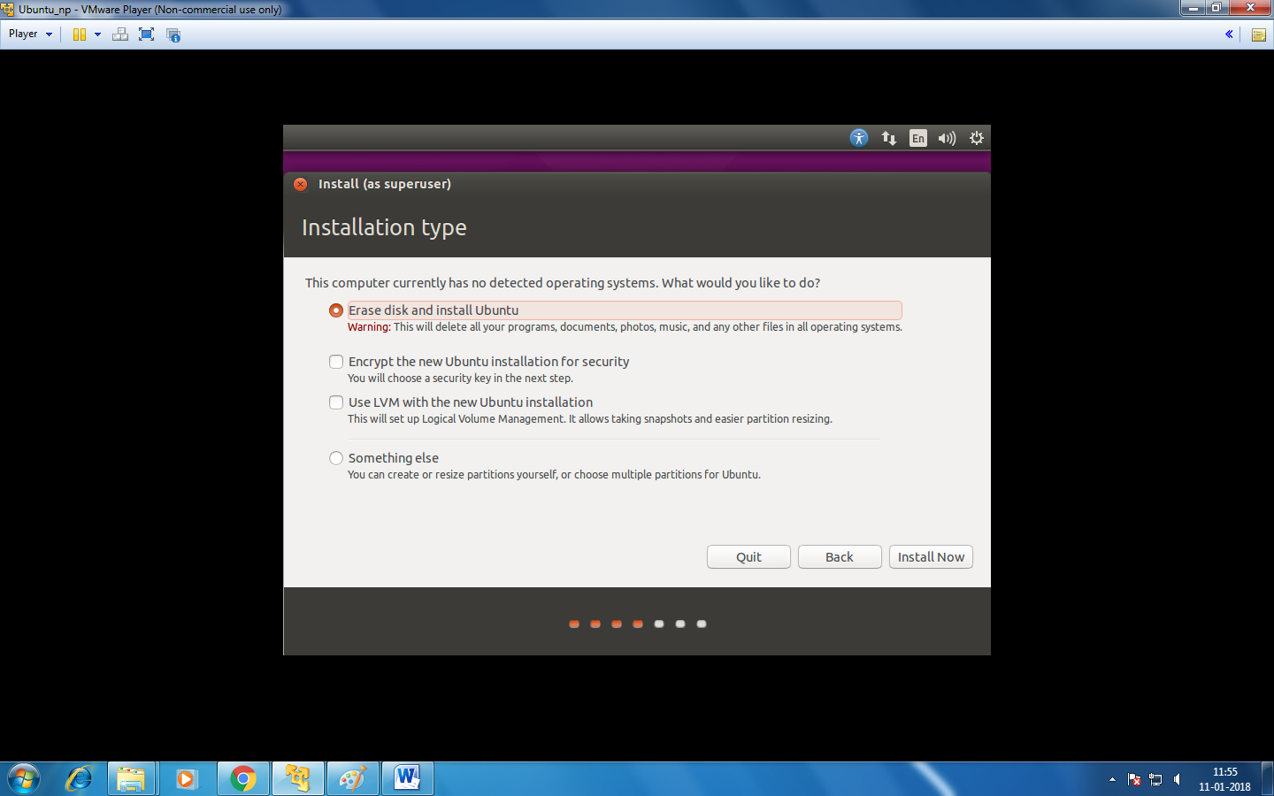

**Step10:we can create the partioning using this option.**

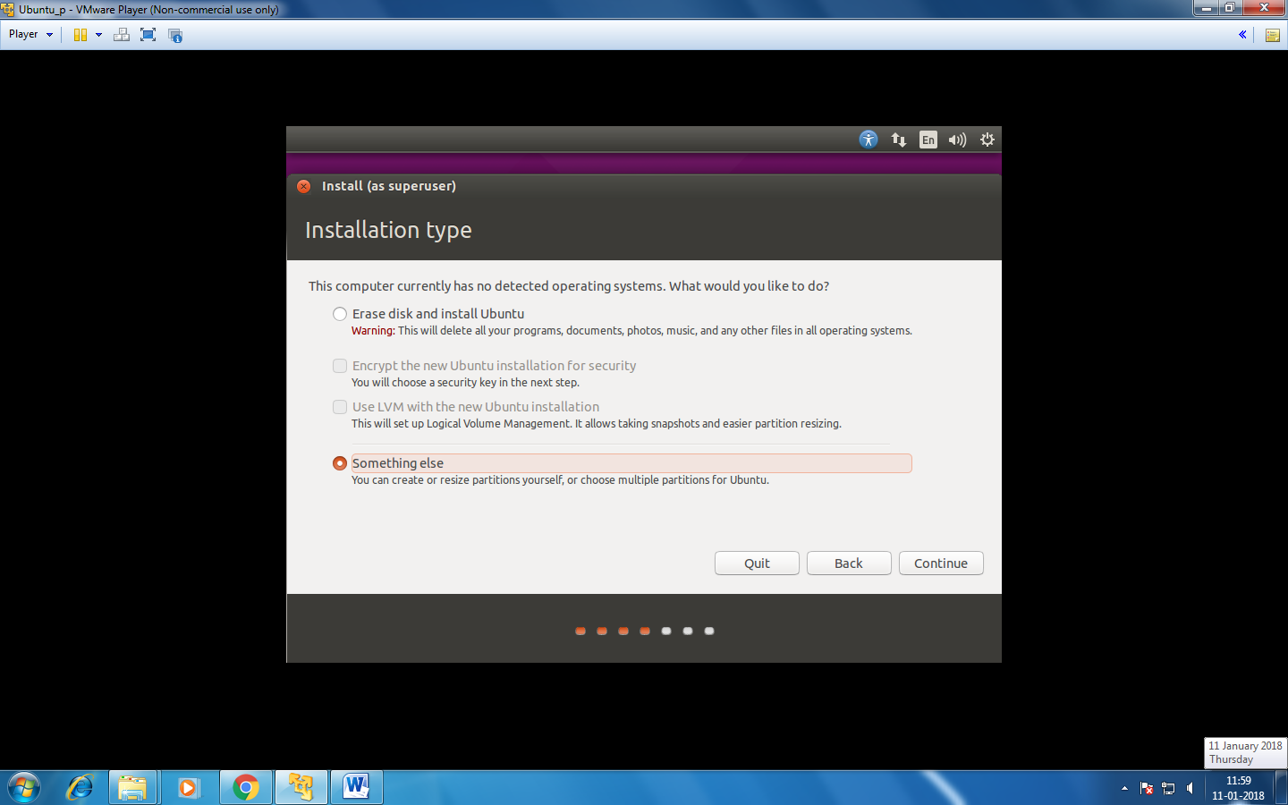

**Step11:give the space as per user requriment and click the install button.**



