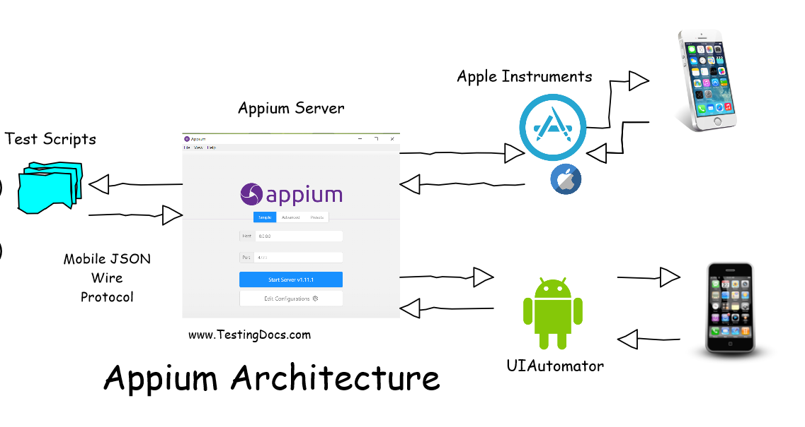

* Eclipse IDE for JAVA Development
* Java Development Kit 8 KDK and JRE

Setting Environment Variables System Variables

JAVA_HOME

C:\Program Files\Java\jdk1.8.0_351

* Android Studio

Setting Environment Variables under System Variables

ANDROID_HOME

C:\Users\ADMIN\AppData\Local\Android\Sdk

* Android Studio Install

Setting Environment Variables under System Variables--- ”path”

C:\Users\ADMIN\AppData\Local\Android\Sdk\tools\bin

C:\Users\ADMIN\AppData\Local\Android\Sdk\tools

C:\Users\ADMIN\AppData\Roaming\npm

C:\Users\ADMIN\AppData\Local\Android\Sdk\platform-tools

* Set Environment Variable under –“Path” to Set npm of Node-Modules to connect the ports

C:\Program Files\nodejs\node_modules\npm\bin

* Open Android Studio and Configure Android Emulator/Virtual Device using Device Manager to ADD a device
* Search in google and install Appium GUI Server open- Add Local ip as unique (127.0.0.1)

With port 4723 Port

Click on Edit Configueration and set the system variables JAVA_HOME and ANDROID_HOME

C:\Program Files\Java\jdk1.8.0_351

C:\Users\ADMIN\AppData\Local\Android\Sdk

Click on Advance tab and enter Server address 127.0.0.1

Click on START SERVER

* If uiautomator is not available then install it through command promt

npm i appium-uiautomator2-driver

* To Open UIAutomatorserver open the path (C:\Users\ADMIN\AppData\Local\Android\Sdk\tools\bin) and Launch "uiautomaterviewer

Click on device screenshot icon (second icon)

* To Connect a ADR device using usb and enable in debugging mode Settings>Developermode ON>USB Debugging ON
* Now open cmd and enter adb driver – connected device will show in list
* Copy phone details and paste somewhere to use in Script automation
* DRGID18082102038 device ID
* Install Eclipse IDE for Java EE Developers – Extract and open Eclipse. Create a project ADD the dependencies

Search Java-Client and TestNG in Maven Repository

JAVA-Client and TestNG dependencies