Contents

Register participant: 1

0xAb8483F64d9C6d1EcF9b849Ae677dD3315835cb2 🡪 Supplier (1) 1

0x4B20993Bc481177ec7E8f571ceCaE8A9e22C02db 🡪Distributor (2) 1

0x78731D3Ca6b7E34aC0F824c42a7cC18A495cabaB 🡪Pharmacy (3) 1

0x617F2E2fD72FD9D5503197092aC168c91465E7f2 🡪Consumer (4) 1

Query Registered participant 2

Manufactured 2

Supplier 2

Distributor 2

Pharmacy 3

Consumer 3

Register Drug: 3

Register drug #1 3

Register drug #2 3

Get drug count 4

Get drug details by drug id: 4

Transfer ownership: 5

Transferring owner ship from manufacturer to Supplier 5

Get Drug transfer history 6

Get Drug details after transfer’ 6

Transfer drug ownership from supplier to Distributor’ 6

Get ownership details after transfer: 7

Get drug details after transfer 7

Transfer drug ownership from Distributor to Pharmacy 7

Get history after ownership transfer 8

Get drug details after transfer 8

Drug owner ship transfer from Pharmacy to consumer 8

Get drug history after ownership transfer: 8

Get drug details after ownership transfer 9

# Register participant:

0x5B38Da6a701c568545dCfcB03FcB875f56beddC4 -> Manufacture (0)

0xAb8483F64d9C6d1EcF9b849Ae677dD3315835cb2 🡪 Supplier

0x4B20993Bc481177ec7E8f571ceCaE8A9e22C02db 🡪Distributor

0x78731D3Ca6b7E34aC0F824c42a7cC18A495cabaB 🡪Pharmacy

0x617F2E2fD72FD9D5503197092aC168c91465E7f2 🡪Consumer

## 0xAb8483F64d9C6d1EcF9b849Ae677dD3315835cb2 🡪 Supplier (1)

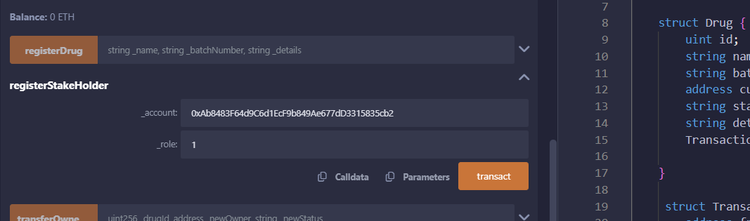

## 0x4B20993Bc481177ec7E8f571ceCaE8A9e22C02db 🡪Distributor (2)

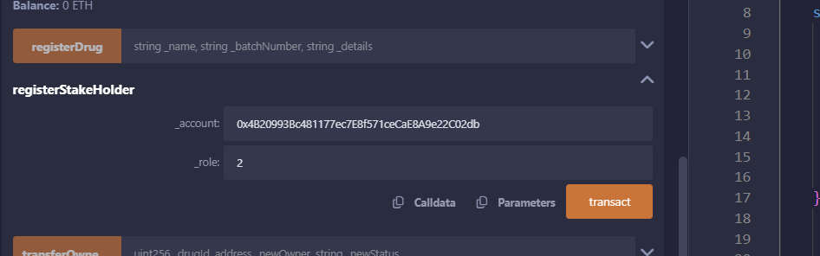

## 0x78731D3Ca6b7E34aC0F824c42a7cC18A495cabaB 🡪Pharmacy (3)

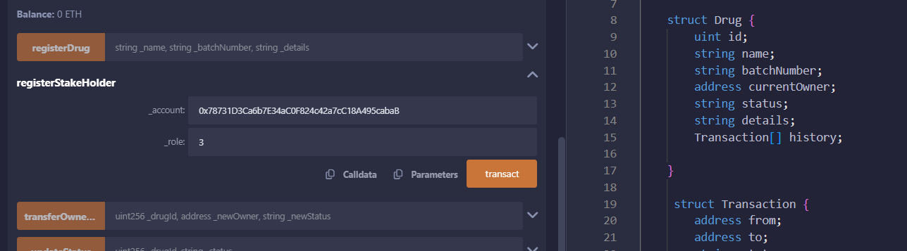

## 0x617F2E2fD72FD9D5503197092aC168c91465E7f2 🡪Consumer (4)

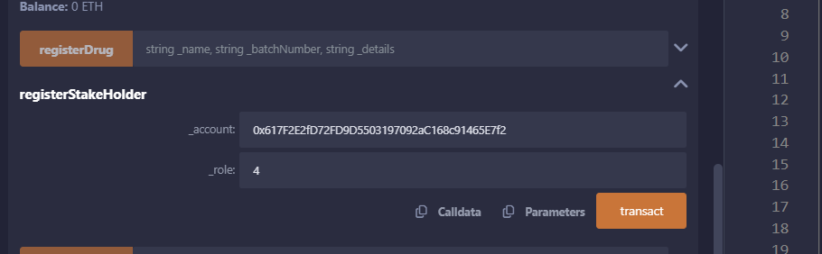

# Query Registered participant

## Manufactured

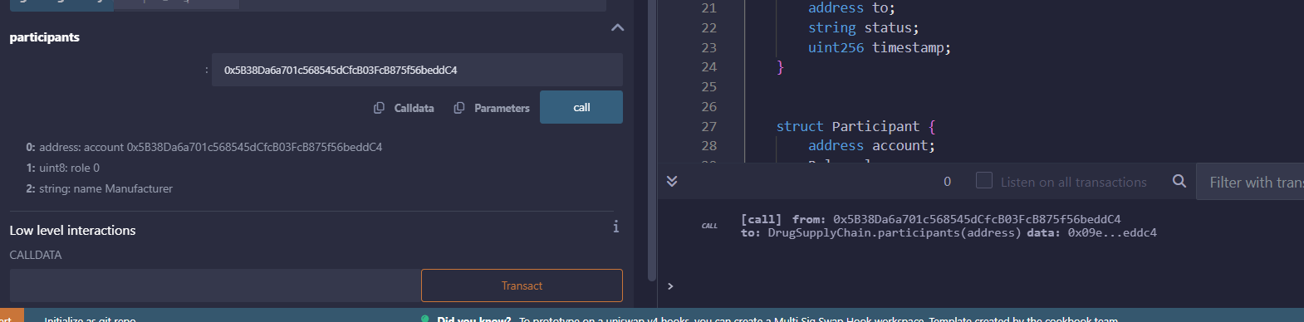

## Supplier

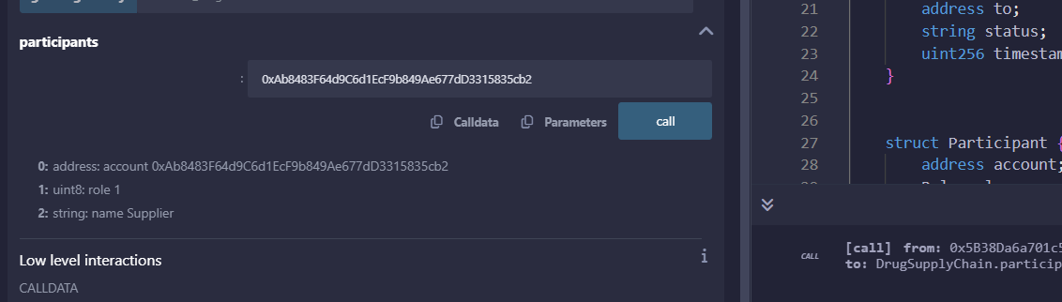

## Distributor

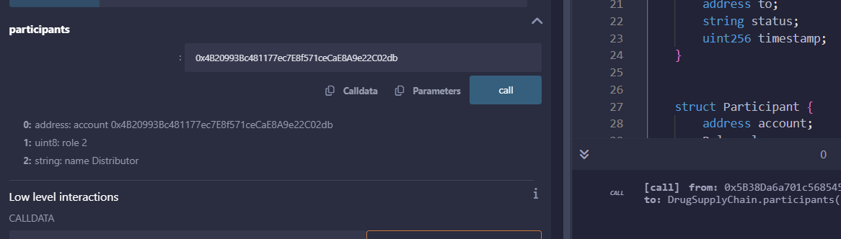

## Pharmacy

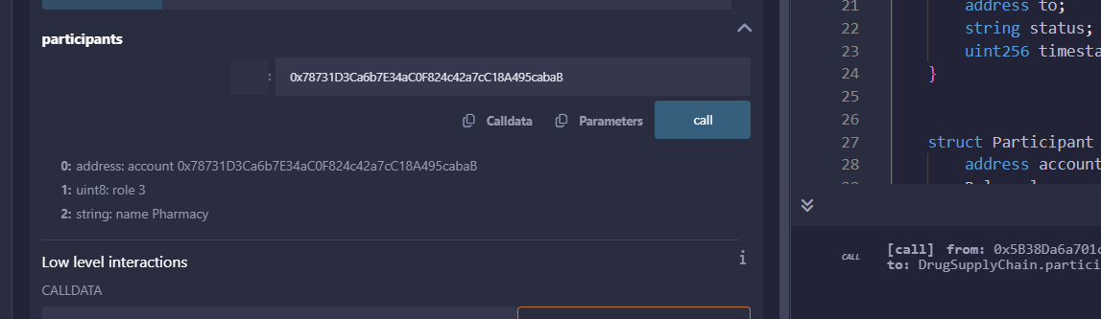

## Consumer

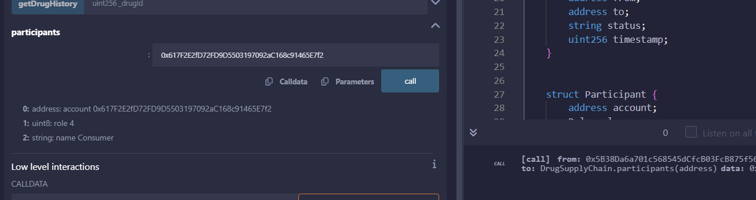

# Register Drug:

## Register drug #1

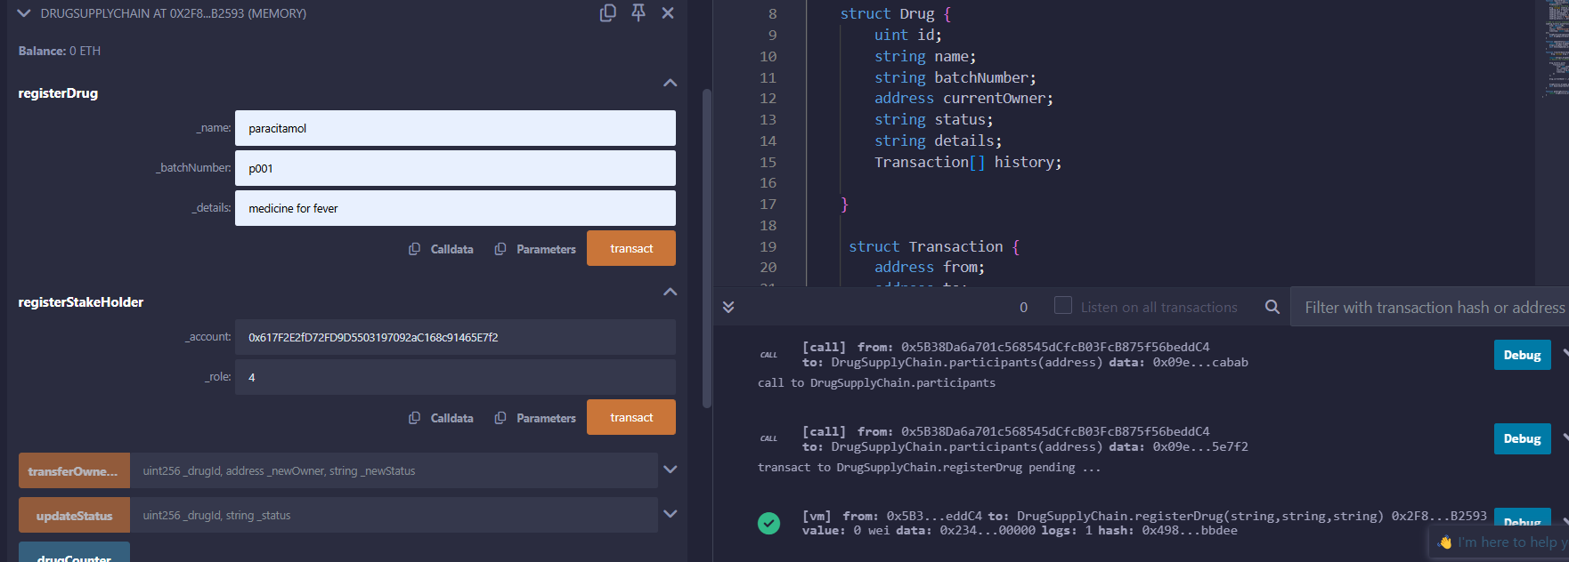

## Register drug #2

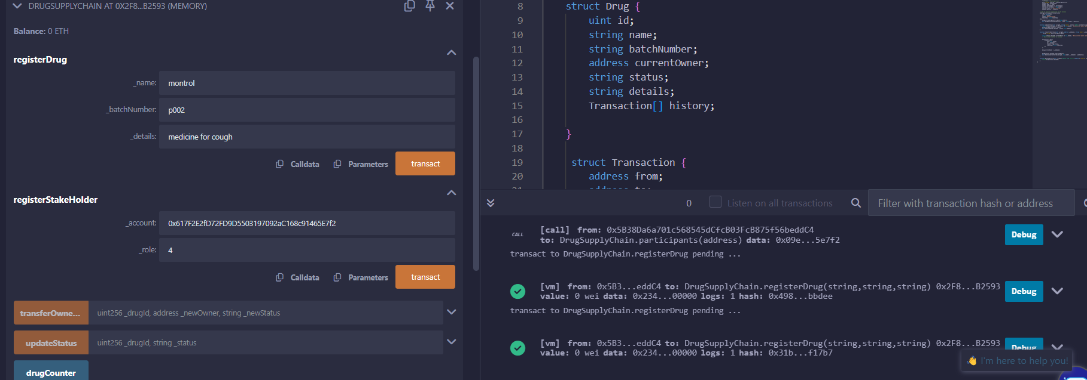

# Get drug count

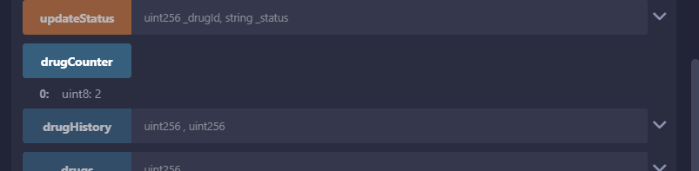

# Get drug details by drug id:

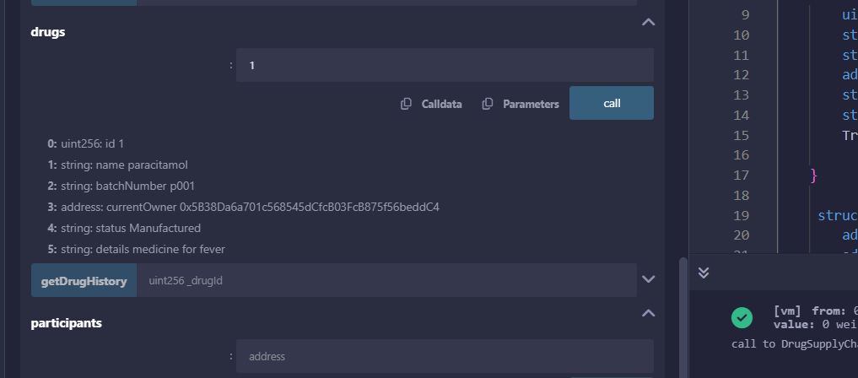

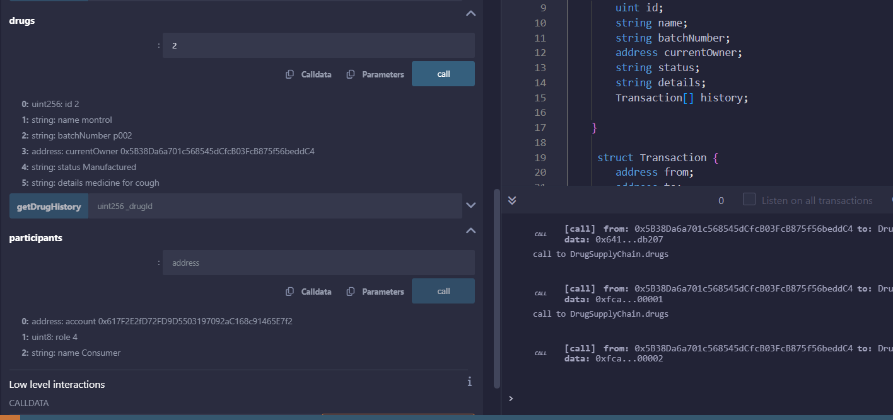

# Transfer ownership:

Transferring owner ship from manufacturer to Supplier 0xAb8483F64d9C6d1EcF9b849Ae677dD3315835cb2

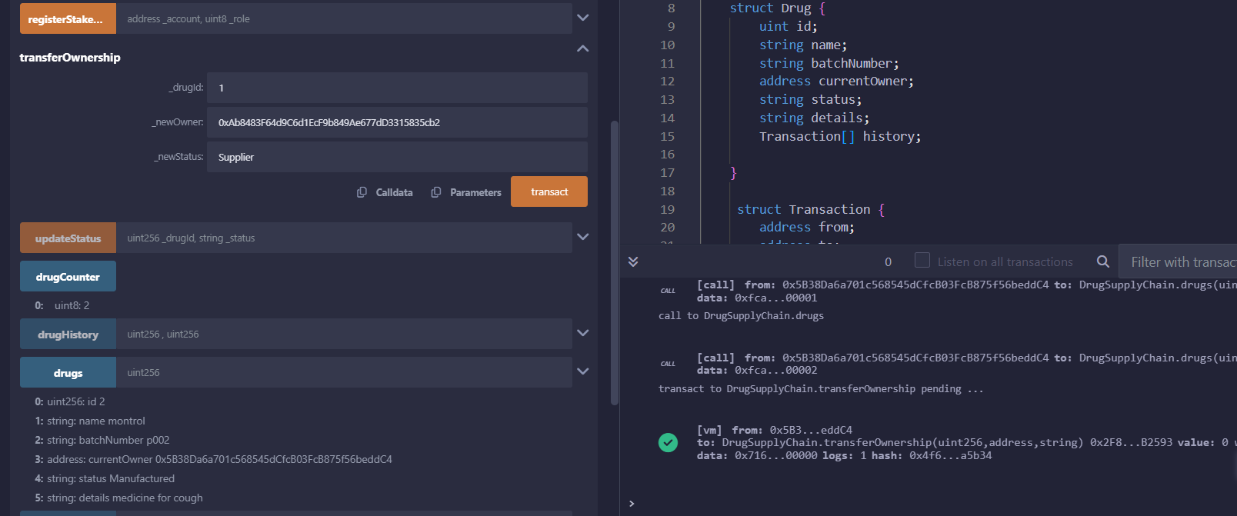

### Get Drug transfer history

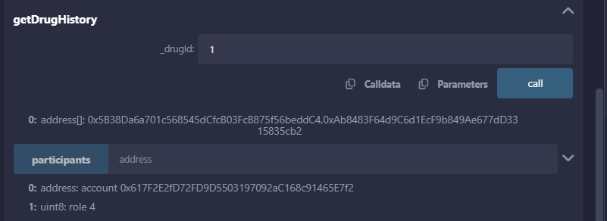

### Get Drug details after transfer’

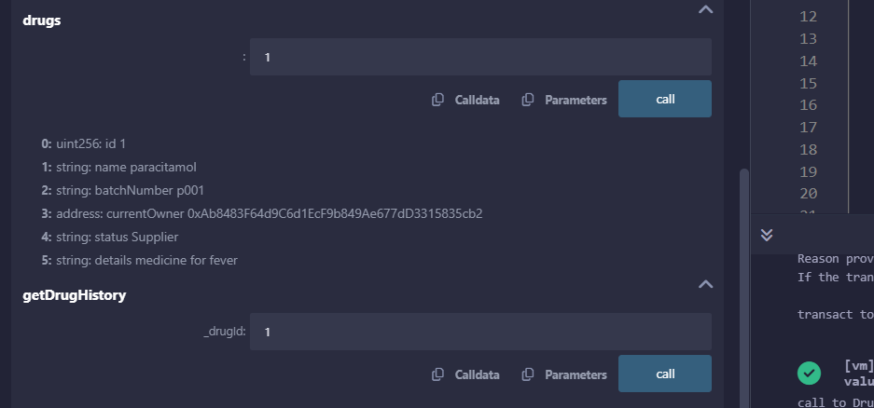

## Transfer drug ownership from supplier to Distributor’

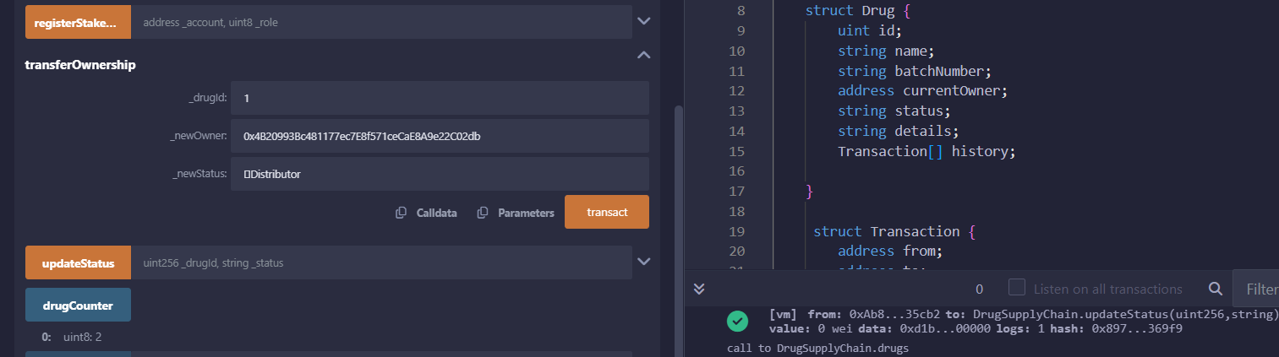

### Get ownership details after transfer:

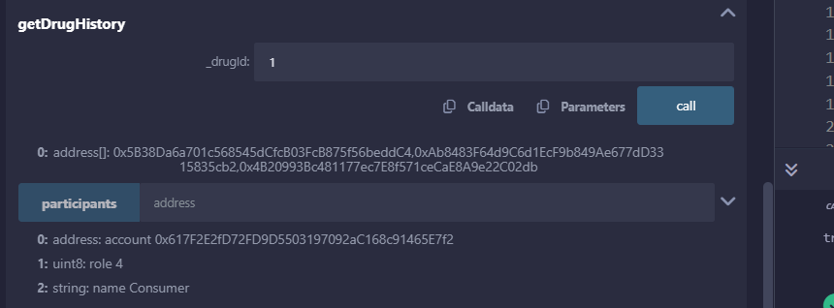

### Get drug details after transfer

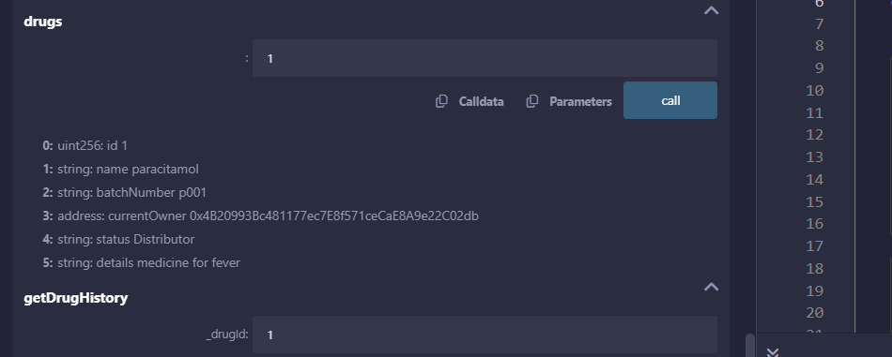

Transfer drug ownership from Distributor to Pharmacy (0x78731D3Ca6b7E34aC0F824c42a7cC18A495cabaB)

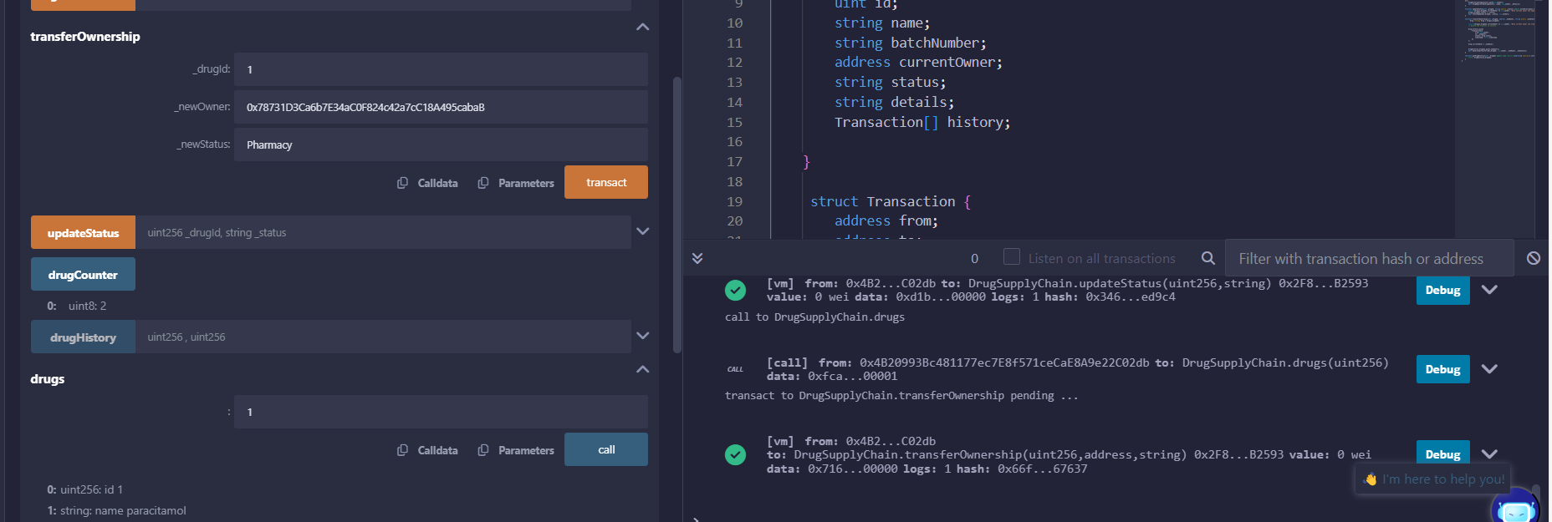

### Get history after ownership transfer

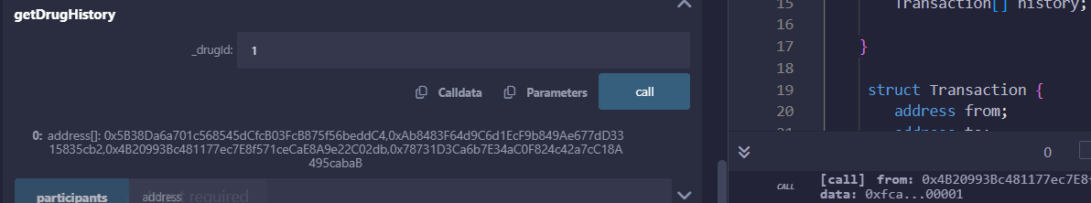

### Get drug details after transfer

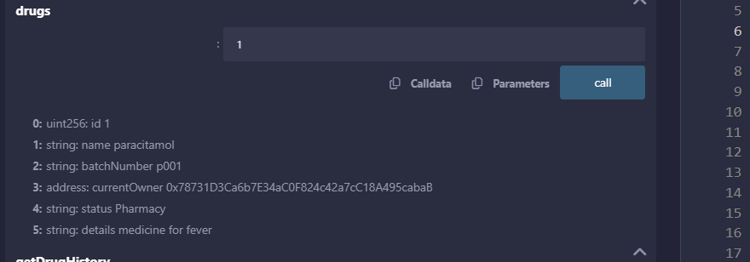

Drug owner ship transfer from Pharmacy to consumer(0x617F2E2fD72FD9D5503197092aC168c91465E7f2)

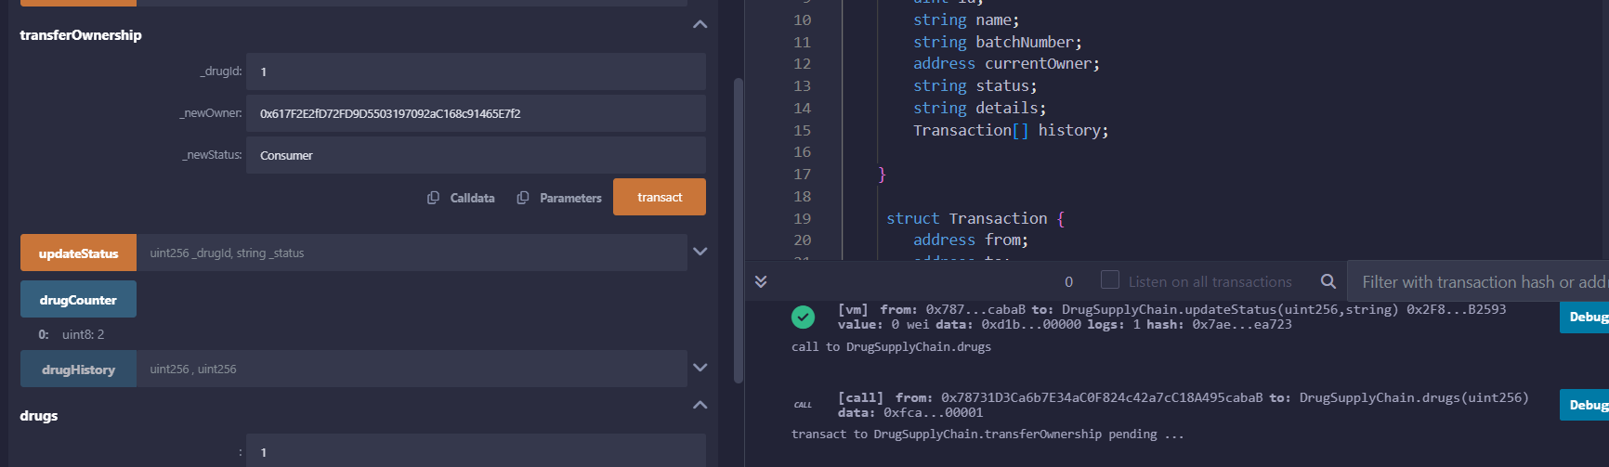

### Get drug history after ownership transfer:

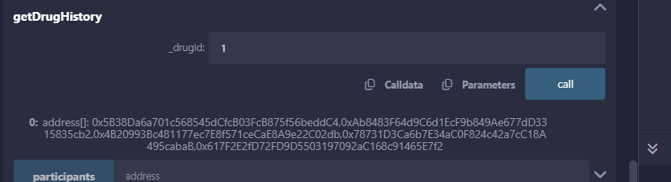

### Get drug details after ownership transfer

