A cab management platform is an excellent choice for a final-year B.Tech project—especially if your goal is to get a Java backend or full-stack internship. It is complex enough to demonstrate software engineering, system design, security, scalability, and real-world architecture, and it aligns well with your Spring Boot experience.
Instead of building a basic "Uber clone," build a production-style platform.

Project Title
RideFlow – Intelligent Cab Management Platform
or
CabRide – Smart Cab Booking & Fleet Management System

Why this project is valuable
It lets you showcase:
- Spring Boot
- Microservices
- Spring Security + JWT/OAuth2
- REST APIs
- System Design
- Redis
- RabbitMQ/Kafka
- Docker
- Kubernetes (optional)
- AWS deployment
- CI/CD
- Monitoring
- Unit & Integration Testing
This is significantly stronger than typical CRUD college projects.

Main Users

Passenger
- Register/Login
- Book ride
- Live driver tracking
- Ride history
- Wallet
- Payment
- Cancel ride
- Rate driver

Driver
- Register
- Upload documents
- Go Online/Offline
- Accept ride
- Navigation
- Earnings
- Ride history

Admin
- Dashboard
- Approve drivers
- Manage users
- Manage pricing
- Manage coupons
- Analytics
- Reports
- Handle complaints

Microservices Architecture
API Gateway

|

-----------------------------------------------------
| | | | | |
User Driver Ride Payment Notification Admin
Service Service Service Service Service Service

|

Location Service

|

Pricing Service

|

Matching Service

|

Review Service

|

Analytics Service

Services

1. User Service
Handles
- Signup
- Login
- JWT
- Roles
- Profile
Database
users

2. Driver Service
Handles
- Driver onboarding
- Vehicle details
- License verification
- Online status
Database
drivers
vehicles

3. Ride Service
Handles
- Ride creation
- Ride lifecycle
States
Requested

↓

Driver Assigned

↓

Accepted

↓

Arriving

↓

Started

↓

Completed

↓

Cancelled

4. Matching Service
This is one of the most interesting services.
Finds nearest available driver.
Algorithm
Passenger Location

↓

Nearby Drivers

↓

Distance Calculation

↓

Rating

↓

Acceptance Rate

↓

Assign Best Driver

You can later enhance it using a shortest-distance algorithm or geospatial queries.

5. Pricing Service
Calculates
Base Fare

+

Distance Fare

+

Time Fare

+

Night Charges

+

Toll

+

Surge Pricing

=

Final Fare

Dynamic pricing is a strong resume feature.

6. Location Service
Stores
Driver Latitude

Driver Longitude

Passenger Latitude

Passenger Longitude

Uses
- Redis
- Geospatial queries

7. Payment Service
Supports
- Wallet
- UPI (simulation)
- Card (simulation)
- Cash

8. Notification Service
Sends
- Email
- SMS (mock)
- Push notifications (mock)

9. Review Service
Stores
Passenger Rating

Driver Rating

Comments

10. Admin Service
Dashboard
Revenue

Drivers Online

Total Trips

Cancelled Trips

Active Users

Average Rating

Database Design

Users
id

name

phone

email

password

role

Drivers
id

user_id

vehicle_id

status

rating

current_location

Vehicles
id

model

plate_number

type

Ride
id

user_id

driver_id

pickup

destination

status

fare

distance

Payments
id

ride_id

amount

payment_mode

status

Reviews
id

ride_id

rating

comment

Tech Stack
Backend
- Java 21
- Spring Boot
- Spring Security
- JWT
- Spring Cloud Gateway
- Eureka
- OpenFeign/WebClient
- Spring Data JPA
- Redis
- RabbitMQ (or Kafka)
- MySQL
- Docker
- Prometheus
- Grafana
Frontend
- React
- TypeScript
- Tailwind CSS
- Leaflet or Google Maps
Deployment
- Docker Compose
- GitHub Actions
- AWS EC2 (optional)

System Design Concepts
Implement features such as:
- API Gateway
- Service Discovery
- Rate Limiter
- Circuit Breaker
- Retry Mechanism
- Distributed Logging
- Centralized Configuration
- Caching
- Event-Driven Communication
- Health Checks
- Monitoring
- Load Balancing
These are commonly discussed in interviews.

Bonus Features
- Scheduled ride booking
- Ride sharing
- Driver heatmap
- Coupon engine
- Referral system
- Wallet
- SOS button
- Lost and found
- Ride subscription
- Favorite locations
- AI route suggestions
- Driver incentive engine
- Admin analytics
- Fraud detection
- ETA prediction
- Demand forecasting

Folder Structure
CabRide

├── api-gateway
├── discovery-server
├── config-server
├── user-service
├── driver-service
├── ride-service
├── matching-service
├── pricing-service
├── payment-service
├── notification-service
├── review-service
├── admin-service
├── frontend
├── docker
└── docs

Development Roadmap
Phase 1 (Week 1–2): Set up the microservices architecture, API Gateway, Eureka, authentication, and core services (User, Driver, Ride).
Phase 2 (Week 3–4): Implement ride booking, driver matching, pricing, and location updates.
Phase 3 (Week 5): Add payment simulation, notifications, ratings, and the admin dashboard.
Phase 4 (Week 6): Add Redis, RabbitMQ/Kafka, monitoring (Prometheus/Grafana), testing, Docker Compose, and CI/CD.

Why this stands out
Since you've already built a supply chain management microservices project, this project can go a step further by emphasizing real-time workflows, location-aware services, asynchronous communication, caching, and scalability. It will demonstrate that you can design and build distributed backend systems similar to those used in production at ride-hailing companies.
I recommend treating this as a production-grade SaaS platform, not just a college project. If executed well, it can become the strongest project on your resume and provide plenty of material for interviews on Java, Spring Boot, microservices, distributed systems, and system design.
—————————————————————————————————————————
I think that's the right direction. Since you're targeting Java backend internships and already have a microservices project, your final-year project should demonstrate both backend engineering and software design skills, not just CRUD APIs.
I'd position it as:

CabRide – Enterprise Cab Management Platform
Instead of saying "Uber Clone", present it as:
A scalable enterprise-grade cab booking platform built using microservices, event-driven architecture, low-level design principles, and modern frontend technologies.
This sounds much stronger on a resume and in interviews.

What interviewers should see
When they open your GitHub, they should immediately notice:
- Clean Architecture
- SOLID Principles
- Design Patterns
- LLD
- System Design
- Microservices
- Docker
- CI/CD
- Testing
- Good UI
- Documentation
That combination is rare in student projects.

Complete Architecture
React Frontend

│

API Gateway

│

------------------------------------------------------------

Auth
User
Driver
Ride
Pricing
Location
Payment
Notification
Review
Admin

------------------------------------------------------------

RabbitMQ / Kafka

------------------------------------------------------------

Redis
MySQL

------------------------------------------------------------

Prometheus
Grafana
Zipkin

------------------------------------------------------------

Docker
GitHub Actions

LLD Concepts to Include
Most students completely skip this. You shouldn't.

1. SOLID Principles
Every service should follow them.
Example
RideService

↓

RideCreationService

↓

RideAssignmentService

↓

RideCompletionService

Each class has one responsibility.

2. Strategy Pattern
Pricing Engine
PricingStrategy

↓

StandardPricing

↓

PremiumPricing

↓

NightPricing

↓

AirportPricing

Changing pricing should not require modifying existing code.

3. Factory Pattern
Vehicle creation
VehicleFactory

↓

Sedan

SUV

Mini

Luxury

4. State Pattern
Ride lifecycle
Requested

↓

DriverAssigned

↓

Accepted

↓

DriverArriving

↓

Started

↓

Completed

↓

Cancelled

Instead of writing:
if(status.equals("Requested"))

Use a State pattern.
Interviewers appreciate this.

5. Observer Pattern
Ride notifications
Ride Completed

↓

Email

↓

SMS

↓

Push Notification

One event triggers multiple notifications.

6. Builder Pattern
Ride Response DTO
Instead of
new RideResponse(...)

Use
RideResponse.builder()
.driver(...)
.fare(...)
.eta(...)
.build();

7. Adapter Pattern
Payment gateways
Razorpay

↓

PhonePe

↓

Stripe

↓

Cash

Each payment provider implements the same interface.

8. Decorator Pattern
Fare calculation
Base Fare

+

Surge Pricing

+

Night Charges

+

Airport Fee

9. Chain of Responsibility
Driver Verification
Upload Docs

↓

License Validation

↓

Insurance Check

↓

Vehicle Check

↓

Admin Approval

10. Repository Pattern
RideRepository

↓

JpaRepository

Backend Features

Authentication
- JWT
- Refresh Token
- Role Based Access

User
- Register
- Login
- Wallet
- Ride History

Driver
- Register
- Upload Documents
- Vehicle
- Online/Offline
- Earnings

Ride
- Book Ride
- Cancel Ride
- Schedule Ride
- Live Status

Pricing
- Dynamic Fare
- Coupons
- Peak Hour Pricing
- Night Charges

Payment
- Wallet
- Cash
- UPI (Mock)

Notification
- Email
- SMS (Mock)

Review
- Ratings
- Feedback

Admin
- Dashboard
- Revenue
- Driver Approval
- Reports

Real-Time Features
These make the project stand out.

WebSocket
Driver moving

↓

Passenger map updates

Live Ride Tracking
Every 5 seconds

↓

Driver sends location

↓

Frontend updates map

Ride Status
Accepted

↓

Arriving

↓

Started

↓

Completed

No page refresh required.

Event-Driven Architecture
Instead of synchronous calls everywhere:
Ride Created

↓

RabbitMQ

↓

Driver Service

↓

Notification Service

↓

Payment Service

This is closer to production systems.

Frontend
This is where many backend-focused projects fall short. A polished frontend makes the whole project look much more professional.

Tech Stack
- React
- TypeScript
- Tailwind CSS
- React Router
- React Query
- Axios
- Leaflet (OpenStreetMap) or Google Maps
- Zustand or Redux Toolkit

Passenger Screens
- Landing Page
- Login
- Register
- Dashboard
- Book Ride
- Live Tracking
- Payment
- Ride History
- Profile

Driver Screens
- Dashboard
- Accept Ride
- Navigation
- Earnings
- Ride History

Admin Screens
- Analytics Dashboard
- Driver Management
- User Management
- Ride Monitoring
- Revenue Charts
- Complaints

Dashboard
Think of something like:
----------------------------------------

Revenue Today

Total Rides

Drivers Online

Passengers Active

Average Rating

----------------------------------------

Ride Requests

Live Map

Revenue Chart

Top Drivers

Recent Bookings

----------------------------------------

Nice UI Components
- Dark Mode
- Toast Notifications
- Skeleton Loading
- Animated Cards
- Charts
- Responsive Design
- Interactive Maps
- Search Filters
- Pagination
- Modern Sidebar
A good UI can significantly improve the impression your project makes.

Documentation
Include:
- Architecture Diagram
- Sequence Diagrams
- Class Diagrams
- ER Diagram
- Deployment Diagram
- API Documentation (Swagger/OpenAPI)
- Postman Collection

Testing
- Unit Tests (JUnit + Mockito)
- Integration Tests
- API Tests
- Load Testing (optional with JMeter or Gatling)

Deployment
- Docker Compose
- GitHub Actions CI
- Prometheus
- Grafana
- Nginx
- Cloud deployment (optional)

My recommendation
Don't try to build all 10–12 microservices immediately. Build it incrementally.

Phase 1
- Auth
- User
- Driver
- Ride
- React frontend

Phase 2
- Pricing
- Payment
- Notifications
- Ratings

Phase 3
- WebSockets
- Redis
- RabbitMQ
- Admin dashboard

Phase 4
- Monitoring
- CI/CD
- Tests
- Documentation
- LLD diagrams and design pattern explanations
By the end, you'll have a project that not only demonstrates Spring Boot and React, but also gives you concrete examples to discuss when interviewers ask about object-oriented design, distributed systems, scalability, and frontend architecture. It will serve as a comprehensive portfolio piece rather than just another college submission.
——————————————————————————————————————————
Actually, I think this is an advantage, not a problem. Based on what I know about your skills, your strength is Java backend, Spring Boot, microservices, and system design. The frontend should support the backend—not become the focus of the project.

My recommendation
Keep the project split like this:
- 70% Backend
- 20% Frontend
- 10% DevOps & Documentation
That's what interviewers for backend roles will care about.

Use an easy frontend stack
Don't use Next.js, Angular, or Vue.
Use:
- React
- TypeScript
- Tailwind CSS
- React Router
- Axios
That's enough.

Don't build a fancy UI
Build a clean professional dashboard.
Think of the UI as similar to:
- Uber
- Ola
- Zomato
- Swiggy
Simple cards, buttons, maps, and tables.
No complex animations.

Use ready-made UI components
Instead of designing everything yourself, use component libraries.
I recommend:
- Tailwind CSS
- shadcn/ui (excellent looking components)
- Lucide React icons
You mostly assemble components rather than designing from scratch.

Keep the number of pages limited

Passenger (6 pages)
- Login
- Register
- Dashboard
- Book Ride
- Live Ride
- Ride History

Driver (5 pages)
- Dashboard
- Available Rides
- Current Ride
- Earnings
- Profile

Admin (6 pages)
- Dashboard
- Users
- Drivers
- Rides
- Analytics
- Settings
Around 17 pages is very manageable over a semester.

Let the backend do the hard work
For example:
Instead of calculating fares in React:
React

↓

POST /fare/calculate

↓

Spring Boot

↓

Response:
₹254

Business logic stays entirely in the backend.

Maps are easier than they look
You don't need to build maps yourself.
Use:
- Leaflet + OpenStreetMap (free)
- or Google Maps if you prefer
A few lines of code can display markers for pickup and driver locations.

Charts are also simple
For the admin dashboard, use a chart library such as Recharts.
You only pass JSON like:
[
{ "day": "Mon", "rides": 120 },
{ "day": "Tue", "rides": 145 }
]

The library draws the graph.

The frontend architecture can stay simple
src/

components/
pages/
services/
hooks/
types/
utils/
routes/

Very easy to understand.

What should impress the examiner?
They won't expect a designer-level interface.
They'll appreciate:
- A clean layout
- Responsive design
- Working authentication
- Real-time ride status
- Interactive map
- Charts
- Smooth API integration
A polished, functional UI is much more valuable than flashy animations.

We can build it together
Since this project is likely to take 3–5 months, I suggest we build it in stages.

Phase 1
- System Design (HLD)
- LLD
- Database Design
- Microservices Architecture

Phase 2
- Backend implementation
- APIs
- Security
- Testing

Phase 3
- React frontend
- Maps
- Dashboards
- Authentication
- API integration

Phase 4
- Docker
- Monitoring
- CI/CD
- Documentation
- Deployment
At each step, I'll explain why we're using a particular design pattern, architecture, or technology so you not only finish the project but also gain the knowledge to confidently discuss it in interviews. Given your backend focus, this approach will play to your strengths while keeping the frontend achievable.
—————————————————————————————————————————
If we're investing 3–5 months into this, let's build something that looks like a real startup product rather than a college assignment.

Project Name
CabRide – Enterprise Cab Management Platform
Tagline:
A scalable microservices-based cab booking platform with real-time ride tracking, intelligent driver allocation, secure payments, and an analytics dashboard.

User Roles

1. Passenger

2. Driver

3. Admin

1. Passenger Features

Authentication
- Sign Up
- Login
- JWT Authentication
- Refresh Token
- Forgot Password
- Email Verification

Profile
- Update profile
- Change password
- Upload profile picture
- Save favourite locations (Home, Work, etc.)
- Emergency contact

Booking

Instant Ride
- Select pickup
- Select destination
- View estimated fare
- Book ride

Schedule Ride
- Choose future date & time
- Auto assign driver near pickup time

Ride Types
- Mini
- Sedan
- SUV
- Premium

Ride Tracking
- Driver assigned
- Driver details
- Vehicle details
- Driver location on map
- ETA
- Ride status timeline

Ride Management
- Cancel ride
- Ride history
- Download invoice
- Rebook previous ride

Payment
- Cash
- Wallet
- Mock UPI/Card payment
- Payment history

Ratings
- Rate driver
- Leave review
- Report issue

Notifications
- Ride booked
- Driver assigned
- Driver arrived
- Ride started
- Ride completed
- Payment successful

2. Driver Features

Registration
- Register
- Upload licence
- Upload RC
- Upload insurance
- Vehicle details

Driver Dashboard
- Go Online/Offline
- Today's earnings
- Ride requests
- Accepted rides
- Completed rides

Ride Handling
- Accept ride
- Reject ride
- Navigate to pickup
- Start ride
- End ride

Earnings
- Daily earnings
- Weekly earnings
- Monthly earnings
- Ride statistics

Ratings
- View ratings
- Passenger reviews

3. Admin Features

Dashboard
- Total rides
- Revenue
- Active users
- Online drivers
- Cancellation rate
- Average rating

User Management
- View passengers
- Block user
- Activate user
- Search users

Driver Management
- Approve drivers
- Reject applications
- Suspend driver
- View driver documents

Ride Management
- Monitor rides
- Cancel ride
- Force assign driver
- Ride analytics

Pricing
- Base fare
- Price per km
- Surge multiplier
- Night charges

Reports
- Revenue reports
- Ride reports
- Driver reports
- User growth

Authentication Features
- JWT Access Token
- Refresh Token
- Role-based authorization
- Secure password hashing
- Session management

Location Features
- Live driver location
- Pickup marker
- Destination marker
- Nearby driver search
- Route visualization

Ride Lifecycle
Requested
↓
Searching Driver
↓
Driver Assigned
↓
Accepted
↓
Driver Arriving
↓
Ride Started
↓
Ride Completed

Cancelled rides can branch off before the ride starts.

Smart Driver Matching
The assignment algorithm considers:
- Distance to passenger
- Driver availability
- Vehicle type
- Driver rating
- Number of recent ride requests (to balance load)

Pricing Engine
Fare consists of:
- Base fare
- Distance charge
- Time charge
- Vehicle multiplier
- Surge pricing
- Night surcharge
- Coupon discount
- Taxes

Notification System
Real-time notifications for:
- Email
- In-app notifications
- WebSocket updates
- (Optional) Mock SMS

Wallet
- Add money (mock)
- Wallet balance
- Transaction history
- Auto deduct after ride

Review System
Passengers rate drivers.
Drivers rate passengers.
Average ratings are updated automatically.

Admin Analytics
Dashboard includes:
- Revenue over time
- Daily rides
- Monthly rides
- Peak booking hours
- Most popular routes
- Driver performance
- Cancellation trends

Real-Time Features
Using WebSockets:
- Live driver movement
- Live ride status
- Live ETA updates
- New ride requests for drivers
- Real-time notifications

Search & Filtering
Admin can search by:
- User
- Driver
- Ride ID
- Vehicle type
- Date range
- Ride status

Backend Features
- Microservices architecture
- API Gateway
- Service Discovery
- JWT Security
- Centralized exception handling
- Request validation
- Logging
- Monitoring
- Dockerized services
- OpenAPI/Swagger documentation
- Unit and integration testing

Frontend Features

Passenger
- Interactive map
- Responsive design
- Ride booking flow
- Ride timeline
- Profile management

Driver
- Ride request dashboard
- Navigation view
- Earnings dashboard

Admin
- Charts
- Tables
- Filters
- KPI cards
- Driver approval interface

Low-Level Design (LLD) Concepts
We'll intentionally incorporate:
- SOLID principles
- Factory Pattern
- Strategy Pattern (pricing)
- State Pattern (ride lifecycle)
- Observer Pattern (notifications)
- Builder Pattern (DTO creation)
- Adapter Pattern (payment providers)
- Chain of Responsibility (driver verification)
- Repository Pattern
- Dependency Injection
These won't just be theoretical—we'll use them where they naturally fit.

System Design Concepts
The project will demonstrate:
- Microservices
- API Gateway
- Service Discovery
- Event-driven architecture
- Asynchronous messaging (RabbitMQ)
- Redis caching
- WebSockets
- Database per service
- API versioning
- Rate limiting (optional)
- Circuit breaker & retries
- Centralized logging
- Monitoring with Prometheus & Grafana
- CI/CD
- Docker Compose deployment

Optional AI Features (to make the project unique)
These are Phase 2 enhancements after the core platform is complete:
- Demand Prediction – Predict busy areas based on historical ride data.
- Smart Fare Suggestions – Recommend the best time to book based on expected demand.
- Driver Performance Insights – Summarize driver metrics using AI.
- Customer Support Chatbot – Answer FAQs and help users track rides.
- Ride Summary Generator – Create natural-language summaries of completed trips.
- Complaint Classification – Automatically categorize user complaints for admins.

Scope
I recommend treating these as milestones:
- MVP (college demo): Authentication, booking, driver matching, ride lifecycle, payments (mock), admin dashboard, and live tracking.
- Advanced version: Real-time updates, event-driven communication, monitoring, caching, and complete LLD implementation.
- Showcase version: AI features, advanced analytics, and deployment.
This approach keeps the project achievable while still giving you a portfolio piece that demonstrates backend engineering, frontend integration, object-oriented design, and distributed system concepts.
—————————————————————————————————————————-

CabRide - Architecture & Engineering Rules (Version 1.0)

Project Vision
CabRide is a production-inspired enterprise cab management platform built primarily to demonstrate:
- Java Backend Development
- Spring Boot
- Microservices
- Low-Level Design (LLD)
- High-Level System Design (HLD)
- Distributed Systems
- Clean Architecture
- Event-Driven Architecture
This project is not an Uber clone.
The goal is to showcase software engineering skills for backend internships and placements.

Core Engineering Principles

Rule 1 - Business Capability Driven Microservices
A new microservice should only be created if it represents an independent business capability.
Good examples
- Auth
- Ride
- Driver
- Payment
- Review
Bad examples
- Calculator Service
- Matching Service
- Pricing Service
- ETA Service
Business logic belongs inside the most relevant business service.

Rule 2 - Database Per Service
Every microservice owns its own database.
No database sharing.
Auth Service
auth_db

User Service
user_db

Driver Service
driver_db

Ride Service
ride_db

Payment Service
payment_db

Review Service
review_db

Notification Service
notification_db

A service must NEVER directly query another service's database.

Rule 3 - Communication Rules
Use the correct communication method for the correct purpose.

REST
Use for
- CRUD
- Login
- Registration
- Profile
- Booking Ride

RabbitMQ
Use for backend events.
Examples
Ride Requested
Driver Assigned
Ride Started
Ride Completed
Payment Completed
Review Submitted

WebSocket
Use ONLY for realtime communication.
Examples
Live Driver Location
Ride Status
Notifications

Rule 4 - Service Independence
Every service
- has its own database
- has its own business logic
- can be deployed independently
- communicates only through APIs or events

Rule 5 - Single Responsibility
Every service should have one business responsibility.
Never create God Services.
Never duplicate business logic.

Final Microservices

1. API Gateway
Responsibilities
- Request Routing
- JWT Validation
- Rate Limiting
- Logging
- CORS
- API Versioning
- Request Filtering
No business logic.

2. Eureka Server
Responsibilities
- Service Registration
- Service Discovery

3. Auth Service
Responsibilities
- Register
- Login
- JWT
- Refresh Token
- Email Verification
- Forgot Password
- Reset Password
- Logout
Database
auth_db

4. User Service
Responsibilities
- Passenger Profile
- Favourite Locations
- Passenger Rating Summary
- Passenger Management
Database
user_db

5. Driver Service
Responsibilities
- Driver Profile
- Vehicle Management
- Driver Documents
- Driver Availability
- Live Driver Location
- Driver Rating Summary
Database
driver_db

6. Ride Service
Responsibilities
- Book Ride
- Driver Matching
- Fare Calculation
- Ride Lifecycle
- ETA
- Ride History
- Ride Cancellation
Database
ride_db
Important
Pricing and Matching belong here.

7. Payment Service
Responsibilities
- Wallet
- Cash
- Mock UPI
- Transactions
- Invoice
Database
payment_db

8. Review Service
Responsibilities
- Reviews
- Ratings
- Average Rating Calculation
- Review Validation
Database
review_db

9. Notification Service
Responsibilities
- Email
- In-App Notification
- WebSocket Notification
Database
notification_db

Redis Responsibilities
Redis stores temporary data only.
Authentication
- Refresh Tokens
- Blacklisted Tokens
- OTP
Driver
- Driver Location
- Online Drivers
- Driver Availability
Ride
- Active Ride Cache
- Ride Status
- ETA Cache
Permanent data always goes into MySQL.

RabbitMQ Events
RideRequested
DriverAssigned
RideAccepted
RideStarted
RideCompleted
PaymentCompleted
ReviewSubmitted
NotificationRequested

Authentication
JWT Authentication
Refresh Token
Role Based Authorization
Roles
Passenger
Driver
Admin

Driver Matching
Algorithm
Passenger requests ride
↓
Find Online Drivers
↓
Filter by Vehicle Type
↓
Calculate Distance
↓
Choose Nearest Driver
↓
Send Request
↓
Rejected?
↓
Assign Next Nearest Driver

Ride Lifecycle
REQUESTED
↓
SEARCHING_DRIVER
↓
DRIVER_ASSIGNED
↓
ACCEPTED
↓
DRIVER_ARRIVING
↓
STARTED
↓
COMPLETED
Alternative States
PASSENGER_CANCELLED
DRIVER_CANCELLED
ADMIN_CANCELLED

Payment Architecture
Payment uses Adapter Pattern.
PaymentProcessor
↓
CashPayment
WalletPayment
MockUPIPayment
New payment methods can be added without changing existing code.

Frontend
Technology
React
TypeScript
TailwindCSS
Axios
React Router
Frontend is responsible for
- UI
- API Calls
- Authentication
- Maps
- Realtime Updates
Business logic always belongs in backend.

Backend Technology
Java
Spring Boot
Spring Security
Spring Cloud Gateway
Spring Data JPA
Hibernate
JWT
RabbitMQ
Redis
MySQL
WebSocket
Docker
Prometheus
Grafana
GitHub Actions

Monitoring
Prometheus
Grafana
Health Checks
Application Metrics
Custom Metrics

Deployment
Docker Compose
One container per service.

LLD Principles
Always follow
SOLID
Clean Architecture
Layered Architecture
Dependency Injection
Repository Pattern
DTO Pattern
Validation
Global Exception Handling
Builder Pattern

Design Patterns
Ride Lifecycle
→ State Pattern
Fare Calculation
→ Strategy Pattern
Payment
→ Adapter Pattern
Vehicle Creation
→ Factory Pattern
Notifications
→ Observer Pattern
Repositories
→ Repository Pattern
DTO Creation
→ Builder Pattern
Spring Beans
→ Dependency Injection

Engineering Rules
Never duplicate business logic.
Never access another service's database.
Never put business logic inside controllers.
Controllers should only handle HTTP requests.
Business logic belongs in Service layer.
Repositories should only interact with the database.
Every service should expose REST APIs.
Use RabbitMQ only for events.
Use WebSocket only for realtime updates.
Every service should have Swagger documentation.
Every service should have unit tests.
Every public API should validate requests.
Every service should have centralized exception handling.
Write readable code before writing clever code.
Follow SOLID principles before optimization.

Project Philosophy
CabRide is an engineering project rather than a feature-heavy application.
The focus is on
- Clean Architecture
- System Design
- Low-Level Design
- Scalable Code
- Maintainability
- Professional Engineering Practices
Every architectural decision should make the system easier to maintain, easier to extend, and easier to explain in a backend interview.
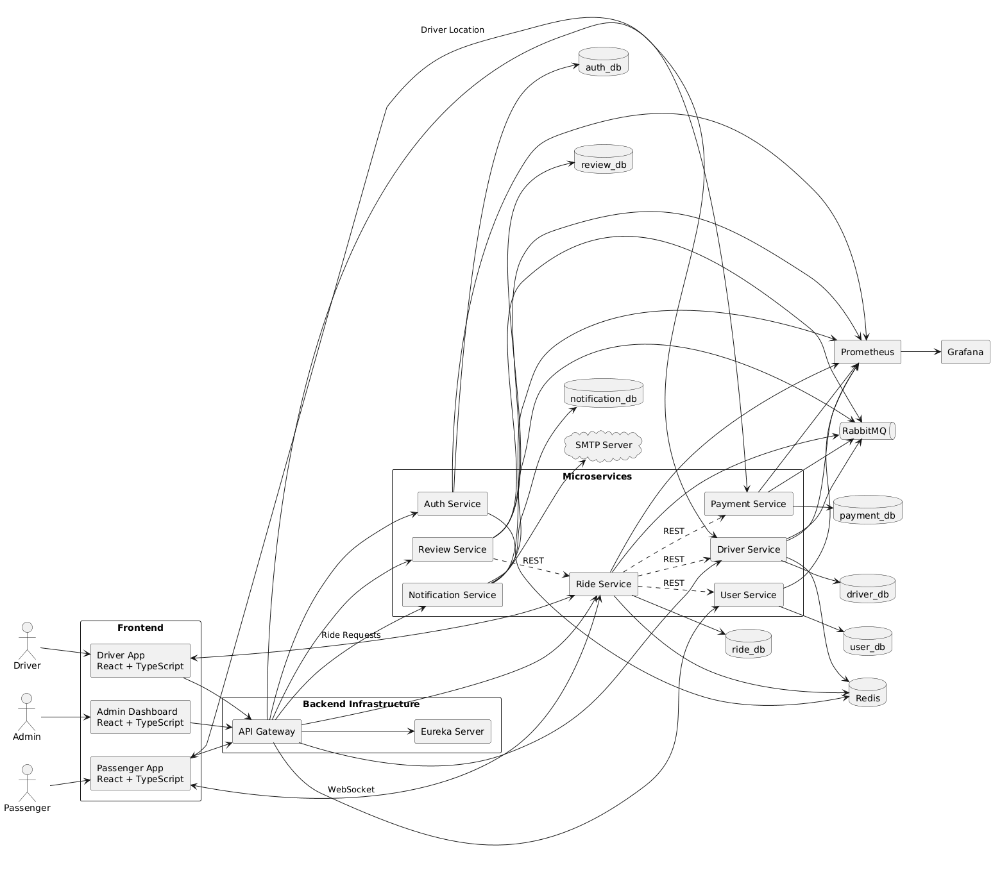
—————————————————————————————————————————

CabRide - Official Architecture & LLD Decisions (Version 1.0)

Project Goal
Build a production-inspired enterprise cab management platform that demonstrates:
- Java Backend Development
- Spring Boot
- Microservices
- Low-Level Design (LLD)
- High-Level Design (HLD)
- Distributed Systems
- Clean Code
- Software Engineering Best Practices
Primary objective:
Backend internship and placement portfolio.

High-Level Architecture Decisions

Architecture Style
Hybrid Microservices Architecture
Business-oriented microservices instead of splitting every feature into a separate service.

Microservices
- API Gateway
- Eureka Server
- Auth Service
- User Service
- Driver Service
- Ride Service
- Payment Service
- Review Service
- Notification Service

Database Strategy
Database per Service
Every service owns its own database.
auth_db
user_db
driver_db
ride_db
payment_db
review_db
notification_db
No service can directly access another service's database.

Communication Strategy

REST
Used for
- CRUD
- Authentication
- Ride Booking
- Profile Management

RabbitMQ
Used only for asynchronous events.
Events
RideRequested
DriverAssigned
RideAccepted
RideStarted
RideCompleted
RideCancelled
PaymentCompleted
ReviewSubmitted
NotificationRequested

WebSocket
Used only for
- Live Driver Location
- Ride Status Updates
- Driver Ride Requests
- Real-time Notifications

Service Discovery
Spring Cloud Eureka
Every service registers with Eureka.
API Gateway discovers services through Eureka.

API Gateway Responsibilities
- Routing
- JWT Validation
- Logging
- Rate Limiting
- CORS
- API Versioning
- Request Filtering
No business logic.

Authentication
JWT
Refresh Token
Role-Based Authorization
Roles
Passenger
Driver
Admin
No Keycloak.

Driver Matching
Implemented inside Ride Service.
Algorithm
Passenger books ride
↓
Find online drivers
↓
Filter by vehicle type
↓
Calculate distance
↓
Assign nearest driver
↓
If rejected
↓
Assign next nearest driver
No separate Matching Service.

Pricing
Pricing belongs to Ride Service.
No Pricing Service.
Pricing includes
- Base Fare
- Distance Fare
- Vehicle Type Multiplier

Driver Location
Managed by Driver Service.
Responsibilities
- Current Location
- Driver Availability
- Online/Offline Status
No Location Service.

Reviews
Dedicated Review Service.
Responsibilities
- Reviews
- Ratings
- Average Rating
- Review Validation

Payment
Dedicated Payment Service.
Uses Adapter Pattern.
Payment Methods
- Cash
- Wallet
- Mock UPI

Redis
Used only for temporary data.
Authentication
- Refresh Tokens
- OTP
- Blacklisted Tokens
Driver
- Online Drivers
- Driver Location
- Availability
Ride
- Active Ride Cache
- Ride Status
- ETA Cache
Permanent data belongs in MySQL.

Monitoring
Prometheus
Grafana
Health Checks
Application Metrics

Deployment
Docker Compose
Every service runs independently.

LLD Decisions

Architecture Style
Layered Architecture
Controller
↓
DTO
↓
Mapper
↓
Service Interface
↓
Service Implementation
↓
Repository
↓
Database

Package Structure
Package by Layer
controller/
dto/
entity/
mapper/
repository/
service/
event/
validation/
exception/
config/
util/
constants/

Domain Model
Anemic Domain Model
Entities contain only:
- Fields
- Relationships
- JPA Mapping
Business logic belongs only in services.

LLD Rules

Rule 1
Controllers never contain business logic.

Rule 2
All APIs use Request DTOs and Response DTOs.
Never expose Entity objects.

Rule 3
Every service has an interface and an implementation.
Example
RideService
RideServiceImpl

Rule 4
Repositories only access the database.
No business logic.

Rule 5
Entities are persistence models only.

Rule 6
Use Constructor Injection only.
Never use field injection.

Rule 7
Every entity has
- Request DTO
- Response DTO
- Mapper

Rule 8
Global Exception Handling in every service.

Rule 9
Use Jakarta Bean Validation.

Rule 10
Every service exposes Swagger/OpenAPI.

Rule 11
Use SLF4J Logging.
Never use System.out.println().

Rule 12
Never use magic strings.
Always use Enums or Constants.

Rule 13
Business events are published through RabbitMQ.

Rule 14
Redis stores only temporary data.

Rule 15
Every REST API returns a standard response format.
Example
{
success,
message,
data
}

Rule 16
Every service owns its own database.

Rule 17
Services communicate only through REST or RabbitMQ.

Rule 18
Every service must be independently deployable.

Rule 19
One business capability per microservice.

Rule 20
Follow SOLID Principles.

Design Patterns
Ride Lifecycle
→ State Pattern
Fare Calculation
→ Strategy Pattern
Payment
→ Adapter Pattern
Vehicle Creation
→ Factory Pattern
Notifications
→ Observer Pattern (Event Driven)
Repositories
→ Repository Pattern
DTO Creation
→ Builder Pattern
Spring Beans
→ Dependency Injection

Coding Standards
- Small methods
- Single Responsibility
- Meaningful names
- No duplicate logic
- Constructor Injection
- Standard API responses
- Proper exception handling
- Centralized validation
- Event-driven communication
- Clean package structure

Project Philosophy
CabRide is an engineering-focused project.
Priority order:
- Clean Architecture
- High-Level Design
- Low-Level Design
- SOLID Principles
- Maintainability
- Scalability
- Backend Excellence
- Professional Documentation
- Decent Frontend
The objective is to build a project that can be confidently presented in backend interviews, demonstrating not only implementation skills but also thoughtful software architecture and design.
—————————————————————————————————————————
Absolutely. This will become the official LLD specification for the Ride Service. Whenever we implement or review code, we'll follow this document.

Ride Service - Low Level Design (LLD)

1. Service Responsibilities ✅
Ride Service owns:
- Book Ride
- Fare Estimation
- Driver Matching
- Ride Lifecycle Management
- ETA Calculation
- Ride Tracking
- Ride Cancellation
- Ride History
- Ride Timeline
Ride Service does NOT own:
- Driver Profile
- Driver Location Storage
- Payment
- Reviews
- Notifications
- Authentication

2. Database Design ✅
Database
ride_db

Tables
rides

ride_timeline

No additional tables.

rides
id
ride_number

passenger_id
driver_id

pickup_address
pickup_latitude
pickup_longitude

drop_address
drop_latitude
drop_longitude

vehicle_type

estimated_distance
actual_distance

estimated_duration
actual_duration

base_fare
distance_fare
tax
total_fare

status

requested_at
accepted_at
started_at
completed_at
cancelled_at

created_at
updated_at

ride_timeline
id

ride_id

event

description

created_at

3. Entity Design ✅
Ride (@Entity)

RideTimeline (@Entity)

RideLocation (@Embeddable)

RideFare (@Embeddable)

RideStatus (Enum)

Java Model
Ride
│
├── RideLocation pickupLocation
│
├── RideLocation dropLocation
│
├── RideFare fare
│
└── RideStatus

No separate database tables for Location or Fare.

4. Ride State Machine ✅
REQUESTED

↓

SEARCHING_DRIVER

↓

DRIVER_ASSIGNED

↓

DRIVER_ACCEPTED

↓

DRIVER_ARRIVING

↓

OTP_VERIFIED

↓

RIDE_STARTED

↓

RIDE_COMPLETED

Cancellation
PASSENGER_CANCELLED

DRIVER_CANCELLED

ADMIN_CANCELLED

Allowed State Transitions
REQUESTED
│
▼
SEARCHING_DRIVER
│
▼
DRIVER_ASSIGNED
│
▼
DRIVER_ACCEPTED
│
▼
DRIVER_ARRIVING
│
▼
OTP_VERIFIED
│
▼
RIDE_STARTED
│
▼
RIDE_COMPLETED

5. REST APIs ✅
Passenger
POST /api/v1/rides

POST /api/v1/rides/fare-estimate

GET /api/v1/rides/{rideId}

GET /api/v1/rides/history

PATCH /api/v1/rides/{rideId}/cancel

Driver
PATCH /api/v1/rides/{rideId}/accept

PATCH /api/v1/rides/{rideId}/reject

PATCH /api/v1/rides/{rideId}/arrived

PATCH /api/v1/rides/{rideId}/verify-otp

PATCH /api/v1/rides/{rideId}/start

PATCH /api/v1/rides/{rideId}/complete

Admin
GET /api/v1/admin/rides/active

GET /api/v1/admin/rides/search

GET /api/v1/rides/{rideId}/timeline

6. RabbitMQ Events ✅

Published
RideRequested

DriverAssigned

DriverAccepted

RideStarted

RideCompleted

RideCancelled

Consumed
DriverLocationUpdated

PaymentCompleted

7. Redis Usage ✅
ride:{rideId}

active-rides

driver:{driverId}:currentRide

Stores
- Active Ride
- ETA
- Current Status
Never stores
- Ride History
- Fare History
- Timeline

8. Package Structure ✅
ride-service

config

controller

dto
request
response

entity

mapper

repository

service
RideService
impl

event
producer
consumer
model

validation

exception

websocket

constants

util

9. LLD Architecture ✅
Controller

↓

Request DTO

↓

Mapper

↓

RideService (Interface)

↓

RideServiceImpl

↓

Repository

↓

Database

↓

Response DTO

10. Design Patterns ✅
Pattern | Usage
State | Ride Lifecycle
Strategy | Fare Calculation
Repository | Data Access
Builder | DTO Creation
Dependency Injection | Spring Beans

11. Class Structure ✅
RideController

↓

RideService

↓

RideServiceImpl

↓

RideRepository

↓

MySQL

Supporting classes
RideMapper

RideValidator

RideStateMachine

FareCalculator

DriverMatchingService

RideEventPublisher

RideWebSocketHandler

12. Global LLD Rules Applied ✅
- No business logic in Controller
- Repository only accesses database
- DTOs for all APIs
- Constructor Injection
- Global Exception Handling
- Bean Validation
- Swagger Documentation
- SLF4J Logging
- Standard API Response
- SOLID Principles
- Layered Architecture
- Package by Layer
- Anemic Domain Model

13. Standard Response Format ✅
{
"success": true,
"message": "Ride booked successfully",
"data": {}
}

14. Final Ride Service Architecture
RideController
│
▼
RideServiceImpl
│
┌───────────────┬───────────────┬─────────────────┐
▼ ▼ ▼ ▼
Booking Matching State Machine Fare Strategy
Service Service Service Service
│ │ │ │
└───────────────┴───────────────┴─────────────────┘
│
RideRepository
│
▼
MySQL

RabbitMQ ◄──────── RideEventPublisher

Redis ◄────────── Active Ride Cache

WebSocket ◄────── Live Ride Updates

📌 Ride Service Design Status
Ride Service LLD is now complete.
It includes:
- ✅ Responsibilities
- ✅ Database Schema
- ✅ Entity Design
- ✅ State Machine
- ✅ REST APIs
- ✅ RabbitMQ Events
- ✅ Redis Strategy
- ✅ Package Structure
- ✅ LLD Architecture
- ✅ Design Patterns
- ✅ Class Structure
- ✅ Coding Standards
This is enough to start implementing the Ride Service with confidence. As we code, we may make small refinements, but we shouldn't need to revisit the core architecture unless the project requirements change.
——————————————————————————————————————————-
Absolutely. Below is the official Driver Service LLD Specification in the same format as the Ride Service. This will serve as the implementation blueprint for the Driver Service.

Driver Service - Low Level Design (LLD)

1. Service Responsibilities ✅
Driver Service owns:
- Driver Registration
- Driver Profile Management
- Vehicle Management
- Driver Documents
- Driver Verification
- Online / Offline Status
- Driver Availability
- Live Driver Location
- Driver Rating Summary
- Current Active Ride
Driver Service does NOT own:
- Authentication
- Ride Booking
- Ride History
- Payments
- Reviews
- Notifications

2. Database Design ✅
Database
driver_db

Tables
drivers

vehicles

driver_documents

drivers
id
driver_number

user_id

first_name
last_name

email
phone

address_line1
address_line2
city
state
country
zip_code

license_number

verification_status

online_status

availability_status

current_ride_id

average_rating

total_ratings

created_at
updated_at

vehicles
id

driver_id

vehicle_number

vehicle_type

brand

model

color

manufacturing_year

rc_number

insurance_number

created_at
updated_at

driver_documents
id

driver_id

document_type

document_url

verification_status

uploaded_at

Example document types
LICENSE

AADHAAR

PAN

RC

INSURANCE

3. Entity Design ✅
Driver (@Entity)
│
├── DriverAddress (@Embeddable)
├── DriverRating (@Embeddable)
│
├── Vehicle (@Entity)
└── DriverDocument (@Entity)

Java Model
Driver
│
├── id
├── driverNumber
├── firstName
├── lastName
├── email
├── phone
│
├── DriverAddress
│
├── verificationStatus
├── onlineStatus
├── availabilityStatus
├── currentRideId
│
├── DriverRating
│
├── createdAt
└── updatedAt

DriverAddress
addressLine1

addressLine2

city

state

country

zipCode

DriverRating
averageRating

totalRatings

Vehicle
id

driverId

vehicleNumber

vehicleType

brand

model

color

manufacturingYear

rcNumber

insuranceNumber

DriverDocument
id

driverId

documentType

documentUrl

verificationStatus

uploadedAt

4. REST APIs ✅

Driver Profile
POST /api/v1/drivers

GET /api/v1/drivers/{driverId}

PUT /api/v1/drivers/{driverId}

Vehicle
POST /api/v1/drivers/{driverId}/vehicle

GET /api/v1/drivers/{driverId}/vehicle

PUT /api/v1/drivers/{driverId}/vehicle

Documents
POST /api/v1/drivers/{driverId}/documents

GET /api/v1/drivers/{driverId}/documents

Driver Status
PATCH /api/v1/drivers/{driverId}/status

Request
{
"onlineStatus":"ONLINE"
}

Status values
ONLINE

OFFLINE

ON_BREAK

SUSPENDED

Driver Availability
PATCH /api/v1/drivers/{driverId}/availability

Request
{
"availability":"AVAILABLE"
}

Availability values
AVAILABLE

BUSY

UNAVAILABLE

Live Location
PATCH /api/v1/drivers/{driverId}/location

Request
{
"latitude":26.8475,
"longitude":80.9462
}

Driver Rating
GET /api/v1/drivers/{driverId}/rating

Admin APIs
GET /api/v1/admin/drivers

PATCH /api/v1/admin/drivers/{driverId}/verify

PATCH /api/v1/admin/drivers/{driverId}/reject

5. RabbitMQ Events ✅

Published Events
DriverRegistered

DriverVerified

DriverStatusChanged

DriverAvailabilityChanged

DriverLocationUpdated

DriverRatingUpdated

Consumed Events
RideAssigned

RideCompleted

RideCancelled

ReviewSubmitted

Event Flow

Ride Assigned
Ride Service

↓

RideAssigned

↓

RabbitMQ

↓

Driver Service

↓

availability = BUSY

currentRideId = rideId

Ride Completed
RideCompleted

↓

RabbitMQ

↓

Driver Service

↓

availability = AVAILABLE

currentRideId = null

Review Submitted
ReviewSubmitted

↓

Driver Service

↓

Update averageRating

Update totalRatings

6. Redis Usage ✅
Stores only temporary data.

Driver Location
driver:{driverId}:location

Driver Status
driver:{driverId}:status

Driver Availability
driver:{driverId}:availability

Active Ride
driver:{driverId}:currentRide

Never store
- Driver Profile
- Vehicles
- Documents
- Ratings
Those belong in MySQL.

7. Package Structure ✅
driver-service
│
├── config
│
├── controller
│
├── dto
│ ├── request
│ └── response
│
├── entity
│
├── mapper
│
├── repository
│
├── service
│ ├── DriverService
│ └── impl
│
├── event
│ ├── producer
│ ├── consumer
│ └── model
│
├── websocket
│
├── validation
│
├── exception
│
├── constants
│
├── util
│
└── DriverServiceApplication

8. LLD Architecture ✅
HTTP Request
│
▼
DriverController
│
▼
Request DTO
│
▼
DriverMapper
│
▼
DriverService
│
▼
DriverServiceImpl
│
┌────┼───────────┬──────────────┐
▼ ▼ ▼ ▼
Vehicle Document Location Rating
Service Service Service Service
│
▼
Repositories
│
▼
MySQL / Redis
│
▼
Response DTO

9. Design Patterns ✅
Pattern | Usage
Repository | Database Access
Builder | DTO Creation
Dependency Injection | Spring Beans
Factory (Optional) | Driver/Vehicle Creation
Observer | RabbitMQ Event Handling

10. Supporting Components ✅
DriverController

DriverService

DriverServiceImpl

DriverRepository

VehicleRepository

DriverDocumentRepository

DriverMapper

DriverValidator

DriverEventPublisher

DriverEventConsumer

RedisLocationService

11. Global LLD Rules Applied ✅
- No business logic in Controller
- DTOs for every API
- Constructor Injection only
- Repository only accesses the database
- Global Exception Handling
- Bean Validation
- Swagger/OpenAPI
- SLF4J Logging
- Standard API Response
- Layered Architecture
- Package by Layer
- Anemic Domain Model
- SOLID Principles

12. Standard Response Format ✅
{
"success": true,
"message": "Driver profile updated successfully",
"data": {}
}

13. Final Driver Service Architecture
DriverController
│
▼
DriverServiceImpl
│
┌─────────────┬──────────────┬───────────────┐
▼ ▼ ▼ ▼
VehicleService DocumentService LocationService RatingService
│ │ │ │
└─────────────┴──────────────┴───────────────┘
│
DriverRepository
VehicleRepository
DriverDocumentRepository
│
┌──────────┴──────────┐
▼ ▼
MySQL Redis
│
RabbitMQ Events

📌 Driver Service LLD Status
The Driver Service LLD is now complete.
It includes:
- ✅ Responsibilities
- ✅ Database Schema
- ✅ Entity Design
- ✅ REST APIs
- ✅ RabbitMQ Events
- ✅ Redis Strategy
- ✅ Package Structure
- ✅ Layered Architecture
- ✅ Design Patterns
- ✅ Supporting Components
- ✅ Coding Standards
- ✅ Standard Response Format
This provides a complete blueprint for implementing the Driver Service while remaining consistent with the architecture and engineering rules established for CabRide.
—————————————————————————————————————————
Perfect. Before we start coding, let's finalize the Auth Service LLD exactly like we did for Ride and Driver Service.

Auth Service - Low Level Design (LLD)

1. Service Responsibilities ✅
The Auth Service owns authentication and authorization only.
It is responsible for:
- User Registration
- Login
- Logout
- JWT Access Token Generation
- Refresh Token Generation
- Refresh Token Rotation
- Email Verification
- Forgot Password
- Reset Password
- Change Password
- Role Management
- Account Locking (after failed login attempts)
- Token Validation
- Blacklisting JWT on Logout
It does NOT own:
- User Profile
- Driver Profile
- Passenger Profile
- Ride Booking
- Reviews
- Payments
- Notifications (only publishes events)

2. Database Design ✅
Database
auth_db

Tables
users

refresh_tokens

email_verifications

password_reset_tokens

users
id

user_number

first_name

last_name

email

phone

password

role

account_status

email_verified

failed_login_attempts

locked_until

created_at

updated_at

refresh_tokens
id

user_id

token

expires_at

revoked

created_at

email_verifications
id

user_id

verification_token

expires_at

verified

created_at

password_reset_tokens
id

user_id

reset_token

expires_at

used

created_at

3. Entity Design ✅
User (@Entity)

RefreshToken (@Entity)

EmailVerification (@Entity)

PasswordResetToken (@Entity)

Java Model
User
│
├── id
├── userNumber
├── firstName
├── lastName
├── email
├── phone
├── password
├── role
├── accountStatus
├── emailVerified
├── failedLoginAttempts
├── lockedUntil
├── createdAt
└── updatedAt

Role Enum
PASSENGER

DRIVER

ADMIN

Account Status
ACTIVE

LOCKED

DISABLED

PENDING_VERIFICATION

4. REST APIs ✅

Authentication
POST /api/v1/auth/register

POST /api/v1/auth/login

POST /api/v1/auth/logout

POST /api/v1/auth/refresh-token

Email Verification
POST /api/v1/auth/verify-email

POST /api/v1/auth/resend-verification

Password
POST /api/v1/auth/forgot-password

POST /api/v1/auth/reset-password

PATCH /api/v1/auth/change-password

User
GET /api/v1/auth/me

Returns currently authenticated user.

Admin
GET /api/v1/admin/users

PATCH /api/v1/admin/users/{userId}/lock

PATCH /api/v1/admin/users/{userId}/unlock

5. RabbitMQ Events ✅

Published Events
UserRegistered

EmailVerified

PasswordChanged

PasswordReset

UserLocked

UserUnlocked

Consumed Events
DriverRegistered

PassengerRegistered

(Optional depending on implementation.)

Event Flow

Registration
User Registers

↓

Auth Service

↓

Store User

↓

Publish UserRegistered

↓

Notification Service

↓

Send Verification Email

Email Verification
Email Verified

↓

Publish EmailVerified

6. Redis Usage ✅
Redis stores only temporary authentication data.

Refresh Token Cache
refresh:{userId}

Blacklisted JWT
blacklist:{jwt}

OTP / Verification Code
otp:{email}

Login Attempts
login-attempt:{email}

Never store
- User Profile
- Password
- Roles permanently
Those belong in MySQL.

7. Package Structure ✅
auth-service
│
├── config
│
├── controller
│
├── dto
│ ├── request
│ └── response
│
├── entity
│
├── mapper
│
├── repository
│
├── service
│ ├── AuthService
│ └── impl
│
├── security
│
├── jwt
│
├── event
│ ├── producer
│ ├── consumer
│ └── model
│
├── validation
│
├── exception
│
├── constants
│
├── util
│
└── AuthServiceApplication

8. LLD Architecture ✅
HTTP Request
│
▼
AuthController
│
▼
Request DTO
│
▼
AuthMapper
│
▼
AuthService
│
▼
AuthServiceImpl
│
┌────────────┬─────────────┬─────────────┐
▼ ▼ ▼
JWTService TokenService EmailService
│
▼
Repositories
│
▼
MySQL / Redis
│
▼
Response DTO

9. Design Patterns ✅
Pattern | Usage
Repository | Database Access
Builder | DTO Construction
Dependency Injection | Spring Beans
Strategy (Optional) | Authentication Provider (future OAuth, Google Login)
Observer | RabbitMQ Events

10. Supporting Components ✅
AuthController

AuthService

AuthServiceImpl

JwtService

RefreshTokenService

EmailVerificationService

PasswordResetService

AuthMapper

JwtProvider

AuthEventPublisher

AuthEventConsumer

SecurityConfig

11. Global LLD Rules Applied ✅
- Controllers contain no business logic
- DTOs for every request and response
- Constructor Injection only
- Repository only accesses the database
- Global Exception Handling
- Bean Validation
- Swagger/OpenAPI
- SLF4J Logging
- Layered Architecture
- Package by Layer
- Anemic Domain Model
- SOLID Principles

12. Standard Response Format ✅
{
"success": true,
"message": "Login successful",
"data": {
"accessToken": "...",
"refreshToken": "..."
}
}

13. Security Architecture
Client
│
▼
API Gateway
│
JWT Validation
│
▼
Auth Service
│
┌───────────────┐
│ Access Token │
│ Refresh Token │
└───────────────┘
│
▼
Redis + MySQL

14. Authentication Flow
Register
│
▼
Email Verification
│
▼
Login
│
▼
Access Token + Refresh Token
│
▼
API Gateway validates JWT
│
▼
Microservices process request
│
▼
Refresh Token when Access Token expires

📌 Auth Service LLD Status
The Auth Service LLD is now complete.
It includes:
- ✅ Responsibilities
- ✅ Database Schema
- ✅ Entity Design
- ✅ REST APIs
- ✅ RabbitMQ Events
- ✅ Redis Strategy
- ✅ Package Structure
- ✅ Security Architecture
- ✅ Authentication Flow
- ✅ Design Patterns
- ✅ Supporting Components
- ✅ Coding Standards

One suggestion
I would make one small improvement to our original architecture: move all user identity information (email, password, role, account status) into the Auth Service, and keep profile information (such as passenger profile and driver profile) in the User and Driver services. This creates a clean separation between Identity & Access Management and Business Domains, which is how many production systems are designed. That means Ride, Driver, and User services never need to know about passwords or authentication internals—they only trust the authenticated user identity provided by the gateway.
——————————————————————————————————————————-
Perfect. We have completed the three most important services.
- ✅ Ride Service
- ✅ Driver Service
- ✅ Auth Service
Now let's decide the order for the remaining services.
Service | Dependency | Complexity
Payment Service | Ride | ⭐⭐⭐⭐
Review Service | Ride + Driver + User | ⭐⭐⭐
Notification Service | All Services | ⭐⭐⭐
User Service | Auth | ⭐⭐
I recommend Payment Service next because it's the only remaining core business service. Review and Notification depend on Ride and Payment events.

Payment Service - Low Level Design (LLD)

1. Service Responsibilities ✅
Payment Service owns everything related to money.
Responsibilities:
- Payment Processing
- Wallet Management
- Mock UPI Payment
- Cash Payment
- Transaction History
- Invoice Generation
- Payment Status Management
- Refund Processing (Future)
- Payment Validation
Payment Service does NOT own:
- Ride Booking
- Fare Calculation
- Driver Earnings Calculation
- Reviews
- Authentication

2. Database Design ✅
Database
payment_db

Tables
payments

wallets

transactions

invoices

payments
id

payment_number

ride_id

payer_id

payee_id

payment_method

amount

status

transaction_id

created_at

updated_at

wallets
id

user_id

balance

created_at

updated_at

transactions
id

payment_id

transaction_reference

status

gateway_response

created_at

invoices
id

payment_id

invoice_number

invoice_url

generated_at

3. Entity Design ✅
Payment (@Entity)

Wallet (@Entity)

Transaction (@Entity)

Invoice (@Entity)

PaymentStatus
PENDING

PROCESSING

SUCCESS

FAILED

REFUNDED

PaymentMethod
CASH

WALLET

MOCK_UPI

4. REST APIs ✅

Payments
POST /api/v1/payments

GET /api/v1/payments/{paymentId}

GET /api/v1/payments/history

Wallet
GET /api/v1/wallet

POST /api/v1/wallet/add-money

GET /api/v1/wallet/transactions

Invoice
GET /api/v1/payments/{paymentId}/invoice

Admin
GET /api/v1/admin/payments

GET /api/v1/admin/transactions

5. RabbitMQ Events ✅

Published
PaymentInitiated

PaymentCompleted

PaymentFailed

InvoiceGenerated

Consumed
RideCompleted

Event Flow
RideCompleted

↓

RabbitMQ

↓

Payment Service

↓

Process Payment

↓

PaymentCompleted

↓

RabbitMQ

↓

Notification Service

6. Redis Usage ✅
Only temporary payment state.
payment:{paymentId}

Stores
- Current Status
- Retry Count
No transaction history in Redis.

7. Package Structure ✅
payment-service

config

controller

dto
request
response

entity

mapper

repository

service
PaymentService
impl

adapter

event
producer
consumer

validation

exception

util

constants

8. LLD Architecture ✅
PaymentController
│
▼
PaymentService
│
▼
PaymentServiceImpl
│
┌──────────┬───────────────┬───────────────┐
▼ ▼ ▼
Wallet Invoice PaymentProcessor
Service Service
│
▼
Repositories
│
▼
Database

9. Design Patterns ✅
This service demonstrates one of the best LLD patterns.
Pattern | Usage
Adapter | Payment Methods
Repository | Database Access
Builder | DTO Creation
Dependency Injection | Spring Beans
Observer | RabbitMQ Events

Adapter Pattern
PaymentProcessor
│
┌──────────────┼──────────────┐
▼ ▼ ▼
CashPayment WalletPayment MockUpiPayment

Adding Razorpay later?
Just create:
RazorpayPayment

No existing code changes.

10. Supporting Components
PaymentController

PaymentService

PaymentServiceImpl

WalletService

InvoiceService

PaymentProcessor

CashPaymentProcessor

WalletPaymentProcessor

MockUpiPaymentProcessor

PaymentRepository

WalletRepository

TransactionRepository

InvoiceRepository

PaymentEventPublisher

PaymentEventConsumer

11. Global LLD Rules Applied
- No business logic in Controller
- DTOs for every API
- Constructor Injection
- Repository only accesses database
- Global Exception Handling
- Bean Validation
- Swagger/OpenAPI
- SLF4J Logging
- Layered Architecture
- Package by Layer
- Anemic Domain Model
- SOLID Principles

12. Standard Response Format
{
"success": true,
"message": "Payment successful",
"data": {}
}

13. Payment Flow
Ride Completed
│
▼
Payment Service
│
Select Payment Adapter
│
┌─────┼─────────────┐
▼ ▼ ▼
Cash Wallet Mock UPI
│
▼
Transaction Saved
│
▼
Invoice Generated
│
▼
PaymentCompleted Event

✅ Payment Service LLD Complete
At this point we have completed 4 out of 7 business services:
Service | Status
✅ Ride Service | Complete
✅ Driver Service | Complete
✅ Auth Service | Complete
✅ Payment Service | Complete
⏳ Review Service | Next
⏳ Notification Service | Pending
⏳ User Service | Pending

One improvement I'd make
I would slightly refine the original Payment design by introducing a PaymentProcessor interface with one implementation per payment method (Cash, Wallet, Mock UPI). That keeps the Adapter/Strategy approach clean and makes it trivial to add a real gateway like Razorpay or Stripe in the future without modifying the existing payment workflow. This also gives you an excellent design-pattern example to discuss in interviews.
—————————————————————————————————————————
Excellent. The Review Service is actually much simpler than Ride or Driver, but it's a great opportunity to demonstrate event-driven architecture. We'll keep it focused on reviews and ratings only.

Review Service - Low Level Design (LLD)

1. Service Responsibilities ✅
Review Service owns:
- Submit Review
- Submit Rating
- Review Validation
- Review History
- Driver Rating Calculation
- Passenger Rating Calculation
- Prevent Duplicate Reviews
Review Service does NOT own:
- Ride Validation (calls Ride Service)
- Driver Profile
- Passenger Profile
- Ride History
- Notifications

2. Database Design ✅
Database
review_db

Tables
reviews

rating_summary

reviews
id

review_number

ride_id

driver_id

passenger_id

reviewer_type

rating

review_text

created_at

rating_summary
id

user_id

user_type

average_rating

total_ratings

updated_at

ReviewerType
PASSENGER

DRIVER

UserType
PASSENGER

DRIVER

3. Entity Design ✅
Review (@Entity)

RatingSummary (@Entity)

Java Model

Review
id

reviewNumber

rideId

driverId

passengerId

reviewerType

rating

reviewText

createdAt

RatingSummary
userId

userType

averageRating

totalRatings

4. REST APIs ✅

Reviews
POST /api/v1/reviews

Submit review.
GET /api/v1/reviews/{reviewId}
GET /api/v1/reviews/ride/{rideId}
GET /api/v1/reviews/driver/{driverId}
GET /api/v1/reviews/passenger/{passengerId}

Ratings
GET /api/v1/ratings/driver/{driverId}
GET /api/v1/ratings/passenger/{passengerId}

Admin
GET /api/v1/admin/reviews
DELETE /api/v1/admin/reviews/{reviewId}

(Optional moderation.)

5. RabbitMQ Events ✅

Published Events
ReviewSubmitted

DriverRatingUpdated

PassengerRatingUpdated

Consumed Events
RideCompleted

Event Flow
RideCompleted
│
▼
RabbitMQ
│
▼
Review Service
│
Enable Review
│
Passenger submits review
│
Review Stored
│
Average Rating Updated
│
Publish ReviewSubmitted
│
─────────────────────────────
│ │
▼ ▼
Driver Service User Service
Update Rating Update Rating

6. Redis Usage ✅
No Redis
Reason:
- Reviews are not high-frequency.
- Ratings are updated infrequently.
- MySQL is sufficient.
This keeps the service simple.

7. Package Structure ✅
review-service
│
├── config
│
├── controller
│
├── dto
│ ├── request
│ └── response
│
├── entity
│
├── mapper
│
├── repository
│
├── service
│ ├── ReviewService
│ └── impl
│
├── event
│ ├── producer
│ ├── consumer
│ └── model
│
├── validation
│
├── exception
│
├── constants
│
├── util
│
└── ReviewServiceApplication

8. LLD Architecture ✅
HTTP Request
│
▼
ReviewController
│
▼
Request DTO
│
▼
ReviewMapper
│
▼
ReviewService
│
▼
ReviewServiceImpl
│
┌────────────┬───────────────┐
▼ ▼
Review Rating
Repository Repository
│
▼
MySQL
│
▼
RabbitMQ

9. Design Patterns ✅
Pattern | Usage
Repository | Database Access
Builder | DTO Creation
Dependency Injection | Spring Beans
Observer | RabbitMQ Event Handling
No State or Strategy patterns are needed because the review lifecycle is straightforward.

10. Supporting Components ✅
ReviewController

ReviewService

ReviewServiceImpl

ReviewRepository

RatingSummaryRepository

ReviewMapper

ReviewValidator

ReviewEventPublisher

ReviewEventConsumer

11. Business Rules ✅
A review can only be submitted if:
- Ride status is COMPLETED
- Reviewer participated in the ride
- Review has not already been submitted
- Rating is between 1 and 5
- Review text length is within limits

12. Global LLD Rules Applied ✅
- No business logic in Controller
- DTOs for every API
- Constructor Injection
- Repository only accesses the database
- Global Exception Handling
- Bean Validation
- Swagger/OpenAPI
- SLF4J Logging
- Layered Architecture
- Package by Layer
- Anemic Domain Model
- SOLID Principles

13. Standard Response Format ✅
{
"success": true,
"message": "Review submitted successfully",
"data": {}
}

14. Final Review Service Architecture
ReviewController
│
▼
ReviewServiceImpl
│
┌───────────────┴────────────────┐
▼ ▼
ReviewRepository RatingSummaryRepository
│ │
└────────────────┬───────────────┘
▼
MySQL
│
▼
RabbitMQ Events

📌 Review Service LLD Status
The Review Service LLD is now complete.

Responsibilities
- Submit Reviews
- Submit Ratings
- Rating Calculation
- Review Validation
- Review History

Database
- reviews
- rating_summary

REST APIs
- Review APIs
- Rating APIs
- Admin APIs

RabbitMQ
Publishes
- ReviewSubmitted
- DriverRatingUpdated
- PassengerRatingUpdated
Consumes
- RideCompleted

Redis
- Not required

Design Patterns
- Repository
- Builder
- Dependency Injection
- Observer

One improvement I recommend
I would not store averageRating permanently in both the Driver/User services and the Review service as independent sources of truth.
Instead:
- Review Service should be the source of truth for all ratings and review calculations.
- Driver Service and User Service should store only a cached rating summary (average rating and total ratings) that gets updated through DriverRatingUpdated and PassengerRatingUpdated events.
This keeps review logic centralized while allowing other services to display ratings efficiently without querying the Review Service on every request. It's a common pattern in event-driven architectures and avoids inconsistent business logic.
——————————————————————————————————————————
Great. We've completed the core business services.
- ✅ Ride Service
- ✅ Driver Service
- ✅ Auth Service
- ✅ Payment Service
- ✅ Review Service
The next service should be Notification Service because almost every other service publishes events that it consumes.

Notification Service - Low Level Design (LLD)

1. Service Responsibilities ✅
Notification Service owns all user notifications.
Responsibilities:
- Email Notifications
- In-App Notifications
- Real-Time Notifications (WebSocket)
- Notification History
- Notification Preferences
- Mark Notifications as Read
- Retry Failed Notifications
Notification Service does NOT own:
- Ride Booking
- Authentication
- Reviews
- Payments
- Driver Profile
- User Profile

2. Database Design ✅
Database
notification_db

Tables
notifications

notification_preferences

notifications
id

notification_number

user_id

user_role

notification_type

title

message

status

channel

read

created_at

notification_preferences
id

user_id

email_enabled

in_app_enabled

websocket_enabled

created_at

updated_at

Notification Status
PENDING

SENT

FAILED

READ

Notification Channel
EMAIL

IN_APP

WEBSOCKET

3. Entity Design ✅
Notification (@Entity)

NotificationPreference (@Entity)

Notification
id

notificationNumber

userId

userRole

notificationType

title

message

status

channel

read

createdAt

NotificationPreference
userId

emailEnabled

inAppEnabled

websocketEnabled

4. REST APIs ✅

Notifications
GET /api/v1/notifications

GET /api/v1/notifications/{notificationId}

PATCH /api/v1/notifications/{notificationId}/read

PATCH /api/v1/notifications/read-all

Preferences
GET /api/v1/notifications/preferences

PUT /api/v1/notifications/preferences

Example
{
"emailEnabled": true,
"inAppEnabled": true,
"websocketEnabled": true
}

Admin
GET /api/v1/admin/notifications

GET /api/v1/admin/notifications/failed

5. RabbitMQ Events ✅

Published Events
NotificationSent

NotificationFailed

Consumed Events
UserRegistered

EmailVerified

RideRequested

DriverAssigned

DriverAccepted

RideStarted

RideCompleted

RideCancelled

PaymentCompleted

PaymentFailed

ReviewSubmitted

DriverVerified

Event Flow
RideCompleted
│
▼
RabbitMQ
│
▼
Notification Service
│
┌──────┼──────────────┐
▼ ▼ ▼
Email WebSocket In-App
│
▼
NotificationSent

6. Redis Usage ✅

Notification Queue (Optional)
notification:{userId}

Stores unread notification count.
notification:15

count = 8

WebSocket Sessions
session:{userId}

Stores active WebSocket connection information.
Redis is optional here. The database remains the source of truth.

7. Package Structure ✅
notification-service
│
├── config
│
├── controller
│
├── dto
│ ├── request
│ └── response
│
├── entity
│
├── mapper
│
├── repository
│
├── service
│ ├── NotificationService
│ └── impl
│
├── websocket
│
├── email
│
├── event
│ ├── producer
│ ├── consumer
│
├── validation
│
├── exception
│
├── constants
│
├── util
│
└── NotificationServiceApplication

8. LLD Architecture ✅
HTTP Request
│
▼
NotificationController
│
▼
Request DTO
│
▼
NotificationMapper
│
▼
NotificationService
│
▼
NotificationServiceImpl
│
┌──────────┬─────────────┬────────────┐
▼ ▼ ▼
Email WebSocket In-App
Service Service Service
│
▼
Repositories
│
▼
MySQL / Redis

9. Design Patterns ✅
Pattern | Usage
Observer | RabbitMQ Event Handling
Strategy | Notification Channel Selection
Repository | Database Access
Builder | DTO Creation
Dependency Injection | Spring Beans

Strategy Pattern
NotificationSender
│
────────┼───────────────
│ │ │
▼ ▼ ▼
Email WebSocket InApp

When a notification arrives:
notificationSender.send(notification);

The correct sender is chosen based on the notification channel.

10. Supporting Components ✅
NotificationController

NotificationService

NotificationServiceImpl

EmailNotificationSender

WebSocketNotificationSender

InAppNotificationSender

NotificationRepository

PreferenceRepository

NotificationMapper

NotificationValidator

NotificationEventConsumer

NotificationEventPublisher

11. Business Rules ✅
- Respect user notification preferences.
- Store every notification before sending.
- Retry failed email deliveries (future enhancement).
- Mark notifications as read/unread.
- One event can trigger multiple channels (email + in-app + WebSocket).

12. Global LLD Rules Applied ✅
- No business logic in Controller
- DTOs for every API
- Constructor Injection
- Repository only accesses the database
- Global Exception Handling
- Bean Validation
- Swagger/OpenAPI
- SLF4J Logging
- Layered Architecture
- Package by Layer
- Anemic Domain Model
- SOLID Principles

13. Standard Response Format ✅
{
"success": true,
"message": "Notification marked as read",
"data": {}
}

14. Final Notification Service Architecture
NotificationController
│
▼
NotificationServiceImpl
│
┌──────────┬────────────┬────────────┐
▼ ▼ ▼
EmailSender WebSocketSender InAppSender
│ │ │
└──────────┴────────────┘
│
▼
NotificationRepository
│
PreferenceRepository
│
▼
MySQL / Redis
│
▼
RabbitMQ Events

📌 Notification Service LLD Status

Responsibilities
- Email Notifications
- In-App Notifications
- WebSocket Notifications
- Notification Preferences
- Notification History

Database
- notifications
- notification_preferences

REST APIs
- Notification APIs
- Preference APIs
- Admin APIs

RabbitMQ
Publishes
- NotificationSent
- NotificationFailed
Consumes
- UserRegistered
- EmailVerified
- RideRequested
- DriverAssigned
- DriverAccepted
- RideStarted
- RideCompleted
- RideCancelled
- PaymentCompleted
- PaymentFailed
- ReviewSubmitted
- DriverVerified

Redis
- WebSocket sessions
- Unread notification count (optional)

Design Patterns
- Strategy
- Observer
- Repository
- Builder
- Dependency Injection
——————————————————————————————————————————
Perfect. This is the last business service of CabRide.
Since we've already separated Auth (identity) and Driver (driver domain), the User Service becomes very clean.

User Service - Low Level Design (LLD)

1. Service Responsibilities ✅
The User Service owns everything related to passenger profiles and preferences.
Responsibilities:
- Passenger Profile Management
- Profile Update
- Profile Picture
- Saved Addresses
- Favourite Locations
- Emergency Contacts
- Passenger Rating Summary
- Passenger Preferences
User Service does NOT own:
- Authentication (Auth Service)
- Ride Booking (Ride Service)
- Payments (Payment Service)
- Reviews (Review Service)
- Notifications (Notification Service)

2. Database Design ✅
Database
user_db

Tables
users

saved_locations

emergency_contacts

Note: We intentionally do not store ratings here. The Review Service remains the source of truth, and Driver/User services keep only a cached rating summary updated via events.

users
id

user_number

auth_user_id

first_name

last_name

phone

profile_picture

gender

date_of_birth

average_rating

total_ratings

created_at

updated_at

saved_locations
id

user_id

label

address

latitude

longitude

is_default

created_at

Example
Home

Office

College

emergency_contacts
id

user_id

name

phone

relationship

created_at

3. Entity Design ✅
User (@Entity)
│
├── UserProfile (@Embeddable)
├── UserRating (@Embeddable)
│
├── SavedLocation (@Entity)
└── EmergencyContact (@Entity)

User
id

userNumber

authUserId

firstName

lastName

phone

profilePicture

gender

dateOfBirth

rating

createdAt

updatedAt

UserRating
averageRating

totalRatings

SavedLocation
id

userId

label

address

latitude

longitude

isDefault

EmergencyContact
id

userId

name

phone

relationship

4. REST APIs ✅

Profile
GET /api/v1/users/me

PUT /api/v1/users/me

Saved Locations
POST /api/v1/users/me/locations

GET /api/v1/users/me/locations

PUT /api/v1/users/me/locations/{locationId}

DELETE /api/v1/users/me/locations/{locationId}

Emergency Contacts
POST /api/v1/users/me/emergency-contacts

GET /api/v1/users/me/emergency-contacts

PUT /api/v1/users/me/emergency-contacts/{contactId}

DELETE /api/v1/users/me/emergency-contacts/{contactId}

Passenger Rating
GET /api/v1/users/{userId}/rating

Admin
GET /api/v1/admin/users

GET /api/v1/admin/users/{userId}

5. RabbitMQ Events ✅

Published
UserProfileUpdated

SavedLocationAdded

EmergencyContactAdded

Consumed
UserRegistered

PassengerRatingUpdated

Event Flow

Registration
Auth Service

↓

UserRegistered

↓

RabbitMQ

↓

User Service

↓

Create Passenger Profile

Rating Update
Review Service

↓

PassengerRatingUpdated

↓

RabbitMQ

↓

User Service

↓

Update Rating Summary

6. Redis Usage ✅
No Redis
Reason
Profile data changes infrequently.
MySQL is sufficient.

7. Package Structure ✅
user-service

config

controller

dto
request
response

entity

mapper

repository

service
UserService
impl

event
producer
consumer

validation

exception

constants

util

UserServiceApplication

8. LLD Architecture ✅
HTTP Request
│
▼
UserController
│
▼
Request DTO
│
▼
UserMapper
│
▼
UserService
│
▼
UserServiceImpl
│
┌──────────────┬──────────────────┐
▼ ▼
Location Emergency Contact
Service Service
│
▼
Repositories
│
▼
MySQL
│
▼
RabbitMQ

9. Design Patterns ✅
Pattern | Usage
Repository | Database Access
Builder | DTO Creation
Dependency Injection | Spring Beans
Observer | RabbitMQ Event Handling
No State or Strategy patterns are needed.

10. Supporting Components ✅
UserController

UserService

UserServiceImpl

SavedLocationService

EmergencyContactService

UserRepository

SavedLocationRepository

EmergencyContactRepository

UserMapper

UserValidator

UserEventPublisher

UserEventConsumer

11. Business Rules ✅
- Every authenticated passenger has one profile.
- Maximum configurable number of saved locations (e.g., 10).
- Maximum configurable number of emergency contacts (e.g., 5).
- Labels like "Home" and "Office" are user-defined.
- Rating summary is updated only through Review Service events.

12. Global LLD Rules Applied ✅
- No business logic in Controller
- DTOs for every API
- Constructor Injection
- Repository only accesses the database
- Global Exception Handling
- Bean Validation
- Swagger/OpenAPI
- SLF4J Logging
- Layered Architecture
- Package by Layer
- Anemic Domain Model
- SOLID Principles

13. Standard Response Format ✅
{
"success": true,
"message": "Profile updated successfully",
"data": {}
}

14. Final User Service Architecture
UserController
│
▼
UserServiceImpl
│
┌───────────────┴────────────────┐
▼ ▼
SavedLocationService EmergencyContactService
│ │
└───────────────┬────────────────┘
▼
UserRepository
SavedLocationRepository
EmergencyContactRepository
│
▼
MySQL
│
▼
RabbitMQ Events

📌 User Service LLD Status

Responsibilities
- Passenger Profile
- Saved Locations
- Emergency Contacts
- Passenger Preferences
- Passenger Rating Summary

Database
- users
- saved_locations
- emergency_contacts

REST APIs
- Profile APIs
- Saved Location APIs
- Emergency Contact APIs
- Admin APIs

RabbitMQ
Publishes
- UserProfileUpdated
- SavedLocationAdded
- EmergencyContactAdded
Consumes
- UserRegistered
- PassengerRatingUpdated

Redis
- Not required

Design Patterns
- Repository
- Builder
- Dependency Injection
- Observer
——————————————————————————————————————
ER diagram of CabRide
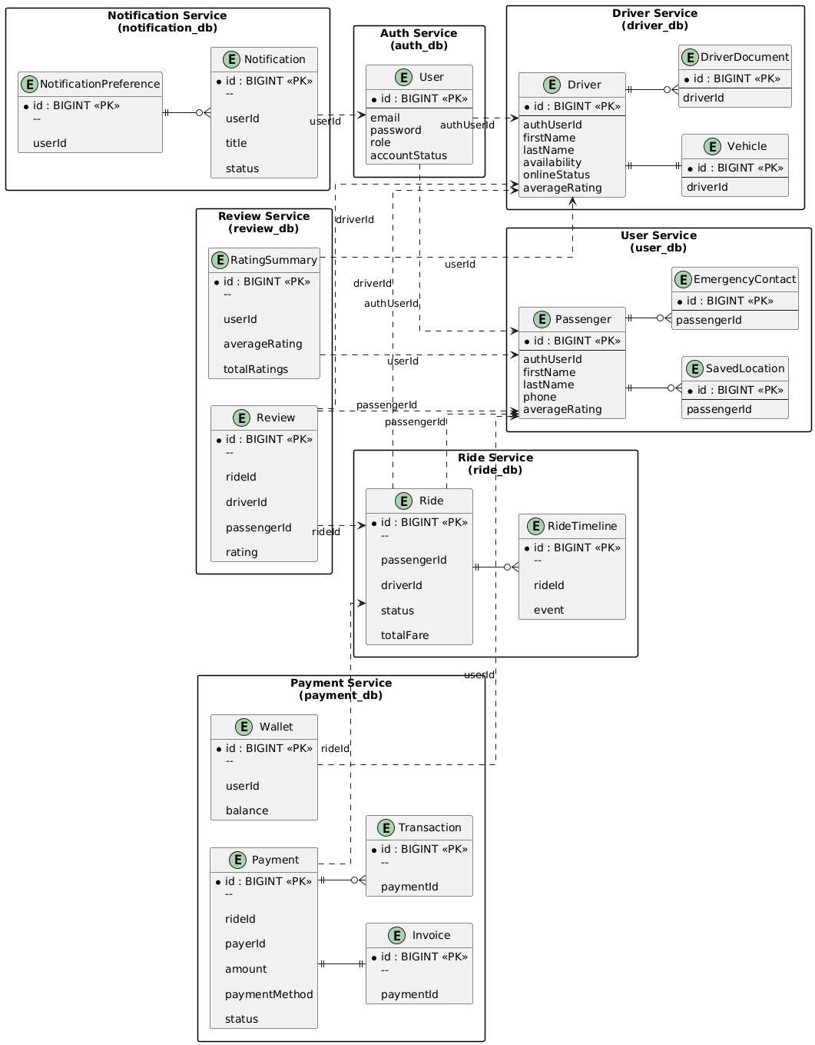
——————————————————————————————————————————-
- Book Ride Sequence Diagram
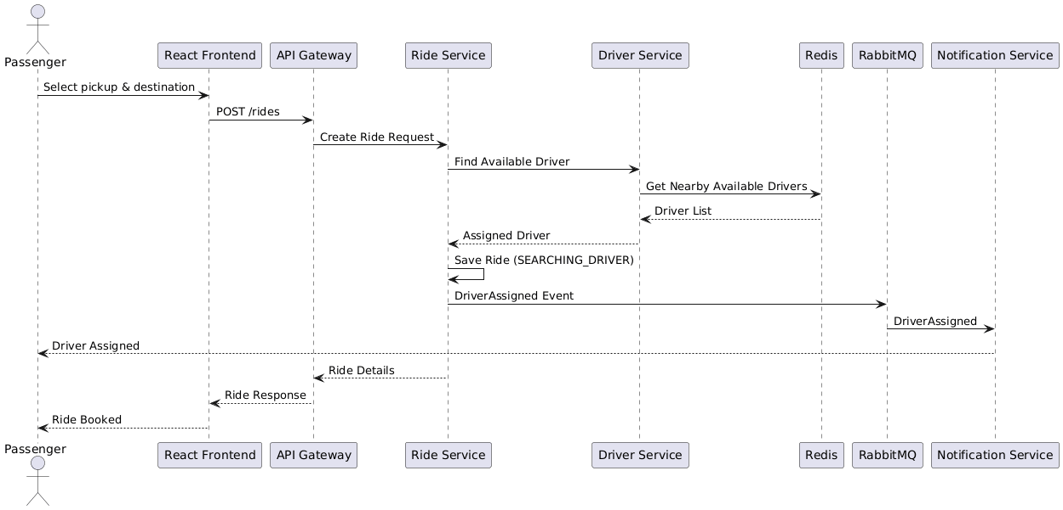——————————————————————————————————————————
2. Login Sequence Diagram
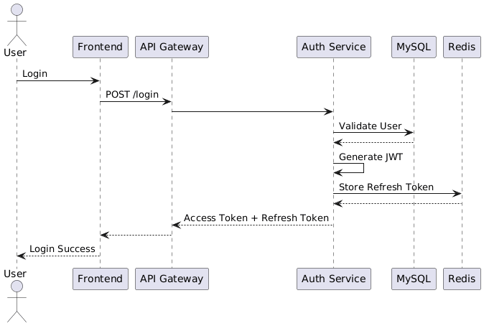
3. Driver Accept Ride
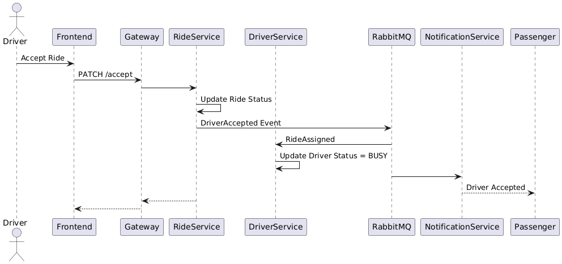
4. Ride Completion & Payment
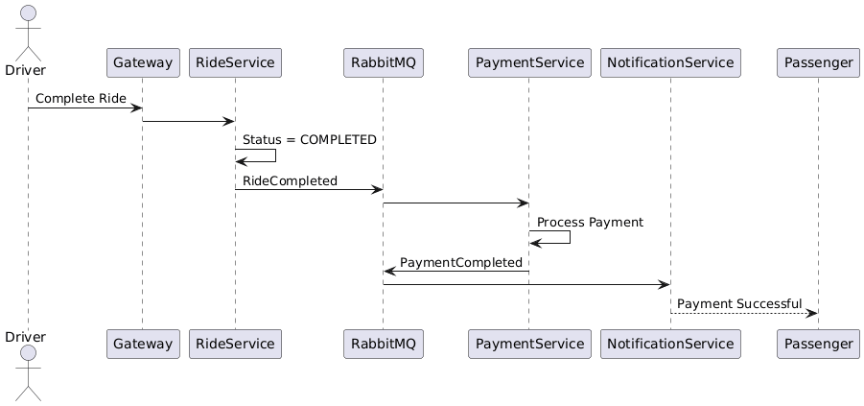
5. Review Submission
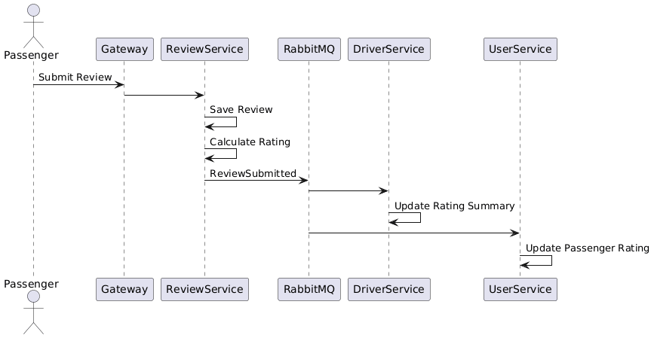
6. Notification Flow
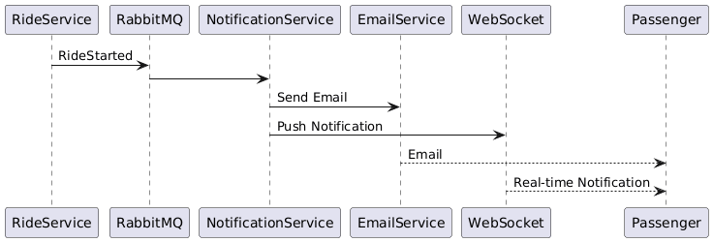
—————————————————————————————————————————
Class Diagram
1. Ride Service Class Diagram
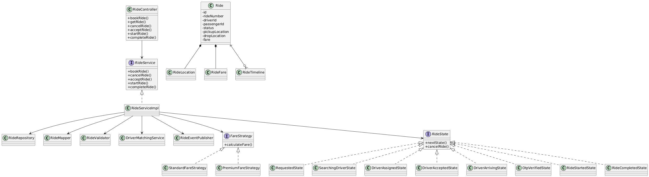

2. Payment Service Class Diagram
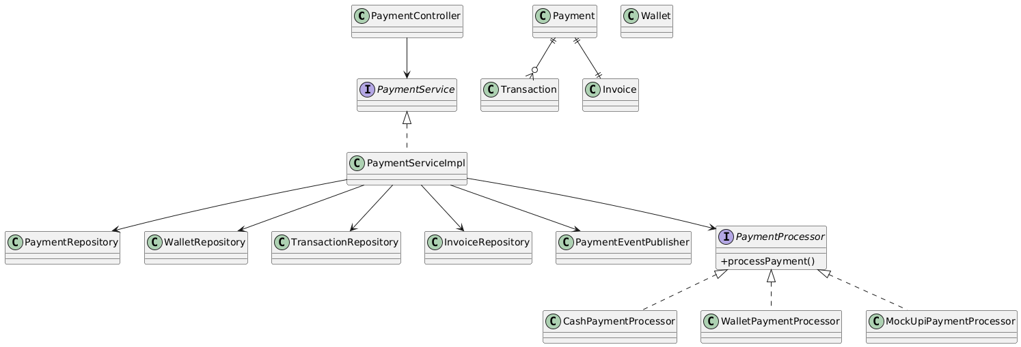
3. Driver Service Class Diagram
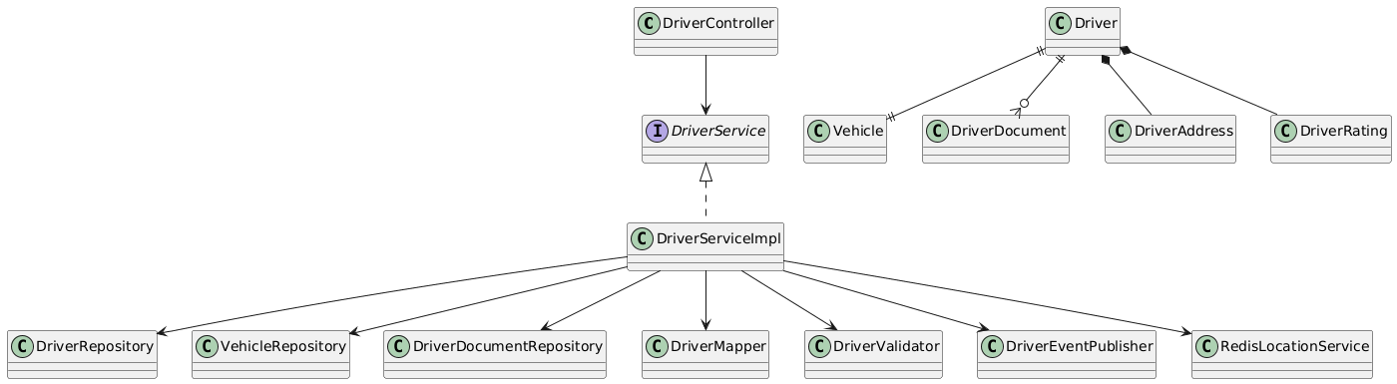
—————————————————————————————————————————

🗺️ CabRide Development Roadmap
Project Planning
│
▼
Milestone 1
Project Setup & Infrastructure
│
▼
Milestone 2
Authentication Service
│
▼
Milestone 3
User Service
│
▼
Milestone 4
Driver Service
│
▼
Milestone 5
Ride Service
│
▼
Milestone 6
Review Service
│
▼
Milestone 7
Payment Service
│
▼
Milestone 8
Notification Service
│
▼
Milestone 9
Frontend
│
▼
Milestone 10
Containerization
│
▼
Milestone 11
Monitoring & Logging
│
▼
Milestone 12
Testing & CI/CD

📌 Milestone 1 — Infrastructure

Goal
Create the project foundation.

Tasks
- Create GitHub Repository
- Parent Maven Project
- Common Library
- Eureka Server
- API Gateway
- MySQL Setup
- RabbitMQ Setup
- Redis Setup
- Docker Compose
- Spring Cloud Configuration
- Centralized Configuration (optional)

Deliverable
All infrastructure services running

✓ Eureka

✓ Gateway

✓ RabbitMQ

✓ Redis

✓ MySQL

📌 Milestone 2 — Auth Service

Goal
Secure the system.

Features
- User Registration
- Login
- JWT Authentication
- Refresh Token
- Email Verification
- Forgot Password
- Change Password
- Account Lock
- Spring Security
- Swagger

Deliverable
Working Authentication System

📌 Milestone 3 — User Service

Goal
Passenger profile management.

Features
- Passenger Profile
- Saved Locations
- Emergency Contacts
- Rating Summary
- CRUD APIs
- RabbitMQ Consumer

Deliverable
Passenger Profile Module

📌 Milestone 4 — Driver Service

Goal
Manage drivers.

Features
- Driver Registration
- Driver Profile
- Vehicle
- Driver Documents
- Verification
- Redis Location
- Driver Availability
- Online Status
- RabbitMQ Events

Deliverable
Driver Management Module

📌 Milestone 5 — Ride Service ⭐

Goal
Core ride booking.

Features
- Book Ride
- Driver Matching
- Ride Timeline
- Fare Calculation
- Ride State Machine
- Ride History
- OTP Verification
- WebSocket Tracking
- Redis Cache
- RabbitMQ Events

Deliverable
Ride Booking System

📌 Milestone 6 — Review Service

Goal
Ratings and reviews.

Features
- Submit Review
- Driver Rating
- Passenger Rating
- Rating Summary
- RabbitMQ Events

Deliverable
Review Module

📌 Milestone 7 — Payment Service

Goal
Payment processing.

Features
- Cash Payment
- Wallet Payment
- Mock UPI
- Invoice
- Transaction History
- Adapter Pattern
- RabbitMQ Events

Deliverable
Payment Module

📌 Milestone 8 — Notification Service

Goal
Real-time notifications.

Features
- Email
- WebSocket
- In-App Notifications
- Notification Preferences
- Notification History
- RabbitMQ Consumers

Deliverable
Notification Module

📌 Milestone 9 — Frontend

Goal
Complete UI.

Passenger
- Login
- Register
- Dashboard
- Book Ride
- Ride History
- Payment
- Reviews

Driver
- Login
- Dashboard
- Accept Ride
- Navigation
- Earnings (basic display if implemented)

Admin
- Dashboard
- Verify Drivers
- Active Rides
- Users

Deliverable
Working Web Application

📌 Milestone 10 — Containerization

Goal
Dockerize the project.

Tasks
- Dockerfile for every service
- Docker Compose
- RabbitMQ Container
- Redis Container
- MySQL Containers
- Network Configuration

Deliverable
Entire project runs using Docker Compose

📌 Milestone 11 — Monitoring & Logging

Goal
Production-style monitoring.

Features
- Spring Boot Actuator
- Prometheus
- Grafana
- Centralized Logging
- Health Checks
- Metrics Dashboard

Deliverable
Production Monitoring

📌 Milestone 12 — Testing & CI/CD

Goal
Production readiness.

Testing
- Unit Tests
- Integration Tests
- Repository Tests
- Controller Tests

CI/CD
- GitHub Actions
- Build Pipeline
- Test Pipeline

Documentation
- README
- Swagger
- Deployment Guide

Deliverable
Production Ready Project

🎯 Final Development Timeline
Planning & Design
✅ Completed
│
▼
M1 Infrastructure
│
▼
M2 Auth Service
│
▼
M3 User Service
│
▼
M4 Driver Service
│
▼
M5 Ride Service ⭐
│
▼
M6 Review Service
│
▼
M7 Payment Service
│
▼
M8 Notification Service
│
▼
M9 Frontend
│
▼
M10 Docker
│
▼
M11 Monitoring
│
▼
M12 Testing + CI/CD
—————————————————————————————————————————————————————————————————————————————
RIDE POOLING SYSTEM FEATURE

What I'd add
Instead of simply:
Passenger → Request Ride → Driver
we introduce:
Passenger A ──┐
Passenger B ──┼──> Shared Ride → Driver
Passenger C ──┘
The interesting part isn't the UI. It's the matching algorithm.
For example:
Passenger A wants to go from A → D.
There is already a driver carrying Passenger B from B → E.
Can we add Passenger A to that ride without causing an unacceptable detour for Passenger B?
That's a genuinely interesting problem.

CabRide could support two modes
RIDE
├── SOLO
└── SHARED
For a shared ride:
Ride Request
↓
Find nearby available/shared drivers
↓
Find existing compatible rides
↓
Check:
• pickup proximity
• destination compatibility
• vehicle capacity
• maximum detour
• estimated additional travel time
↓
Calculate shared fare
↓
Offer match
↓
Update ride

And this gives us some really good engineering topics
We can eventually implement:
- Geospatial driver matching
- Redis GEO for nearby drivers
- Route compatibility
- Maximum detour constraints
- Dynamic passenger capacity
- Shared fare calculation
- Ride state machines
- Concurrent booking protection
- Idempotency
- Matching priority
- Real-time ride updates
And importantly, we can make some of these actual design decisions rather than just adding technologies for the sake of saying we used them.

I would NOT make it a separate "Sharing Ride Service"
I'd initially make Ride Service responsible for the ride domain:
Ride Service
│
├── Solo Ride
├── Shared Ride
├── Ride Matching
├── Ride State
└── Fare calculation
Then other services support it:
Ride Service
/ | \
/ | \
Driver User Payment
Service Service Service
│
Redis
(location/matching)
That keeps the architecture sane.
And there's another advantage for your public-building strategy: shared rides give you much better things to post about than "implemented another CRUD endpoint."
You could eventually post:
"Today I started thinking about something I hadn't considered before: what actually makes two ride requests compatible?"
Then explain your matching constraints.
That is the kind of technical story that can make a developer/recruiter stop scrolling.
So yes, I'd absolutely include shared rides in CabRide. In fact, I'd make it one of the signature features of the project rather than a small add-on.
Yes. I would redesign the Ride Service now, before we start building it. This is exactly the point where we should think through the domain rather than discovering halfway through implementation that shared rides don't fit the original model.
And I agree with your instinct: pooling should be a core capability of Ride Service, not a separate microservice.

1. First, change the mental model
Don't think:
Ride = one passenger + one driver
Instead:
Ride = one vehicle journey
+
multiple passengers
Then a passenger has a RideRequest / RideBooking associated with a Ride.
For example:
RIDE
Driver: D101
Vehicle: V201
Capacity: 4
┌─────────────────────────┐
│ Passenger A │
│ A → D │
├─────────────────────────┤
│ Passenger B │
│ B → E │
├─────────────────────────┤
│ Passenger C │
│ C → F │
└─────────────────────────┘
This is much more flexible than putting passengerId directly inside Ride.

2. The Ride Service should probably contain these concepts
I'd redesign it around:
Ride Service
│
├── Ride
│
├── RideBooking
│
├── RideRequest
│
├── Matching
│
├── Fare
│
└── RideState

Ride
Represents the actual journey being performed by a driver.
Ride
├── id
├── driverId
├── vehicleId
├── rideType
├── status
├── availableSeats
├── pickupArea
├── destinationArea
├── startedAt
└── completedAt

RideBooking
Represents one passenger's participation in that ride.
RideBooking
├── id
├── rideId
├── passengerId
├── pickupLocation
├── dropLocation
├── status
├── fare
├── pickupSequence
└── dropSequence
This is the key design change.
A single Ride can have:
Ride #R100
│
├── Booking #B1 → Passenger A
├── Booking #B2 → Passenger B
└── Booking #B3 → Passenger C

3. Solo rides still work
We don't need a separate architecture for solo rides.
A solo ride is simply:
Ride R100
│
└── Booking B1
└── Passenger A
A shared ride:
Ride R200
│
├── Booking B1 → A
├── Booking B2 → B
└── Booking B3 → C
So:
RIDE
├── SOLO
└── SHARED
becomes mostly a business-rule difference rather than two completely different systems.

4. Now the interesting part: pooling
Suppose we have:

Existing ride
Driver D1
Capacity: 4

Passenger A:
Pickup → P1
Drop → P5
Now Passenger B requests:
Pickup → P2
Drop → P4
We don't simply ask:
"Is Driver D1 nearby?"
We ask:
"Can Passenger B be inserted into D1's existing route without violating our pooling rules?"
That's the actual pooling problem.

5. Pooling algorithm
I'd make the first version relatively understandable.
When a shared ride request arrives:
Passenger B requests ride
↓
Find nearby eligible drivers
↓
Find active shared rides
↓
For each candidate ride:
↓
Check capacity
↓
Check pickup compatibility
↓
Check destination compatibility
↓
Calculate additional detour
↓
Calculate additional travel time
↓
Rank candidates
↓
Choose best candidate

6. What makes two passengers compatible?
We need explicit constraints.

Constraint 1 — Capacity
If:
Vehicle capacity = 4
Current passengers = 4
then:
New passenger → REJECT
Simple.

Constraint 2 — Maximum detour
This is probably the most important rule.
Suppose without Passenger B:
A → D

10 km
20 minutes
After adding B:
A → B_pickup → B_drop → D

13 km
28 minutes
If our maximum allowed additional time is:
5 minutes
then:
+8 minutes → REJECT
This prevents shared rides from becoming frustrating.

7. Constraint 3 — Route compatibility
Consider:
Passenger A:

A ───────────────→ D

Passenger B:

X ─────────→ Y
They don't overlap meaningfully.
Pooling them would create a ridiculous detour.
Reject.
But:
Passenger A:

A ─────────────────────→ D
↑ ↑
B pickup B drop

Passenger B:

B ───────────→ C
That's potentially a good pool.

8. Constraint 4 — Maximum waiting time
This is something I would definitely include.
Passenger B shouldn't wait indefinitely while we try to find a perfect pool.
For example:
maxPickupWait = 5 minutes
If the matching process can't provide a suitable shared ride within that constraint, we can:
Option A → offer solo ride
Option B → keep searching
We can make this configurable.

9. Constraint 5 — Pickup/drop ordering
This gets really interesting.
Suppose the route is currently:
A pickup
↓
A drop
Adding B might require:
A pickup
↓
B pickup
↓
B drop
↓
A drop
That's valid.
But we cannot allow:
B drop
↓
B pickup
obviously.
More importantly, every passenger's pickup must happen before their drop.
So internally we can represent the route as ordered stops:
Ride
│
├── Stop 1: PICKUP A
├── Stop 2: PICKUP B
├── Stop 3: DROP B
└── Stop 4: DROP A
This becomes the foundation for the pooling algorithm.

10. This leads to a much better data model
Instead of storing only:
pickupLocation
dropLocation
inside Ride, we can eventually have:
RideStop
├── id
├── rideId
├── bookingId
├── stopType
├── latitude
├── longitude
├── sequence
└── completedAt
where:
StopType:
PICKUP
DROP
Then:
Ride
│
├── Stop 1 → PICKUP A
├── Stop 2 → PICKUP B
├── Stop 3 → DROP B
└── Stop 4 → DROP A
That's much closer to how a real pooling system needs to reason about routes.

11. How do we actually calculate the detour?
Initially, don't build our own routing engine.
We can abstract it:
RouteService
with something like:
Route calculateRoute(List<Location> stops);
It returns:
distance
duration
Then our pooling algorithm doesn't care whether the route came from:
- Google Maps
- Mapbox
- OSRM
- another routing provider
The architecture becomes:
Pooling Engine
↓
Route Service
↓
Routing API
That's a much cleaner design.
For our first implementation, we can even use a simplified distance calculation for development/testing.

12. Where Redis comes in
This is another reason I wouldn't design Ride Service as a simple CRUD service.
We eventually want:
Driver Service
↓
Driver location
↓
Redis GEO
For example:
GEOADD drivers:available
longitude latitude driverId
Then:
Ride Request
↓
Redis GEOSEARCH
↓
Nearby drivers
↓
Pooling engine
So we don't query MySQL every time someone requests a ride.

13. The complete future flow
Here's the architecture I'd aim for:
Passenger
│
│ Request shared ride
▼
API Gateway
│
▼
Ride Service
│
├───────────────┐
│ │
▼ ▼
Redis GEO Existing Rides
│ │
└───────┬───────┘
▼
Pooling Engine
│
├── Capacity?
├── Route overlap?
├── Detour?
├── Wait time?
└── Stop ordering?
│
▼
Best Match
│
▼
Create Booking
│
▼
Update Ride

14. And concurrency becomes a serious problem
This is something I really want us to handle properly because it makes CabRide much more impressive technically.
Imagine:
Vehicle capacity = 4
Current passengers = 3
Available seats = 1
Two passengers simultaneously request the last seat:
Request A ─────┐
├──> Pooling Engine
Request B ─────┘
If both read:
availableSeats = 1
they could both get accepted.
Now we have:
3 + A + B = 5 passengers ❌
So eventually we'll need some form of:
- optimistic locking
- pessimistic locking
- atomic Redis operation
- transactional booking
- idempotency
That is excellent interview material.

15. I would therefore redesign Day 9+ around this
Instead of immediately making:
RideController
RideService
RideRepository
we should first build:
Ride
RideBooking
RideStop
RideStatus
RideType
BookingStatus
StopType
Then:
Ride Service
↓
Ride creation
↓
Booking
↓
Matching
↓
Pooling
↓
Concurrency

And the killer feature
A user should eventually be able to choose:
POST /api/rides

{
"rideType": "SHARED",
"pickup": {...},
"destination": {...}
}
and the system determines:
"There's an existing ride 800m away whose route is compatible. Adding you increases the route by 3.2 minutes, so we'll pool you."
That's a far stronger portfolio story than:
"I built a ride booking CRUD API."
So yes — let's redesign the Ride Service before implementing it. I would actually pause the Day 8/Driver work at the current stable point and spend a session designing the Ride + Pooling domain properly. That's going to save us a lot of rework later.

