**DAILY ONLINE ACTIVITIES SUMMARY**

|  |  |  |  |  |  |  |  |  |
| --- | --- | --- | --- | --- | --- | --- | --- | --- |
| **Date:** | **03/06/2020** | | | | | **Name:** | **Prashant Rama Bhat Kodlekere** | |
| **Sem & Sec** | **4th sem (B sec)** | | | | | **USN:** | **4AL18CS060** | |
| **Online Test Summary** | | | | | | | | |
| **Subject** | | **OBJECT ORIENTED CONCEPTS (OOC)** | | | | | | |
| **Max. Marks** | | **30** | | **Score** | | | **17** | |
| **Certification Course Summary** | | | | | | | | |
| **Course** | **Python 3 for biginners in2020.** | | | | | | | |
| **Certificate Provider** | | | **Udemy** | | **Duration** | | | 3 hours |
| **Coding Challenges** | | | | | | | | |
| **Problem Statement:** Write a code segment in java to swap two numbers using call by object reference.  Top of Form  Bottom of Form | | | | | | | | |
| **Status:Completed** | | | | | | | | |
| **Uploaded the report in Github** | | | | | **YES** | | | |
| **If yes Repository name** | | | | | **https://github.com/prashantkodlekere/codingactivity** | | | |
| **Uploaded the report in slack** | | | | | **YES** | | | |

Online Test Details:

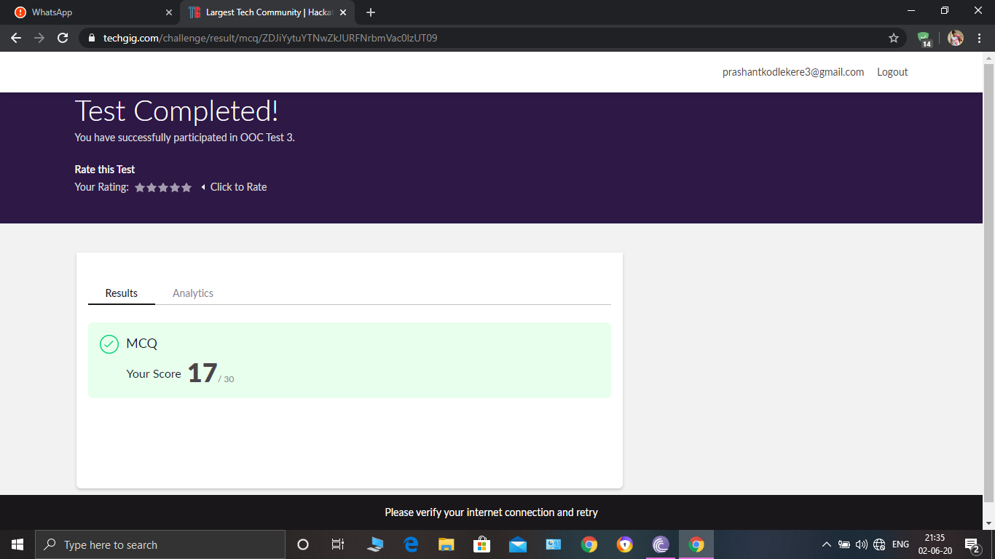

OBJECT ORIENTED CONCEPTS Internals was conducted. A total of 30 questions were Multiple Choice Questions.

The above snapshot is the result sheet which was mailed to us by the Techgig team.

Certification Course Details:

Course name: Python 3 for biginners in 2020.(section11)

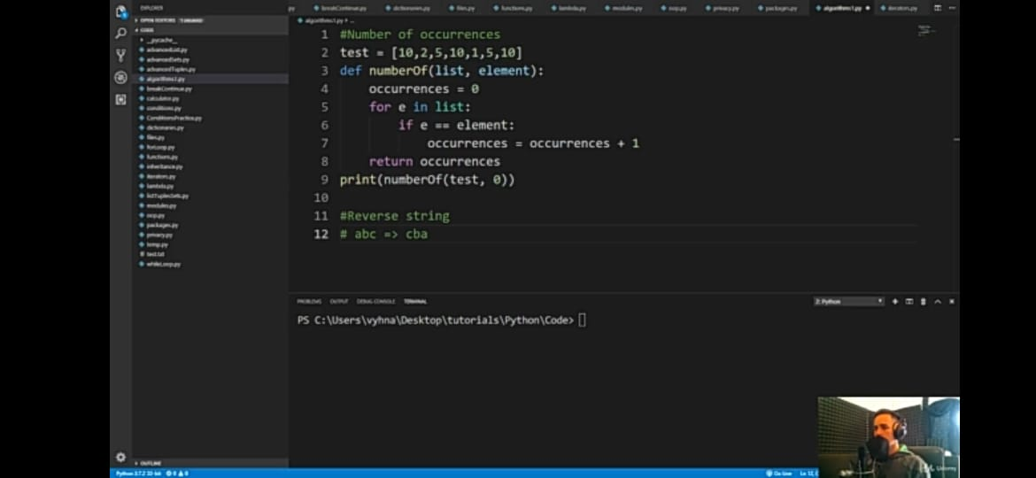

In section 11, I have learnt about some simple algorithms like number of occurences,Reverse string,Sum of list,biggest element in list,number of a words in string, and checking of array sorting and etc.and same thing I have implemented using languages.

Coding Challenges Details:

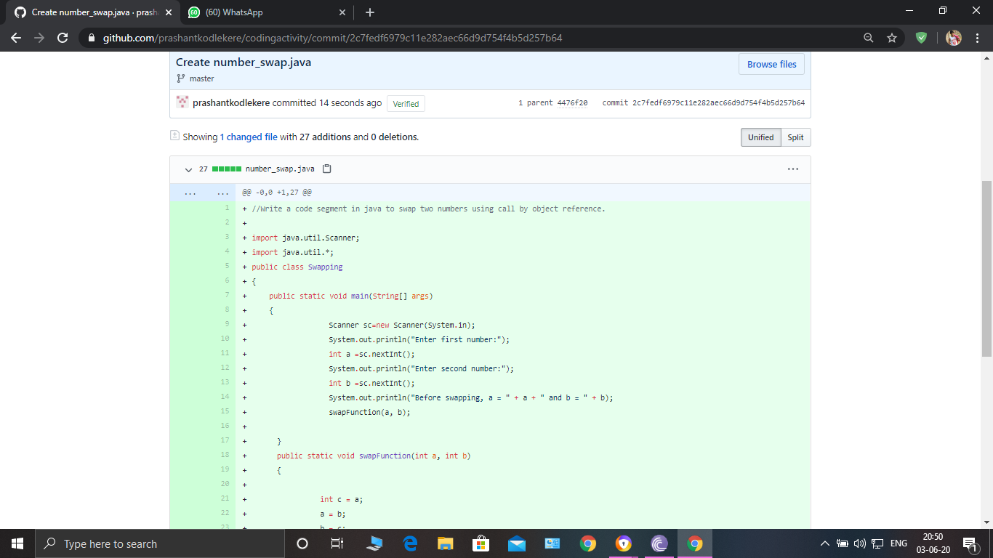

**The question I took to code is:**

Write a code segment in java to swap two numbers using call by object reference.

Code: The above snapshot is the code which I have uploaded in my Github repository.