**DAILY ONLINE ACTIVITIES SUMMARY**

|  |  |  |  |  |  |  |  |  |
| --- | --- | --- | --- | --- | --- | --- | --- | --- |
| **Date:** | **04/06/2020** | | | | | **Name:** | **Prashant Rama Bhat Kodlekere** | |
| **Sem & Sec** | **4th sem (B sec)** | | | | | **USN:** | **4AL18CS060** | |
| **Online Test Summary** | | | | | | | | |
| **Subject** | | **MICROCONTROLLERS AND EMBEDDED SYSTEM** | | | | | | |
| **Max. Marks** | | **20** | | **Score** | | | **16** | |
| **Certification Course Summary** | | | | | | | | |
| **Course** | **Python3 for biginners in 2020** | | | | | | | |
| **Certificate Provider** | | | **Udemy** | | **Duration** | | | 3 hours |
| **Coding Challenges** | | | | | | | | |
| **Problem Statement:** write a java program to read three integer values from the keyboard and find the sum of the values. Declare a variable "sum" of type int and store the result in it.  Top of Form  Bottom of Form | | | | | | | | |
| **Status:Completed** | | | | | | | | |
| **Uploaded the report in Github** | | | | | **YES** | | | |
| **If yes Repository name** | | | | | **https://github.com/prashantkodlekere/codingactivity** | | | |
| **Uploaded the report in slack** | | | | | **YES** | | | |

Online Test Details:

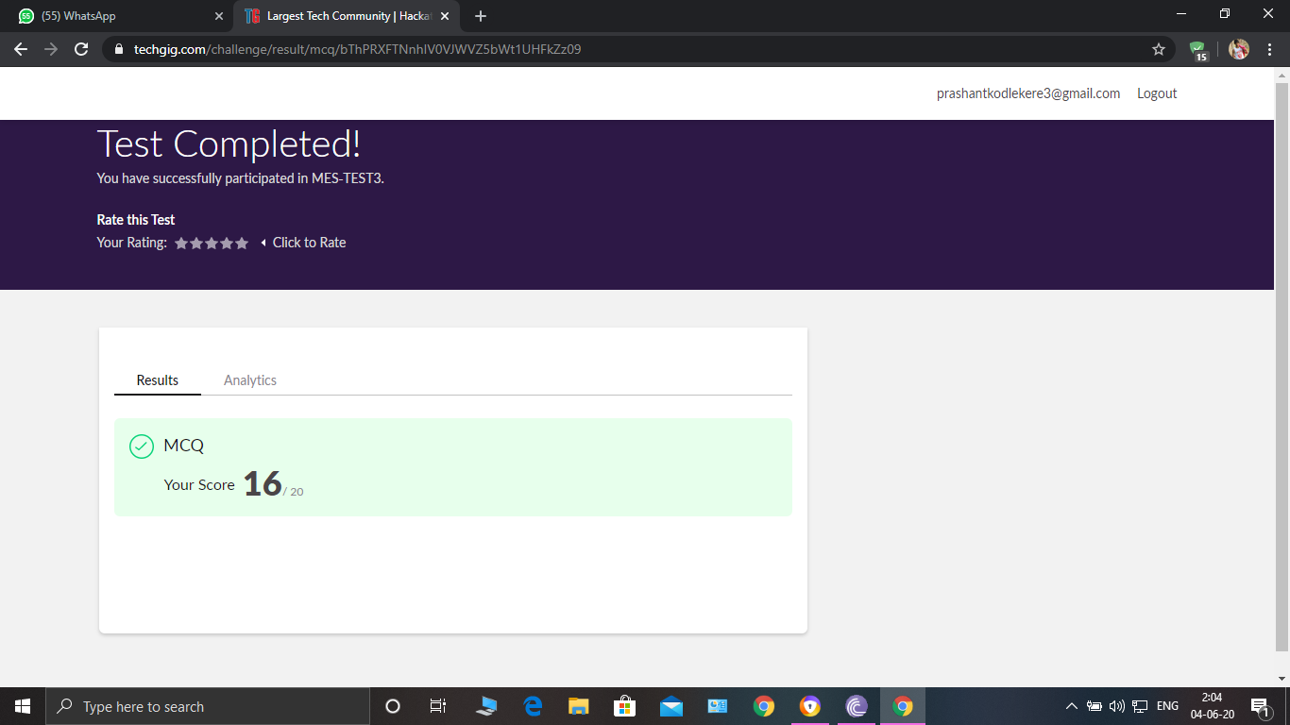

MICROCONTROLLERS AND EMBEDDED SYSTEM Internals was conducted. A total of 20 questions were Multiple Choice Questions.

The above snapshot is the result sheet which was mailed to us by the Techgig team.

Certification Course Details:

Course name: Python 3 for bigginers in 2020

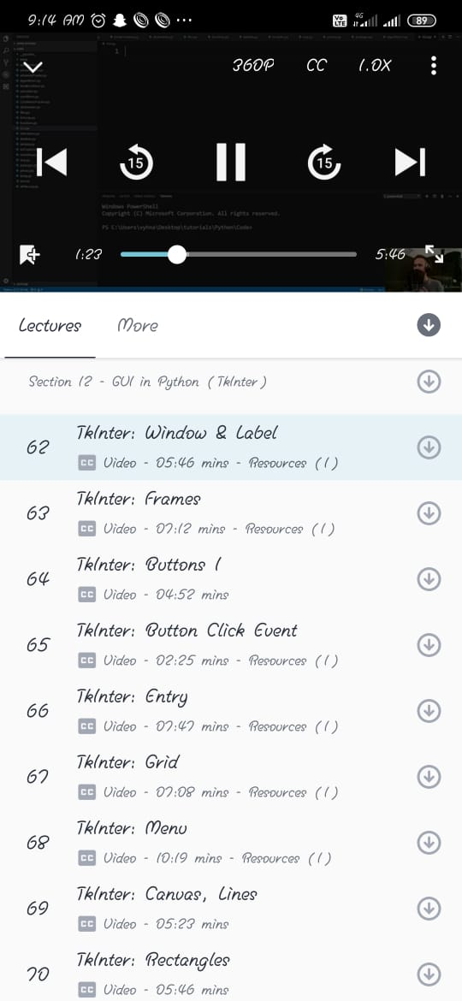

In sec 12,I have learnt about GUI in python.same thing I have done practically.

Coding Challenges Details:

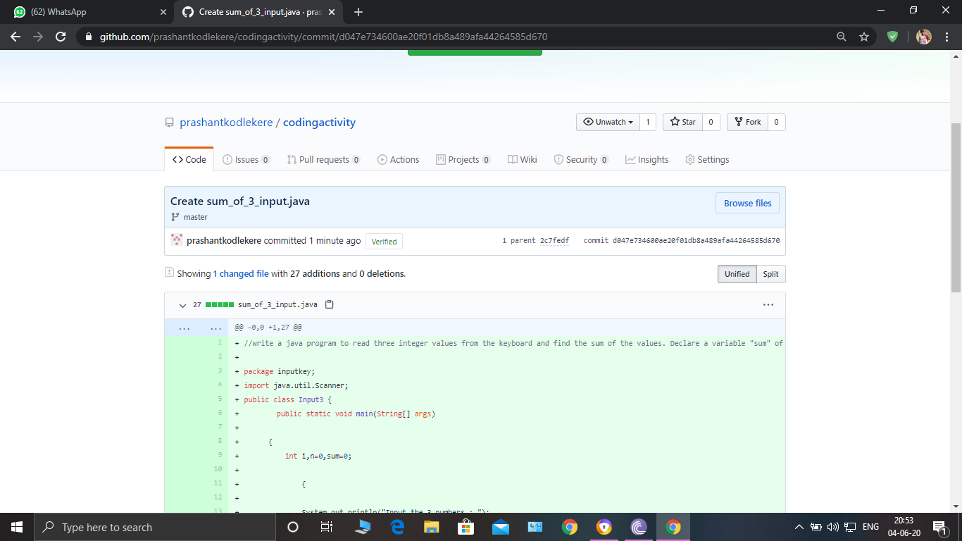

**The question I took to code is:**

write a java program to read three integer values from the keyboard and find the sum of the values. Declare a variable "sum" of type int and store the result in it.

Code: The above snapshot is the code which I have uploaded in my Github repository.