­

PYTHON GUI BASED

PROJECT

PRICE ESTIMATION OF USED BIKES

PROPOSED TO: MOIN HASSAN

LOVELY PROFESSIONAL UNIVERSITY

INT 213

2020

REPORT

SNEHA KAPOOR, 12012333, 72

PRASHANT KUMAR ROY, 11917920, 44

PARTH PURI, 11903489, 12

Table of Contents

1. Objective of project
2. Introduction
3. Working process
4. Structure Of application
5. GUI of application
6. Database connectivity of application
7. Formula used for finding price
8. Conclusion and Learning Outcomes
9. References

Objective

Objective of this project is to implement different learning of course of Python Programming Language and to develop a software which calculates the price of used bikes with all required functionalities. Objective is to also provide user with an interactive and fully functional used bikes price calculator. This project also aims at establishing a database connectivity between the developed app using MySQL so that user can be provided with the benefit of viewing calculated price he got for his bike by using the particular app. Through this project other objective is in order to implement one the indispensable part of today’s modern technology world which is calculator using our knowledge of python programming language as this put’s our knowledge of python programming language to test and also helps to practically showcase skills.

Used bike price Calculator is one the most important tool for any kind of person who wants to make his/her find market value of his used bikes work easier and since it’s an important part so this projects objective is to make us able to develop day to important applications with knowledge we have gained. This project also aims at improving knowledge of already known parts and modules of python and develop the understanding of additional modules and put our knowledge into use. This project aims at providing us with the confidence of skills on python programming language and with a sense of satisfaction that we can implement things practically we have learnt.

Introduction

As world is improving day by day in the technology field there are no limits on what we can achieve through this technological advancement going on. But as we heading forward some of the devices and the logics remain in a constant touch with us no matter how far we have progressed there are many instances in our day to day life that we use the devices that were developed and invented long back but are still in use although their functionality may be improved . One such gadget is price calculator. Everybody in their lives buy or sell their vehicles and no one want to waste their valuable time in finding a perfect price for their used bikes in present market. This software comes at rescue for this part and saves valuable amount of time in everybody’s life.

Working Process

This software has only one working feature which is to calculate the price of used bikes, software contains few entry boxes which will take some details about user’s bike as input and then software will search the original price of the bike in database of the software searching will be done with the help of the inputs (brand name, model name, registration year and trim) given by user after that software will take the original price of the given bike from database and it will apply it in the mathematical formula given by user and after calculation the price will be inserted in entry box which will be visible to user.

And there is one condition part of software also, the condition is that if the bike about which user wants to check price it is not available in database of software then software will ask user to enter it’s original price also and then rest of the task will perform as how it was doing earlier.

Structure Of the application

Size of the root window is ("1500x800+0+0") which is resizable it means it can be maximized as full screen or can be minimized also in background part there is an image which covers the background and created a frame inside the root and main software is inside the frame there is some entry boxes which work as taking input from user and there is a calculate and quit button quit button is commanded with destroy function which will shut down the software when quit button will be clicked.

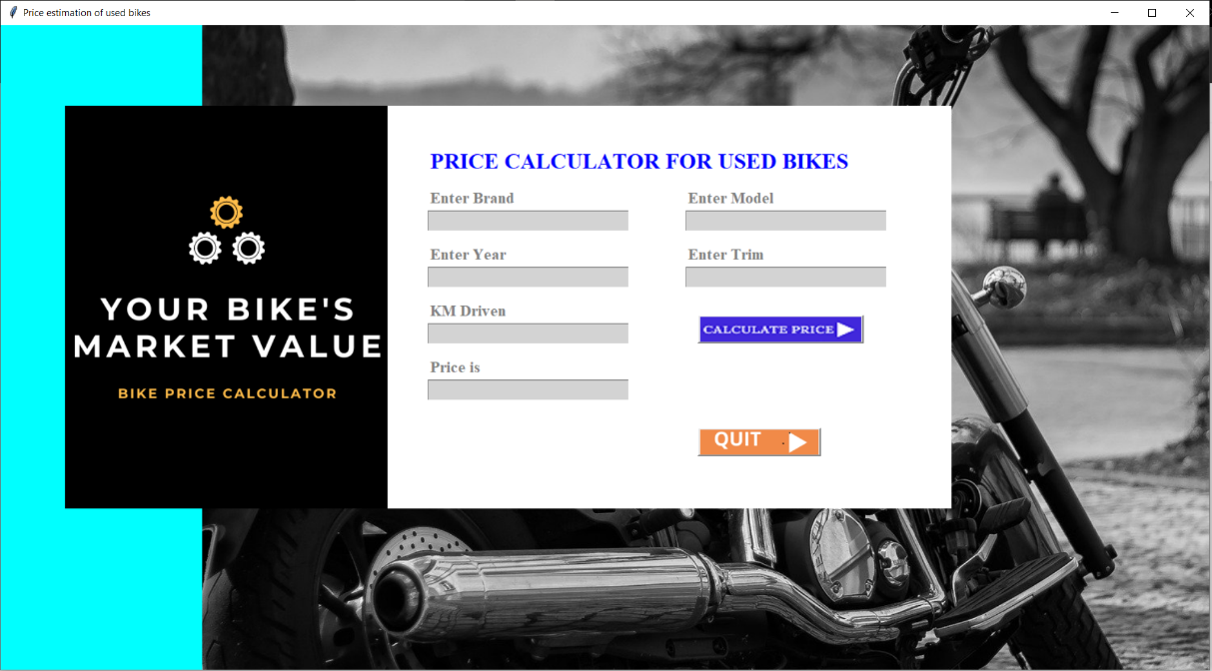

GUI of application

1. Entry box



* Entry box is placed within the frame using place geometry manager.
* It’s thickness is highlighted.
* It’s relief is specified by the frame in which it is placed.
* Width of Entry box is adjusted according to the size of window.

1. Buttons

There are total 2 buttons Each button instead of utilizing the conventional text format is assigned with a separate .png image for each. Using “PhotoImage” part of tkinter module image is imported from directory. Image is resized in order to fit button using “subsample”.Pixel size is used to specify x , y length

Buttons consist of command to insert value associated in them. Each button is placed in the frame using the grid geometry manger.



1. 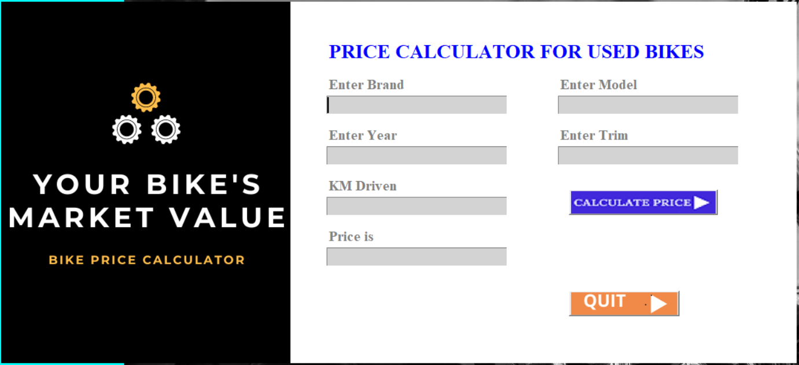Frame

There is an image in root in left side and in right side created another frame inside it added a title “PRICE CALCULATOR FOR USED BIKES” named label below it there are some entry boxes which takes details of bike and then there is calculate button to calculate the price and in the end one QUIT button is there which is commanded with destroy function it will close the program.

DATABASE CONNECTIVITY OF APPLICATION-

For database connectivity we have **mysql.connector** module. Firstly , we have connect our project with Mysql server of our System using **connect()** function of mysql.connector module. In , connect function we have passed the server name (In our case it is localhost) and the password of our mysql server.

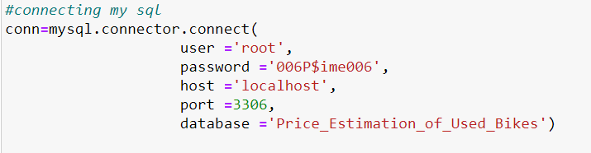

After the successful connection we have created an database named as **calculator123** using execute() function then after that we have created a table in the ‘Price_Estimation_of_Used_Bikes’ database named as **storevalues** . Table storevalues have one attribute named as **value** .

We have used database connectivity in our project to store all the bike details which will help software to find original price of particular bike whatever details user will enter.

By the use of calculate button available in our gui interface user would be able to get the price of its used old bike in this all will work in backend.

Formula Used for Finding Price

As we know there is not any proved mathematical formula to find price of used bikes originally it is done by Regression analysis method which comes under machine learning process in which we had to take all the details of bike and by analysis those values will come at one parameter which can give the price as output.

we also did something similar to this by the analysis generated a mathematical formula which shows approximate value of the bike.

Formula for calculating price of used bikes-

((((original Price - 20,000)-5xno. of years %)-(2.5x(no. of km driven/1000))%))

example-

There is any bike who's original Price is Rs.74,000, bought in 2016

and driven 20,000 kms. estimate it's present price.

according to formula-

step 1> (original price - 20,000) -> 74,000 - 20,000 = 54,000

step 2> ((original Price - 20,000)-5xno. of years %) -> 54,000 - 5x4% => 54,000 - 20% = 43,200

step 3> (((original Price - 20,000)-5xno. of years %)-(2x(no. of km driven/1000))%) -> 43,200 - 2.5x(20,000/1000)% => 43,200 - 50% => 21,500

hence, Price estimation of used bike = Rs.21,500

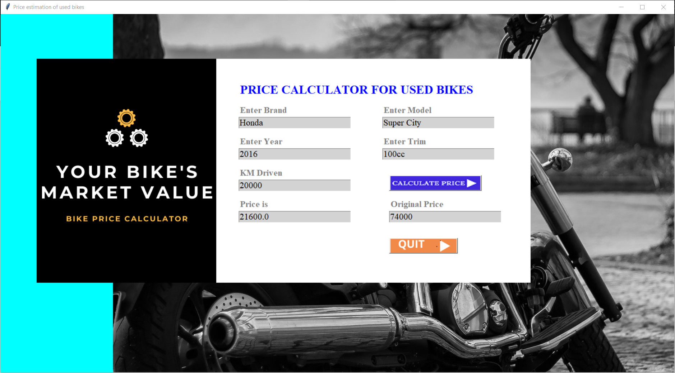

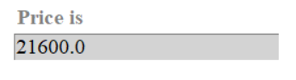

CONCLUSION AND LEARNING OUTCOME-

In this project we have created an complete Price Estimation of Used Bikes . To implement it we have used tkinter module for GUI interface and for database connectivity we have used mysql.connector module . From tkinter module we have used different widgets like – Buttons , Entry box. we have 2 buttons in total having different functionalities . For providing functionalities we have used math module.

To make our project more attractive we have used different attractive images for different buttons using PhotoImage() function. Our first interface is for blank form which is a kind of simple entry details. To find price user will have to enter all the details then click on calculate. Once, we will click the Quit button software will close.

For database connectivity we have first created the required database and table. Then we have used then whenever required for the storage purpose of data . we have used an e_orice entry button to take the value of original price of software for calculation.

We have gone through deep learning about python tkinter module and how to get started with it.

* Learned about different widgets of tkinter module .
* Learned about database connectivity for an python GUI.
* We have used different photos for different buttons.
* We have learned how to use different styles to make our project more attractive.

REFERENCES-

* [**https://www.w3schools.com/python/**](https://www.w3schools.com/python/)
* [**https://www.geeksforgeeks.org/sql-using-python/**](https://www.geeksforgeeks.org/sql-using-python/)
* [**https://stackoverflow.com**](https://stackoverflow.com)
* [**www.tutorialspoint.com**](http://www.tutorialspoint.com)
* [**www.google.com**](http://www.google.com)
* [**www.quora.com**](http://www.quora.com)

==THE END==