Linux Basics – DevOps Assignment
Project: Linux File, Search, Archive, Permission and Environment Variable Operations

Objective
Practice essential Linux command-line operations including file and directory management, viewing files, searching, archiving, downloading, permissions and environment variables.
1. Creating and Renaming Files/Directories

1. Creating the directory
Command: mkdir -p test_dir
Explanation: Creates a directory named test_dir.
Screenshot: 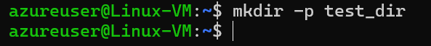
2. Creating an empty file
Command: touch test_dir/Example.txt
Explanation: Creates an empty file named Example.txt inside test_dir.
Screenshot: 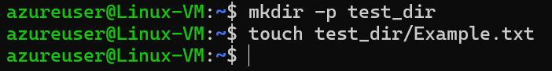
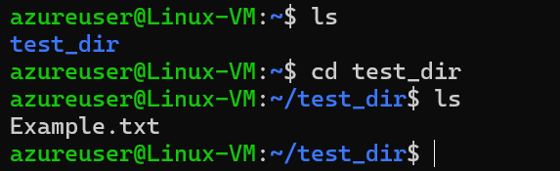
3. Renaming the file
Command: mv Example.txt renamed_example.txt
Explanation: Renames Example.txt to renamed_example.txt using mv.
Screenshot: 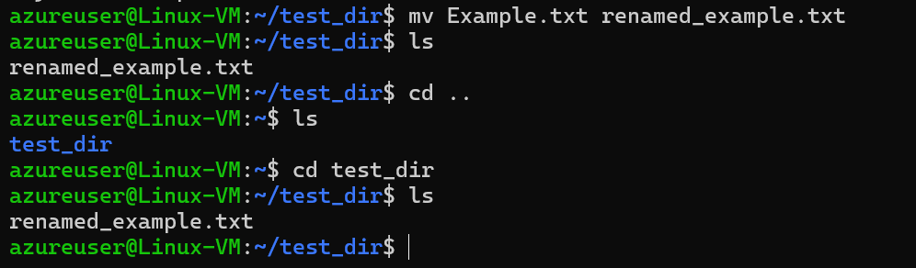
2. Viewing File Contents
4. Viewing /etc/passwd
Command: cat /etc/passwd
Explanation: Displays the complete contents of /etc/passwd.
Screenshot: 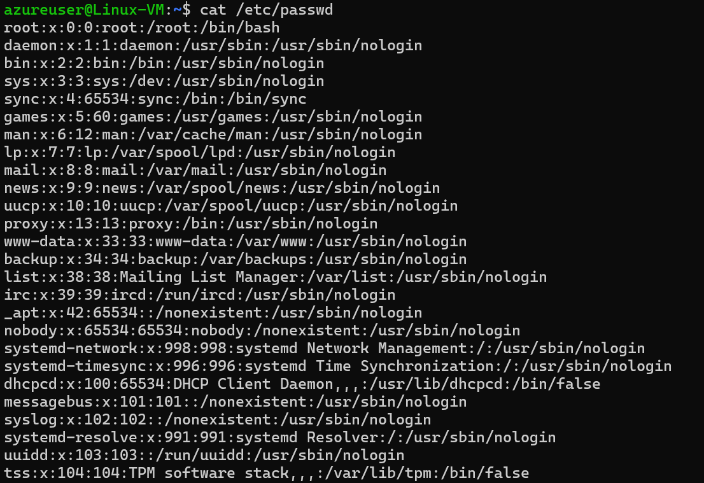
5. First 5 lines
Command: head -n 5 /etc/passwd
Explanation: Displays only the first five lines.
Screenshot: 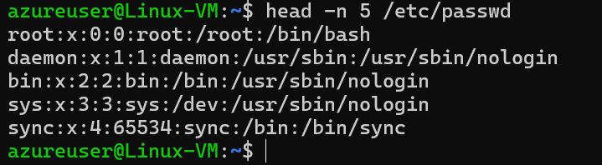
6. Last 5 lines
Command: tail -n 5 /etc/passwd
Explanation: Displays only the last five lines.
Screenshot: 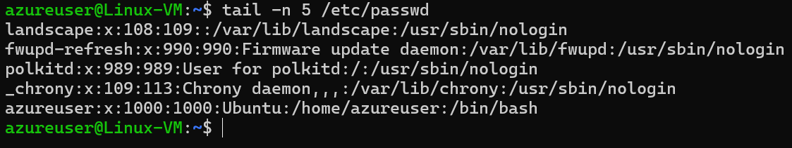
3. Searching for Patterns
7. Searching for root
Command: grep "root" /etc/passwd
Explanation: Finds lines containing the word root.
Screenshot: 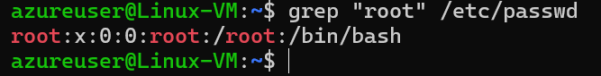

4. Zipping and Unzipping
8. Zipping the directory
Command: zip -r test_dir.zip test_dir
Explanation: Compresses test_dir into test_dir.zip.
Screenshot: 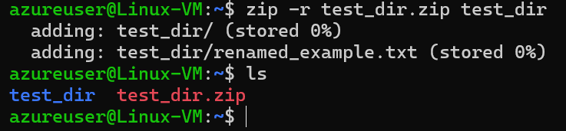

9. Unzipping the directory
Command: mkdir -p unzipped_dir
unzip -o test_dir.zip -d unzipped_dir
Explanation: Extracts the ZIP archive into unzipped_dir.
Screenshot: 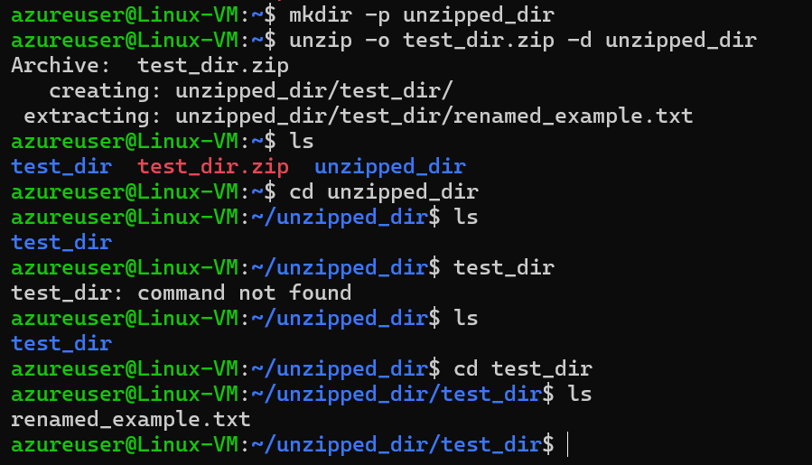

5. Downloading a file
10. Download a File
Command: wget -O sample.txt https://www.example.com/
Explanation: Downloads a public test file using wget.
Screenshot: 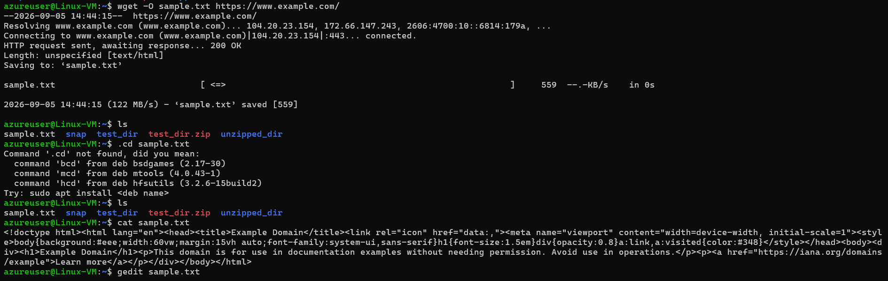

6. Changing Permissions
11. Read-only permissions
Command: touch secure.txt
chmod 444 secure.txt
ls -l secure.txt
Explanation: Sets read-only permission for owner, group and others.
Screenshot: 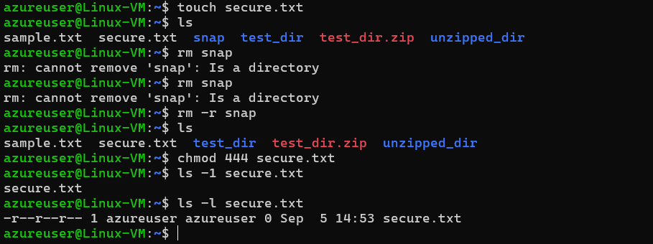

7. Working with Environment Variables
12. Environment variable
Command:
export MY_VAR="Hello, Linux!"
echo $MY_VAR
Explanation: Creates an environment variable and displays its value.
Screenshot: 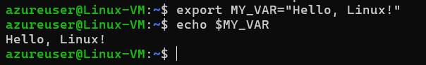

GitHub Repository
Paste your GitHub repository URL here after pushing the project.

Submission Checklist
- All 12 tasks completed.
- Terminal screenshot/output captured for every task.
- Complete project files included in the ZIP.
- Documentation file included.
- GitHub repository link added.
- Final folder compressed into Linux_Basics_Prashant.zip.

ssh -i C:\Users\pm102908\Downloads\azureuser@52.140.63.70

