Flask & MongoDB - DevOps Assignment

Objective
Build a Flask application with a JSON API route and a frontend form that stores submitted data in MongoDB Atlas, with proper success and error handling.

Task 1 - JSON API Route
1. Create a Flask /api route that returns backend data as a JSON list/object.
Implementation:
@app.route("/api", methods=["GET"])
def api():
data = {
"project": "Flask & MongoDB DevOps Assignment",
"status": "success",
"message": "JSON API route is working",
"technology": ["Flask", "MongoDB Atlas"]
}
return jsonify(data), 200
Command / Test:
python3 app.py
Open: http://127.0.0.1:5000/api
Explanation: The route uses Flask jsonify() to return backend Python data as a JSON response with HTTP status 200.
Screenshot:
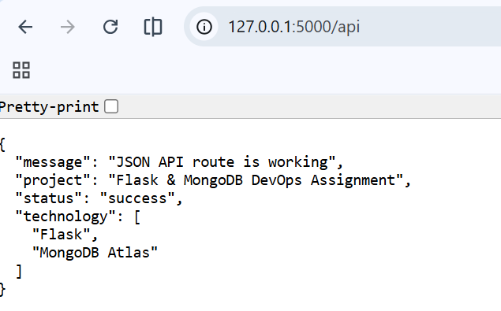

Task 2 - Frontend Form with MongoDB Atlas
2. Create a frontend form that inserts submitted data into MongoDB Atlas.
Implementation:
document = {"name": name, "email": email, "message": message}
collection = get_collection()
collection.insert_one(document)
Command / Test:
Open: http://127.0.0.1:5000/
Fill in the form and click Submit.

Explanation: The POST request reads form values, validates them, connects to MongoDB Atlas and inserts the document into the submissions collection.
Screenshot: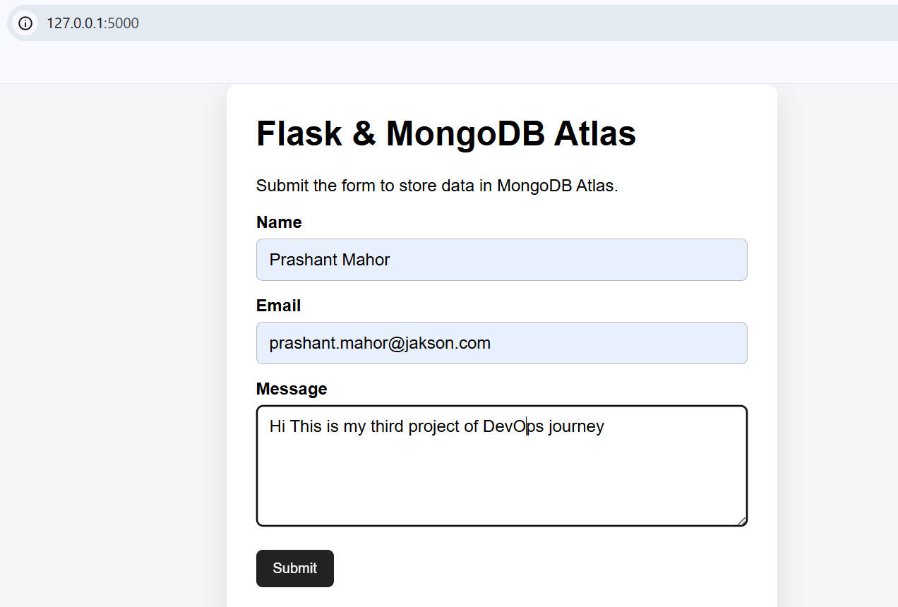
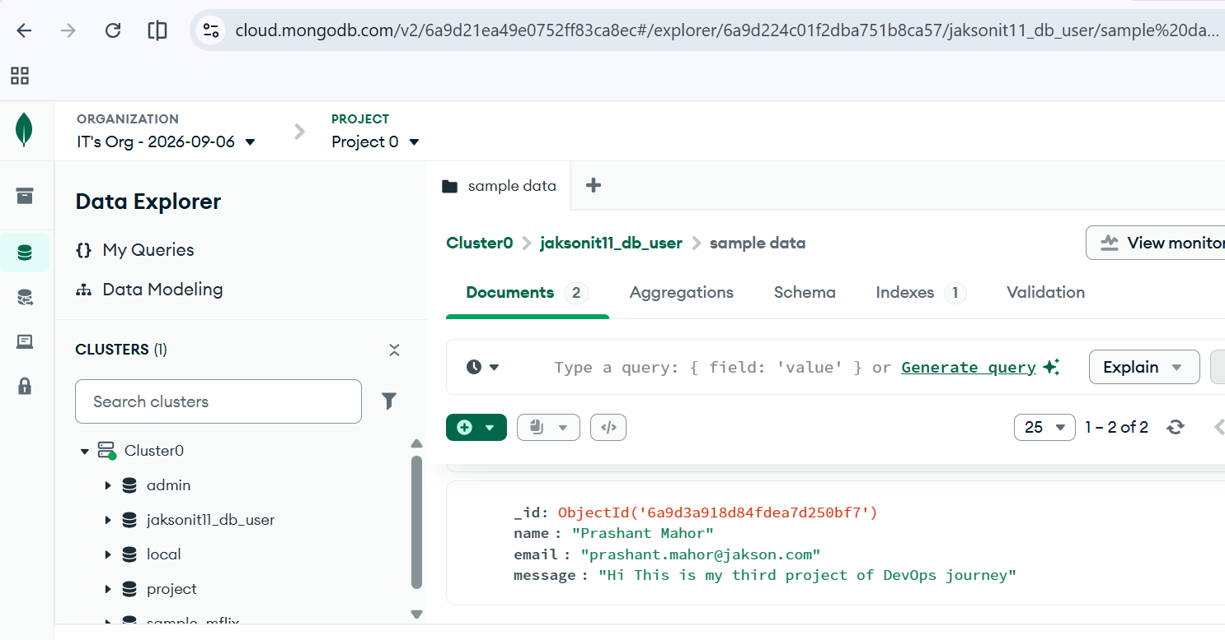

3. On successful insert, redirect the user to another page displaying "Data submitted successfully".
Implementation:
collection.insert_one(document)
return redirect(url_for("success"))
@app.route("/success")
def success():
return render_template("success.html")
Command / Test:
Submit a valid form while MongoDB Atlas is connected.

Explanation: After insert_one() succeeds, Flask redirects to /success. The success page displays the required confirmation message.
Screenshot: 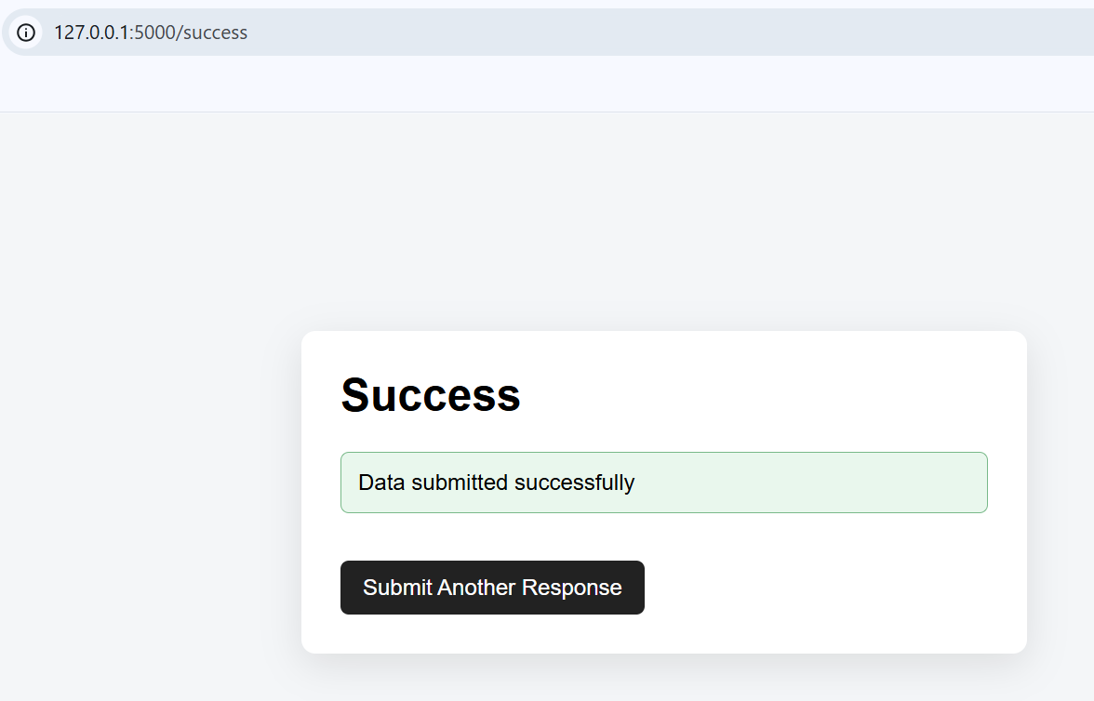
4. On error, display the error on the same page without redirecting.
Implementation:
except (PyMongoError, RuntimeError) as exc:
error = f"Unable to save data: {exc}"
return render_template("index.html", error=error, ...)
Command / Test:
Test by submitting incomplete data or temporarily using an invalid MongoDB URI.
Explanation: Validation/database errors are rendered back on index.html, so the user stays on the same page and can correct the problem.
Screenshot: 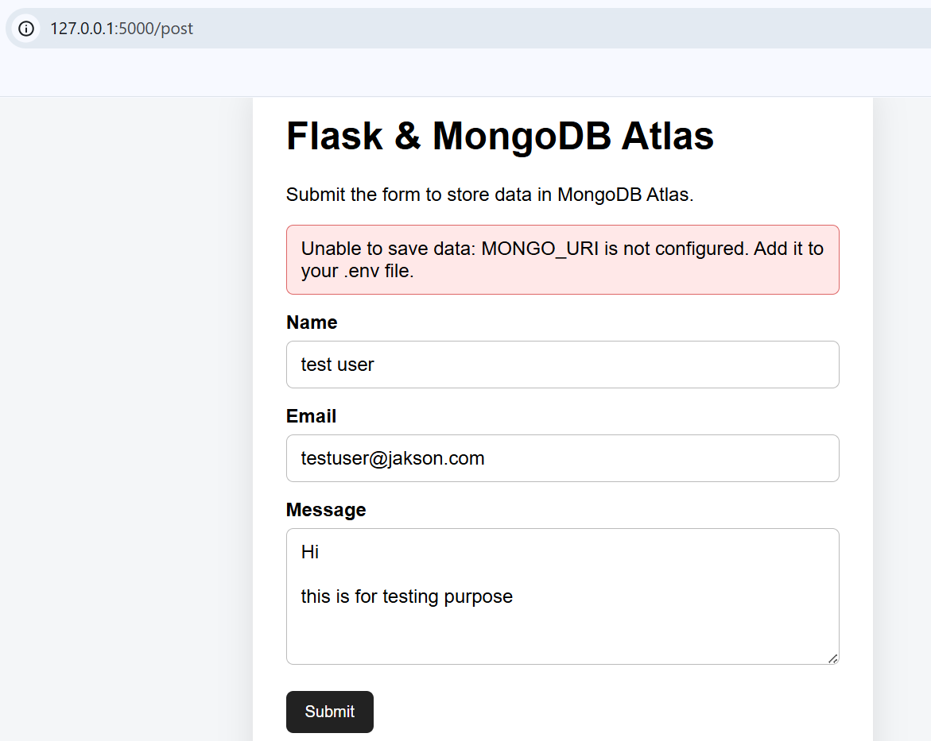

Installation and Run Commands
- python3 -m venv venv
- source venv/bin/activate
- pip install -r requirements.txt
- cp .env.example .env
- nano .env
- python3 app.py

GitHub Repository
Repository URL: _______________________________________________

Submission Checklist
- Complete Flask application source code included.
- Genuine terminal/browser/MongoDB Atlas screenshots added.
- Documentation updated with screenshots.
- GitHub repository link added.
- Real .env credentials NOT included.
- Complete folder compressed as Flask_and_MongoDB_Prashant.zip.

