Python & Bash – DevOps Assignment
Objective:
Practice core Python programming - conditionals, dictionaries, and file handling (reading and writing fi

Grade Checker
- 90+ : “A”
Command: python .\ grade_checker.py
Explanation: The program accepts a numeric score as user input and uses if/elif/else conditions to determine the grade “A”.
Screenshot: 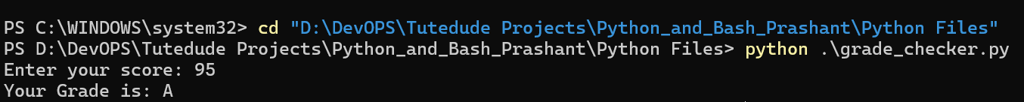
- 80–89 : “B”
Explanation: The program accepts a numeric score as user input and uses if/elif/else conditions to determine the grade “B”.
Screenshot:
- 70-89 : "c”
Explanation: The program accepts a numeric score as user input and uses if/elif/else conditions to determine the grade “C”.
Screenshot: 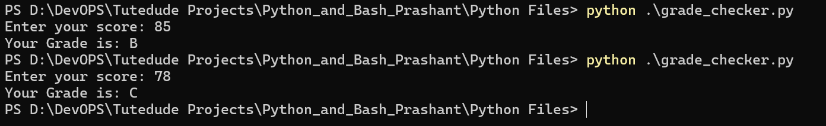
- 60–69 : “D”
Explanation: The program accepts a numeric score as user input and uses if/elif/else conditions to determine the grade “D”.

Screenshot:
- Below 60 : “F”
Explanation: The program accepts a numeric score as user input and uses if/elif/else conditions to determine the grade “F”.
Screenshot:
- Error Handling 4
Explanation: The program accepts a numeric score as user input. If the user enters text or other non-numeric input, it raises an error, which is handled through exception handling.
Screenshot:
2. Student Grades
Requirement: Create a dictionary where the keys are student names and the values are their grades. Allow the user to:
7. Add a new student and grade
Command: python .\student_grades.py
Explanation: A Python dictionary stores student names as keys and grades as values. A new key/value pair is added, all records are printed, and if/else checks whether a student exists.
Screenshot: 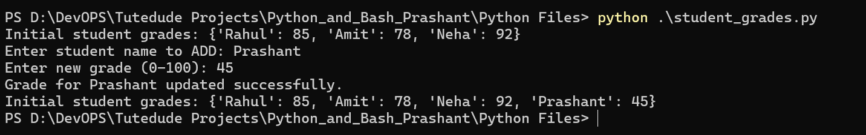
8. Update an existing student's grade.
Command: python .\student_grades.py
Explanation: A Python dictionary stores student names as keys and grades as values. A new key/value pair is added and update the grades of existing student .

Screenshot: 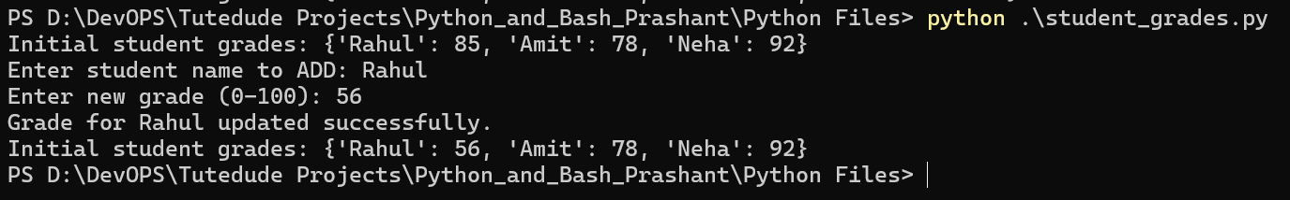
9. Print all student grades.
Command: python .\student_grades.py
Explanation: A Python dictionary stores student names as keys and grades as values. A new key/value pair is added and print all students key and grades in dictionary format
Screenshot: 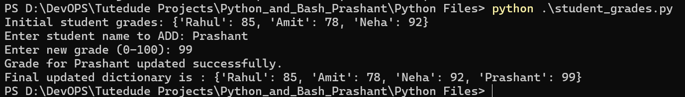
3. Write to a File
9. Create a text file and write some content using open() and write().
Command: python .\write_file.py
Explanation: The file is opened in write mode (w). write() stores text inside sample.txt, and close() closes the file after writing.
Text write as input : This Is My 3Rd Sectionn Of My Python Project Write File With Function "W" And Open File With Using Function "O"
Screenshot: 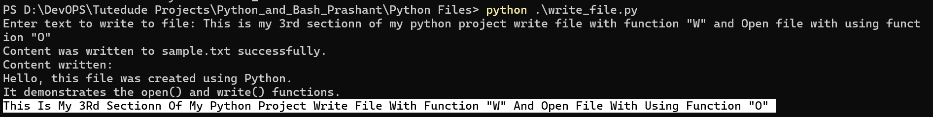Screenshot:

4. Read from a File
12. Open the file in read mode and use file.read() to read and display its content .
Command: python .\read_file.py
Explanation: The file is opened in read mode (r). file.read() reads the complete file content and print() displays it in the terminal.
Screenshot: 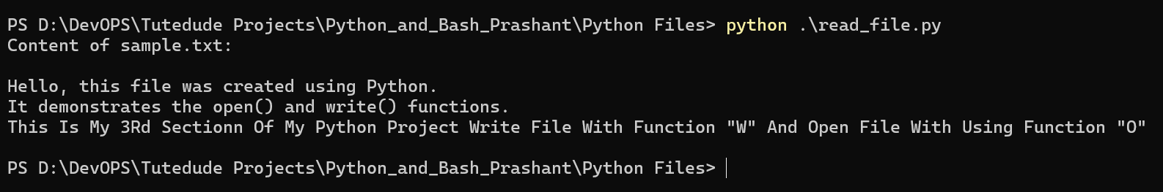

GitHub Repository

https://github.com/prashantmahor99/DevOps_Basic_Projects/tree/main/Python_and_Bash_Prashant

Submission Checklist
- All assignment tasks completed and tested.
- Terminal screenshots showing commands and outputs added.
- All Python source files included in the project folder.
- Documentation file included inside the ZIP.
- GitHub repository link added to the documentation.
- Complete folder compressed as Python_and_Bash_Prashant.zip.

