Git & GitHub - DevOps Assignment

Objective
Practice the complete Git workflow using a Flask + MongoDB project: SSH setup, branching, merging, conflict resolution, parallel feature development, sequential commits, soft reset, re-commit, rebase, and GitHub push.

Task 1 - Repository Setup & First Branch

1. Create a new GitHub repository
Command / Action:
Create an empty repository from your GitHub account.
Explanation: GitHub repository creation page / repository home.
Screenshot: 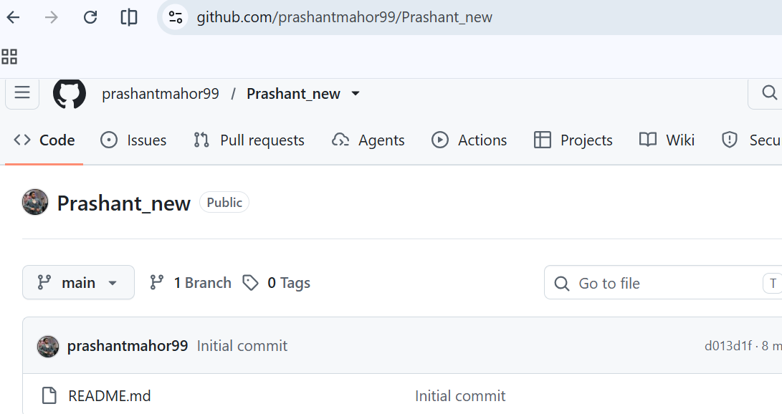
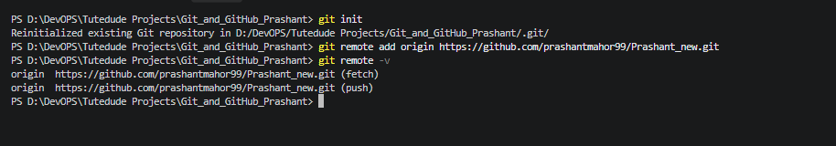

2. Clone using SSH
Command / Action:
Explanation: Generate an SSH key if required, add the public key to GitHub, verify SSH authentication, and clone the repository using SSH.
Screenshot: 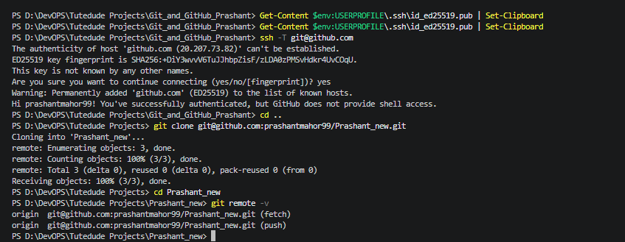

3. Create a branch named after your username
Command / Action:
Explanation: Creates and switches to the branch prashantmahor99.
Screenshot: 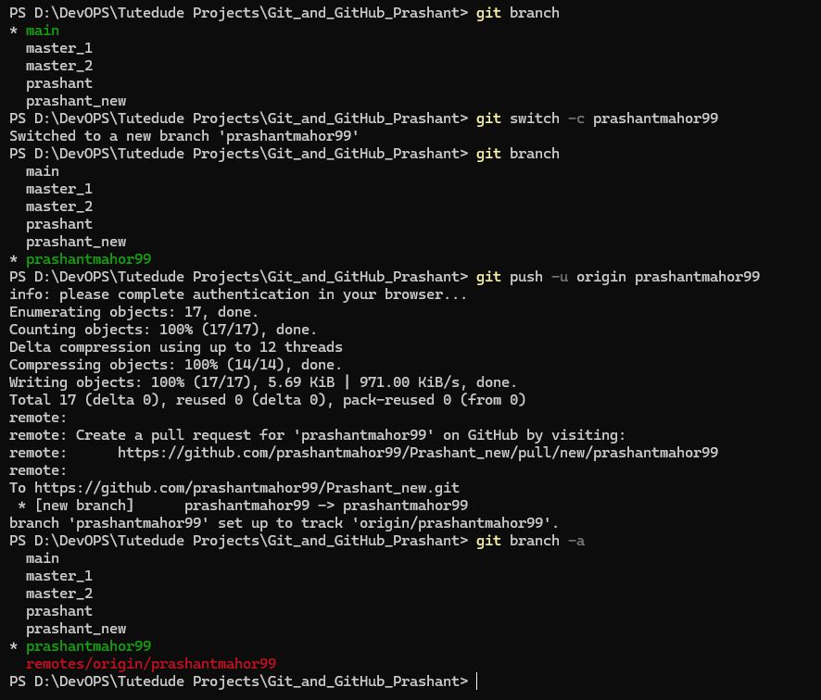

4. Add Flask project files and commit
Command / Action: git add . , git commit -m "prashantmahor99"
Explanation: Stages the complete project and creates the first feature commit.Screenshot: 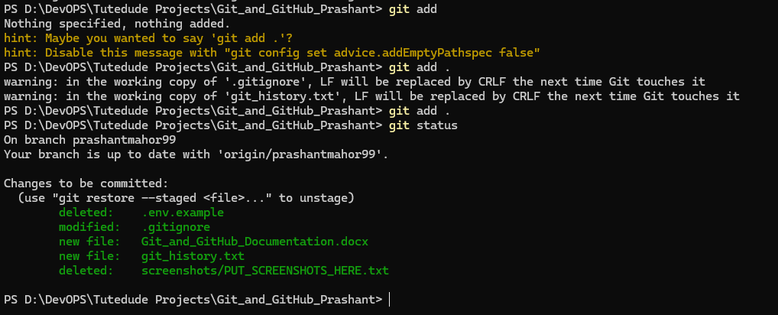
5. Merge into main
Command / Action: git merge prashantmahor99
git push origin main
Explanation: Merges the username branch into main and pushes the result.
Screenshot: 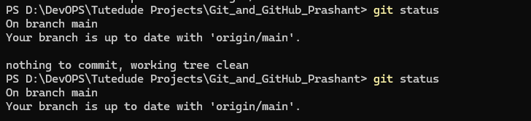

Task 2 - Update JSON & Resolve Conflicts

6. Create a new branch
Command / Action:
git checkout -b prashant_new
Explanation: Creates the second working branch required by the assignment.
Screenshot: 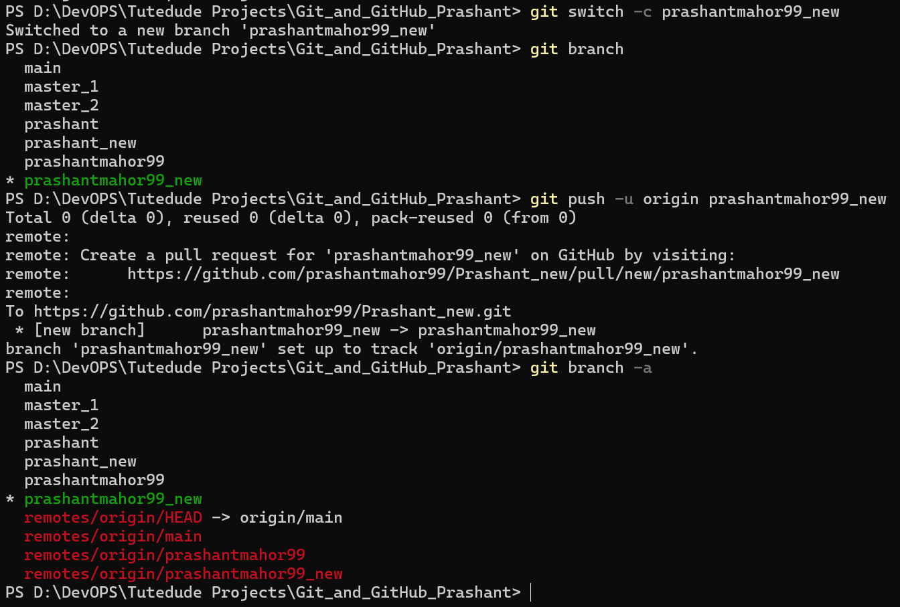
7. Update JSON used by /api
Command / Action:
notepad .\data\api_data.json
git commit -m "json update"

Explanation: The Flask /api route reads this JSON file and returns it as a JSON response.
Screenshot: 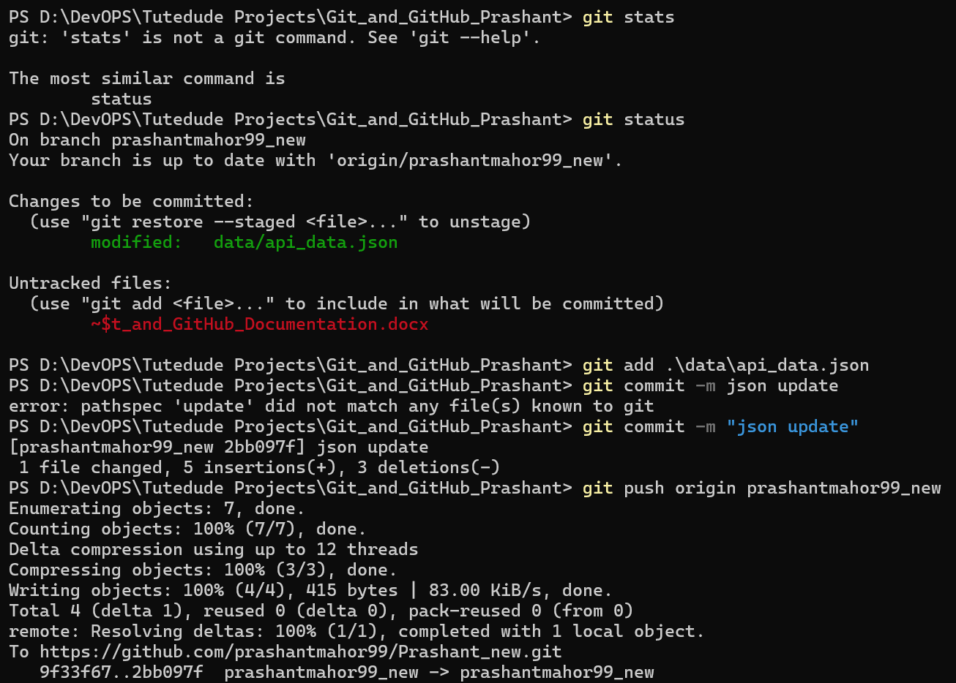8. Merge the new branch into main
Command / Action:
git checkout main
git merge prashant_new
Explanation: Merges the JSON change into main.
Screenshot: Paste your genuine terminal / GitHub / browser screenshot here.

9. Resolve conflicts if present
Command / Action:
git status
# edit conflicted file
git add data/api_data.json
git commit -m "Resolve JSON merge conflict"
Explanation: Accept the required changes, remove conflict markers, stage the resolved file and commit.
Screenshot: Paste your genuine terminal / GitHub / browser screenshot here.

10. Push updates
Command / Action:
git push origin main
git push origin prashant_new
Explanation: Uploads the updated main branch and working branch to GitHub.
Screenshot: Paste your genuine terminal / GitHub / browser screenshot here.

Task 3 - Parallel Feature Development

11. Create master_1 and master_2 from main
Command / Action:
git checkout main
git checkout -b master_1
git checkout main
git checkout -b master_2
Explanation: Creates two parallel development branches from main.
Screenshot: Paste your genuine terminal / GitHub / browser screenshot here.

12. Frontend in master_1
Command / Action:
git checkout master_1
# edit templates/todo.html
git add templates/todo.html static/style.css
git commit -m "Add To-Do frontend form"
Explanation: Build a To-Do form containing Item Name and Item Description.
Screenshot: Paste your genuine terminal / GitHub / browser screenshot here.

13. Backend in master_2
Command / Action:
git checkout master_2
# edit app.py
git add app.py requirements.txt .env.example .gitignore
git commit -m "Add submitto API and MongoDB storage"
Explanation: Adds POST /submitto and inserts submitted values into MongoDB Atlas.
Screenshot: Paste your genuine terminal / GitHub / browser screenshot here.

14. Merge both branches into main
Command / Action:
git checkout main
git merge master_1
git merge master_2
git push origin main
Explanation: Combines the parallel frontend and backend features.
Screenshot: Paste your genuine terminal / GitHub / browser screenshot here.

Task 4 - Sequential Commits, Reset & Rebase

15. Add Item ID, UUID and Hash separately
Command / Action:
git checkout master_1
# add Item ID
git add templates/todo.html
git commit -m "Add Item ID field"
# add Item UUID
git add templates/todo.html
git commit -m "Add Item UUID field"
# add Item Hash
git add templates/todo.html
git commit -m "Add Item Hash field"
Explanation: Each field must be committed separately so the history contains three individual commits.
Screenshot: Paste your genuine terminal / GitHub / browser screenshot here.

16. Verify sequential commits
Command / Action:
git log --oneline -5
Explanation: Shows the three separate commits in history.
Screenshot: Paste your genuine terminal / GitHub / browser screenshot here.

17. Merge master_1 into main
Command / Action:
git checkout main
git merge master_1
Explanation: Brings the enhanced To-Do form into main.
Screenshot: Paste your genuine terminal / GitHub / browser screenshot here.

18. Soft reset and re-commit
Command / Action:
git log --oneline
git reset --soft <COMMIT_BEFORE_ITEM_ID>
git status
git commit -m "Recommit To-Do enhancements after soft reset"
Explanation: Moves HEAD back while keeping changes staged, then creates a new commit and merges the work back into main as required.
Screenshot: Paste your genuine terminal / GitHub / browser screenshot here.

19. Rebase main onto master_1
Command / Action:
git checkout master_1
git rebase main
# assignment equivalent: git rebase main master_1
git log --oneline --graph --decorate --all
Explanation: Replays master_1 on top of the updated main while preserving commit history and without squashing.
Screenshot: Paste your genuine terminal / GitHub / browser screenshot here.

Flask Application Verification
Run the included application after configuring MongoDB Atlas:
python3 -m venv venv
source venv/bin/activate
pip install -r requirements.txt
cp .env.example .env
python3 app.py
Verify http://127.0.0.1:5000/ and http://127.0.0.1:5000/api. Do not commit your real .env file or MongoDB password.

GitHub Repository
Repository URL: _________________________________________________

Final Verification Commands
git status
git branch
git log --oneline --graph --decorate --all

Submission Checklist
- All 19 assignment steps completed.
- Complete Flask project source code included.
- Genuine screenshots added for commands, output, GitHub and application testing.
- GitHub repository URL added to this document.
- .env and real credentials are not committed.
- Complete folder compressed as Git_and_GitHub_Prashant.zip.

