HALO: Hop-by-Hop Adaptive Link-State Optimal Routing

Abstract:-
Link State routing protocols do not view networks in terms of adjacent routers and hop counts, but they build a comprehensive view of the overall network which fully describes the all possible routes along with their costs. Using the SPF (Shortest Path First) algorithm, the router creates a "topological database" which is a hierarchy reflecting the network routers it knows about. It then puts it's self on the top of this hierarchy, and has a complete picture from it's own perspective. Open Shortest Path First (OSPF) and Intermediate System-Intermediate System (IS-IS), split traffic evenly over shortest paths based on link weights. However, optimizing the link weights for OSPF/IS-IS to the offered traffic is a well-known NP-hard problem, and even the best setting of the weights can deviate significantly from an optimal distribution of the traffic. In this paper, we propose a new link-state routing protocol, PEFT, that splits traffic over multiple paths with an exponential penalty on longer paths.

Existing System:-
The information routers require to build their databases is provided in the form of Link State advertisement packets (LSAP). Routers do not advertise their entire routing tables, instead each router advertises only its information regarding immediately adjacent routers.
Link State protocols in comparison to Distance Vector protocols have:
- Big memory requirements
- Shortest path computations require many CPU circles
- If network is stable little bandwidth is used; react quickly to topology changes
- Announcements cannot be “filtered”. All items in the database must be sent to neighbors
- All neighbors must be trusted
- Authentication mechanisms can be used to avoid undesired adjacencies
- No split horizon techniques are possible

.

Proposed System:-

Our goal in this paper is to eliminate this tradeoff between optimality and ease of implementation in routing. The result is Hop-by-hop Adaptive Link-state Optimal (HALO), a routing solution that retains the simplicity of link-state, hop-by-hop protocols while iteratively converging to the optimal routing assignment. To the best of our knowledge, this is the first optimal link-state hop-by-hop routing solution. Not surprisingly, there are multiple challenges to overcome when designing such a solution. Before getting into them, we define the following important recurring terms for ease of exposition.

Hop-by-hop:
Each router, based on the destination address, controls only the next hop that a
packet takes.

Adaptive: The algorithm does not require the traffic demand matrix as an explicit input in order to compute link weights. Specifically, the algorithm seamlessly recognizes and adapts to changes in the network, both topology changes and traffic variations, as inferred from the network states like link flow rates.

Link-state:
Each router receives the state of all the network’s links through periodically flooded link-state updates and makes routing decisions based on the link states.

Optimal: The routing algorithm minimizes some cost function (e.g., minimize total delay) determined by the network operator. The problem of guiding network traffic through routing to minimize a given global cost function is called traffic engineering (TE).

Advantage:-

1) Dampen update frequency
2) Target link-state updates to multicast
3) Use link-state area hierarchy for topology
4) Exchange route summaries at area borders
5) Use Time-stamps Update numbering & counters
6) Manage partitions using a area hierarchy

Future Enhancement:-

Link State protocols work more efficiently, problem can arise. Usually problems occur cause of changes in the network topology (links go up-down), and all routers don't get updated immediately cause they might be on different line speeds, there for, routers connected via a fast link will receive these changes faster than the others on a slower link. The hop-by-hop forwarding requirement presents the next challenge. As a result, a router cannot determine the entire path that traffic originating at it takes to its destination. Without this requirement, a projected gradient approach can be used to yield optimal iterative link-state algorithms that can be implemented with source routing, where the path a packet takes through the network is encoded in its entirety at the source. However, the need for source routing means that these techniques are not practical given the size of modern networks

Module:-

Network Node Configuration:-

Iteratively adjust each router’s split ratios and move traffic from one outgoing link to another. This only controls the next hop on a packet’s path leading to hop-by-hop routing. If instead we controlled path rates, we would get source
routing.

Path Design:-

Increase the split ratio to the link that is part of the shortest path at each iteration even though the average price via the next-hop router may not be the lowest. If instead we forwarded traffic via the next-hop router with the lowest average price, we get Gallager’s approach, which is a distance vector solution.

Link Management:-

Adapt split ratios dynamically and incrementally by decreasing along links that belong to nonshortest paths while increasing along the link that is part of the shortest path at every router. If instead split ratios are set to be positive instantaneously only to the links leading to shortest paths, then we get OSPF with weights,
Shortest Path:-

Dijkstra:-

For a given source vertex (node) in the graph, the algorithm finds the path with lowest cost (i.e. the shortest path) between that vertex and every other vertex. It can also be used for finding costs of shortest paths from a single vertex to a single destination vertex by stopping the algorithm once the shortest path to the destination vertex has been determined. For example, if the vertices of the graph represent cities and edge path costs represent driving distances between pairs of cities connected by a direct road, Dijkstra's algorithm can be used to find the shortest route between one city and all other cities. As a result, the shortest path algorithm is widely used in network routing protocols, most notably IS-IS and OSPF (Open Shortest Path First)

function Dijkstra(Graph, source):
dist[source] := 0 // Distance from source to source
for each vertex v in Graph: // Initializations
if v ≠ source
dist[v] := infinity // Unknown distance function from source to v
previous[v] := undefined // Previous node in optimal path from source
end if
add v to Q // All nodes initially in Q (unvisited nodes)
end for

while Q is not empty: // The main loop
u := vertex in Q with min dist[u] // Source node in first case
remove u from Q

for each neighbor v of u: // where v has not yet been removed from Q.
alt := dist[u] + length(u, v)
if alt < dist[v]: // A shorter path to v has been found
dist[v] := alt
previous[v] := u
end if
end for
end while
return dist[], previous[]
end function

Architecture:-
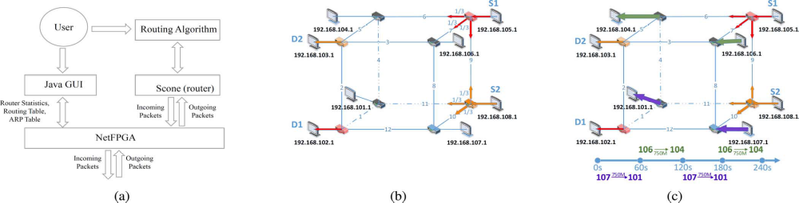
System Configuration:-

H/W System Configuration:-

Processor - Pentium –III

Speed - 1.1 Ghz
RAM - 256 MB(min)
Hard Disk - 20 GB
Key Board - Standard Windows Keyboard
Mouse - Two or Three Button Mouse
Monitor - SVGA

S/W System Configuration:-

Operating System : Windows XP / 7
Front End : JAVA,RMI, SWING.

