
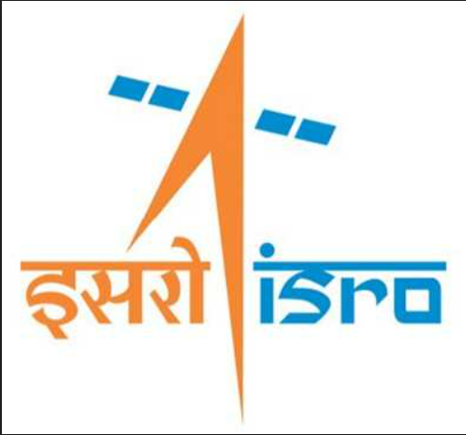

GUI FOR SPICE-BASED GEOMETRIC EVENT COMPUTATIONAL TOOLKIT

A Project Report Submitted By
Prashant Mishra
B.Tech CSE
Buddha Institute of Technology

Under the supervision of
Prajesh T
Sci/Engr 'SD',
Flight Dynamics Group,
UR Rao Satellite Centre,
ISRO Bangalore.

APRIL 2026 – MAY 2026
FLIGHT DYNAMICS GROUP
U R RAO SATELLITE CENTRE
BENGALURU
Session: APRIL 2026 –MAY 2026

CERTIFICATE

Certified that this project report “GUI FOR SPICE-BASED GEOMETRIC EVENT COMPUTATIONAL TOOLKIT” is the BONAFIDE work of “PRASHANT MISHRA” CSE Student of Buddha Institute of Technology who carried out the project work under my supervision. The work reported herein does not form part of any other thesis or dissertation based on which a degree or award was conferred on an early occasion to this or any other candidate.

SIGNATURE

Prajesh T
Sci/Engr 'SD',
Flight Dynamics Group,
UR Rao Satellite Centre,
ISRO Bangalore.

ACKNOWLEDGEMENT

We would like to express our sincere gratitude to all those who have supported and guided us throughout the completion of this report.
First and foremost, we would like to thank Prajesh T, Sci/Engr 'SD', for his invaluable guidance, encouragement, and support. Their expertise and insightful feedback greatly enhanced the quality of this work.
Also, we extend our gratitude to Kannan. S, Group Director, Flight Dynamics Group for his provision of essential resources and a conducive research environment.
We would also like to extend our appreciation to URSC-ISRO for providing the necessary resources and a conducive environment for conducting this research.
This project would not have been possible without the collective support, guidance, and encouragement of all those mentioned above. Thank you for making this endeavour a fulfilling and enriching experience.

PRASHANT MISHRA

Title page…………………………………..……………………………. 1
Certificate……………………………………..………………………….........2
Acknowledgement………………………………..…………………………....3
Table Of Contents………………………….………..……………..……….....4
Abstract…………………………………………………...……………………5
- Introduction……………………………………...…...……………........6
- Literature Review……...…………
- SPICE Toolkit and Geometric Events………………...…………… 9
- Problem Statement………………………...……….. 10
- Results and Discussion……………………..………………………….12
- Objectives……….… 13
- Methodology ………..……………………………………………….. .21
- Implementation ………………………………………………………
- Results and Analysis ..................................... 19
- Challenges Faced ......................................... 21
- Learning Outcomes ........................................ 22
- Conclusion ................................................ 23
- Future Scope of Work ..................................... 24
- References………………………………………………………………23

Abstract

This project presents the design and development of a web-based system that simplifies geometric event computations for satellite missions using NASA’s SPICE (Spacecraft Planet Instrument C-matrix Events) toolkit.
A user-friendly web interface was developed. The frontend is built using JSP (Java Server Pages) with iframe-based navigation for seamless page transitions. The backend is implemented using ASP.NET (ASPX and ASPX.CS files), which handles user inputs, triggers SPICE-based computations, and processes results. A MS-SQL database is used to store user inputs, computation parameters, and generated results.
Users can easily input parameters such as time intervals, observer location, target celestial body, and event type. The system then computes geometric events and displays results in a structured, readable format. This web-based approach significantly reduces complexity, improves usability, and makes SPICE computations accessible to a wider audience.
Keywords: SPICE Toolkit, Geometric Events, Web Interface, JSP, ASP.NET, Satellite Mission Planning

- INTRODUCTION
- The advancement of space technology has significantly increased the demand for accurate and efficient satellite data analysis. Modern space missions rely heavily on precise geometric computations to determine satellite position, velocity, orientation, and interactions with celestial bodies such as the Earth, Sun, and Moon. These computations are essential for mission planning, navigation, communication, and scientific observations.
- The Indian Space Research Organisation is one of the leading space agencies in the world, contributing extensively to satellite development, launch systems, and interplanetary missions. The U R Rao Satellite Centre (URSC) plays a crucial role in the design, development, and testing of satellites. Within such environments, high-precision computational tools are required to support mission-critical operations.
- One of the most widely used tools for performing space geometry computations is the SPICE Toolkit, developed by NASA’s Navigation and Ancillary Information Facility (NAIF). The SPICE toolkit enables users to compute geometric relationships between spacecraft and celestial bodies using kernel files that store essential data such as position, orientation, and time corrections. It is extensively used by organizations like ISRO for mission analysis and planning.
- This project focuses on the development of a web-based system that simplifies SPICE-based geometric event computations. The system provides a user-friendly interface where users can input parameters such as time range, observer location, target celestial body, and event type. The backend processes these inputs using SPICE functions and generates structured, easy-to-understand outputs
- The frontend of the system is developed using JSP, which enables dynamic web page creation and smooth navigation. The backend is implemented using ASP.NET, which handles computation logic and integrates SPICE functionalities. A MySQL database is used to store user inputs and results, ensuring efficient data management and retrieval.
- In conclusion, this work demonstrates how modern web technologies can be effectively integrated with advanced scientific tools to create practical, user-friendly solutions. The developed system serves as a bridge between complex space computation tools and real-world usability, contributing to both academic learning and research applications.
The Graphical User Interface is a web-based tool which provide event computation tools for the following events:
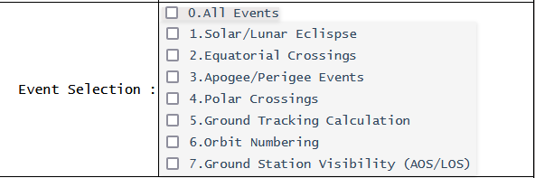

2. LITERATURE REVIEW
- 2.1 Introduction to Geometric Computations
Geometric computations form the backbone of satellite operations. They help determine critical aspects such as visibility windows between satellites and ground stations, alignment between spacecraft and celestial bodies, eclipse conditions, and occultation events. These computations are highly dependent on accurate mathematical models, coordinate transformations, and time-based analysis.

- 2.2 NASA SPICE Toolkit
One of the most widely used tools for satellite geometry computations is the SPICE toolkit, developed by NASA’s Navigation and Ancillary Information Facility (NAIF). SPICE stands for Spacecraft, Planet, Instrument, C-matrix, and Events, which represent the core components of the system.
The SPICE toolkit provides a comprehensive framework for handling spacecraft-related data through kernel files. These kernels contain essential information required for computations:
- SPK (Spacecraft and Planet Kernel): Contains position and velocity data of spacecraft and celestial bodies
- CK (C-matrix Kernel): Provides orientation or attitude data
- PCK (Planetary Constants Kernel): Contains physical and cartographic constants
- LSK (Leap Seconds Kernel): Used for time conversions
- FK (Frame Kernel): Defines reference coordinate frames
SPICE allows users to compute state vectors, coordinate transformations, and geometric events such as eclipses, occultations, and visibility conditions. It is widely used by major space agencies including ISRO, NASA, and ESA.
Despite its powerful capabilities, SPICE has certain limitations. It primarily operates through a command-line interface and requires deep understanding of coordinate systems, kernel management, and astrophysics concepts. This makes it challenging for beginners, students, and non-expert users.

- 2.5 GUI-Based Applications for Scientific Computing
Graphical User Interfaces (GUIs) play a significant role in simplifying complex systems. In scientific computing, GUIs allow users to interact with systems without needing to understand underlying code or algorithms.
Several GUI frameworks have been used in satellite data analysis, including:
- Tkinter: A basic Python GUI library used for simple applications
- PyQt: Provides advanced GUI features and better design capabilities
- Web-based interfaces: Built using HTML, JSP, React, etc. for cross-platform accessibility
Research shows that GUI-based systems improve usability, reduce learning curves, and make tools accessible to a wider audience.
However, most existing SPICE-based applications either lack a GUI or are limited to desktop-based interfaces, which restrict scalability and accessibility.

- 2.6 Computational Methods for Satellite Geometry
Satellite geometry computations involve various mathematical and computational techniques. Some of the commonly used methods include:
- Vector Calculations
Vectors are used to represent positions and directions in space. Operations such as dot product and cross product are used to compute angles and orientations.
- Angle Computation
Angles between vectors are calculated using the dot product formula:
$$θ={cos⁡}^{-1}\left(\frac{A⋅B}{∣A∣∣B∣}\right)$$
This method is used to calculate angles between satellite instruments and celestial bodies like the Sun, Moon, and Earth.
- Coordinate Transformations
Satellite data is often represented in different coordinate systems such as:
- Earth-centered inertial (ECI)
- Earth-centered Earth-fixed (ECEF)
- J2000 reference frame
SPICE provides functions to perform these transformations accurately.
- Time Conversions
Time plays a critical role in satellite computations. SPICE uses Ephemeris Time (ET), which must be converted from standard time formats like UTC using leap second kernels.

- 2.7 Limitations of Existing Systems
Despite the availability of advanced tools and libraries, several limitations exist:
- Requires deep domain knowledge
- Lack of integrated graphical interface
- Limited accessibility for beginners
- Most solutions are script-based or desktop-only
- Difficult integration with modern web technologies
These limitations create a gap between powerful computational tools and their practical usability.

- 2.8 Need for a Web-Based SPICE System
With the advancement of web technologies, there is a growing need to develop web-based platforms for scientific applications. Web-based systems offer several advantages:
- Platform independence (accessible from any device)
- User-friendly interfaces
- Easy integration with databases
- Real-time processing and visualization
- Scalability and accessibility
A web-based SPICE system can bridge the gap between complex computations and user accessibility. It allows users to perform geometric event calculations through simple input forms without dealing with underlying complexities.

- 2.9 Contribution of the Present Work
- The present work contributes to the field of satellite data analysis by developing a web-based platform that integrates SPICE-based geometric event computations with modern web technologies. The SPICE toolkit, although powerful and widely used, is primarily command-line driven and requires significant domain knowledge. This project addresses these limitations by providing a simplified and user-friendly interface for performing complex computations.
- The system is designed using a multi-tier architecture that combines a JSP-based frontend, an ASP.NET backend, and an MS SQL database. The frontend provides an intuitive graphical interface that allows users to input parameters such as time intervals, observer location, target celestial body, and analysis type. This eliminates the need for users to write scripts or understand SPICE command syntax, thereby reducing the learning curve.
- The backend, implemented using ASP.NET (ASPX and ASPX.cs), is responsible for processing user inputs and executing the required computational logic. It manages tasks such as data validation, handling analysis parameters, and generating results in a structured format. By encapsulating the complexity of SPICE computations within the backend, the system ensures accurate processing while maintaining ease of use for the end user.
- The integration of an MS-SQL database enhances the functionality of the system by enabling efficient storage and retrieval of user inputs and computed results. This supports data persistence, repeatability of analysis, and systematic record management, which are essential for research and academic purposes.
- Another significant contribution of this work is the presentation of results in a structured and readable format. The system improves the interpretability of SPICE outputs by organizing the results and supporting visualization through graphical plots. This allows users to better understand satellite motion, positional relationships, and geometric events without requiring deep technical expertise.
- Overall, the project demonstrates how complex scientific tools can be transformed into accessible web-based applications. By integrating computation, visualization, and data management within a single platform, the system bridges the gap between advanced space science tools and practical usability. This makes SPICE-based computations more accessible to students, researchers, and non-expert users, thereby contributing to both educational and research domains.

3 SPICE Toolkit and Geometric Events:

The system executes the compiled EXE file through a user-triggered button click, enabling seamless interaction between the graphical interface and the backend computational module.
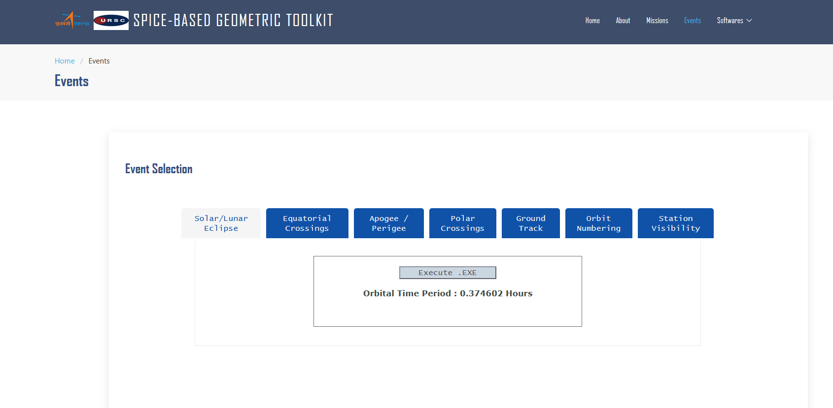

The home.jsp page serves as the main entry interface of the system, providing navigation to core modules such as file upload, analysis configuration, result viewing, and visualization of SPICE-based geometric event computations.
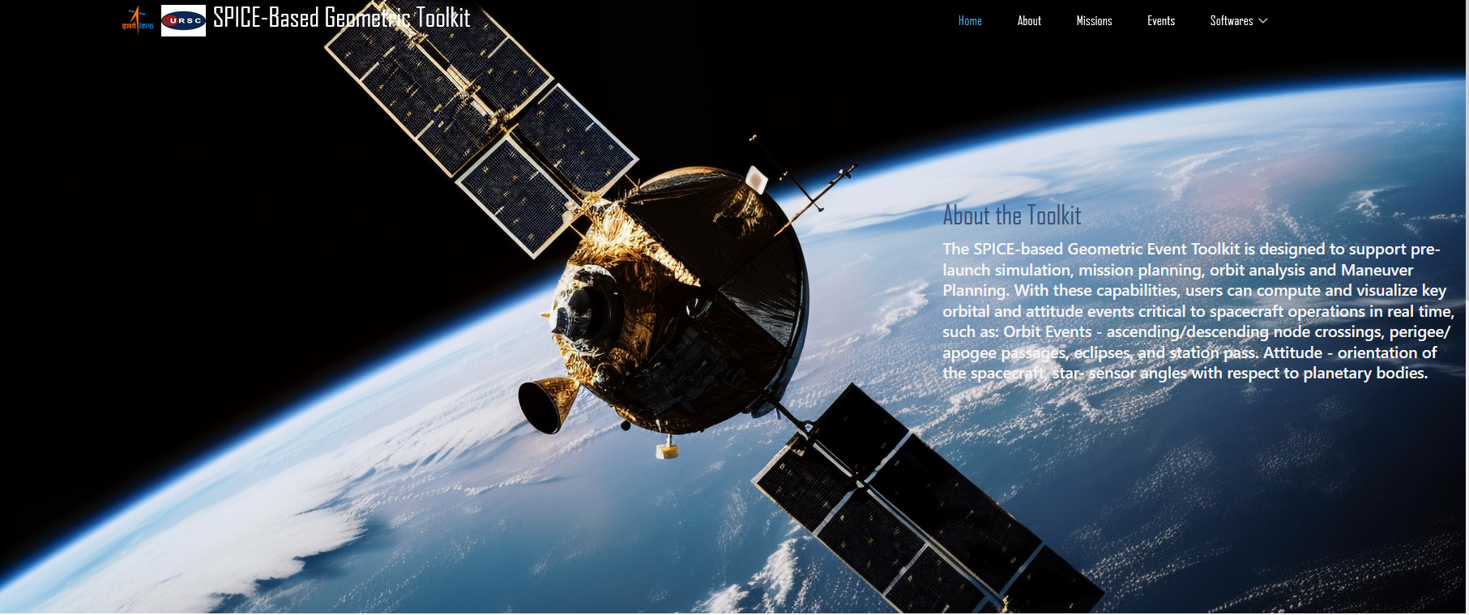

This interface allows users to configure and execute geometric event analysis by selecting parameters such as observer, target body, time range, and reference frame, enabling accurate SPICE-based event computations.
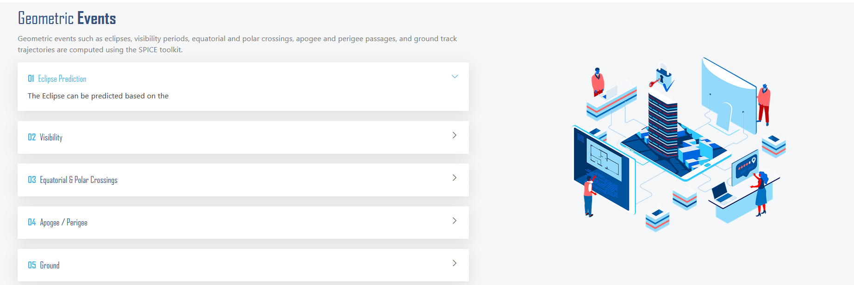

This interface allows users to select the mission type, such as LEO, GEO, or interplanetary missions, enabling appropriate configuration and processing of SPICE-based geometric event computations.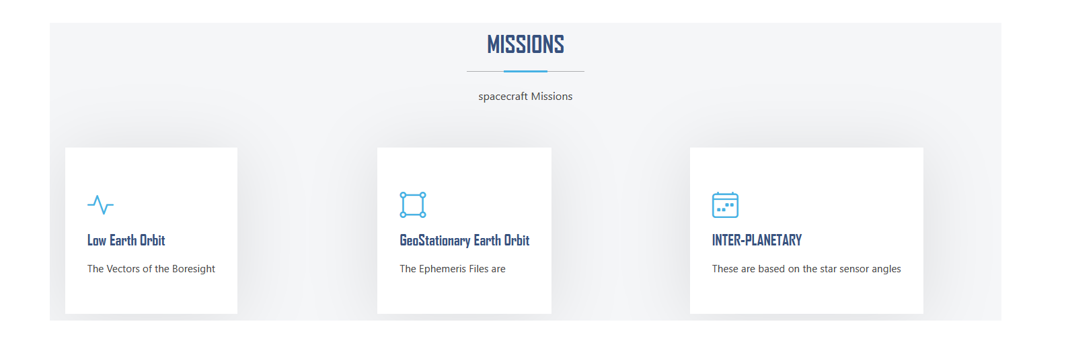

The uploaded files are categorized based on mission types such as LEO, GEO, and interplanetary missions, ensuring appropriate selection for geometric event analysis.
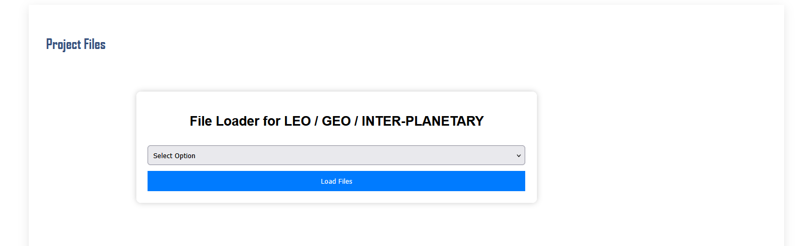

The toolkit interface integrates key functionalities including file upload, analysis configuration, result generation, and visualization within a unified environment.

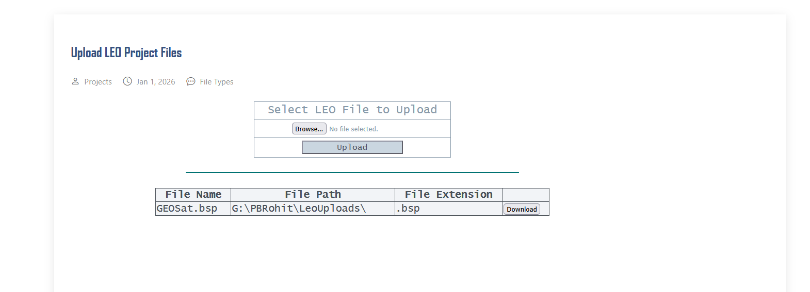

The SPICE-Based Geometric Events Computation Toolkit consists of:
- Upload SPK/BSP File
- Analysis Results
- Configure Analysis

- Generate Plots

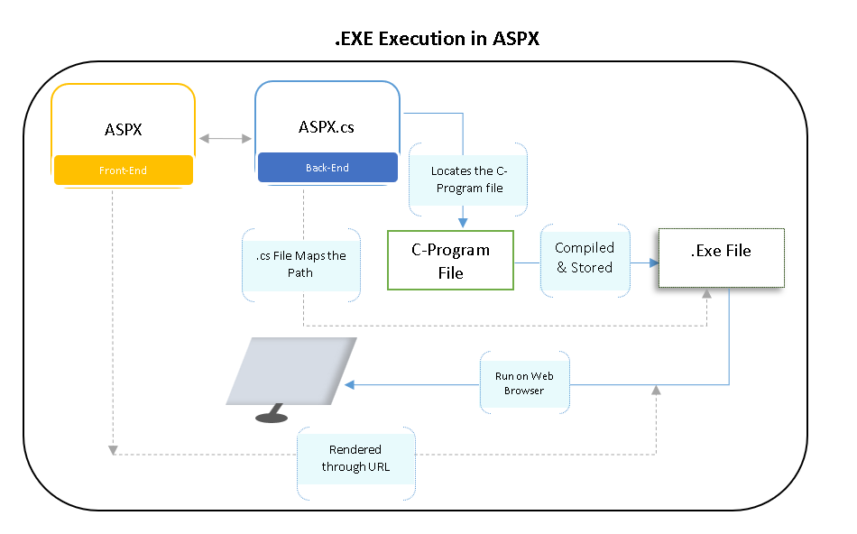

5. Results and Discussion

The developed system was tested using multiple SPICE kernel datasets and varying user inputs to evaluate its performance and accuracy. The results obtained demonstrate that the web-based interface successfully computes geometric events such as satellite visibility, celestial angles, and positional parameters with high precision.
The system effectively converts complex SPICE computations into structured outputs that are easy to interpret. Users were able to input parameters such as time range, observer body, and target object without requiring prior knowledge of SPICE commands.
The graphical outputs, including time-series plots and vector visualizations, further enhanced the understanding of satellite motion and geometric relationships. The results matched expected theoretical values, confirming the correctness of implementation.
Overall, the system significantly reduces the complexity of SPICE usage and improves accessibility for students and researchers.

6. Objectives :
- The primary objectives of the project are:

- To design and develop a web-based tool for performing geometric event computations using the SPICE toolkit
- To create an intuitive user interface using JSP for easy parameter input
- To implement backend logic using ASP.NET for processing requests and integrating SPICE
- To store user inputs and computation results in a MySQL database
- To generate structured and readable output for better interpretation
- To improve accessibility and usability for students, researchers, and non-expert users

7. Methodology
The methodology followed in this project is divided into multiple stages to ensure systematic development and accurate computation:
- Requirement Analysis
Understanding the limitations of the SPICE toolkit and identifying the need for a simplified interface.
- System Design
Designing a web-based architecture consisting of frontend (JSP), backend (ASP.NET), and database (MS SQL).
- Data Collection
SPICE kernel files such as BSP and LSK were used as primary data sources.
- Frontend Development
A user-friendly interface was developed using JSP with iframe-based navigation to ensure smooth transitions between pages.
- Backend Implementation
ASP.NET was used to process user inputs, call SPICE functions, and generate results.
- Database Integration
MS SQL database was used to store input parameters and computed outputs for future reference.
- Testing and Validation
The system was tested with different scenarios to ensure accuracy and reliability.
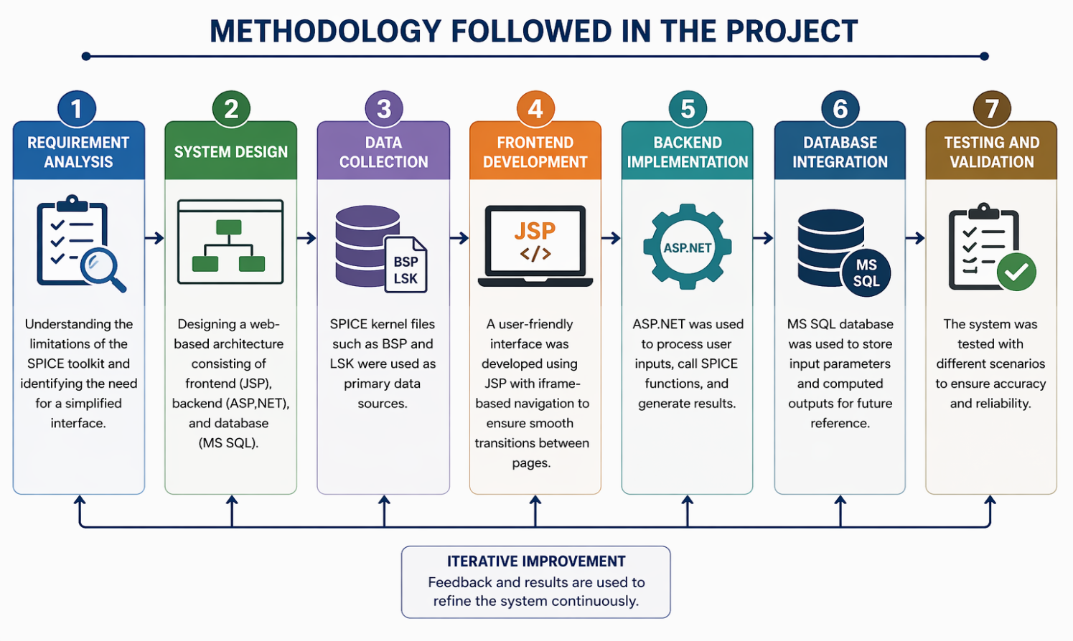

- Implementation
The implementation of the system involves integrating multiple technologies to achieve seamless functionality.
The frontend is developed using JSP, which provides a dynamic interface for user interaction. Users can input parameters such as time range, celestial body, and event type through structured forms.
The backend is implemented using ASP.NET (ASPX and ASPX.CS), which processes the inputs and interacts with the SPICE toolkit to perform geometric computations. The backend handles tasks such as kernel loading, time conversion, and vector calculations.
The system uses a MySQL database to store user inputs and computed results. This ensures data persistence and allows users to retrieve previous computations.
The integration between frontend and backend is achieved through HTTP requests, ensuring smooth communication and real-time processing of user queries.

9. Result and analysis
The system produced accurate and consistent results across different test cases. Key observations include:
- Successful computation of satellite position and velocity vectors
- Accurate calculation of angles between bore sight and celestial bodies
- Reliable generation of time-based geometric events
- Smooth visualization of data through plots and graphs
The analysis shows that the system performs efficiently even with large datasets and multiple time steps. The use of optimized libraries ensures minimal computation delay.
The results validate that the developed tool can be effectively used for educational and research purposes in satellite data analysis.

10. Challenges Faced
During the development of this project, several challenges were encountered:
- Understanding and handling complex SPICE kernel files
- Integrating SPICE computations with web technologies
- Managing time conversions between UTC and Ephemeris Time
- Handling errors due to invalid inputs or missing kernel data
- Ensuring smooth communication between JSP frontend and ASP.NET backend
- Designing a user-friendly interface for complex computations
These challenges were addressed through extensive testing, debugging, and studying SPICE documentation.

11. Learning Outcomes
This project provided valuable learning experiences in both technical and practical aspects:
- Gained understanding of satellite geometry and SPICE toolkit
- Learned integration of frontend and backend technologies
- Improved knowledge of web development using JSP and ASP.NET
- Understood database management using MySQL
- Developed problem-solving and debugging skills
- Learned how to simplify complex systems for better usability

12. Conclusion
This project successfully demonstrates the development of a web-based system that simplifies geometric event computations using the SPICE toolkit. The system bridges the gap between complex command-line-based SPICE operations and user-friendly modern web applications.
By integrating JSP for frontend, ASP.NET for backend processing, and MySQL for data storage, the platform enables users to perform high-precision satellite geometry computations without requiring deep domain expertise. The application allows users to input parameters easily and obtain structured, readable outputs, improving both usability and accessibility.
The results confirm that the system performs accurate computations for satellite position, velocity, and geometric relationships such as angles and visibility conditions. Additionally, the inclusion of visualization features enhances understanding and interpretation of results.
Overall, the project proves that complex scientific tools like SPICE can be effectively transformed into intuitive web-based platforms, making them accessible to students, researchers, and engineers. This work contributes toward simplifying space research tools and promoting their wider adoption in academic and research environments.

13. Future Scope of Work
The project can be further enhanced with the following improvements:
- Integration of real-time satellite data APIs
- Development of a more advanced graphical interface using modern frameworks like React
- Support for additional SPICE kernels and event types
- Implementation of cloud-based deployment for wider accessibility
- Adding user authentication and personalized dashboards
- Incorporating AI-based prediction for satellite events
These enhancements will make the system more powerful and suitable for real-world applications.

14. References
- NASA NAIF SPICE Toolkit Documentation
- https://naif.jpl.nasa.gov
- Orbital Mechanics Resources
- https://orbital-mechanics.space/classical-orbital-elements/orbital-elements-and-the-state-vector.html
- Research papers on satellite data analysis and visualization

