Diet Coke Custom Can Campaign
Unit test report with screenshots
Item | Detail
Branch | feat/diet-coke-campaign (nothing pushed to main or testing)
Run date | 30 October 2026
URL under test | http://127.0.0.1:3000/user-campaign (staff app stays at /offline-store)
Environment | Local: Postgres, FastAPI (uvicorn), Next.js production build, Chrome emulating 402x775 @2x mobile
OTP mode | Infobip flag OFF, bypass ON (code 123456). No SMS was sent.
Entry window | Forced open for the run (PRINTFLOW_CAMPAIGN_OPEN_HOUR=0, CLOSE_HOUR=24) because the local clock was outside 10:00-22:00 IST
Moderation | Switched off for the run (no Gemini/Vertex access locally); the server therefore approved the text
Recording | docs/ut/ut-flow.mp4 (screen recording of the same run)

1. Summary
The complete consumer journey ran end to end on the root URL /user-campaign using the bypass OTP: landing, login, OTP, design and text, preview, entry, thank-you. All nine executed journey steps passed. The Figma pixel comparison could not be run (see UT-10 and section 6).

2. Test cases
ID | Step | Expected | Actual | Result
UT-01 | Open /user-campaign on the domain root | Landing page renders: logo, can with sticker, "Make it yours", CTA, Terms and Privacy links. URL stays /user-campaign. | As expected. Links point at /user-campaign/terms and /privacy. | Pass
UT-02 | Tap "Let's set the vibes" | Login dialog opens (mobile, email, terms checkbox, Submit). | As expected. | Pass
UT-03 | Enter 9876543210, aanya@example.com, tick terms, Submit | Moves to the OTP step; no SMS sent (Infobip flag off). | OTP step opened; the API recorded a bypass send (null code hash). | Pass
UT-04 | OTP step content | Shows the masked number, 6-digit field, resend countdown, Verify, Change number. | Shows +91 98765 43210 and a 30 s countdown. | Pass
UT-05 | Enter a wrong code (000000) | Error "That code doesn't match. Try again."; failure counted. | As expected; countdown continues. | Pass
UT-06 | Enter the bypass code (123456), Verify | Logs in; session cookie set; goes to /user-campaign/create on the root URL. | Landed on http://127.0.0.1:3000/user-campaign/create. | Pass
UT-07 | Customiser: heads-up popup, pick Beach vibes, type "Aanya" | Popup dismisses; sticker and text show on the can; counter 5/12. | As expected. | Pass
UT-08 | Tap "Check my vibe" | Server text check, then preview with Download / Share / Make It Happen. | Preview opened at /user-campaign/preview. Moderation was disabled in this run (see section 6). | Pass
UT-09 | Tap "Make It Happen" | Entry accepted (201); thank-you page; no win/loss claim. | Thank-you page shown. Database: 1 participant, 1 entry (BEACH_VIBES, "Aanya"). Window was forced open for the run. | Pass
UT-10 | Pixel comparison against the Figma frames | Each screen matches the Figma design. | Not done: Figma access for this account is still pending (edit access required to read the file). Screenshots are attached so the comparison can be made as soon as access exists. | Not run

3. Screenshots (copy of the live run)
Captured at 402x775 CSS pixels, device scale 2, which is the Figma frame size the screens were built to.
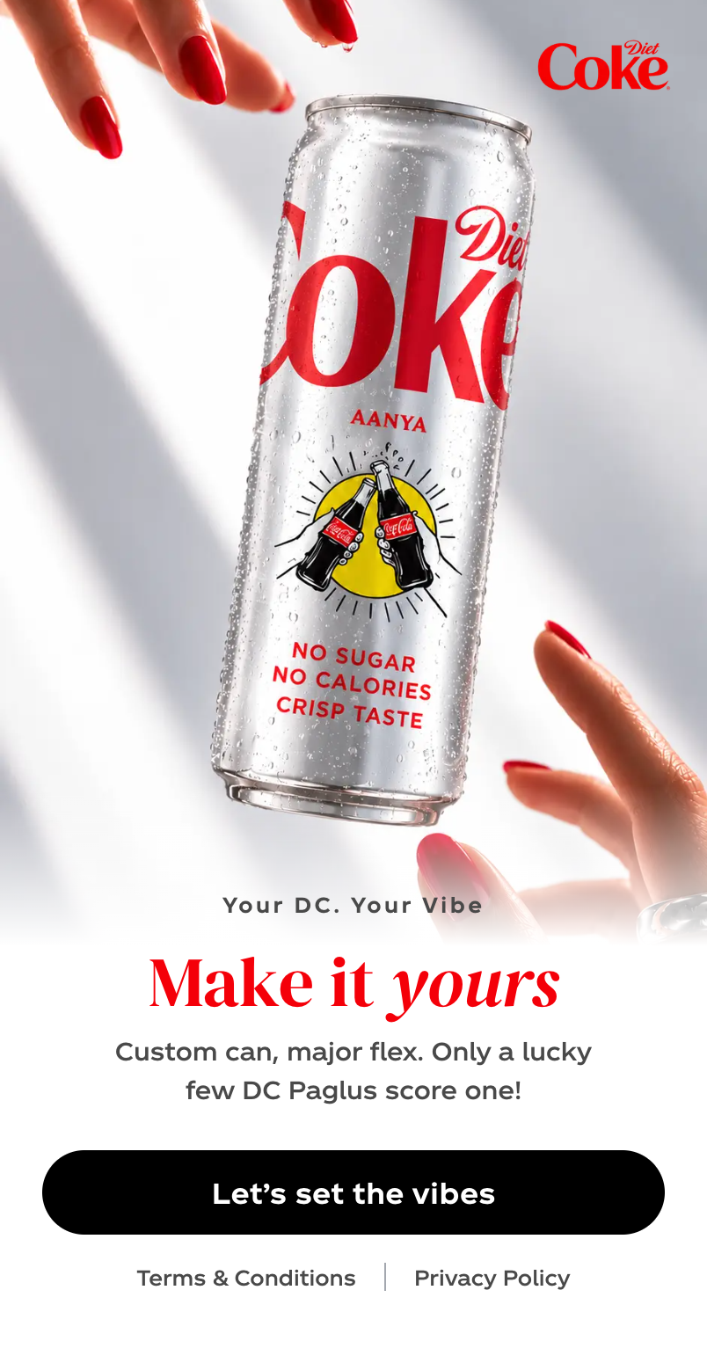  UT-01 Landing at /user-campaign | 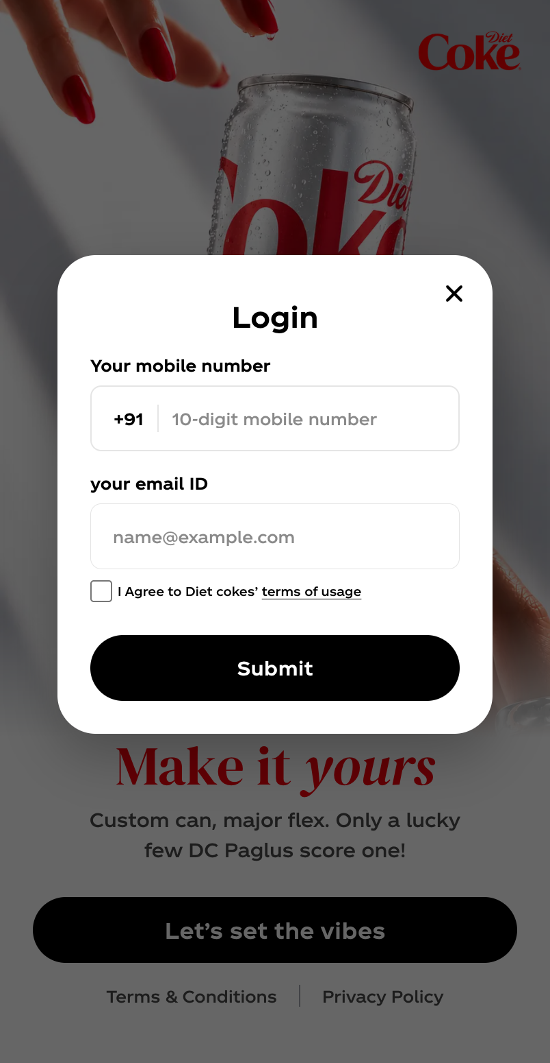  UT-02 Login dialog | 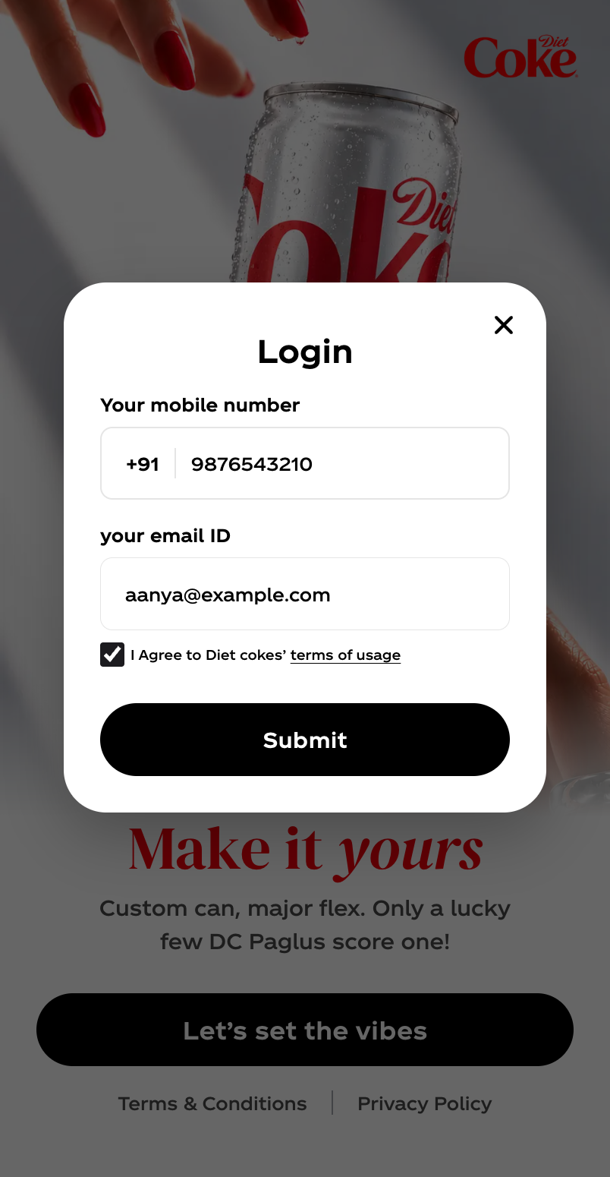  UT-03 Details filled, terms ticked
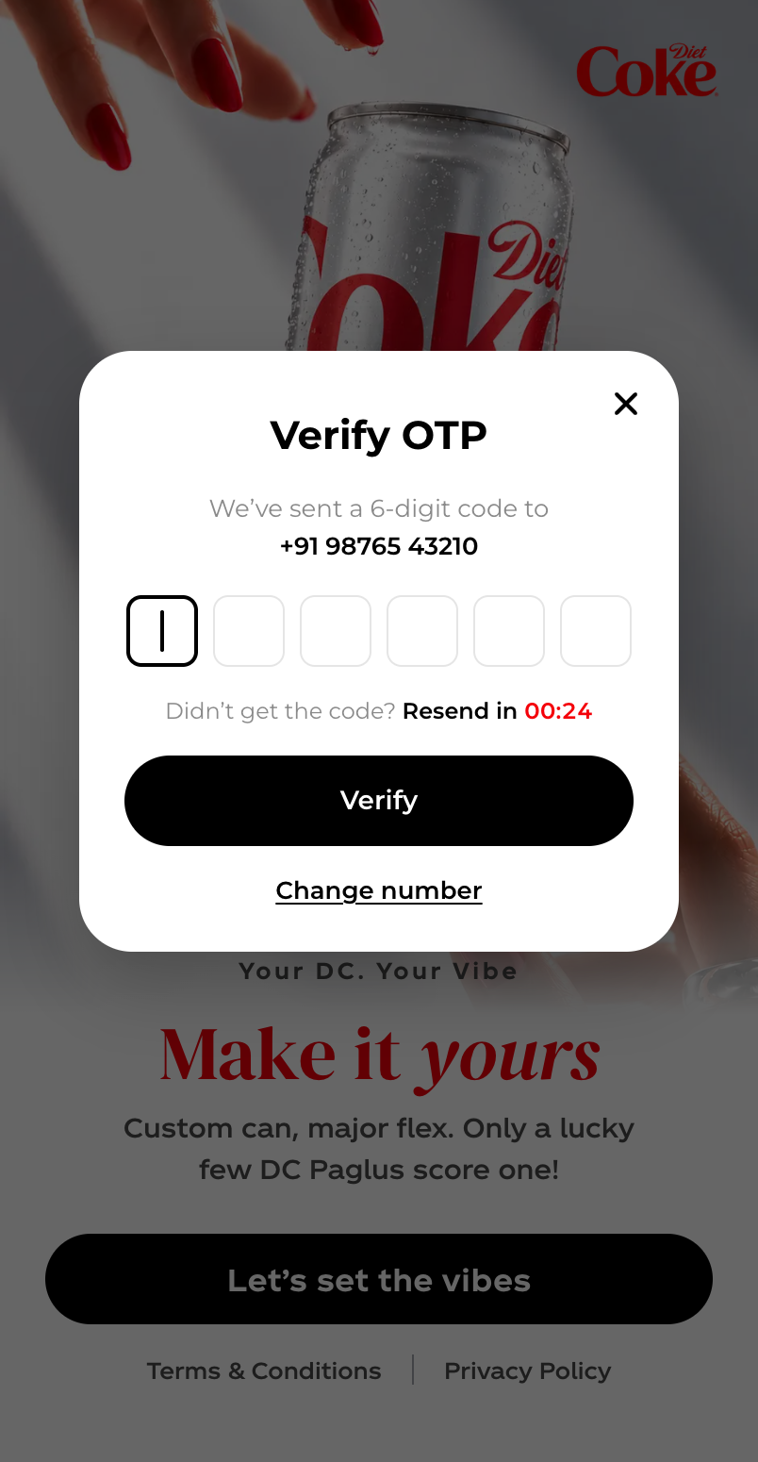  UT-04 OTP step | 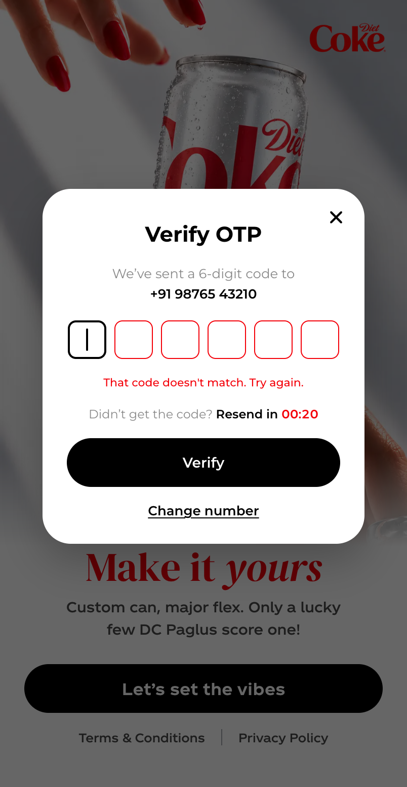  UT-05 Wrong code error | 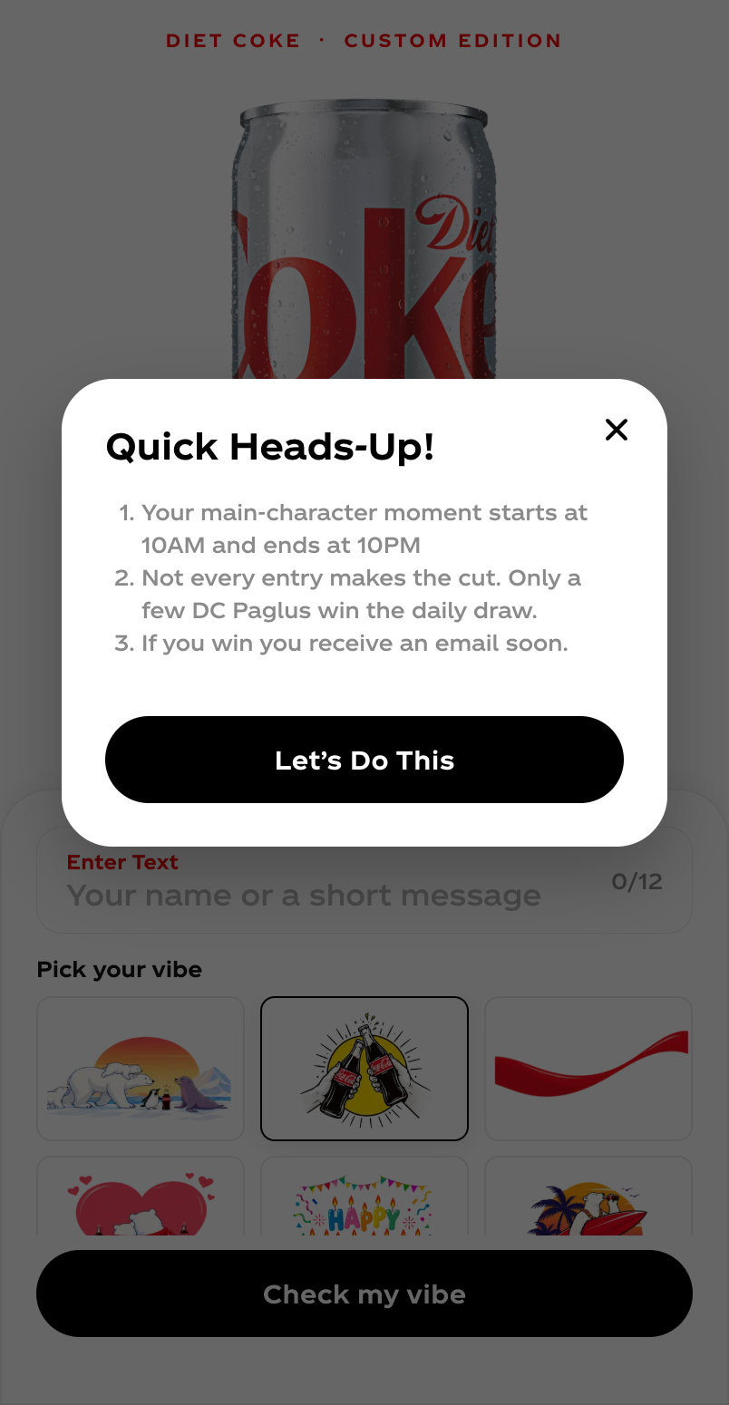  UT-06 After login: customiser

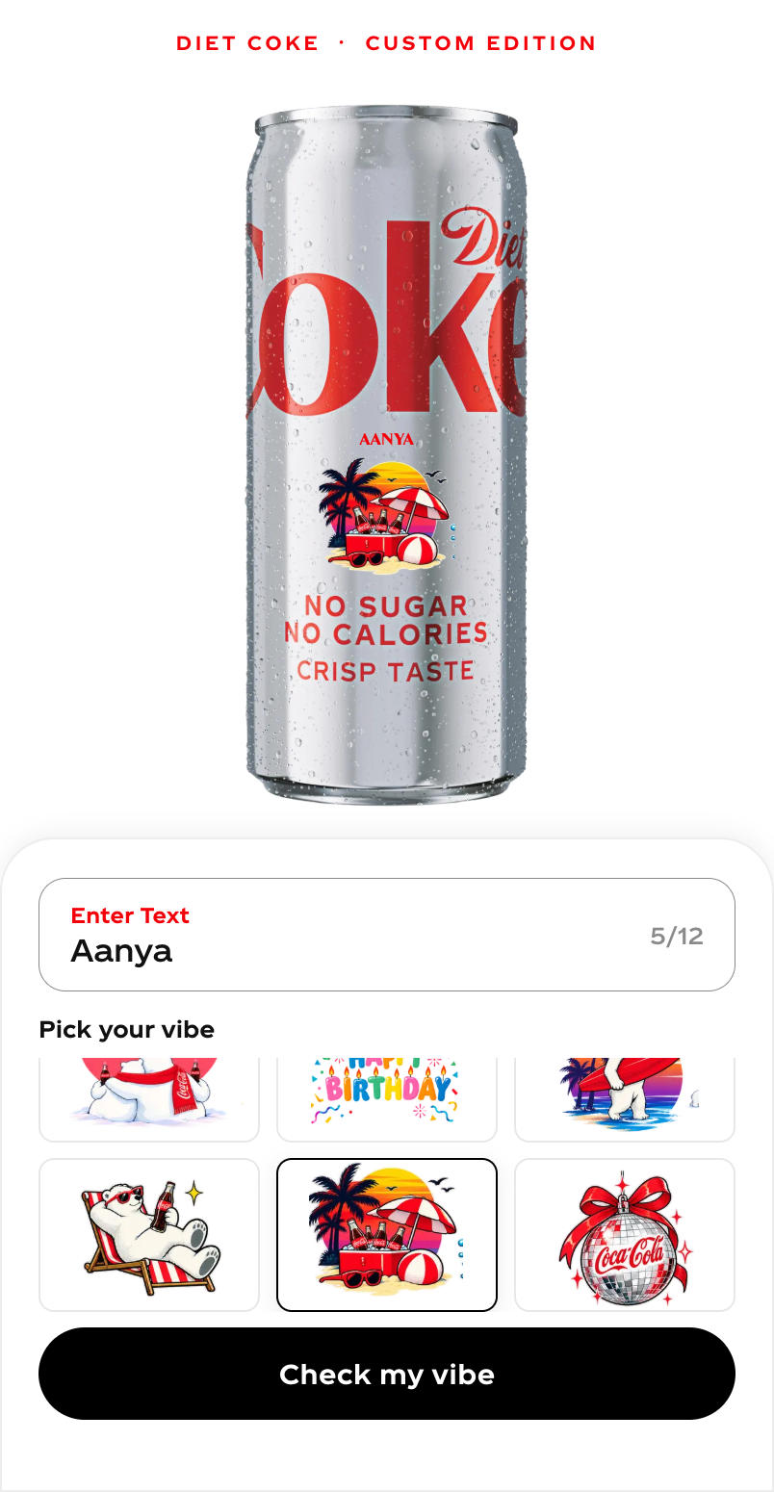  UT-07 Beach vibes + "Aanya" | 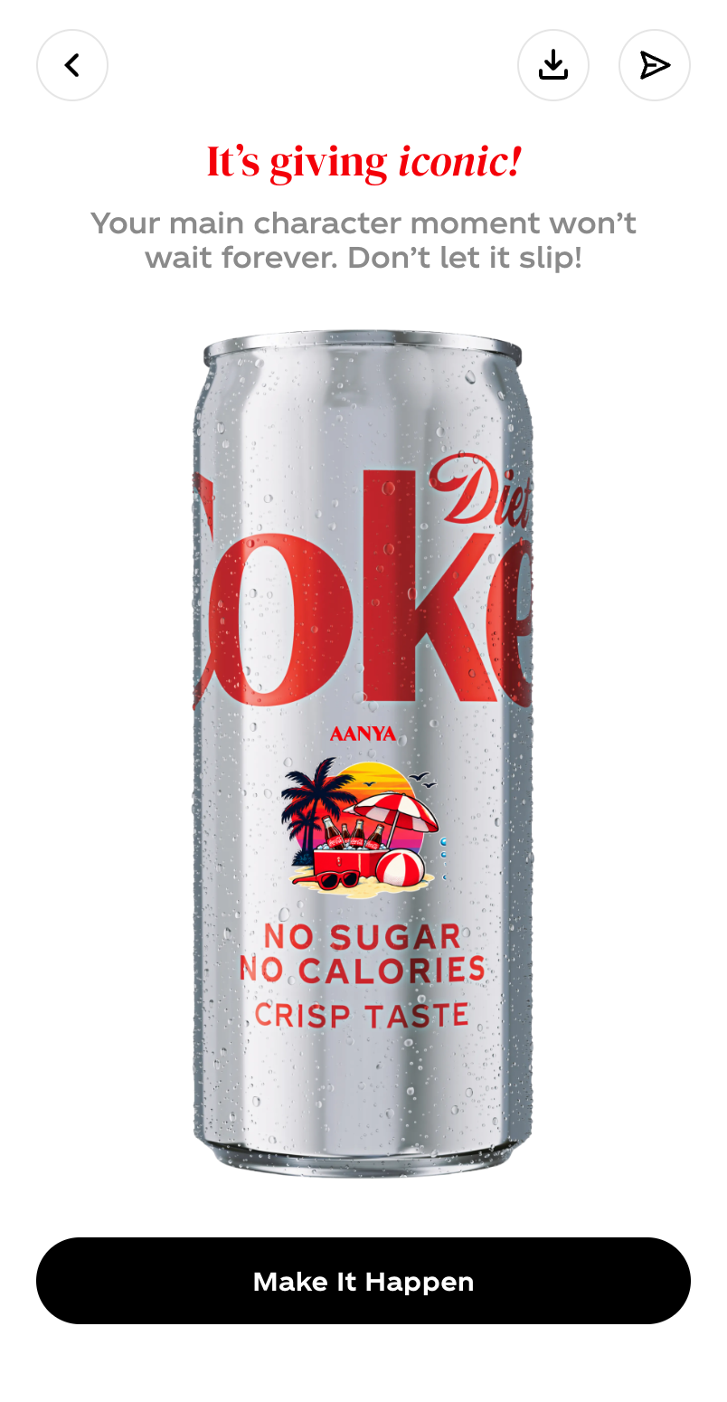  UT-08 Preview | 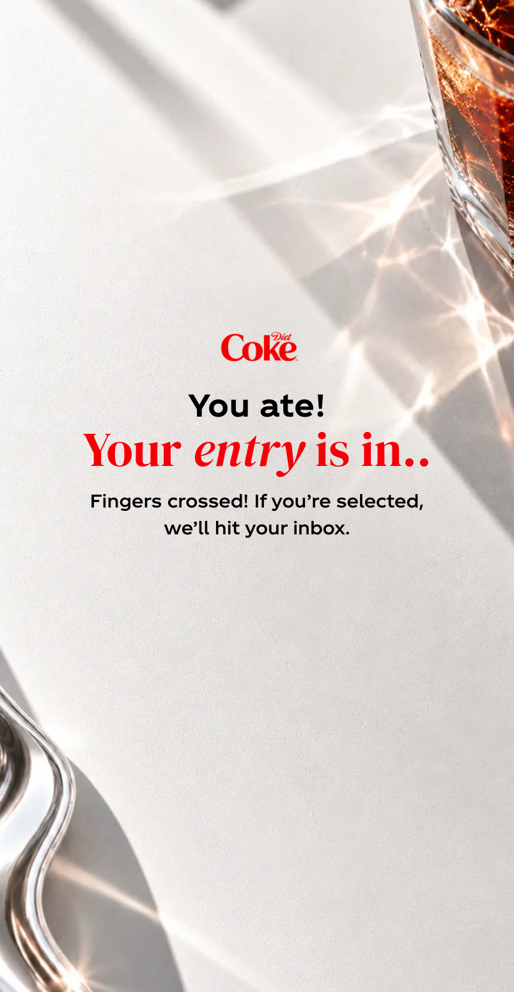  UT-09 Thank-you

4. Rate limiting and token checks (API, through the web proxy)
Run against the real stack with defaults: 5 OTP requests in 5 minutes, then a 2 hour block.
Scenario | Observed
Sends 1 to 5 for one phone within 5 minutes | 200 {resend_after:30} each
Send 6 and 7 | 429 OTP_BLOCKED, retry_after 7200, Retry-After: 7200
Verify with the right code while blocked | 429 OTP_BLOCKED
A different phone verifies at the same time | 200; unaffected by the block
100 concurrent sends for one phone | 5 x 200 and 95 x 429 (per-phone lock holds)
Session cookie from verify | dc_token, HttpOnly, path /offline-store/api/campaign

5. Automated suites
Suite | Size | Result | Note
API (pytest) | 300 tests | 298 pass, 2 fail | The 2 failures are in test_moderation.py (batch ordering with the fake Gemini). They fail identically on the branch without my changes.
Web (vitest) | 186 tests | 186 pass | Includes the new nav, proxy path-guard, error-code and rewrite-config tests.
Type check (tsc --noEmit) | web | clean
Production build (next build) | web | pass | Caught an invalid rewrite that the unit tests had passed; fixed.

Also covered by automated tests: OTP hashing and single use, expiry, replacement by a newer code, wrong-code lock, Infobip request shape (DLT template, 91 prefix, auth header), flag-off sends nothing, flag-on-but-unconfigured refuses, vendor failure maps to 503, token claims (aud, iss, jti, ver, iat, exp, sub), logout revocation, entry cap, configurable entry window and timezone, non-ASCII digits rejected, proxy path guard, no open redirect in navigation.

6. Not covered and known gaps
- Pixel-to-pixel match with Figma is not verified. The Figma MCP returned "no edit access" for this account; the access request is pending. The screenshots above are ready for the comparison.
- Real SMS through Infobip was not exercised (flag is off by design). It needs the Diet Coke DLT entity id, template id, sender id and approved text.
- Rejected-text and moderation-unavailable screens were not captured because moderation was off locally.
- The heads-up popup copy ("10AM and ends 10PM") is hard-coded in the web app, although the entry window itself is now a server setting. If the window is changed, that copy must be changed with it.
- The load balancer needs a path rule for /user-campaign/* to the web service. It could not be applied from here (GCP project access returned 403).
- Two tests in test_moderation.py already fail on the branch without these changes.

