An Internship Report
Of
Power BI Internship
Submitted
To
School of Computer Science and Engineering
IILM University, Greater Noida, U.P.
In partial fulfilment of the requirement of degree of
B.Tech (Computer Science and Engineering)

By
Roll Number of Student: 25SCS1003002209
Name of Student: PRASHANT PANDEY
Section: 2CSE2
Batch: 2025-2029

CANDIDATE'S DECLARATION
I, PRASHANT PANDEY, do hereby declare that the internship report titled "Power BI Internship" has been completed by me to fulfil the requirement for the award of the degree of Bachelor of Technology in Computer Science and Engineering. All the references have been quoted and I have not taken as such any material from any other source. I affirm that this report is my own and has not been submitted to any other institute for any degree/diploma requirement, and further I shall be solely responsible for any kind of copyright violation in this regard.

Signature:-
Student Name: PRASHANT PANDEY
Roll No.: 25SCS1003002209

ACKNOWLEDGEMENT
I am using this opportunity to express my gratitude to everyone who supported me throughout the Internship Program. I am thankful for their aspiring guidance, invaluably constructive criticism and friendly advice during this work. I am sincerely grateful to them for sharing their truthful and illuminating views on a number of issues related to this work.
I would like to thank the Cognifyz IT Solutions Pvt. Ltd. team for providing me the opportunity and the structured platform to learn and gain hands-on exposure in the domain of Power BI and data analysis. I am also thankful to my institute, IILM University, Greater Noida, and the faculty of the School of Computer Science and Engineering for their continuous support and encouragement.
I express my gratitude to my parents for their blessings.

Signature:-
Student Name: PRASHANT PANDEY
Roll No.: 25SCS1003002209

TABLE OF CONTENTS
1. Candidate's Declaration i
2. Acknowledgement ii
3. Internship Completion Certificate -
4. Project Description 1
4.1 Introduction 1
4.2 Organization Profile 2
4.3 Problem Statement 2
4.4 Project Objectives 3
4.5 Scope of the Project 3
4.6 Technologies and Tools Used 4
4.7 System Architecture 4
4.8 Methodology 5
4.9 Expected Outcomes 8
4.10 Certificates of Completion and Communication Proof 8
5. Bibliography/References 9

3. INTERNSHIP COMPLETION CERTIFICATE
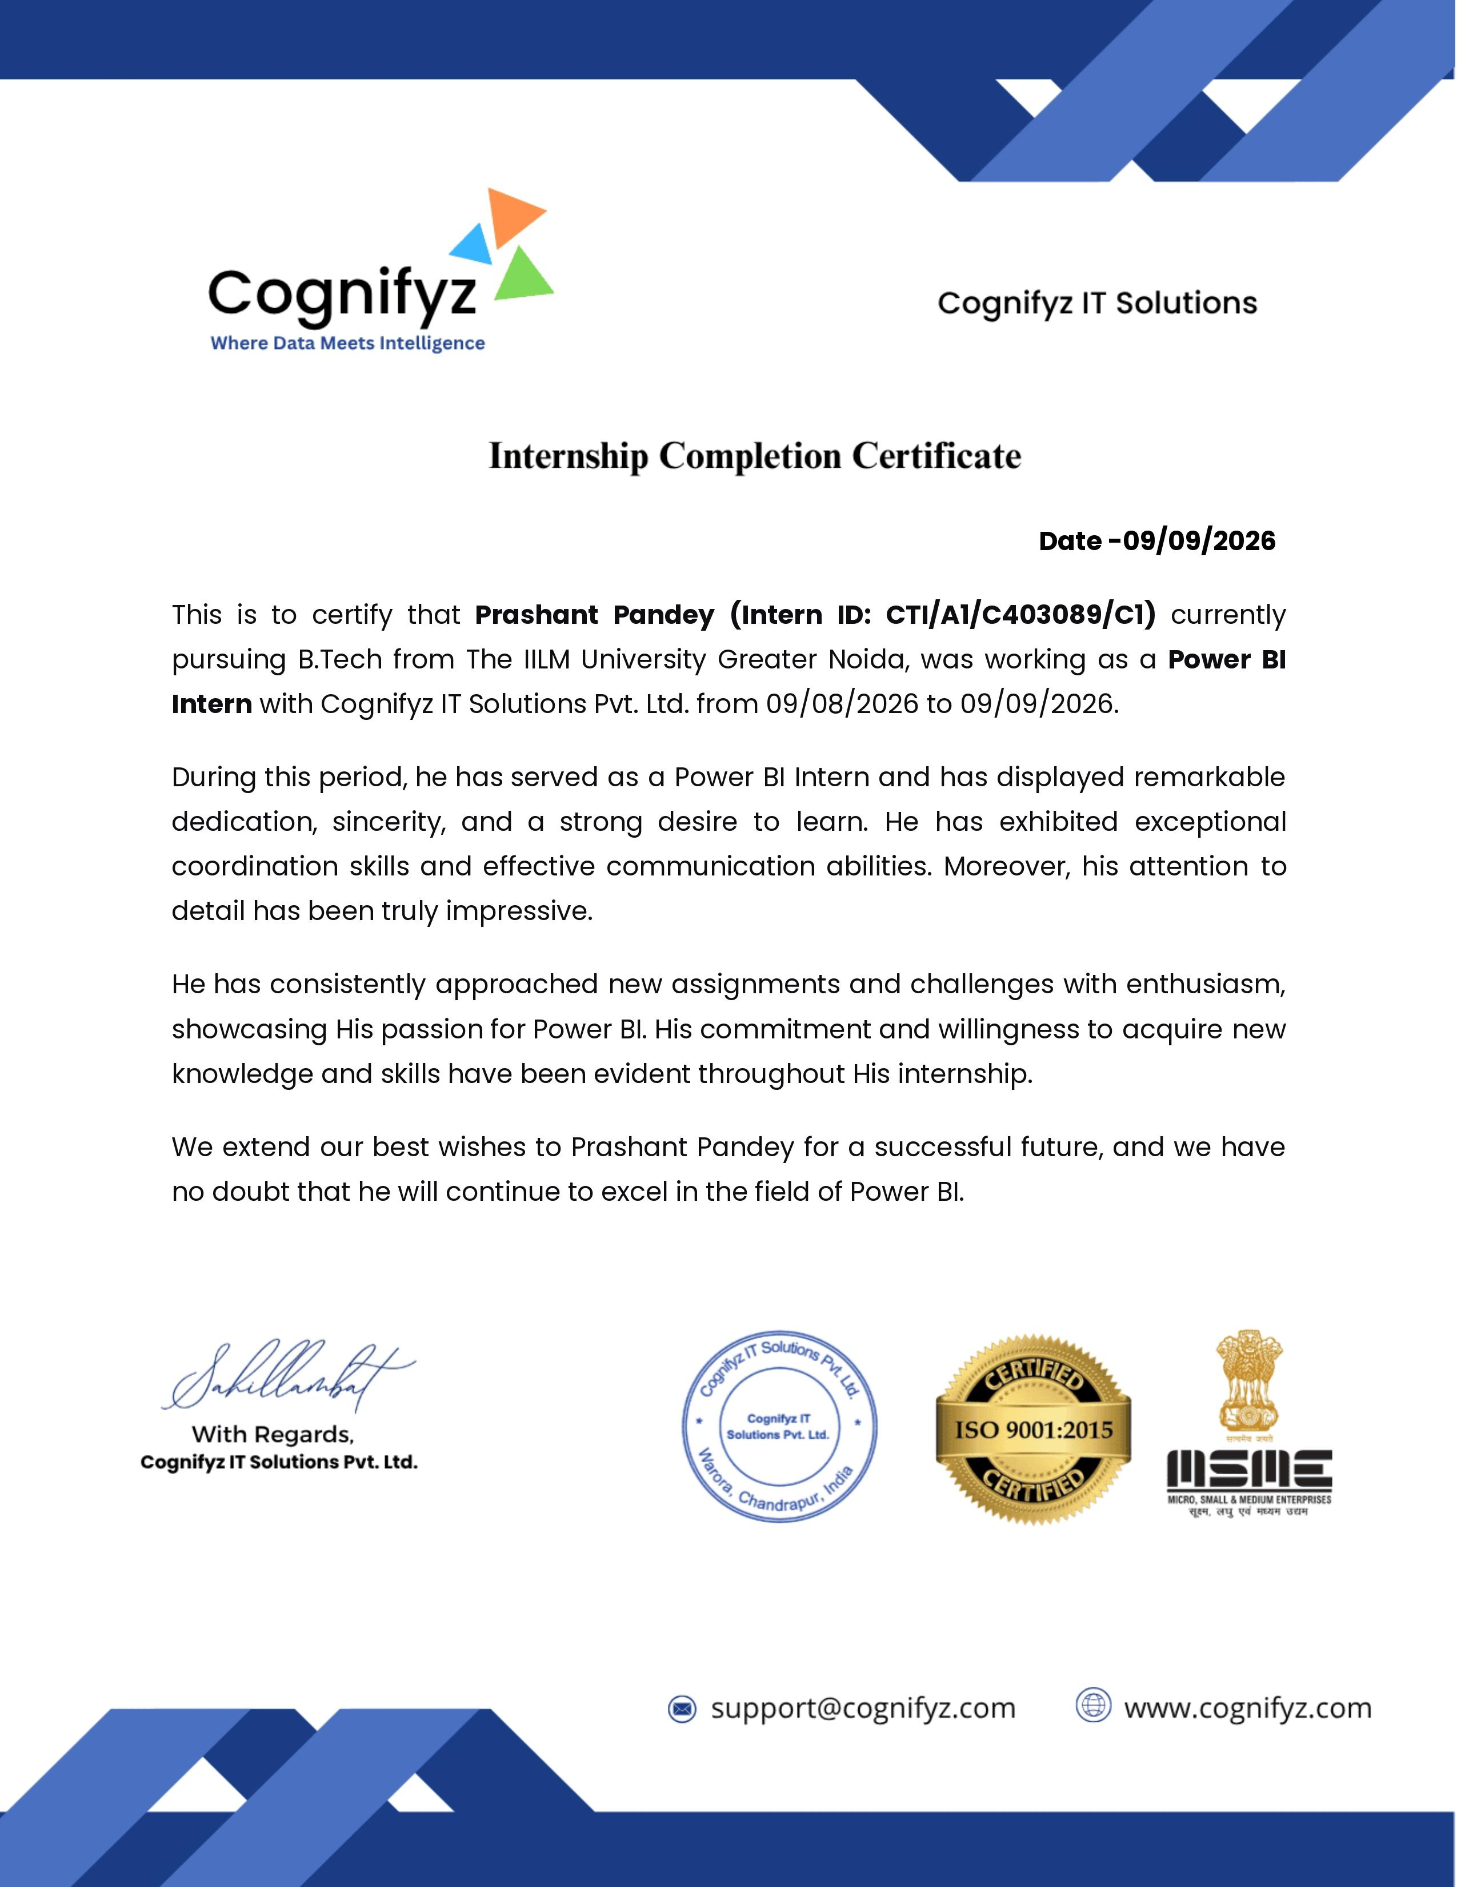

Internship Offer Letter
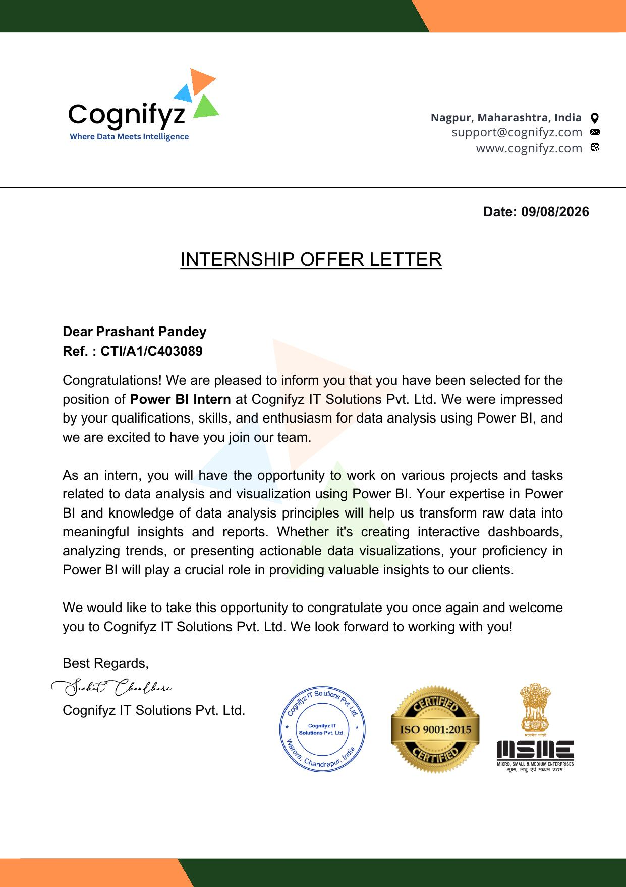

4. PROJECT DESCRIPTION
4.1 Introduction
This report presents a detailed account of the Power BI Internship undertaken at Cognifyz IT Solutions Pvt. Ltd. from 09 August 2026 to 09 September 2026, as part of the requirement of the Bachelor of Technology programme at IILM University, Greater Noida. The primary aim of this internship was to build a strong practical foundation in data analysis and business intelligence using Microsoft Power BI, and to apply it to a real dataset on individual investment behaviour.
The internship followed a structured, project-based approach combining dataset exploration, calculated statistics, visual analysis, and dashboard design. The seven assigned tasks were designed as a progressive learning path: the first task established the fundamentals of data import and summary statistics; the second and third introduced segmented and correlation-based analysis; the fourth and fifth examined behavioural and motivational patterns in the data; the sixth analyzed information-source patterns; and the seventh combined all preceding insights into one professional, interactive Power BI dashboard.
4.2 Organization Profile
Cognifyz IT Solutions Pvt. Ltd. (operating under the brand “Cognifyz — Where Data Meets Intelligence”) is a technology company focused on the field of data science. The organization offers products and services spanning artificial intelligence, machine learning, and data analytics, and also runs structured training and internship programs to help students build practical skills in these areas. The Power BI internship offered a project-oriented environment in which concepts of data import, transformation, statistical summarization, and interactive visualization could be applied to a real dataset, while also encouraging documentation and professional presentation of completed work.
4.3 Problem Statement
Although many engineering students are introduced to spreadsheets and basic charting during their academic coursework, comparatively few get sufficient exposure to a complete business-intelligence workflow using an industry-standard tool such as Power BI. Working with raw survey data requires careful inspection, cleaning, and structuring before reliable statistics can be calculated; deriving insights requires selecting the right chart types and comparison techniques; and communicating findings requires assembling individual visuals into one coherent, interactive dashboard. The problem addressed by this internship was to understand and practically implement this complete workflow through seven tasks covering data exploration, segmented analysis, correlation analysis, behavioural analysis, and dashboard consolidation.
4.4 Project Objectives
- To understand the complete Power BI workflow from raw data import to a finished interactive dashboard.
- To learn practical data exploration techniques for reviewing structure, data types, and key summary statistics.
- To use Power BI and DAX to calculate statistics such as averages, percentages, and category-wise breakdowns.
- To create meaningful, well-labelled visualizations for comparing categories and demographics.
- To perform correlation-style analysis between survey attributes (e.g., objectives and investment choices).
- To analyze behavioural patterns such as investment duration, monitoring frequency, and information sources.
- To design and assemble a single, interactive, professionally styled Power BI dashboard combining all findings.
- To document and present project findings in a structured and professional manner.
4.5 Scope of the Project
The scope of this internship covers the complete practical Power BI workflow — starting from importing and exploring a raw dataset, calculating summary statistics, and progressing through demographic and correlation-based analysis, behavioural analysis, and finally the design of a consolidated interactive dashboard. The internship includes seven task-based deliverables covering data exploration, gender-based analysis, objective analysis, investment duration and frequency, reasons for investment, source of information, and dashboard consolidation. The internship was conducted in a virtual, project-based environment and did not involve deployment on any live organizational production system.
4.6 Technologies and Tools Used
- Business Intelligence Tool: Microsoft Power BI Desktop
- Data Transformation: Power Query Editor
- Calculations: DAX (Data Analysis Expressions)
- Data Visualization: Power BI native visuals (bar, column, donut, matrix/heatmap, card visuals, slicers)
- Dashboard Design: Power BI report canvas, bookmarks and interactive filtering
- Documentation: Structured project/internship reporting
4.7 System Architecture
The general workflow followed during the internship for completing the Power BI project can be summarized in the following layers. The workflow was not limited to building charts; it also involved understanding the analytical objective, validating the quality of the data, selecting appropriate visuals, interpreting results, and documenting the final findings.
- Data Layer: The raw dataset is imported into Power BI and inspected to understand rows, columns, and data types.
- Transformation Layer: Power Query is used to clean, reshape, and structure the data before it enters the model.
- Modelling Layer: Fields are organized and, where needed, relationships and calculated columns are defined.
- Calculation Layer: DAX measures are written to compute statistics such as averages, percentages, and counts.
- Visualization Layer: Bar charts, donut charts, matrices, and card visuals are used to communicate findings.
- Interactivity Layer: Slicers and cross-filtering are added so users can explore the data from different angles.
- Insight Layer: Analytical findings are converted into structured conclusions and a final dashboard narrative.
4.8 Methodology
The internship followed a structured, task-based methodology combining dataset exploration, statistical calculation, comparative and correlation analysis, and dashboard design, as summarized in the table below.
Task | Module | Description
1 | Data Exploration and Summary | Import the dataset, explore its structure and data types, and calculate key summary statistics such as average age, investment percentages, and common savings objectives.
2 | Gender-based Analysis | Compare investment choices (equity, mutual funds, government bonds) across genders and derive insights on gender-based trends.
3 | Objective Analysis | Explore the relationship between savings objectives and investment avenues, and chart preferred investments for each objective.
4 | Investment Duration and Frequency | Visualize the distribution of investment durations and examine how monitoring frequency relates to investment preferences.
5 | Reasons for Investment | Identify common trends in stated reasons for investing and visualize the most frequently cited reasons.
6 | Source of Information | Visualize where individuals gather investment information and identify the most relied-upon sources.
7 | Combine Insights into a Dashboard | Design an intuitive, interactive Power BI dashboard incorporating all prior visualizations, and summarize key findings.

Note: There was no stipend associated with this internship.
Task 1 — Data Exploration and Summary
Data Import and Exploration
The task began with importing the raw investment-survey dataset into Power BI Desktop and reviewing its structure through the Power Query editor, including column names, data types, and overall data quality. Summary statistics — average respondent age, the percentage of respondents holding each investment type, and the most common savings objectives — were then calculated using DAX measures, and card and bar-chart visuals were built to present these statistics clearly.
This task focused on building familiarity with the dataset and establishing baseline statistics that informed every subsequent task.
Task 2 — Gender-based Analysis
Comparative Visualization
Investment avenues — equity, mutual funds, and government bonds — were segmented by gender using clustered bar charts, with slicers added to allow interactive filtering. The resulting visuals were reviewed to identify any consistent gender-based differences in investment preference.
This task reinforced how clustered charts and slicers can be combined to surface differences between subgroups within a dataset.
Task 3 — Objective Analysis
Correlation and Relationship Analysis
The relationship between stated savings objectives (such as capital appreciation) and investment avenues (such as equity) was explored using a matrix/heatmap visual, and stacked bar charts were built to show the dominant investment choice associated with each savings objective.
This task reinforced the use of matrix visuals to reveal which investment choices are most closely tied to particular financial objectives.
Task 4 — Investment Duration and Frequency
Distribution and Cross-tabulation
The distribution of preferred investment durations was visualized to understand whether respondents leaned toward short, medium, or long-term horizons, and monitoring frequency (daily, weekly, monthly) was cross-tabulated against investment-avenue preference to examine its impact.
This task showed how the frequency with which investors monitor their portfolios relates to the type of instruments they prefer.
Task 5 — Reasons for Investment
Trend Identification
Responses describing motivations for investing were grouped into standard categories, and a ranked bar chart was built to highlight the most frequently cited reasons, such as better returns and tax benefits.
This task translated categorical trend data into a clear, ranked visual of investor motivations.
Task 6 — Source of Information
Source Analysis
The sources from which individuals gather investment information — such as newspapers, the internet, and financial consultants — were visualized using a donut/bar chart, and the most commonly relied-upon sources were identified.
This task reinforced the use of simple proportion-based charts to summarize categorical preference data.
Task 7 — Combine Insights into a Dashboard
Dashboard Design and Integration
All visuals produced in Tasks 1 through 6 were brought together onto a single, intuitively laid-out Power BI report page. Slicers for gender, age group, and investment duration were added for interactivity, and consistent theming, titles, and tooltips were applied for a polished, professional appearance.
This final task combined every prior analysis into one interactive dashboard that allows a viewer to explore investment behaviour from multiple angles simultaneously.
4.9 Expected Outcomes
- Ability to independently import, explore, and summarize a raw dataset in Power BI.
- Practical understanding of DAX-based calculation of averages, percentages, and category breakdowns.
- Hands-on experience designing comparative and correlation-style visualizations.
- Ability to analyze behavioural patterns such as duration, frequency, and information-source preferences.
- Practical understanding of assembling multiple analyses into one coherent, interactive dashboard.
- Improved analytical thinking, data storytelling, and technical documentation skills.
4.10 Certificates of Completion and Communication Proof
The Internship Offer Letter and the Internship Completion Certificate issued by Cognifyz IT Solutions Pvt. Ltd., confirming the Power BI internship undertaken by Prashant Pandey from 09 August 2026 to 09 September 2026, are attached in Section 3 of this report.

5. BIBLIOGRAPHY/REFERENCES
1. Cognifyz IT Solutions Pvt. Ltd., “Offer Letter for Internship in Power BI,” Ref.: CTI/A1/C403089, 2026.
2. Cognifyz IT Solutions Pvt. Ltd., “Internship Completion Certificate — Power BI Internship,” Intern ID: CTI/A1/C403089/C1, 2026.
3. Microsoft, “Power BI Documentation,” Microsoft Learn, https://learn.microsoft.com/power-bi/
4. Microsoft, “DAX Reference,” Microsoft Learn, https://learn.microsoft.com/dax/
5. Microsoft, “Power Query M Reference,” Microsoft Learn.
6. Marco Russo and Alberto Ferrari, “The Definitive Guide to DAX,” Microsoft Press.
7. Brett Powell, “Mastering Microsoft Power BI,” Packt Publishing.
8. Cognifyz Technologies, “Internship Program — Power BI Task List,” 2026.

