CA1-CAP777
Name: Prashant Patil
Roll no: 24
Group: 1
Reg no: 12527088
Q1. create calculator define method add(), subtract(), multiply(), devide() take twonumber from user and call all Methode
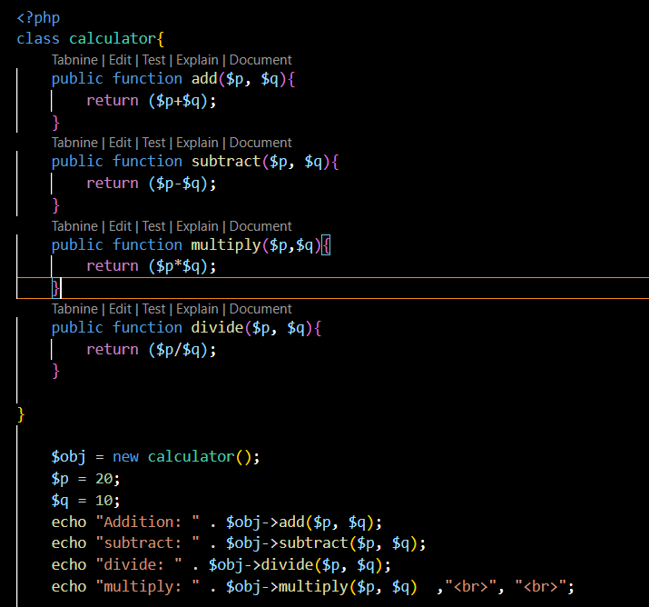
Q2. take string count no of words, no of characters, number of vowels, reverse string
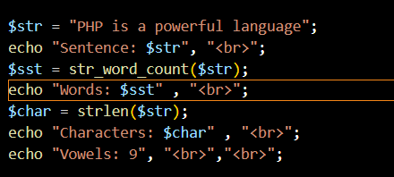
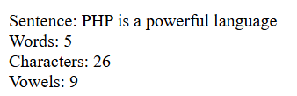

Q3. associate array of 5 students with their marks and print the name of student who got highest marks and descending order on their marks
