# Create Databases and Tables / Insert sufficient Data

## CREATING Student Table

CREATE TABLE `Student` (

`student_id` VARCHAR(10),

`student_name` VARCHAR(30) NOT NULL,

`class_id` VARCHAR(10) NOT NULL,

`roll_no` INT NOT NULL,

`DOB` DATE NOT NULL,

`gender` VARCHAR(20) NOT NULL,

PRIMARY KEY (`student_id`)

);

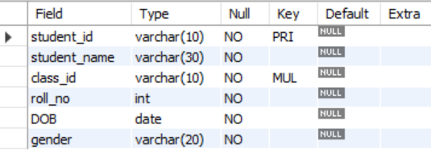

INSERT INTO `Student` VALUES

('NP01', 'Prashant Phuyal', 'LT01', '10', '2001-01-16', 'MALE'),

('NP02', 'Razz BC', 'LT01', '11', '2001-02-11', 'MALE'),

('NP03', 'Aayush Shrestha', 'LT01', '12', '2001-02-19', 'MALE'),

('NP04', 'Rachana Subedi', 'LT02', '09', '2001-05-16', 'FEMALE'),

('NP05', 'Aavinab Shah', 'LT02', '14', '2001-07-11', 'MALE'),

('NP06', 'Shruti Kc', 'LT02', '16', '2000-09-11', 'FEMALE'),

('NP07', 'Sam Gautam', 'LT03', '01', '2002-01-03', 'MALE'),

('NP08', 'Jeevan Risal', 'LT03', '05', '2001-07-04', 'MALE'),

('NP09', 'Kareena Shrestha', 'LT04', '07', '2000-01-11', 'FEMALE'),

('NP10', 'Babi Acharya', 'LT04', '05', '2001-07-04', 'FEMALE');

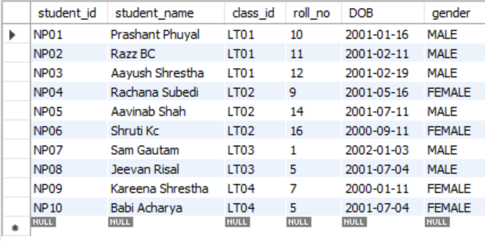

CREATE TABLE `Parent` (

`parent_name` VARCHAR(30) NOT NULL,

`student_id` VARCHAR(10) NOT NULL,

`phone_number` BIGINT NOT NULL,

`parent_address` VARCHAR(40) NOT NULL,

FOREIGN KEY (`student_id`) REFERENCES Student(`student_id`)

);

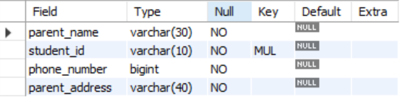

INSERT INTO `Parent` VALUES

('Chandra', 'NP01', '9814365499', 'Itahari-9, Sunsari'),

('Calvin', 'NP02', '9814262492', 'Dharan-17, Sunsari'),

('Jonathan', 'NP03', '9826245349', 'Biratnagar-1, Morang'),

('Tristan', 'NP04', '9812412124', 'Biratnagar-2, Morang'),

('Bran', 'NP05', '9868758782', 'Itahari-1, Sunsari'),

('Eden', 'NP06', '9826245349', 'Itahari-9, Sunsari'),

('Jonathan', 'NP07', '9826765745', 'dharan-9, Sunsari'),

('Abdul', 'NP08', '9826765712', 'Itahari-9, Sunsari'),

('Adam', 'NP09', '9826765713', 'dharan-2, Sunsari'),

('Bran', 'NP10', '9826765715', 'Khorsane-1, Morang');

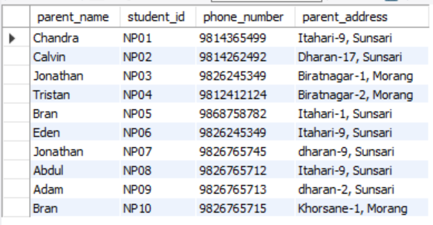

CREATE TABLE `Courses` (

`course_id` VARCHAR(10),

`course_name` VARCHAR(20) NOT NULL,

PRIMARY KEY (`course_id`)

);

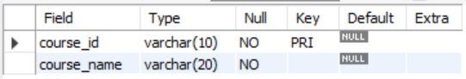

INSERT INTO `Courses` VALUES

('S10', 'Arts and Humanity'),

('S11', 'Computer Science'),

('S12', 'IT'),

('S13', 'Business');

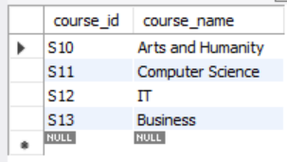

CREATE TABLE `student_course` (

`course_id` VARCHAR(10) NOT NULL,

`student_id` VARCHAR(10) NOT NULL,

FOREIGN KEY (`course_id`) REFERENCES Courses(`course_id`),

FOREIGN KEY (`student_id`) REFERENCES Student(`student_id`)

);

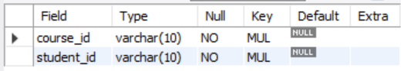

INSERT INTO `student_course` VALUES

('S10','NP01'), ('S10','NP02'), ('S10','NP03'),

('S11','NP04'), ('S11','NP05'), ('S11','NP06'),

('S12','NP07'), ('S12','NP08'), ('S13','NP09'), ('S13','NP10');

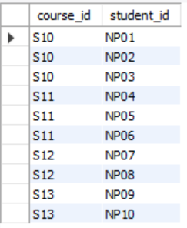

CREATE TABLE `Class` (

`class_id` VARCHAR(10),

`class_name` VARCHAR(20) NOT NULL,

PRIMARY KEY (`class_id`)

);

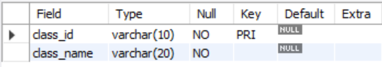

INSERT INTO `class` VALUES

('LT01','Lecture Theatre 1'),

('LT02','Lecture Theatre 2'),

('LT03','Lecture Theatre 3'),

('LT04','Lecture Theatre 4');

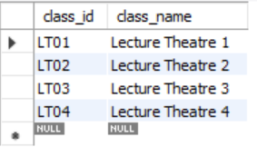

CREATE TABLE `Subject` (

`subject_id` VARCHAR(10),

`subject_name` VARCHAR(20) NOT NULL,

`class_id` VARCHAR(10) NOT NULL,

`course_id` VARCHAR(10) NOT NULL,

PRIMARY KEY (`subject_id`),

FOREIGN KEY (`class_id`) REFERENCES Class(`class_id`),

FOREIGN KEY (`course_id`) REFERENCES Courses(`course_id`)

);

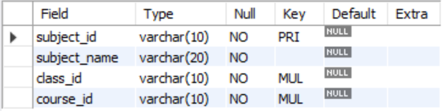

INSERT INTO `Subject` VALUES

('E01', 'History', 'LT01','S10'),

('E02', 'Music and Art','LT01','S10'),

('E03', 'Philosophy', 'LT01','S10'),

('F01', 'Algorithms', 'LT02','S11'),

('F02', 'Software Development', 'LT02','S11'),

('F03', 'Computer Security', 'LT02','S11'),

('F04', 'Design and Product', 'LT02','S11'),

('H10', 'Networking', 'LT03','S12'),

('H11', 'Cloud Computing', 'LT03','S12'),

('H12', 'Data Management', 'LT03','S12'),

('H13', 'Security', 'LT03','S12'),

('T10', 'Finance', 'LT04','S13'),

('T11', 'Marketing', 'LT04','S13'),

('T12', 'Entrepreneurship', 'LT04','S13');

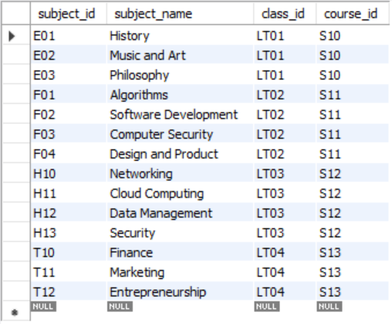

CREATE TABLE `PeriodHour` (

`subject_id` VARCHAR(10) NOT NULL,

`time_period` FLOAT NOT NULL,

FOREIGN KEY (`subject_id`) REFERENCES Subject(`subject_id`)

);

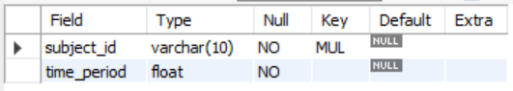

INSERT INTO `PeriodHour` VALUES

('E01', '1'), ('E02', '1.5'), ('E03','1.5'), ('F01', '1'), ('F02', '1.5'),

('F03', '2'), ('F04', '2'), ('H10', '1.5'), ('H11', '2'), ('H12', '2'),

('H13', '2'), ('T10', '1.5'), ('T11','1.5'), ('T12', '2');

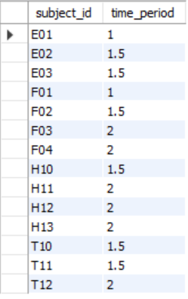

CREATE TABLE `Eximination` (

`exam_id` VARCHAR(10),

`exam_date` DATE NOT NULL,

PRIMARY KEY (`exam_id`)

);

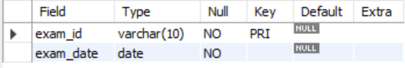

INSERT INTO `Eximination` VALUES

('EX19E01','2019-05-09'), ('EX19E02','2019-05-11'),

('EX19E03','2019-05-13'), ('EX19F01','2019-05-09'),

('EX19F02','2019-05-10'), ('EX19F03','2019-05-12'),

('EX19F04','2019-05-14'), ('EX19H10','2019-05-09'),

('EX19H11','2019-05-10'), ('EX19H12','2019-05-12'),

('EX19H13','2019-05-13');

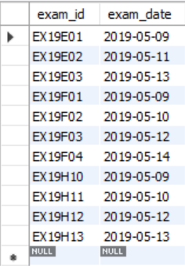

CREATE TABLE `exam_subject` (

`subject_id` VARCHAR(10) NOT NULL,

`exam_id` VARCHAR(10) NOT NULL,

FOREIGN KEY (`subject_id`) REFERENCES Subject(`subject_id`),

FOREIGN KEY (`exam_id`) REFERENCES Eximination(`exam_id`)

);

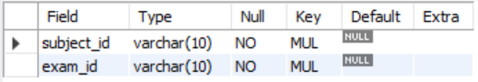

INSERT INTO `exam_subject` VALUES

('E01','EX19E01'), ('E02','EX19E02'), ('E03','EX19E03'),

('F01','EX19F01'), ('F02','EX19F02'), ('F03','EX19F03'), ('F04','EX19F04'),

('H10','EX19H10'), ('H11','EX19H11'), ('H12','EX19H12'), ('H13','EX19H13');

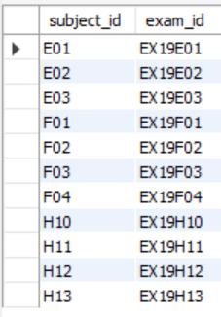

CREATE TABLE `Attendance` (

`student_id` VARCHAR(10) NOT NULL,

`total_class` INT NOT NULL,

`present_days` INT NOT NULL,

FOREIGN KEY (`student_id`) REFERENCES Student(`student_id`)

);

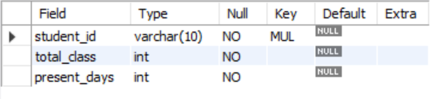

INSERT INTO `Attendance` VALUES

('NP01', '182', '140'), ('NP02', '182','150'), ('NP03', '182','162'),

('NP04', '190','178'), ('NP05', '190','177'), ('NP06', '190','181'),

('NP07', '185','178'), ('NP08', '185','181'),

('NP09', '192','187'), ('NP10', '192','178');

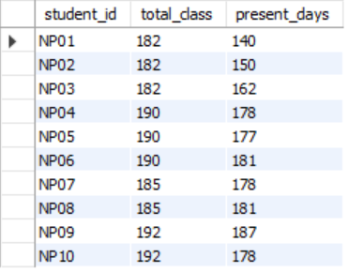

CREATE TABLE `Marks` (

`student_id` VARCHAR(10) NOT NULL,

`subject_id` VARCHAR(10) NOT NULL,

`sub_marks` INT NOT NULL,

FOREIGN KEY (`student_id`) REFERENCES Student(`student_id`),

FOREIGN KEY (`subject_id`) REFERENCES Subject(`subject_id`)

);

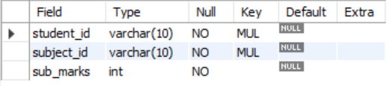

INSERT INTO `Marks` VALUES

('NP01','E01','60'), ('NP01','E02','65'), ('NP01','E03','75'),

('NP02','E01','63'), ('NP02','E02','55'), ('NP02','E03','61'),

('NP03','E01','70'), ('NP03','E02','61'), ('NP03','E03','65'),

('NP04','F01','60'), ('NP04','F02','65'), ('NP04','F03','57'), ('NP04','F04','70'),

('NP05','F01','61'), ('NP05','F02','67'), ('NP05','F03','75'), ('NP05','F04','75'),

('NP06','F01','64'), ('NP06','F02','64'), ('NP06','F03','78'), ('NP06','F04','42'),

('NP07','H10','61'), ('NP07','H11','67'), ('NP07','H12','75'), ('NP07','H13','75'),

('NP08','H10','64'), ('NP08','H11','64'), ('NP08','H12','78'), ('NP08','H13','42'),

('NP09','T10','61'), ('NP09','T11','67'), ('NP09','T12','75'),

('NP10','T10','64'), ('NP10','T11','64'), ('NP10','T12','78');

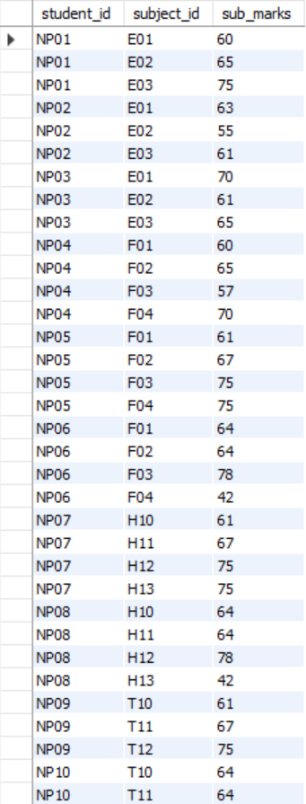

CREATE TABLE `Staff` (

`staff_id` VARCHAR(10),

`staff_name` VARCHAR(30) NOT NULL,

`work_role` VARCHAR(40) NOT NULL,

`staff_phone` BIGINT NOT NULL,

`department_id` VARCHAR(10) NOT NULL,

PRIMARY KEY (`staff_id`),

FOREIGN KEY (`department_id`) REFERENCES Department(`department_id`)

);

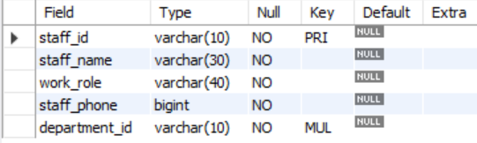

INSERT INTO `Staff` VALUES

('SF01','Romany Firth','Accountant','9865432411','SS00'),

('SF02','Anna Lowe', 'Accountant Assistance','9862353212','SS00'),

('SF03','Rosa Byrne','Librarian','9823423231','SS00'),

('SF04','Bilal Howells','Librarian','9823456321','SS00'),

('SF05','Mischa Friedman','Maintanance','9823453435','SS00'),

('SF06','Robert Betts','Cleaner','9842432412','SS00'),

('SF07','Fardeen Pittman','BodyGaurd','9842325256','SS00');

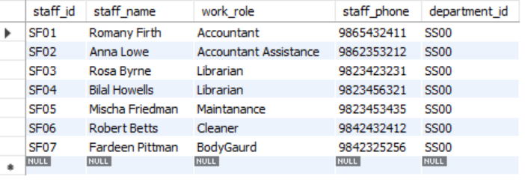

CREATE TABLE `Teacher` (

`teacher_id` INT,

`teacher_name` VARCHAR(30) NOT NULL,

`teacher_address` VARCHAR(40) NOT NULL,

`department_id` VARCHAR(10) NOT NULL,

PRIMARY KEY (`teacher_id`),

FOREIGN KEY (`department_id`) REFERENCES Department(`department_id`)

);

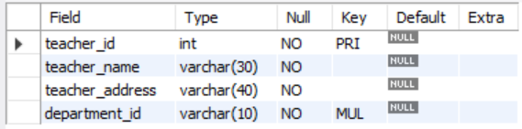

INSERT INTO `Teacher` VALUES

('100','Arun Knott','Pokhara','TS10'),

('102',' Sufyan Wilder', 'Hetauda', 'TS10'),

('104',' Marta Rangel','Biratnagar','TS11'),

('105',' Malcolm Lucas', 'Itahari', 'TS11'),

('106',' Roscoe Ochoa','Biratnagar','TS12'),

('108',' Nawal Whittaker', 'Dharan', 'TS12'),

('110', 'Mila House', 'Rara', 'TS12'),

('109',' Roscoe Ochoa','Biratnagar','TS13'),

('111','Haidar Townsend', 'Kakarvitta', 'TS13');

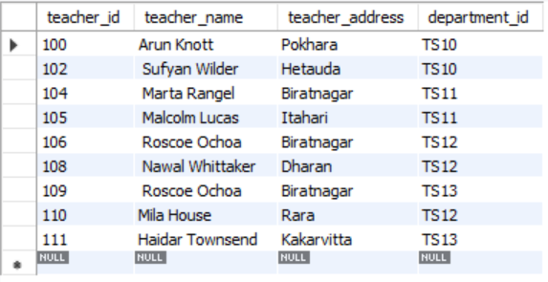

CREATE TABLE `teacher_teaches` (

`teacher_id` INT NOT NULL,

`subject_id` VARCHAR(10) NOT NULL,

FOREIGN KEY (`teacher_id`) REFERENCES Teacher(`teacher_id`),

FOREIGN KEY (`subject_id`) REFERENCES Subject(`subject_id`)

);

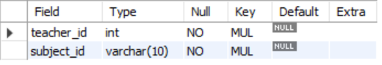

INSERT INTO `teacher_teaches` VALUES

('100','E01'), ('100','E03'), ('102','E02'), ('102','E01'),

('104','F01'), ('104','F04'), ('105','F02'), ('105','F03'),

('106','H10'), ('108','H11'), ('110','H12'), ('110','H13'),

('109','T10'), ('111','T11'), ('111','T12');

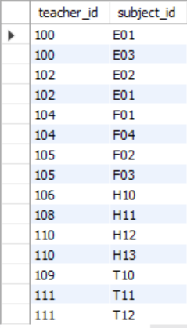

CREATE TABLE `Department` (

`department_id` VARCHAR(10),

`department_name` VARCHAR(50) NOT NULL,

PRIMARY KEY (`department_id`)

);

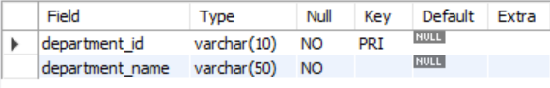

INSERT INTO `Department` VALUES

('TS10','Arts and Humanity Department'),

('TS11','Computer Science Department'),

('TS12','Information Technology Department'),

('TS13','Business Department'),

('SS00','Staff Department');

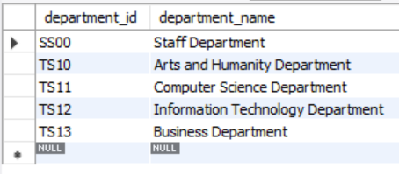

CREATE TABLE `School` (

`school_name` VARCHAR(60) NOT NULL,

`school_address` VARCHAR(60) NOT NULL,

`CST No.` BIGINT NOT NULL

);

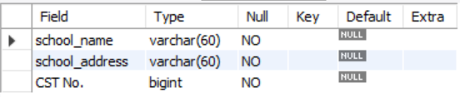

INSERT INTO `School` VALUES

('Riverdale Middle School', 'Bp-chowk Itahari-8, Sunsari', '31526816182');



CREATE TABLE `Library` (

`library_id` INT,

`library_name` VARCHAR(40) NOT NULL,

PRIMARY KEY (`library_id`)

);

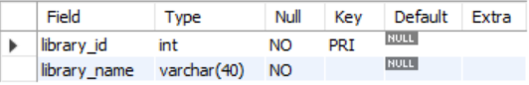

INSERT INTO `Library` VALUES

('746782','Library of Riverdale');



CREATE TABLE `Books` (

`book_id` INT AUTO_INCREMENT,

`book_name` VARCHAR(40) NOT NULL,

`writer` VARCHAR(30) NOT NULL,

PRIMARY KEY (`book_id`)

);

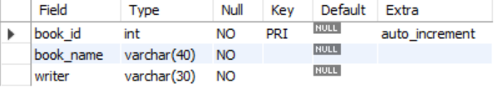

INSERT INTO `Books` VALUES

('1000', 'To Kill a Mockingbird', 'Harper Lee'),

('1001', '1984', 'George Orwell'),

('1002', 'Harry Potter and the Philosopher\'s Stone', 'J.K. Rowling'),

('1003', 'the Lord of the Rings', 'J.R.R'),

('1004', 'the Great Gatsby', 'F. Scott Fitzgerald'),

('1005', 'Pride and Prejudice', 'Jane Austen'),

('1006', 'the Diary of a Young Girl', 'Markus Zusak'),

('1007', 'the Book Thief', 'George Orwell'),

('1008', 'the hobbit', 'J.R.R Tolkien'),

('1009', 'Little Women', 'Louisa May Alcott');



CREATE TABLE `Members` (

`member_id` VARCHAR(10),

`student_id` VARCHAR(10) NOT NULL,

PRIMARY KEY (`member_id`),

FOREIGN KEY (`student_id`) REFERENCES Student(`student_id`)

);

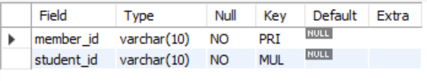

INSERT INTO `Members` VALUES

('LRBNP01','NP01'), ('LRBNP02','NP02'), ('LRBNP03','NP03'), ('LRBNP04','NP04'),

('LRBNP05','NP05'), ('LRBNP06','NP06'), ('LRBNP07','NP07'), ('LRBNP08','NP08'),

('LRBNP09','NP09'), ('LRBNP10','NP10');

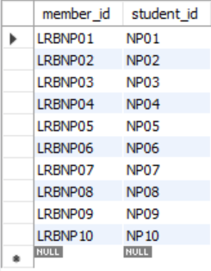

CREATE TABLE `issued_books` (

`member_id` VARCHAR(10) NOT NULL,

`book_id` INT,

FOREIGN KEY (`member_id`) REFERENCES Members(`member_id`),

FOREIGN KEY (`book_id`) REFERENCES Books(`book_id`)

);

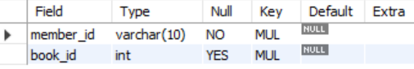

INSERT INTO `issued_books` VALUES

('LRBNP01','1000'), ('LRBNP01','1007'), ('LRBNP05','1002'),

('LRBNP03','1009'), ('LRBNP10','1003'), ('LRBNP04','1006'),

('LRBNP03','1005');

