**Assignment – 1**

• Install Power BI Desktop and share the final screenshot of the report view page which appears when power desktop starts.

Report View-

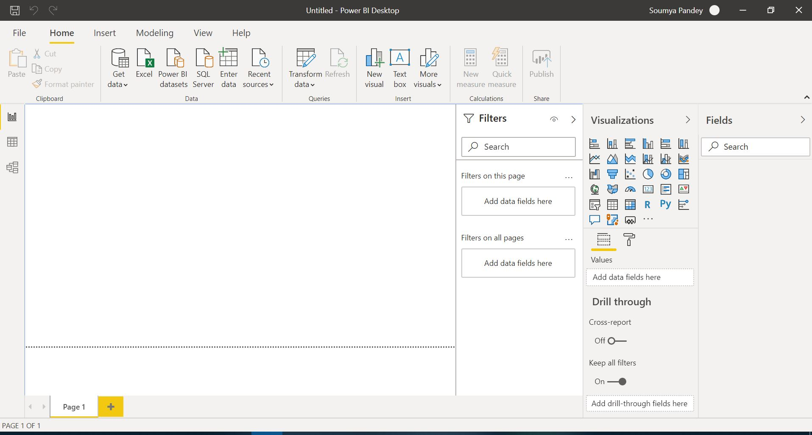

• Prepare a document and with the following screenshot − Report View − Data View − Model View − Power Query Editor − Advance Editor.

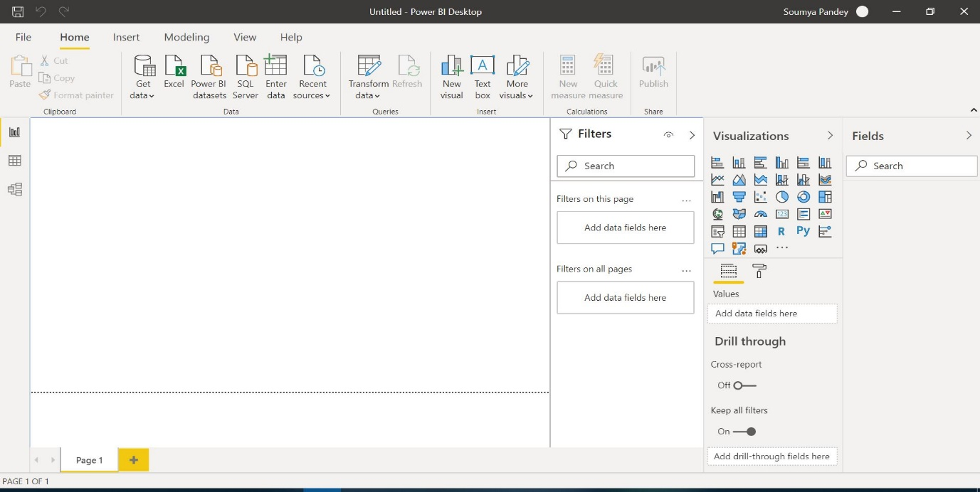Report View-

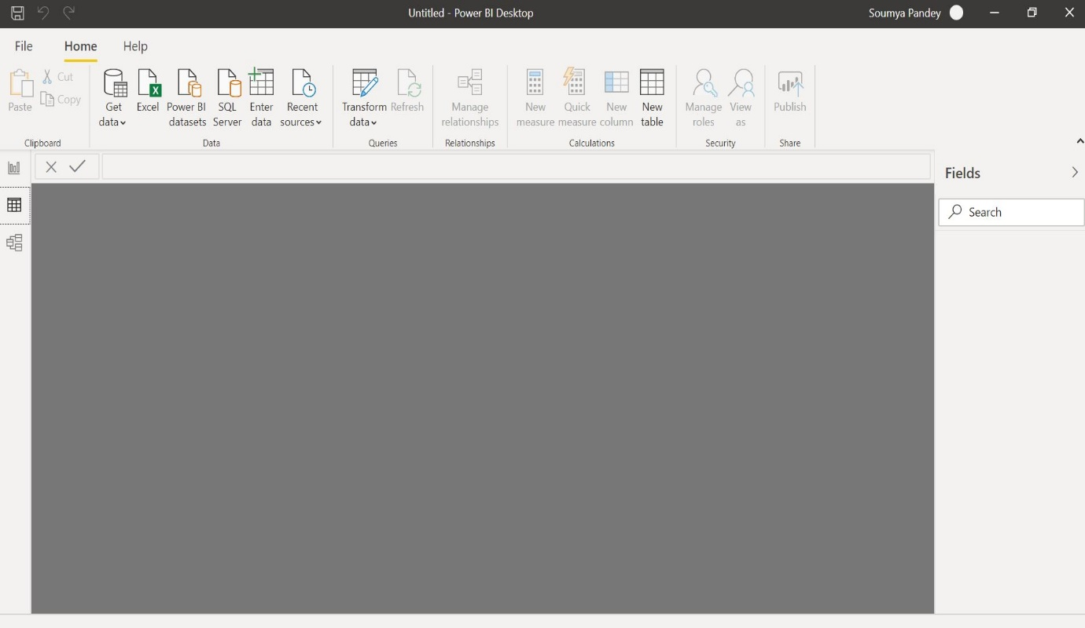Data View-

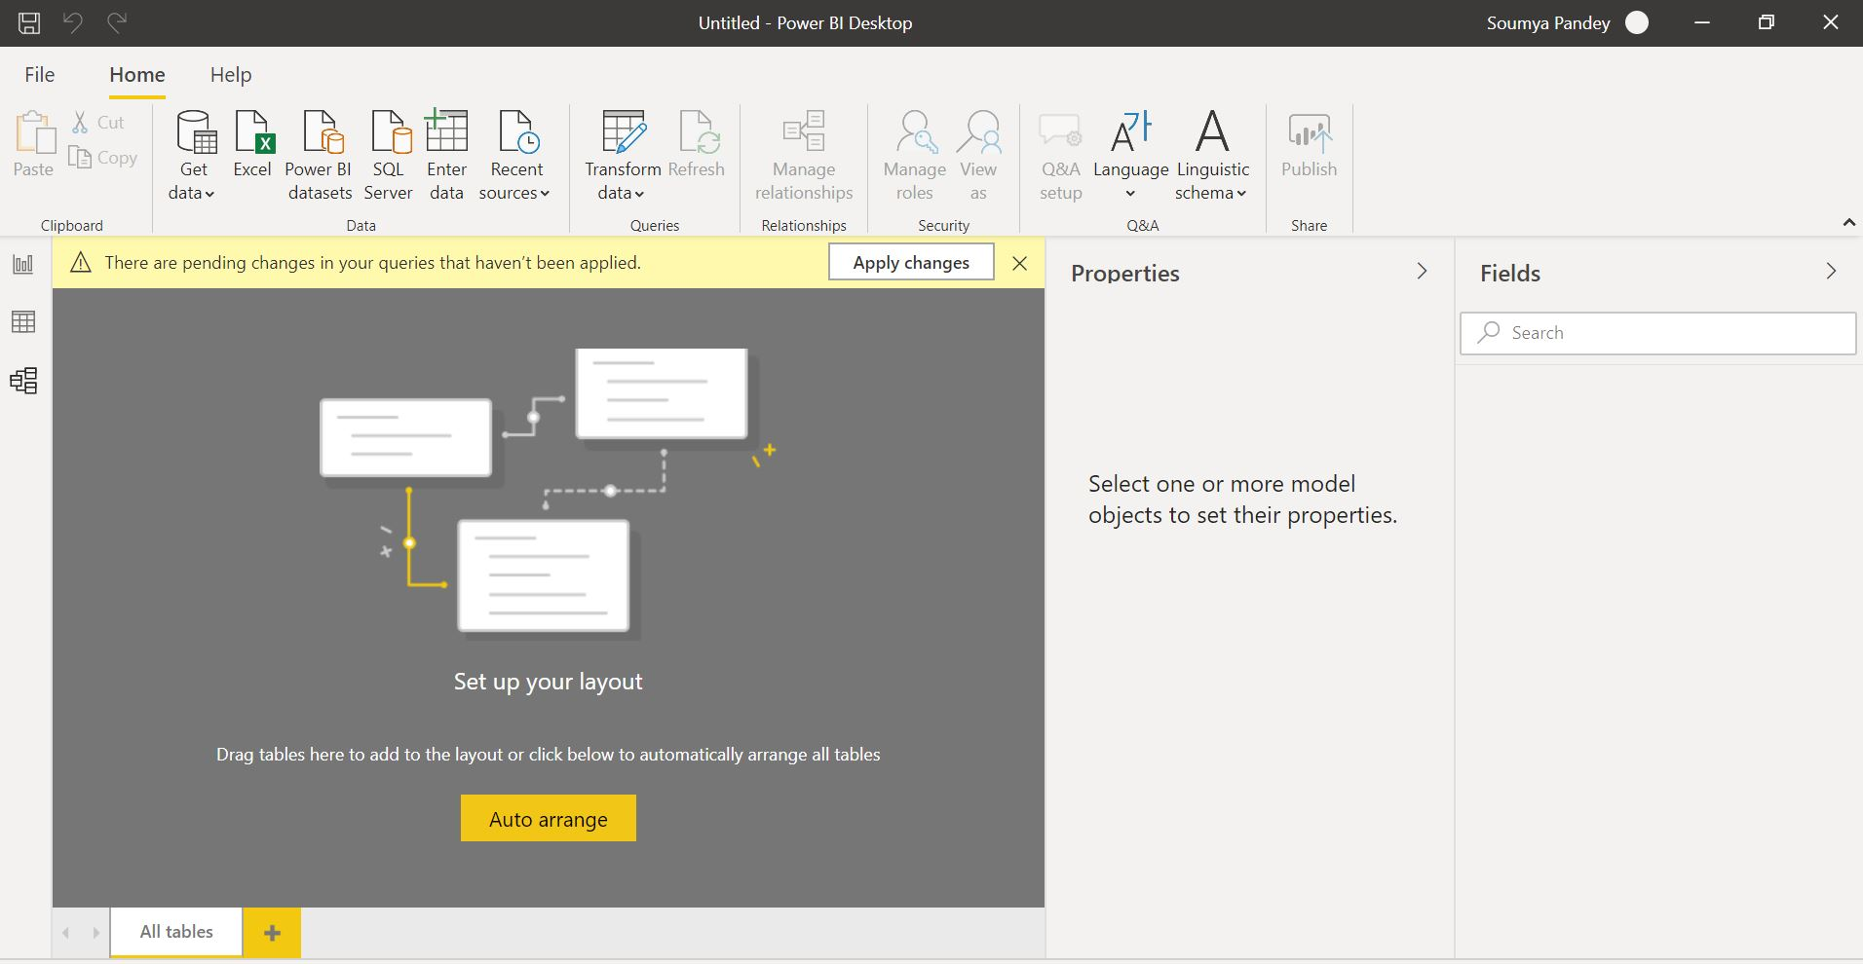Model View-

Power Query Editor-

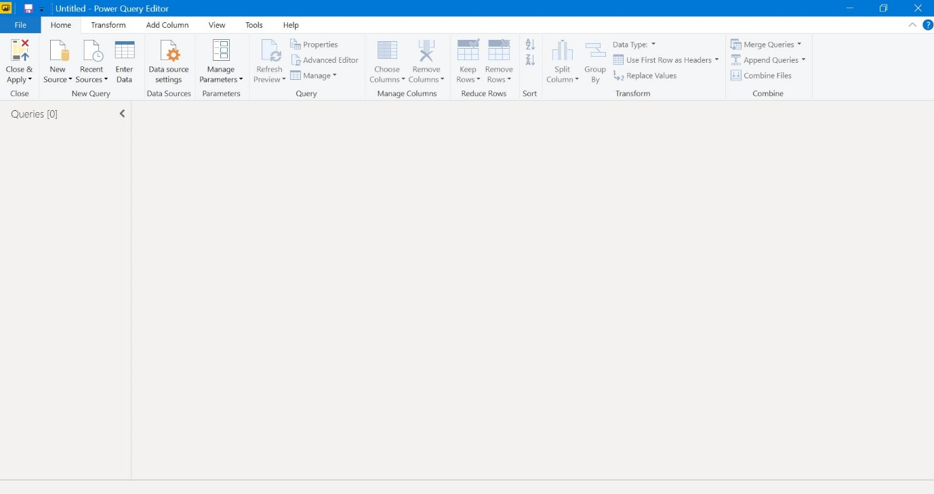

Advance Editor-

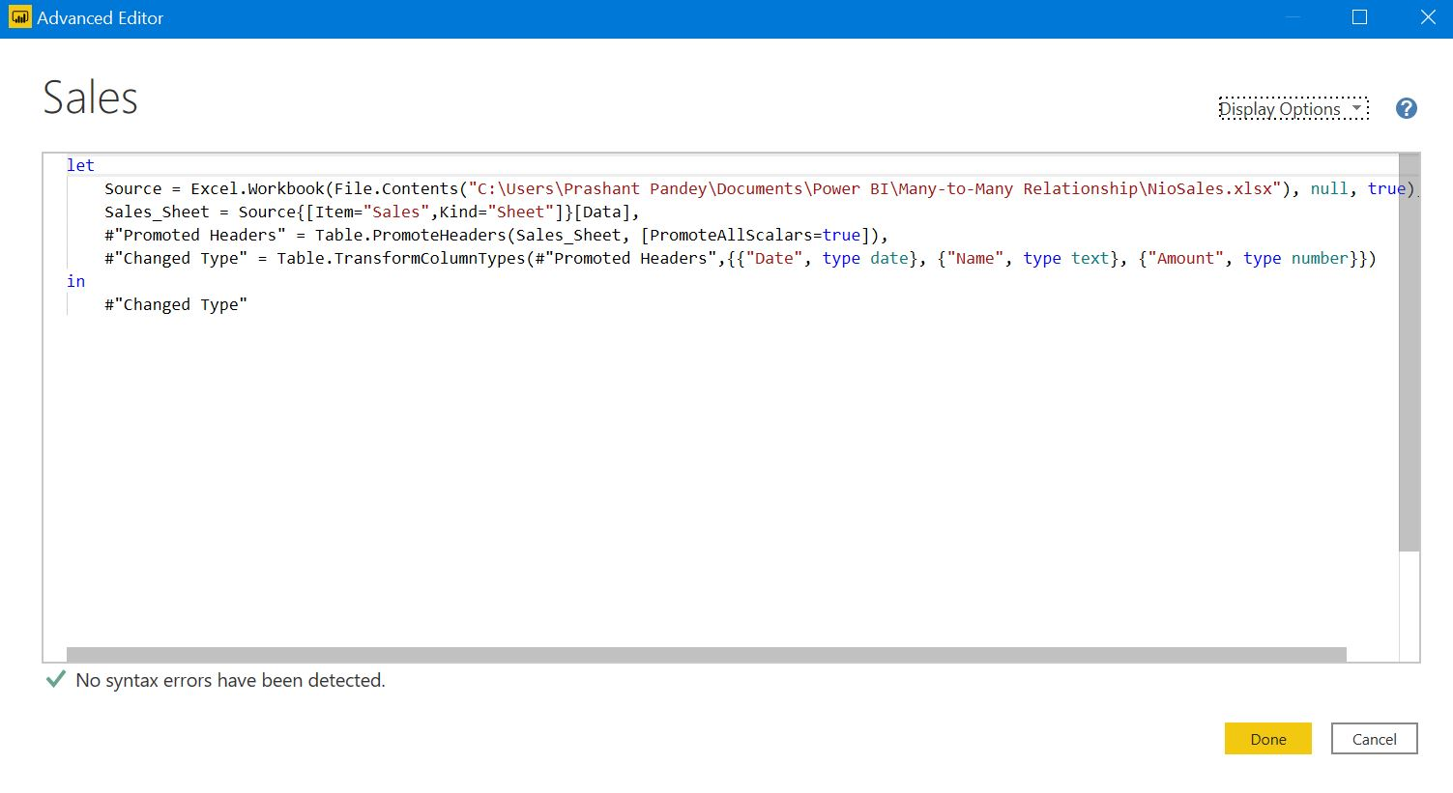

• Prepare a document with details of the following along with their price − Power BI Desktop − Power BI Pro − Power BI Premium

