Q 1. Select unique job from EMP table.

Ans: select distinct job from emp;

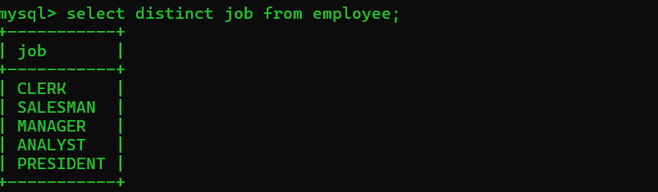

Q 2. List the details of the emps in asc order of the Dptnos and desc of Jobs?  
Ans: select \* from emp order by Deptno asc;

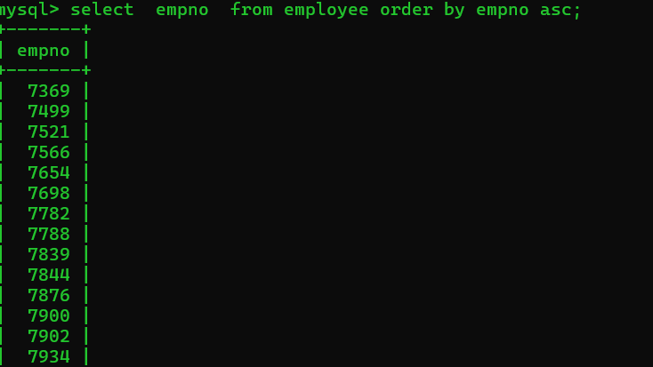

Q 3. Display all the unique job groups in the descending order?

Ans: select distinct job from emp order by job desc;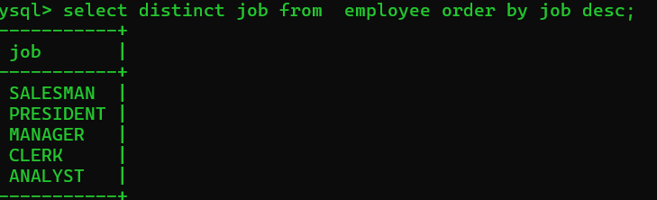

Q 4. List the emps who joined before 1981

Ans: select \* from emp from employee where hire date < (‘1981-02-20’;

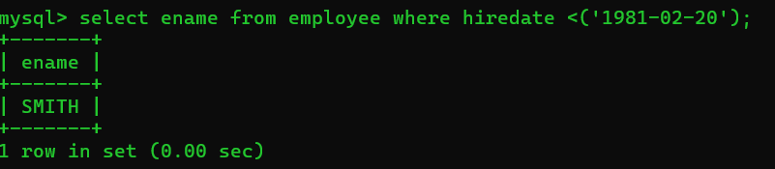

Q 5. List the Empno, Ename, Sal, Daily sal of all emps in the asc order of Annsal.

Ans: select Empno, Ename, Sal, Sal/30,12\*Sal annsal from employee order by annsal asc;

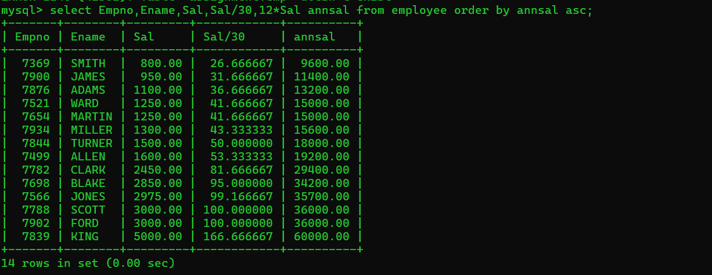

Q 6. List the Empno, Ename, Sal, Exp of all emps working for Mgr7369.

WHERE mgr. =7369;

Ans: select Empno, Ename, Sal from employee where Empno like”7369%"

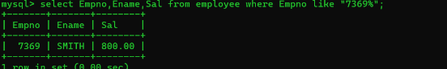

Q 7. Display all the details of the emps who’s Comm. Is more than their Sal?

Ans: select \* from employee where comn >Sal;

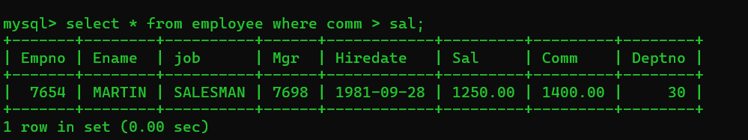

Q 8. List the emps who are either ‘CLERK’ or ‘ANALYST’ in the Desc order.

Ans: Select \* from employee where job= ” clerk” or job=”analyst” order by job desc;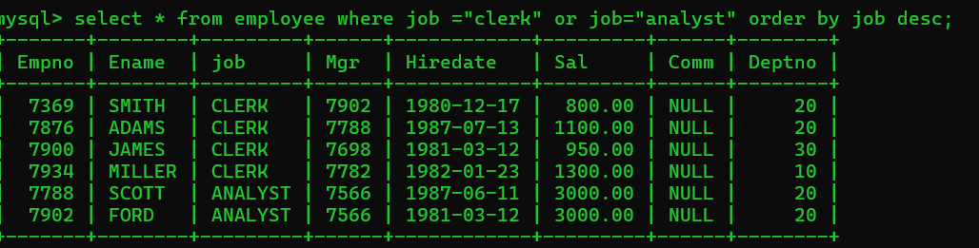

Q 9. List the emps Who Annual sal ranging from 22000 and 45000.

Ans: select \* from employee where 12\*Sal between 22000 and 45000;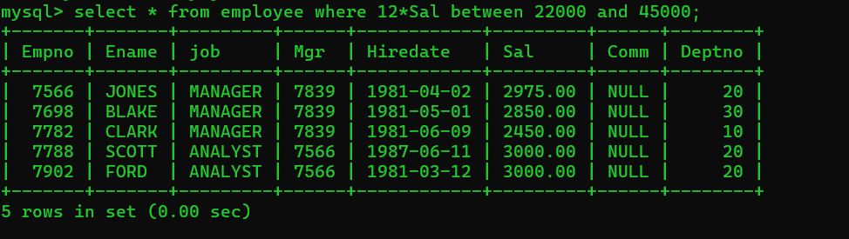

Q 10. List the Enames those are starting with ‘S’ and with five characters.

Ans: select Ename from employee where Ename like “s%”;

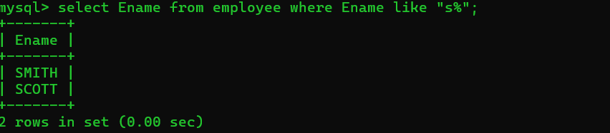

Q 11. List the emps whose Empno not starting with digit78.

Ans: select Empno from employee where Empno not like “78%”;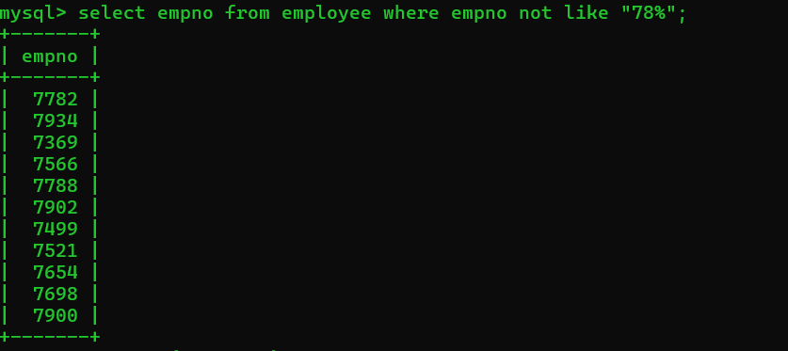

Q 12. List all the Clerks of Deptno 20.

Ans: select \* from employee where job=” clerk” and Deptno=20;

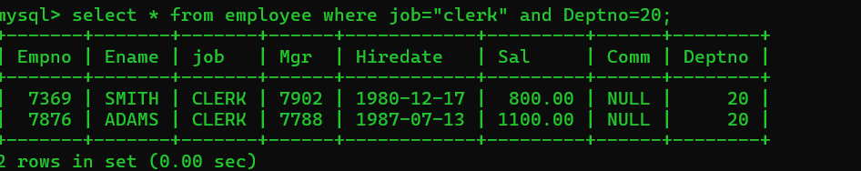

Q 13. List the Emps of Deptno 20who’s Jobs are same as Deptno10.

Ans: select \* from emp where Deptno=20 and job in (select job from employee

where Deptno=10); 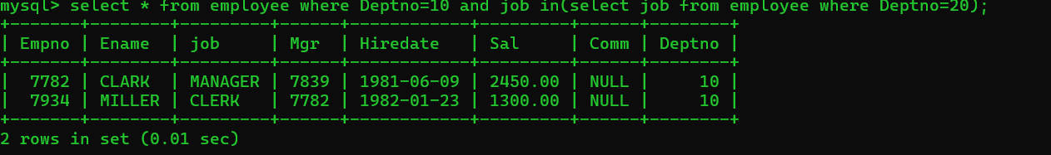

Q14. List the Emps who’s Sal is same as FORD or SMITH in desc order of Sal.

Ans: select \* from employee where Sal in(select Sal from employee where(Ename="SMITH" or Ename="FORD")order by Sal desc);

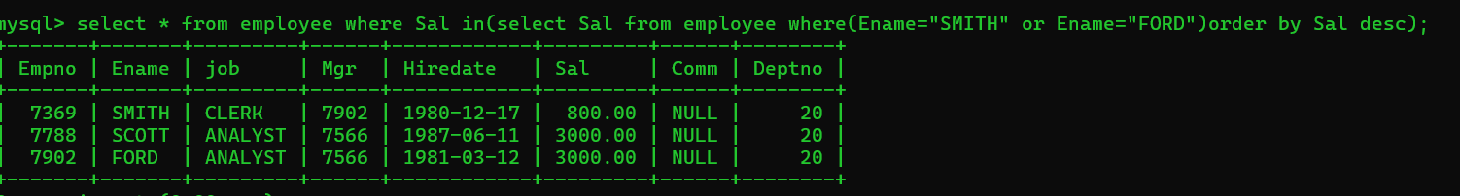

Q 15. List the emps whose jobs same as SMITH or ALLEN.

Ans: select Ename, job from employee where job =’CLERK’ or job= ‘SALESMAN’; 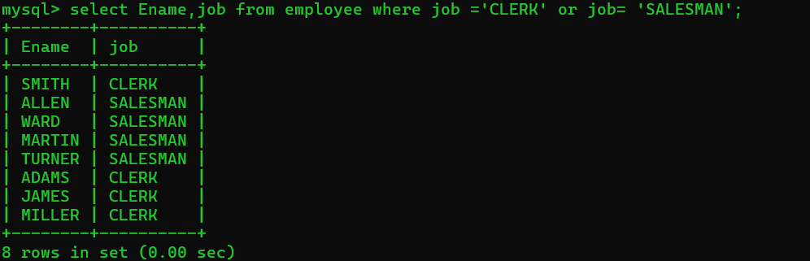

Q 16. Any jobs of deptno 10 those that are not found in deptno 20.

Ans: select \* from employee where Deptno=10 and job not in (select job from

Employee where Deptno=20);

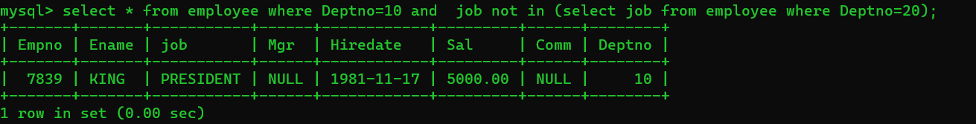

Q 17. Find the highest sal of EMP table.

Ans: select max (Sal) as highest Sal from emp;

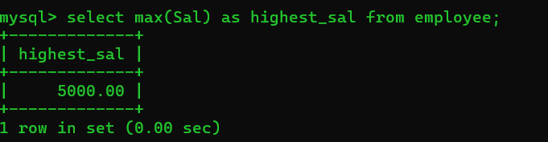

Q 18. Find details of highest paid employee.

Ans: select \* from employee where Sal= (select max (Sal) from employee);

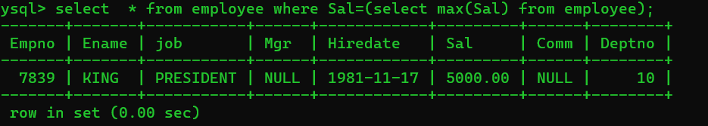

Q 19. Find the total sal given to the MGR.

Ans: select sum(Sal) from employee where mgr;

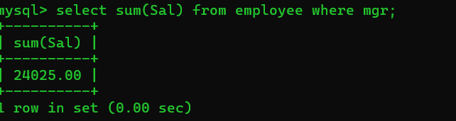

Q 20. List the emps whose names contains ‘A.’

Ans: select \* from employee where Ename like ‘%A%;’

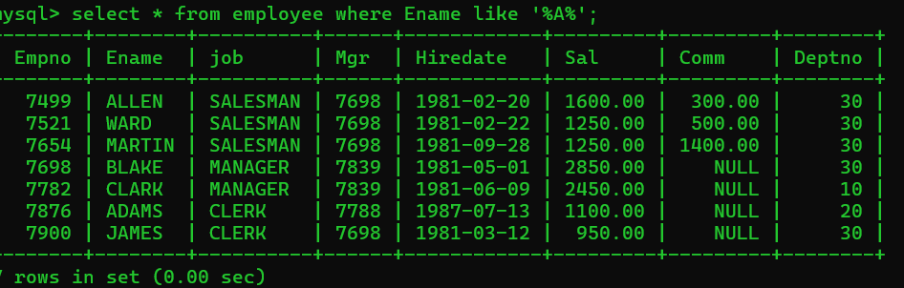

Q 21. Find all the emps who earn the minimum salary for each job wise in ascending order.

Ans: select \* from employee where (job, Sal) in (select job, min (Sal) from employee group by job) order by job, Sal asc;

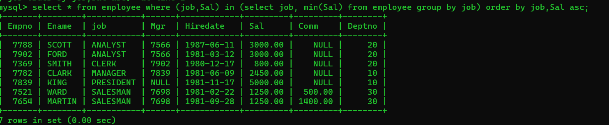

Q 22. List the emps whose sal greater than Blake’s sal.

Ans: select \* from employee WHERE sal > (SELECT sal FROM employee WHERE e name = ‘blake’);

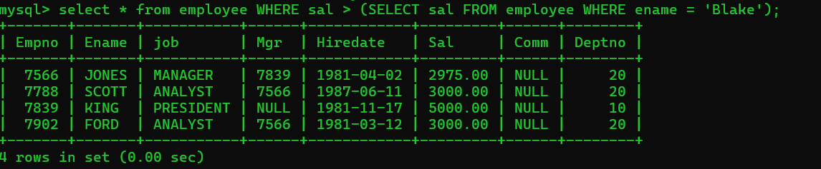

Q23.Create view v1 to select e name, job, d name, loc whose deptno are same.

Ans: select \* from v1;

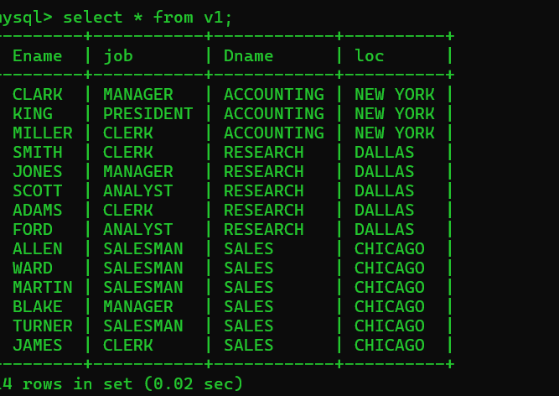

Q 24. Add column Pin with bigint data type in table student.

