

**PublicisSapient Hiring Challenge**

Participate name: Prashant verma

horizontal line

# Introduction

# This document is related with Mini-cart Application. It’s cart which can be persist with browser without calling server. It is well designed for desktop and mobile and further can be used in PWA.

# Technology/Tool Stack Used:

* React JS
* VS Code

# Github: - <https://github.com/prashantpv08/sap>

# How to run :- 1) npm install 2) npm start

# 

# Screenshots:

1)

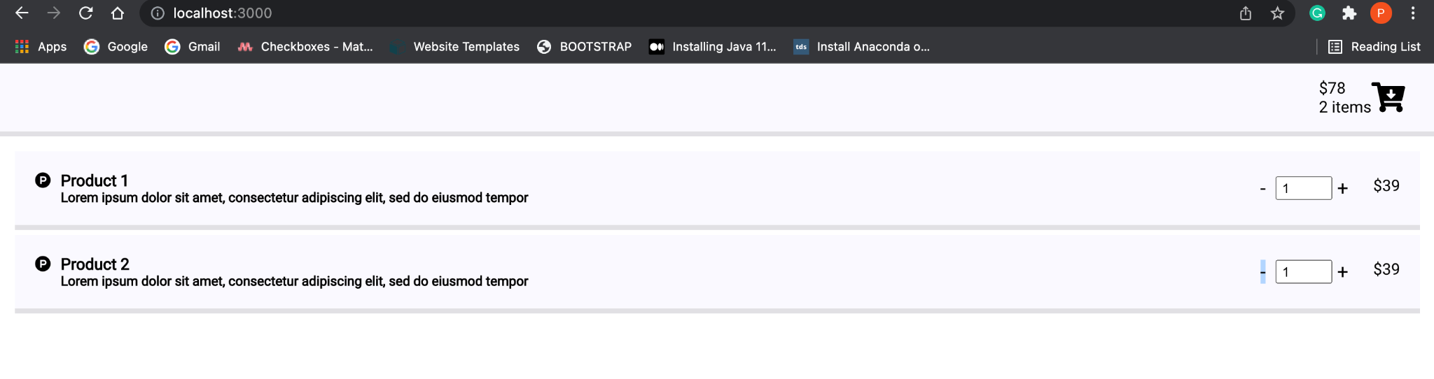

2)

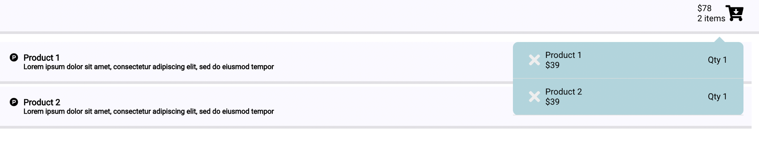

3)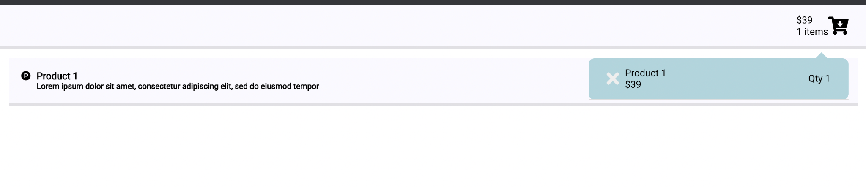

4)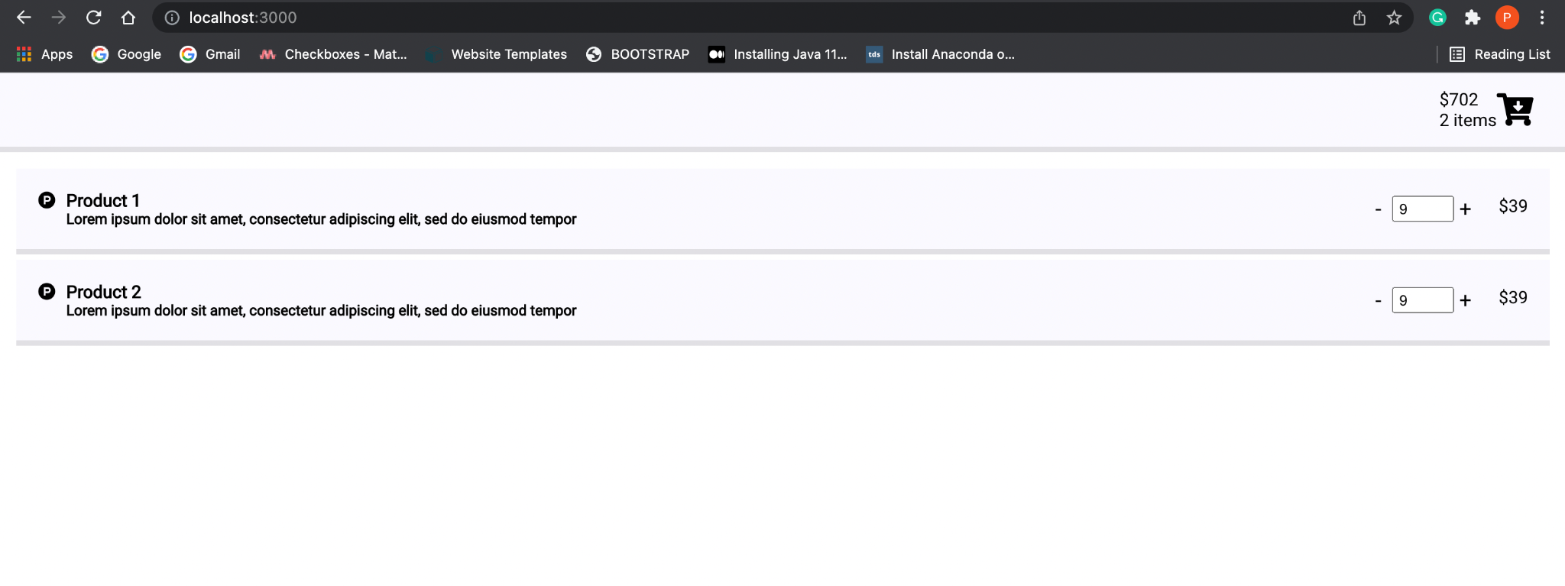

**5) Mobile**

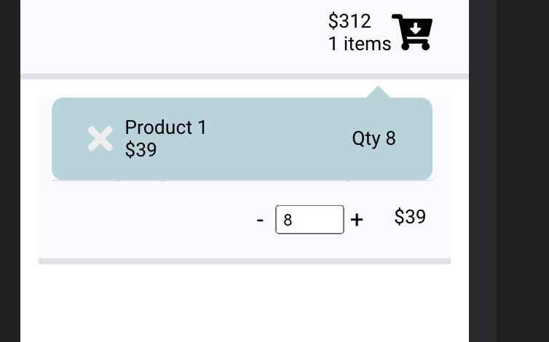

6)

