Experiment 7
AIM: Use Selenium to create browser-based tests.
Step 1 Import Required Libraries
from selenium import webdriver
from selenium.webdriver.common.by import By
from selenium.webdriver.chrome.service import Service
from selenium.webdriver.support.ui import WebDriverWait
from selenium.webdriver.support import expected_conditions as EC
from webdriver_manager.chrome import ChromeDriverManager
import time
Step 2 Start Browser
service = Service(ChromeDriverManager().install())
driver = webdriver.Chrome(service=service)
driver.get("https://the-internet.herokuapp.com/login")
driver.maximize_window()
Step 3 Wait for Page Elements
wait = WebDriverWait(driver, 10)
Step 4 Enter Login Credentials
username = wait.until(
EC.presence_of_element_located((By.ID, "username"))
)
username.send_keys("tomsmith")
driver.find_element(By.ID, "password").send_keys("SuperSecretPassword!")
Step 5 Click Login Button
driver.find_element(By.CSS_SELECTOR, "button.radius").click()
Step 6 Verify Login Success
message = wait.until(
EC.presence_of_element_located((By.ID, "flash"))
)
print("Login Message:", message.text)
Step 7 Logout
driver.find_element(By.CSS_SELECTOR, "a.button.secondary.radius").click()
Step 8 Close Browser
time.sleep(3)
driver.quit()

Command Prompt:
Microsoft Windows [Version 10.0.26200.8037]
(c) Microsoft Corporation. All rights reserved.

C:\Users\prash>pip install selenium
Collecting selenium
Downloading selenium-4.41.0-py3-none-any.whl.metadata (7.5 kB)
Collecting certifi>=2026.1.4 (from selenium)
Downloading certifi-2026.2.25-py3-none-any.whl.metadata (2.5 kB)
Collecting trio<1.0,>=0.31.0 (from selenium)
Downloading trio-0.33.0-py3-none-any.whl.metadata (8.5 kB)
Collecting trio-websocket<1.0,>=0.12.2 (from selenium)
Downloading trio_websocket-0.12.2-py3-none-any.whl.metadata (5.1 kB)
Collecting typing_extensions<5.0,>=4.15.0 (from selenium)
Downloading typing_extensions-4.15.0-py3-none-any.whl.metadata (3.3 kB)
Collecting urllib3<3.0,>=2.6.3 (from urllib3[socks]<3.0,>=2.6.3->selenium)
Downloading urllib3-2.6.3-py3-none-any.whl.metadata (6.9 kB)
Collecting websocket-client<2.0,>=1.8.0 (from selenium)
Downloading websocket_client-1.9.0-py3-none-any.whl.metadata (8.3 kB)
Collecting attrs>=23.2.0 (from trio<1.0,>=0.31.0->selenium)
Downloading attrs-26.1.0-py3-none-any.whl.metadata (8.8 kB)
Collecting sortedcontainers (from trio<1.0,>=0.31.0->selenium)
Downloading sortedcontainers-2.4.0-py2.py3-none-any.whl.metadata (10 kB)
Collecting idna (from trio<1.0,>=0.31.0->selenium)
Downloading idna-3.11-py3-none-any.whl.metadata (8.4 kB)
Collecting outcome (from trio<1.0,>=0.31.0->selenium)
Downloading outcome-1.3.0.post0-py2.py3-none-any.whl.metadata (2.6 kB)
Collecting sniffio>=1.3.0 (from trio<1.0,>=0.31.0->selenium)
Using cached sniffio-1.3.1-py3-none-any.whl.metadata (3.9 kB)
Collecting cffi>=1.14 (from trio<1.0,>=0.31.0->selenium)
Downloading cffi-2.0.0-cp313-cp313-win_amd64.whl.metadata (2.6 kB)
Collecting wsproto>=0.14 (from trio-websocket<1.0,>=0.12.2->selenium)
Downloading wsproto-1.3.2-py3-none-any.whl.metadata (5.2 kB)
Collecting pysocks!=1.5.7,<2.0,>=1.5.6 (from urllib3[socks]<3.0,>=2.6.3->selenium)
Downloading PySocks-1.7.1-py3-none-any.whl.metadata (13 kB)
Collecting pycparser (from cffi>=1.14->trio<1.0,>=0.31.0->selenium)
Downloading pycparser-3.0-py3-none-any.whl.metadata (8.2 kB)
Collecting h11<1,>=0.16.0 (from wsproto>=0.14->trio-websocket<1.0,>=0.12.2->selenium)
Using cached h11-0.16.0-py3-none-any.whl.metadata (8.3 kB)
Downloading selenium-4.41.0-py3-none-any.whl (9.5 MB)
━━━━━━━━━━━━━━━━━━━━━━━━━━━━━━━━━━━━━━━━ 9.5/9.5 MB 2.6 MB/s eta 0:00:00
Downloading trio-0.33.0-py3-none-any.whl (510 kB)
Downloading trio_websocket-0.12.2-py3-none-any.whl (21 kB)
Downloading typing_extensions-4.15.0-py3-none-any.whl (44 kB)
Downloading urllib3-2.6.3-py3-none-any.whl (131 kB)
Downloading PySocks-1.7.1-py3-none-any.whl (16 kB)
Downloading websocket_client-1.9.0-py3-none-any.whl (82 kB)
Downloading attrs-26.1.0-py3-none-any.whl (67 kB)
Downloading certifi-2026.2.25-py3-none-any.whl (153 kB)
Downloading cffi-2.0.0-cp313-cp313-win_amd64.whl (183 kB)
Downloading outcome-1.3.0.post0-py2.py3-none-any.whl (10 kB)
Using cached sniffio-1.3.1-py3-none-any.whl (10 kB)
Downloading wsproto-1.3.2-py3-none-any.whl (24 kB)
Using cached h11-0.16.0-py3-none-any.whl (37 kB)
Downloading idna-3.11-py3-none-any.whl (71 kB)
Downloading pycparser-3.0-py3-none-any.whl (48 kB)
Downloading sortedcontainers-2.4.0-py2.py3-none-any.whl (29 kB)
Installing collected packages: sortedcontainers, websocket-client, urllib3, typing_extensions, sniffio, pysocks, pycparser, idna, h11, certifi, attrs, wsproto, outcome, cffi, trio, trio-websocket, selenium
Successfully installed attrs-26.1.0 certifi-2026.2.25 cffi-2.0.0 h11-0.16.0 idna-3.11 outcome-1.3.0.post0 pycparser-3.0 pysocks-1.7.1 selenium-4.41.0 sniffio-1.3.1 sortedcontainers-2.4.0 trio-0.33.0 trio-websocket-0.12.2 typing_extensions-4.15.0 urllib3-2.6.3 websocket-client-1.9.0 wsproto-1.3.2

[notice] A new release of pip is available: 25.1.1 -> 26.0.1
[notice] To update, run: python.exe -m pip install --upgrade pip

C:\Users\prash>pip install webdriver-manager
Collecting webdriver-manager
Downloading webdriver_manager-4.0.2-py2.py3-none-any.whl.metadata (12 kB)
Collecting requests (from webdriver-manager)
Downloading requests-2.33.1-py3-none-any.whl.metadata (4.8 kB)
Collecting python-dotenv (from webdriver-manager)
Downloading python_dotenv-1.2.2-py3-none-any.whl.metadata (27 kB)
Collecting packaging (from webdriver-manager)
Downloading packaging-26.0-py3-none-any.whl.metadata (3.3 kB)
Collecting charset_normalizer<4,>=2 (from requests->webdriver-manager)
Downloading charset_normalizer-3.4.6-cp313-cp313-win_amd64.whl.metadata (41 kB)
Requirement already satisfied: idna<4,>=2.5 in c:\users\prash\appdata\local\programs\python\python313\lib\site-packages (from requests->webdriver-manager) (3.11)
Requirement already satisfied: urllib3<3,>=1.26 in c:\users\prash\appdata\local\programs\python\python313\lib\site-packages (from requests->webdriver-manager) (2.6.3)
Requirement already satisfied: certifi>=2023.5.7 in c:\users\prash\appdata\local\programs\python\python313\lib\site-packages (from requests->webdriver-manager) (2026.2.25)
Downloading webdriver_manager-4.0.2-py2.py3-none-any.whl (27 kB)
Downloading packaging-26.0-py3-none-any.whl (74 kB)
Downloading python_dotenv-1.2.2-py3-none-any.whl (22 kB)
Downloading requests-2.33.1-py3-none-any.whl (64 kB)
Downloading charset_normalizer-3.4.6-cp313-cp313-win_amd64.whl (154 kB)
Installing collected packages: python-dotenv, packaging, charset_normalizer, requests, webdriver-manager
Successfully installed charset_normalizer-3.4.6 packaging-26.0 python-dotenv-1.2.2 requests-2.33.1 webdriver-manager-4.0.2

[notice] A new release of pip is available: 25.1.1 -> 26.0.1
[notice] To update, run: python.exe -m pip install --upgrade pip

C:\Users\prash>cd C:\Users\prash\Desktop
C:\Users\prash\Desktop>mkdir selenium
C:\Users\prash\Desktop>cd selenium
C:\Users\prash\Desktop\selenium>notepad selenium_login_test.py
C:\Users\prash\Desktop\selenium>python selenium_login_test.py
Login Message: You logged into a secure area!

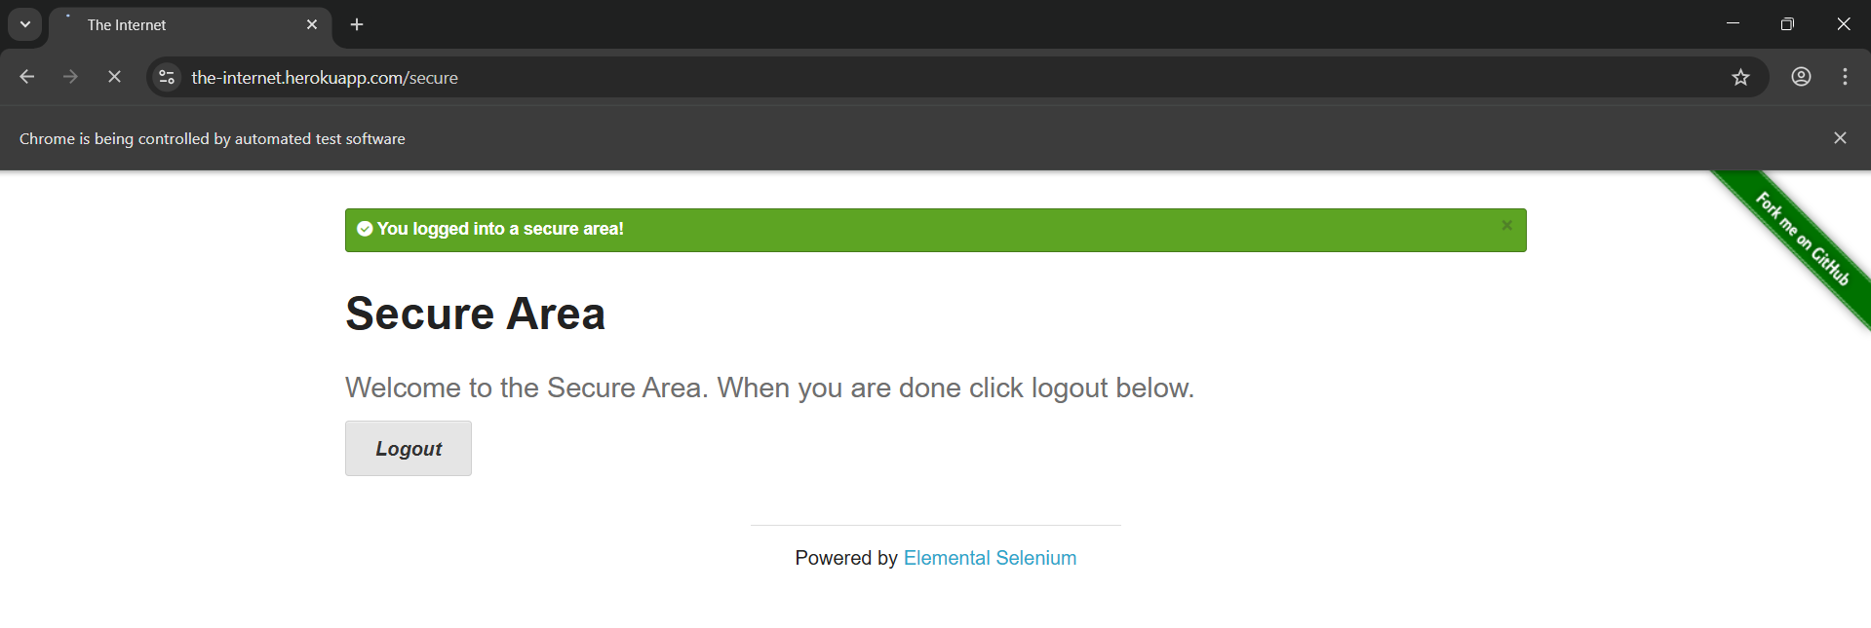

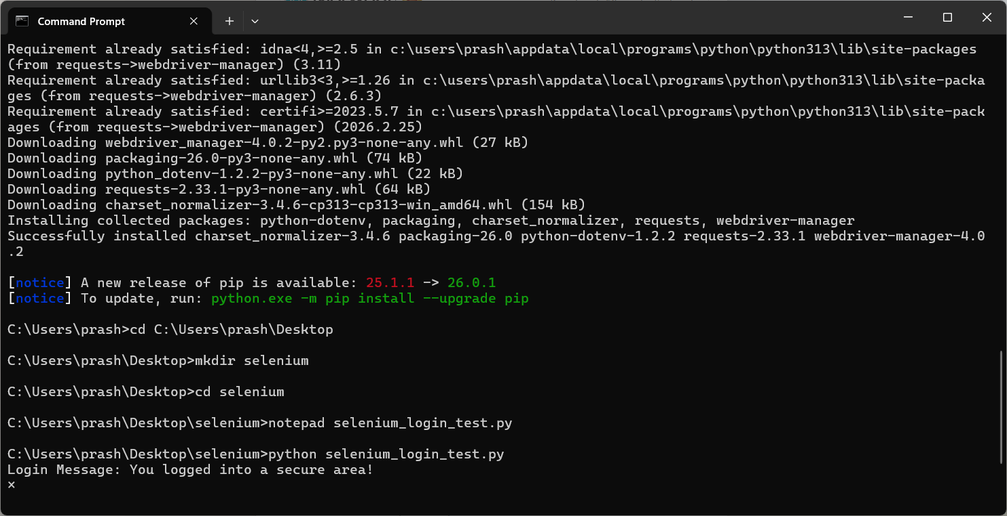

TASK : Automate YouTube Search using Selenium:
from selenium import webdriver
from selenium.webdriver.common.by import By
from selenium.webdriver.chrome.service import Service
from selenium.webdriver.support.ui import WebDriverWait
from selenium.webdriver.support import expected_conditions as EC
from webdriver_manager.chrome import ChromeDriverManager
import time

# Start browser
driver = webdriver.Chrome(service=Service(ChromeDriverManager().install()))

# Open YouTube
driver.get("https://www.youtube.com")
driver.maximize_window()

# Wait object
wait = WebDriverWait(driver, 10)

# Find search box
search = wait.until(
EC.presence_of_element_located((By.NAME, "search_query"))
)
search.send_keys("open source software")

# Click search button
search_btn = wait.until(
EC.element_to_be_clickable((By.ID, "search-icon-legacy"))
)
search_btn.click()

# Wait to see results
time.sleep(5)

driver.quit()
Command Prompt:
C:\Users\prash\Desktop\selenium>notepad selenium_youtube_test.py

C:\Users\prash\Desktop\selenium>python selenium_youtube_test.py
Traceback (most recent call last):
File "C:\Users\prash\Desktop\selenium\selenium_youtube_test.py", line 26, in <module>
search_btn = wait.until(
EC.element_to_be_clickable((By.ID, "search-icon-legacy"))
)
File "C:\Users\prash\AppData\Local\Programs\Python\Python313\Lib\site-packages\selenium\webdriver\support\wait.py", line 121, in until
raise TimeoutException(message, screen, stacktrace)
selenium.common.exceptions.TimeoutException: Message:
Stacktrace:
chromedriver!GetHandleVerifier [0xb2cdf3+10b03]
chromedriver!GetHandleVerifier [0xb2cf24+10c34]
chromedriver!(No symbol) [0x912120]
chromedriver!(No symbol) [0x95abca]
chromedriver!(No symbol) [0x95ae6b]
chromedriver!(No symbol) [0x99d0b2]
chromedriver!(No symbol) [0x97db54]
chromedriver!(No symbol) [0x99a9a5]
chromedriver!(No symbol) [0x97d8a6]
chromedriver!(No symbol) [0x950229]
chromedriver!(No symbol) [0x950fe4]
chromedriver!GetHandleVerifier [0xd948b9+2785c9]
chromedriver!GetHandleVerifier [0xd8feb5+273bc5]
chromedriver!GetHandleVerifier [0xdae06b+291d7b]
chromedriver!GetHandleVerifier [0xb45cc8+299d8]
chromedriver!GetHandleVerifier [0xb4d9fd+3170d]
chromedriver!GetHandleVerifier [0xb358c8+195d8]
chromedriver!GetHandleVerifier [0xb35a92+197a2]
chromedriver!GetHandleVerifier [0xb1ee9a+2baa]
KERNEL32!BaseThreadInitThunk [0x74f25d49+19]
ntdll!RtlInitializeExceptionChain [0x77c0d81b+6b]
ntdll!RtlGetAppContainerNamedObjectPath [0x77c0d7a1+231]

C:\Users\prash\Desktop\selenium>python selenium_youtube_test.py
Traceback (most recent call last):
File "C:\Users\prash\Desktop\selenium\selenium_youtube_test.py", line 26, in <module>
search_btn = wait.until(
EC.element_to_be_clickable((By.ID, "search-icon-legacy"))
)
File "C:\Users\prash\AppData\Local\Programs\Python\Python313\Lib\site-packages\selenium\webdriver\support\wait.py", line 121, in until
raise TimeoutException(message, screen, stacktrace)
selenium.common.exceptions.TimeoutException: Message:
Stacktrace:
chromedriver!GetHandleVerifier [0xb2cdf3+10b03]
chromedriver!GetHandleVerifier [0xb2cf24+10c34]
chromedriver!(No symbol) [0x912120]
chromedriver!(No symbol) [0x95abca]
chromedriver!(No symbol) [0x95ae6b]
chromedriver!(No symbol) [0x99d0b2]
chromedriver!(No symbol) [0x97db54]
chromedriver!(No symbol) [0x99a9a5]
chromedriver!(No symbol) [0x97d8a6]
chromedriver!(No symbol) [0x950229]
chromedriver!(No symbol) [0x950fe4]
chromedriver!GetHandleVerifier [0xd948b9+2785c9]
chromedriver!GetHandleVerifier [0xd8feb5+273bc5]
chromedriver!GetHandleVerifier [0xdae06b+291d7b]
chromedriver!GetHandleVerifier [0xb45cc8+299d8]
chromedriver!GetHandleVerifier [0xb4d9fd+3170d]
chromedriver!GetHandleVerifier [0xb358c8+195d8]
chromedriver!GetHandleVerifier [0xb35a92+197a2]
chromedriver!GetHandleVerifier [0xb1ee9a+2baa]
KERNEL32!BaseThreadInitThunk [0x74f25d49+19]
ntdll!RtlInitializeExceptionChain [0x77c0d81b+6b]
ntdll!RtlGetAppContainerNamedObjectPath [0x77c0d7a1+231]

