Experiment 10

AIM: Develop a Laravel/Django based web application

- Open VS Code -> Terminal -> New Terminal

- Create New Project
python -m django startproject myproject or django-admin startproject myproject
cd myproject
pip install Django

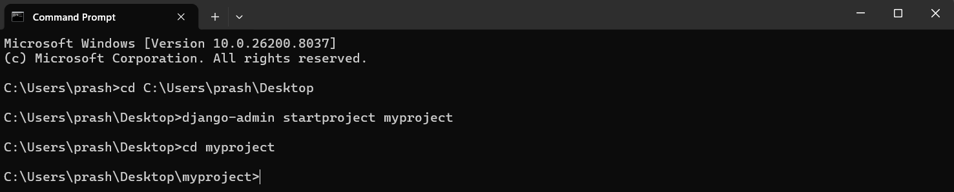

- Run Server (First Test) python manage.py runserver Open browser: http://127.0.0.1:8000/

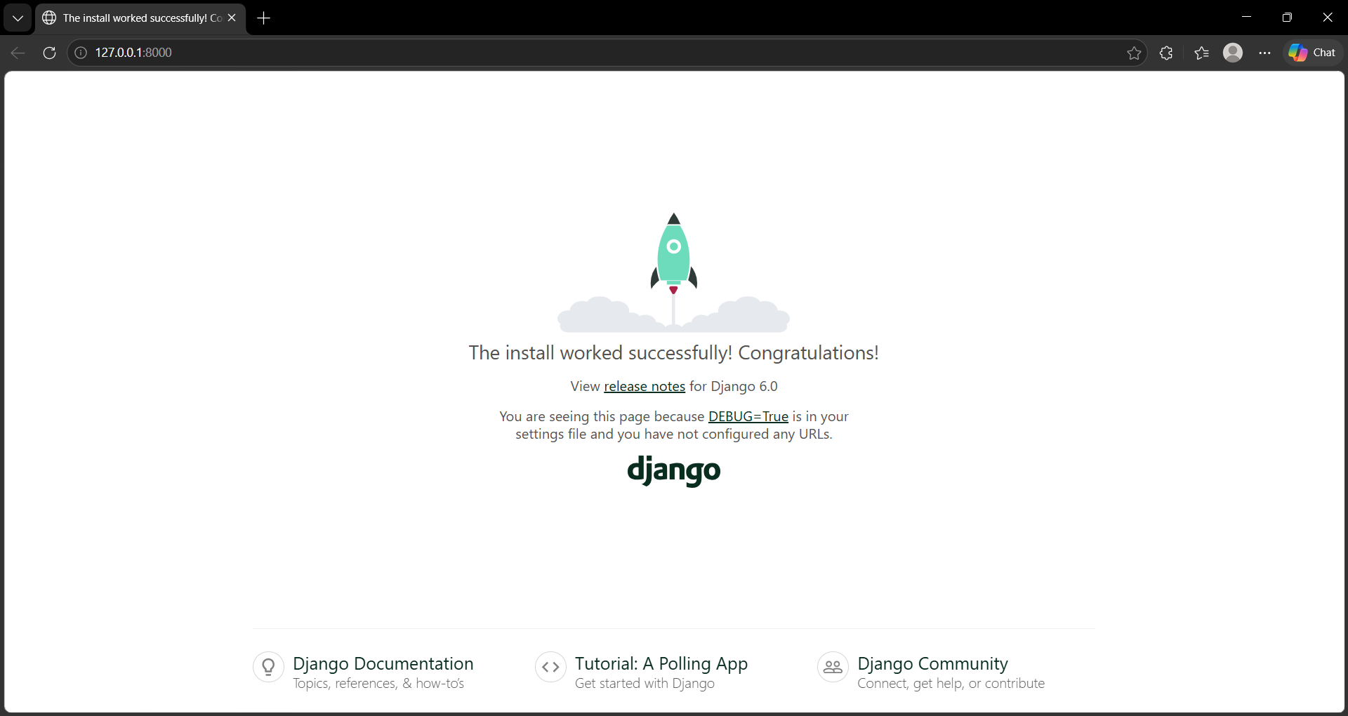

- Create Simple App
python manage.py startapp myapp
- Register App
Open: myproject/settings.py and include the below code INSTALLED_APPS = [
'django.contrib.admin', 'django.contrib.auth', 'django.contrib.contenttypes', 'django.contrib.sessions', 'django.contrib.messages', 'django.contrib.staticfiles', 'myapp', # your app
]

- Create Simple View
Open: myapp/views.py and include below code from django.http import HttpResponse
def home(request):
return HttpResponse("Hello from VS Code Django!")

- Create URL File
Create file: myapp/urls.py and include below code from django.urls import path
from . import views urlpatterns = [ path('', views.home),

]
- Connect URLs
Open: myproject/urls.py include below code from django.contrib import admin
from django.urls import path, include urlpatterns = [
path('', include('myapp.urls')), path('admin/', admin.site.urls),
]

- Run
python manage.py runserver Open: http://127.0.0.1:8000/ Output:

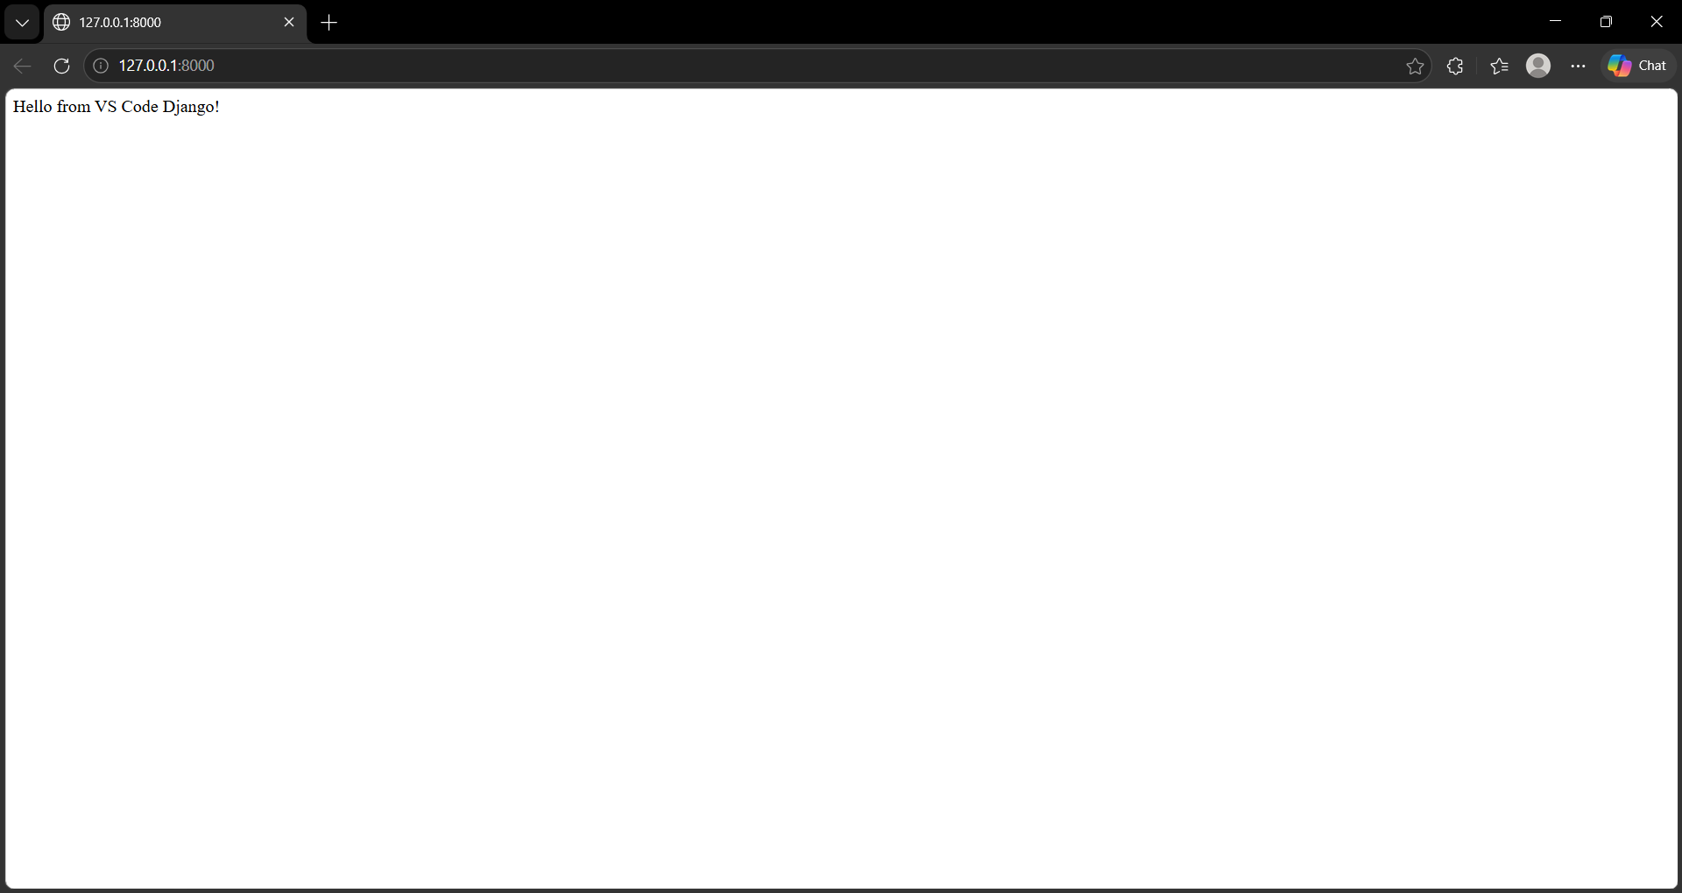
To add GUI:
  - Create Template Folder Inside myapp, create:
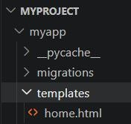

  - Add the below GUI Code
<!DOCTYPE html>

<html>
<head>
<title>Django GUI Demo</title>
</head>
<body style="font-family: Arial; text-align: center;">
<h1 style="color: blue;">Welcome to Django GUI</h1>
<p>This is a simple interface created using HTML</p>
<button onclick="alert('Hello!!!')"> Click Me
</button>
</body>
</html>

  - Update views.py
Open: myapp/views.py and include below code from django.shortcuts import render
def home(request):
return render(request, 'home.html')

  - Run Server
python manage.py runserver

