Experiment 8
AIM: Use Postman to test sample API.

1. Objective
• Understand how to test REST APIs using Postman by sending different types of HTTP requests.
    - Get
    - Post
    - Put
    - Delete
2. Prerequisites
• postman
• API to be tested
- Create a simple node.js API / use some free fake API

3. Test API
Get:
URL: https://jsonplaceholder.typicode.com/posts
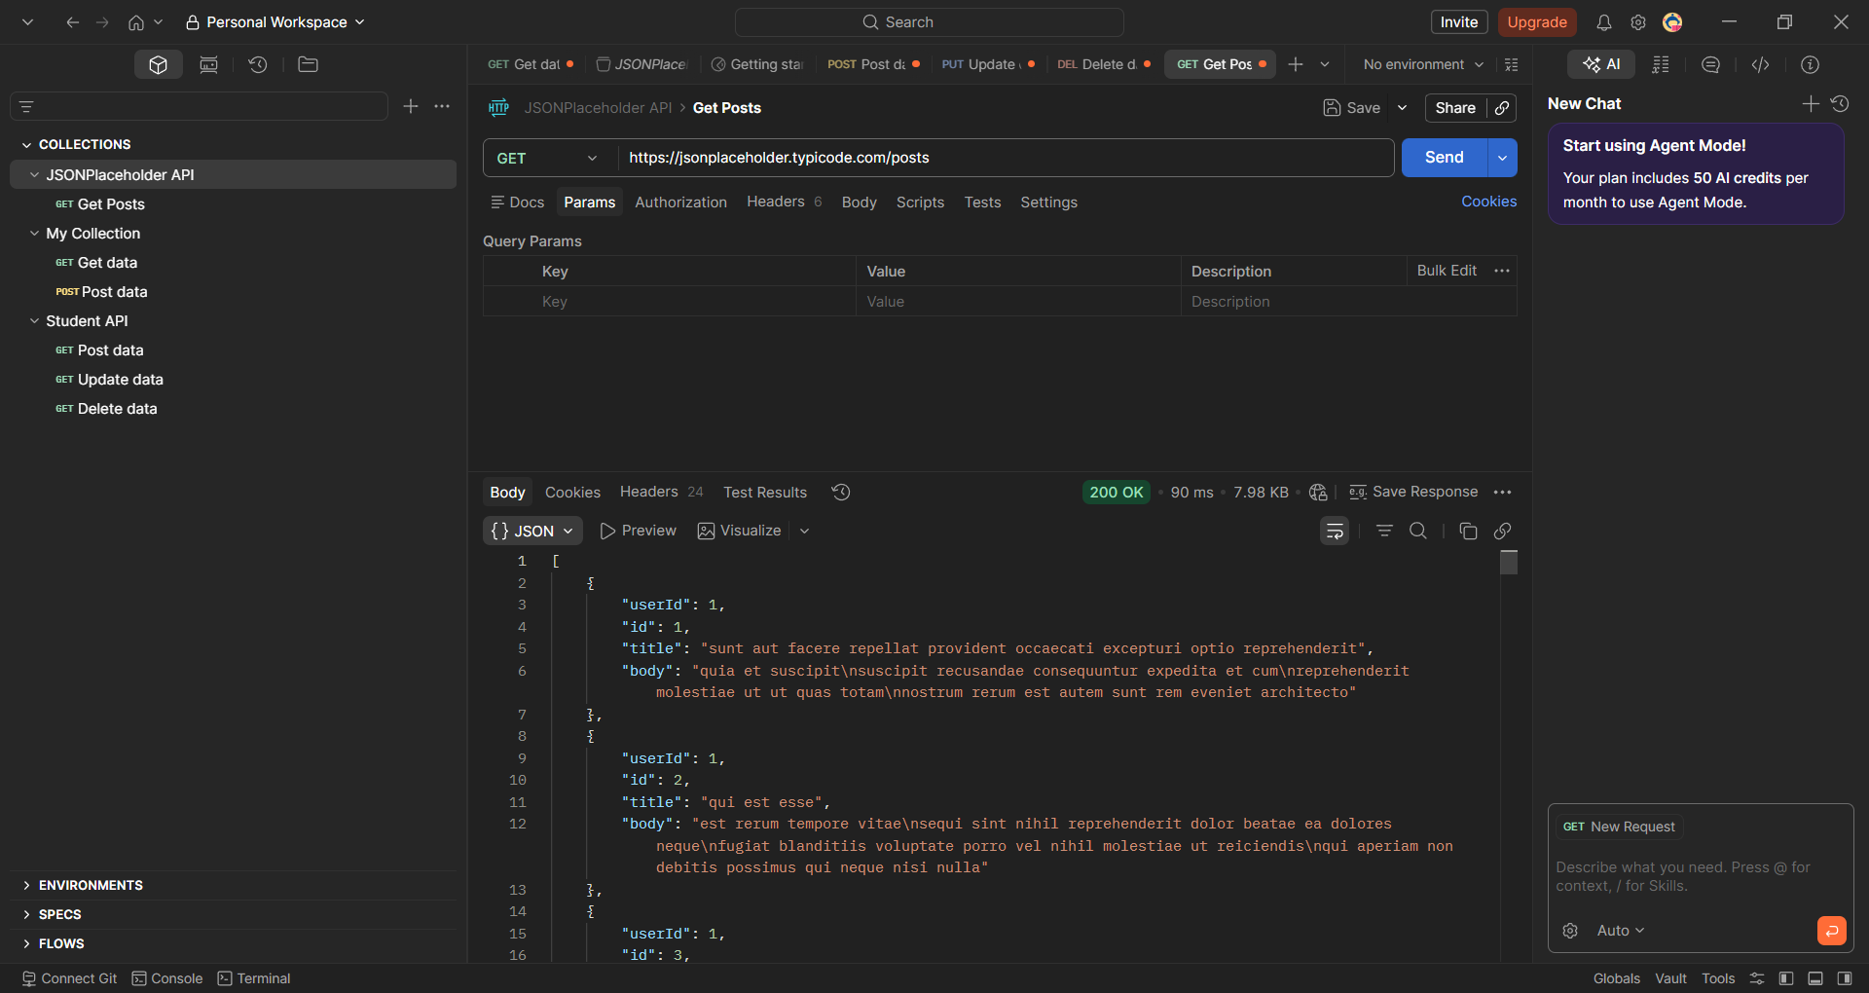

Post:
https://jsonplaceholder.typicode.com/posts
{
"title": "Test Post",
"body": "This is a sample post",
"userId": 1
}
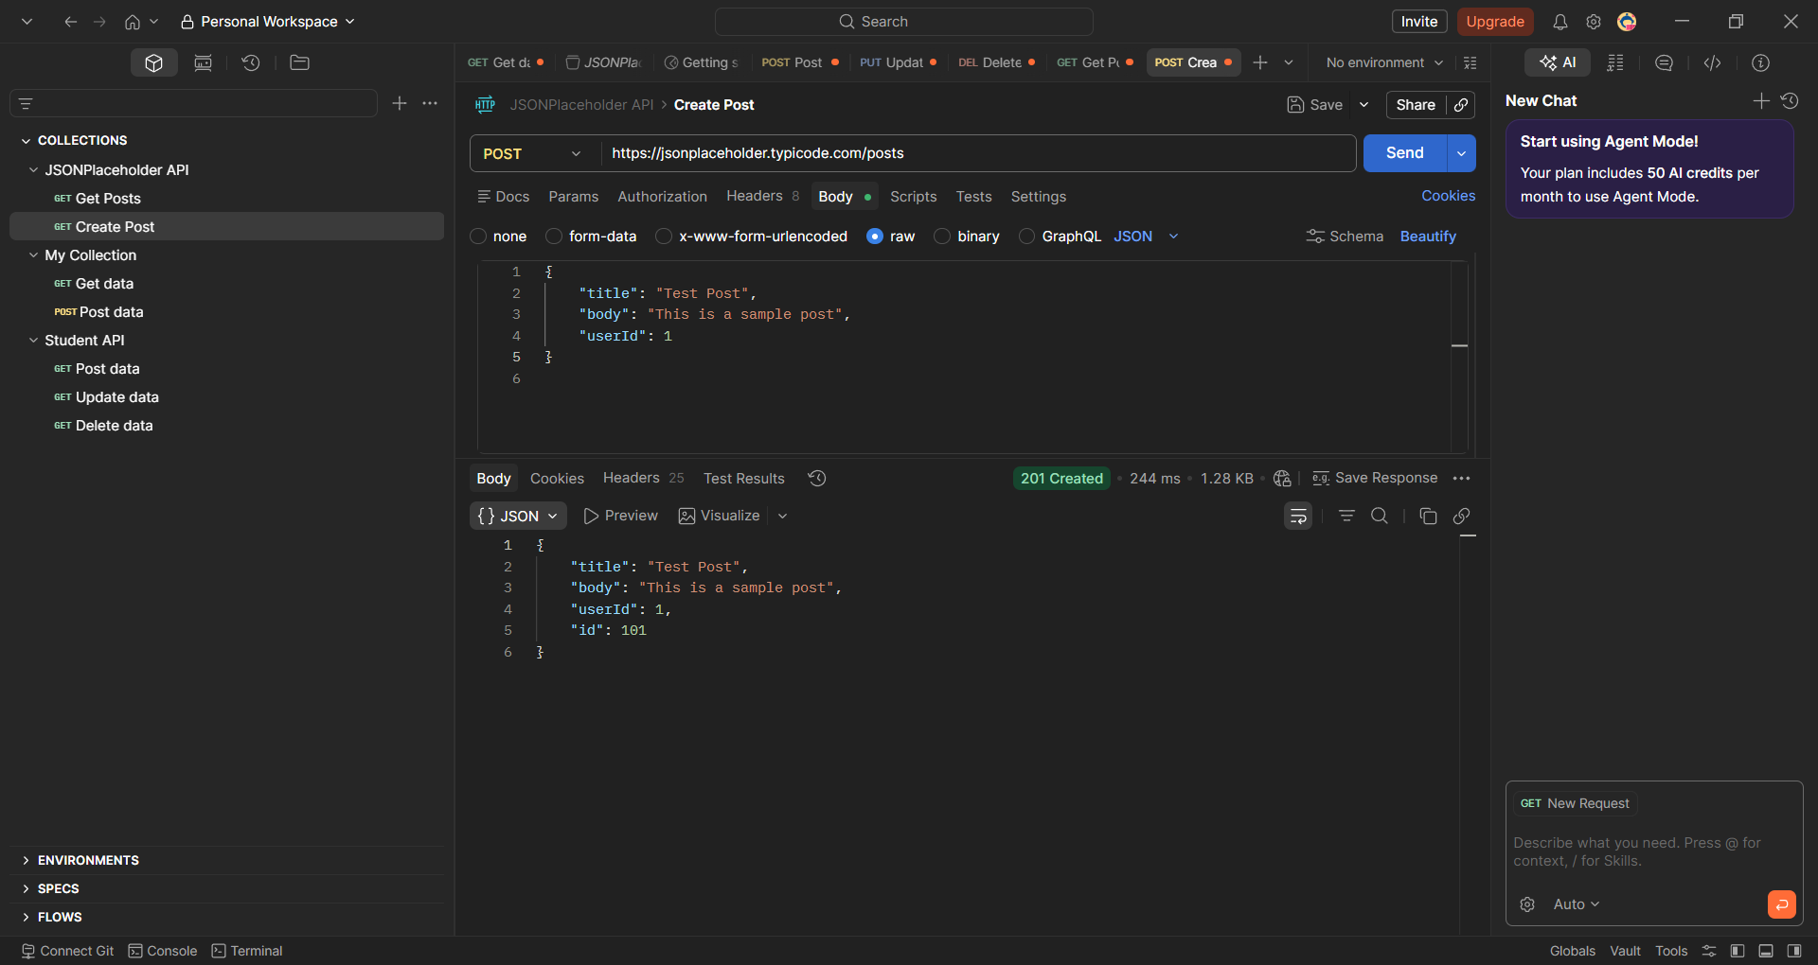

Put:
https://jsonplaceholder.typicode.com/posts/1
{
"id": 1,
"title": "Updated Title",
"body": "Updated content",
"userId": 1
}
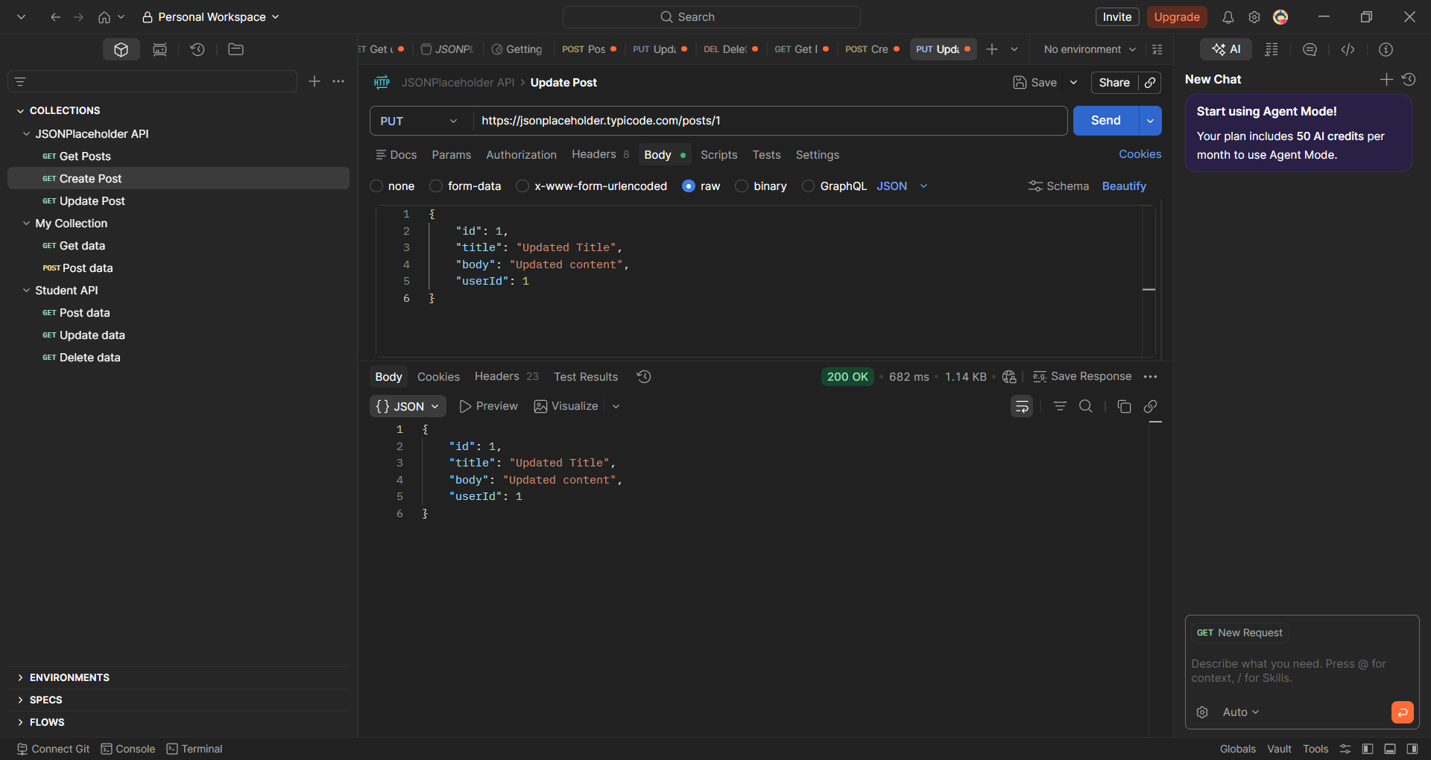

Delete:
https://jsonplaceholder.typicode.com/posts/1
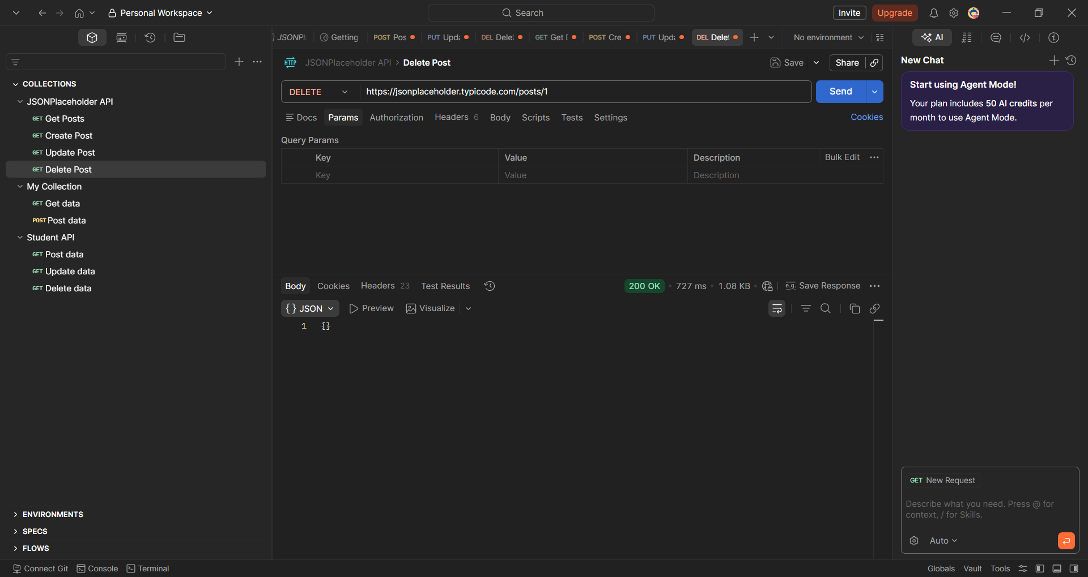

4. Create node.js API
Step 1: Create Project
mkdir simple-api
cd simple-api
npm init -y
npm install express
Step 2: Create server.js file
const express = require('express');
const app = express();
app.use(express.json());
let students = [
{ id: 1, name: "Viraj", branch: "CE" },
{ id: 2, name: "Ravi", branch: "CE" }
];
app.get('/students', (req, res) => {
res.json(students);
});
app.get('/students/:id', (req, res) => {
const student = students.find(s => s.id == req.params.id);
res.json(student);
});
app.post('/students', (req, res) => {
const newStudent = {
id: students.length + 1,
name: req.body.name,
branch: req.body.branch
};
students.push(newStudent);
res.status(201).json(newStudent);
});
app.put('/students/:id', (req, res) => {
const student = students.find(s => s.id == req.params.id);
if (student) {
student.name = req.body.name;
student.branch = req.body.branch;
res.json(student);
} else {
res.status(404).json({ message: "Student not found" });
}
});
// DELETE - Remove student
app.delete('/students/:id', (req, res) => {
students = students.filter(s => s.id != req.params.id);
res.json({ message: "Student deleted" });
});
app.listen(3000, () => {
console.log("Server running on http://localhost:3000");
});
Step 3: Run server
Node server.js
Command :
Microsoft Windows [Version 10.0.26200.8037]
(c) Microsoft Corporation. All rights reserved.

C:\Users\prash>cd C:\Users\prash\Desktop
C:\Users\prash\Desktop>mkdir simple-api
C:\Users\prash\Desktop>cd simple-api
C:\Users\prash\Desktop\simple-api>npm init -y
Wrote to C:\Users\prash\Desktop\simple-api\package.json:
{
"name": "simple-api",
"version": "1.0.0",
"description": "",
"main": "index.js",
"scripts": {
"test": "echo \"Error: no test specified\" && exit 1"
},
"keywords": [],
"author": "",
"license": "ISC",
"type": "commonjs"
}

C:\Users\prash\Desktop\simple-api>npm install express

added 65 packages, and audited 66 packages in 2s

22 packages are looking for funding
run `npm fund` for details

found 0 vulnerabilities
C:\Users\prash\Desktop\simple-api>notepad server.js
Server running on http://localhost:3000

5. Procedure TEST using postman
1. GetAll:
Type: Get
URL : http://localhost:3000/students
Check response
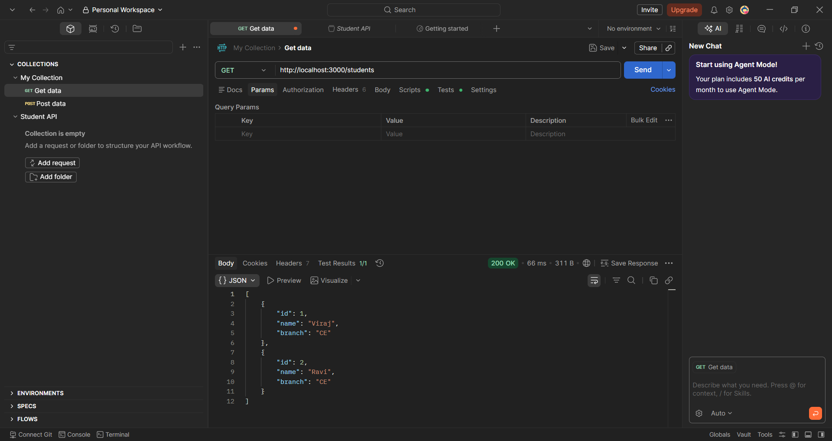

2. Post:
Type: Post
URL: http://localhost:3000/students
Body:
{
"name": "Prashant",
"branch": "CE"
}
Check response
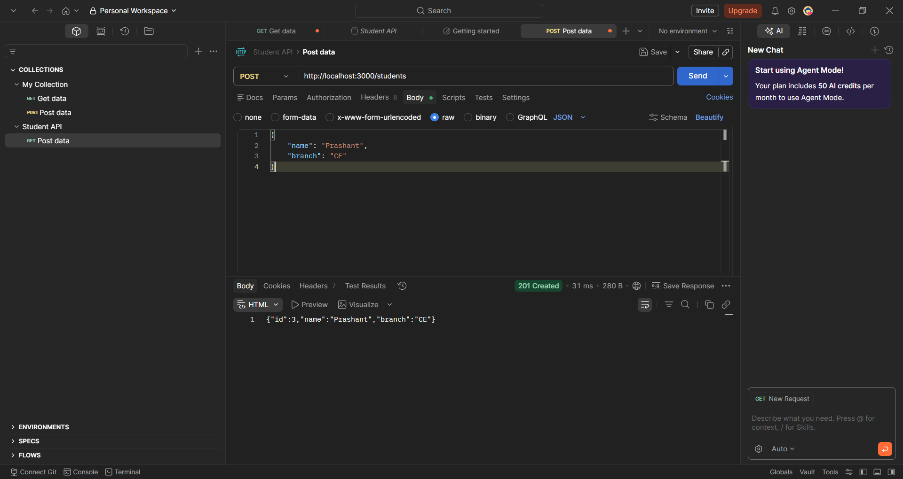

Send Get request to see new data inserted
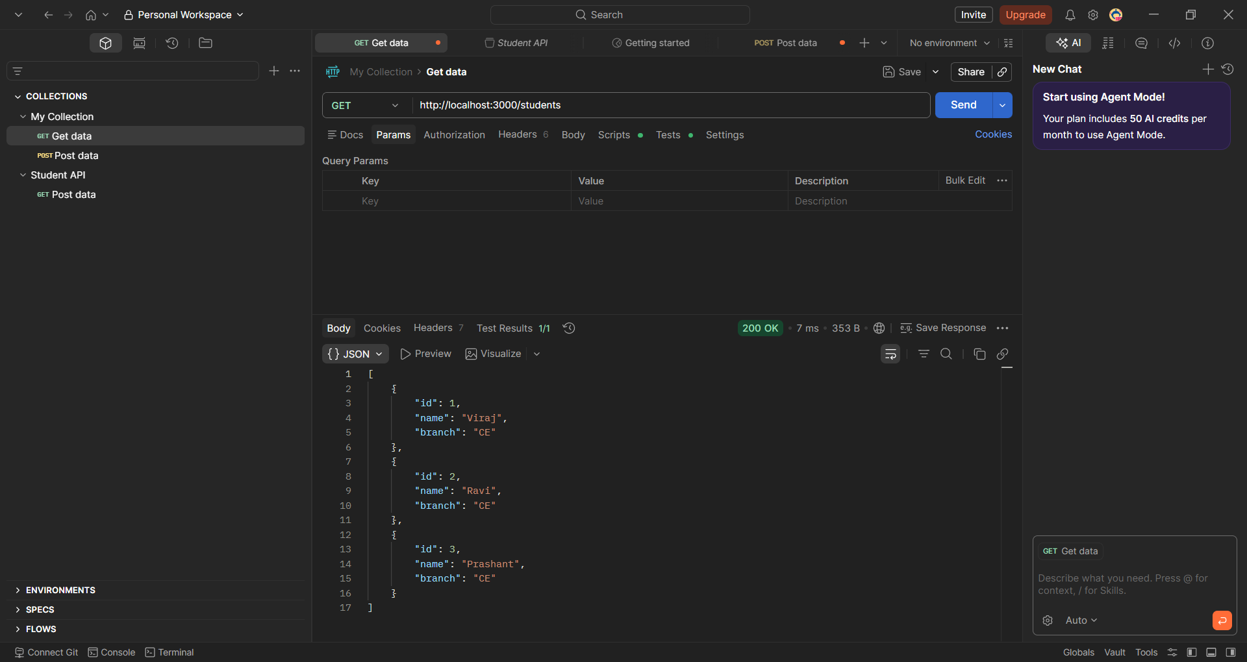

3. Put request:
Type: PUT
URL : http://localhost:3000/students/1
Body:
{
"name": "Viraj Updated",
"branch": "IT"
}
Check response
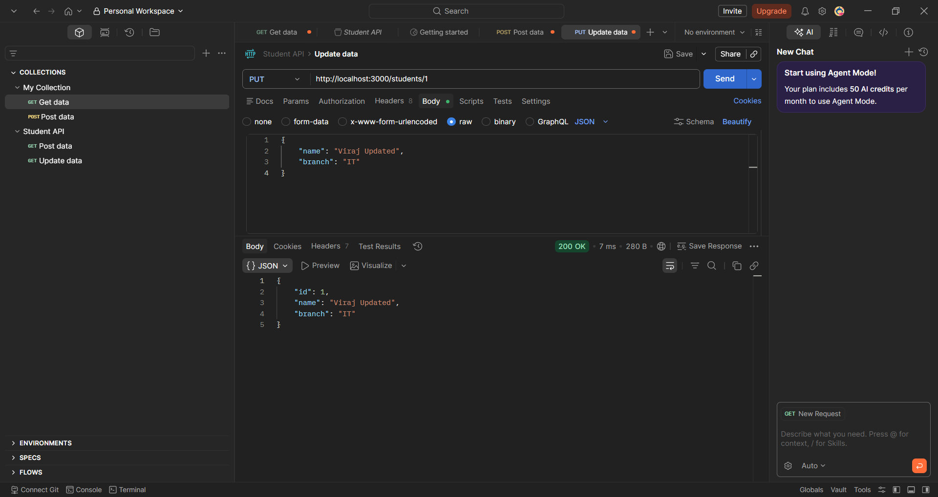

Send Get request to see updated data
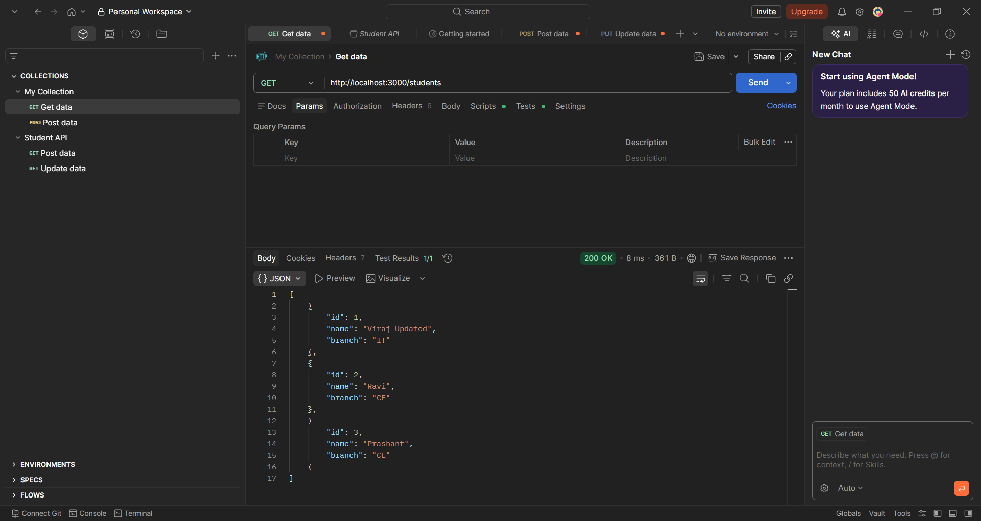

4. Delete request:
Type: DELETE
URL : http://localhost:3000/students/1
Check response
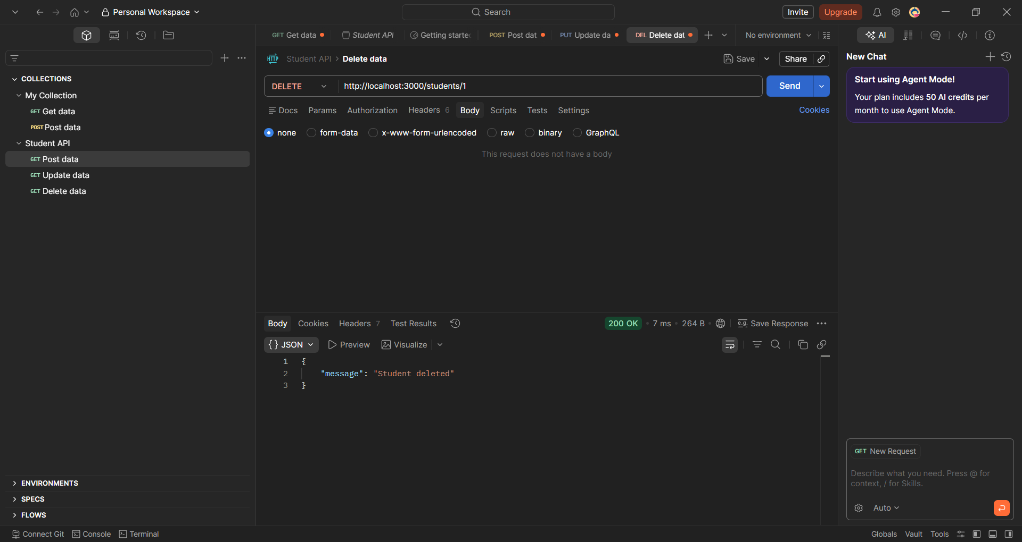

Send Get request to see updated data
