Experiment 9
AIM: Use pytest to test python application.
1. Objective
⮚ Understand unit testing concepts
⮚ Write test cases using PyTest
⮚ Execute and analyze test results
⮚ Handle edge cases and exceptions
⮚ Use parameterized testing
2. Prerequisites
⮚ Python
⮚ Pytest
3. Installation
Install pytest using pip:
pip install pytest
Verify it :
pytest –version
4. Create a Python module with basic mathematical operations and write PyTest test cases to validate:
⮚ Correct outputs
⮚ Edge cases
⮚ Exception handling
Step 1: Create Project PythonDemo and add file pythondemo.py
def add(a, b):
return a + b
def subtract(a, b):
return a - b
def multiply(a, b):
return a * b
def divide(a, b):
if b == 0:
raise ValueError("Cannot divide by zero")
return a / b
def is_even(num):
return num % 2 == 0
Step 2: Create a test file test_pythondemo.py
import pytest
import pythondemo
# Passing test
def test_add():
assert pythondemo.add(2, 3) == 5
# Failing test
def test_multiply_fail():
assert pythondemo.multiply(4, 3) == 11
# Exception test
def test_divide_by_zero():
with pytest.raises(ValueError):
pythondemo.divide(10, 0)
# Logical test
def test_is_even():
assert pythondemo.is_even(4) is True
assert pythondemo.is_even(5) is False
# Parametrized test
@pytest.mark.parametrize("a,b,result", [
(1,2,3),
(2,2,4),
(5,5,11) # failing case
])
def test_add_param(a,b,result):
assert pythondemo.add(a,b) == result
5. Execution
Open terminal in that folder
pytest –v
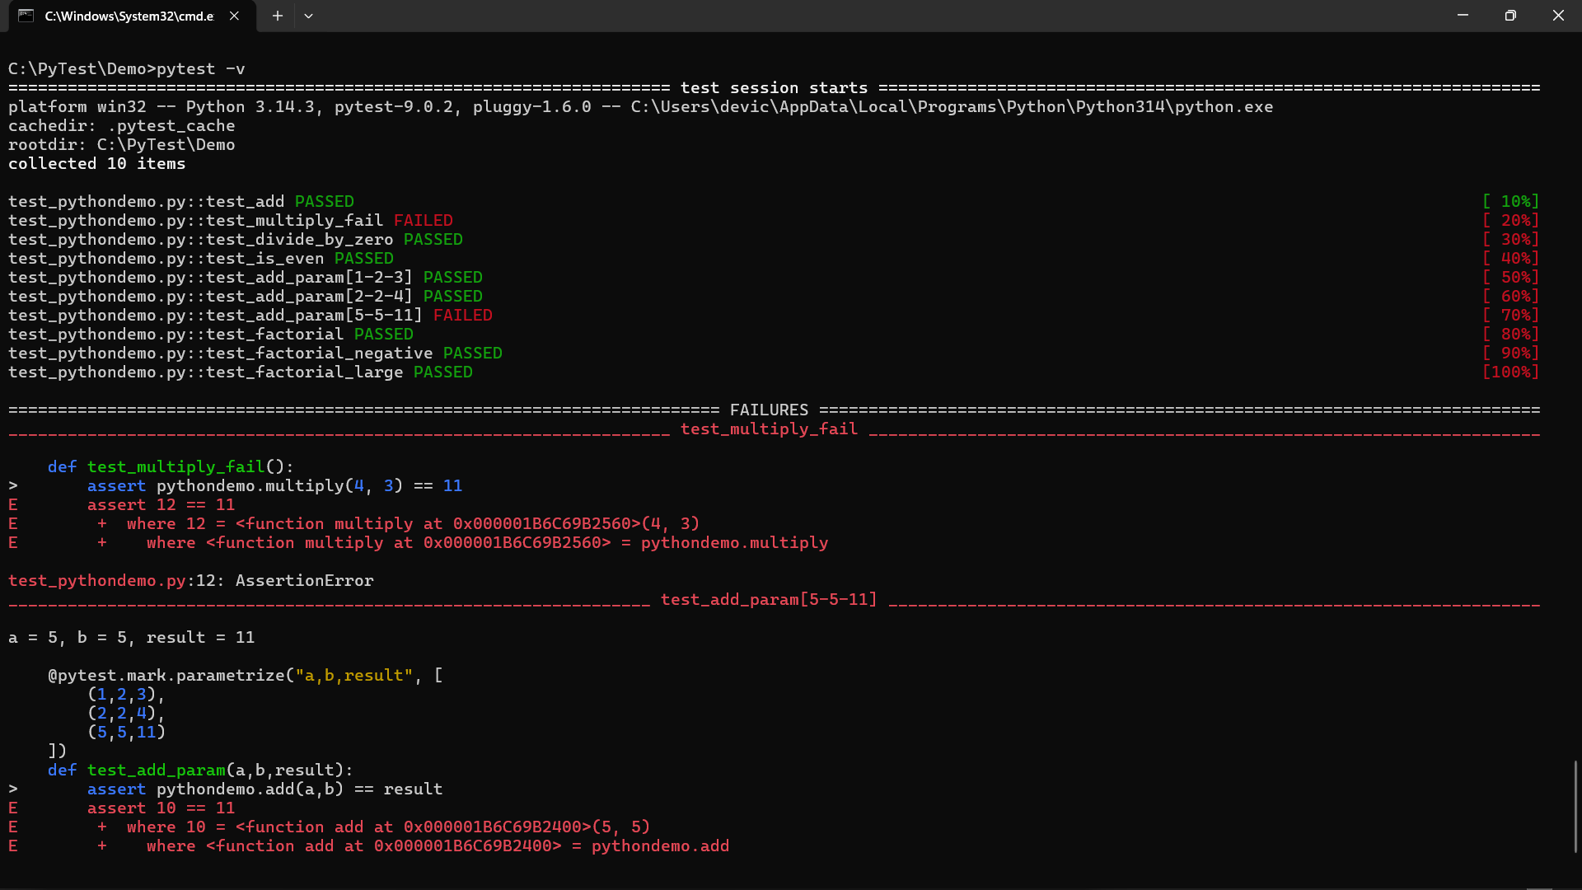

Task 1 and 2:
- PythonDemp.py
def add(a, b):
return a + b

def subtract(a, b):
return a - b

def multiply(a, b):
return a * b

def divide(a, b):
if b == 0:
raise ValueError("Cannot divide by zero")
return a / b

def is_even(num):
return num % 2 == 0

# Task 1 — factorial function
def factorial(n):
if n < 0:
raise ValueError("Negative numbers not allowed")

result = 1
for i in range(1, n + 1):
result *= i

return result

- Test_PythonDemo.py
import pytest
import PythonDemo

# Passing test
def test_add():
assert PythonDemo.add(2, 3) == 5

# Failing test
def test_multiply_fail():
assert PythonDemo.multiply(4, 3) == 11

# Exception test
def test_divide_by_zero():
with pytest.raises(ValueError):
PythonDemo.divide(10, 0)

# Logical test
def test_is_even():
assert PythonDemo.is_even(4) is True
assert PythonDemo.is_even(5) is False

# Parameterized test
@pytest.mark.parametrize("a,b,result", [
(1,2,3),
(2,2,4),
(5,5,11) # failing case
])
def test_add_param(a,b,result):
assert PythonDemo.add(a,b) == result

# Task 1 — factorial tests
def test_factorial():
assert PythonDemo.factorial(5) == 120
assert PythonDemo.factorial(0) == 1

# Task 2 — negative number test
def test_factorial_negative():
with pytest.raises(ValueError):
PythonDemo.factorial(-5)

# Task 2 — large input test
def test_factorial_large():
assert PythonDemo.factorial(10) == 3628800
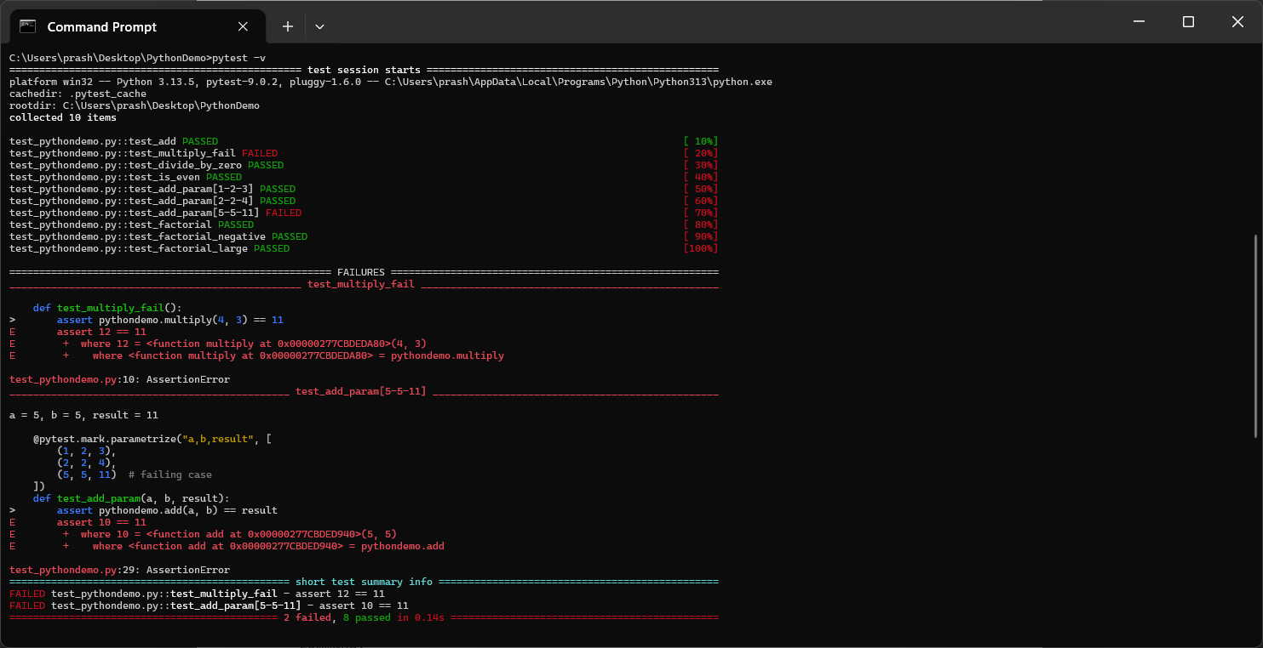
Command:
Microsoft Windows [Version 10.0.26200.8037]
(c) Microsoft Corporation. All rights reserved.

C:\Users\prash>pip install pytest
Collecting pytest
Downloading pytest-9.0.2-py3-none-any.whl.metadata (7.6 kB)
Collecting colorama>=0.4 (from pytest)
Using cached colorama-0.4.6-py2.py3-none-any.whl.metadata (17 kB)
Collecting iniconfig>=1.0.1 (from pytest)
Downloading iniconfig-2.3.0-py3-none-any.whl.metadata (2.5 kB)
Requirement already satisfied: packaging>=22 in c:\users\prash\appdata\local\programs\python\python313\lib\site-packages (from pytest) (26.0)
Collecting pluggy<2,>=1.5 (from pytest)
Downloading pluggy-1.6.0-py3-none-any.whl.metadata (4.8 kB)
Collecting pygments>=2.7.2 (from pytest)
Downloading pygments-2.20.0-py3-none-any.whl.metadata (2.5 kB)
Downloading pytest-9.0.2-py3-none-any.whl (374 kB)
Downloading pluggy-1.6.0-py3-none-any.whl (20 kB)
Using cached colorama-0.4.6-py2.py3-none-any.whl (25 kB)
Downloading iniconfig-2.3.0-py3-none-any.whl (7.5 kB)
Downloading pygments-2.20.0-py3-none-any.whl (1.2 MB)
━━━━━━━━━━━━━━━━━━━━━━━━━━━━━━━━━━━━━━━━ 1.2/1.2 MB 9.2 MB/s eta 0:00:00
Installing collected packages: pygments, pluggy, iniconfig, colorama, pytest
Successfully installed colorama-0.4.6 iniconfig-2.3.0 pluggy-1.6.0 pygments-2.20.0 pytest-9.0.2

[notice] A new release of pip is available: 25.1.1 -> 26.0.1
[notice] To update, run: python.exe -m pip install --upgrade pip

C:\Users\prash>pytest --version
pytest 9.0.2

C:\Users\prash>cd C:\Users\prash\Desktop

C:\Users\prash\Desktop>mkdir PythonDemo

C:\Users\prash\Desktop>cd PythonDemo

C:\Users\prash\Desktop\PythonDemo>notepad pythondemo.py

C:\Users\prash\Desktop\PythonDemo>notepad test_pythondemo.py

C:\Users\prash\Desktop\PythonDemo>pytest -v
================================================= test session starts =================================================
platform win32 -- Python 3.13.5, pytest-9.0.2, pluggy-1.6.0 -- C:\Users\prash\AppData\Local\Programs\Python\Python313\python.exe
cachedir: .pytest_cache
rootdir: C:\Users\prash\Desktop\PythonDemo
collected 10 items

test_pythondemo.py::test_add PASSED [ 10%]
test_pythondemo.py::test_multiply_fail FAILED [ 20%]
test_pythondemo.py::test_divide_by_zero PASSED [ 30%]
test_pythondemo.py::test_is_even PASSED [ 40%]
test_pythondemo.py::test_add_param[1-2-3] PASSED [ 50%]
test_pythondemo.py::test_add_param[2-2-4] PASSED [ 60%]
test_pythondemo.py::test_add_param[5-5-11] FAILED [ 70%]
test_pythondemo.py::test_factorial PASSED [ 80%]
test_pythondemo.py::test_factorial_negative PASSED [ 90%]
test_pythondemo.py::test_factorial_large PASSED [100%]

====================================================== FAILURES =======================================================
_________________________________________________ test_multiply_fail __________________________________________________

def test_multiply_fail():
> assert pythondemo.multiply(4, 3) == 11
E assert 12 == 11
E + where 12 = <function multiply at 0x00000277CBDEDA80>(4, 3)
E + where <function multiply at 0x00000277CBDEDA80> = pythondemo.multiply

test_pythondemo.py:10: AssertionError
_______________________________________________ test_add_param[5-5-11] ________________________________________________

a = 5, b = 5, result = 11

@pytest.mark.parametrize("a,b,result", [
(1, 2, 3),
(2, 2, 4),
(5, 5, 11) # failing case
])
def test_add_param(a, b, result):
> assert pythondemo.add(a, b) == result
E assert 10 == 11
E + where 10 = <function add at 0x00000277CBDED940>(5, 5)
E + where <function add at 0x00000277CBDED940> = pythondemo.add

test_pythondemo.py:29: AssertionError
=============================================== short test summary info ===============================================
FAILED test_pythondemo.py::test_multiply_fail - assert 12 == 11
FAILED test_pythondemo.py::test_add_param[5-5-11] - assert 10 == 11
============================================= 2 failed, 8 passed in 0.14s =============================================

