**Accuknox**

1. **Signals in Django**

**Q1. By default, django signals executed synchronously or asynchronously?**

* Django execute signals synchronously.

Let me make you understand by code snippet. Basically I will be creating a signal handler and then put 3 seconds pause in between main execution and give command to print the complete execution message If it calls before 3 seconds then its asynchronous else its synchronous

Steps to be performed –

1. Import required modules
2. Defining the signal handler
3. Trigger the signal

Code snippet –

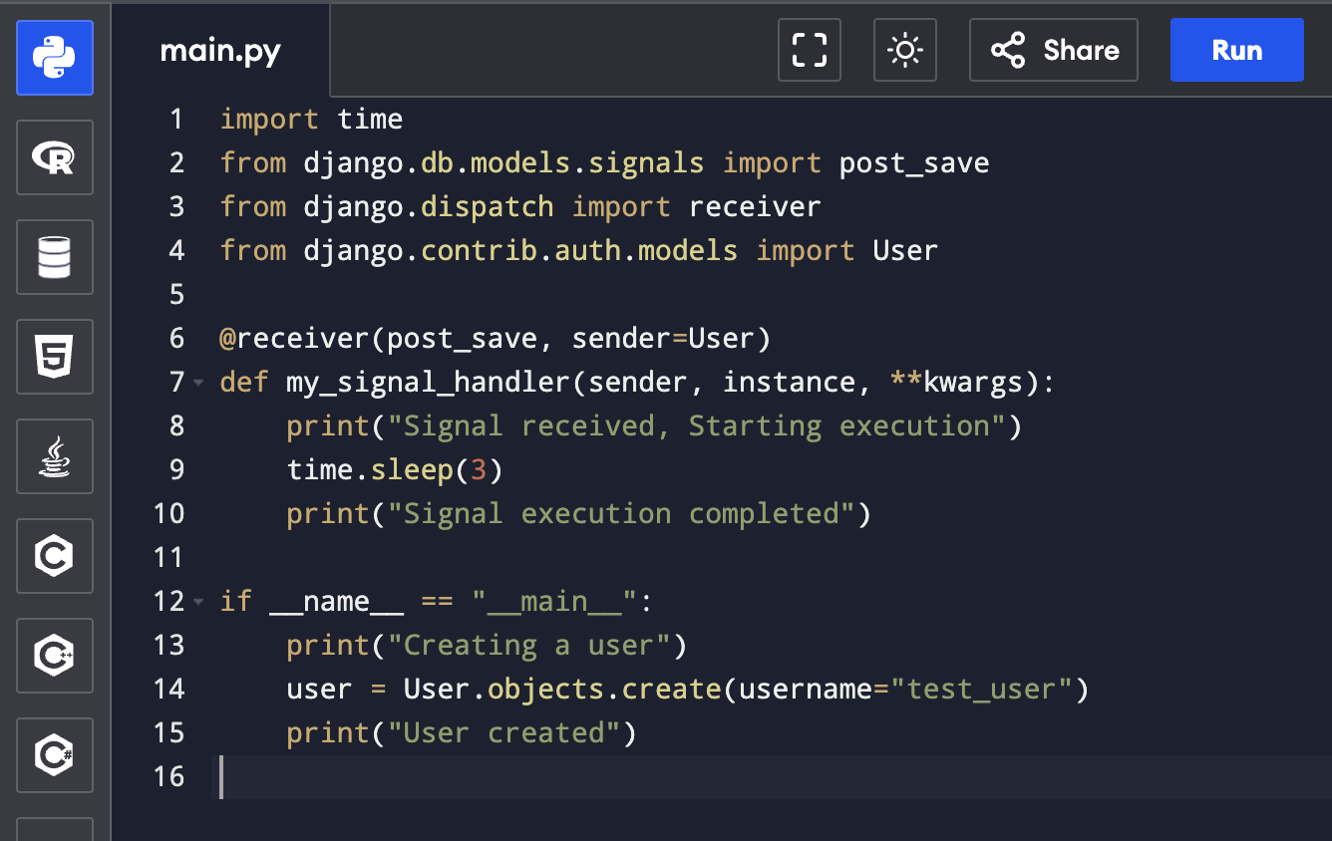

**Q2. In django, signals run in same thread as caller?**

* Yes, by default it does as when a signal is triggered, the receiver function runs.

To check this we can call signal and check the thread IDs in both main execution and signal handler by comparing if both are same then it runs in same thread else it doesn’t

Steps –

1. Importing thread.get_ident
2. Defining a signal
3. Printing thread IDs in both state
4. Comparing IDs

Code snippet -

Q3. Do django signals runs in same DB transaction as the caller?

* By default yes it does run in same DB
* If transaction is successful, signal will be executed else if its unsuccessful/rollbacked, signal will be rollbacked too

To check I’ll create a transaction and then intentionally to check we will raise an exception

Steps –

1. Create a user
2. Log message inside signal
3. Raise an exception to check

Code snippet -

**creating a Rectangle class**

1. Length and width initialize as integer value
2. Iterate
3. Get len and width

Code snippet –

