Given a road network represented as a graph and some cars’ locations from GPS, the car may exactly be on the road because of GPS deviation. In this solution, an R-Tree is used to figure out the road nearest to a car and then the perpendicular distance to that road is calculated (approximated here), for a dataset provided by Uber in Beijing.

The archery library for Scala (<https://github.com/meetup/archery>) is used to implement the R-Tree. Please compile the jar file from the above link directly. Sample data is also provided in this repository.

The exact location of a car is the perpendicular distance between the car and the nearest road. For example,[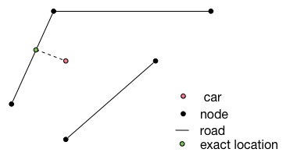](http://bigdata2016.pacman-thu.org/lib/exe/detail.php?id=hw3&media=exact_location.png)

Tested on the spark-shell. To run

1. spark-shell -classpath archery.jar
2. Paste the code in the main method in main.scala