**WEBSITE ON AUDITORIUM BOOKING**

**A PROJECT REPORT**

*Submitted by*

**GROUP 231**

**NAME OF THE CANDIDATES**

**(Registration No)**

Giriraj Pradeep Parsewar

Samriddhi Saraf

Prashasti Priya

Pranjali Srivastava

Ridhima Srivastava

22BCE10681

22BCE10734

22BCE10737

22BCE11114

22BCE11648

*in partial fulfilment for the award of the degree*

*of*

**BACHELOR OF TECHNOLOGY**

*in*

**PROGRAM OF STUDY**

**CSE - CORE**



**SCHOOL OF COMPUTING SCIENCE AND ENGINEERING**

**VIT BHOPAL UNIVERSITY**

**KOTHRIKALAN, SEHORE**

**MADHYA PRADESH - 466114**

AUGUST, 2023

**BACHELOR OF TECHNOLOGY**

*in*

**COMPUTER SCIENCE AND ENGINEERING**

**VIT BHOPAL UNIVERSITY, KOTHRIKALAN SEHORE**

**MADHYA PRADESH – 466114**

**BONAFIDE CERTIFICATE**

Certified that this project report titled **“…. WEBSITE ON AUDITORIUM BOOKING ...”** is the bonafide work of

* 1. **22BCE10681 Giriraj Pradeep Parsewar**
  2. **22BCE10734 Samriddhi Saraf**
  3. **22BCE10737 Prashasti Priya**
  4. **22BCE11114 Pranjali Srivastava**
  5. **22BCE11648 Ridhima Srivastava**

who carried out the project work under my supervision. Certified further that to the best of my knowledge the work reported here does not form part of any other project / research work on the basis of which a degree or award was conferred on an earlier occasion on this or any other candidate.

**PROGRAM CHAIR**

Dr. Preetam Suman

Program Chair, CSE-CORE, SCSE

School of Computer Science and Engineering

VIT BHOPAL UNIVERSITY

**PROJECT GUIDE**

Dr. Rajneesh Kumar Patel

School of Computer Science and Engineering

VIT BHOPAL UNIVERSITY

The Project Exhibition I Examination is held on __/__/2023.

**ACKNOWLEDGEMENT**

First and foremost, I would like to thank the Lord Almighty for His presence and immense blessings throughout the project work.

I wish to express my heartfelt gratitude to Dr. Preetam Suman, Program Chair, CSE-Core, SCSE School of Computer Science and Engineering, for much of his valuable support encouragement in carrying out this work.

I would like to thank my internal guide Dr. Rajneesh Kumar Patel, for continually guiding and actively participating in my project, giving valuable suggestions to complete the project work.

I would like to thank all the technical and teaching staff of the School of Computer Science and Engineering, who extended directly or indirectly all support.

Last, but not the least, I am deeply indebted to my parents who have been the greatest support while I worked day and night for the project to make it a success.

**TABLE OF CONTENTS**

|  |  |  |
| --- | --- | --- |
| **Index No.** | **Content** | **Page No.** |
| **1.** | **List of tables** | **6** |
| **2.** | **Abstract** | **7** |
|  | **Introduction**   * **Area of computer science** * **Hardware and software requirements**   + - **Hardware**     - **Software** * **Problem definition and objective** * **Background** * **Design** * **Data flow diagram** | **8-11** |
| **3.** | **Literature review**   * **Front-end development** * **Back-end development** * **Major input and output and major functions of the system** * **Inputs** * **Outputs** | **12-14** |
| **4.** | **Snapshots**   * **Homepage** * **Login page** * **User homepage** * **New and previous booking service page** * **Admin homepage** * **Booking approval/rejection page** * **Logout page** | **15-22** |
| **5.** | **System analysis**   * **Existing system** * **Proposed system** | **23** |
| **6.** | **Future enhancements** | **24** |
| **7.** | **Conclusion** | **25** |
| **8.** | **References** | **26** |

**LIST OF TABLES**

|  |  |
| --- | --- |
| **TABLE NO.** | **TITLE** |
|  | **User Login** |
|  | **User Sign up** |
|  | **Available Slots** |
|  | **Request Booking** |
|  | **Requested Booking** |
|  | **Booking Approved** |

**ABSTRACT**

An auditorium booking website for a university is a valuable tool that serves multiple purposes, enhancing the overall experience for students, faculty, and the institution as a whole. This digital platform allows users to book and manage auditorium spaces efficiently, while also providing a comprehensive overview of upcoming university events.

One of the key advantages of such a website is the streamlining of auditorium booking processes. Universities often have multiple events with varying arrangements and features, they often have various intermediaries for the booking of the auditorium making manual booking procedures cumbersome and prone to errors. With an online booking system, users can easily check the availability of auditoriums, choose suitable dates and times, and make reservations, all from the comfort of their devices. This simplifies the logistics for both students organizing events and university staff managing auditorium schedules.

Additionally, it serves as a centralized hub where students, faculty, and staff can stay informed about lectures, workshops, seminars, concerts, and other campus events. This transparency fosters a sense of community and engagement, encouraging more participation in university activities. Moreover, it ensures that scheduling conflicts between auditorium bookings and university events are minimized, promoting a harmonious coexistence of various activities on campus.

In conclusion, an auditorium booking website is a powerful asset for any university. It simplifies booking processes, increases transparency regarding campus events, and enhances the overall university experience for students, faculty, and staff. By investing in such a digital platform, universities can effectively manage their resources, promote community engagement, and create a more dynamic and informed campus environment.

**INTRODUCTION**

In today's fast-paced and digitally driven educational landscape, the integration of technology into university operations has become increasingly essential. An auditorium booking website is a dynamic solution designed to simplify and enhance the management of auditorium spaces and events within a university campus. This digital platform empowers users, including students, faculty, and administrators, to efficiently request auditorium bookings for their desired dates and times. The amalgamation of user-friendly features and administrative control not only makes this website a valuable asset but also significantly contributes to the efficient orchestration of academic, cultural, and community activities on campus.

The heart of this system lies in its user sign-up and login capabilities, which provide individuals with the tools they need to interact seamlessly with the university's auditorium resources. Faculty, and event organizers can easily create accounts, enabling them to submit requests for auditorium bookings tailored to their specific needs. This straightforward process eliminates the cumbersome back-and-forth typically associated with manual booking procedures, making it a convenient and time-saving solution.

On the administrative side, the website offers an essential login portal through which university staff can manage and oversee the booking requests. This administrative control ensures that auditorium availability aligns with the university's scheduling requirements. By providing this level of oversight, the website minimizes scheduling conflicts, streamlines resource allocation, and optimizes the use of these valuable spaces.

In conclusion, an auditorium booking and upcoming event viewing website stands as a pivotal tool in modernizing university operations. By enabling users to effortlessly request auditorium bookings, granting administrators the means to manage them efficiently, and promoting campus events, this digital platform not only simplifies logistical challenges but also enhances engagement within the academic community. The combination of user-friendly design and essential features makes it an indispensable asset in creating a more dynamic, informed, and interconnected university environment.

**Area of Computer Science**

Web Development is a broad term for the work involved in developing a web site for the internet or an Intranet (a private network). Web development can range from developing the simplest static single page of plain text to the most complex web-based internet applications, electronic businesses, and social network services.

Using Web development, we can design different types of websites and the web application. A more comprehensive list of tasks to which web development commonly refers, may include web engineering, web design, web content development, client liaison, e-commerce development. Among web professionals, "web development" usually refers to the main non-design aspects of building web sites: writing markup and coding.

**HARDWARE AND SOFTWARE REQUIREMENTS**

**Hardware: -**

RAM: 4 GB

OS: Windows/Mac

**Software: -**

Git & GitHub, Vs code (IDE), Java script

**PROBLEM DEFINITION AND OBJECTIVES**

Purpose:

An auditorium booking website in a university serves the crucial purpose of efficiently managing auditorium spaces and providing a central hub for students and staff to stay informed about upcoming events. It simplifies the booking process, reduces scheduling conflicts, fosters community engagement, and enhances the overall campus experience by promoting attendance at university events. This digital platform streamlines operations and contributes to a vibrant and well-organized university community.

**Main Objectives:**

* Optimizes the utilization of campus resources
* Promotes engagement within the university community
* Provides a convenient and transparent platform for event management and attendance

**BACKGROUND**

Universities, as hubs of diverse academic and cultural activities, often grapple with the efficient allocation of auditorium spaces and the dissemination of information about upcoming events. Recognizing the need for a streamlined solution, we embarked on the journey to create this platform.

Our goal was to empower students, faculty, and staff with the ability to seamlessly request and manage auditorium bookings while providing a centralized space to promote and explore a rich tapestry of upcoming university events. This innovative website not only simplifies administrative processes but also fosters community engagement, ultimately enhancing the vibrancy of campus life and the overall educational experience.

Auditorium booking is a web-based application made in the JAVASCRIPT. So, with the help of this project user can apply for the reservation of auditorium. All details of timing, date and capacity are checked by Admin on the Admin panel. User can request and the admin has to approve thus creating web page that visitors can interact with in wonderful way.

**DESIGN**

The auditorium booking website is the practical implementation of modern technology and digital innovation in the realm of university event management and resource allocation. The coordinators of different clubs can request their appeal under one window. The booking process is made easier for coordinators. The flexibility and enhanced booking environment are provided to customers. The admin is also getting the benefits of the same. Thus, it is very important to focus on design and implementation of the said booking website.

**DATABASE DESIGN / DATA STRUCTURE DESIGN**

**Tables and Relationship**

* In this Project Tour and travel, we used Git & GitHub, Vs code (IDE) as a front end and use MongoDB as a backend.
* Front end is mainly used for the designing purpose or designing the various kinds of forms and implement the logic and the backend is mainly used for, to store the data, records, or the information.
* All the tables are used to store the records, and administrator is able to watch all the data. Now we talk about the tables and how this tables work in a back end that we can know but the main thing is the relationship of the tables.
* That’s the most important thing for the back end. In my project there is a relationship between the tables means all the tables are connected with each other so all the records or the data or the information can easily store and there is a no chance of the mistakes in the tables.
* The relationship between the tables is also considered as a security part if the records are not stored properly so candidate cannot able to work further so it can avoid the chance of the dummy records.

**Data Flow Diagram**

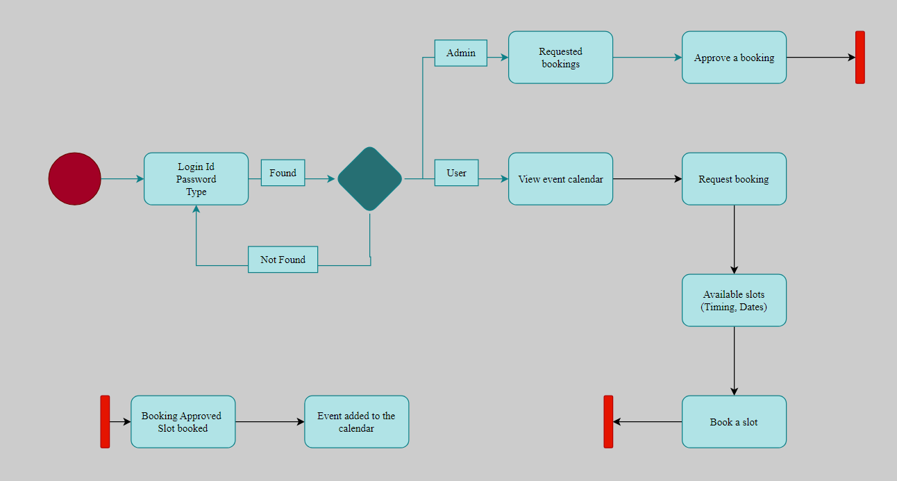

**LITERATURE REVIEW**

Various skills**/**steps are required for the completion of the website

**FRONT-END DEVELOPMENT:**

1. **HTML (Hypertext Markup Language):** HTML is the backbone of web development, responsible for structuring the content on a web page. It defines elements and their relationships, enabling the creation of a cohesive and organized web interface.
2. **CSS (Cascading Style Sheets):** CSS complements HTML by controlling the visual presentation of web pages. It allows developers to apply styles, such as fonts, colours, and layouts, making websites visually appealing and user-friendly.
3. **JS (JavaScript):** JavaScript is a powerful scripting language used to add interactivity and dynamic behaviour to websites. It enables features like form validation, animations, and real-time updates.
4. **Front-End Framework (Angular/React):** Front-end frameworks like Angular and React provide pre-built components and structures to simplify web development. They enhance code organization and maintainability while delivering rich, responsive user interfaces.
5. **Responsive Web Design (Bootstrap/Foundation):** Responsive web design frameworks like Bootstrap and Foundation ensure that websites adapt to various screen sizes and devices. This approach enhances user experience and accessibility.

**BACK-END DEVELOPMENT:**

1. **Node.js:** Node.js is a runtime environment that enables server-side JavaScript execution. It is commonly used for building scalable and high-performance web applications.
2. **Backend Framework (Express.js):** Express.js is a popular backend framework for Node.js, streamlining server-side development. It simplifies routing, middleware management, and database interactions.
3. **RESTful API (Representational State Transfer):** RESTful APIs provide a standardized way for web applications to communicate with each other. They use HTTP requests for data exchange, enabling integration with external services.
4. **Database Fundamentals (MongoDB):** Database fundamentals, such as MongoDB, are essential for storing and managing data in web applications. They allow for efficient data retrieval and storage.
5. **Authentication Authorization:** Authentication and authorization mechanisms secure web applications by verifying user identities and controlling access to resources. They safeguard sensitive data and functionalities.
6. **API Testing:** API testing ensures the reliability and functionality of web services. It involves validating API endpoints, data exchange, and error handling.
7. **Deployment (AWS, Heroku):** Deployment platforms like AWS and Heroku provide infrastructure and services for hosting web applications in a production environment, ensuring accessibility to users.
8. **Continuous Integration and Deployment (Jenkins, Travis):** CI/CD tools like Jenkins and Travis automate the testing, integration, and deployment of code changes, facilitating efficient development workflows.
9. **Performance Optimization:** Performance optimization techniques, such as code minification, caching, and load balancing, enhance web application speed and responsiveness.
10. **DevOps and Deployment Automation (AWS, Netlify, Firebase):** DevOps practices and deployment automation tools like AWS, Netlify, and Firebase streamline collaboration between development and operations teams, enabling seamless and rapid deployment of web applications.

**The major inputs and outputs and major functions of the system are follows:**

**Inputs:**

* Administration enters his admin id and password for login.
* User enters his user id and password for login.
* Administration gives approvals for the various requests of the bookings.
* User gives timings, dates and matter for the events to request a booking.

**Outputs:**

* Administration has his own home page.
* Customer enter his or her own home page.
* The customer-defined data can store in the centralized database.
* Administration will get the information of a particular customer.
* Administration gets the booking details of different events with timings and dates.
* Customer gets his upcoming event calendar.
* User gets requested, pending and approved for their requested booking

**SNAPSHOTS:**

**HOMEPAGE**

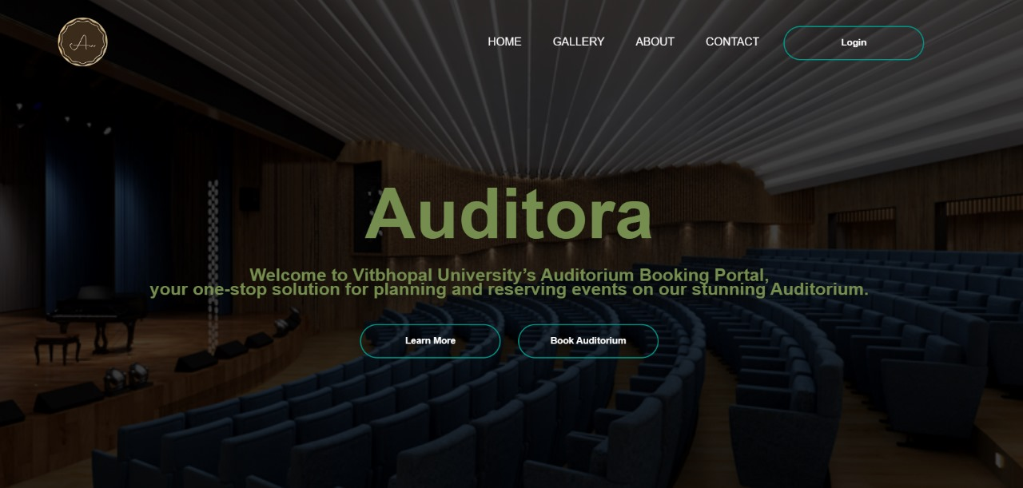

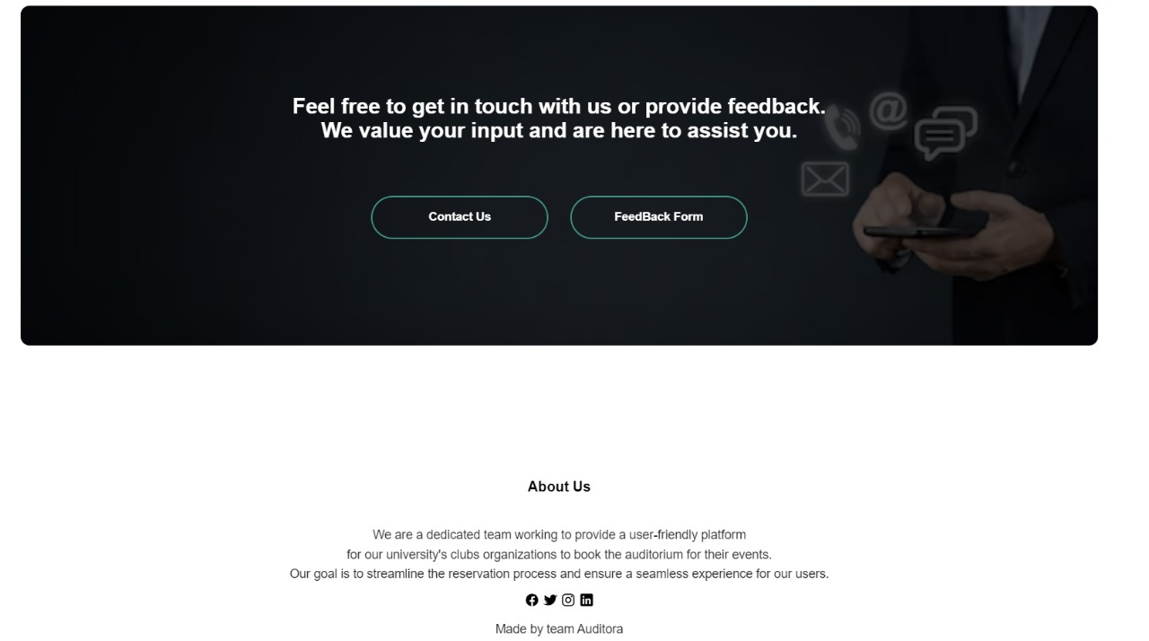

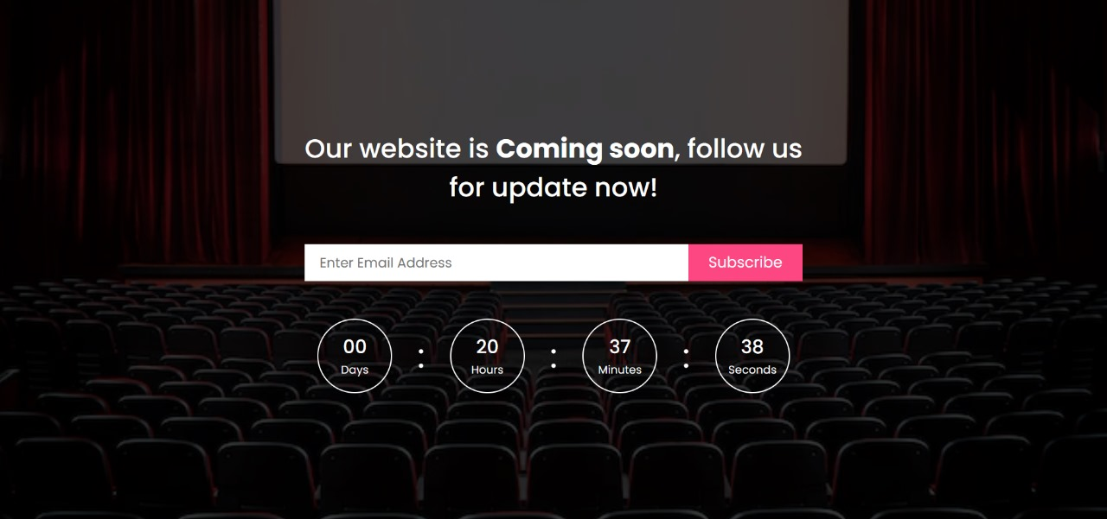

**ABOUT US**

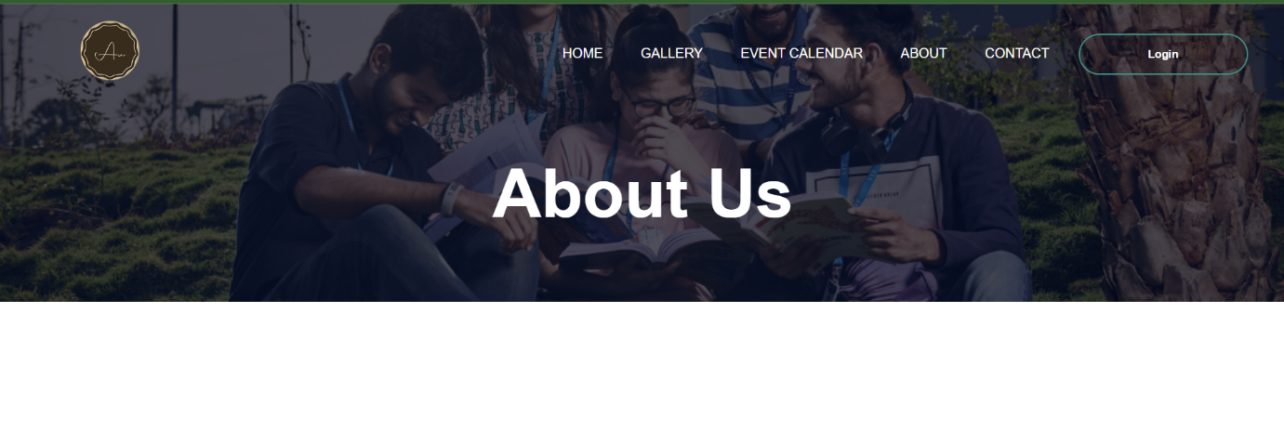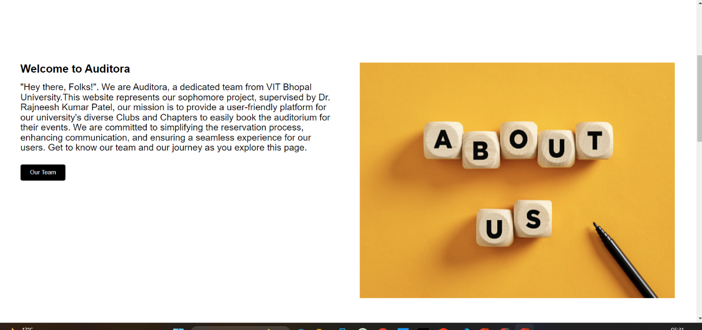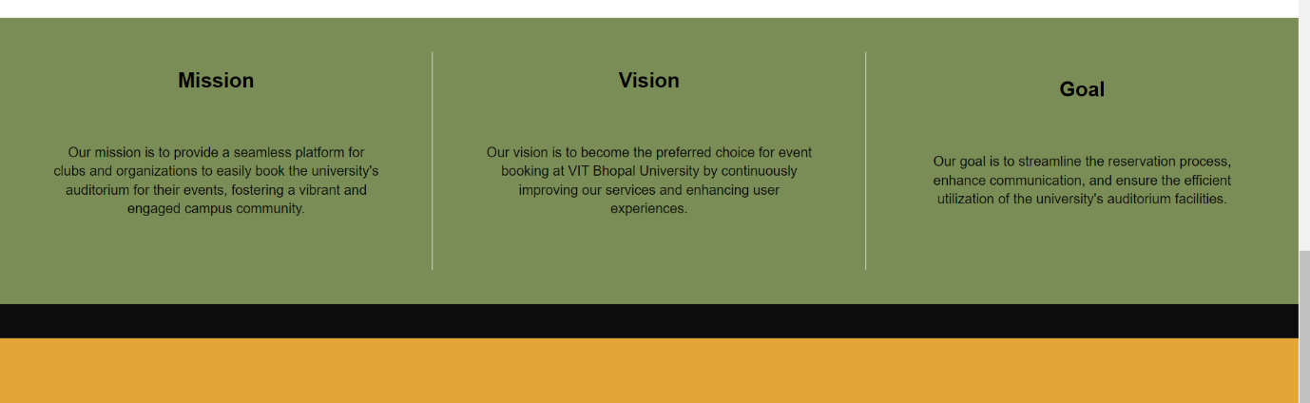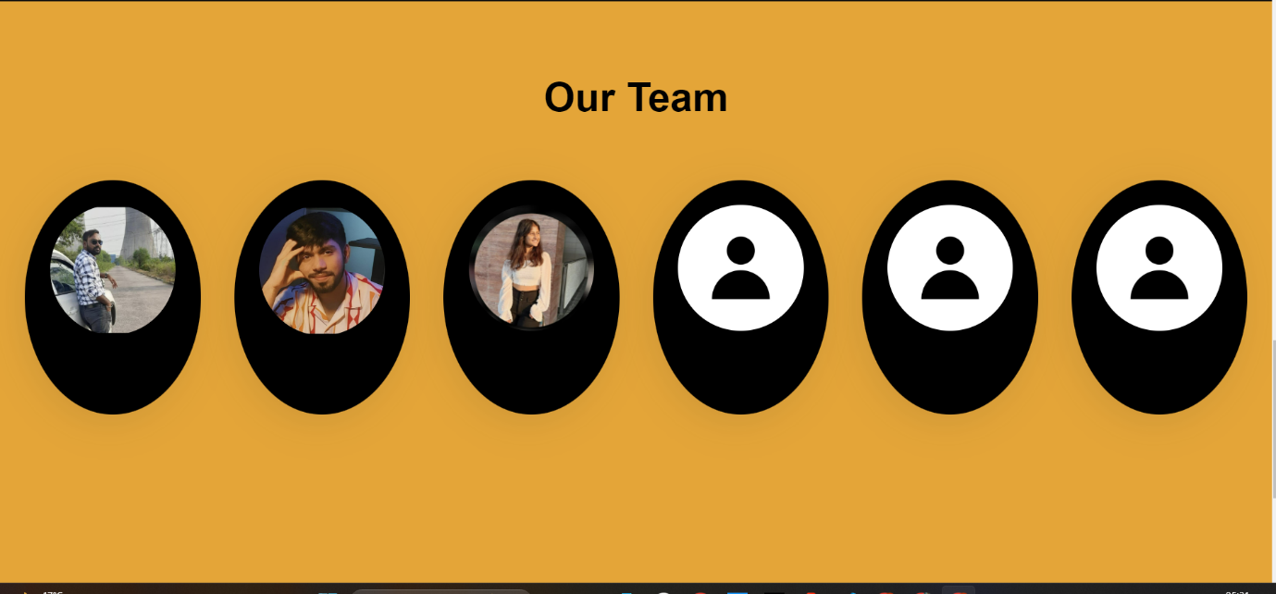

**Contact US and Feedback**

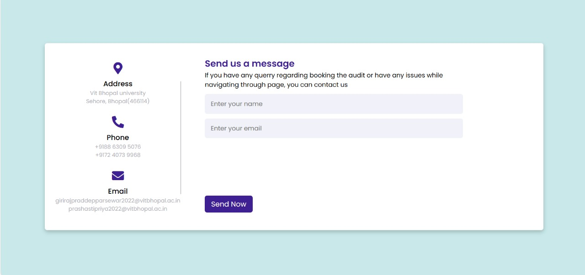

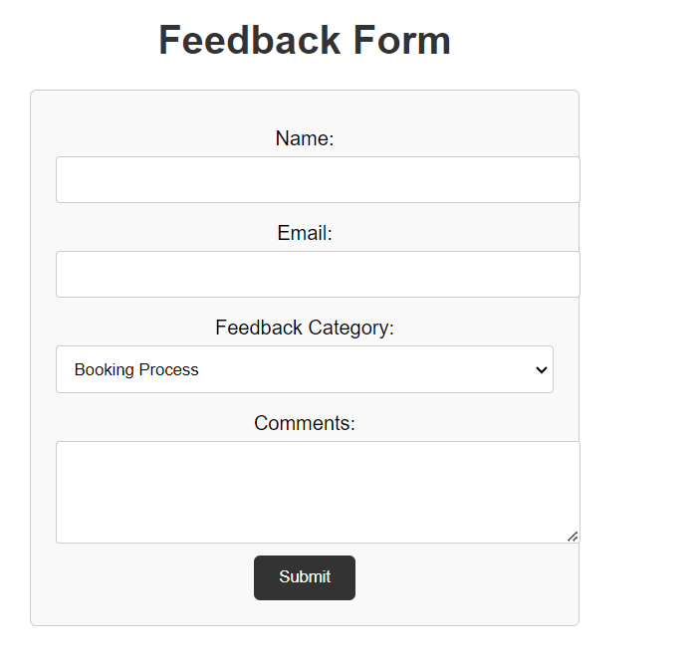

**LOGIN PAGE**:

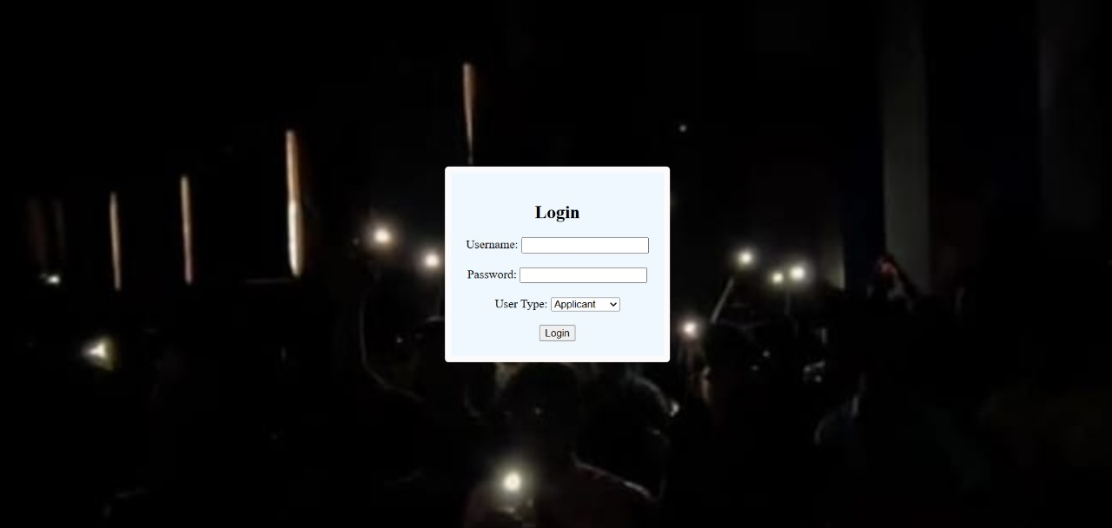

**USER HOME PAGE:**

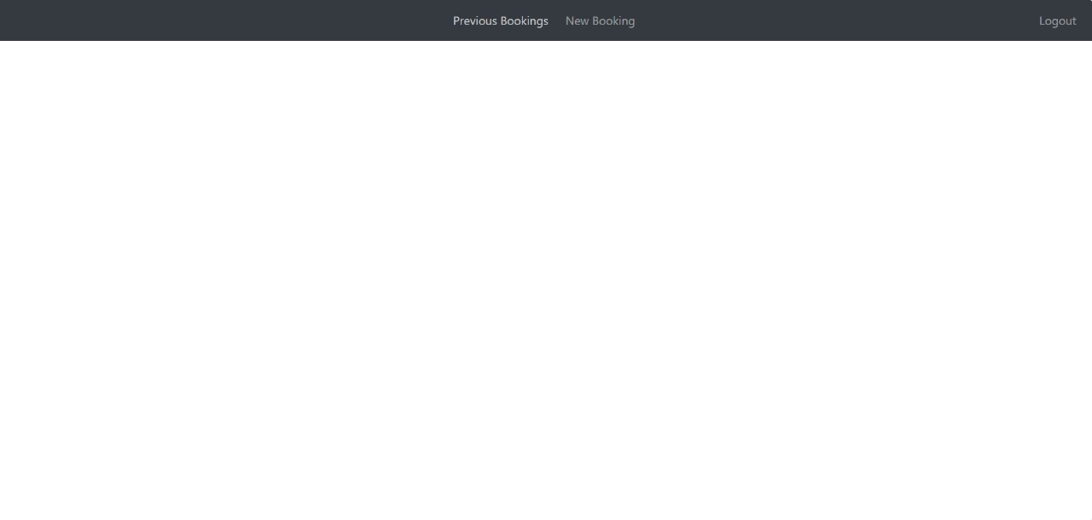**NEW AND PREVIOUS BOOKING SERVICE:**

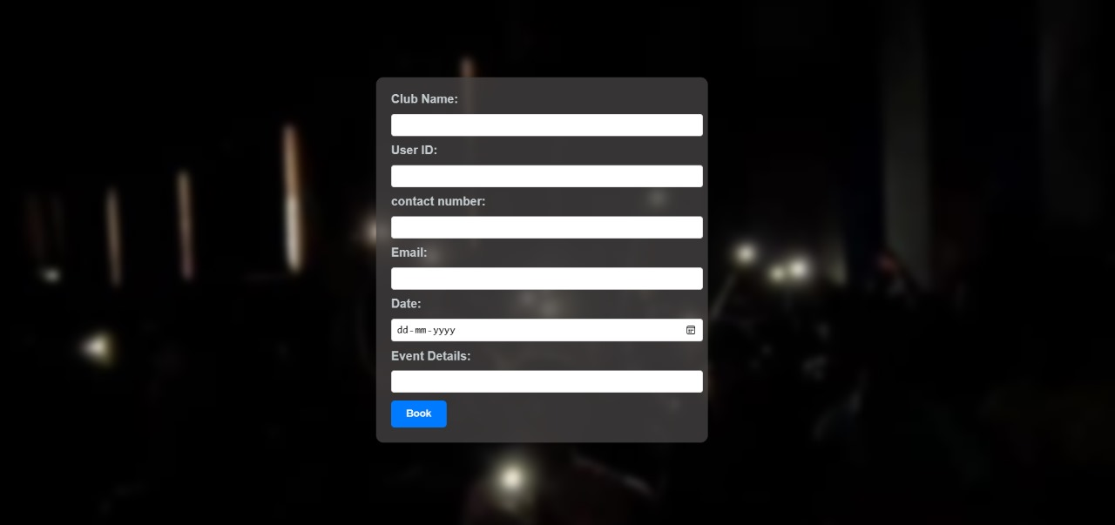

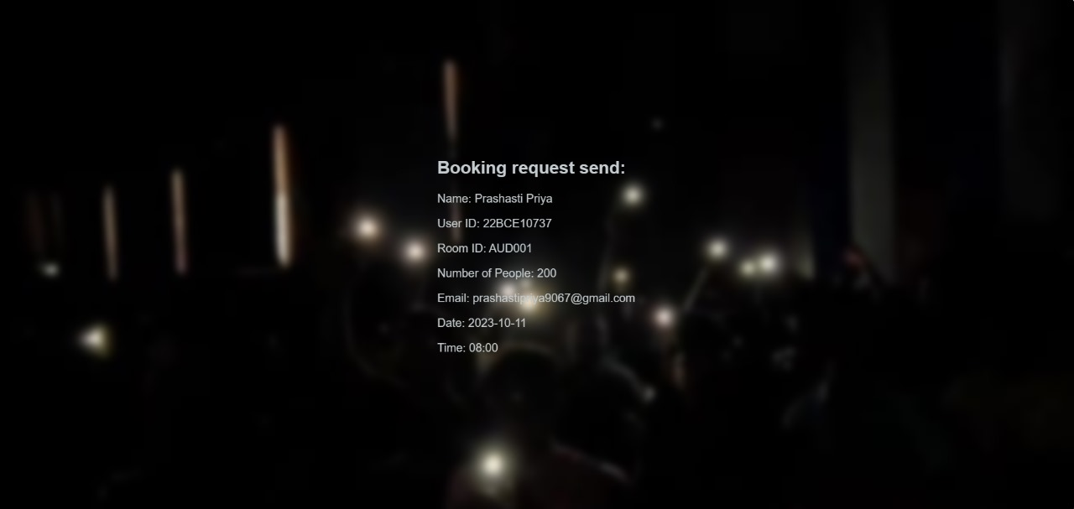

**ADMIN HOME PAGE:**

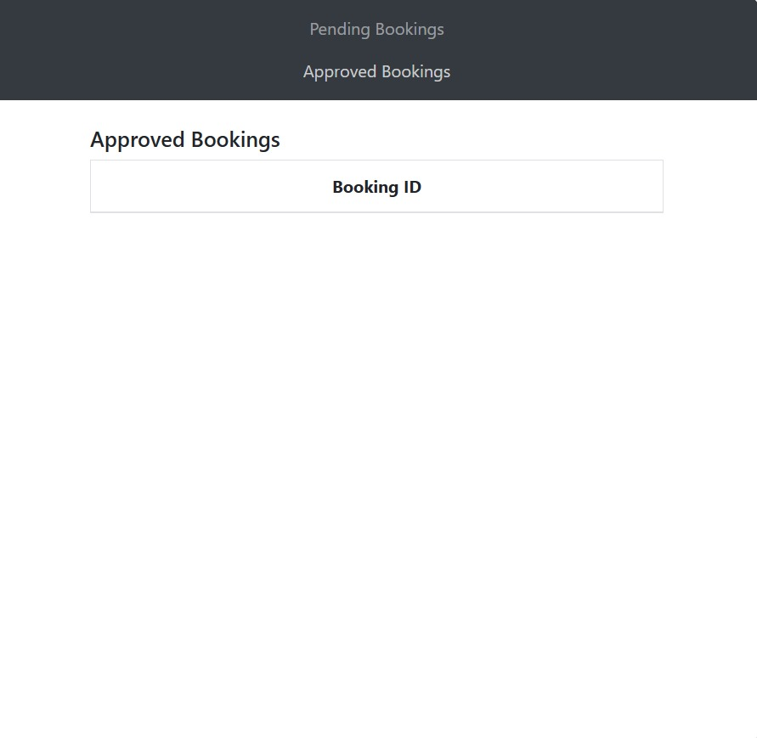

**BOOKING APPROVAL/REJECTION PAGE:**

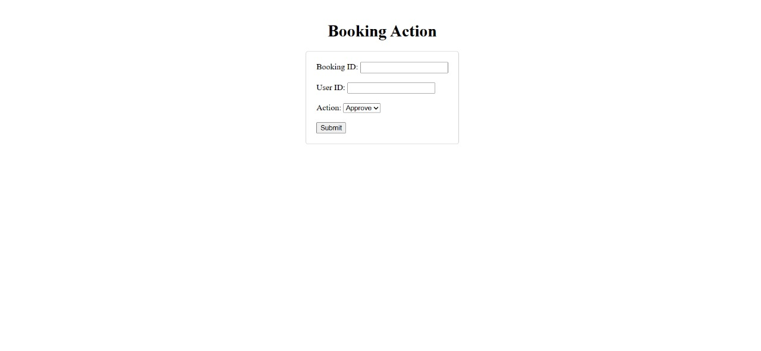

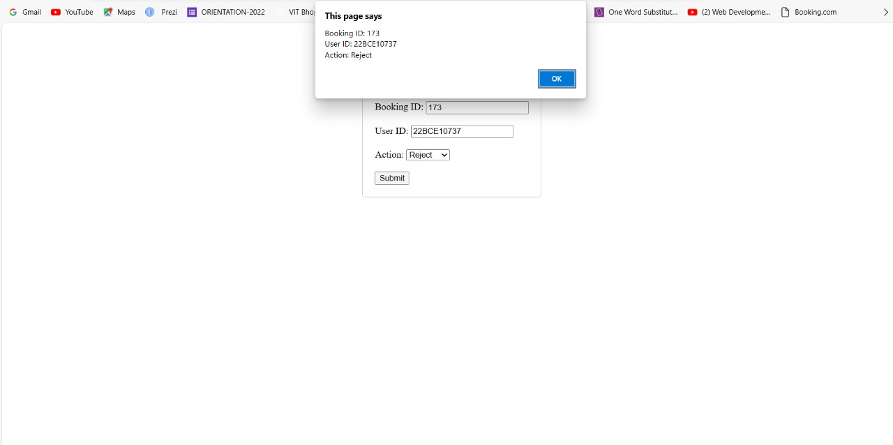

**LOG OUT PAGE:**

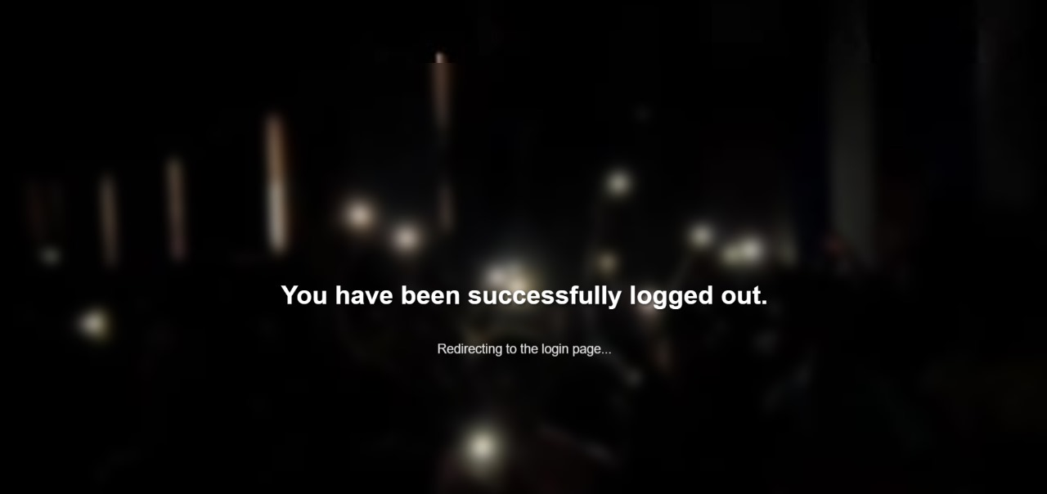

**SYSTEM ANALYSIS**

**Existing System:**

• All works are done manually.

• Difficult to maintain the booking details and timings.

• Advertisements through mails and Instagram stories.

• A number of intermediaries to book a slot.

**Proposed System:**

• To create Web Based Application for organisation.

• To provide a hassle-free approval system for booking.

• To provide one-step booking and approval mechanism

• To reduce the chances of duplicate booking.

**FUTURE ENHNACEMENT**

* Logical and technical error will be less found in future.
* System will be more user friendly as compare to today’s system.
* System will have more detail information about the different events and other services.
* System will also showcase an upcoming events’ calendar for the students, faculties and authorities to stay informed and involve more in the society.
* In the security vision the user’s name and password authentication will be more secure than today’s model.

**CONCLUSION**

It was great opportunity for us as a student to learn and

understand various aspects associated with project development.

We did undergo from various phases of project development life

cycle like analysis, design, coding, implementation, and

testing.

The preceding material is a sincere effort from my side to

create the “WEBSITE ON AUDITORIUM BOOKING” software.

We got the idea about

the ups and downs taking place during the project development.

We analysed the problems and solved those problems that were

faced in my project.

The project shows the flow of each and every booking and approval

which is being carried out by the desired user successfully thus

giving them the desired result.

**References**:

**W3Schools HTML Tutorial**

**MDN Web Docs (HTML)**

**CSS Tricks**

**GitHub**

**Figma**

**Framer**

**Bootstrap**

**React**

**WordPress**

**Git**

**Gitlab**

**Stack overflow**

**Dev.to**

**GitHub discussions**

**Mozilla Developer Network (MDN) Web Docs**

**Smashing Magazine**

https://www.w3schools.com/html/

https://developer.mozilla.org/en-US/docs/Web/HTML

<https://css-tricks.com/>

<https://github.com/>

https://www.figma.com/

https://www.framer.com/

https://getbootstrap.com/

https://legacy.reactjs.org/

<https://wordpress.org/>

https://git-scm.com/

<https://about.gitlab.com/>

<https://stackoverflow.com/>

<https://dev.to/>

<https://docs.github.com/en/discussions>

https://developer.mozilla.org/en-US/

https://www.smashingmagazine.com/

registration.

• Administration gives different kind of tourist information for search the tourist data.

• Tourist gives his tourist id, hint question, answer for getting the forgotten password.