INTERNAL NETWORK DISCOVERY
& RISK ASSESSMENT REPORT
Lab Project — Week 1, Day 1
SOC Analyst Training Portfolio
Analyst | Sumesh Kumar
Report Date | April 30, 2026
Engagement Type | Internal network reconnaissance — authorized lab
Scope | 192.168.2.0/24 (analyst-owned home network)
Tools Used | Nmap 7.99 (Npcap 1.87, OpenSSL 3.0.16)
Classification | Confidential — Training Use Only

1. Executive Summary
An authorized internal network discovery scan was executed against the analyst's home network on April 30, 2026 at 16:14 EDT. The objective was to enumerate live hosts, identify exposed TCP services, and assess associated risk.
Three live hosts were identified across the 256-address /24 subnet. Eleven TCP ports were observed open in total. Two findings warrant remediation: an SMB service exposed on the perimeter router (TCP/445) and an Intel Active Management Technology (AMT) interface active on a Windows workstation (TCP/16992).

Key Findings
ID | Host | Finding | Risk
F-001 | 192.168.2.1 (Sagemcom router) | SMB service (TCP/445) exposed on perimeter router | High
F-002 | 192.168.2.42 (Workstation) | Intel AMT interface (TCP/16992) detected | Medium
F-003 | 192.168.2.42 (Workstation) | Legacy NetBIOS Session Service (TCP/139) enabled | Low
F-004 | 192.168.2.1 (Sagemcom router) | Plaintext HTTP admin service (TCP/80) open | Low
F-005 | 192.168.2.1 (Sagemcom router) | Unidentified service on TCP/9000 (cslistener) | Info

2. Scope and Methodology

2.1 Scope
Target subnet: 192.168.2.0/24 (256 addresses)
Network type: Residential / lab — analyst-owned
Authorization: Self-authorized; no third-party assets in scope
Date and time: April 30, 2026 — 16:14 EDT (UTC-4)
Scan duration: 10.43 seconds

2.2 Methodology
A TCP connect scan was executed against the full /24 range using Nmap default port selection (top 1,000 most common TCP ports per host). Service identification relied on Nmap's nmap-services file. No version detection (-sV), OS fingerprinting (-O), or scripting engine (-sC) was executed in this initial discovery pass.

Tool Configuration
Tool: Nmap 7.99
Command: nmap 192.168.2.0/24
Mode: TCP connect (default for unprivileged Windows)
Ports: Top 1000 TCP (Nmap default)
Platform: Windows 10 build 26200.8246
Libraries: Npcap 1.87, OpenSSL 3.0.16, libssh2 1.11.1

2.3 Limitations
- Only the top 1,000 TCP ports were probed; services on uncommon high ports may be missed.
- UDP services (DNS responses, SNMP, NetBIOS Name Service) were not enumerated.
- Service banners were not retrieved; software versions and CVE mapping require a follow-up -sV scan.
- Mobile devices were partially powered-off or sleeping; some hosts may have been missed.

3. Evidence
The screenshot below captures the complete Nmap session — version banner and full /24 scan output — exactly as observed on the analyst workstation.
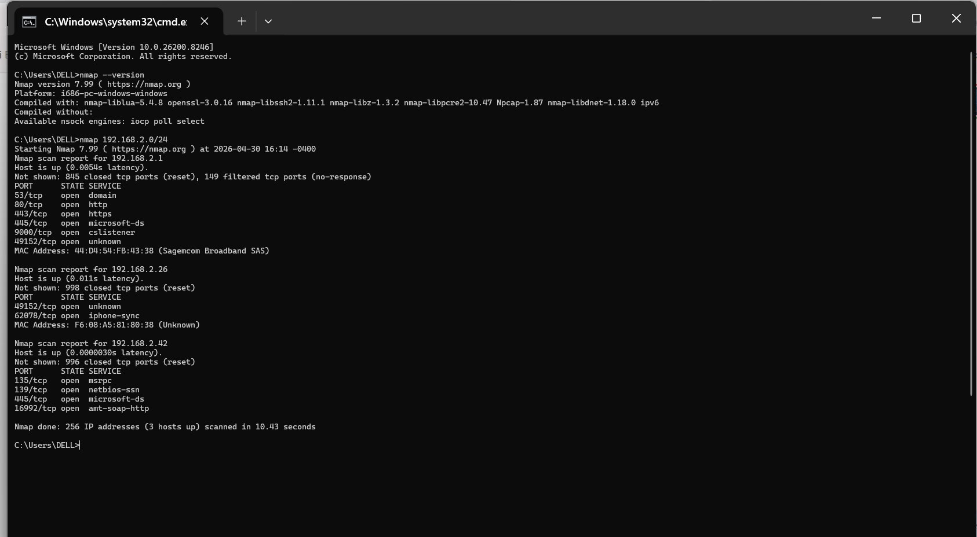
Figure 1 — Nmap scan output (192.168.2.0/24, April 30 2026, 16:14 EDT)
File hash and chain-of-custody metadata for this evidence file are recorded in Appendix B.

4. Detailed Findings

4.1 Host Inventory
Three hosts responded during the scan window.
IP Address | MAC Address | Vendor / Identification | Open TCP Ports
192.168.2.1 | 44:D4:54:FB:43:38 | Sagemcom Broadband SAS — perimeter router/gateway | 6
192.168.2.26 | F6:08:A5:81:80:38 | Apple iOS device (locally-administered MAC; iphone-sync confirmed) | 2
192.168.2.42 | (scan host — local) | Windows 10 workstation (analyst — DELL) | 4

4.2 Finding F-001 — SMB Exposed on Perimeter Router
Host | 192.168.2.1 (Sagemcom Broadband SAS)
Port / Service | TCP/445 — microsoft-ds (SMB)
Risk Rating | High
ATT&CK Technique | T1021.002 — Remote Services: SMB/Windows Admin Shares

Evidence
Nmap scan report for 192.168.2.1
PORT STATE SERVICE
445/tcp open microsoft-ds
MAC Address: 44:D4:54:FB:43:38 (Sagemcom Broadband SAS)

Interpretation
TCP/445 is the Microsoft Server Message Block (SMB) port used for Windows file and printer sharing. Consumer broadband routers do not require this service for normal operation. Its presence on the gateway interface indicates either an embedded SMB stack used for vendor-specific functions (e.g., USB share, remote configuration) or a misconfiguration.
SMB has been the vector for high-impact malware families including WannaCry (2017, EternalBlue / CVE-2017-0144) and TrickBot. Embedded Linux SMB stacks (Samba) on consumer devices have historically lagged on patching.

Forensic Implication
This service expands the router's attack surface. If exploitable, compromise of the gateway grants pivot access to every device on the LAN.

Recommendation
- Confirm with the ISP / device documentation whether SMB on the LAN interface is required.
- If not required, disable the service in the router admin panel.
- If required (USB share), restrict access via firewall rules to specific source IPs and confirm authentication is enforced.
- Run a follow-up scan with `nmap -p445 --script smb-protocols,smb2-security-mode 192.168.2.1` to identify the SMB dialect and signing posture.

4.3 Finding F-002 — Intel AMT Interface Detected
Host | 192.168.2.42 (analyst workstation — Windows 10)
Port / Service | TCP/16992 — amt-soap-http (Intel Active Management Technology)
Risk Rating | Medium
Reference CVE | CVE-2017-5689 (AMT authentication bypass)

Evidence
Nmap scan report for 192.168.2.42
PORT STATE SERVICE
16992/tcp open amt-soap-http

Interpretation
TCP/16992 is the standard listening port for Intel Active Management Technology (AMT), part of the Intel Management Engine (ME). AMT operates below the host operating system and provides out-of-band remote management — including keyboard/video/mouse redirection and remote power control — independent of the OS.
CVE-2017-5689 allowed authentication bypass against AMT/ISM/SBT firmware versions 6.x through 11.6 by submitting an empty response hash. Unprovisioned AMT is not exploitable in the same manner, but its mere presence indicates remote-management capability that may not be intended on a personal workstation.

Forensic Implication
If AMT is provisioned and reachable, an attacker on the LAN with valid (or bypassed) credentials can take full hardware-level control of the workstation — including booting into attacker-controlled media — without any OS-level detection.

Recommendation
- Confirm AMT provisioning state via MEBx (Ctrl+P at boot) or the Intel MEI driver. If unused, set provisioning state to Unconfigured.
- Apply latest BIOS/firmware updates from the OEM (Dell) to patch known ME vulnerabilities.
- If AMT is required, configure TLS, strong credentials, and restrict the management interface to a dedicated admin VLAN.

4.4 Finding F-003 — Legacy NetBIOS Session Service
Host | 192.168.2.42 (analyst workstation)
Port / Service | TCP/139 — netbios-ssn (NetBIOS over TCP)
Risk Rating | Low

Interpretation
NetBIOS Session Service is a legacy protocol superseded by direct SMB over TCP/445. Modern Windows networks do not require TCP/139. Its presence on a 2026-era system indicates that NetBIOS over TCP/IP is enabled in the network adapter properties.

Forensic Implication
Active NetBIOS exposes the workstation to NBNS (Name Service) poisoning attacks and increases footprint for SMB relay attacks.

Recommendation
- Disable NetBIOS over TCP/IP: Network Adapter Properties → IPv4 → Advanced → WINS tab → Disable NetBIOS over TCP/IP.

4.5 Finding F-004 — Plaintext HTTP Admin on Router
Host | 192.168.2.1 (Sagemcom router)
Port / Service | TCP/80 — http
Risk Rating | Low

Interpretation
The router exposes both HTTP (TCP/80) and HTTPS (TCP/443) for its administrative interface. Plaintext HTTP transmits credentials in clear text. On a wired network the impact is limited, but in mixed wired/wireless or shared-Wi-Fi environments this enables credential sniffing.

Recommendation
- Disable HTTP admin in the router configuration. Enforce HTTPS only.
- If HTTP cannot be disabled, configure auto-redirect to HTTPS.

4.6 Finding F-005 — Unidentified Service on TCP/9000
Host | 192.168.2.1 (Sagemcom router)
Port / Service | TCP/9000 — cslistener (per IANA / Nmap services)
Risk Rating | Informational

Interpretation
`cslistener` is a generic Nmap service-name mapping for TCP/9000. The port is commonly used by SonarQube, Portainer, Php-FPM status, and various vendor management daemons. On a Sagemcom router it is most likely a vendor remote-management or TR-069/CWMP-adjacent service.

Recommendation
- Run `nmap -sV -p 9000 192.168.2.1` to retrieve the service banner and confirm the application.
- If the service is vendor management and not required, disable in the router configuration.

5. Risk Summary Matrix
ID | Asset | Recommended Action | Priority
F-001 | Router 192.168.2.1 | Disable SMB or restrict to authorized hosts | High
F-002 | Workstation 192.168.2.42 | Verify AMT provisioning; patch BIOS/ME firmware | Medium
F-003 | Workstation 192.168.2.42 | Disable NetBIOS over TCP/IP | Low
F-004 | Router 192.168.2.1 | Disable plaintext HTTP admin; force HTTPS | Low
F-005 | Router 192.168.2.1 | Identify TCP/9000 service via banner grab | Info

6. Next Steps
The following follow-up activities are scheduled to extend coverage of this baseline assessment:
- Run `nmap -sV -O -p- 192.168.2.0/24` to obtain service versions, OS fingerprints, and full port coverage.
- Capture a 5–10 minute Wireshark baseline on the active interface to characterize normal traffic patterns and protocol distribution.
- Repeat enumeration on the wireless segment if separate SSIDs are present.
- Ingest scan output into Splunk for correlation with subsequent host-based telemetry (Sysmon, Windows Event Logs).

7. Conclusion
The initial discovery scan identified three live hosts and five findings of varying severity. The two material findings — SMB exposure on the router (F-001) and Intel AMT presence on the workstation (F-002) — represent legitimate attack surface and should be remediated before further lab activity is performed against this network.
All remaining hosts and services observed are consistent with expected baseline traffic for a residential network. This report establishes the baseline against which future scans and incident detections will be compared.

Appendix A — Raw Nmap Output
C:\Users\DELL>nmap --version
Nmap version 7.99 ( https://nmap.org )
Platform: i686-pc-windows-windows
Compiled with: nmap-liblua-5.4.8 openssl-3.0.16 nmap-libssh2-1.11.1 nmap-libz-1.3.2
nmap-libpcre2-10.47 Npcap-1.87 nmap-libdnet-1.18.0 ipv6
Available nsock engines: iocp poll select

C:\Users\DELL>nmap 192.168.2.0/24
Starting Nmap 7.99 ( https://nmap.org ) at 2026-04-30 16:14 -0400

Nmap scan report for 192.168.2.1
Host is up (0.0054s latency).
Not shown: 845 closed tcp ports (reset), 149 filtered tcp ports (no-response)
PORT STATE SERVICE
53/tcp open domain
80/tcp open http
443/tcp open https
445/tcp open microsoft-ds
9000/tcp open cslistener
49152/tcp open unknown
MAC Address: 44:D4:54:FB:43:38 (Sagemcom Broadband SAS)

Nmap scan report for 192.168.2.26
Host is up (0.011s latency).
Not shown: 998 closed tcp ports (reset)
PORT STATE SERVICE
49152/tcp open unknown
62078/tcp open iphone-sync
MAC Address: F6:08:A5:81:80:38 (Unknown)

Nmap scan report for 192.168.2.42
Host is up (0.0000030s latency).
Not shown: 996 closed tcp ports (reset)
PORT STATE SERVICE
135/tcp open msrpc
139/tcp open netbios-ssn
445/tcp open microsoft-ds
16992/tcp open amt-soap-http

Nmap done: 256 IP addresses (3 hosts up) scanned in 10.43 seconds

Appendix B — Evidence Chain of Custody
The following artifacts were preserved as part of this engagement. Hash values should be computed by the analyst on the original files and entered below.
Artifact | Filename | SHA-256 Hash
Terminal screenshot | nmap port scanning .png | 29a5f766d04016c7bab8739b5795658d84b71289d46942938faa8f0acb84fef4
Raw scan output | SOC HOME LAB — INITIAL NETWORK SCAN.txt | c6ae272dd7a56e62578c6a2af78aa0caecfc0941a4d23a434adaed0f3678b8f3

Compute hashes on the analyst workstation:
certutil -hashfile "nmap port scanning .png" SHA256
certutil -hashfile "SOC HOME LAB — INITIAL NETWORK SCAN.txt" SHA256

Appendix C — References
- MITRE ATT&CK — T1021.002 Remote Services: SMB/Windows Admin Shares
- MITRE ATT&CK — T1046 Network Service Discovery
- CVE-2017-5689 — Intel AMT Authentication Bypass
- CVE-2017-0144 — SMBv1 Remote Code Execution (EternalBlue)
- Nmap Reference Guide — https://nmap.org/book/man.html
- NIST SP 800-115 — Technical Guide to Information Security Testing and Assessment

