
Kubernetes Nanoservices Checkout System
Enterprise Architecture Design Assignment 1
Patrick K. Rashidi
X00231098

Module : Enterprise Architecture Design
Programme : MSc DevOps
Lecturer : Enda Lee
Submission Date : 6 April 2026

Table of Contents
Summary 2
1. Introduction 3
2. Solution Design 3
2.1. Core Services 3
2.2. System Architecture 4
2.3. Request Flow and Correlation 5
2.4. Scaling Strategy with KEDA 6
2.5. Reliability and Failure Handling 6
2.6. Persistence Design 6
3. Implementation 6
4. Testing and Validation 7
4.1. Functional Testing 7
4.2. Request Correlation 8
4.3. Scaling and Performance (KEDA) 8
4.4. Reliability and Failure Scenarios 10
4.5. Troubleshooting Workflow 11
4.6. Inside-Cluster Connectivity 12
4.7. Persistence Validation 12
Appendix 15
Appendix A: Readiness failure scenario 15
Appendix B: 17

Summary
This report details the design, build-out, and evaluation of a nanoservice-based Kubernetes architecture for an online checkout process. The architecture consists of Gateway, Checkout, Pricing, and Inventory services with a PostgreSQL database for persistence and the KEDA (Kubernetes-based Event Driven Autoscaling) system for scale-to-zero auto-scaling functionality.
The system demonstrates the ability to operate as a distributed system, support request correlation using X-Request-Id, exhibit fault tolerance when handling failed requests in a controlled manner, and support operational troubleshooting by using Kubernetes native tools.
The performance tests conducted show how resource utilization impacts latency and demonstrate significantly higher response times for warm requests when compared to cold-start delay times while the system was in scale-to-zero mode.

Introduction
This project describes the creation of a Kubernetes (K3s) Nanoservices architecture (a distributed/microservices architecture) to support a simplified e-commerce checkout workflow. The Nanoservices include (but are not limited to) Gateway, Checkout, Pricing, and Inventory. The database is PostgreSQL and the database approach is persistent.
The goal was to analyze the migration from Docker Compose to Kubernetes (K3s), in order to assess the levels of scalability, reliability, and control over the operations of the system. The solution also implements KEDA which enables "scale to zero" behaviour, enabling the services to scale dynamically based upon demand. Additionally, the system displays several characteristics of a distributed system, including service to service communication, request propagation, and handling partial failures. Request correlation is required to support observability of the system, so an 'X-Request-Id' header has been created and used to support tracing requests across various services.
PostgreSQL is also used to support persistent storage of the database and to provide persistent volume claims (PVCs), thus ensuring that the data will persist even in the event of pod restarts. A defined troubleshooting methodology is also employed to assist in the diagnosis and resolution of failed components within the Kubernetes environment.
Finally, this project illustrates the numerous pros and cons associated with deploying nanoservices to Kubernetes environments, specifically in relation to scalability, performance, and operational complexity.

Solution Design
The system has been developed using a nanoservices-based architecture with distinct services, where each service performs a single, specific job and communicates with others via HTTP. This type of architecture increases the modularity and scalability of the solution, as well as helps isolate failures of one service from the rest of the system; however, this type of architecture also presents difficulties in managing the communications and dependencies between services.

Core Services
The system consists of the following components:
- Gateway: acts as the entry point for external clients, serving the user interface and routing API requests.
- Checkout Service: Orchestrates the checkout workflow by invoking pricing and inventory services and aggregating their responses.
- Pricing Service: Calculates product pricing, including tax and totals.
- Inventory Service: Validates stock availability for requested items.
- PostgreSQL Database: Provides persistent storage for checkout records using a Persistent Volume Claim (PVC).

System Architecture
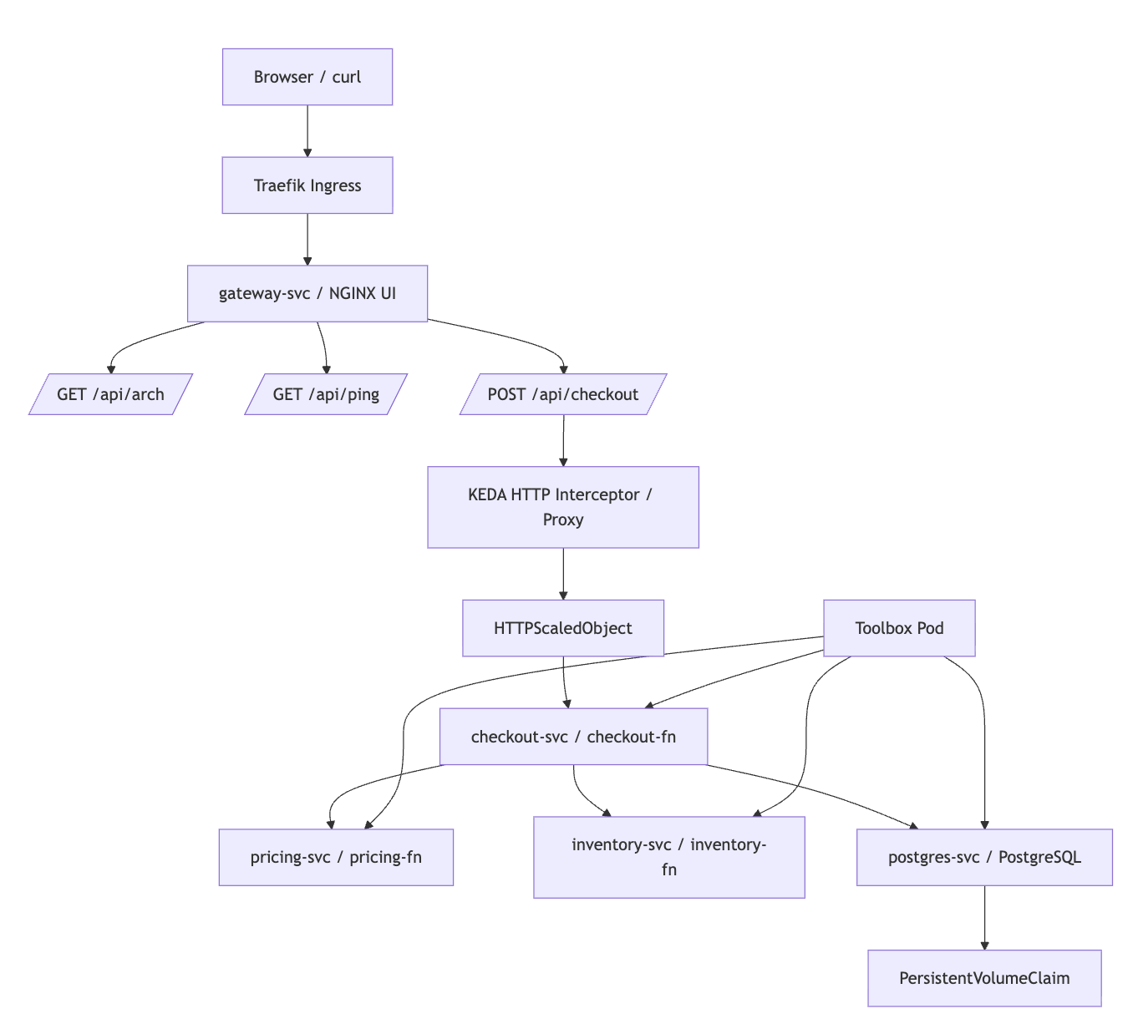
Figure 1: Kubernetes nanoservices system architecture
The architecture of the system is based on layers of requests. The External Requests come in through Kubernetes Ingress (Traefik), which directs traffic to Gateway Service (as an example, checkout request would be sent from Gateway Service through to Checkout Service which will process the Incoming Request by interfacing with both Pricing and Inventory Services and insert transactional data into PostgreSQL).
KEDA has been integrated into Checkout Service via an HTTP Interceptor, allowing the service to dynamically scale according to incoming requests (Dhandala, 2026). This means that when there are no incoming requests the system could ccale down to zero and when there is any incoming traffic the service will automatically scale up.

Request Flow and Correlation
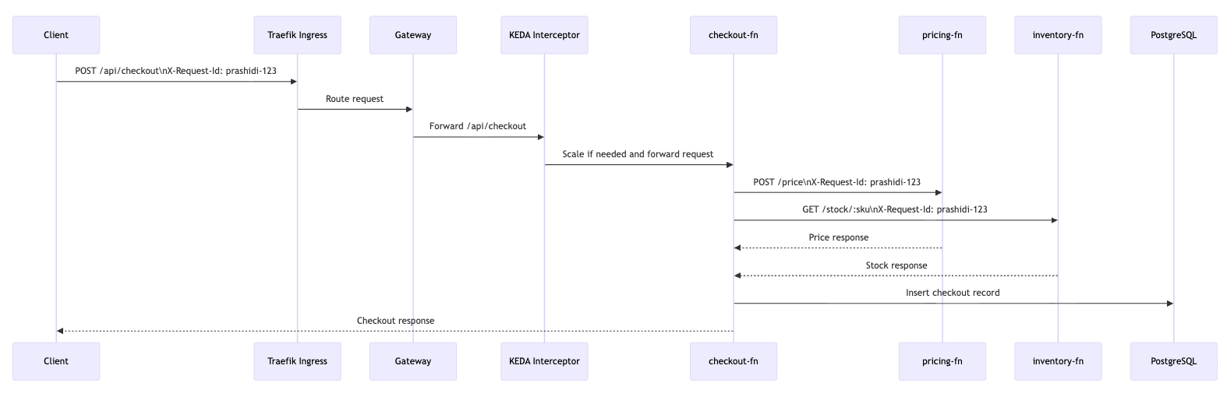
Figure 2: End-to-end request flow with X-Request-Id propagation

The system implements request correlation using an X-Request-Id header, which is propagated across all services involved in processing a request. This ensures that each request can be traced end-to-end across the gateway, checkout, pricing, and inventory services.
Each service logs the request ID alongside request details, enabling effective debugging and analysis of distributed interactions. This approach is particularly important in nanoservices architectures, where a single request may traverse multiple independent components.

Scaling Strategy with KEDA
The checkout service is set for dynamic scaling via KEDA configured with 0 minimum replicas allowing it to scale down to 0 when idle and allow for automatic scaling when new requests come in. Incoming requests are captured using HTTP interceptor, which triggers scaling before traffic is sent to the checkout service (Dhandala, 2026). This design uses resources efficiently however results in cold-start latency for the first request after a period of inactivity. The checkout service has potential for scaling as it is a user-facing component that has variable demand therefore it is a candidate for event-driven scaling.

Reliability and Failure Handling
The system is designed to handle partial failures in a controlled manner. The checkout service depends on external services (pricing and inventory) and therefore includes timeout mechanisms to prevent indefinite blocking when dependencies are unavailable. If a dependency fails, the checkout service fails fast and returns an appropriate error response. This ensures that failures are clearly visible and do not degrade overall system responsiveness. Kubernetes readiness probes are also used to ensure that traffic is only routed to healthy pods, improving system reliability and preventing requests from reaching unready services.

Persistence Design
Persistent storage is implemented using PostgreSQL deployed within the Kubernetes cluster. A Persistent Volume Claim (PVC) is used to ensure that data remains durable across pod restarts or rescheduling (Kubernetes, 2024). Database credentials are managed using Kubernetes Secrets, avoiding hardcoded sensitive information. The database is used to store checkout records, providing a simple audit trail and enabling validation of persistence behaviour (Groundcover, 2026).

Implementation
The system was initially developed using Docker Compose and then deployed to Kubernetes (K3s) on a Linux virtual machine accessed via SSH. All components were defined using declarative YAML manifests. Each service was deployed as a Kubernetes Deployment, with Services enabling internal communication. External access was provided through Ingress (Traefik), routing traffic to the gateway. Sensitive data such as database credentials was managed using Kubernetes Secrets.
The checkout, pricing, inventory, and gateway services were containerised and deployed independently. Health endpoints and readiness checks ensured traffic was only routed to healthy pods.
KEDA was configured to enable scale-to-zero behaviour for the checkout service using an HTTP interceptor. PostgreSQL was deployed with a Persistent Volume Claim (PVC) to provide durable storage across pod restarts.

Testing and Validation
This section presents evidence of system functionality, reliability, scaling behaviour, request correlation, and persistence. Testing was performed using HTTP requests, Kubernetes diagnostic commands, and log inspection.

Functional Testing
The system was validated using standard API endpoints:
- GET /api/ping: confirmed service availability
- GET /api/arch: returned system architecture information
- POST /api/checkout: successfully processed checkout requests
Figure 3: Successful API response from /api/checkout
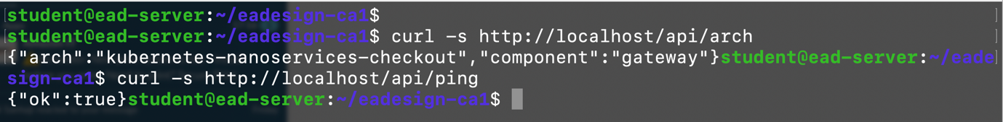
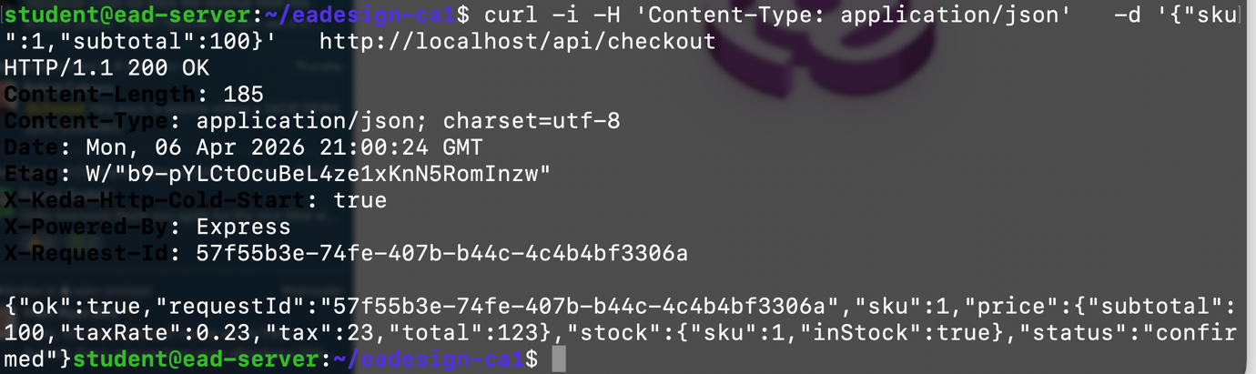
Figure 3 demonstrates that the system processes checkout requests correctly under normal conditions.
Edge cases were also tested. Invalid input resulted in appropriate error responses, while out-of-stock scenarios were handled correctly by the inventory service.
Figure 4: Error response for invalid checkout request
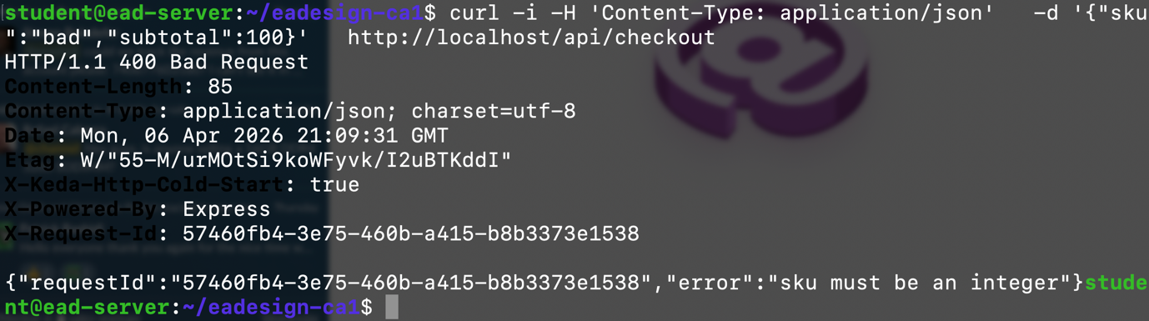
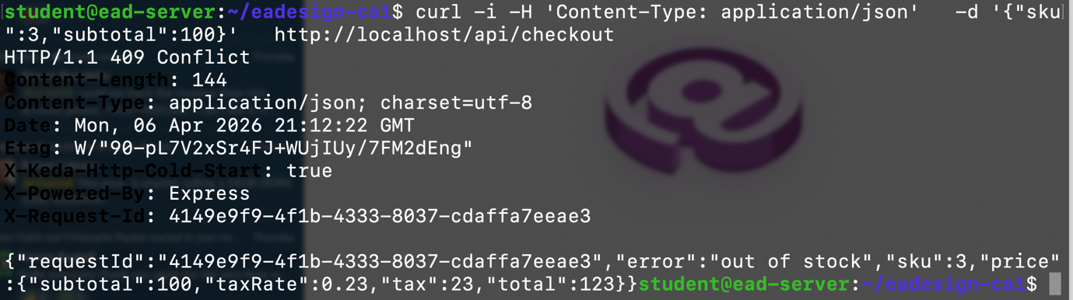
Figure 4 shows that the system validates input and returns an appropriate error when required fields are missing or malformed.

Request Correlation
Request correlation was validated using the X-Request-Id header. A request was issued with a custom identifier, which was propagated across all services.
Figure 5: Logs showing X-Request-Id propagation across services.
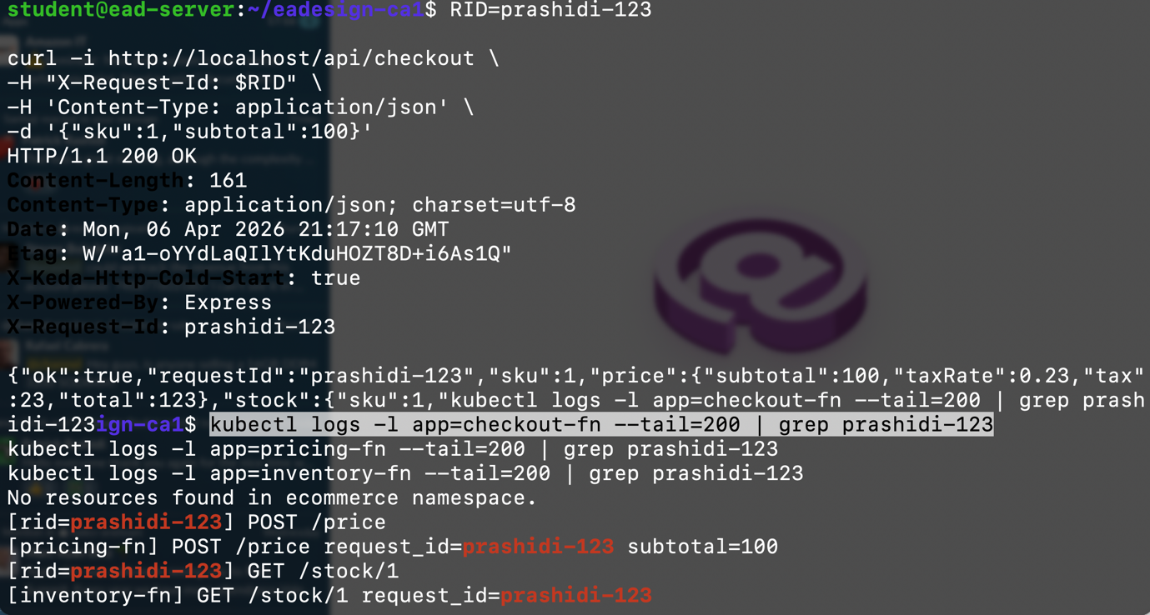
The figure shows the same X-Request-Id value (prashidi-123) is visible across logs from multiple services (gateway, checkout, pricing, and inventory), confirming successful propagation and enabling end-to-end traceability of a single request.

Scaling and Performance (KEDA)
The checkout service was configured with KEDA to support scale-to-zero behaviour. When idle, the service scaled down to zero replicas. Upon receiving a request, KEDA triggered a scale-up event.
Measured results:
Cold request latency: ~7.9 seconds
Warm request latency: ~0.04 seconds
The cold request includes pod startup and readiness delays, while the warm request benefits from already running instances. This demonstrates the trade-off between cost efficiency and latency, as scale-to-zero reduces resource usage but increases response time for initial requests.
Figure 6: Scale-from-zero behaviour triggered by incoming request.
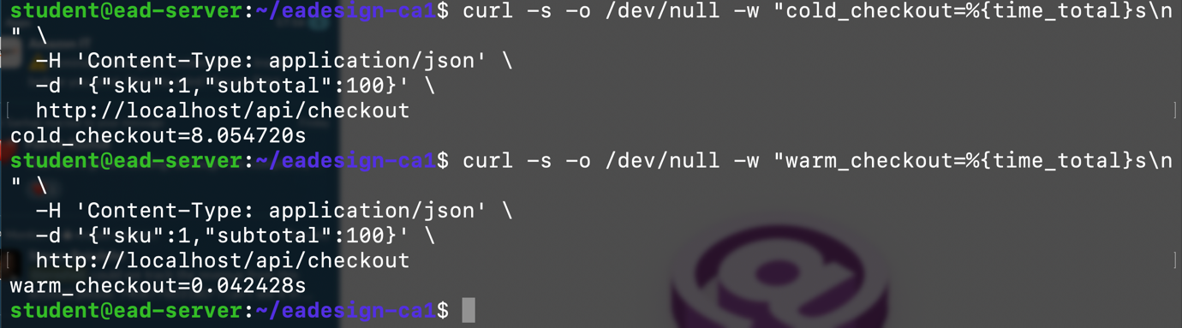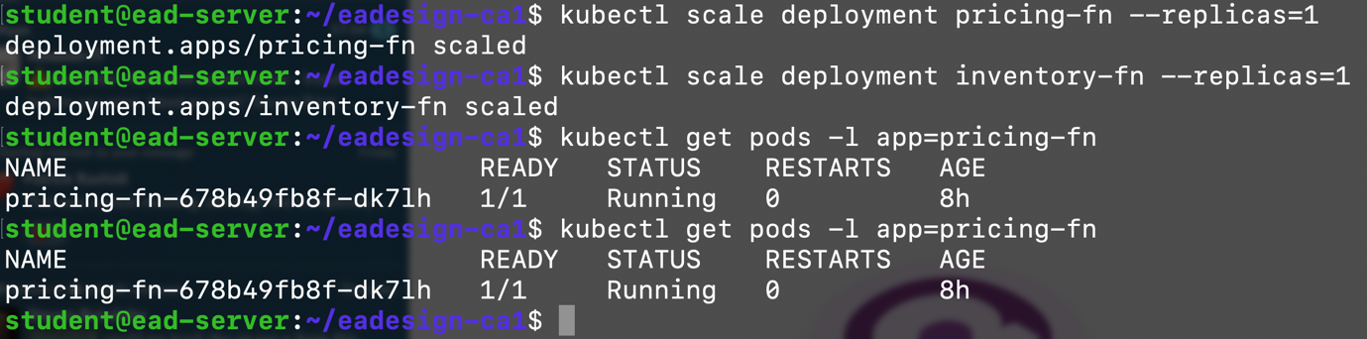
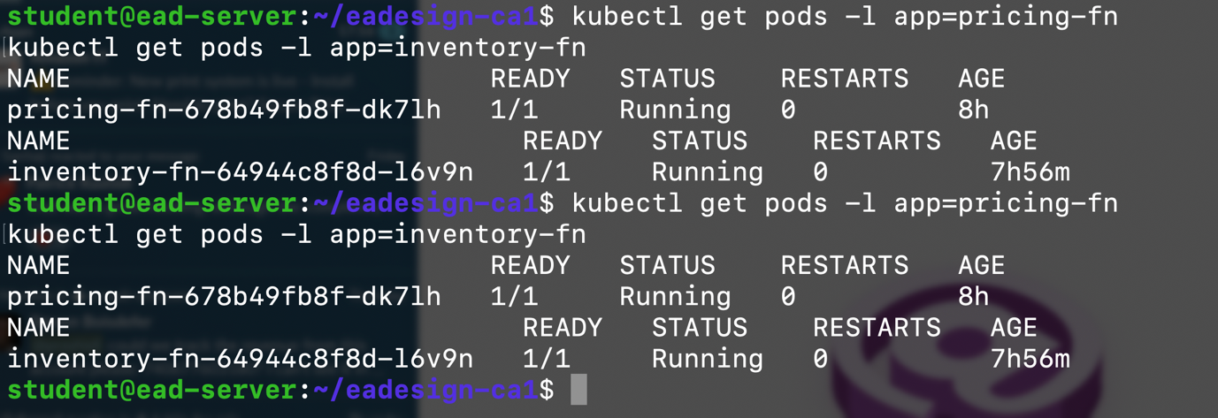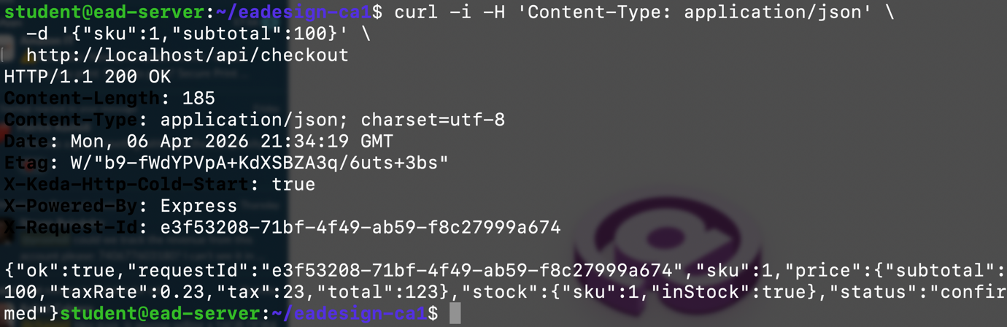
This figure shows the initial checkout request sent to the system and the corresponding KEDA scaling trigger. When the system is idle, the checkout service is scaled to zero. Upon receiving a request, KEDA activates the service and initiates pod creation.
Figure 7: Dynamic scaling of checkout service pods after activation.
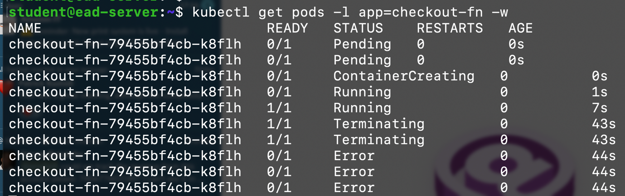
This figure demonstrates the scaling behaviour of the checkout service. Initially, no pods are running due to scale-to-zero configuration. After the request is processed, new pods are created and transition to a running state, confirming successful scale-up.

Reliability and Failure Scenarios
Partial failuere:
The below Figure 8 demonstrates that the system detects dependency failure and checkout requests fail appropriately.
Figure 8: Missing endpoints when inventory service is unavailable.
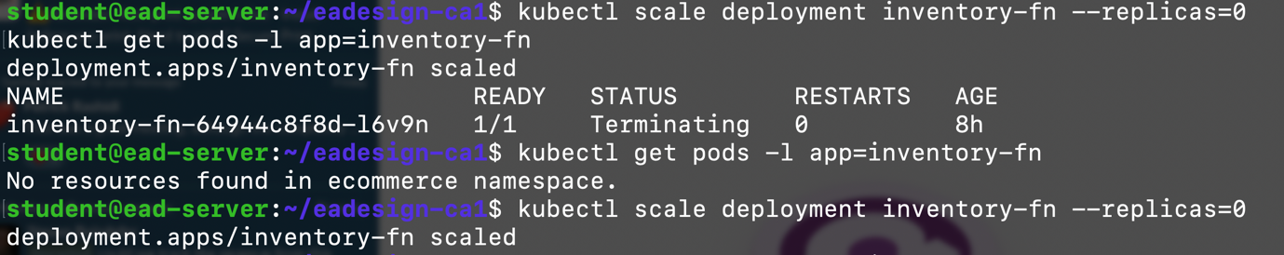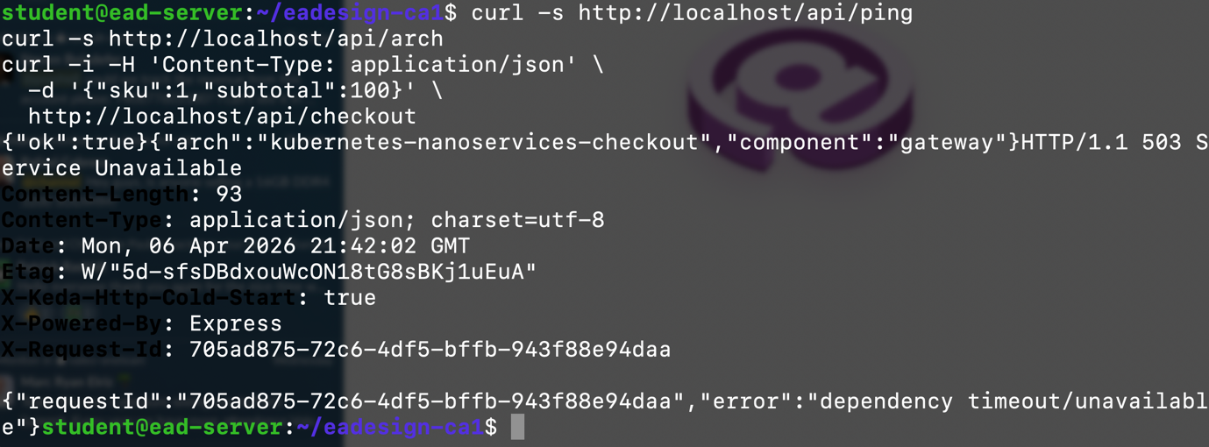
- /api/ping works
- /api/arch works
- checkout fails with a clear error
Bad rollout scenario:
Figure 9 shows how Kubernetes detects invalid image versions and prevents rollout vcompletion.
Figure 9: ImagePullBackOff error during failed deployment
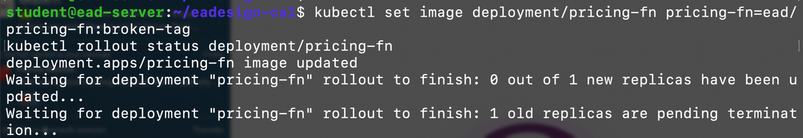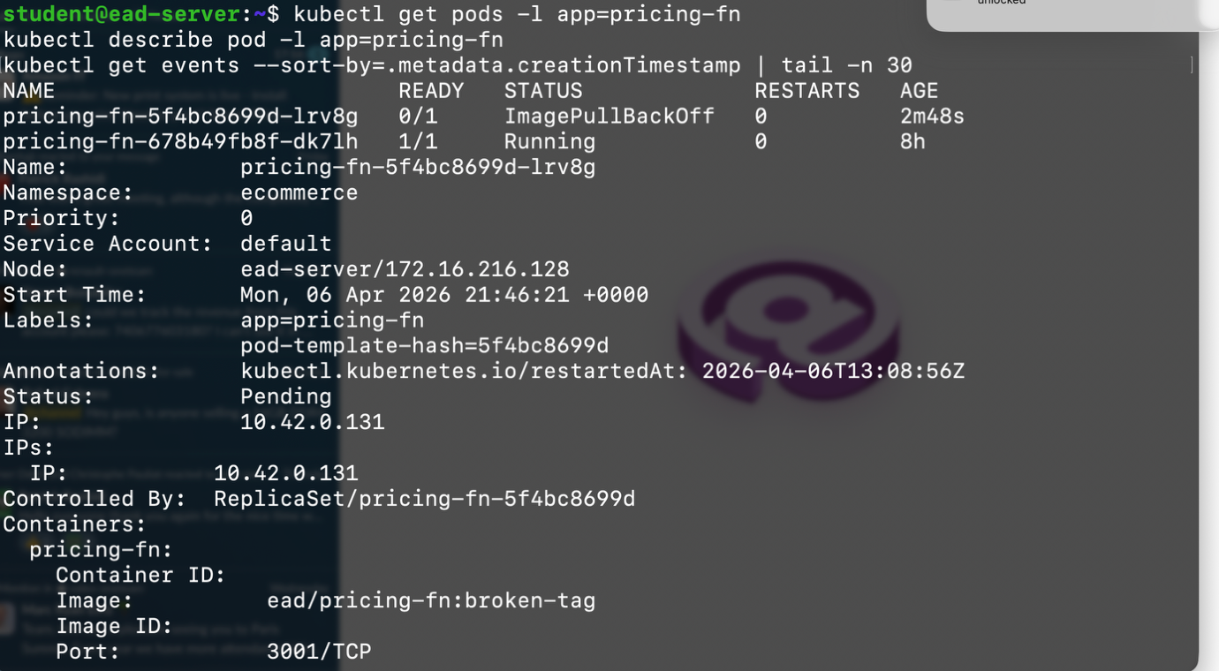
Readiness failure scenario:

In the pricing-fn readiness probe, changed the path: /health to: path: /health-broken
Figure 10 demonstrates how incorrect readiness configuration prevents traffic routing.
Figure 10. Pod in running state but not ready due to failed readiness probe.

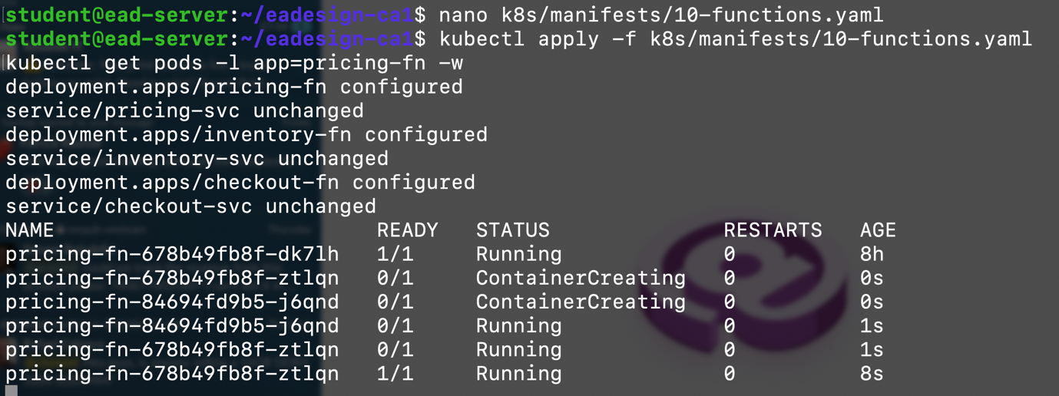

See Appendix A for the full logs.

Troubleshooting Workflow
A structured troubleshooting approach was applied using Kubernetes tools:
kubectl get pods,svc,ingress
kubectl describe pod <pod>
kubectl logs <pod>
kubectl get events
kubectl get endpoints
The above commands enabled identification of deployment issues, service routing problems, and runtime errors. Please see Appendix B for the full output to see how kubectl commands were used to inspect system state and identify issues.

Inside-Cluster Connectivity
Internal service communication was validated using a temporary curl pod.
Figure 12: Successful internal service communication using curl pod
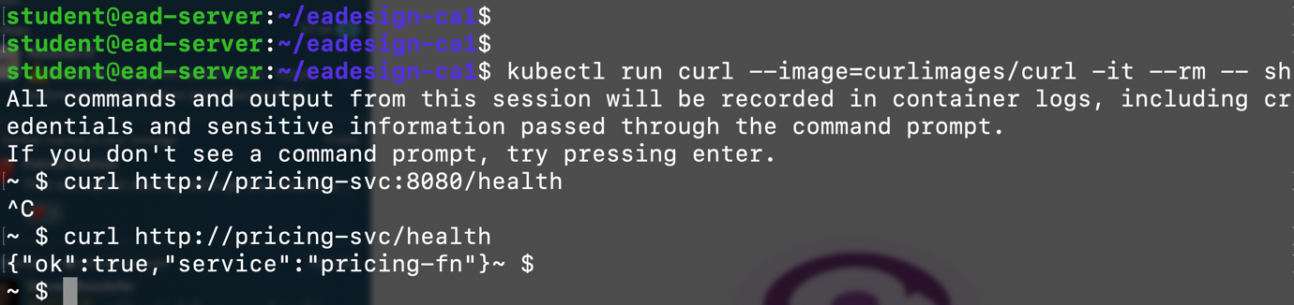
Above figure confirms that services can communicate within the cluster network.

Persistence Validation
Persistence was verified using PostgreSQL. A record was inserted into the database, after which the Postgres pod was restarted. The data remained available after restart, confirming that storage is backed by a Persistent Volume Claim (PVC).
Figure 13: Database record before PostgreSQL pod restart
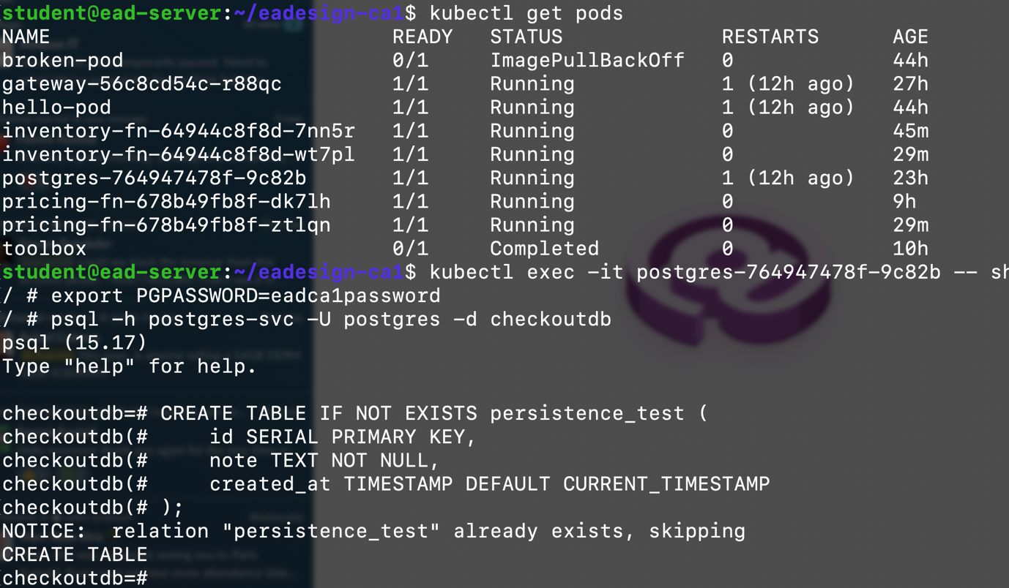
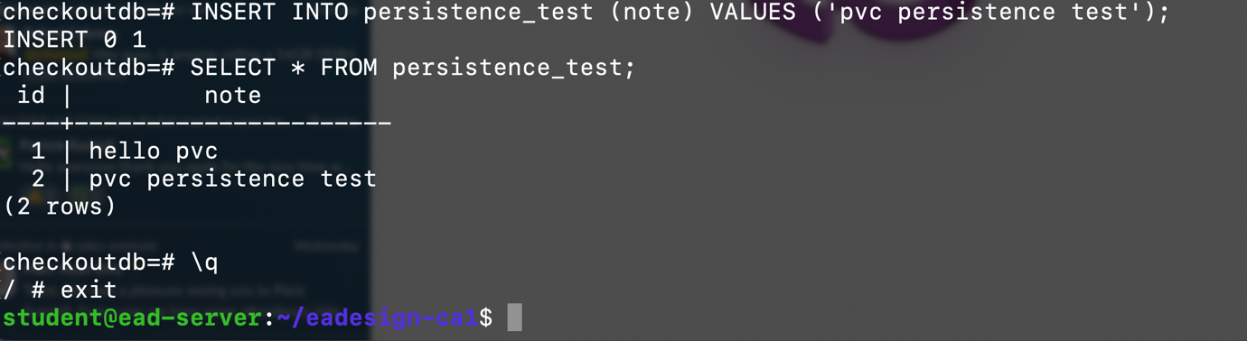

The above figure Shows inserted data before restart

Figure 14: Database record after PostgreSQL pod restart

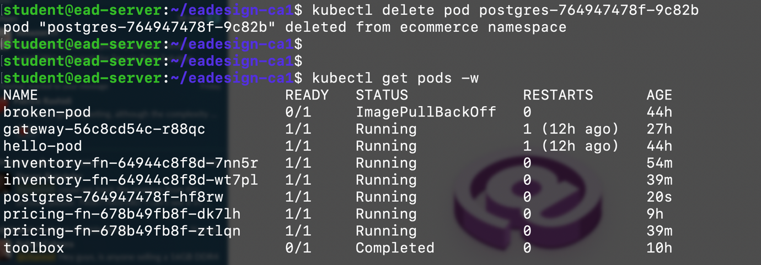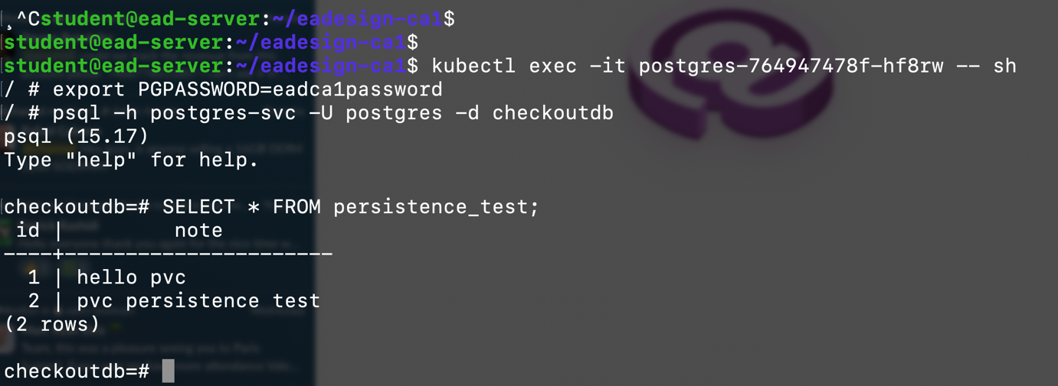
Confirms that data persists after pod recreation, validating PVC usage.

5. Conclusion
This project illustrated the architecture and implementation of a nanoservices-based checkout system deployed on Kubernetes. The checkout included four individual services (gateway, checkout, pricing and inventory) that are able to autoscale with KEDA and use PostgreSQL as their data store.
All tests validated the implementation with respect to functioning correctly, handling failures correctly and tracing requests correctly with X-Request-Id. Test validation for persistence used PVC-based storage, which was utilized for the pods to ensure the data persisted across pod restarts.
The results of the project display tradeoffs. Although KEDA allows for improved resource utilization through scale-to-zero, it introduces cold start latency. Overall, Kubernetes offers excellent scalability, resiliency, operational control and increased complexity to the system.

Appendix

Appendix A: Readiness failure scenario

(difference between Running and Ready.)
student@ead-server:~/eadesign-ca1$ kubectl get pods -l app=pricing-fn
kubectl get endpoints pricing-svc -o wide
kubectl describe pod -l app=pricing-fn
NAME READY STATUS RESTARTS AGE
pricing-fn-678b49fb8f-dk7lh 1/1 Running 0 8h
pricing-fn-678b49fb8f-ztlqn 1/1 Running 0 88s
pricing-fn-84694fd9b5-j6qnd 0/1 Running 0 88s
Warning: v1 Endpoints is deprecated in v1.33+; use discovery.k8s.io/v1 EndpointSlice
NAME ENDPOINTS AGE
pricing-svc 10.42.0.111:3001,10.42.0.135:3001 27h
Name: pricing-fn-678b49fb8f-dk7lh
Namespace: ecommerce
Priority: 0
Service Account: default
Node: ead-server/172.16.216.128
Start Time: Mon, 06 Apr 2026 13:08:56 +0000
Labels: app=pricing-fn
pod-template-hash=678b49fb8f
Annotations: kubectl.kubernetes.io/restartedAt: 2026-04-06T13:08:56Z
Status: Running
IP: 10.42.0.111
IPs:
IP: 10.42.0.111
Controlled By: ReplicaSet/pricing-fn-678b49fb8f
Containers:
pricing-fn:
Container ID: containerd://b997baea0fa835faa814108c063cc5e50941f8781662df1c7524cc1f6b536168
Image: ead/pricing-fn:v3
Image ID: sha256:594afa255db909b988bfdb07c8e486ecb17a61bc77c8f740109b12d0979f5ca9
Port: 3001/TCP
Host Port: 0/TCP
State: Running
Started: Mon, 06 Apr 2026 13:08:56 +0000
Ready: True
Restart Count: 0
Readiness: http-get http://:3001/health delay=3s timeout=1s period=5s #success=1 #failure=3
Environment:
PORT: 3001
DELAY_MS: 0
Mounts:
/var/run/secrets/kubernetes.io/serviceaccount from kube-api-access-z7h8b (ro)
Conditions:
Type Status
PodReadyToStartContainers True
Initialized True
Ready True
ContainersReady True
PodScheduled True
Volumes:
kube-api-access-z7h8b:
Type: Projected (a volume that contains injected data from multiple sources)
TokenExpirationSeconds: 3607
ConfigMapName: kube-root-ca.crt
Optional: false
DownwardAPI: true
QoS Class: BestEffort
Node-Selectors: <none>
Tolerations: node.kubernetes.io/not-ready:NoExecute op=Exists for 300s
node.kubernetes.io/unreachable:NoExecute op=Exists for 300s
Events: <none>

Name: pricing-fn-678b49fb8f-ztlqn
Namespace: ecommerce
Priority: 0
Service Account: default
Node: ead-server/172.16.216.128
Start Time: Mon, 06 Apr 2026 21:59:53 +0000
Labels: app=pricing-fn
pod-template-hash=678b49fb8f
Annotations: kubectl.kubernetes.io/restartedAt: 2026-04-06T13:08:56Z
Status: Running
IP: 10.42.0.135
IPs:
IP: 10.42.0.135
Controlled By: ReplicaSet/pricing-fn-678b49fb8f
Containers:
pricing-fn:
Container ID: containerd://ef1450e7c4ee92bebeda88d50dbf6557e77d19a61d14f4033486c6443de73d63
Image: ead/pricing-fn:v3
Image ID: sha256:594afa255db909b988bfdb07c8e486ecb17a61bc77c8f740109b12d0979f5ca9
Port: 3001/TCP
Host Port: 0/TCP
State: Running
Started: Mon, 06 Apr 2026 21:59:54 +0000
Ready: True
Restart Count: 0
Readiness: http-get http://:3001/health delay=3s timeout=1s period=5s #success=1 #failure=3
Environment:
PORT: 3001
DELAY_MS: 0
Mounts:
/var/run/secrets/kubernetes.io/serviceaccount from kube-api-access-tngl2 (ro)
Conditions:
Type Status
PodReadyToStartContainers True
Initialized True
Ready True
ContainersReady True
PodScheduled True
Volumes:
kube-api-access-tngl2:
Type: Projected (a volume that contains injected data from multiple sources)
TokenExpirationSeconds: 3607
ConfigMapName: kube-root-ca.crt
Optional: false
DownwardAPI: true
QoS Class: BestEffort
Node-Selectors: <none>
Tolerations: node.kubernetes.io/not-ready:NoExecute op=Exists for 300s
node.kubernetes.io/unreachable:NoExecute op=Exists for 300s
Events:
Type Reason Age From Message
---- ------ ---- ---- -------
Normal Scheduled 88s default-scheduler Successfully assigned ecommerce/pricing-fn-678b49fb8f-ztlqn to ead-server
Normal Pulled 88s kubelet Container image "ead/pricing-fn:v3" already present on machine
Normal Created 88s kubelet Created container: pricing-fn
Normal Started 88s kubelet Started container pricing-fn

Name: pricing-fn-84694fd9b5-j6qnd
Namespace: ecommerce
Priority: 0
Service Account: default
Node: ead-server/172.16.216.128
Start Time: Mon, 06 Apr 2026 21:59:53 +0000
Labels: app=pricing-fn
pod-template-hash=84694fd9b5
Annotations: kubectl.kubernetes.io/restartedAt: 2026-04-06T13:08:56Z
Status: Running
IP: 10.42.0.134
IPs:
IP: 10.42.0.134
Controlled By: ReplicaSet/pricing-fn-84694fd9b5
Containers:
pricing-fn:
Container ID: containerd://4b84f582508347b46ffd70b7b25006c1c74a9dcdb5b2face85a47d17c17ec3a6
Image: ead/pricing-fn:v3
Image ID: sha256:594afa255db909b988bfdb07c8e486ecb17a61bc77c8f740109b12d0979f5ca9
Port: 3001/TCP
Host Port: 0/TCP
State: Running
Started: Mon, 06 Apr 2026 21:59:54 +0000
Ready: False
Restart Count: 0
Readiness: http-get http://:3001/health-broken delay=3s timeout=1s period=5s #success=1 #failure=3
Environment:
PORT: 3001
DELAY_MS: 0
Mounts:
/var/run/secrets/kubernetes.io/serviceaccount from kube-api-access-gjhvt (ro)
Conditions:
Type Status
PodReadyToStartContainers True
Initialized True
Ready False
ContainersReady False
PodScheduled True
Volumes:
kube-api-access-gjhvt:
Type: Projected (a volume that contains injected data from multiple sources)
TokenExpirationSeconds: 3607
ConfigMapName: kube-root-ca.crt
Optional: false
DownwardAPI: true
QoS Class: BestEffort
Node-Selectors: <none>
Tolerations: node.kubernetes.io/not-ready:NoExecute op=Exists for 300s
node.kubernetes.io/unreachable:NoExecute op=Exists for 300s
Events:
Type Reason Age From Message
---- ------ ---- ---- -------
Normal Scheduled 88s default-scheduler Successfully assigned ecommerce/pricing-fn-84694fd9b5-j6qnd to ead-server
Normal Pulled 88s kubelet Container image "ead/pricing-fn:v3" already present on machine
Normal Created 88s kubelet Created container: pricing-fn
Normal Started 88s kubelet Started container pricing-fn
Warning Unhealthy 1s (x18 over 82s) kubelet Readiness probe failed: HTTP probe failed with statuscode: 404
student@ead-server:~/eadesign-ca1$

student@ead-server:~/eadesign-ca1$ kubectl apply -f k8s/manifests/10-functions.yaml
kubectl rollout status deployment/pricing-fn
kubectl get endpoints pricing-svc -o wide
deployment.apps/pricing-fn unchanged
service/pricing-svc unchanged
deployment.apps/inventory-fn unchanged
service/inventory-svc unchanged
deployment.apps/checkout-fn configured
service/checkout-svc unchanged
deployment "pricing-fn" successfully rolled out
Warning: v1 Endpoints is deprecated in v1.33+; use discovery.k8s.io/v1 EndpointSlice
NAME ENDPOINTS AGE
pricing-svc 10.42.0.111:3001,10.42.0.135:3001 27h

Appendix B:

student@ead-server:~/eadesign-ca1$ kubectl get pods,svc,ingress
NAME READY STATUS RESTARTS AGE
pod/broken-pod 0/1 ImagePullBackOff 0 44h
pod/gateway-56c8cd54c-r88qc 1/1 Running 1 (11h ago) 27h
pod/hello-pod 1/1 Running 1 (11h ago) 44h
pod/inventory-fn-64944c8f8d-7nn5r 1/1 Running 0 24m
pod/inventory-fn-64944c8f8d-wt7pl 1/1 Running 0 9m1s
pod/postgres-764947478f-9c82b 1/1 Running 1 (11h ago) 23h
pod/pricing-fn-678b49fb8f-dk7lh 1/1 Running 0 8h
pod/pricing-fn-678b49fb8f-ztlqn 1/1 Running 0 9m1s
pod/toolbox 0/1 Completed 0 10h

NAME TYPE CLUSTER-IP EXTERNAL-IP PORT(S) AGE
service/checkout-svc ClusterIP 10.43.241.180 <none> 80/TCP 27h
service/gateway-svc ClusterIP 10.43.96.29 <none> 80/TCP 27h
service/inventory-svc ClusterIP 10.43.129.117 <none> 80/TCP 27h
service/postgres-svc ClusterIP 10.43.70.77 <none> 5432/TCP 23h
service/pricing-svc ClusterIP 10.43.107.188 <none> 80/TCP 27h

NAME CLASS HOSTS ADDRESS PORTS AGE
ingress.networking.k8s.io/ead-ingress traefik localhost 172.16.216.128 80 27h
student@ead-server:~/eadesign-ca1$ kubectl describe pod inventory-fn-64944c8f8d-7nn5r
Name: inventory-fn-64944c8f8d-7nn5r
Namespace: ecommerce
Priority: 0
Service Account: default
Node: ead-server/172.16.216.128
Start Time: Mon, 06 Apr 2026 21:44:30 +0000
Labels: app=inventory-fn
pod-template-hash=64944c8f8d
Annotations: kubectl.kubernetes.io/restartedAt: 2026-04-06T13:34:40Z
Status: Running
IP: 10.42.0.130
IPs:
IP: 10.42.0.130
Controlled By: ReplicaSet/inventory-fn-64944c8f8d
Containers:
inventory-fn:
Container ID: containerd://7ca878431c073999a215ec7ae8426c98815ab8cec98badd989ee6c33813800d5
Image: ead/inventory-fn:v3
Image ID: sha256:24adc5a2b972e3cdae54e03c72d33c07fbca1c0ea8f8dcd696fbf52b1c360a15
Port: 3002/TCP
Host Port: 0/TCP
State: Running
Started: Mon, 06 Apr 2026 21:44:30 +0000
Ready: True
Restart Count: 0
Readiness: http-get http://:3002/health delay=3s timeout=1s period=5s #success=1 #failure=3
Environment:
PORT: 3002
DELAY_MS: 0
Mounts:
/var/run/secrets/kubernetes.io/serviceaccount from kube-api-access-4qx6r (ro)
Conditions:
Type Status
PodReadyToStartContainers True
Initialized True
Ready True
ContainersReady True
PodScheduled True
Volumes:
kube-api-access-4qx6r:
Type: Projected (a volume that contains injected data from multiple sources)
TokenExpirationSeconds: 3607
ConfigMapName: kube-root-ca.crt
Optional: false
DownwardAPI: true
QoS Class: BestEffort
Node-Selectors: <none>
Tolerations: node.kubernetes.io/not-ready:NoExecute op=Exists for 300s
node.kubernetes.io/unreachable:NoExecute op=Exists for 300s
Events:
Type Reason Age From Message
---- ------ ---- ---- -------
Normal Scheduled 26m default-scheduler Successfully assigned ecommerce/inventory-fn-64944c8f8d-7nn5r to ead-server
Normal Pulled 26m kubelet Container image "ead/inventory-fn:v3" already present on machine
Normal Created 26m kubelet Created container: inventory-fn
Normal Started 26m kubelet Started container inventory-fn
student@ead-server:~/eadesign-ca1$
student@ead-server:~/eadesign-ca1$
student@ead-server:~/eadesign-ca1$
student@ead-server:~/eadesign-ca1$ kubectl logs postgres-764947478f-9c82b

PostgreSQL Database directory appears to contain a database; Skipping initialization

2026-04-06 10:23:26.766 UTC [1] LOG: starting PostgreSQL 15.17 on aarch64-unknown-linux-musl, compiled by gcc (Alpine 15.2.0) 15.2.0, 64-bit
2026-04-06 10:23:26.766 UTC [1] LOG: listening on IPv4 address "0.0.0.0", port 5432
2026-04-06 10:23:26.766 UTC [1] LOG: listening on IPv6 address "::", port 5432
2026-04-06 10:23:26.794 UTC [1] LOG: listening on Unix socket "/var/run/postgresql/.s.PGSQL.5432"
2026-04-06 10:23:26.818 UTC [29] LOG: database system was interrupted; last known up at 2026-04-06 09:46:05 UTC
2026-04-06 10:23:26.959 UTC [29] LOG: database system was not properly shut down; automatic recovery in progress
2026-04-06 10:23:26.974 UTC [29] LOG: redo starts at 0/19BC0B8
2026-04-06 10:23:26.974 UTC [29] LOG: invalid record length at 0/19BC1A0: wanted 24, got 0
2026-04-06 10:23:26.974 UTC [29] LOG: redo done at 0/19BC168 system usage: CPU: user: 0.00 s, system: 0.00 s, elapsed: 0.00 s
2026-04-06 10:23:27.008 UTC [27] LOG: checkpoint starting: end-of-recovery immediate wait
2026-04-06 10:23:27.061 UTC [27] LOG: checkpoint complete: wrote 3 buffers (0.0%); 0 WAL file(s) added, 0 removed, 0 recycled; write=0.023 s, sync=0.004 s, total=0.059 s; sync files=2, longest=0.004 s, average=0.002 s; distance=0 kB, estimate=0 kB
2026-04-06 10:23:27.079 UTC [1] LOG: database system is ready to accept connections
2026-04-06 11:18:28.054 UTC [27] LOG: checkpoint starting: time
2026-04-06 11:18:28.581 UTC [27] LOG: checkpoint complete: wrote 6 buffers (0.0%); 0 WAL file(s) added, 0 removed, 0 recycled; write=0.506 s, sync=0.012 s, total=0.531 s; sync files=5, longest=0.011 s, average=0.003 s; distance=3 kB, estimate=3 kB
2026-04-06 11:53:29.213 UTC [27] LOG: checkpoint starting: time
2026-04-06 11:53:29.641 UTC [27] LOG: checkpoint complete: wrote 4 buffers (0.0%); 0 WAL file(s) added, 0 removed, 0 recycled; write=0.305 s, sync=0.003 s, total=0.446 s; sync files=4, longest=0.003 s, average=0.001 s; distance=3 kB, estimate=3 kB
2026-04-06 12:28:30.248 UTC [27] LOG: checkpoint starting: time
2026-04-06 12:28:30.565 UTC [27] LOG: checkpoint complete: wrote 4 buffers (0.0%); 0 WAL file(s) added, 0 removed, 0 recycled; write=0.304 s, sync=0.007 s, total=0.318 s; sync files=4, longest=0.006 s, average=0.002 s; distance=3 kB, estimate=3 kB
2026-04-06 13:18:31.497 UTC [27] LOG: checkpoint starting: time
2026-04-06 13:18:31.830 UTC [27] LOG: checkpoint complete: wrote 4 buffers (0.0%); 0 WAL file(s) added, 0 removed, 0 recycled; write=0.304 s, sync=0.003 s, total=0.334 s; sync files=4, longest=0.002 s, average=0.001 s; distance=3 kB, estimate=3 kB
2026-04-06 13:43:32.205 UTC [27] LOG: checkpoint starting: time
2026-04-06 13:43:32.522 UTC [27] LOG: checkpoint complete: wrote 4 buffers (0.0%); 0 WAL file(s) added, 0 removed, 0 recycled; write=0.309 s, sync=0.005 s, total=0.318 s; sync files=4, longest=0.004 s, average=0.002 s; distance=4 kB, estimate=4 kB
2026-04-06 21:03:40.135 UTC [27] LOG: checkpoint starting: time
2026-04-06 21:03:40.788 UTC [27] LOG: checkpoint complete: wrote 4 buffers (0.0%); 0 WAL file(s) added, 0 removed, 0 recycled; write=0.427 s, sync=0.004 s, total=0.653 s; sync files=4, longest=0.003 s, average=0.001 s; distance=4 kB, estimate=4 kB
2026-04-06 21:08:40.882 UTC [27] LOG: checkpoint starting: time
2026-04-06 21:08:41.219 UTC [27] LOG: checkpoint complete: wrote 4 buffers (0.0%); 0 WAL file(s) added, 0 removed, 0 recycled; write=0.316 s, sync=0.008 s, total=0.338 s; sync files=4, longest=0.007 s, average=0.002 s; distance=4 kB, estimate=4 kB
2026-04-06 21:13:40.316 UTC [27] LOG: checkpoint starting: time
2026-04-06 21:13:40.635 UTC [27] LOG: checkpoint complete: wrote 4 buffers (0.0%); 0 WAL file(s) added, 0 removed, 0 recycled; write=0.306 s, sync=0.004 s, total=0.320 s; sync files=4, longest=0.003 s, average=0.001 s; distance=4 kB, estimate=4 kB
2026-04-06 21:18:40.727 UTC [27] LOG: checkpoint starting: time
2026-04-06 21:18:41.052 UTC [27] LOG: checkpoint complete: wrote 4 buffers (0.0%); 0 WAL file(s) added, 0 removed, 0 recycled; write=0.308 s, sync=0.005 s, total=0.325 s; sync files=4, longest=0.004 s, average=0.002 s; distance=4 kB, estimate=4 kB
2026-04-06 21:23:40.157 UTC [27] LOG: checkpoint starting: time
2026-04-06 21:23:40.488 UTC [27] LOG: checkpoint complete: wrote 4 buffers (0.0%); 0 WAL file(s) added, 0 removed, 0 recycled; write=0.308 s, sync=0.007 s, total=0.332 s; sync files=4, longest=0.006 s, average=0.002 s; distance=5 kB, estimate=5 kB
2026-04-06 21:38:40.711 UTC [27] LOG: checkpoint starting: time
2026-04-06 21:38:41.073 UTC [27] LOG: checkpoint complete: wrote 4 buffers (0.0%); 0 WAL file(s) added, 0 removed, 0 recycled; write=0.315 s, sync=0.007 s, total=0.362 s; sync files=4, longest=0.005 s, average=0.002 s; distance=5 kB, estimate=5 kB
2026-04-06 21:43:40.153 UTC [27] LOG: checkpoint starting: time
2026-04-06 21:43:40.482 UTC [27] LOG: checkpoint complete: wrote 4 buffers (0.0%); 0 WAL file(s) added, 0 removed, 0 recycled; write=0.307 s, sync=0.008 s, total=0.329 s; sync files=4, longest=0.005 s, average=0.002 s; distance=5 kB, estimate=5 kB
student@ead-server:~/eadesign-ca1$
student@ead-server:~/eadesign-ca1$
student@ead-server:~/eadesign-ca1$
student@ead-server:~/eadesign-ca1$
student@ead-server:~/eadesign-ca1$ kubectl get events
kubectl get endpoints
LAST SEEN TYPE REASON OBJECT MESSAGE
3m54s Normal BackOff pod/broken-pod Back-off pulling image "nginxxxx:latest"
3m54s Warning Failed pod/broken-pod Error: ImagePullBackOff
5m30s Normal Scheduled pod/checkout-fn-79455bf4cb-5dz5j Successfully assigned ecommerce/checkout-fn-79455bf4cb-5dz5j to ead-server
5m30s Normal Pulled pod/checkout-fn-79455bf4cb-5dz5j Container image "ead/checkout-fn:v5" already present on machine
5m30s Normal Created pod/checkout-fn-79455bf4cb-5dz5j Created container: checkout-fn
5m30s Normal Started pod/checkout-fn-79455bf4cb-5dz5j Started container checkout-fn
5m16s Normal Killing pod/checkout-fn-79455bf4cb-5dz5j Stopping container checkout-fn
49m Normal Scheduled pod/checkout-fn-79455bf4cb-5l7sc Successfully assigned ecommerce/checkout-fn-79455bf4cb-5l7sc to ead-server
49m Normal Pulled pod/checkout-fn-79455bf4cb-5l7sc Container image "ead/checkout-fn:v5" already present on machine
49m Normal Created pod/checkout-fn-79455bf4cb-5l7sc Created container: checkout-fn
49m Normal Started pod/checkout-fn-79455bf4cb-5l7sc Started container checkout-fn
49m Normal Killing pod/checkout-fn-79455bf4cb-5l7sc Stopping container checkout-fn
55m Normal Scheduled pod/checkout-fn-79455bf4cb-8zkm5 Successfully assigned ecommerce/checkout-fn-79455bf4cb-8zkm5 to ead-server
55m Normal Pulled pod/checkout-fn-79455bf4cb-8zkm5 Container image "ead/checkout-fn:v5" already present on machine
55m Normal Created pod/checkout-fn-79455bf4cb-8zkm5 Created container: checkout-fn
55m Normal Started pod/checkout-fn-79455bf4cb-8zkm5 Started container checkout-fn
54m Normal Killing pod/checkout-fn-79455bf4cb-8zkm5 Stopping container checkout-fn
30m Normal Scheduled pod/checkout-fn-79455bf4cb-dtc6w Successfully assigned ecommerce/checkout-fn-79455bf4cb-dtc6w to ead-server
30m Normal Pulled pod/checkout-fn-79455bf4cb-dtc6w Container image "ead/checkout-fn:v5" already present on machine
30m Normal Created pod/checkout-fn-79455bf4cb-dtc6w Created container: checkout-fn
30m Normal Started pod/checkout-fn-79455bf4cb-dtc6w Started container checkout-fn
29m Normal Killing pod/checkout-fn-79455bf4cb-dtc6w Stopping container checkout-fn
4m58s Normal Scheduled pod/checkout-fn-79455bf4cb-gtqlx Successfully assigned ecommerce/checkout-fn-79455bf4cb-gtqlx to ead-server
4m57s Normal Pulled pod/checkout-fn-79455bf4cb-gtqlx Container image "ead/checkout-fn:v5" already present on machine
4m57s Normal Created pod/checkout-fn-79455bf4cb-gtqlx Created container: checkout-fn
4m57s Normal Started pod/checkout-fn-79455bf4cb-gtqlx Started container checkout-fn
4m46s Normal Killing pod/checkout-fn-79455bf4cb-gtqlx Stopping container checkout-fn
4m58s Normal Scheduled pod/checkout-fn-79455bf4cb-hldsd Successfully assigned ecommerce/checkout-fn-79455bf4cb-hldsd to ead-server
4m57s Normal Pulled pod/checkout-fn-79455bf4cb-hldsd Container image "ead/checkout-fn:v5" already present on machine
4m57s Normal Created pod/checkout-fn-79455bf4cb-hldsd Created container: checkout-fn
4m57s Normal Started pod/checkout-fn-79455bf4cb-hldsd Started container checkout-fn
4m46s Normal Killing pod/checkout-fn-79455bf4cb-hldsd Stopping container checkout-fn
38m Normal Scheduled pod/checkout-fn-79455bf4cb-k8flh Successfully assigned ecommerce/checkout-fn-79455bf4cb-k8flh to ead-server
38m Normal Pulled pod/checkout-fn-79455bf4cb-k8flh Container image "ead/checkout-fn:v5" already present on machine
38m Normal Created pod/checkout-fn-79455bf4cb-k8flh Created container: checkout-fn
38m Normal Started pod/checkout-fn-79455bf4cb-k8flh Started container checkout-fn
37m Normal Killing pod/checkout-fn-79455bf4cb-k8flh Stopping container checkout-fn
12m Normal Scheduled pod/checkout-fn-79455bf4cb-qhqkl Successfully assigned ecommerce/checkout-fn-79455bf4cb-qhqkl to ead-server
12m Normal Pulled pod/checkout-fn-79455bf4cb-qhqkl Container image "ead/checkout-fn:v5" already present on machine
12m Normal Created pod/checkout-fn-79455bf4cb-qhqkl Created container: checkout-fn
12m Normal Started pod/checkout-fn-79455bf4cb-qhqkl Started container checkout-fn
12m Normal Killing pod/checkout-fn-79455bf4cb-qhqkl Stopping container checkout-fn
12m Warning Unhealthy pod/checkout-fn-79455bf4cb-qhqkl Readiness probe failed: Get "http://10.42.0.136:3003/health": EOF
60m Normal Scheduled pod/checkout-fn-79455bf4cb-s5cfc Successfully assigned ecommerce/checkout-fn-79455bf4cb-s5cfc to ead-server
60m Normal Pulled pod/checkout-fn-79455bf4cb-s5cfc Container image "ead/checkout-fn:v5" already present on machine
60m Normal Created pod/checkout-fn-79455bf4cb-s5cfc Created container: checkout-fn
60m Normal Started pod/checkout-fn-79455bf4cb-s5cfc Started container checkout-fn
59m Normal Killing pod/checkout-fn-79455bf4cb-s5cfc Stopping container checkout-fn
12m Normal Scheduled pod/checkout-fn-79455bf4cb-smv6m Successfully assigned ecommerce/checkout-fn-79455bf4cb-smv6m to ead-server
12m Normal Pulled pod/checkout-fn-79455bf4cb-smv6m Container image "ead/checkout-fn:v5" already present on machine
12m Normal Created pod/checkout-fn-79455bf4cb-smv6m Created container: checkout-fn
12m Normal Started pod/checkout-fn-79455bf4cb-smv6m Started container checkout-fn
12m Normal Killing pod/checkout-fn-79455bf4cb-smv6m Stopping container checkout-fn
5m30s Normal Scheduled pod/checkout-fn-79455bf4cb-vgzkf Successfully assigned ecommerce/checkout-fn-79455bf4cb-vgzkf to ead-server
60m Normal SuccessfulCreate replicaset/checkout-fn-79455bf4cb Created pod: checkout-fn-79455bf4cb-s5cfc
59m Normal SuccessfulDelete replicaset/checkout-fn-79455bf4cb Deleted pod: checkout-fn-79455bf4cb-s5cfc
55m Normal SuccessfulCreate replicaset/checkout-fn-79455bf4cb Created pod: checkout-fn-79455bf4cb-8zkm5
54m Normal SuccessfulDelete replicaset/checkout-fn-79455bf4cb Deleted pod: checkout-fn-79455bf4cb-8zkm5
49m Normal SuccessfulCreate replicaset/checkout-fn-79455bf4cb Created pod: checkout-fn-79455bf4cb-5l7sc
49m Normal SuccessfulDelete replicaset/checkout-fn-79455bf4cb Deleted pod: checkout-fn-79455bf4cb-5l7sc
38m Normal SuccessfulCreate replicaset/checkout-fn-79455bf4cb Created pod: checkout-fn-79455bf4cb-k8flh
37m Normal SuccessfulDelete replicaset/checkout-fn-79455bf4cb Deleted pod: checkout-fn-79455bf4cb-k8flh
30m Normal SuccessfulCreate replicaset/checkout-fn-79455bf4cb Created pod: checkout-fn-79455bf4cb-dtc6w
29m Normal SuccessfulDelete replicaset/checkout-fn-79455bf4cb Deleted pod: checkout-fn-79455bf4cb-dtc6w
12m Normal SuccessfulCreate replicaset/checkout-fn-79455bf4cb Created pod: checkout-fn-79455bf4cb-qhqkl
12m Normal SuccessfulCreate replicaset/checkout-fn-79455bf4cb Created pod: checkout-fn-79455bf4cb-smv6m
12m Normal SuccessfulDelete replicaset/checkout-fn-79455bf4cb Deleted pod: checkout-fn-79455bf4cb-smv6m
12m Normal SuccessfulDelete replicaset/checkout-fn-79455bf4cb Deleted pod: checkout-fn-79455bf4cb-qhqkl
5m30s Normal SuccessfulCreate replicaset/checkout-fn-79455bf4cb Created pod: checkout-fn-79455bf4cb-5dz5j
5m30s Normal SuccessfulCreate replicaset/checkout-fn-79455bf4cb Created pod: checkout-fn-79455bf4cb-vgzkf
5m30s Normal SuccessfulDelete replicaset/checkout-fn-79455bf4cb Deleted pod: checkout-fn-79455bf4cb-vgzkf
5m16s Normal SuccessfulDelete replicaset/checkout-fn-79455bf4cb Deleted pod: checkout-fn-79455bf4cb-5dz5j
4m58s Normal SuccessfulCreate replicaset/checkout-fn-79455bf4cb Created pod: checkout-fn-79455bf4cb-hldsd
4m58s Normal SuccessfulCreate replicaset/checkout-fn-79455bf4cb Created pod: checkout-fn-79455bf4cb-gtqlx
4m46s Normal SuccessfulDelete replicaset/checkout-fn-79455bf4cb Deleted pod: checkout-fn-79455bf4cb-gtqlx
4m46s Normal SuccessfulDelete replicaset/checkout-fn-79455bf4cb Deleted pod: checkout-fn-79455bf4cb-hldsd
4m58s Normal ScalingReplicaSet deployment/checkout-fn Scaled up replica set checkout-fn-79455bf4cb from 0 to 2
5m30s Normal ScalingReplicaSet deployment/checkout-fn Scaled down replica set checkout-fn-79455bf4cb from 2 to 1
5m16s Normal ScalingReplicaSet deployment/checkout-fn Scaled down replica set checkout-fn-79455bf4cb from 1 to 0
30m Normal ScalingReplicaSet deployment/checkout-fn Scaled up replica set checkout-fn-79455bf4cb from 0 to 1
4m46s Normal ScalingReplicaSet deployment/checkout-fn Scaled down replica set checkout-fn-79455bf4cb from 2 to 0
5m16s Normal KEDAScaleTargetDeactivated scaledobject/checkout-httpso Deactivated apps/v1.Deployment ecommerce/checkout-fn from 1 to 0
38m Normal KEDAScaleTargetActivated scaledobject/checkout-httpso Scaled apps/v1.Deployment ecommerce/checkout-fn from 0 to 1, triggered by
30m Normal KEDAScaleTargetActivated scaledobject/checkout-httpso Scaled apps/v1.Deployment ecommerce/checkout-fn from 0 to 1, triggered by s0-http-ecommerce_002Fcheckout-httpso
4m46s Normal KEDAScaleTargetDeactivated scaledobject/checkout-httpso Deactivated apps/v1.Deployment ecommerce/checkout-fn from 2 to 0
27m Normal Scheduled pod/inventory-fn-64944c8f8d-7nn5r Successfully assigned ecommerce/inventory-fn-64944c8f8d-7nn5r to ead-server
27m Normal Pulled pod/inventory-fn-64944c8f8d-7nn5r Container image "ead/inventory-fn:v3" already present on machine
27m Normal Created pod/inventory-fn-64944c8f8d-7nn5r Created container: inventory-fn
27m Normal Started pod/inventory-fn-64944c8f8d-7nn5r Started container inventory-fn
43m Normal Killing pod/inventory-fn-64944c8f8d-c4cb8 Stopping container inventory-fn
32m Normal Killing pod/inventory-fn-64944c8f8d-l6v9n Stopping container inventory-fn
12m Normal Scheduled pod/inventory-fn-64944c8f8d-wt7pl Successfully assigned ecommerce/inventory-fn-64944c8f8d-wt7pl to ead-server
12m Normal Pulled pod/inventory-fn-64944c8f8d-wt7pl Container image "ead/inventory-fn:v3" already present on machine
12m Normal Created pod/inventory-fn-64944c8f8d-wt7pl Created container: inventory-fn
12m Normal Started pod/inventory-fn-64944c8f8d-wt7pl Started container inventory-fn
43m Normal SuccessfulDelete replicaset/inventory-fn-64944c8f8d Deleted pod: inventory-fn-64944c8f8d-c4cb8
32m Normal SuccessfulDelete replicaset/inventory-fn-64944c8f8d Deleted pod: inventory-fn-64944c8f8d-l6v9n
27m Normal SuccessfulCreate replicaset/inventory-fn-64944c8f8d Created pod: inventory-fn-64944c8f8d-7nn5r
12m Normal SuccessfulCreate replicaset/inventory-fn-64944c8f8d Created pod: inventory-fn-64944c8f8d-wt7pl
27m Normal ScalingReplicaSet deployment/inventory-fn Scaled up replica set inventory-fn-64944c8f8d from 0 to 1
43m Normal ScalingReplicaSet deployment/inventory-fn Scaled down replica set inventory-fn-64944c8f8d from 2 to 1
32m Normal ScalingReplicaSet deployment/inventory-fn Scaled down replica set inventory-fn-64944c8f8d from 1 to 0
12m Normal ScalingReplicaSet deployment/inventory-fn Scaled up replica set inventory-fn-64944c8f8d from 1 to 2
5m30s Normal SuccessfulRescale horizontalpodautoscaler/keda-hpa-checkout-httpso New size: 1; reason: All metrics below target
26m Normal Scheduled pod/pricing-fn-5f4bc8699d-lrv8g Successfully assigned ecommerce/pricing-fn-5f4bc8699d-lrv8g to ead-server
23m Normal Pulling pod/pricing-fn-5f4bc8699d-lrv8g Pulling image "ead/pricing-fn:broken-tag"
23m Warning Failed pod/pricing-fn-5f4bc8699d-lrv8g Failed to pull image "ead/pricing-fn:broken-tag": failed to pull and unpack image "docker.io/ead/pricing-fn:broken-tag": failed to resolve reference "docker.io/ead/pricing-fn:broken-tag": pull access denied, repository does not exist or may require authorization: server message: insufficient_scope: authorization failed
23m Warning Failed pod/pricing-fn-5f4bc8699d-lrv8g Error: ErrImagePull
20m Normal BackOff pod/pricing-fn-5f4bc8699d-lrv8g Back-off pulling image "ead/pricing-fn:broken-tag"
20m Warning Failed pod/pricing-fn-5f4bc8699d-lrv8g Error: ImagePullBackOff
26m Normal SuccessfulCreate replicaset/pricing-fn-5f4bc8699d Created pod: pricing-fn-5f4bc8699d-lrv8g
18m Normal SuccessfulDelete replicaset/pricing-fn-5f4bc8699d Deleted pod: pricing-fn-5f4bc8699d-lrv8g
44m Normal Killing pod/pricing-fn-678b49fb8f-m6hw9 Stopping container pricing-fn
12m Normal Scheduled pod/pricing-fn-678b49fb8f-ztlqn Successfully assigned ecommerce/pricing-fn-678b49fb8f-ztlqn to ead-server
12m Normal Pulled pod/pricing-fn-678b49fb8f-ztlqn Container image "ead/pricing-fn:v3" already present on machine
12m Normal Created pod/pricing-fn-678b49fb8f-ztlqn Created container: pricing-fn
12m Normal Started pod/pricing-fn-678b49fb8f-ztlqn Started container pricing-fn
44m Normal SuccessfulDelete replicaset/pricing-fn-678b49fb8f Deleted pod: pricing-fn-678b49fb8f-m6hw9
12m Normal SuccessfulCreate replicaset/pricing-fn-678b49fb8f Created pod: pricing-fn-678b49fb8f-ztlqn
18m Normal Scheduled pod/pricing-fn-7dff48ff86-p2xbd Successfully assigned ecommerce/pricing-fn-7dff48ff86-p2xbd to ead-server
17m Normal Pulled pod/pricing-fn-7dff48ff86-p2xbd Container image "ead/pricing-fn:v2" already present on machine
17m Normal Created pod/pricing-fn-7dff48ff86-p2xbd Created container: pricing-fn
17m Normal Started pod/pricing-fn-7dff48ff86-p2xbd Started container pricing-fn
17m Warning BackOff pod/pricing-fn-7dff48ff86-p2xbd Back-off restarting failed container pricing-fn in pod pricing-fn-7dff48ff86-p2xbd_ecommerce(6a043e99-9ef6-48bf-be19-c6559111138c)
18m Normal SuccessfulCreate replicaset/pricing-fn-7dff48ff86 Created pod: pricing-fn-7dff48ff86-p2xbd
17m Normal SuccessfulDelete replicaset/pricing-fn-7dff48ff86 Deleted pod: pricing-fn-7dff48ff86-p2xbd
12m Normal Scheduled pod/pricing-fn-84694fd9b5-j6qnd Successfully assigned ecommerce/pricing-fn-84694fd9b5-j6qnd to ead-server
12m Normal Pulled pod/pricing-fn-84694fd9b5-j6qnd Container image "ead/pricing-fn:v3" already present on machine
12m Normal Created pod/pricing-fn-84694fd9b5-j6qnd Created container: pricing-fn
12m Normal Started pod/pricing-fn-84694fd9b5-j6qnd Started container pricing-fn
7m25s Warning Unhealthy pod/pricing-fn-84694fd9b5-j6qnd Readiness probe failed: HTTP probe failed with statuscode: 404
5m31s Normal Killing pod/pricing-fn-84694fd9b5-j6qnd Stopping container pricing-fn
12m Normal SuccessfulCreate replicaset/pricing-fn-84694fd9b5 Created pod: pricing-fn-84694fd9b5-j6qnd
5m31s Normal SuccessfulDelete replicaset/pricing-fn-84694fd9b5 Deleted pod: pricing-fn-84694fd9b5-j6qnd
44m Normal ScalingReplicaSet deployment/pricing-fn Scaled down replica set pricing-fn-678b49fb8f from 2 to 1
26m Normal ScalingReplicaSet deployment/pricing-fn Scaled up replica set pricing-fn-5f4bc8699d from 0 to 1
18m Normal ScalingReplicaSet deployment/pricing-fn Scaled down replica set pricing-fn-5f4bc8699d from 1 to 0
18m Normal ScalingReplicaSet deployment/pricing-fn Scaled up replica set pricing-fn-7dff48ff86 from 0 to 1
17m Normal ScalingReplicaSet deployment/pricing-fn Scaled down replica set pricing-fn-7dff48ff86 from 1 to 0
12m Normal ScalingReplicaSet deployment/pricing-fn Scaled up replica set pricing-fn-678b49fb8f from 1 to 2
12m Normal ScalingReplicaSet deployment/pricing-fn Scaled up replica set pricing-fn-84694fd9b5 from 0 to 1
5m31s Normal ScalingReplicaSet deployment/pricing-fn Scaled down replica set pricing-fn-84694fd9b5 from 1 to 0
Warning: v1 Endpoints is deprecated in v1.33+; use discovery.k8s.io/v1 EndpointSlice
NAME ENDPOINTS AGE
checkout-svc <none> 27h
gateway-svc 10.42.0.72:80 27h
inventory-svc 10.42.0.130:3002,10.42.0.133:3002 27h
postgres-svc 10.42.0.68:5432 23h
pricing-svc 10.42.0.111:3001,10.42.0.135:3001 27h
student@ead-server:~/eadesign-ca1$

References
Dhandala, N. (2026) How to use Keda httpscaledobject for HTTP-based autoscaling, OneUptime. Available at: https://oneuptime.com/blog/post/2026-02-09-keda-http-scaled-object-autoscaling/view (Accessed: 01 April 2026).
groundcover Team February 12 (2026) Kubernetes Secrets: How They Work, types, and best practices, groundcover. Available at: https://www.groundcover.com/learn/security/kubernetes-secrets (Accessed: 01 April 2026).
Kubernetes (2024) Configure a pod to use a persistentvolume for storage, Kubernetes. Available at: https://kubernetes.io/docs/tasks/configure-pod-container/configure-persistent-volume-storage/ (Accessed: 02 April 2026).

