CA2 Report: Enterprise Architecture Design
Student: Patrick Rashidi Module: Enterprise Architecture Design Assignment: CA2 Security, Observability & Testing Repository: https://github.com/prashidi/eadesign-ca2

Introduction
This report documents the security review, observability improvements, and controlled security testing carried out on the cloud-native e-commerce platform built in CA1. The system is a nanoservices-based checkout platform deployed on Kubernetes (K3s), consisting of four services — gateway (NGINX), checkout-fn, pricing-fn, and inventory-fn — backed by a PostgreSQL database and scaled using KEDA HTTP add-on.
The platform was functionally complete but lacked the security posture and operational visibility required for an enterprise setting. This report covers what was found, what was fixed, and what remains as future work.

Secure Design Review
A review of the current system identified ten security weaknesses across six risk areas. The most critical finding was that 50-db-secret.yaml contained the database password in plaintext (eadca1password) committed directly to a public GitHub repository. Kubernetes Secrets are only base64-encoded by default and offer no encryption without additional configuration — committing them in stringData format exposes credentials in full to anyone with repository access.
No NetworkPolicy resources existed anywhere in the cluster, leaving the internal network completely flat. Any pod could reach any other pod, including the PostgreSQL service on port 5432, with no enforcement boundary. This means a compromised pricing or inventory pod could query the database directly without passing through checkout.
All pods ran on the default ServiceAccount with automountServiceAccountToken not disabled, meaning every pod carried a Kubernetes API token it had no legitimate reason to hold. Combined with the absence of any RBAC configuration, a compromised pod could use that token to enumerate cluster resources or read Secrets.
No container securityContext was defined on any workload. Containers ran as root by default with no dropped Linux capabilities and no read-only filesystem. No resource limits were set, meaning a single misbehaving pod could exhaust node CPU or memory and cause a cluster-wide outage.
Internal service calls from checkout-fn to pricing-fn and inventory-fn used plain HTTP with no authentication. Any pod in the cluster could call these services directly. Images used mutable version tags (e.g. ead/checkout-fn:v5) with imagePullPolicy: IfNotPresent, meaning a previously cached compromised image could persist silently. The Traefik Ingress had no TLS configuration. Logging used unstructured console.log statements with no severity levels or parseable fields.
The architecture diagrams below illustrate the current-state system with its trust boundaries and weaknesses (Diagram A), and the revised design after security and observability improvements were applied (Diagram B).

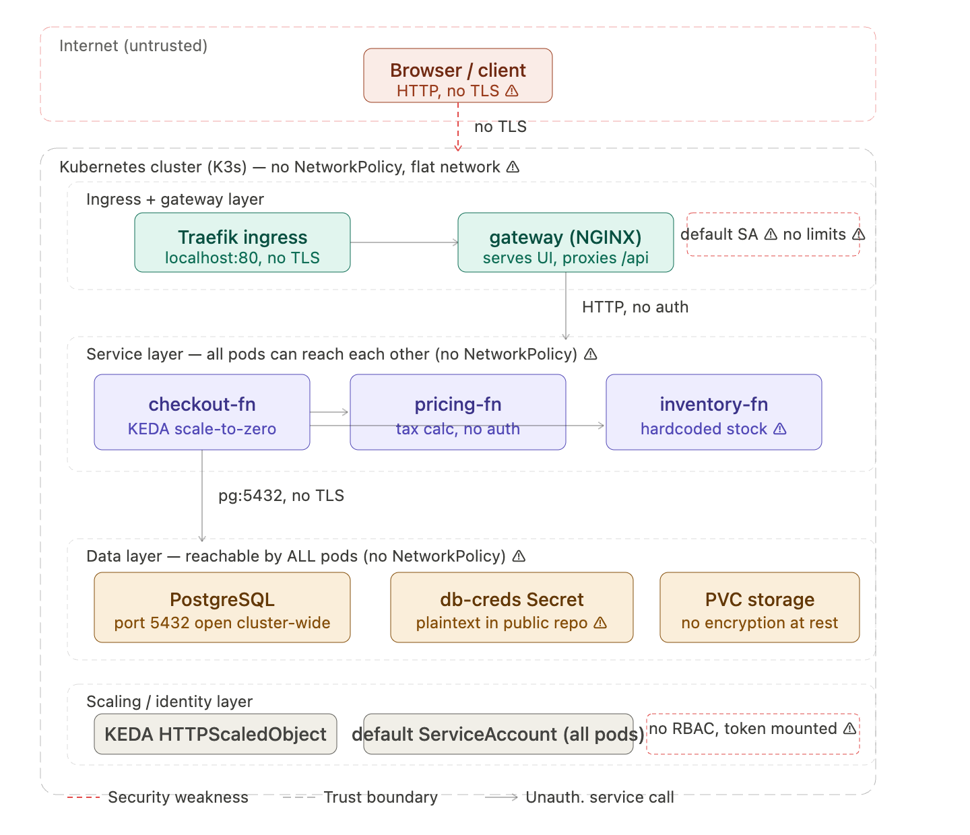
[DIAGRAM B — insert here]

