Introduction
This Release Management Plan (RMP) outlines the architecture, tool choices, and deployment strategies that were used to design and deploy the RashMedix cloud-based pharmacy stock management solution. RashMedix was developed as part of Continuous Assessment 2 (CA2) for the Enterprise Architecture Deployment module of the Master of Science in Computing with DevOps at TU Dublin.
The primary objective of RashMedix was to shift from a traditional monolithic, tightly-coupled deployment model to a distributed microservices architecture. According to Newman (2022), a microservices architecture breaks down an application into independent, deployable services, each with a clear boundary and separate data store. While this type of decomposition increases the engineering complexity of deployment, when executed appropriately it provides measurable benefits in scalability, resiliency, and team autonomy.
RashMedix is made up of three loosely coupled components: the user interface is a ReactJS single-page application; the business logic layer is provided by the Django REST Framework backend; and the persistence layer is implemented using PostgreSQL relational database. The complete system is deployed on Amazon Web Services (AWS) using Kubernetes (EKS) as its container orchestration platform, provisioned and managed using Infrastructure as Code (IaC) with Terraform. Continuous Integration and Delivery (CI/CD) are automated using GitHub Actions, with Helm being used as the Kubernetes package manager. Security scanning occurs within the pipeline by utilizing Trivy and Dive.
This report has been structured to meet the assessment requirements for application architecture, container orchestration, continuous delivery, deployment strategies, infrastructure automation, configuration management, monitoring and logging, security, sustainability and the reflection of the use of GenAI. It is structured in two parts. Part 1 presents the plan itself consisting of the research conducted, the options evaluated, and the decisions made across each domain of the deployment: container orchestration, CI/CD tooling, deployment strategy, infrastructure automation, monitoring, and security. Part 2 presents the implementation evidence of what was built, how it was configured, and the results achieved.
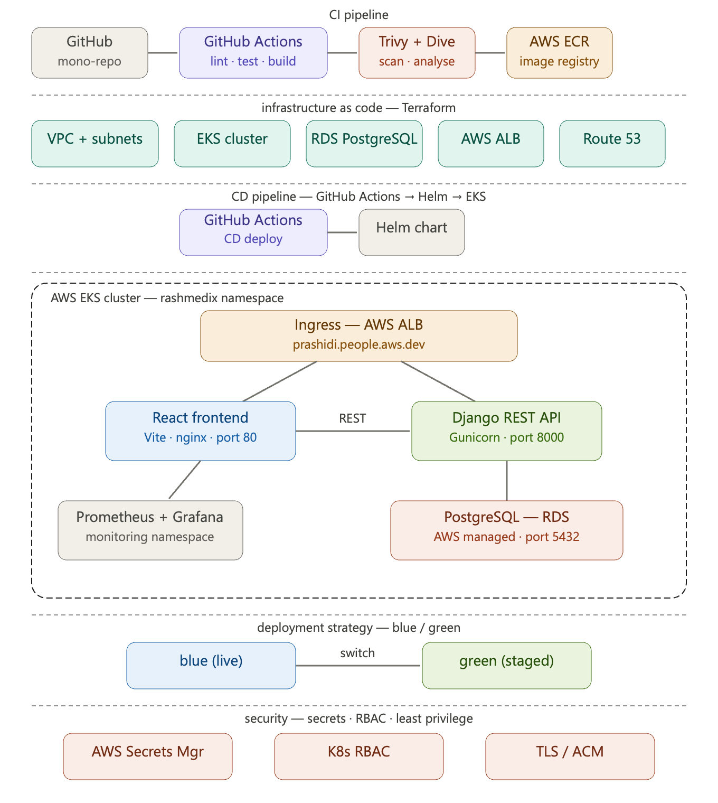
Figure 1: Architecture overview diagram

The Reslease Management Plan

Application Architecture Plan

Microservice Design
According to the bounded context principle of microservices architectures (Newman, 2021), there are three distinct services that comprise the entire application. Each of these individual services is able to be independently deployed while communicating via a defined interface. Communication between the front end and back end services occurs only through a RESTful HTTP API. In addition, only the backend service has direct access to the data layer; therefore, none of the three service have any knowledge of the internal state, or schema of another service.
The decision to implement a mono-repo pattern by grouping all three services and the infrastructure code into one GitHub repository organized into separate folders as follows: /frontend, /backend, /infrastructure/terraform and /k8s; was deliberate because the two services are closely version controlled together. The use of a single repository for version tracking, and triggering CI/CD build processes for each service only when its directory has been modified simplifies both processes.

Data Layer Design
The relational database management system of choice was PostgreSQL. The data model consists of four entities (Medicine, Category, Supplier, and StockTransaction). The StockTransaction Entity provides a complete, irreversible, traceable history of all stock movements in compliance with regulatory requirements in the pharmaceutical environment. Schema evolution is performed via Django migrations that are automatically run at container start-up, ensuring that the data schema is always consistent with the version of deployed code (Humble and Farley, 2010).
AWS RDS serves as the database backend for the Persistence strategy as opposed to a database in Kubernetes because this will separate stateful vs. stateless workloads. In addition, it would also provide the benefits of automated and AWS-managed backups, encryption at rest, and managing the patching process (AWS, no date).

Container Orchestration Plan

Options Evaluated
Kubernetes was selected as the only container orchestration platform considered. It is the de facto industry standard as stated by Portillo (2026), 91% of container users deploy Kubernetes and a CNCF survey found 93% of companies polled are using it with 80% running it in production (Portillo, 2026). Docker Swarm and Mesosphere Marathon were ruled out due to declining adoption and the absence of managed cloud offerings.
Three managed Kubernetes services were evaluated: Azure Kubernetes Service (AKS), Google Kubernetes Engine (GKE) and Amazon Elastic Kubernetes Service (EKS):
- AKS: Used in all module lab exercises and the platform Dr Portillo taught in (Portillo, 2026). The control plane is free, only node costs apply (Microsoft Azure, 2024). Simplest to configure via Azure CLI. Integrates natively with Azure services but introduces cross-cloud credential complexity when paired with the AWS ecosystem required for this project.
- GKE: Strong Google Cloud integration with Cloud SQL, GCR, and Cloud Load Balancing. Control plane charged at $0.10/hour for standard clusters (Google Cloud, 2024). Less relevant given the existing AWS account context.
- EKS: Control plane charged at $0.10/hour (Amazon Web Services, 2024). Native integration with ECR (image registry), RDS (database), ALB (load balancing), Secrets Manager (credentials), and Route 53 (DNS). IAM Roles for Service Accounts (IRSA) provides fine-grained pod-level AWS permissions. Requires more IAM configuration than AKS.
Criterion | EKS (AWS) | AKS (Azure) | GKE (Google)
Control plane cost | $0.10/hr | Free | $0.10/hr
AWS-native integration | ECR, RDS, ALB, SM | None (Free-Tier available) | None
Ease of setup | Moderate: IAM-heavy | Simple: taught in module | Moderate
Security model | IAM + IRSA + VPC | AAD + RBAC + VNet | Workload Identity + VPC
Private IP policy | ALB ingress: no raw IPs | Application Gateway | Cloud LB
Support | AWS Enterprise tiers | Microsoft tiers | Google tiers
Table 1: Container orchestration platform comparison

Decision
EKS was chosen for the project because it utilizes an existing AWS account. All of the supporting services (ECR, RDS, ALB, Secrets Manager, Route 53) are native AWS services, which avoid complexity of cross-cloud credentials. The additional configuration and management of IAM were considered a reasonable trade-off for the benefits of using EKS.
The Helm package manager was chosen for the purpose of encapsulating the entire deployment in a versioned chart that contains template values to allow for atomic upgrades and rollbacks as well as allowing for environment-specific overrides (Helm, 2024).
The Horizontal Pod Autoscaling (HPA) strategy will be configured to scale both deployments as discussed in the Week 6 module content; the HPA requires that the metrics-server provides CPU metrics via the Kubernetes Metrics API (Portillo, 2026). HPA parameters include: minimum 2 replicas, maximum 6, target CPU utilization of 70%. The default five 5 minute stabilization period will be used for scale-in to avoid flapping.

Continuous Software Delivery Plan

CI/CD Tool Options
The evaluation included three CI/CD Deployment tools. Self-hosting a build server with Jenkins created too much operational overhead, had risk of configuration drift, and contradicted the Infrastructure as Code (IaC) principles this project is based on; therefore, Jenkins was eliminated.
Azure DevOps offers 1,800 free pipeline minutes per month. When using GitHub as a code repository, it functions as a separate service and requires cross-service authentication (Microsoft Azure, 2024). Azure DevOps integrates well with Azure services, but deploying an application to AWS can create additional complexity because of the need for additional credentials to access both AWS and Azure services.
GitHub Actions are tied to the code repository, have 2,000 monthly pipeline minutes free, can be integrated via aws-actions/amazon-ecr-login to AWS ECR natively, and have over 20000 thousand marketplace actions available to you. With native path-based triggers, each service can have a separate pipeline.
Criterion | GitHub Actions | Azure DevOps | Jenkins
Free tier | 2,000 min/month | 1,800 min/month | Unlimited (self-managed)
AWS integration | Native ECR/EKS actions | Service connections needed | Plugins available
Code co-location | Yes; same repo | Separate service | Separate server
Maintenance | None | Low | High; self-hosted
Path-based triggers | Native | Native | Plugin-dependent
Table 2: CI/CD tool comparison

Pipeline Design
All CI pipelines will adhere to the same six-stage cycle: lint and test, build a linux/amd64 Docker image (based on multi-stage Dockerfile), run trivy vulnerability scan against the built image, push the image to ECR and perform dive image efficiency analysis. The last stage of the CD pipeline will include running helm upgrade -i, updating the K8 secret with current DB credentials, restarting the backend deployment, and validating roll-out status.

Decision
As GitHub Actions offers repository co-location, native integration with AWS ECR, and a more extensive free plan than Azure DevOps, it make it the best fit for this project.
The decision to implement Continuous Delivery rather than complete automation is important since the operational success of an automated pharmacy stock system is critical for testing medication data. Any potential issues resulting from an accidental migration failure could result in pharmacists not having the appropriately dispensed medications. Therefore, utilizing a workflow_dispatch manual trigger provides a human safety check (Dhandala, 2026).
Every service has its own CI pipeline that uses a path filter to trigger the build process. Once builds are complete and successful the CI pipeline sends artifacts to a shared CD pipeline for deployment via Helm which deploys both services based on the CI success of both services. This allows the services to be independently released while using one common deployment artefact.

Deployment Strategy Plan

Options Evaluated
Four different deployment methods were analysed against the needs of a production pharmacy management system (Kubegrade, 2025):
- Recreate: Stops all pods prior to starting new pods. Creates downtime. Not acceptable for a system that requires constant stock access
- Rolling Update: Replacement of pods one at-a-time providing no downtime as a feature of the Kubernetes management system. Old pod and new pod are serving the traffic during the transitional period and could lead to inconsistency when transitioning after a Breaking Database Migration.
- Blue/Green (VIP Swap): Two complete deployments run in parallel with the service selector patching and switching the traffic atomically. There is no downtime, no mixing of versions, and there is an instant revert capability. Disadvantage: Uses twice the resources throughout the transition period.
- Canary: A small percentage of the traffic is routed to the New Version for A/B testing at a Large Scale. Very complex routing to accomplish this; therefore, this deployment method will be more suited to Large Scale Consumer environments than to a Pharmacy Management System.

Backup and Restore Strategy
AWS RDS will also support automated backups with a retention period of 7 days and daily backups occurring from 03:00 to 04:00 UTC. The point-in-time recovery capability will provide the ability to restore to any second during the daily backup timeframe. A versioned and encrypted S3 bucket and DynamoDB locking will be used for the Terraform state file, allowing for the ability to completely rebuild all infrastructure through terraform apply.

Decision

This project has opted for a Blue/Green deployment strategy due to the significant risk of inconsistent service responses during a rolling update, especially following database schema migration, as compared to the cost of operating two replicas briefly. With the atomic service selector switch, you achieve an optimal separation between versions and the most expedited route for rolling back (Ferranti, 2026).

There are three rollback plans for each failure level:

Level 1: Repatch service selector back to Blue, <1s, 0s downtime.

Level 2: Helm rollback for chart level configuration change.

Level 3: RDS point-in-time restore for data layer failures (RPO of approximately 5 minutes).

Automated Infrastructure Delivery Plan

IaC Tool Options
Terraform: Cloud-agnostic, declarative HCL syntax, thousands of providers including Kubernetes and Helm, clean plan/apply review workflow, S3 and DynamoDB remote state management. Open-source under BSL licence (HashiCorp, 2024). Explicitly taught in Week 11 (Portillo, 2026h).
AWS CloudFormation: AWS-native, no additional tooling. Verbose JSON/YAML syntax. Drift detection exists but the review workflow is less explicit than Terraform's plan/apply. AWS-specific, which limits reusability.
Ansible: Strong for post-provisioning configuration management. Procedural rather than declarative — not ideal for detecting and correcting infrastructure drift automatically.
Selected tool: Terraform — cloud-agnostic, plan/apply review workflow prevents unreviewed changes, and it was explicitly taught in the module (Portillo, 2026h). As the lecture notes observe, without IaC the scale of modern cloud infrastructure becomes increasingly difficult to manage.

Infrastructure to be Provisioned
The following AWS resources will be provisioned through Terraform: VPC with public and private subnets across three availability zones; internet gateway and NAT gateway; EKS cluster v1.31 with a managed node group of t3.medium instances (1-4 nodes, auto-scaling); RDS PostgreSQL 15 instance in the private subnet with encrypted storage and seven-day backup retention; AWS Secrets Manager secret for database credentials; IAM roles for EKS nodes, ALB controller, and ECR access; and an S3 bucket with DynamoDB table for Terraform remote state.

Configuration Drift Prevention
All infrastructure changes must go through the Terraform plan/apply workflow. No manual AWS console changes are permitted. At the application layer, Helm's upgrade --install command provides the same idempotent, drift-free deployment model. The combination of Terraform state and Helm release history means the complete state of both infrastructure and application can be inspected, compared, and rolled back at any time.

Implementation

Architecture and Service Communication
RashMedix follows the microservices architectural pattern, as described by Portillo (2026), where each service is responsible for the single bounded context. These services are independently deployed as separate containerized workloads in a Kubernetes namespace and communicate through the cluster-internal network.
The frontend (ReactJS application) communicates to the backend (Django Rest Framework application) exclusively via the RESTful HTTP API (running on port 8000). All requests from the frontend that are prefixed with /api are routed to the backend via the Nginx proxy configuration, using the Kubernetes DNS name backend-service.rashmedix.svc.cluster.local, which resolves via the ClusterIP service. Therefore, no direct communication occurs between the frontend and backend applications (through the database), and the front end does not have an awareness of the data layer.
Through the use of the psycopg2 driver, Django connects to a PostgreSQL database. Instead of being hardcoded into the application or container image, the hostname, authentications, and connection settings of the database are provided through environment variables that are imported from a Kubernetes Secret. All intersevice communication occurs within the private cluster network and is not accessible via the public internet.
Component | Technology | Port | Replicas
Frontend | React (Vite) + nginx:alpine | 80 | 2
Backend API | Django REST Framework + Gunicorn | 8000 | 2
Database | PostgreSQL 15 on AWS RDS | 5432 | Managed
Table 1: RashMedix service summary
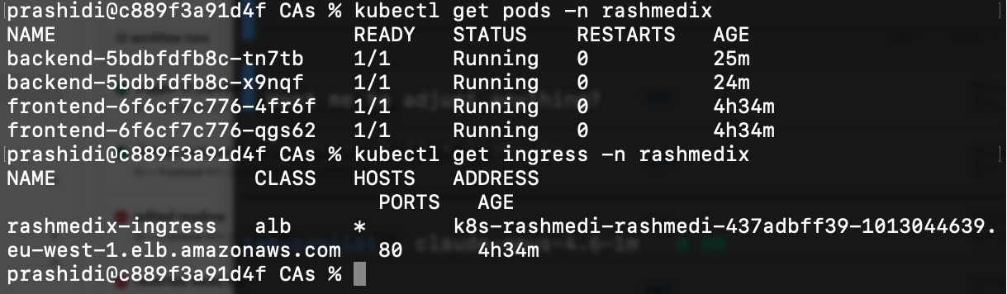
Figure 2: kubectl get pods -n rashmedix
prashidi@c889f3a91d4f rashmedix % kubectl get services -n rashmedix
kubectl get endpoints -n rashmedix
NAME TYPE CLUSTER-IP EXTERNAL-IP PORT(S) AGE
backend-service ClusterIP 172.20.63.164 <none> 8000/TCP 135m
frontend-service ClusterIP 172.20.20.252 <none> 80/TCP 135m
NAME ENDPOINTS AGE
backend-service 10.0.2.34:8000,10.0.3.166:8000 135m
frontend-service 10.0.2.141:80,10.0.3.227:80 135m
prashidi@c889f3a91d4f rashmedix %
Figure 3: kubectl get services -n rashmedix: backend-service and frontend-service ClusterIP
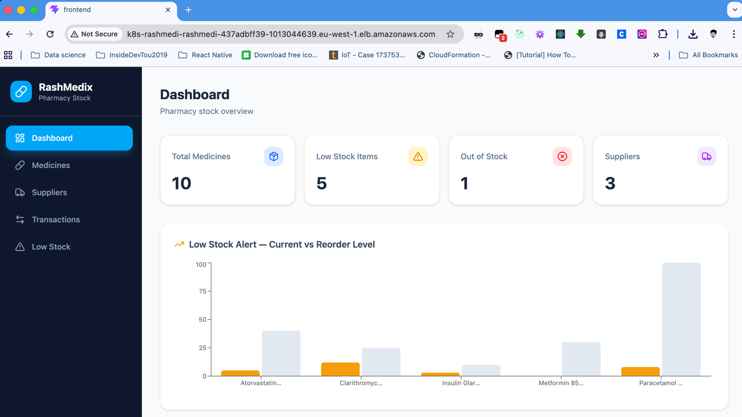
Figure 4: Browser screenshot: RashMedix dashboard running at ALB

Data Layer Design and Integration
The data layer has been designed using PostgreSQL 15 hosted on Amazon RDS in a private subnet inside Amazon VPC. The design decision to use a managed RDS database instead of placing the database in the Kubernetes cluster provides separation between stateful database and stateless application workloads. Using an Amazon RDS service will also provide benefits of AWS managed automated backups, Multi-AZ failover, and patch management.
Django’s Object-Relational Mapping (ORM) uses migrations for managing the data schema and performs migrations automatically when the container starts. This makes sure that the schema matches with the version of application code that was deployed, which is a central component of reliable continuous delivery (Humble & Farley, 2011).
The data model contains four fundamental entities: Medicine, Category, Supplier and StockTransaction. The StockTransaction entity includes the complete audit history of all of the stock movements such as restocking of products, quantities that have been dispensed, adjustments and stock that has expired. This model is designed to meet the traceability regulatory requirements that are often seen in pharmaceutical environments.
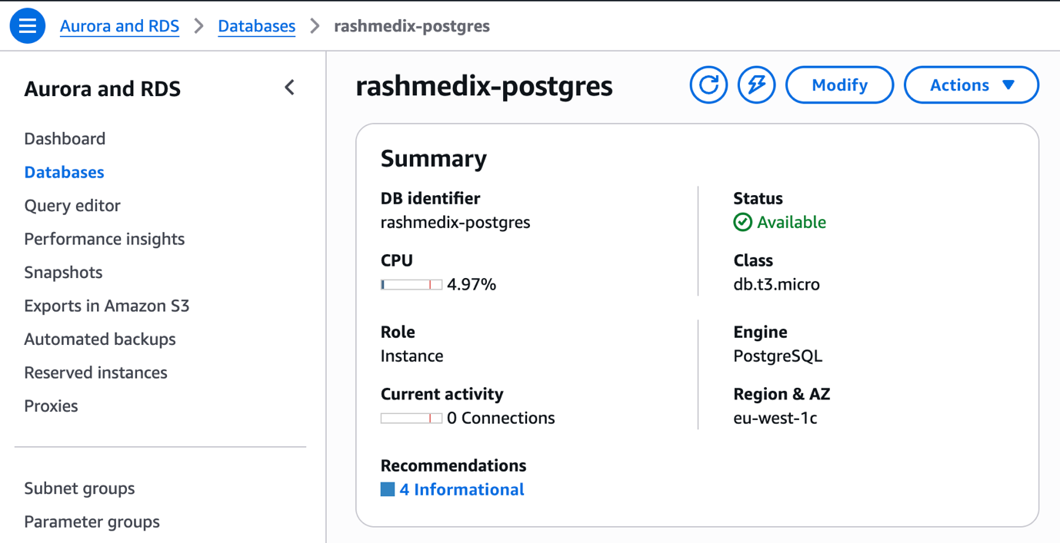
Figure 5: AWS Console — RDS instance detail
prashidi@c889f3a91d4f rashmedix % kubectl exec -n rashmedix \
$(kubectl get pods -n rashmedix -l app=backend \
-o jsonpath='{.items[0].metadata.name}') \
-- python manage.py seed_data
Seeding categories...
Seeding suppliers...
Seeding medicines...
Created: Amoxicillin 500mg
Created: Ibuprofen 400mg
Created: Lisinopril 10mg
Created: Salbutamol 100mcg
Created: Omeprazole 20mg
Created: Paracetamol 500mg
Created: Atorvastatin 20mg
Created: Clarithromycin 250mg
Created: Metformin 850mg
Created: Insulin Glargine 100u/ml
Seeding stock transactions...

Done!
Categories: 5
Suppliers: 3
Medicines: 10
Transactions: 4
Low stock: 5
Out of stock: 1
Figure 6: Terminal: python manage.py seed_data output

Monorepo Structure
A deliberate decision was made to use a single GitHub repository containing all three services and the infrastructure code, organised into separate directories: /frontend, /backend, /infrastructure/terraform, and /k8s. This approach, sometimes referred to as a mono-repo pattern, was chosen because the two services are tightly versioned together. Maintaining a single repository simplifies version tracking and the CI/CD trigger logic, while each service retains its own pipeline triggered only when its respective directory is modified.

