Introduction
This Release Management Plan (RMP) outlines the architecture, tool choices, and deployment strategies that were used to design and deploy the RashMedix cloud-based pharmacy stock management solution. RashMedix was developed as part of Continuous Assessment 2 (CA2) for the Enterprise Architecture Deployment module of the Master of Science in Computing with DevOps at TU Dublin.
The primary objective of RashMedix was to shift from a traditional monolithic, tightly-coupled deployment model to a distributed microservices architecture. According to Newman (2022), a microservices architecture breaks down an application into independent, deployable services, each with a clear boundary and separate data store. While this type of decomposition increases the engineering complexity of deployment, when executed appropriately it provides measurable benefits in scalability, resiliency, and team autonomy.
RashMedix is made up of three loosely coupled components: the user interface is a ReactJS single-page application; the business logic layer is provided by the Django REST Framework backend; and the persistence layer is implemented using PostgreSQL relational database. The complete system is deployed on Amazon Web Services (AWS) using Kubernetes (EKS) as its container orchestration platform, provisioned and managed using Infrastructure as Code (IaC) with Terraform. Continuous Integration and Delivery (CI/CD) are automated using GitHub Actions, with Helm being used as the Kubernetes package manager. Security scanning occurs within the pipeline by utilizing Trivy and Dive.
This report has been structured to meet the assessment requirements for application architecture, container orchestration, continuous delivery, deployment strategies, infrastructure automation, configuration management, monitoring and logging, security, sustainability and the reflection of the use of GenAI.

Overview of the Microservice Application
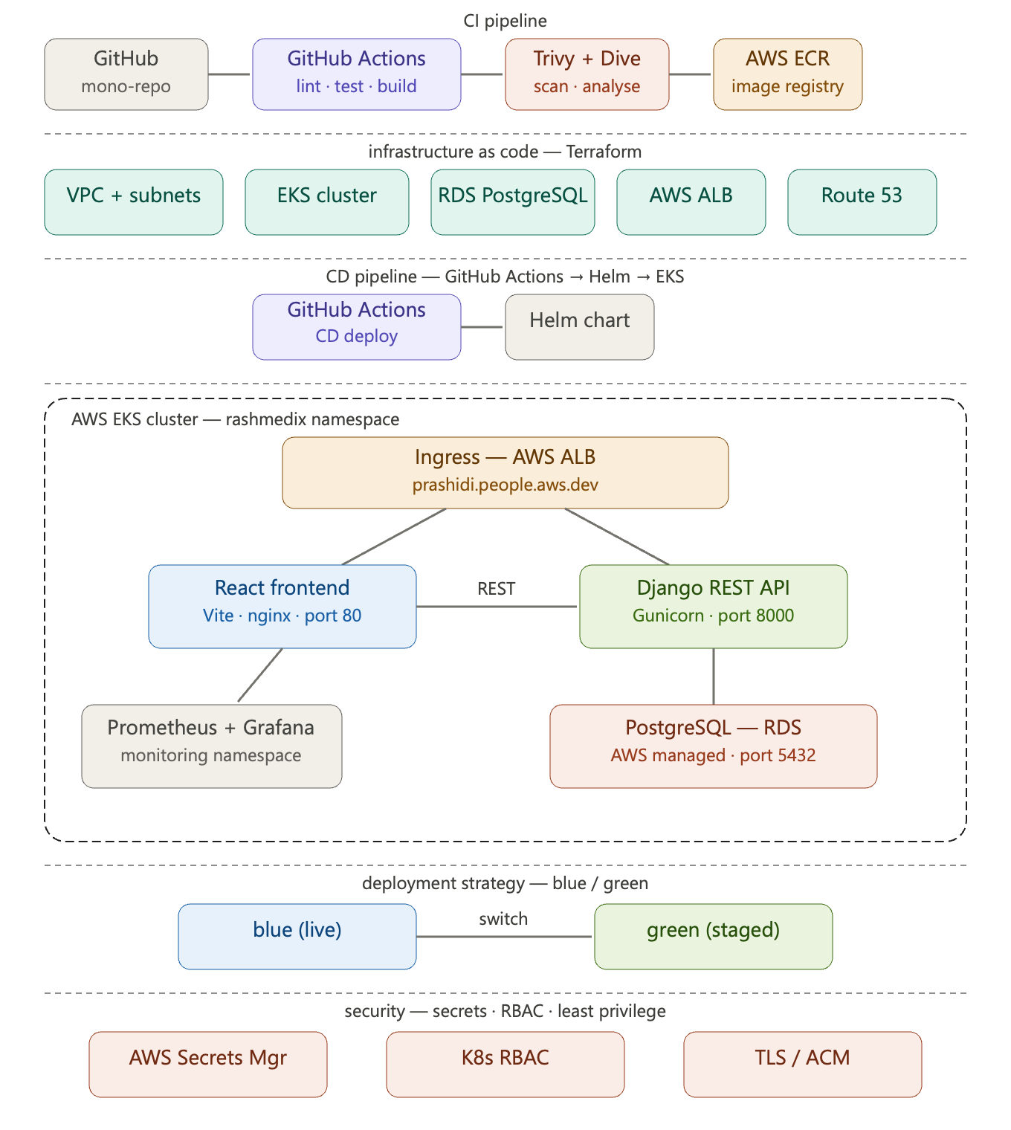
Figure 1: Architecture overview diagram

Architecture and Service Communication
RashMedix follows the microservices architectural pattern, as described by Portillo (2026), where each service is responsible for the single bounded context. These services are independently deployed as separate containerized workloads in a Kubernetes namespace and communicate through the cluster-internal network.
The frontend (ReactJS application) communicates to the backend (Django Rest Framework application) exclusively via the RESTful HTTP API (running on port 8000). All requests from the frontend that are prefixed with /api are routed to the backend via the Nginx proxy configuration, using the Kubernetes DNS name backend-service.rashmedix.svc.cluster.local, which resolves via the ClusterIP service. Therefore, no direct communication occurs between the frontend and backend applications (through the database), and the front end does not have an awareness of the data layer.
Through the use of the psycopg2 driver, Django connects to a PostgreSQL database. Instead of being hardcoded into the application or container image, the hostname, authentications, and connection settings of the database are provided through environment variables that are imported from a Kubernetes Secret. All intersevice communication occurs within the private cluster network and is not accessible via the public internet.
Component | Technology | Port | Replicas
Frontend | React (Vite) + nginx:alpine | 80 | 2
Backend API | Django REST Framework + Gunicorn | 8000 | 2
Database | PostgreSQL 15 on AWS RDS | 5432 | Managed
Table 1: RashMedix service summary
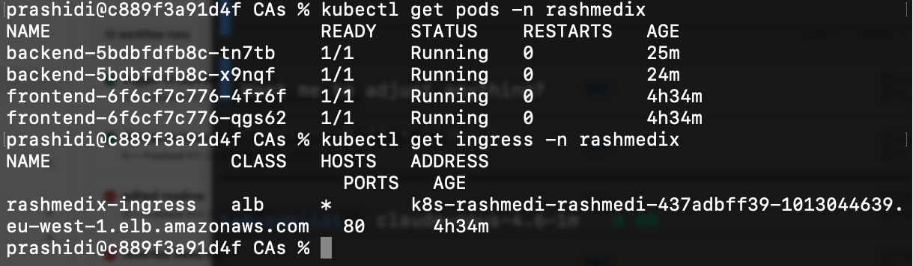
Figure 2: kubectl get pods -n rashmedix
prashidi@c889f3a91d4f rashmedix % kubectl get services -n rashmedix
kubectl get endpoints -n rashmedix
NAME TYPE CLUSTER-IP EXTERNAL-IP PORT(S) AGE
backend-service ClusterIP 172.20.63.164 <none> 8000/TCP 135m
frontend-service ClusterIP 172.20.20.252 <none> 80/TCP 135m
NAME ENDPOINTS AGE
backend-service 10.0.2.34:8000,10.0.3.166:8000 135m
frontend-service 10.0.2.141:80,10.0.3.227:80 135m
prashidi@c889f3a91d4f rashmedix %
Figure 3: kubectl get services -n rashmedix: backend-service and frontend-service ClusterIP
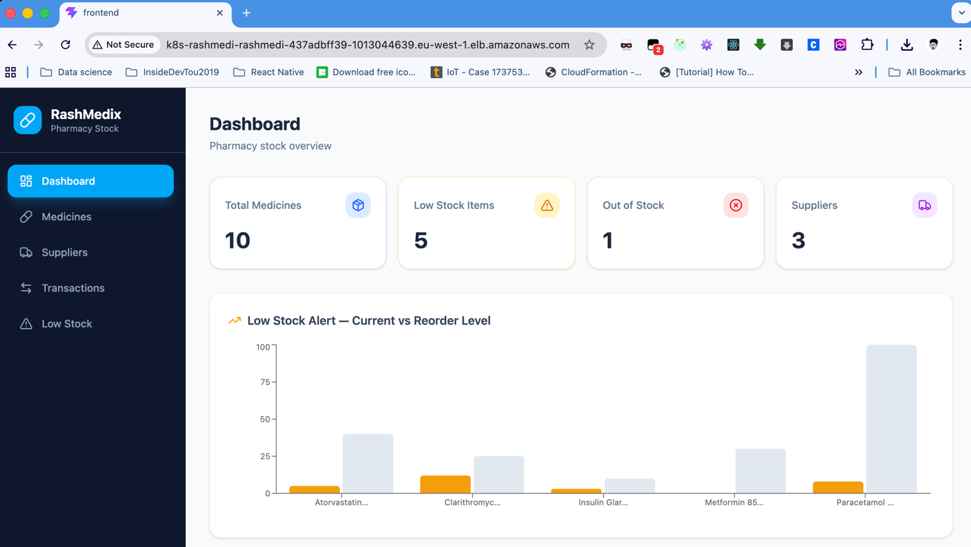
Figure 4: Browser screenshot: RashMedix dashboard running at ALB

Data Layer Design and Integration
The data layer has been designed using PostgreSQL 15 hosted on Amazon RDS in a private subnet inside Amazon VPC. The design decision to use a managed RDS database instead of placing the database in the Kubernetes cluster provides separation between stateful database and stateless application workloads. Using an Amazon RDS service will also provide benefits of AWS managed automated backups, Multi-AZ failover, and patch management. Django’s Object-Relational Mapper (ORM) uses migrations for managing the data schema and performs migrations automatically when the container starts. This makes sure that the schema matches with the version of application code that was deployed, which is a central component of reliable continuous delivery (Humble and Farley, 2010). The data model contains four fundamental entities: Medicine, Category, Supplier and StockTransaction. The StockTransaction entity includes the complete audit history of all of the stock movements such as restocking of products, quantities that have been dispensed, adjustments and stock that has expired. This model is designed to meet the traceability regulatory requirements that are often seen in pharmaceutical environments.

