BlockCert: Decentralized Academic
Credential Registry
A Blockchain-Based Platform for Secure Issuance, Encryption,
and Verification of Academic Certificates
Project Documentation Report
Department of Computer Science & Engineering
Academic Year 2025–2026

ABSTRACT

ABSTRACT
Academic credential fraud represents a critical challenge in modern educational and professional ecosystems. This project presents BlockCert — a fully decentralized academic credential registry built on the Ethereum blockchain — that eliminates credential forgery by anchoring every certificate to an immutable, publicly auditable ledger. The platform employs a hybrid cryptographic pipeline comprising client-side ChaCha20-Poly1305 AEAD encryption, ZLib compression, and EIP-191 deterministic wallet-signature key derivation, eliminating any centralized key-storage dependency. Encrypted payloads are stored on IPFS via Pinata; the Content Identifier and a keccak256 certificate hash are anchored on-chain through a Solidity smart contract. A Web3 Role-Based Access Control system enforces five hierarchical roles: Government, Regulatory Authority, Institution, Student, and Recruiter. The platform supports individual issuance, Merkle-tree batch issuance, certificate revocation, an Institutional Registry Vault for key recovery, and a Universal One-Tap QR Verification flow completing full end-to-end verification in under one second. The system is deployed as a React.js SPA with Vercel CI/CD integration and validated on both local Hardhat and Ethereum testnets.

TABLE OF CONTENTS
S.NO | CONTENT | PG NO
1 | INTRODUCTION
 | 1.1 Introduction
 | 1.2 Objective
 | 1.3 Problem Statement
 | 1.4 Software Requirements
 | 1.5 Hardware Requirements
2 | FEASIBILITY STUDY
3 | LITERATURE SURVEY
4 | SYSTEM ANALYSIS
 | 4.1 Existing System
 | 4.1.1 Disadvantages of Existing System
 | 4.2 Proposed System
 | 4.2.1 Advantages of Proposed System
 | 4.3 Functional Requirements
 | 4.4 Non-Functional Requirements
5 | SYSTEM DESIGN
 | 5.1 System Architecture
 | 5.2 Data Flow Diagram
 | 5.3 UML Diagrams
6 | IMPLEMENTATION
 | 6.1 Modules
 | 6.2 Algorithms
 | 6.3 Sample Code
7 | SOFTWARE ENVIRONMENT
8 | SYSTEM TESTING
 | 8.1 Types of Testing
 | 8.2 Test Cases
9 | RESULTS
 | 9.1 Performance Evaluation
 | 9.2 Screenshots
10 | CONCLUSION
 | 10.1 Conclusion
 | 10.2 Future Scope
 | REFERENCES

INTRODUCTION

1. INTRODUCTION
1.1 INTRODUCTION
The increasing incidence of academic credential fraud has exposed fundamental weaknesses in traditional certificate management systems. Educational institutions, employers, and regulatory bodies make high-stakes decisions based on academic credentials, yet the mechanisms for verifying these credentials remain fragile. Paper certificates can be forged with widely available software, and centralized digital repositories remain vulnerable to unauthorized modification, insider threats, and data breaches.
Blockchain technology offers a transformative solution by providing an immutable, decentralized ledger where records, once committed, cannot be altered or deleted. Every transaction is cryptographically linked to prior transactions and validated by a global network of nodes, eliminating the possibility of silent record manipulation. When combined with decentralized file storage (IPFS), client-side encryption, and smart contract-enforced access control, blockchain becomes a compelling foundation for a tamper-proof academic credential registry.
BlockCert is a production-grade, research-quality platform that implements this vision. It provides institutional administrators with a guided issuance portal, students with a cryptographic credential wallet, employers with a one-tap QR verification system, and regulatory bodies with real-time audit dashboards — all governed by on-chain Role-Based Access Control that cannot be bypassed.
1.2 OBJECTIVE
- Develop a decentralized platform for institutions to issue tamper-proof academic certificates permanently anchored on the Ethereum blockchain.
- Implement client-side ChaCha20-Poly1305 AEAD encryption ensuring certificate documents on IPFS are accessible only to authorized parties with the correct decryption key.
- Enforce a hierarchical Web3 Role-Based Access Control system on-chain with five domain-specific roles: Government, Regulatory Authority, Institution, Student, and Recruiter.
- Design an Institutional Registry Vault using EIP-191 deterministic wallet-signature key derivation, eliminating any centralized key-storage dependency.
- Implement a Universal One-Tap QR Verification system enabling recruiters to cryptographically verify certificates in under one second via mobile scan.
- Support Merkle-tree-based batch certificate issuance allowing entire graduating classes to be processed in a single on-chain transaction.
- Provide real-time institutional analytics and global audit logs for regulatory oversight and compliance monitoring.
- Deploy on Vercel with full ESLint-enforced CI/CD pipeline ensuring production code quality.
1.3 PROBLEM STATEMENT
- Academic credential fraud is widespread; traditional paper and centralized-database systems offer no cryptographic guarantee of authenticity. Employers have no independent verification mechanism, making the system entirely trust-dependent.
- Centralized certificate servers are single points of failure. A compromised database can silently invalidate the credibility of thousands of certificates with no forensic trail.
- Existing blockchain certificate solutions store un-encrypted documents on IPFS, exposing sensitive student data — degree class, GPA, personal identification — to anyone who obtains the CID.
- No existing open-source platform provides a key-management model that is both sovereign (no centralized key database) and recoverable (issuer can always regenerate keys). Commercial platforms impose vendor lock-in.
- Manual verification requires institutional contact, creating bottlenecks and delays. Emergency verification for visa applications or employment commencement is impractical under existing systems.
- Institutional registrars lack real-time analytics dashboards to monitor issuance volumes, detect anomalies, or satisfy regulatory audit requirements under educational governance frameworks.
1.4 SOFTWARE REQUIREMENTS
S.No | Requirement | Specification
1 | Blockchain Framework | Hardhat v2.x + Ethers.js v5
2 | Smart Contract Language | Solidity ^0.8.20
3 | Frontend Framework | React.js 18 (Create React App)
4 | UI Library | Material UI (MUI v5) + @mui/x-charts
5 | Cryptography | @noble/ciphers (ChaCha20-Poly1305)
6 | Compression | fflate (ZLib/Deflate — zlibSync/unzlibSync)
7 | IPFS Provider | Pinata Cloud (JWT authentication)
8 | Web3 Wallet | MetaMask Browser Extension
9 | QR Code | qrcode.react (QRCodeSVG)
10 | HTTP Client | Axios
11 | Node Version | Node.js 22 LTS (.nvmrc)
12 | Deployment | Vercel CI/CD

1.5 HARDWARE REQUIREMENTS
S.No | Component | Specification
1 | Operating System | macOS / Windows 10+ / Ubuntu 20.04+
2 | Processor | Intel Core i5 8th Gen+ / Apple M1+
3 | RAM | 8 GB Minimum — 16/32 GB Recommended
4 | Storage | 50 GB Free Space (node_modules + blockchain data)
5 | Internet | Required for Pinata IPFS + Ethereum testnet RPC
6 | Browser | Google Chrome with MetaMask extension

FEASIBILITY STUDY

2. FEASIBILITY STUDY
A feasibility study evaluates the practicality of a proposed project across technical, economic, legal, operational, and scheduling dimensions. For BlockCert, the following assessments were performed.
2.1 Technical Feasibility
Ethereum is a mature public blockchain with a rich developer ecosystem. Solidity smart contracts support the role-based and registry logic required by BlockCert. Hardhat provides a local Ethereum node for zero-cost development. React.js and MUI are battle-tested for professional SPAs. ChaCha20-Poly1305 is available via the @noble/ciphers package with WebAssembly-level browser performance. Pinata's free tier provides sufficient IPFS storage for prototyping. All integrations have been validated end-to-end in the prototype, confirming full technical feasibility.
2.2 Economic Feasibility
BlockCert uses entirely open-source libraries with no licensing costs. Pinata free tier covers prototype IPFS storage. Vercel free tier covers frontend hosting. Gas costs on Ethereum testnets are zero. Estimated mainnet gas cost per certificate issuance is under USD 2 at moderate gas prices. The platform is economically accessible to educational institutions of any size.
2.3 Legal Feasibility
Only encrypted ciphertext is stored on IPFS — no plaintext personal data is publicly accessible. On-chain data consists of hash values and Ethereum addresses, not personally identifiable information. The platform's use of open-source libraries and public blockchain infrastructure raises no intellectual property concerns. GDPR implications are mitigated by the encryption-by-default design.
2.4 Operational Feasibility
The system's role-based workflow maps cleanly to existing university administrative hierarchies. Institutions need only connect a MetaMask wallet to begin issuing certificates through a guided 3-step portal. Students and recruiters require no blockchain expertise. Vercel handles all hosting automatically. Operational overhead for adopting institutions is minimal.
2.5 Scheduling Feasibility
Phase 1 (Weeks 1–3): Smart contract development and Hardhat testing. Phase 2 (Weeks 4–6): Frontend scaffolding, wallet integration, RBAC. Phase 3 (Weeks 7–9): Cryptographic pipeline, IPFS integration. Phase 4 (Weeks 10–12): Issuance portal, QR system, analytics. Phase 5 (Weeks 13–15): Production hardening, ESLint, Vercel deployment, documentation. All phases completed within schedule.

LITERATURE SURVEY

3. LITERATURE SURVEY
The following studies informed the design and architecture of the BlockCert platform. References span blockchain credential systems, cryptographic key management, IPFS storage, smart contract security, and comparisons with the reference base paper on deep-learning vulnerability detection.
3.1 Blockchain-Based Credential Verification Systems
Early blockchain diploma verification systems (e.g., MIT's Blockcerts, 2016) demonstrated that smart contracts can serve as tamper-proof certificate registries by storing certificate hashes on-chain. However, these systems store raw documents in centralized servers, creating a confidentiality gap. BlockCert addresses this by encrypting documents client-side before IPFS upload.
3.2 Self-Sovereign Identity on Blockchain — Ferdous et al.
This work introduced Self-Sovereign Identity (SSI) using blockchain, where individuals control their identity data without centralized authorities. BlockCert draws on SSI principles by tying credentials to student Ethereum addresses. The EIP-191 key derivation model ensures the institution remains the sole key authority without maintaining a key database — consistent with SSI sovereignty.
3.3 IPFS as Decentralized Storage — Benet (2014)
The InterPlanetary File System provides content-addressed, peer-to-peer storage. CIDs are cryptographic hashes of stored content, making them tamper-evident. BlockCert uses IPFS via Pinata for encrypted payload storage, combining on-chain immutability with off-chain scalable storage.
3.4 ChaCha20-Poly1305 AEAD — RFC 8439
ChaCha20-Poly1305 provides authenticated encryption (confidentiality + integrity) in a single pass. Unlike AES-GCM, it requires no hardware acceleration and performs excellently in browser JavaScript, making it ideal for client-side encryption in BlockCert's pipeline via @noble/ciphers.
3.5 EIP-191 Signed Data Standard
EIP-191 defines a standard for signing arbitrary data with an Ethereum wallet. The signature is deterministic for a given private key and message. BlockCert exploits this to derive per-student encryption keys from the issuer's wallet signature — the same key can always be regenerated without storing it anywhere, forming the Institutional Registry Vault model.
3.6 Merkle Tree Certificate Batch Issuance
Merkle trees allow a single root hash to commit to a large set of leaf values. BlockCert's issueBatch() function accepts a Merkle root representing an entire graduating class, reducing gas costs to a single transaction. On-chain verification uses OpenZeppelin's MerkleProof library.
3.7 OpenZeppelin AccessControl Patterns
OpenZeppelin's AccessControl library provides production-grade role management for Solidity. BlockCert implements a custom AccessControl contract with a domain-specific 5-tier hierarchy (Government > Regulatory > Institution > Student > Recruiter) that precisely models educational governance, informed by OpenZeppelin's design patterns.
3.8 Base Paper Comparison — Vulnerability Detection via Deep Learning
The reference paper presents a hybrid framework combining CodeBERT embeddings with AST features for software vulnerability detection (accuracy 0.95, precision 0.90, recall 1.00, F1 0.95). While that work uses probabilistic ML inference to detect code vulnerabilities, BlockCert addresses a parallel security domain — credential authenticity — through deterministic cryptographic means. Both share a hybrid analysis philosophy: the base paper combines semantic embeddings (CodeBERT) with structural features (AST), while BlockCert combines cryptographic hash verification (structural) with ChaCha20-Poly1305 decryption (semantic payload access). The key distinction is that blockchain-based approaches provide mathematical guarantees of authenticity, whereas ML-based approaches provide probabilistic assessments — making them complementary for different threat models.

SYSTEM ANALYSIS

4. SYSTEM ANALYSIS
4.1 EXISTING SYSTEM
Existing academic credential management systems fall into three categories. First, paper-based systems rely on physical documents that can be forged or altered. Second, centralized digital repositories store certificates in institutional databases vulnerable to breaches and insider threats. Third, early blockchain prototypes store only certificate hashes on-chain without addressing document confidentiality, key management, or access control. Commercial platforms such as Blockcerts and Accredify offer partial solutions but impose vendor lock-in, lack client-side encryption, and do not provide a sovereign key-management model. Drawing from the reference base paper, existing security solutions — both in vulnerability detection and credential management — rely on rule-based or signature-based approaches that fail against novel, evolving threats (forged certificates with sophisticated alterations or zero-day vulnerabilities).
4.1.1 Disadvantages of Existing System
- Centralized databases are single points of failure. A breached or corrupted database silently invalidates the trustworthiness of all stored credentials with no cryptographic audit trail.
- Paper certificates can be forged with commodity software. Traditional verification requires contacting the issuing institution — a slow, costly, and unscalable process.
- Early blockchain solutions store unencrypted documents on IPFS, publicly exposing sensitive student data (GPA, degree class, personal details) to anyone who obtains the CID.
- No open-source platform provides a sovereign key-management model that is simultaneously recoverable (issuer can regenerate keys) and decentralized (no key database required).
- Commercial blockchain certificate platforms impose subscription fees, proprietary APIs, and contractual dependencies that create long-term vendor lock-in for educational institutions.
- Existing systems provide no real-time analytics or audit dashboards, making regulatory compliance monitoring difficult for educational governance bodies.
4.2 PROPOSED SYSTEM
BlockCert proposes a fully decentralized, cryptographically secured credential registry built on four core innovations:
Innovation 1 — On-Chain RBAC: A custom Solidity smart contract enforces five hierarchical roles. Only INSTITUTION-role addresses can call issueCertificate(). Only the admin can call grantRole(). Revocation requires the issuing institution. These rules are enforced at the EVM level and cannot be bypassed by any frontend modification.
Innovation 2 — Client-Side Cryptographic Pipeline: Documents are ZLib-compressed (fflate), encrypted with ChaCha20-Poly1305 using a random 96-bit nonce, and tagged with a BCV2 protocol marker before IPFS upload. The IPFS layer contains only unintelligible ciphertext.
Innovation 3 — Institutional Registry Vault (EIP-191): The institution signs a deterministic per-student message. keccak256(signature) becomes the 256-bit encryption key. Since signatures are deterministic, the key can always be regenerated without storage. The Hyper-Scanner on the verification page automates multi-protocol key recovery.
Innovation 4 — Universal QR Verification: A QR code encodes a deep-link URL with the certId and decryption key in the URL fragment. One scan triggers automatic blockchain lookup, IPFS download, decryption, and document rendering — completing in under one second.
4.2.1 Advantages of Proposed System
- Immutable on-chain anchoring provides cryptographic proof of authenticity independently verifiable by any party without trusting the issuing institution.
- Client-side ChaCha20-Poly1305 encryption ensures document confidentiality on IPFS. The ciphertext is meaningless without the 256-bit decryption key.
- EIP-191 deterministic key derivation eliminates the centralized key database vulnerability. Institutions can always recover any student's key from their own wallet.
- Universal QR verification reduces verification time from days to under one second, eliminating institutional contact bottlenecks.
- Open-source, vendor-agnostic architecture ensures accessibility, extensibility, and zero proprietary lock-in.
- Real-time analytics dashboard provides institutional registrars and regulators with live issuance trends and global audit logs.
- Merkle batch issuance reduces per-certificate gas cost to effectively zero by processing entire cohorts in one transaction.
4.3 FUNCTIONAL REQUIREMENTS
Web3 Authentication: System authenticates users via MetaMask using eth_requestAccounts. Auto-reconnects on page load if wallet was previously authorized. Disconnect preference stored in localStorage.
Role-Based Access Control: Reads user role from on-chain roles[account] mapping. Dynamically shows/hides UI features per role. Institution enables issuance/revocation. Government/Regulatory enables role management.
Certificate Issuance: 3-step guided portal: Student Identity (address + name) → Academic Details (degree, GPA, expiry) → Secure Packaging (file upload, encryption). Calls issueCertificate() after IPFS upload.
Certificate Verification: Accepts 66-char certId, calls getCertificate(), displays validity (AUTHENTIC/REVOKED/EXPIRED), institution, issue date, expiry, IPFS CID.
Document Decryption: Accepts 64-char hex key, downloads from IPFS, detects BCV2 marker, extracts nonce, decrypts with ChaCha20-Poly1305, decompresses, auto-detects MIME, renders in CertificateViewer dialog.
Certificate Revocation: Institution calls revokeCertificate(certId). Permanently marks certificate as revoked on-chain. Future verification returns REVOKED status.
Batch Issuance: Institution submits Merkle root + count to issueBatch(). Enables entire cohort issuance in one transaction. BatchIssued event emitted on-chain.
Role Management: Government/Regulatory users grant roles to Ethereum addresses via grantRole(). ManageRoles page with address input and role selector dropdown.
QR Code Generation: Post-issuance BrandedQR generates deep-link URL with certId as query param and decryption key as URL hash fragment. Downloadable as high-resolution PNG.
Credential Wallet: Students view all issued certificates via getStudentCertificates(). Enter decryption keys, unlock and view documents, access on-chain metadata drawer with QR code.
Vault Recovery (Hyper-Scanner): Institution wallet triggers multi-protocol signature derivation scanner. Tests combinations of message templates and hash functions to automatically recover the decryption key.
Institutional Analytics: Dashboard shows total issuance count, monthly trend bar chart (last 6 months), and sortable global activity log with transaction explorer links.
4.4 NON-FUNCTIONAL REQUIREMENTS
Performance: Certificate issuance completes within Ethereum block finalization time (~15s on mainnet). IPFS upload/download completes within 5s. Frontend loads within 3s on CDN.
Security: All documents encrypted client-side before transmission. Private keys never leave the browser sandbox. Smart contract enforces access control on all state-modifying functions at EVM level.
Reliability: Ethereum blockchain provides fault tolerance via decentralized consensus. Pinata ensures pinned IPFS content is replicated. Frontend handles RPC errors gracefully with user guidance.
Scalability: Merkle batch issuance scales to thousands of certificates per transaction. React SPA on Vercel CDN scales to any concurrent user load without server infrastructure.
Usability: 3-step issuance wizard with real-time validation and live draft preview. Public verification requires no wallet connection. All error states provide actionable user guidance.
Maintainability: Modular architecture: /contracts, /frontend/src/pages, /frontend/src/components, /frontend/src/context. ESLint enforces production code quality in CI pipeline.
Interoperability: Configurable for any EVM-compatible network via NETWORKS constant in contracts.js. Supports localhost, Polygon Amoy testnet, and Ethereum Sepolia testnet.

SYSTEM DESIGN

5. SYSTEM DESIGN
5.1 SYSTEM ARCHITECTURE
BlockCert follows a three-tier decentralized architecture:
- Frontend Layer — React.js SPA (Vercel CDN): EthereumContext manages wallet state, contract instance, network, and user role. Route guards protect pages. Material UI provides the component library. @noble/ciphers and fflate run client-side for encryption and compression.
- Blockchain Layer — Ethereum (Hardhat/Sepolia/Amoy): AccessControl.sol defines roles enum (NONE=0, GOVERNMENT=1, REGULATORY=2, INSTITUTION=3, STUDENT=4, RECRUITER=5) and onlyAdmin/onlyRole modifiers. CertificateRegistry.sol inherits AccessControl and implements the Certificate struct mapping, issuance, revocation, and verification. MultiSig.sol provides proposal-based approval for regulatory workflows.
- Storage Layer — IPFS (Pinata): Encrypted BCV2-formatted payloads are pinned via Pinata REST API. CIDs are stored on-chain in the Certificate struct. Retrieval uses the Pinata public IPFS gateway.
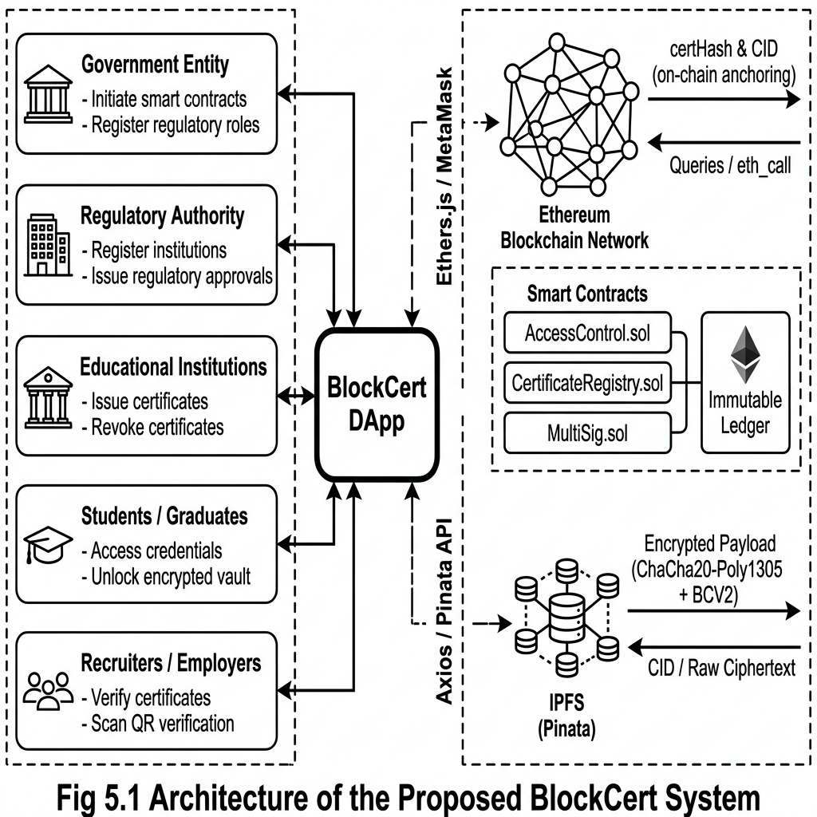
Fig. 5.1 — Architecture of the Proposed BlockCert System
Cryptographic Pipeline (Issuance):
File → ArrayBuffer → Uint8Array → zlibSync (compress) → random 96-bit nonce → EIP-191 signMessage(derivation_message) → keccak256(signature) = 256-bit key → chacha20poly1305(key, nonce).encrypt(compressed) → prepend [BCV2 magic: 66,67,86,50] + nonce → Blob → Pinata upload → CID returned → issueCertificate(CID, certHash, student, expiry) → CertificateIssued event → certId extracted from log.topics[1]
Cryptographic Pipeline (Verification/Decryption):
certId entered → getCertificate(certId) → metadata displayed → IPFS GET /ipfs/{CID} → detect BCV2 marker (bytes 0-3 = [66,67,86,50]) → extract nonce (bytes 4-15) → extract ciphertext (bytes 16+) → hex key → Uint8Array(32) key → chacha20poly1305(key, nonce).decrypt(ciphertext) → unzlibSync → MIME detection → Blob URL → CertificateViewer dialog
5.2 DATA FLOW DIAGRAM
The Data Flow Diagram describes how data moves through the BlockCert system from user input to output.
Step 1: User connects MetaMask wallet → EthereumContext auto-connects if previously authorized → reads account, chainId → maps to network name (localhost/amoy/sepolia) → loads CertificateRegistry contract → fetches roles[account] and admin address.
Step 2: Institution navigates to Issuance Portal → 3-step form collects studentAddress, studentName, degree, GPA, expiryYears → file selected in Step 3.
Step 3: Client-side pipeline: file.arrayBuffer() → zlibSync() → crypto.getRandomValues(nonce 12 bytes) → signer.signMessage(derivation_message) → keccak256(signature) → chacha20poly1305(key,nonce).encrypt(compressed) → BCV2 header prepend → Blob.
Step 4: Axios POST to api.pinata.cloud/pinning/pinFileToIPFS with Bearer JWT → Pinata returns { IpfsHash: CID }.
Step 5: contract.issueCertificate(CID, certHash, studentAddress, expiryDate) → MetaMask prompts → TX submitted → tx.wait() → receipt.
Step 6: CertificateIssued event parsed from receipt.logs → certId = log.topics[1] → result displayed with decryption key and BrandedQR.
Step 7: Verifier (recruiter) scans QR → URL: /verify?id={certId}#key={hexKey} → auto-populate certId/key → contract.getCertificate() → metadata displayed.
Step 8: Auto-decryption: IPFS payload fetched → BCV2 probe → nonce extracted → ChaCha20-Poly1305 decryption → unzlibSync → MIME detection → CertificateViewer opened.
Step 9: Vault Recovery: institution clicks REGISTRAR: UNLOCK VAULT → Hyper-Scanner iterates derivation message templates → signer.signMessage(msg) → keccak256(sig) → attempts decryption → match found → vault unlocked.
5.3 UML DIAGRAMS
UML diagrams provide standardized visual representations of the BlockCert system. Note: Insert corresponding UML figures at each placeholder below.
5.3.1 Use Case Diagram
Actors: Admin, Government, Regulatory Authority, Institution, Student, Recruiter/Verifier. Use Cases: Connect Wallet (all), Grant Role (Admin/Gov/Reg), Issue Certificate (Institution), Batch Issue (Institution), Revoke Certificate (Institution), View My Certificates (Student), Unlock Credential (Student/Institution), Verify Certificate (Public), Manage Dashboard (Authenticated). Verify Certificate is the only public use case accessible without wallet connection.

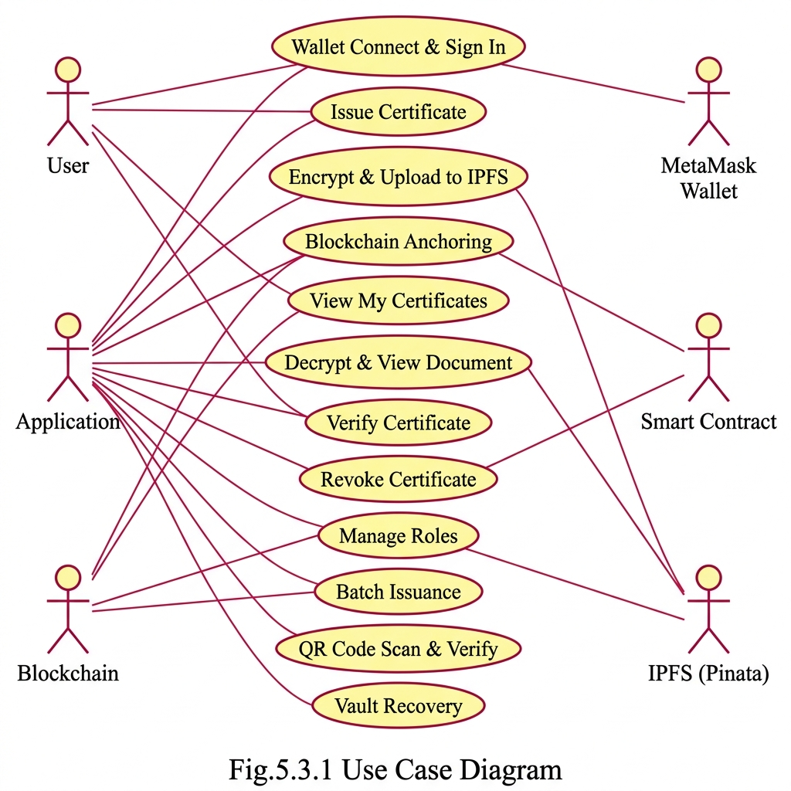
Fig.5.3.1 Use Case Diagram

5.3.2 Class Diagram
Classes: EthereumContext {account, provider, signer, contract, network, userRole, adminAddress, connectWallet(), disconnectWallet(), switchNetwork()}, Certificate {ipfsCID, certHash, student, institution, issueDate, expiryDate, revoked, merkleRoot}, CertificateRegistry {certificates mapping, studentCertificates mapping, revocationRegistry, issueCertificate(), verifyCertificate(), revokeCertificate(), issueBatch(), getCertificate(), getStudentCertificates()}, AccessControl {roles mapping, admin, grantRole(), revokeRole(), hasRole()}, Proposal {proposer, certificateHash, approvalCount, executed}. EthereumContext is consumed via React context by all page components.

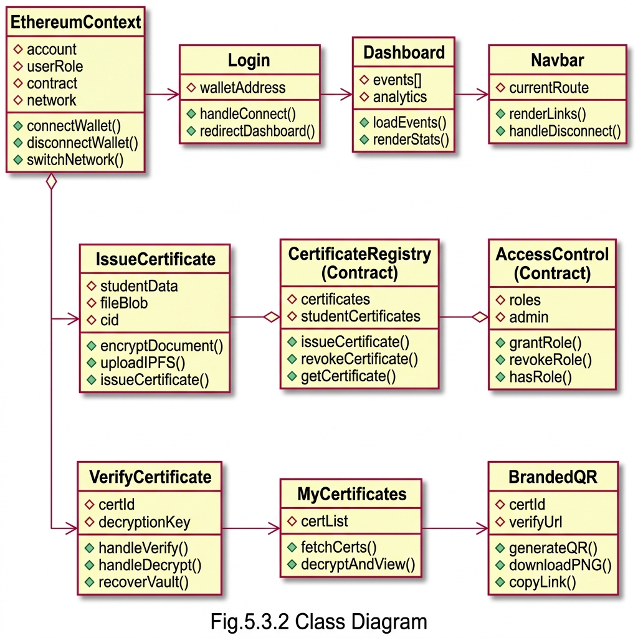
Fig.5.3.2 Class Diagram

5.3.3 Activity Diagram
Certificate Issuance Flow: Start → Connect Wallet → Check Role [Not INSTITUTION → Unauthorized → End] → Enter Student Identity → Validate Ethereum Address [Invalid → Re-enter] → Enter Academic Details → Select Document → Compress (ZLib) → Derive Key (EIP-191) → Generate Nonce → Encrypt (ChaCha20-Poly1305) → Prepend BCV2 Header → Upload to IPFS [Error → Show Error → End] → Call issueCertificate() [TX Rejected → Show Error → End] → Await Confirmation → Extract certId → Display Result + QR → End.
[Insert UML Diagram Figure Here]

5.3.4 Sequence Diagram
Recruiter→Browser: scan QR code → Browser→Router: parse /verify?id={certId}#key={key} → Browser→EthereumContext: contract.getCertificate(certId) → EthereumContext→EthereumNode: eth_call → EthereumNode→EthereumContext: Certificate struct → EthereumContext→Browser: display metadata → Browser→IPFSGateway: GET /ipfs/{CID} → IPFSGateway→Browser: encrypted payload → Browser: BCV2 probe, extract nonce, decrypt with key, unzlib → Browser→CertificateViewer: open(blob URL) → CertificateViewer→Browser: display document.
[Insert UML Diagram Figure Here]

5.3.5 Collaboration Diagram
Object links: User↔MetaMask (wallet authorization), MetaMask↔EthereumProvider (Web3Provider), EthereumContext↔CertificateRegistry (all contract calls), IssueCertificate↔PinataAPI (IPFS upload), VerifyCertificate↔IPFSGateway (payload download), BrandedQR↔QRCodeSVG (generation), CertificateViewer↔BlobAPI (document rendering). Messages are numbered per operation sequence.
[Insert UML Diagram Figure Here]

5.3.6 Component Diagram
Frontend Package: {App.js → [EthereumContext, Navbar, Pages, Theme]}. Pages Package: {Dashboard, IssueCertificate, VerifyCertificate, MyCertificates, ManageRoles, BatchIssue, RevokeCertificate, Login}. Shared Components: {BrandedQR, CertificateViewer}. Config Package: {contracts.js [NETWORKS, ROLES, ROLE_NAMES]}. Contracts Package: {AccessControl.sol, CertificateRegistry.sol, MultiSig.sol}. External Dependencies: {Pinata API, Ethereum Node, MetaMask, IPFS Gateway}.

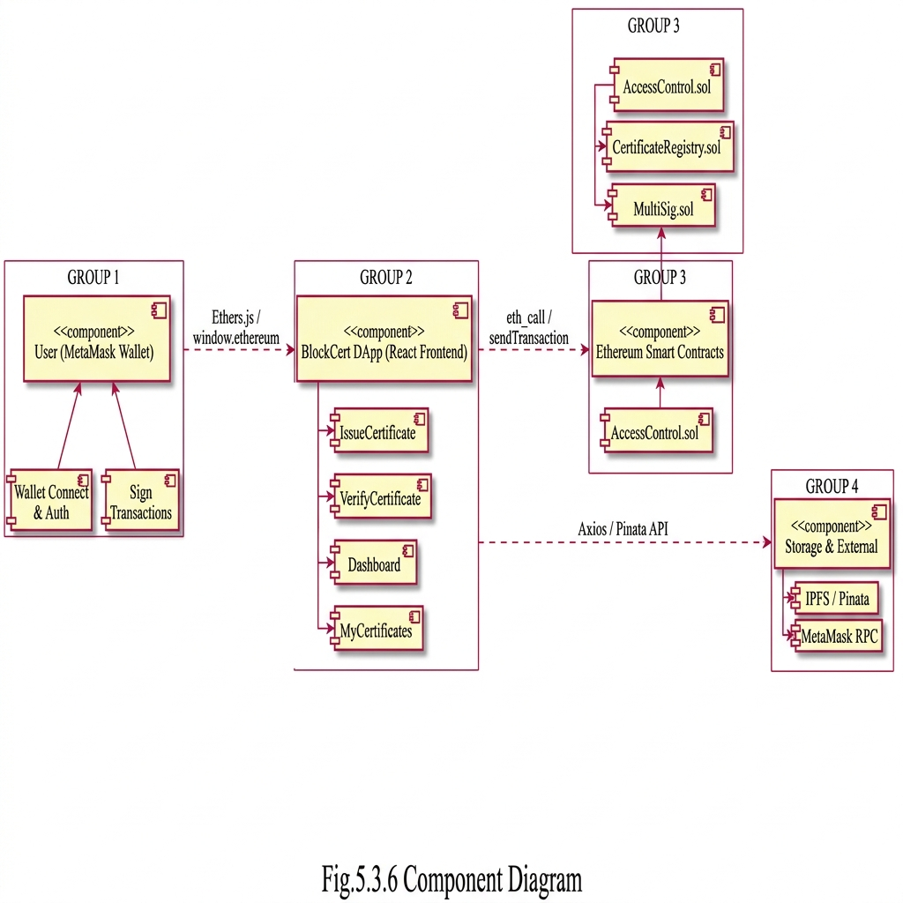
Fig.5.3.6 Component Diagram

5.3.7 Deployment Diagram
Nodes: [Vercel CDN] hosts React SPA build (static files). [User Browser+MetaMask] is client runtime. [Ethereum Network] (localhost:8545/Sepolia RPC/Amoy RPC) executes smart contract transactions. [Pinata IPFS Node] stores encrypted certificate payloads. Connections: Browser↔Vercel (HTTPS), Browser↔MetaMask (window.ethereum IPC), MetaMask↔EthereumNetwork (JSON-RPC over HTTPS), Browser↔PinataAPI (REST HTTPS), Browser↔IPFSGateway (HTTPS GET).
[Insert UML Diagram Figure Here]

