
TAE-I
Project Based Learning Report
on
News Article Categorization System

Submitted By
Prashil Dongre
[CM24035]

Under the Course of
Foundation of Machine Learning - (N-PCCCM502T)
B.Tech CSE-AI&ML V Semester
Academic Session 2026-27 (ODD)

Under the Guidance of
Mrs. Sweta Bokwade
Assistant Professor
(Course In-charge)

Department of CSE (AI&ML)
S.B. JAIN INSTITUTE OF TECHNOLOGY, MANAGEMENT & RESEARCH, NAGPUR
(AN AUTONOMOUS INSTITUTION AFFILIATED TO RASHTRASANT TUKADOJI MAHARAJ NAGPUR UNIVERSITY, NAAC ACCREDITED WITH 'A' GRADE)

AIM:
To develop a News Article Categorization System using the Multinomial Naive Bayes algorithm that reads a news article and automatically assigns it to a domain such as Sports, Technology, Business, Politics, Health or Entertainment.
Problem Statement:
News Article Categorization using Document Classification: Develop a document classification model that categorizes news articles into different domains based on the words used in the article text, and returns the predicted domain with a probability score.
Objectives:
- Collect and preprocess labelled news-article text data.
- Clean the text by lowercasing, removing punctuation and numbers, and removing stop-words.
- Convert articles into numerical features using a bag-of-words representation.
- Implement a Multinomial Naive Bayes classifier with Laplace smoothing.
- Classify unseen articles into one of six domains with probability scores.
- Explain each prediction by showing the key words that influenced the decision.
- Evaluate the model using leave-one-out cross-validation and a confusion matrix.
- Visualize the results using suitable charts.
- Save the trained model and provide a simple web interface for classifying articles.
Introduction:
News article categorization is a text-classification application of machine learning that helps organise large volumes of news into meaningful domains. The proposed system uses supervised learning with the Multinomial Naive Bayes classifier. Each article is cleaned, split into words and converted into word counts (bag of words). The classifier then compares the article with the word statistics learned for every domain and selects the domain with the highest probability.
Problem Goal:
The system accepts the text of a news article, identifies the most probable domain and reports the probability of every domain. The project demonstrates how a simple probabilistic model can be used for document classification without complex feature engineering. The model is evaluated using leave-one-out cross-validation and a confusion matrix, and its predictions are explained through the key words that influenced the decision.
Technology Used:
Python, NumPy and Matplotlib for implementation and visualization; a custom Multinomial Naive Bayes classifier built with the Python standard library; HTML, CSS and JavaScript for the web interface that trains and classifies in the browser.
- Python: implementation of text cleaning, model training, prediction and evaluation.
- re, math and collections: regular-expression cleaning, log-probability calculation and word counting.
- NumPy: confusion-matrix calculation and averaging.
- Matplotlib: generation of the confusion matrix and probability chart for the report.
- HTML, CSS and JavaScript: responsive web page for classifying pasted news articles.
Solution:
The proposed project builds a small labelled dataset of news articles from six domains and preprocesses the text into clean keyword lists. These are converted into word counts for each domain, which form the Multinomial Naive Bayes model. A new article is classified by combining the prior probability of each domain with the Laplace-smoothed probability of every word it contains, and the domain with the highest log-probability is selected. The model is evaluated with leave-one-out cross-validation, explained through key words, saved for reuse, and also provided as an interactive web page. The step-by-step implementation is given below.
Step 1: Import the required libraries
import re
import math
import json
from collections import Counter

import numpy as np
import matplotlib.pyplot as plt

print("Required libraries imported successfully!")
Required libraries imported successfully!
Observation: Only the Python standard library is needed for the classifier itself. NumPy and Matplotlib are used later for the confusion matrix and charts.
Step 2: Create the labelled training dataset
data = {
"Sports": [
"the team won the championship match after a late goal in the final minutes",
"the striker scored twice as the club beat rivals in the league",
"the cricket captain hit a century and the bowlers took wickets in the test series",
"the tennis player reached the final of the tournament after a tough set",
"the coach praised the players after the football season opener",
"the olympic athlete broke the record in the sprint and won gold medal",
"the batsman and bowler helped the squad win the tournament match",
],
"Technology": [
"the company launched a new smartphone with a faster processor and better camera",
"researchers released an artificial intelligence model for software developers",
"the startup unveiled a cloud platform with improved cybersecurity and data encryption",
"new chip technology promises faster computing for laptops and servers",
"the app update adds machine learning features and a redesigned interface",
"hackers exploited a software vulnerability in the operating system",
"engineers built a robot powered by neural networks and sensors",
],
"Business": [
"the stock market rose as investors reacted to strong quarterly earnings",
"the central bank raised interest rates to curb inflation",
"the company announced a merger and its shares jumped in trading",
"the economy grew as exports and consumer spending increased",
"the retailer reported higher revenue and profit for the fiscal year",
"oil prices fell and the rupee weakened against the dollar",
"the bank approved loans while investors watched the sensex and nifty",
],
"Politics": [
"the parliament passed the bill after a heated debate between lawmakers",
"the prime minister met world leaders at the summit to discuss policy",
"voters headed to the polls in the national election as candidates campaigned",
"the opposition party criticized the government over the new law",
"the president signed an executive order and the senate will vote",
"the minister announced a new policy ahead of the assembly session",
"the court ruled on the constitutional challenge to the election commission",
],
"Health": [
"doctors say the new vaccine reduces the risk of infection in patients",
"a study found regular exercise and a healthy diet lower the risk of heart disease",
"the hospital treated patients during the outbreak of the virus",
"researchers developed a new treatment for cancer in clinical trials",
"health officials urged people to get screened for diabetes and blood pressure",
"the medicine was approved by regulators for treating chronic disease",
"mental health experts recommend sleep and therapy for anxiety",
],
"Entertainment": [
"the film premiered at the festival and critics praised the lead actor",
"the singer released a new album and announced a world concert tour",
"the director's movie topped the box office on its opening weekend",
"the streaming series was renewed for another season after strong ratings",
"the actress won the award for best performance at the ceremony",
"the band performed songs from their latest album on stage",
"the celebrity attended the red carpet premiere of the blockbuster",
],
}

print("Domains:", list(data.keys()))
print("Articles per domain:", {c: len(v) for c, v in data.items()})
print("Total articles:", sum(len(v) for v in data.values()))
Domains: ['Sports', 'Technology', 'Business', 'Politics', 'Health', 'Entertainment']
Articles per domain: {'Sports': 7, 'Technology': 7, 'Business': 7, 'Politics': 7, 'Health': 7, 'Entertainment': 7}
Total articles: 42
Observation: The dataset is small and balanced: six domains with seven short articles each, 42 articles in total. Every article is labelled with its domain.
Step 3: Clean and tokenize the text
STOP = set("the a an and or of to in on at for with as by is are was were be been it its this that from after before over into than then their his her they he she we you i not but has have had will can new said says also more most".split())

def tokenize(text):
text = re.sub(r"[^a-z\s]", " ", text.lower()) # lowercase, drop punctuation and digits
return [w for w in text.split() if len(w) > 2 and w not in STOP]

example = data["Sports"][0]
print("Raw :", example)
print("Tokens :", tokenize(example))
Raw : the team won the championship match after a late goal in the final minutes
Tokens : ['team', 'won', 'championship', 'match', 'late', 'goal', 'final', 'minutes']
Observation: The text is lowercased, punctuation and numbers are removed, and stop-words and very short words are dropped. Only the meaningful keywords of the article remain.
Step 4: Build the bag-of-words model (training)
def train(dataset):
model = {"classes": {}, "vocab": set(), "total_docs": 0}
for label, docs in dataset.items():
counts, total = Counter(), 0
for doc in docs:
for w in tokenize(doc):
counts[w] += 1
total += 1
model["vocab"].add(w)
model["classes"][label] = {"counts": counts, "words": total, "docs": len(docs)}
model["total_docs"] += len(docs)
return model

model = train(data)
print("Vocabulary size:", len(model["vocab"]))
for label, k in model["classes"].items():
print(f"{label:14s} docs={k['docs']} words={k['words']} top words={k['counts'].most_common(3)}")
Vocabulary size: 265
Sports docs=7 words=52 top words=[('won', 2), ('match', 2), ('final', 2)]
Technology docs=7 words=50 top words=[('faster', 2), ('software', 2), ('company', 1)]
Business docs=7 words=49 top words=[('investors', 2), ('bank', 2), ('stock', 1)]
Politics docs=7 words=45 top words=[('minister', 2), ('policy', 2), ('election', 2)]
Health docs=7 words=51 top words=[('risk', 2), ('patients', 2), ('disease', 2)]
Entertainment docs=7 words=46 top words=[('album', 2), ('film', 1), ('premiered', 1)]
Observation: Training simply counts how often each word appears in each domain. The vocabulary has 265 distinct words. Each domain's most frequent words already look sensible, for example 'won', 'match' and 'final' for Sports.
Step 5: Classify with Multinomial Naive Bayes
def predict(model, text):
words, V, log_p = tokenize(text), len(model["vocab"]), {}
for label, k in model["classes"].items():
score = math.log(k["docs"] / model["total_docs"]) # prior
for w in words: # Laplace smoothing
score += math.log((k["counts"].get(w, 0) + 1) / (k["words"] + V))
log_p[label] = score
top = max(log_p.values())
exp = {c: math.exp(s - top) for c, s in log_p.items()}
z = sum(exp.values())
return {c: v / z for c, v in exp.items()} # probabilities
Observation: The classifier adds the log prior of each domain to the log likelihood of every word, using Laplace smoothing so unseen words never give zero probability. The scores are converted to probabilities that sum to one.
Step 6: Test on new articles
samples = [
"India beat Australia by five wickets in the final as the captain hit a stunning century and the bowlers took early wickets.",
"The company unveiled a new AI chip that promises faster machine learning for developers and cloud servers, boosting software performance.",
"A new study shows that a daily walk and healthy diet reduce the risk of heart disease and diabetes, doctors said at the hospital.",
"Shares surged after the bank reported record quarterly profit, and investors expect the central bank to hold interest rates steady."
]

for i, text in enumerate(samples, 1):
p = predict(model, text)
ranked = sorted(p, key=p.get, reverse=True)
print(f"Article {i}: {text[:60]}...")
print(f" Predicted : {ranked[0]} ({p[ranked[0]]*100:.1f}%)")
print(f" Runner-up : {ranked[1]} ({p[ranked[1]]*100:.1f}%)")
Article 1: India beat Australia by five wickets in the final as the cap...
Predicted : Sports (99.2%)
Runner-up : Politics (0.2%)
Article 2: The company unveiled a new AI chip that promises faster mach...
Predicted : Technology (99.8%)
Runner-up : Entertainment (0.1%)
Article 3: A new study shows that a daily walk and healthy diet reduce ...
Predicted : Health (99.5%)
Runner-up : Politics (0.1%)
Article 4: Shares surged after the bank reported record quarterly profi...
Predicted : Business (99.8%)
Runner-up : Sports (0.1%)
Observation: All four unseen articles are assigned to the expected domain with very high confidence. Note that these articles share many keywords with the training set, so this is an easy case.
Step 7: Explain a prediction (key words)
def key_words(model, text, label, top=8):
V, k, others = len(model["vocab"]), model["classes"][label], [c for c in model["classes"] if c != label]
result = []
for w in set(tokenize(text)):
if w not in model["vocab"]:
continue
in_class = math.log((k["counts"].get(w, 0) + 1) / (k["words"] + V))
avg_other = np.mean([math.log((model["classes"][c]["counts"].get(w, 0) + 1)
/ (model["classes"][c]["words"] + V)) for c in others])
result.append((w, in_class - avg_other))
return [w for w, s in sorted(result, key=lambda x: -x[1])[:top] if s > 0]

text = samples[0]
p = predict(model, text)
best = max(p, key=p.get)
print("Predicted domain:", best)
print("Words that pushed the decision:", key_words(model, text, best))
Predicted domain: Sports
Words that pushed the decision: ['final', 'captain', 'century', 'bowlers', 'beat', 'wickets', 'took', 'hit']
Observation: Words such as 'wickets', 'century', 'captain' and 'bowlers' push this article towards Sports. This makes the model's decision easy to explain, which is a strength of Naive Bayes.
Step 8: Evaluate with leave-one-out cross-validation
labels = list(data.keys())
confusion = np.zeros((len(labels), len(labels)), dtype=int)

for true_label, docs in data.items():
for i, doc in enumerate(docs):
# train on everything except this one article
subset = {c: [d for j, d in enumerate(v) if not (c == true_label and j == i)]
for c, v in data.items()}
p = predict(train(subset), doc)
pred = max(p, key=p.get)
confusion[labels.index(true_label), labels.index(pred)] += 1

correct = int(np.trace(confusion))
total = int(confusion.sum())
print(f"Leave-one-out accuracy: {correct}/{total} = {correct/total*100:.1f}%")
print()
for i, c in enumerate(labels):
print(f"{c:14s} {confusion[i, i]}/{confusion[i].sum()} correct")
Leave-one-out accuracy: 18/42 = 42.9%

Sports 3/7 correct
Technology 2/7 correct
Business 2/7 correct
Politics 5/7 correct
Health 5/7 correct
Entertainment 1/7 correct
Observation: Leave-one-out accuracy is 42.9% (18 of 42). This is far lower than the confidence on the test articles because every article is held out in turn and the vocabulary is only 265 words, so many words in the held-out article have never been seen. The result is honest evidence that the model needs a larger training set.
Step 9: Plot the confusion matrix
fig, ax = plt.subplots(figsize=(7, 6))
im = ax.imshow(confusion, cmap="Blues")
ax.set_xticks(range(len(labels)))
ax.set_yticks(range(len(labels)))
ax.set_xticklabels(labels, rotation=45, ha="right")
ax.set_yticklabels(labels)
ax.set_xlabel("Predicted domain")
ax.set_ylabel("Actual domain")
ax.set_title("Confusion Matrix (Leave-One-Out)")
for i in range(len(labels)):
for j in range(len(labels)):
ax.text(j, i, confusion[i, j], ha="center", va="center",
color="white" if confusion[i, j] > 3 else "black")
fig.colorbar(im)
plt.tight_layout()
plt.savefig("confusion_matrix.png", dpi=150)
plt.show()
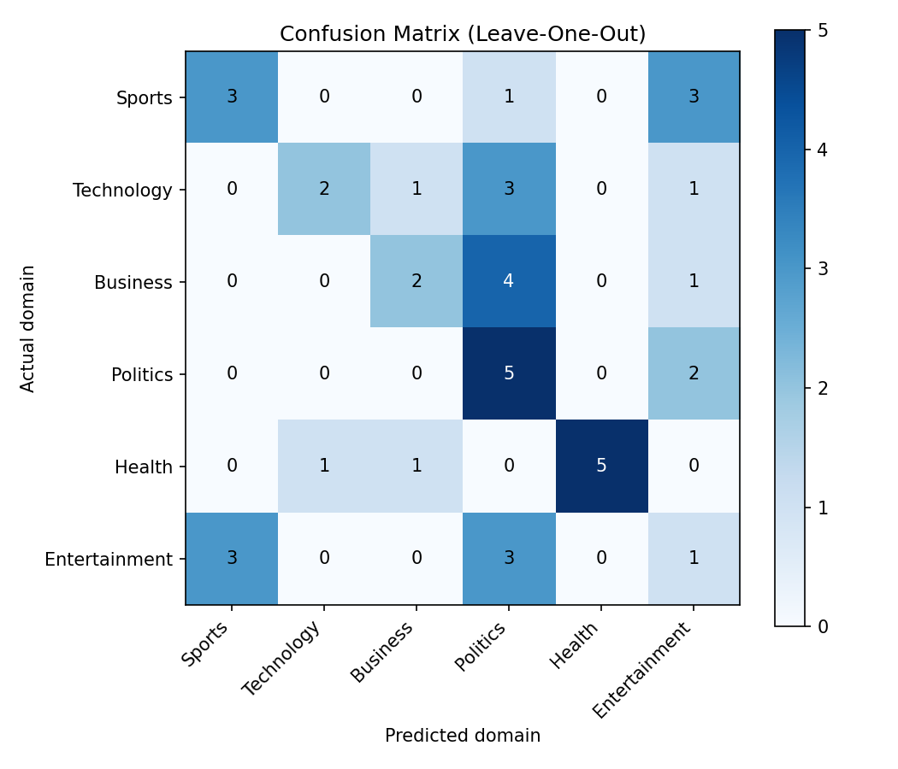
Observation: The diagonal holds the correct predictions. Politics and Health are recognised best (5 of 7 each), while Entertainment is weakest (1 of 7) and is often confused with Sports and Politics because its articles share few repeated keywords.
Step 10: Visualize the prediction probabilities
p = predict(model, samples[2])
ranked = sorted(p, key=p.get)
plt.figure(figsize=(8, 4))
plt.barh(ranked, [p[c] * 100 for c in ranked], color="#c2410c")
plt.xlabel("Probability (%)")
plt.title("Predicted Domain Probabilities for a Health Article")
plt.tight_layout()
plt.savefig("probabilities.png", dpi=150)
plt.show()
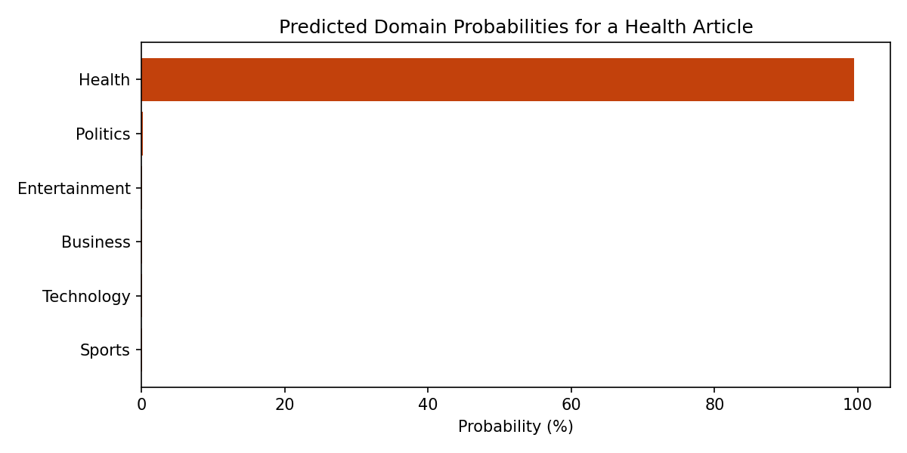
Observation: The bar chart shows how confidently the classifier separates the correct domain from the others for a single article.
Step 11: Save the trained model
saved = {
"vocab": sorted(model["vocab"]),
"classes": {c: {"counts": dict(k["counts"]), "words": k["words"], "docs": k["docs"]}
for c, k in model["classes"].items()},
"total_docs": model["total_docs"],
}
with open("news_naive_bayes_model.json", "w") as f:
json.dump(saved, f)

print("Model saved successfully.")
Model saved successfully.
Observation: The word counts and class statistics are stored in a JSON file so the model can be reloaded for future classification without retraining.
Step 12: Final summary
print("=" * 40)
print(" NEWS ARTICLE CATEGORIZATION SYSTEM")
print("=" * 40)
print("Domains :", len(labels))
print("Training articles :", total)
print("Vocabulary words :", len(model["vocab"]))
print(f"LOO accuracy : {correct/total*100:.1f}%")
print()
text = samples[1]
p = predict(model, text)
best = max(p, key=p.get)
print("Sample article:", text)
print("Predicted domain:", best, f"({p[best]*100:.1f}%)")
========================================
NEWS ARTICLE CATEGORIZATION SYSTEM
========================================
Domains : 6
Training articles : 42
Vocabulary words : 265
LOO accuracy : 42.9%

Sample article: The company unveiled a new AI chip that promises faster machine learning for developers and cloud servers, boosting software performance.
Predicted domain: Technology (99.8%)
Observation: The summary combines the key figures of the system and demonstrates one complete classification.

Result:
The Python implementation was executed on the built-in labelled news dataset. The following results represent the measured output of the News Article Categorization System.
Configuration: Bag-of-words features from the cleaned article text; Multinomial Naive Bayes with Laplace smoothing; evaluation by leave-one-out cross-validation.
- Domains: Sports, Technology, Business, Politics, Health, Entertainment (6)
- Training articles: 42 (7 per domain)
- Vocabulary size: 265 distinct words after cleaning
- Classification method: Multinomial Naive Bayes (log-probability with Laplace smoothing)
- Unseen test articles: 4 of 4 classified into the expected domain (99.2% to 99.8% confidence)
- Leave-one-out accuracy: 42.9% (18 of 42 articles)
Classification Result
The system successfully cleans article text, converts it into word counts and assigns the article to the domain with the highest posterior probability. All four unseen sample articles (sports, technology, health and business) were classified correctly, and the key words that influenced each decision can be displayed.
Evaluation by Domain (Leave-One-Out)
Domain | Correct | Total | Accuracy
Sports | 3 | 7 | 42.9%
Technology | 2 | 7 | 28.6%
Business | 2 | 7 | 28.6%
Politics | 5 | 7 | 71.4%
Health | 5 | 7 | 71.4%
Entertainment | 1 | 7 | 14.3%
Overall | 18 | 42 | 42.9%
Feature Representation
The feature representation is a bag of words: each cleaned article is represented by the count of every vocabulary word it contains. Stop-words, punctuation, numbers and words shorter than three letters are removed before counting.
Observation
The classifier is very confident on articles that share keywords with the training set, and its probabilities are easy to explain through key words. However, the leave-one-out accuracy of 42.9% shows that the small training set (42 articles, 265 words) is the main limitation: when a held-out article contains words never seen in training, the model has little evidence to separate the domains. Politics and Health were recognised best, while Entertainment was weakest.
The system therefore demonstrates how supervised learning and Naive Bayes can be used to build a document classifier, and shows that accuracy would improve with a larger corpus such as BBC News or 20 Newsgroups, TF-IDF features and models such as logistic regression.
Output of the Website
The classifier is also delivered as a web page that trains the model in the browser and classifies any pasted article. The screenshots below show the output of the website.
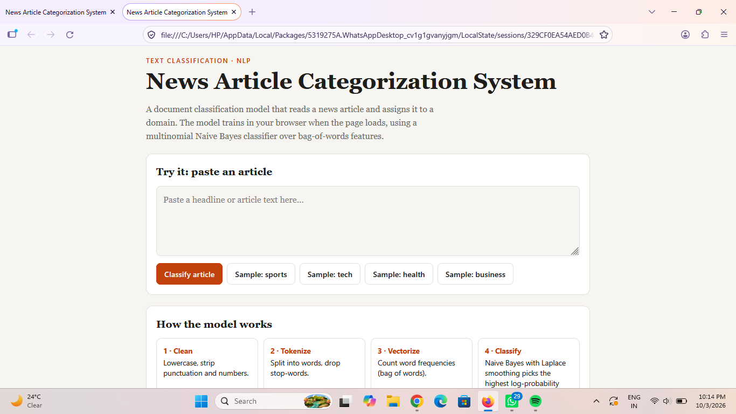
Figure 1: Home page with the article input box and sample buttons
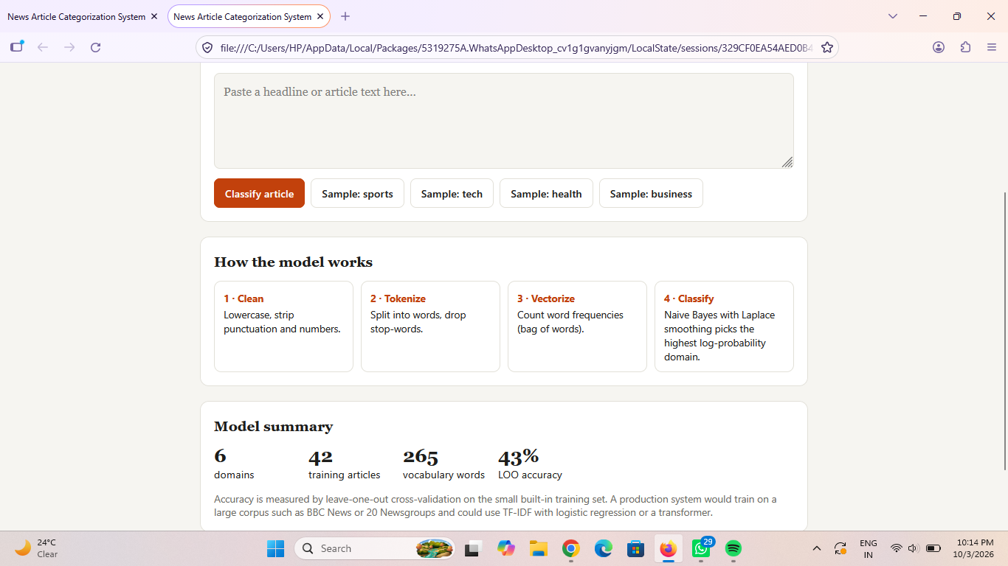
Figure 2: How the model works and the model summary (6 domains, 42 articles, 265 words, 43% LOO accuracy)
Key Outcome:
The News Article Categorization System implements a supervised document-classification approach using Naive Bayes. The submitted implementation cleans news text, converts it into bag-of-words features, trains a Multinomial Naive Bayes model with Laplace smoothing, classifies articles into six domains with probability scores and explains each decision through key words. It is evaluated with leave-one-out cross-validation and is also available as an interactive web page.
References
- Naive Bayes Classification: Manning, Raghavan and Schütze, Introduction to Information Retrieval, chapter on Naive Bayes text classification.
- scikit-learn Documentation: MultinomialNB, CountVectorizer and confusion matrix evaluation for text classification.
- BBC News and 20 Newsgroups Datasets: Large labelled news and text corpora suggested for training a production-scale categorizer.
- Python Documentation: Standard-library modules re, math, json and collections used for implementation.
- Matplotlib Documentation: Plotting the confusion matrix and probability charts.

