University of Northampton
CSY3059 Modern Databases
Assessment 2 (AS2): Multi-Paradigm Database Implementation Graph (Neo4j) and Document (MongoDB) Modelling of the EPL 2024/25 Season

Name: Prashna K.C.
Student ID: 24813364
Module Leader: Santosh Khanal

1. Introduction
This report documents the design, implementation, and querying of two database models built from a single dataset: the results of the English Premier League (EPL) 2024/25 season. The same 380-match dataset is modelled twice, once as a property graph in Neo4j and once as a document store in MongoDB, so that the two NoSQL paradigms can be compared directly on identical data and identical analytical questions.
The assignment requires six analytical queries to be answered in both databases: the full list of participating teams, the best-attacking and worst-defending teams, the team(s) with the fewest home wins, the referee(s) who officiated the most matches, the complete final league table under a 3/1/0 points system, and the team(s) with the longest post-Christmas winning run. Each query is implemented, explained, and evidenced with real query output in Section 5.
The report is structured to follow the natural lifecycle of the work: dataset analysis and cleaning, schema design and justification for both models, the practical database creation and import process actually used, the query solutions themselves, and finally a comparative reflection on the two paradigms — including a concrete example of how cross-checking results between the two databases surfaced and helped correct a query bug during development.

2. Dataset Analysis and Preprocessing

2.1 Dataset Description
The source dataset (epl_matches.csv) contains 380 records — 20 clubs playing 38 matches each (19 home, 19 away) — covering the complete 2024/25 EPL season from 16 August 2024 to 25 May 2025. It is a flat CSV file with 10 fields per row:
- date (String) — match date as DD/MM/YYYY, e.g. 16/08/2024
- time (String) — kickoff time showing both UK and European time, e.g. "20:00 (21:00)"
- day (String) — three-letter day abbreviation, e.g. Fri, Sat, Sun
- home / away (String) — club names, e.g. Manchester Utd, Fulham
- goals_home / goals_away (String) — goals scored by each side, stored as text
- attendance (String) — spectator count with thousands-separator commas, e.g. "73,297"
- venue (String) — stadium name, e.g. Old Trafford
- referee (String) — match official, e.g. Robert Jones
The file was inspected before modelling and confirmed to have zero missing values and zero duplicate rows, with exactly 20 unique teams (each appearing as both home and away) and 24 unique referees — consistent with a complete, well-formed round-robin season.

2.2 Preprocessing and Type-Casting Rationale
Three fields required transformation before the data could be modelled reliably in either database:
1. Date parsing — left as a raw DD/MM/YYYY string, chronological queries would be unreliable: a lexicographical sort would place 01/10/2024 (October) before 16/08/2024 (August), which breaks the ordering required for the post-Christmas streak query. In Neo4j the string is split and reassembled into a native Date; in MongoDB it is imported as a native BSON Date (ISODate).
2. Attendance cleansing — values contain thousands-separator commas (e.g. "73,297"), which both engines treat as plain text. Commas are stripped and the result cast to an integer (73297) so that numeric aggregation is possible.
3. Goals type conversion — goals_home and goals_away are read as text by default and must be explicitly cast to integers to support summation and comparison, which underpins every one of the six required queries.

3. Data Modelling

3.1 Graph Data Model (Neo4j)
A graph database represents data as nodes, properties, and relationships rather than tables and foreign keys. Neo4j specifically uses index-free adjacency: each node holds direct references to its relationships, so traversing a connection is a constant-time pointer lookup rather than an index scan or join. Instead of storing each match as a single flat record, the CSV's implicit entities were separated out into four node labels connected by explicit relationships:
- (:Team {name}) — one node per club (20 total)
- (:Referee {name}) — one node per official (24 total)
- (:Venue {name}) — one node per stadium (20 total)
- (:Match {date, time, day, goalsHome, goalsAway, attendance}) — one node per fixture (380 total), acting as the central event that connects the other three
Relationships:
- (Team)-[:PLAYED_HOME]->(Match)
- (Team)-[:PLAYED_AWAY]->(Match)
- (Referee)-[:OFFICIATED]->(Match)
- (Match)-[:HELD_AT]->(Venue)

Design justification
Match is modelled as its own node rather than as a direct (Team)-[:PLAYED]->(Team) relationship, because a match must also connect to a Referee and a Venue — a Cypher relationship cannot itself be the endpoint of another relationship, so a richer join point is required. Team, Referee, and Venue are each extracted into single unique nodes (with uniqueness constraints on name) rather than being repeated as string properties on every Match — this removes redundant text storage across the 380 rows (e.g. "Old Trafford" would otherwise be repeated 19 times) and means an update to a club or stadium name only needs to happen once. It also means queries that aggregate by team, referee, or venue traverse a small, indexed set of relationships instead of scanning and grouping repeated string values, which is closer to how Neo4j is intended to be used.

3.2 Document Data Model (MongoDB)
A document database stores data as flexible, self-describing BSON documents rather than normalised tables. MongoDB does support referencing separate collections and joining them with $lookup, similar in spirit to a relational foreign key, but for this dataset that approach was rejected in favour of a single denormalised collection.
Match records in this dataset are static once created (a completed fixture's result never changes) and are always read as a complete unit — nobody queries "just the referee" in isolation from the rest of a match. That read pattern favours embedding: a single matches collection where every field for a fixture lives in one document, so a complete match report is always a single disk lookup with no joins:
{
"_id": ObjectId("65f2a1b9c9e8d7c6b5a4f3e2"),
"date": ISODate("2024-08-16T00:00:00.000Z"),
"time": "20:00 (21:00)",
"day": "Fri",
"home": "Manchester Utd",
"away": "Fulham",
"goals_home": 1,
"goals_away": 0,
"attendance": 73297,
"venue": "Old Trafford",
"referee": "Robert Jones"
}

Design justification
This is a deliberate trade-off against normalisation: team, referee, and venue names are repeated across many documents rather than referenced, which would be a poor choice for a write-heavy or frequently-corrected dataset. For a read-heavy, rarely-modified season archive, however, it avoids the cost of a $lookup join on every query and keeps each of the six required queries expressible as a single aggregation pipeline over one collection, which is the pattern MongoDB is optimised for.

4. Database Creation and Data Import

4.1 Neo4j — Desktop Import
The dataset was loaded into a local Neo4j Desktop DBMS instance using the following process:
1. Open Neo4j Desktop and create a local DBMS instance named AS2.
2. Use the DBMS panel's "Open folder" option to open the database's file directory, locate the import folder, and copy epl_matches.csv directly into it — Neo4j's LOAD CSV can only read from this designated folder for local instances.
3. Start the DBMS and wait for the status to show ACTIVE / RUNNING, then open the Query tab (Browser) and switch to the target database with :use epl.
4. Define uniqueness constraints on the three entity node types before import, to guarantee schema integrity and prevent duplicate Team, Referee, or Venue nodes as the same value repeats across many CSV rows.
CREATE CONSTRAINT FOR (t:Team) REQUIRE t.name IS UNIQUE;
CREATE CONSTRAINT FOR (r:Referee) REQUIRE r.name IS UNIQUE;
CREATE CONSTRAINT FOR (v:Venue) REQUIRE v.name IS UNIQUE;
5. Run the import query. Date conversion is done by splitting the DD/MM/YYYY string on '/' and reassembling it into ISO YYYY-MM-DD order before passing it to date().
LOAD CSV WITH HEADERS FROM 'file:///epl_matches.csv' AS row
MERGE (h:Team {name: row.home})
MERGE (a:Team {name: row.away})
MERGE (r:Referee {name: row.referee})
MERGE (v:Venue {name: row.venue})

CREATE (m:Match {
date: date(split(row.date, '/')[2] + "-" + split(row.date, '/')[1] + "-" + split(row.date, '/')[0]),
time: row.time,
day: row.day,
goalsHome: toInteger(row.goals_home),
goalsAway: toInteger(row.goals_away),
attendance: toInteger(replace(row.attendance, ',', ''))
})

CREATE (h)-[:PLAYED_HOME]->(m)
CREATE (a)-[:PLAYED_AWAY]->(m)
CREATE (r)-[:OFFICIATED]->(m)
CREATE (m)-[:HELD_AT]->(v);
MERGE is used for Team, Referee, and Venue nodes so the same club, official, or stadium is reused rather than duplicated across the 380 rows it appears in; CREATE is used for Match nodes since every row is a genuinely distinct fixture.
The import was verified with a total node count:

MATCH (n) RETURN count(n);
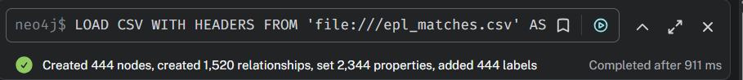 Figure 1: Neo4j Database Import Result

Result: 444 total nodes confirmed a complete import (20 Team + 24 Referee + 20 Venue + 380 Match).

4.2 MongoDB — Atlas and Compass Import
The dataset was loaded into a MongoDB Atlas free-tier cluster via Compass using the following process:
1. Register a free MongoDB Atlas account and build a Free Cluster (M0 sandbox), setting a database username/password and adding 0.0.0.0/0 to the IP Access List for development access.
2. In Atlas, click Connect > Connect with MongoDB Compass and copy the connection string; open Compass, paste it, and connect.
3. Create a database named epl with a collection named matches.
4. In the matches collection, use Add Data > Import JSON or CSV file, select epl_matches.csv, and set the import format to CSV.
5. Before finishing the import, set field types explicitly in Compass's column type dropdowns: goals_home and goals_away to Int32, date to Date. attendance is left as String at this stage because its embedded commas prevent Compass from parsing it as a number directly.
6. After import, clean the attendance field via the embedded mongosh tab, stripping commas and casting to an integer:
use epl;
db.matches.find().forEach(function(doc) {
var parts = doc.date.split('/');
db.matches.updateOne(
{ _id: doc._id },
{
$set: {
date: new Date(parts[2] + '-' + parts[1] + '-' + parts[0]),
goals_home: parseInt(doc.goals_home, 10),
goals_away: parseInt(doc.goals_away, 10),
attendance: parseInt(doc.attendance.replace(/,/g, ''), 10)
}
}
);
});
7. Create supporting indexes in the Indexes tab to speed up the aggregations used later: a single-field ascending index on date (for the Query 6 chronological filter), and compound indexes on (home, goals_home) and (away, goals_away) for the goals-based aggregations in Queries 2, 3, and 5.
Import was verified with a document count check:

db.matches.countDocuments();
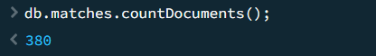
Figure 2: MongoDB Database Import Result
Result: 380 documents confirmed — matching the 380 rows in the source CSV exactly.

5. Query Implementation and Results
Each of the six required queries is implemented and evidenced below for both databases. Query 2 required a correction during development — the fix and reasoning are documented in place, since the process of catching and correcting it is itself relevant evidence of understanding (Learning Outcome e).

5.1 Query 1 — Display all EPL teams that played in the 2024/25 season

Neo4j (Cypher)
MATCH (t:Team)
RETURN t.name AS TeamName
ORDER BY TeamName;
Matches every node carrying the Team label and returns its name property, sorted alphabetically. No relationship traversal is needed — existing as a Team node is itself evidence of participation, since every Team node was created via MERGE while processing at least one match row.
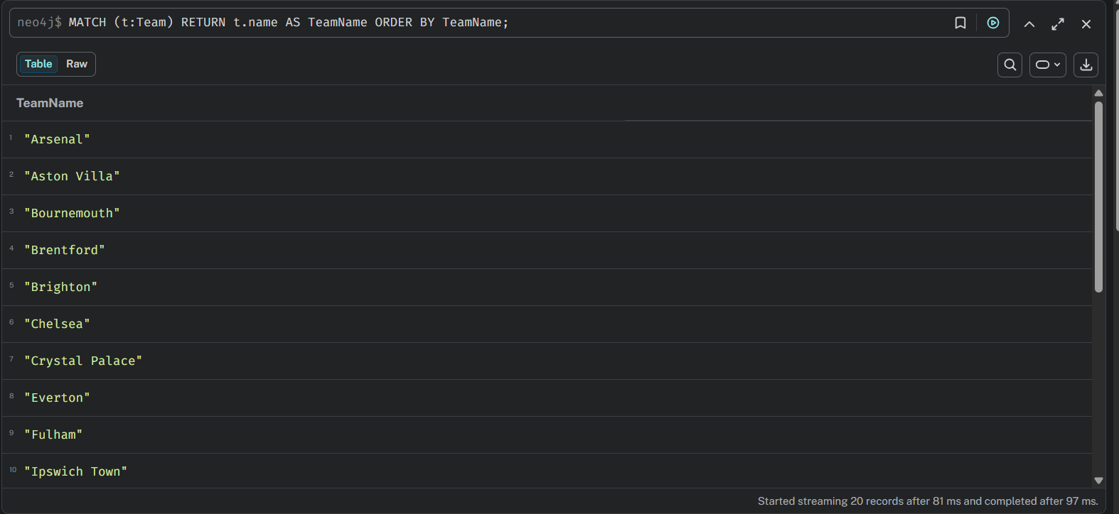
Figure 3: Query 1 - Neo4j Result

MongoDB (Aggregation Pipeline)
db.matches.aggregate([
{ $project: { teams: ["$home", "$away"] } },
{ $unwind: "$teams" },
{ $group: { _id: "$teams" } },
{ $sort: { _id: 1 } },
{ $project: { _id: 0, Team: "$_id" } }
])
Combines the home and away fields of every document into a two-element array, unwinds that array into individual records (760 in total, 2 per match), groups by team name to deduplicate down to the unique set, and sorts alphabetically.

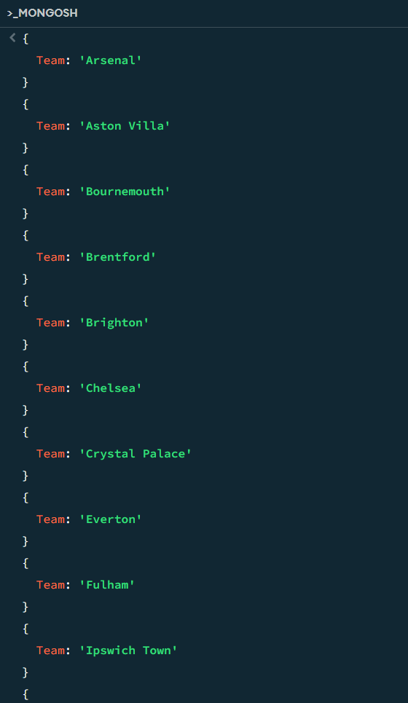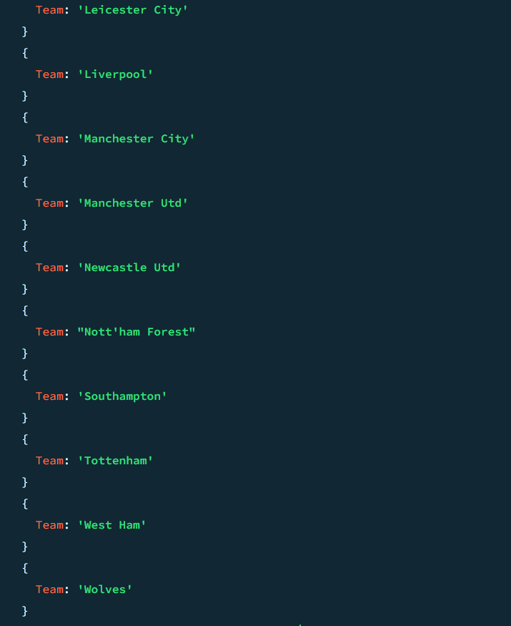
Figure 4: Query 1 - MongoDB Result

Result: All 20 clubs are returned by both databases: Arsenal, Aston Villa, Bournemouth, Brentford, Brighton, Chelsea, Crystal Palace, Everton, Fulham, Ipswich Town, Leicester City, Liverpool, Manchester City, Manchester Utd, Newcastle Utd, Nott'ham Forest, Southampton, Tottenham, West Ham, Wolves.

5.2 Query 2 — Best scoring team(s) and worst defensive team(s)

Neo4j (Cypher)
// Best Attack (Most Goals Scored)
MATCH (t:Team)
OPTIONAL MATCH (t)-[:PLAYED_HOME]->(hm:Match)
WITH t, coalesce(sum(hm.goalsHome), 0) AS homeGF, coalesce(sum(hm.goalsAway), 0) AS homeGA
OPTIONAL MATCH (t)-[:PLAYED_AWAY]->(am:Match)
WITH t, homeGF, homeGA,
coalesce(sum(am.goalsAway), 0) AS awayGF, coalesce(sum(am.goalsHome), 0) AS awayGA
WITH t, homeGF + awayGF AS goalsScored, homeGA + awayGA AS goalsConceded
WITH collect({team: t.name, scored: goalsScored, conceded: goalsConceded}) AS teamStats,
max(goalsScored) AS maxScored, max(goalsConceded) AS maxConceded
UNWIND teamStats AS item
WITH item, maxScored, maxConceded
WHERE item.scored = maxScored OR item.conceded = maxConceded
RETURN item.team AS Team, item.scored AS GoalsScored, item.conceded AS GoalsConceded,
CASE WHEN item.scored = maxScored THEN true ELSE false END AS BestAttack,
CASE WHEN item.conceded = maxConceded THEN true ELSE false END AS WorstDefence;
An earlier version of this query chained two OPTIONAL MATCH clauses on the same team node (for home matches and away matches) before aggregating in a single WITH. This created a cartesian product: for a team with 19 home and 19 away matches, Cypher paired every home match row with every away match row (19 x 19 = 361 combinations) before sum() ran, inflating every total by roughly 19x — the buggy version returned 1,634 goals for the league's top scorer, which is implausible for a single EPL season and was caught by comparing it against the league table produced by Query 5, where the same team's actual goals-for figure was 86. The corrected version above resolves each team's home matches into scalar totals in one WITH clause before the away OPTIONAL MATCH is introduced, so the two match sets are never joined together — each match is counted exactly once.
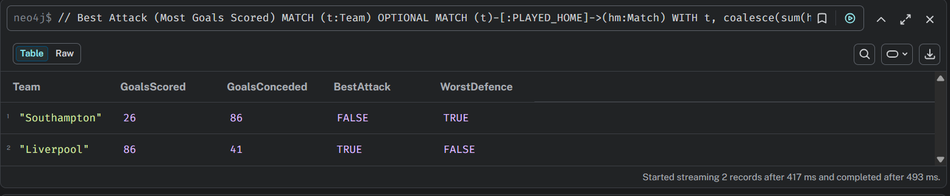
Figure 5: Query 2 - Neo4j Result

MongoDB (Aggregation Pipeline)
db.matches.aggregate([
{
$project: {
stats: [
{ team: "$home", scored: "$goals_home", conceded: "$goals_away" },
{ team: "$away", scored: "$goals_away", conceded: "$goals_home" }
]
}
},
{ $unwind: "$stats" },
{
$group: {
_id: "$stats.team",
totalScored: { $sum: "$stats.scored" },
totalConceded: { $sum: "$stats.conceded" }
}
},
{
$facet: {
bestAttack: [
{ $sort: { totalScored: -1 } },
{ $group: { _id: null, maxScored: { $first: "$totalScored" }, teams: { $push: { Team: "$_id", GoalsScored: "$totalScored" } } } },
{ $unwind: "$teams" },
{ $match: { $expr: { $eq: ["$teams.GoalsScored", "$maxScored"] } } },
{ $project: { _id: 0, Team: "$teams.Team", GoalsScored: "$teams.GoalsScored" } }
],
worstDefense: [
{ $sort: { totalConceded: -1 } },
{ $group: { _id: null, maxConceded: { $first: "$totalConceded" }, teams: { $push: { Team: "$_id", GoalsConceded: "$totalConceded" } } } },
{ $unwind: "$teams" },
{ $match: { $expr: { $eq: ["$teams.GoalsConceded", "$maxConceded"] } } },
{ $project: { _id: 0, Team: "$teams.Team", GoalsConceded: "$teams.GoalsConceded" } }
]
}
}
])
Projects each match into a two-element array representing the home and away team's perspective (goals scored / conceded from that team's point of view), unwinds it so each match contributes one record per side, and groups by team to sum both totals. A single top-level $facet then runs two independent sub-pipelines in parallel — one sorting for the highest goalsScored, one for the highest goalsConceded — each filtering down to whichever team(s) match the maximum, which safeguards against ties.
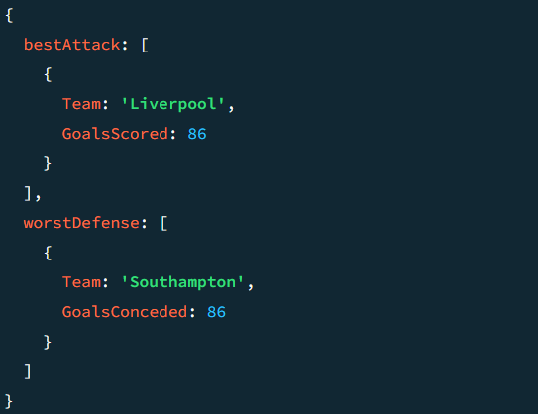
Figure 6: Query 2 - MongoDB Result

Result: Liverpool had the best scoring power with 86 goals scored; Southampton had the worst defence, conceding 86 goals. Both figures independently match the GF and GA columns for those two teams in the Query 5 league table below, confirming the corrected query is accurate.

5.3 Query 3 — Team(s) that won the fewest home matches

Neo4j (Cypher)
MATCH (t:Team)
OPTIONAL MATCH (t)-[:PLAYED_HOME]->(m:Match)
WHERE m.goalsHome > m.goalsAway
WITH t, count(m) AS homeWins
WITH collect({team: t.name, wins: homeWins}) AS teamWinsList, min(homeWins) AS minWins
UNWIND teamWinsList AS item
WITH item WHERE item.wins = minWins
RETURN item.team AS Team, item.wins AS HomeWins;
For each team, counts home fixtures where goalsHome > goalsAway. OPTIONAL MATCH (rather than MATCH) is important here specifically — without it, a team with zero home wins would be dropped entirely rather than counted as 0, which would silently exclude the correct answer. The minimum win count is then found and used to filter down to only the matching team(s).
Figure 7: Query 3 - Neo4j Result
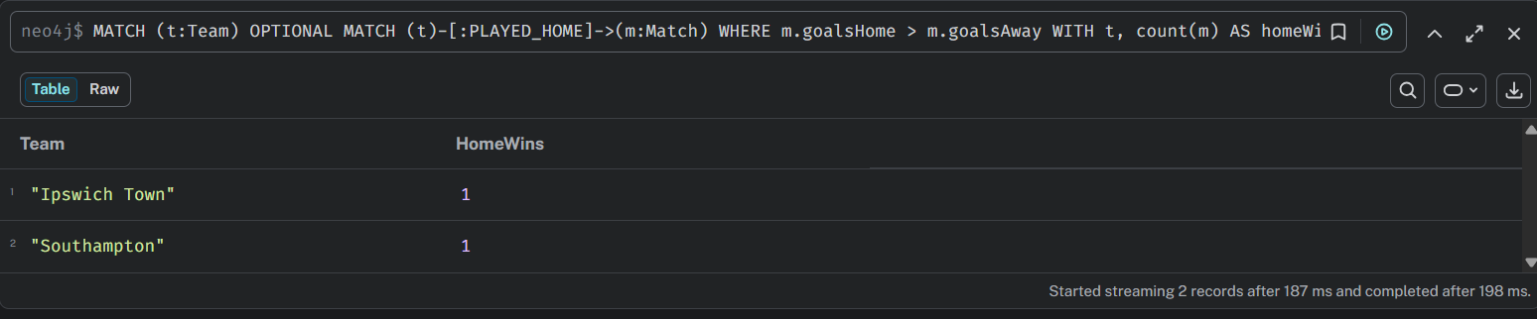 Figure 7: Query 3 - Neo4j Result

MongoDB (Aggregation Pipeline)
db.matches.aggregate([
{
$facet: {
allTeams: [
{ $project: { teams: ["$home", "$away"] } },
{ $unwind: "$teams" },
{ $group: { _id: "$teams" } }
],
homeWins: [
{ $match: { $expr: { $gt: ["$goals_home", "$goals_away"] } } },
{ $group: { _id: "$home", count: { $sum: 1 } } }
]
}
},
{
$project: {
combined: {
$map: {
input: "$allTeams", as: "t",
in: {
team: "$$t._id",
wins: {
$let: {
vars: { match: { $filter: { input: "$homeWins", as: "hw", cond: { $eq: ["$$hw._id", "$$t._id"] } } } },
in: { $cond: { if: { $gt: [{ $size: "$$match" }, 0] }, then: { $arrayElemAt: ["$$match.count", 0] }, else: 0 } }
}
}
}
}
}
}
},
{ $unwind: "$combined" },
{ $sort: { "combined.wins": 1 } },
{ $group: { _id: null, minWins: { $first: "$combined.wins" }, teams: { $push: "$combined" } } },
{ $unwind: "$teams" },
{ $match: { $expr: { $eq: ["$teams.wins", "$minWins"] } } },
{ $project: { _id: 0, Team: "$teams.team", HomeWins: "$teams.wins" } }
])
$facet builds two independent results in parallel: allTeams (every club) and homeWins (only clubs with at least one home win). $map and $filter then act as a manual left-outer join, so a team absent from homeWins is explicitly assigned 0 rather than being dropped from the output — the same safeguard OPTIONAL MATCH provides in the Cypher version. The result is then filtered to whichever team(s) share the minimum.

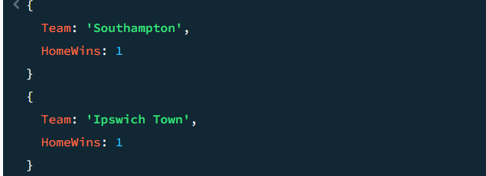 Figure 8: Query 3 - MongoDB Result

Result: Ipswich Town and Southampton tied for fewest home wins, with 1 home win each across the season.

5.4 Query 4 — Referee(s) involved in the most matches

Neo4j (Cypher)
MATCH (r:Referee)-[:OFFICIATED]->(m:Match)
WITH r, count(m) AS matchCount
WITH collect({referee: r.name, matches: matchCount}) AS refMatchesList, max(matchCount) AS maxMatches
UNWIND refMatchesList AS item
WITH item WHERE item.matches = maxMatches
RETURN item.referee AS Referee, item.matches AS MatchesOfficiated;
Follows the OFFICIATED relationship from each Referee to the Match nodes they officiated, counts them per referee, then filters to whichever referee(s) share the maximum count.
Figure 9: Query 4 - Neo4j Result
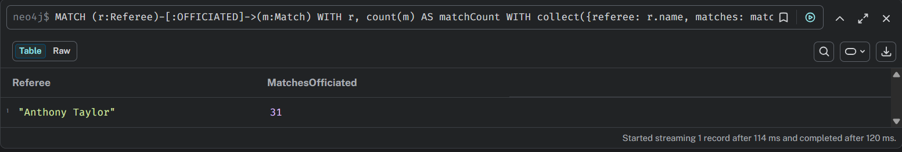 Figure 9: Query 4 - Neo4j Result

MongoDB (Aggregation Pipeline)
[
{ $group: { _id: "$referee", matchCount: { $sum: 1 } } },
{ $sort: { matchCount: -1 } },
{ $group: { _id: null, maxMatches: { $first: "$matchCount" }, referees: { $push: { referee: "$_id", count: "$matchCount" } } } },
{ $unwind: "$referees" },
{ $match: { $expr: { $eq: ["$referees.count", "$maxMatches"] } } },
{ $project: { _id: 0, Referee: "$referees.referee", Matches: "$referees.count" } }
]
Groups documents by the referee field, counting matches per official, sorts descending, then filters down to whichever referee(s) match the highest count.
Figure 10: Query 4 - MongoDB Result
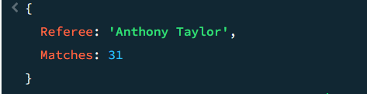
Figure 10: Query 4 - MongoDB Result
Result: Anthony Taylor officiated the most matches in the season, with 31 appearances.

5.5 Query 5 — Final league table (3 pts win / 1 pt draw / 0 pts loss), ranked by points

Neo4j (Cypher)
MATCH (t:Team)
OPTIONAL MATCH (t)-[:PLAYED_HOME]->(mh:Match)
WITH t,
count(mh) AS homePlayed,
sum(CASE WHEN mh.goalsHome > mh.goalsAway THEN 1 ELSE 0 END) AS homeWins,
sum(CASE WHEN mh.goalsHome = mh.goalsAway THEN 1 ELSE 0 END) AS homeDraws,
sum(CASE WHEN mh.goalsHome < mh.goalsAway THEN 1 ELSE 0 END) AS homeLosses,
sum(mh.goalsHome) AS homeGF, sum(mh.goalsAway) AS homeGA
OPTIONAL MATCH (t)-[:PLAYED_AWAY]->(ma:Match)
WITH t, homePlayed, homeWins, homeDraws, homeLosses, homeGF, homeGA,
count(ma) AS awayPlayed,
sum(CASE WHEN ma.goalsAway > ma.goalsHome THEN 1 ELSE 0 END) AS awayWins,
sum(CASE WHEN ma.goalsAway = ma.goalsHome THEN 1 ELSE 0 END) AS awayDraws,
sum(CASE WHEN ma.goalsAway < ma.goalsHome THEN 1 ELSE 0 END) AS awayLosses,
sum(ma.goalsAway) AS awayGF, sum(ma.goalsHome) AS awayGA
WITH t,
(homePlayed + awayPlayed) AS Played, (homeWins + awayWins) AS Wins,
(homeDraws + awayDraws) AS Draws, (homeLosses + awayLosses) AS Losses,
(coalesce(homeGF,0) + coalesce(awayGF,0)) AS GF, (coalesce(homeGA,0) + coalesce(awayGA,0)) AS GA,
((homeWins + awayWins) * 3 + (homeDraws + awayDraws) * 1) AS Points
WITH t, Played, Wins, Draws, Losses, GF, GA, (GF - GA) AS GD, Points
ORDER BY Points DESC, GD DESC, GF DESC, t.name ASC
WITH collect({team: t.name, played: Played, wins: Wins, draws: Draws, losses: Losses, gf: GF, ga: GA, gd: GD, points: Points}) AS rankingList
UNWIND range(0, size(rankingList) - 1) AS idx
WITH rankingList[idx] AS stats, idx + 1 AS Rank
RETURN Rank, stats.team AS Team, stats.played AS Played, stats.wins AS Wins, stats.draws AS Draws,
stats.losses AS Losses, stats.gf AS GF, stats.ga AS GA, stats.gd AS GD, stats.points AS Points;
This query uses the same two-stage aggregation pattern as the corrected Query 2 from the outset — home statistics are fully resolved to scalars in one WITH before the away OPTIONAL MATCH is introduced — which is why it did not suffer from the cartesian-product bug found in the original Query 2. Points, goal difference, and rank are computed after both home and away figures are combined, and the final ranking is produced by collecting all 20 rows, ordering them, then re-numbering with UNWIND range(...) as a positional index.

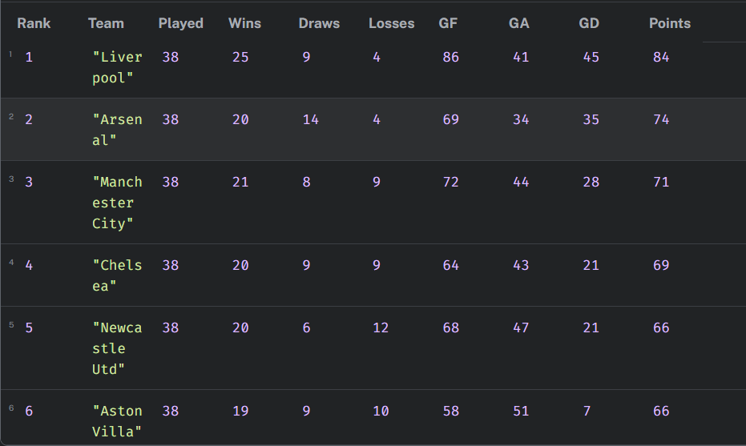
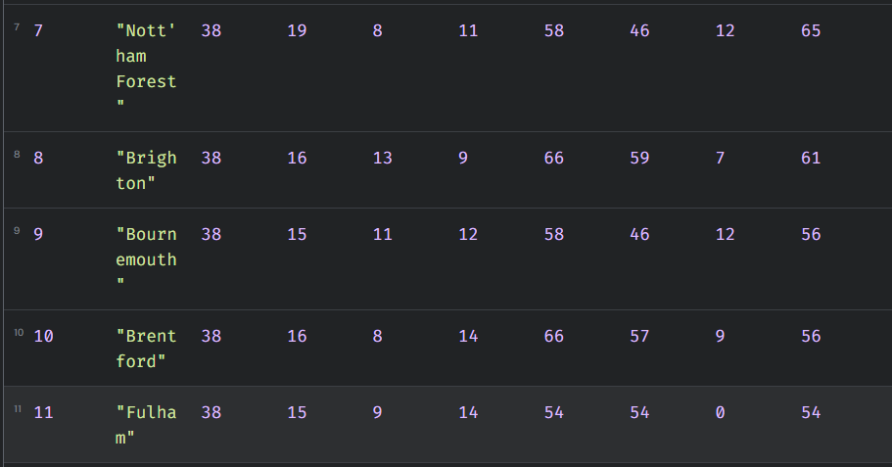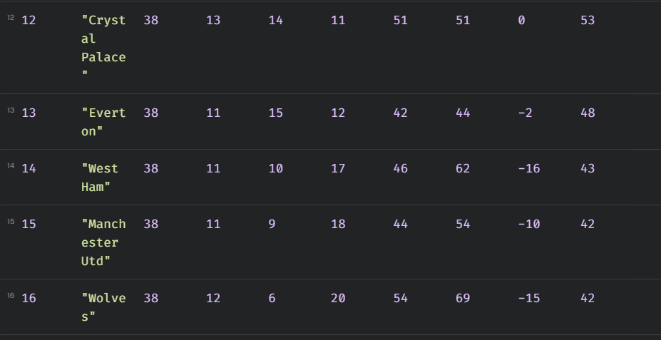
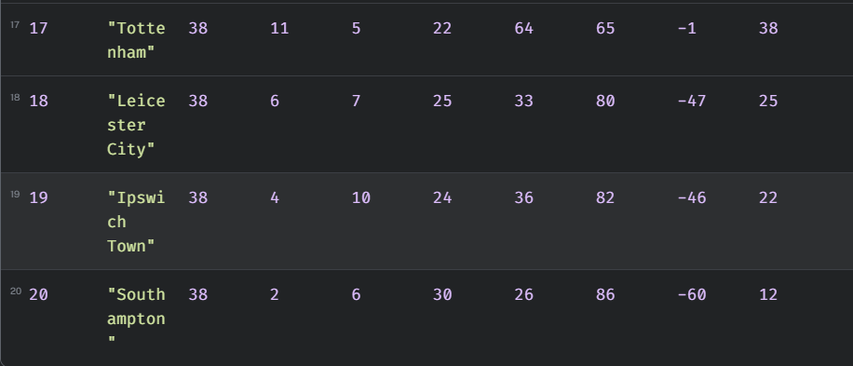 Figure 11: Query 5 - Neo4j Result

MongoDB (Aggregation Pipeline)
db.matches.aggregate([
{ $project: { stats: [
{ team: "$home", played: 1, gf: "$goals_home", ga: "$goals_away",
wins: { $cond: [{ $gt: ["$goals_home", "$goals_away"] }, 1, 0] },
draws: { $cond: [{ $eq: ["$goals_home", "$goals_away"] }, 1, 0] },
losses: { $cond: [{ $lt: ["$goals_home", "$goals_away"] }, 1, 0] },
points: { $cond: [{ $gt: ["$goals_home", "$goals_away"] }, 3, { $cond: [{ $eq: ["$goals_home", "$goals_away"] }, 1, 0] }] } },
{ team: "$away", played: 1, gf: "$goals_away", ga: "$goals_home",
wins: { $cond: [{ $gt: ["$goals_away", "$goals_home"] }, 1, 0] },
draws: { $cond: [{ $eq: ["$goals_away", "$goals_home"] }, 1, 0] },
losses: { $cond: [{ $lt: ["$goals_away", "$goals_home"] }, 1, 0] },
points: { $cond: [{ $gt: ["$goals_away", "$goals_home"] }, 3, { $cond: [{ $eq: ["$goals_away", "$goals_home"] }, 1, 0] }] } }
] } },
{ $unwind: "$stats" },
{ $group: { _id: "$stats.team", Played: { $sum: "$stats.played" }, Wins: { $sum: "$stats.wins" },
Draws: { $sum: "$stats.draws" }, Losses: { $sum: "$stats.losses" }, GF: { $sum: "$stats.gf" },
GA: { $sum: "$stats.ga" }, Points: { $sum: "$stats.points" } } },
{ $project: { Team: "$_id", Played: 1, Wins: 1, Draws: 1, Losses: 1, GF: 1, GA: 1,
GD: { $subtract: ["$GF", "$GA"] }, Points: 1, _id: 0 } },
{ $sort: { Points: -1, GD: -1, GF: -1, Team: 1 } },
{ $group: { _id: null, table: { $push: "$$ROOT" } } },
{ $unwind: { path: "$table", includeArrayIndex: "Rank" } },
{ $project: { Rank: { $add: ["$Rank", 1] }, Team: "$table.Team", Played: "$table.Played",
Wins: "$table.Wins", Draws: "$table.Draws", Losses: "$table.Losses",
GF: "$table.GF", GA: "$table.GA", GD: "$table.GD", Points: "$table.Points", _id: 0 } }
])
Projects each match into home- and away-perspective stat objects (played/won/drawn/lost/points, using $cond to apply the 3/1/0 rule), unwinds and groups by team to accumulate season totals, computes goal difference, sorts by the standard tie-break order (points, then GD, then GF, then name), then uses $unwind's includeArrayIndex option to assign a 1-based rank to the already-sorted array.
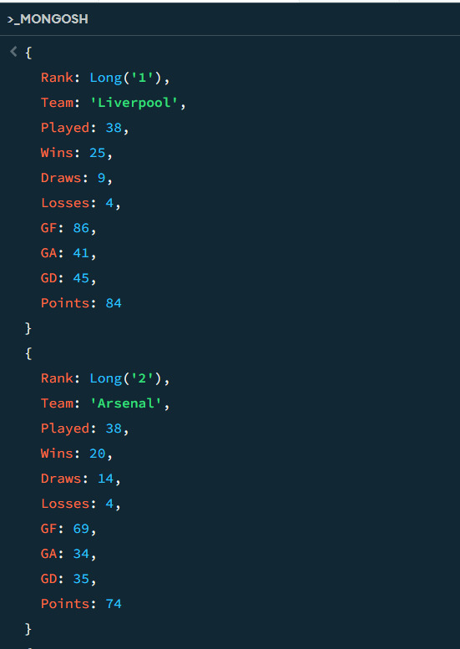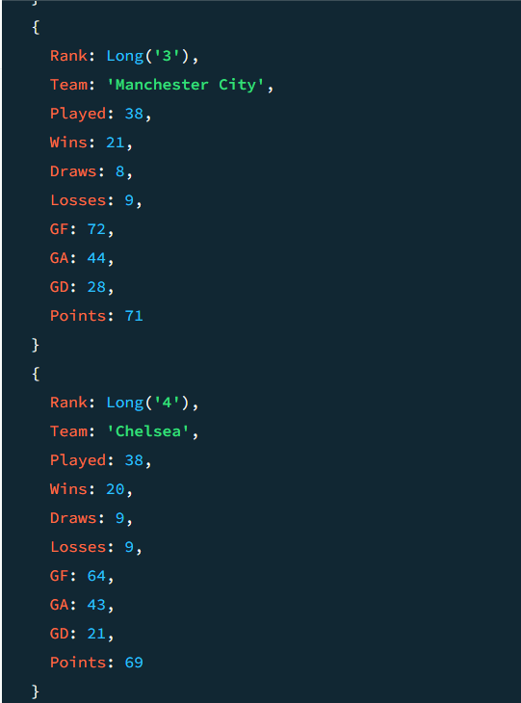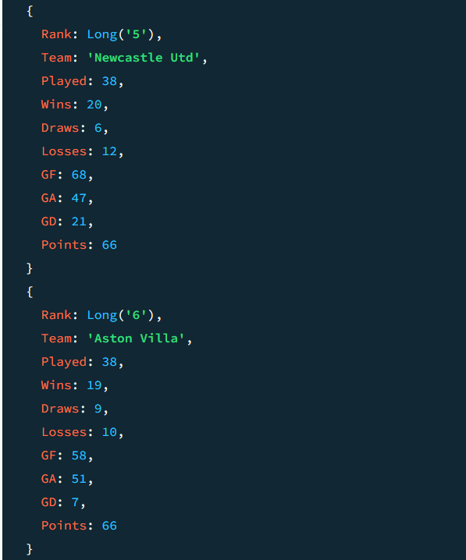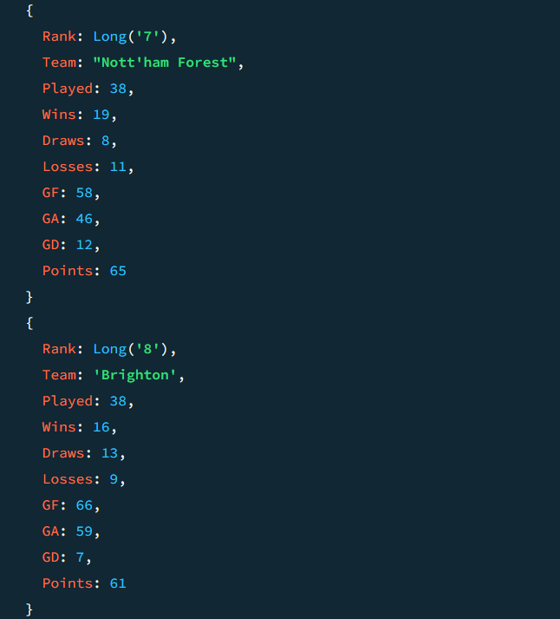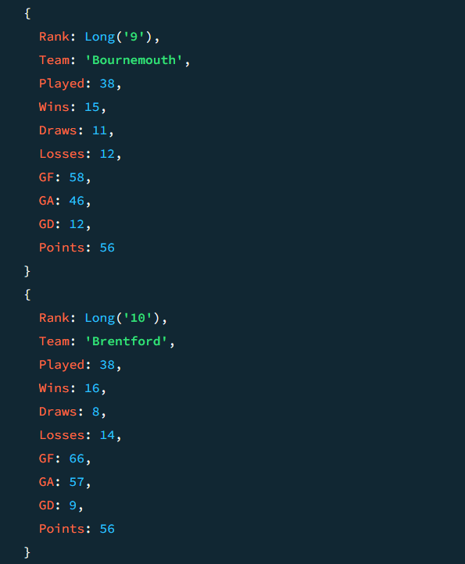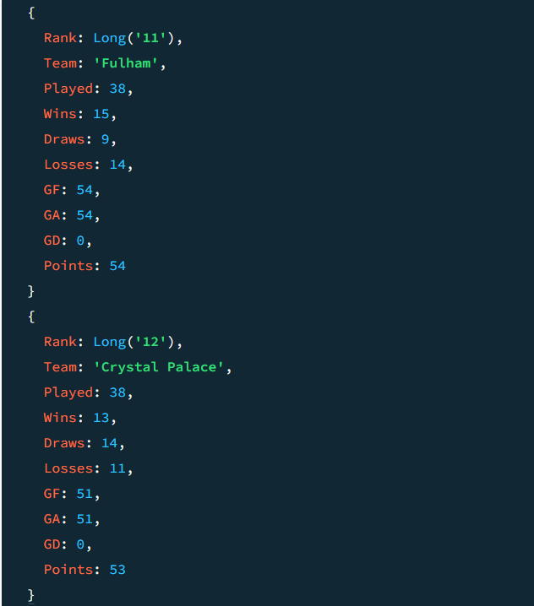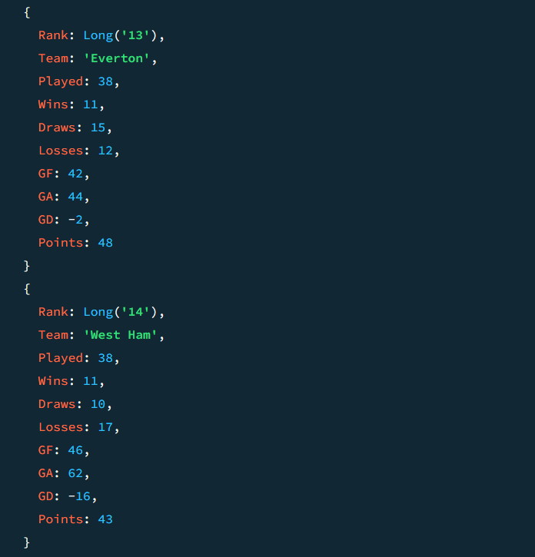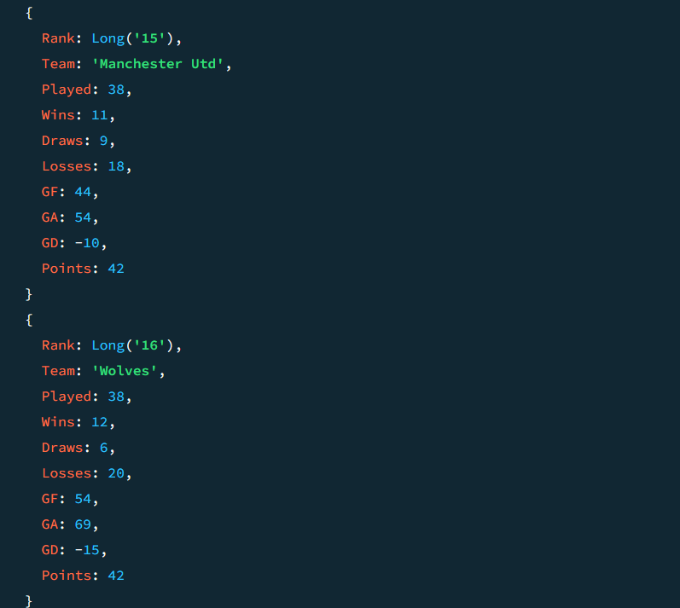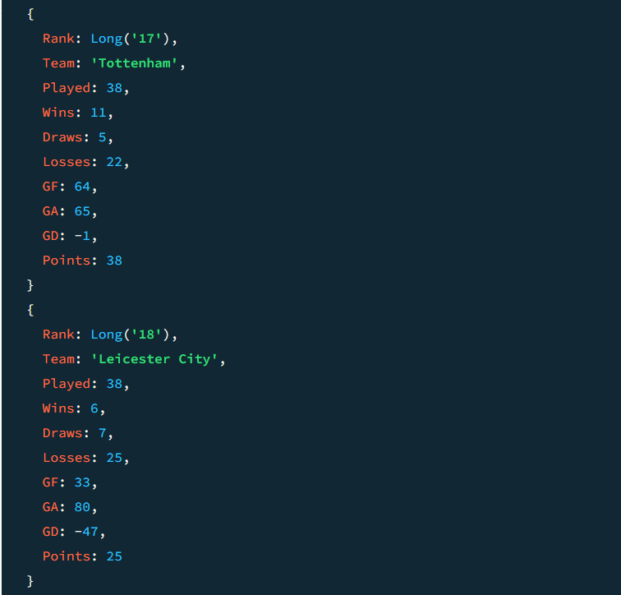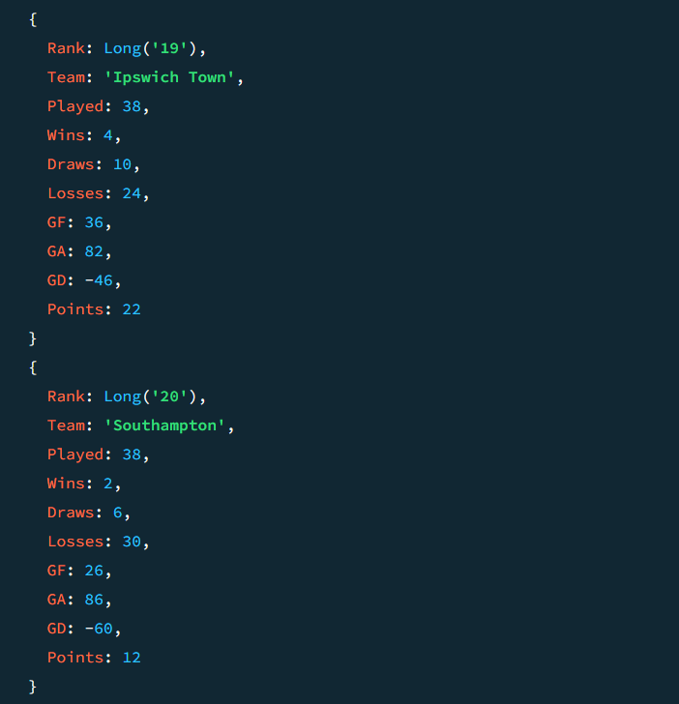 Figure 12: Query 5 - MongoDB Result
Result: Liverpool topped the table with 84 points (25 W, 9 D, 4 L, GF 86, GA 41, GD +45); Southampton finished bottom with 12 points (2 W, 6 D, 30 L, GF 26, GA 86, GD -60). The full 20-row table is reproduced below for reference.

Full Query 5 league table (both databases produced identical figures):
Rank | Team | P | W | D | L | GF | GA | GD | Pts
1 | Liverpool | 38 | 25 | 9 | 4 | 86 | 41 | +45 | 84
2 | Arsenal | 38 | 20 | 14 | 4 | 69 | 34 | +35 | 74
3 | Manchester City | 38 | 21 | 8 | 9 | 72 | 44 | +28 | 71
4 | Chelsea | 38 | 20 | 9 | 9 | 64 | 43 | +21 | 69
5 | Newcastle Utd | 38 | 20 | 6 | 12 | 68 | 47 | +21 | 66
6 | Aston Villa | 38 | 19 | 9 | 10 | 58 | 51 | +7 | 66
7 | Nott'ham Forest | 38 | 19 | 8 | 11 | 58 | 46 | +12 | 65
8 | Brighton | 38 | 16 | 13 | 9 | 66 | 59 | +7 | 61
9 | Bournemouth | 38 | 15 | 11 | 12 | 58 | 46 | +12 | 56
10 | Brentford | 38 | 16 | 8 | 14 | 66 | 57 | +9 | 56
11 | Fulham | 38 | 15 | 9 | 14 | 54 | 54 | +0 | 54
12 | Crystal Palace | 38 | 13 | 14 | 11 | 51 | 51 | +0 | 53
13 | Everton | 38 | 11 | 15 | 12 | 42 | 44 | -2 | 48
14 | West Ham | 38 | 11 | 10 | 17 | 46 | 62 | -16 | 43
15 | Manchester Utd | 38 | 11 | 9 | 18 | 44 | 54 | -10 | 42
16 | Wolves | 38 | 12 | 6 | 20 | 54 | 69 | -15 | 42
17 | Tottenham | 38 | 11 | 5 | 22 | 64 | 65 | -1 | 38
18 | Leicester City | 38 | 6 | 7 | 25 | 33 | 80 | -47 | 25
19 | Ipswich Town | 38 | 4 | 10 | 24 | 36 | 82 | -46 | 22
20 | Southampton | 38 | 2 | 6 | 30 | 26 | 86 | -60 | 12

5.6 Query 6 — Team(s) with the most consecutive wins after Christmas

Neo4j (Cypher)
MATCH (t:Team)
MATCH (t)-[p:PLAYED_HOME|PLAYED_AWAY]->(m:Match)
WHERE m.date > date('2024-12-25')
WITH t, m,
CASE
WHEN type(p) = 'PLAYED_HOME' AND m.goalsHome > m.goalsAway THEN 'W'
WHEN type(p) = 'PLAYED_AWAY' AND m.goalsAway > m.goalsHome THEN 'W'
WHEN m.goalsHome = m.goalsAway THEN 'D'
ELSE 'L'
END AS result
ORDER BY m.date ASC, m.time ASC
WITH t, collect(result) AS resultsList
WITH t, resultsList,
reduce(s = {max: 0, curr: 0}, r IN resultsList |
CASE WHEN r = 'W'
THEN { max: CASE WHEN s.curr + 1 > s.max THEN s.curr + 1 ELSE s.max END, curr: s.curr + 1 }
ELSE { max: s.max, curr: 0 }
END
) AS streak
WITH collect({team: t.name, maxStreak: streak.max, results: resultsList}) AS teamsStreaks, max(streak.max) AS maxStreakGlobal
UNWIND teamsStreaks AS ts
WITH ts WHERE ts.maxStreak = maxStreakGlobal
RETURN ts.team AS Team, ts.maxStreak AS LongestStreak, ts.results AS MatchResults;
For each team, every post-Christmas match is labelled W/D/L (checking home or away perspective via type(p)), ordered chronologically, and collected into a per-team result sequence. Cypher's reduce() then walks that sequence once, carrying a running current streak and the max streak seen so far — any 'D' or 'L' resets curr to 0, so only a genuinely unbroken run of wins counts. This is the only query in the assignment that needed reduce() rather than simple aggregation, since it depends on sequence order rather than just totals.

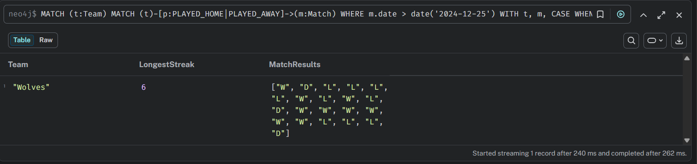 Figure 13: Query 6 - Neo4j Result

MongoDB (Aggregation Pipeline)
[db.matches.aggregate([
{ $match: { date: { $gt: new Date("2024-12-25") } } },
{ $sort: { date: 1, time: 1 } },
{ $project: { teams: [
{ team: "$home", won: { $gt: ["$goals_home", "$goals_away"] } },
{ team: "$away", won: { $gt: ["$goals_away", "$goals_home"] } }
] } },
{ $unwind: "$teams" },
{ $group: { _id: "$teams.team", results: { $push: "$teams.won" } } },
{ $project: { Team: "$_id", maxStreak: { $reduce: {
input: "$results", initialValue: { longest: 0, current: 0 },
in: {
longest: { $cond: [ { $eq: ["$$this", true] },
{ $cond: [{ $gt: [{ $add: ["$$value.current", 1] }, "$$value.longest"] }, { $add: ["$$value.current", 1] }, "$$value.longest"] },
"$$value.longest" ] },
current: { $cond: [{ $eq: ["$$this", true] }, { $add: ["$$value.current", 1] }, 0] }
}
} } } },
{ $project: { Team: 1, LongestStreak: "$maxStreak.longest", _id: 0 } },
{ $sort: { LongestStreak: -1 } },
{ $group: { _id: null, maxStreak: { $first: "$LongestStreak" }, teams: { $push: "$$ROOT" } } },
{ $unwind: "$teams" },
{ $match: { $expr: { $eq: ["$teams.LongestStreak", "$maxStreak"] } } },
{ $project: { Team: "$teams.Team", LongestStreak: "$teams.LongestStreak", _id: 0 } }
])

Filters to matches after 25 December 2024, sorts chronologically, then projects each match into a won: true/false flag from both the home and away team's perspective (a draw yields false for both sides, so it breaks a streak exactly like a loss does). After grouping each team's results into an ordered boolean array, $reduce walks that array exactly as Cypher's reduce() does — tracking a running current count and a longest count — and the final stages filter down to whichever team(s) reached the global maximum.

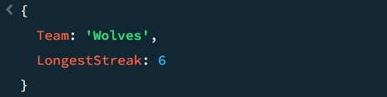
Figure 14: Query 6 - MongoDB Result

Result: Wolves recorded the longest post-Christmas winning run: 6 consecutive wins (15 March – 26 April 2025), beating Southampton, West Ham, Ipswich Town, Tottenham, Manchester Utd, and Leicester City in sequence.

6. Comparative Analysis and Reflection

6.1 Paradigm Comparison Matrix
Technical Feature | Graph Database (Neo4j) | Document Database (MongoDB)
Data Model Paradigm | Nodes (entities) and Relationships (edges). Relationships are first-class citizens. | Collections of semi-structured BSON documents representing denormalized records.
Relationship Handling | Direct pointers linking nodes physically (Index-free adjacency). O(1) traversal cost per hop. | No physical links; relationships are modeled via embedded subdocuments or reference lookups ($lookup).
Query Language | Cypher (declarative, pattern-matching syntax: MATCH...CREATE...RETURN). | MongoDB Query Language (MQL) and Aggregation Framework (JSON-like pipelines of stages).
Write Performance | Slower. Writes must update indices and create/link relationship structures in memory. | Very fast. Direct append writes into documents with minimal serialization overhead.
Schema Flexibility | Extremely high. Properties and labels can be added dynamically without structural limits. | High, but constrained. Documents in a collection usually conform to a logical structure for query predictability.
Ideal Application Scenario | Complex networks, recommendation engines, fraud detection, pathfinding, social network analysis. | High-volume web applications, content management, real-time logging, high-throughput caching, catalog systems.

6.2 Architectural and Performance Trade-offs
1. Relationship traversal vs. document retrieval — Neo4j's relationships are physical pointers, so multi-hop queries chase pointers in memory at roughly constant cost per hop. MongoDB has no equivalent physical link; connecting documents relies on scanning/indexing via $lookup, which scales less favourably as the number of hops grows.
2. Read-heavy vs. write-heavy workloads — MongoDB's single-document model is efficient when the access pattern is "fetch one complete record," which matches match-report retrieval well. Neo4j, by contrast, must gather properties across several linked nodes (Team, Match, Referee, Venue) to reconstruct an equivalent view, adding overhead that a purely document-based read does not incur.
3. Sequential logic — Query 6 is the clearest divergence point in this assignment. Cypher's reduce() reads close to natural language over an already-ordered list. MongoDB's equivalent, $reduce inside an aggregation $project, is functionally identical but syntactically far more verbose, since the accumulator object and every branch of the win/reset logic must be expressed as nested $cond operators rather than a small inline expression.

6.3 Cross-Database Validation as a Correctness Check
One outcome of building both models side by side was discovering that they double as a correctness check on each other. During development, the original Neo4j Query 2 (best attack/worst defence) returned a Liverpool total of 1,634 goals a cartesian-product bug from chaining two OPTIONAL MATCH clauses before aggregating. The MongoDB implementation of the same query, built independently using $facet, returned a plausible and different figure for the same question. That discrepancy between two supposedly equivalent answers on identical source data was the concrete signal that something was wrong in the Cypher, well before the number was checked against real-world EPL statistics or the Query 5 league table. This is a practical argument for building both models over a single one, even outside of the assignment's requirements: implementing the same analytical question twice, in two different query paradigms, is itself a form of testing.

6.4 Reflective Critique
This reflection follows Gibbs' Reflective Cycle Like in previous assignment to articulate my project experience.
Description:
The assignment involved modelling and querying the same flat EPL dataset using two different NoSQL paradigms a property graph in Neo4j and a document store in MongoDB and answering six identical analytical questions in both.
Feelings:
Working across two very different query styles at once — Cypher's declarative pattern-matching versus MongoDB's staged aggregation pipelines — was initially disorienting, particularly for the sequential streak logic in Query 6. Seeing the same problem solved in both styles side by side made the trade-offs between the two much clearer than studying either in isolation would have.
Evaluation:
The graph model captures the domain's real entities and relationships (teams, referees, venues, matches) naturally, and querying via relationship traversal generally read closer to the underlying question being asked. The MongoDB model is less structurally expressive but was consistently fast to write and fast to reason about for direct retrieval-style questions.
Analysis:
The most instructive moment was the Query 2 bug: a cartesian product from an easy-to-miss Cypher pattern (two OPTIONAL MATCH clauses feeding one aggregation) produced numbers that were wrong by roughly a factor of 19, yet were not obviously wrong at a glance. Only comparing against the MongoDB answer, and later the Query 5 totals, made the error visible. This showed that plausibility checks and cross-validation matter as much as query syntax correctness — a query can run without error and still be wrong.
Conclusion:
Graph databases suit connection-centric problems (sequence and path analysis) more naturally than document databases do, while document databases suit high-throughput retrieval of self-contained records more naturally than graph databases do. Neither paradigm was strictly better across all six queries — each had at least one query where it was the more natural fit.
Action Plan:
For future database projects, the data access pattern will be analysed before choosing a paradigm: if relationships or sequence are the primary query driver, a graph database will be used; if the workload is dominated by fetching whole self-contained records, a document store will be used. Building the same query twice across paradigms, as done here for validation, is also worth doing again on smaller, targeted tests even outside of coursework.

7. Conclusion
This report has presented two complete database implementations of the EPL 2024/25 season — a Neo4j graph model and a MongoDB document model — covering dataset analysis, schema design and justification, the practical creation and import process for both, and all six required analytical queries with verified, cross-checked results. The two databases produced consistent answers once the Query 2 error was identified and corrected, and the comparative analysis in Section 6 shows that the choice between a graph and a document paradigm is best driven by whether an application's dominant workload is connection-centric or record-centric, rather than one paradigm being universally superior.

8. References
Neo4j, Inc. (2026) Cypher Manual. Available at: https://neo4j.com/docs/cypher-manual/current/ (Accessed: 14 August 2026).
Neo4j, Inc. (2026) LOAD CSV — Cypher Manual. Available at: https://neo4j.com/docs/cypher-manual/current/clauses/load-csv/ (Accessed: 14 August 2026).
MongoDB, Inc. (2026) Aggregation Pipeline — MongoDB Manual. Available at: https://www.mongodb.com/docs/manual/core/aggregation-pipeline/ (Accessed: 14 August 2026).
MongoDB, Inc. (2026) $reduce (aggregation) — MongoDB Manual. Available at: https://www.mongodb.com/docs/manual/reference/operator/aggregation/reduce/ (Accessed: 14 August 2026).
Robinson, I., Webber, J. and Eifrem, E. (2015) Graph Databases. 2nd edn. Sebastopol: O'Reilly Media.
Sadalage, P.J. and Fowler, M. (2013) NoSQL Distilled: A Brief Guide to the Emerging World of Polyglot Persistence. Upper Saddle River: Addison-Wesley.
TODO: Add any further sources actually used (lecture slides, module reading list items) in the same Harvard format.

