A DISSERTATION REPORT ON
EasyGov: A Mobile Application for Improving Accessibility
and Understanding of Government Services in Nepal

A dissertation submitted partial fulfillment of the requirement for the degree of
BSc (Hons) Computer Science

SUBMITTED BY:
Prashna KC
UNID:24813364
Supervisor:Ankit Thapa

Abstract
Citizens navigating public administrative procedures in Nepal encounter severe procedural ambiguity and operational friction caused by fragmented guidelines distributed across static portals, unformatted PDFs, and physical notice boards. Essential public servicesincluding passport issuance, citizenship certification, national identity registration, and driver licensing involve multi-departmental prerequisite dependencies that existing e-governance portals fail to contextualize. This dissertation presents EasyGov, a localized mobile e-governance platform that pairs a deterministic, state-aware recommendation engine with an asynchronous Retrieval-Augmented Generation (RAG) conversational agent. Developed under a Design Science Research (DSR) methodology through Agile-Scrum iterations, EasyGov implements a decoupled three-tier architecture: a native Android client secured with AES-256-GCM encryption, a FastAPI middleware layer, and a hybrid persistence schema coupling SQLite with a ChromaDB vector store (paraphrase-multilingual-MiniLM-L12-v2). The recommendation engine maps user profile attributes and historical state against a directed prerequisite dependency graph to deliver personalized procedural steps. Concurrently, the RAG agent processes bilingual queries in English and Romanized Nepali, providing factual, hallucination-resistant guidance anchored to source citations. System validation confirmed high backend reliability, achieving a 100% pass rate across a 97-test automated Pytest suite. Evaluation against a 31-item gold-standard benchmark via the RAGAS framework demonstrated retrieval quality of 0.871 Faithfulness and 0.773 Context Recall. Finally, User Acceptance Testing (UAT) across five representative cohorts yielded an average System Usability Scale (SUS) score of 80.5/100 ("Grade A / Excellent"), verifying that EasyGov significantly reduces procedural uncertainty and improves digital public service accessibility.
Keywords: E-Governance, Retrieval-Augmented Generation, RAG, Mobile Application, State-Aware Recommendation, Design Science Research, Nepal
Acknowledgement
I would like to express my sincere gratitude to my supervisor, Mr. Nischal Khadka, whose guidance, critical feedback, and continuous support at every stage of this dissertation were instrumental in shaping its technical direction and ensuring rigorous academic quality.
I also extend my thanks to Naaya Aayam Multi-Disciplinary Institute (NAMI) and the University of Northampton for providing the academic resources, research facilities, and learning environment required to complete this project.
Finally, I am deeply grateful to my family and friends for their enduring patience, encouragement, and understanding throughout the course of this dissertation year.
Declaration
I declare that this dissertation is my own original work, submitted in partial fulfilment of the requirements for the degree of BSc (Hons) Computing at the University of Northampton. All sources of information, software libraries, datasets, and intellectual contributions that are not my own have been appropriately acknowledged and referenced. This work has not been submitted, in whole or in part, for any other academic award at this or any other institution.
Signed: Prashna K.C
Date: June 2026
Table of Contents
Contents
Abstract 2
1. Introduction 11
1.1 Background 12
1.2 Rationale 13
1.2.1 Socio-Technical Rationale & The Guidance Gap 13
1.2.2 Technical Rationale: The Hybrid Architectural Necessity 13
1.2.3 Academic Contribution & Technical Novelty 14
1.3 Aim and Objectives 15
1.3.1 Aim 15
1.3.2 Objectives 15
1.3.3 Target Audience 16
1.4.Project scope 17
2. Requirement Engineering 18
2.1 Literature Review 18
2.1.1 Retrieval-Augmented Generation (RAG) for Domain-Specific Question Answering 18
2.1.2 Personalised, Rule-Based Recommendation for Service Navigation 20
2.1.3 Multilingual and Cross-Lingual Retrieval and Generation 21
2.1.4 E-Governance, Digital Government and Citizen-Facing AI Services 22
2.1.5 Evaluation of Retrieval-Augmented Generation System 24
2.1.6 Synthesis and Research Gap 25
2.2 Problem Domain 26
2.3 Proposed Solution Strategy 27
2.3.1 Proposed Solution Flowchart 28
2.4 Alternate Solution Strategy 30
2.5 Comparative System 30
3. System Analysis and Design 32
3.1 Use Case Diagram 32
3.2 Class Diagram 35
3.3 Entity Relationship Diagram (ERD) 37
3.4 Database Schema Diagram 38
3.5 Sequence Diagram 39
3.5.1 Admin Ingestion Sequence Diagram 39
3.5.2 State-Aware Recommendation Sequence Diagram 40
3.5.3 RAG Conversational AI Sequence Diagram 41
3.5.4.Recommendation Sequence Diagram 42
3.6 System Architecture Diagram 43
3.7 Activity Diagrams 43
3.7.1 Login and Authentication Activity Diagram 43
3.7.2 Progress Tracking Activity Diagram 46
3.7.3 Admin Knowledge Management Activity Diagram 48
3.7.4 RAG Conversational AI Activity Diagram 51
3.7.Algorithm Implemented 52
3.7.1. Retrieval-Augmented Generation (RAG) Pipeline 52
3.7.2. State-Aware Procedural Recommendation Engine 62
3.8.Wireframes 67
3.9.Mockups 70
4. Requirement Specification 79
4.2.Functional Requirements (FR) 79
4.3 Non-Functional Requirements 80
4.4. Performance Requirements (Speed, Accessibility, Reusability) 81
4.5. Hardware and Software Requirements 81
5. Dissertation Methodology 85
5.1 Overarching Research Paradigm: Design Science Research (DSR) 85
5.4 System Architecture and Design 88
5.5 Implementation Approach 90
5.6 Evaluation Strategy 91
5.7 Ethical Considerations and Data Safeguards 91
5.9 Methodology Workflow Diagram 93
6. System Implementation 96
6.1 RAG Knowledge Ingestion and Vector Indexing 96
6.2 Multilingual RAG Query & AI Assistant Endpoint 97
6.3 Geospatial Proximity Finder (Haversine Formula) 98
6.4 Fernet (AES-256) Data Encryption at Rest 100
6.5 Android Retrofit API Client & Network Interceptor 101
6.6 Android AI Chat UI & Markdown Rendering Controller 102
7. Testing Strategy and System Evaluation 104
7.1 Phase 1: Backend Test Suite & Environment Isolation (97 Tests) 104
7.1.1 Test Isolation Architecture 104
7.1.2 Backend Test Suite Layer Breakdown (97 Passing Tests) 105
7.2 Phase 2: RAG Pipeline Evaluation & The 5-Run Iterative Improvement Loop 107
7.2.1 5-Run Iterative RAG Evaluation Improvement Loop 108
7.2.1 Iterative Improvement Loop Breakdown 109
7.3.Validate client-side stability and automated CI build verification 112
7.4.Manual test 113
7.5 Empirical User Acceptance Testing (UAT) & SUS Evaluation 119
7.6.Usability Synthesis & Discussion 121
8. Future Work and System Expansion 122
8.1 Dual-Language Native Embedding 122
8.2 Expansion of Government Services and Knowledge Resources 123
8.3 Voice Assistance and Speech-to-Text Interaction 123
8.4 Migration to a Distributed Database Architecture 124
9. Conclusion 125
10. References 126
Appendix A: Project Gantt Chart 128
Appendix B: Project Progress Log Sheet 129
Appendix C: Presentation Slides 135

List of Figures

Figure 2.1: Proposed solution workflow diagram for EasyGov platform. 32
Figure 3.1: Use case diagram for the EasyGov system. 36
Figure 3.2: Class diagram for EasyGov backend and mobile architecture. 39
Figure 3.3: Entity relationship diagram for the EasyGov database schema. 39
Figure 3.4: Physical database schema diagram for EasyGov persistence layer. 41
Figure 3.5: Sequence diagram for admin knowledge ingestion workflow. 41
Figure 3.6: Sequence diagram for state-aware procedural recommendation workflow. 42
Figure 3.7: Sequence diagram for multilingual RAG conversational assistant workflow. 43
Figure 3.8: Three-tier system architecture overview of EasyGov platform. 45
Figure 3.9: Activity diagram for user login and authentication workflow. 47
Figure 3.10: Activity diagram for user progress tracking workflow. 49
Figure 3.11: Activity diagram for administrative knowledge management workflow. 51
Figure 3.12: Activity diagram for RAG conversational AI query processing. 51
Figure 3.13: Advanced RAG pipeline execution flowchart. 62
Figure 3.14: State-aware recommendation decision flowchart. 6874
Figure 5.1: Methodology workflow diagram integrating Design Science Research with Agile Scrum. 91
Figure 6.1: Vector knowledge ingestion pipeline module code implementation. 92
Figure 6.2: Multilingual RAG query and AI assistant endpoint code implementation. 93
Figure 6.3: Geospatial proximity finder engine code implementation. 95
Figure 6.4: AES-256 Fernet document encryption module code implementation. 96
Figure 6.5: Android Retrofit network client and auth interceptor code implementation. 97
Figure 6.6: Android AI chat UI controller and markdown renderer code implementation. 99
Figure 7.1: Automated Pytest suite execution log demonstrating 97 passing tests. 103
Figure 7.2: Automated RAGAS evaluation runner log across iterative improvement loops. 108
Figure 7.3: Streamlit administrative portal for RAG knowledge ingestion and vector management. 109
Figure A.1: Project Gantt chart for EasyGov development sprints. 119
Figure B.1: Project progress log sheets. 125

List of Tables

Table 2.1: Comparative system analysis and strategic trade-offs. 32
Table 4.1: Hardware and software environment requirements. 78
Table 5.1: Mapping of EasyGov activities to the Design Science Research process model. 81
Table 7.1: Backend test suite layer breakdown and test distribution. 101
Table 7.2: Iterative RAG evaluation improvement loop results and technical findings. 104
Table 7.3: Manual verification test procedures and execution outcomes. 109
Table 7.4: System Usability Scale (SUS) empirical evaluation results. 111

1. Introduction
EasyGov is a civic-tech mobile application designed to simplify the navigation of public services and administrative procedures in Nepal. The platform addresses the challenges citizens face when accessing fragmented government information and navigating interconnected government processes. To achieve this,EasyGov implements a hybrid architecture combining an advanced Retrieval-Augmented Generation (RAG) pipeline for document-grounded conversational guidance with a deterministic, state-aware procedural recommendation engine that enforces legal prerequisite dependencies and generates personalised next-step roadmaps.
The state-aware procedural recommendation engine formally models the inter-service dependencies and statutory prerequisites inherent in public administration, where civic services are hierarchically chained (e.g., an applicant is legally ineligible for an E-Passport without a verified National Identity Card (NID) and Citizenship Certificate). By securely evaluating a citizen's profile attributes, demographic criteria, and existing documentation portfolio, the engine dynamically constructs personalised priority queues and procedural roadmaps. Concurrently, the state-aware tracking subsystem maintains the citizen's lifecycle progression across multi-step administrative workflows. This mechanism empowers citizens to proactively comprehend prerequisite constraints, identify their immediate next actionable step, and navigate intricate bureaucratic procedures with minimal friction.
Complementing the recommendation engine, the Retrieval-Augmented Generation (RAG) AI conversational assistant dynamically fetches contextually relevant passages from an embedded, metadata-enriched knowledge base constructed directly from official government handbooks and statutory procedural documents prior to response generation. Rather than relying solely on the parametric memory of the underlying Large Language Model (LLM), the retrieval pipeline firmly grounds every generated response in authoritative government sources. This design significantly mitigates hallucinations while substantially improving factual accuracy, auditability, and institutional trust which is Exactly what build a trust when working with administrative technologies.
EasyGov establishes a unified intelligent platform that not only answers ad-hoc citizen inquiries but also proactively guides users along personalized administrative journeys. Furthermore, by incorporating multilingual support, the system accommodates diverse literacy levels across the population. Through this dual-layer architectural approach, EasyGov enhances the accessibility, transparency, and operational usability of Nepal’s digital public administration while reducing citizen confusion in complex bureaucratic procedures.

1.1 Background
The landscape of digital governance in Nepal has undergone a significant shift with the launch of the Nagarik App in 2021, which now serves over 1.5 million active users. While this flagship initiative and portals such as the Department of Transport Management have successfully digitised various administrative transactions, they primarily function as execution layers rather than guidance systems. Consequently, a usability gap remains in which digital services are available, but the procedural knowledge required to navigate them such as understanding quota-based appointment systems or specific document prerequisites is not effectively communicated to the public.
Currently, official procedural information is predominantly hosted on departmental websites, such as nepalpassport.gov.np and donidcr.gov.np, in the form of dense, non-conversational PDF handbooks. These resources are designed primarily for administrative record-keeping rather than public consumption, creating an environment in which information is fragmented and often inaccessible to the average citizen. This project seeks to leverage Retrieval-Augmented Generation (RAG) and state-aware procedural logic to transform these static official records into a dynamic, personalised guidance system that bridges the divide between digital service availability and citizen comprehension.

This project addresses the following research question:
How can a hybrid guidance architecture integrating Retrieval-Augmented Generation (RAG) with deterministic, state-aware procedural logic effectively guide citizens through complex Nepalese government services while ensuring factual accuracy, source grounding, and actionable personalization?

1.2 Rationale
The rationale for EasyGov is grounded in addressing a critical socio-technical divide in Nepal's public administration ecosystem. While digital governance initiatives have expanded rapidly over the past decade, significant structural usability barriers remain. The rationale is structured across three core dimensions: practical socio-technical need, technical architectural necessity, and academic contribution.

1.2.1 Socio-Technical Rationale & The Guidance Gap
The primary civic challenge in Nepal is not merely service availability, but procedural information asymmetry. Existing official portals such as the Nagarik App (serving over 1.5 million users) and departmental transaction sites function primarily as transaction execution layers (e.g., submitting a completed form or verifying a record). However, they fail to provide the prerequisite guidance required to reach that execution stage. Citizens are frequently unaware of complex document dependencies, quota-based appointment constraints, or category-specific requirements.
Consequently, citizens are forced to navigate dense, non-conversational PDF handbooks hosted on departmental websites (such as nepalpassport.gov.np and donidcr.gov.np), which are authored for legal record-keeping rather than public comprehension. This information gap creates a heavy reliance on informal intermediaries brokers and misinformation, leading to administrative delays, financial exploitation, and inequitable access to public services particularly for first-time applicants and people with low digital literacy.
Furthermore, EasyGov adopts a mobile-first architectural approach to reflect Nepal's socio-economic infrastructure, where smartphone adoption significantly outpaces desktop and laptop ownership. Delivering guidance via an intuitive mobile interface ensures accessibility at the point of need whether at home, in transit, or outside a district administration office.

1.2.2 Technical Rationale: The Hybrid Architectural Necessity
From a computer science perspective, neither standalone Generative AI nor traditional static database applications can independently solve this problem. Generic Large Language Models (e.g., ChatGPT, Claude) suffer from non-deterministic outputs, parametric memory decay, and hallucinations, and in legal and administrative contexts where regulatory compliance is non-negotiable, ungrounded LLM responses pose severe risks to citizens.
At the same time, static rule-based systems or keyword search portals cannot interpret complex, natural language citizen queries across English and Nepali. To overcome these constraints, EasyGov introduces a hybrid architectural model that pairs Retrieval-Augmented Generation (RAG), which restricts the LLM's generative scope by dynamically retrieving context exclusively from metadata-tagged official government handbooks ensuring transparent source attribution and eliminating hallucinations with a Deterministic State-Aware Procedural Engine, which manages prerequisite logic and document lifecycle state machines through deterministic SQL rules, guaranteeing legally compliant eligibility scoring that cannot be compromised by probabilistic model outputs.

1.2.3 Academic Contribution & Technical Novelty
EasyGov contributes to the field of AI-augmented civic technology in developing nations by demonstrating how RAG and deterministic state logic can be adapted to resource-constrained, multilingual environments. Its novelty rests on four key technical innovations:
1. State-Aware Lifecycle Tracking: Proactively recommends actionable next steps based on user documentation status while enforcing statutory prerequisite chains.
2. Hybrid Intelligence Coupling: Synthesizes non-deterministic semantic search (RAG) with deterministic rule-based dependency engines.
3. Document-Grounded Conversational Verification: Enforces inline citation tags [Source: document_name] for minimal hallucination compliance.
4. Structured Category Guidance Hub: Provides integrated access to interactive checklists, office geolocation maps, and official resources at one place.

Based on the literature reviewed(Chapter 2.1), EasyGov is the first system to integrate document-grounded RAG with state-aware dependency tracking specifically tailored to Nepalese public administration.

1.3 Aim and Objectives

1.3.1 Aim
The aim of this project is to design, develop, and empirically evaluate EasyGov, a mobile-first civic assistant that combines a Retrieval-Augmented Generation (RAG) pipeline with a deterministic, state-aware procedural logic engine, delivering source-grounded, personalised guidance across four Nepalese government service domains.

1.3.2 Objectives
- Construct and validate the domain knowledge base:Curate and structure official documentation for all four service domains into a standardised four-part model (Basic Info, FAQs, Special Cases, Form Guides), chunked at an 800-character window with 150-character overlap and tagged with category/doc_type/source metadata
- Implement the RAG retrieval and generation pipeline: Deploy a RAG pipeline using paraphrase-multilingual-MiniLM-L12-v2 embeddings and ChromaDB, integrated with an OpenRouter LLM (gpt-oss-120b) via metadata filtering, inline citation tags ([Source: document_name]).
- Build the deterministic state-aware prerequisite engine :Implement a SQL-backed engine modelling inter-service dependencies (e.g., Citizenship → NID → Passport) that evaluates citizen profile and documentation status to block invalid applications and rank personalised "Recommended Next Step" cards.
- Develop the Android application : Build a native Android app (Kotlin, Material Design 3, Retrofit) with a state-aware dashboard, service guidance hub with embedded office locator maps, progress tracker, and chatbot UI with citation chips.
- Build the backend API : Implement an asynchronous FastAPI backend with JWT session management, SQLAlchemy/MySQL persistence, vector store querying, and LLM orchestration.
- Deliver multilingual support across the RAG pipeline and application UI:Extend the RAG pipeline to accept queries in English, Pure Nepali, and Romanised Nepali with localised Devanagari step-template output, and implement an app-wide English/Nepali language toggle covering the dashboard, service guides, and all in-app content.
- Evaluate the system empirically:
Conduct a three-tier evaluation:
  - RAG quality: benchmark against a 20-pair Golden Dataset using RAGAS, targeting Faithfulness ≥ 0.90 and Answer Relevancy ≥ 0.85.
  - Usability: task-based acceptance testing with a minimum of 5 participants spanning at least two age brackets and digital-literacy levels, targeting SUS ≥ 70.
  - Functional coverage: unit, integration, and system tests covering all API endpoints, metadata filters, and prerequisite-blocking logic, targeting ≥ 80% test coverage on core modules.

1.3.3 Target Audience
Target Audience The primary target audience for EasyGov consists of Nepalese citizens who face significant barriers when interacting with government services. This includes first-time applicants with limited prior bureaucratic experience; individuals with low digital literacy who struggle with complex official portals; mobile-first users who rely predominantly on smartphones for digital access; rural and semi-urban residents with restricted opportunities for in-person administrative support; and returning migrants requiring up-to-date information on evolving procedures.
By focusing on these underserved groups, EasyGov addresses critical information asymmetries through personalised, conversational, and context-aware guidance. This approach not only reduces dependency on middlemen but also promotes more equitable access to civic services in a linguistically and geographically diverse nation.

1.4.Project scope
The scope of EasyGov encompasses the design, development, and empirical evaluation of a mobile-cloud platform providing personalized guidance across four major government service domains in Nepal: National Identity Card, Passport,Business registration, Citizenship Certificate, and Driving License. The technical boundaries include a native Kotlin Android application with Material 3 UI (featuring dynamic state-aware checklists, an interactive RAG chatbot, and a geolocation office locator), an asynchronous Python FastAPI middleware, a ChromaDB vector database implementing 384-dimensional dense embeddings, a Streamlit administrative knowledge ingestion portal, and multilingual query handling across English, Pure Devanagari Nepali, and Romanised Nepali. Out-of-scope items include direct automated write access into internal Nepal government databases (due to statutory security boundaries) and online financial revenue payment collection.

2. Requirement Engineering

2.1 Literature Review
Citizens navigating government services in Nepal must reconcile fragmented procedural information, prerequisite documents that differ by service, and content that is unevenly available in Nepali and English. The 2024 United Nations E-Government Survey reports that, despite a rapid narrowing of the global digital-government gap since 2022, the proportion of the world's population still underserved by online government services remains concentrated in South Asia, and highlights artificial intelligence, open data and digital identity as the frontier capabilities separating leading from lagging administrations (United Nations Department of Economic and Social Affairs, 2024). EasyGov responds to this gap with a mobile application that combines a retrieval-augmented generation (RAG) chatbot, a rule- and graph-based recommendation engine, a bilingual English-Nepali interface, and a custom RAGAS-style evaluation harness. This chapter reviews scholarship published between 2022 and 2026 across the five technical pillars of the system

2.1.1 Retrieval-Augmented Generation (RAG) for Domain-Specific Question Answering
Retrieval-Augmented Generation (RAG) is a technique that improves AI responses by fetching relevant facts from external sources before the model writes an answer, rather than relying solely on parametric knowledge. Gao et al. (2023) provide the most widely cited synthesis of the field, distinguishing Naive RAG (a single retrieve-then-generate pass), Advanced RAG (pre- and post-retrieval optimisation such as query rewriting and re-ranking) and Modular RAG (composable, task-specific pipelines with routing, memory and iterative retrieval). Zhao et al. (2024) extend this taxonomy to AI-generated content more broadly and stress that retrieval quality, not generator capacity, is usually the binding constraint on RAG accuracy.
This architecture directly targets a well-documented failure mode of ungrounded generation. Ji et al. (2023) formalise hallucination in natural language generation as spanning both intrinsic hallucination, where output contradicts the source content, and extrinsic hallucination, where output cannot be verified against it at all, while Huang et al. (2023), surveying mitigation strategies specific to large language models, identify retrieval grounding as one of the few interventions shown to measurably reduce both categories in knowledge-intensive tasks.
A second strand of research addresses how retrieved context is consumed once it reaches the model. Liu et al. (2023) show empirically that transformer-based LLMs are markedly less accurate at using information placed in the middle of a long context window than information at the beginning or end the 'lost in the middle' effect which motivates keeping retrieved context short, ordered by relevance, and free of redundant chunks. On hybrid retrieval specifically, Fensore et al. (2025), reporting on the LiveRAG Challenge, combine sparse BM25 retrieval with dense E5 embeddings and show that neural re-ranking substantially improves ranking quality at a proportionally large latency cost.
Collectively, this literature supports hybrid retrieval, short and ordered context windows, and a generation prompt that explicitly constrains the model to answer only from supplied context as the primary levers against hallucination in knowledge-intensive question answering.

Application to EasyGov:
EasyGov's /ask pipeline language detection, hybrid retrieval, top-k selection, a scope-constrained system prompt, and a strict JSON response contract corresponds most closely to an Advanced/Modular RAG configuration. It adds a service-tag pass on top of vector similarity and an explicit instruction not to over-refuse borderline queries. The investment in hybrid rather than purely dense retrieval follows Zhao et al.'s (2024) finding that retrieval quality is the binding constraint. The 800-character / 150-character-overlap chunking policy and top-k limiting directly address the 'lost in the middle' effect identified by Liu et al. (2023). Rather than a full cross-encoder re-ranker, EasyGov uses a lighter lexical/keyword-and-tag pass, prioritising response latency on mobile devices in line with the latency–quality trade-off reported by Fensore et al. (2025). The requirement that the model answer only from retrieved context, and decline when retrieval is insufficient, operationalises the hallucination-mitigation strategies formalised by Ji et al. (2023) and Huang et al. (2023).

2.1.2 Personalised, Rule-Based Recommendation for Service Navigation
EasyGov's recommendation engine differs from conventional content-based or collaborative-filtering recommenders in that it operates over a small, expert-defined dependency graph (`NEXT_STEP_CHAIN` and `prerequisite_rules`) rather than a large item catalogue with sparse interaction data. This places it closer to graph-based and sequential recommendation research than to classical matrix-factorisation approaches.
Boka, Niu and Neupane (2024) survey sequential recommendation techniques and evaluation practices, noting a shift from purely sequence-based architectures toward hybrid approaches that incorporate side information such as prerequisite or dependency structures. Graph neural network approaches to recommendation, surveyed by Wu et al. (2022), Gao et al. (2023), and Anand and Maurya (2025), demonstrate that encoding relational structures between items consistently improves next-item prediction over flat, non-relational baselines.Li et al. (2024) survey the sub-field of session- and graph-based recommendation, observing that most contemporary systems trade the interpretability of rule-based recommenders for the predictive accuracy of learned graph models. However, recent calls in recommender-systems literature emphasize constraint-driven and explainable ranking in high-stakes domains (Harte et al., 2023).

Framed formally, prerequisite rules and next-step chains constitute a deterministic knowledge graph over administrative dependencies rather than an ad-hoc lookup table. Pan et al. (2024), surveying the integration of Large Language Models with structured knowledge graphs, argue that pairing symbolic graph reasoning with generative components is the appropriate configuration precisely when a domain demands both semantic flexibility and provably consistent rule enforcement. This is a guarantee purely probabilistic recommendations cannot offer, and one that public-sector prerequisite logic where an incorrect recommendation carries real legal and administrative costs.
Application to EasyGov:
EasyGov models government services as a directed dependency graph rather than an unordered list, consistent with the empirical advantage of relational structure demonstrated by Wu et al. (2022) and Anand and Maurya (2025). The deterministic design transitive prerequisite resolution via `resolve_completed_titles()`, followed by a fixed ranking of prerequisites-met status, chain position, and identity-document priority deliberately favours complete explainability over learned probability.
Because the domain is closed and safety-critical, full explainability of why a step was recommended is treated as a strict functional requirement rather than an optional feature, aligning with Harte et al. (2023). Framing prerequisite rules as a deterministic knowledge graph follows Pan et al.’s (2024) formulation that symbolic graph reasoning is required when rule enforcement cannot be compromised. This constitutes a deliberate, evidence-based design choice that prioritises cold-start robustness, legal compliance, and interpretability for onboarding-derived citizen states.

2.1.3 Multilingual and Cross-Lingual Retrieval and Generation
EasyGov serves both English and Nepali-speaking users from a predominantly English-language document base, its retrieval layer depends on a single multilingual sentence-embedding model, paraphrase-multilingual-MiniLM-L12-v2, to represent queries and passages in a shared vector space regardless of language. Feng et al. (2022) introduce LaBSE, trained via translation-ranking and additive-margin softmax over billions of monolingual and parallel sentences, and establish that a single dual-encoder model can support competitive bitext retrieval across more than 100 languages without language-specific fine-tuning. Zhang et al. (2023) formalise the evaluation of this setting with MIRACL, a multilingual retrieval benchmark spanning eighteen typologically diverse languages, and report that retrieval quality varies substantially by language and by the amount of language-specific training data available.
The broader cross-lingual information retrieval (CLIR) principle holds that query-side translation can compensate for an embedding model's weaker performance on lower-resource languages when the underlying corpus is monolingual or English-dominant. Zhao et al. (2024) identify cross-lingual retrieval as an open challenge for RAG systems deployed on asymmetric corpora (rich in one language, sparse in another).
This performance asymmetry is not specific to any single encoder. Muennighoff et al. (2023), benchmarking a broad range of dense embedding models on the Massive Text Embedding Benchmark (MTEB), find that multilingual bi-encoders systematically underperform on morphologically complex, lower-resource languages relative to English, mirroring the accuracy gap MIRACL documents. Within the South Asian language family specifically, Doddapaneni et al. (2023) and Gala et al. (2023) show that specialised Indic translation and retrieval models such as IndicTrans2 substantially close this gap through large-scale parallel-corpus pretraining, but at a parameter and inference cost that is difficult to justify on a mobile client.
Application to EasyGov:
EasyGov embeds Nepali and English chunks into one ChromaDB index using paraphrase-multilingual-MiniLM-L12-v2, relying on the same shared-space assumption established by Feng et al. (2022). The measured accuracy gap between English and Nepali queries mirrors the language-dependent variation reported by Zhang et al. (2023) on MIRACL and by Muennighoff et al. (2023) on MTEB. EasyGov's mitigation translating Nepali questions to English before retrieval while answering in Nepali, and widening the retrieved-chunk count for Nepali queries implements the CLIR principle of query-side translation on an asymmetric, English-dominant corpus. The decision to pair a compact multilingual encoder with a query-translation fallback, rather than deploy a heavier Indic-specific model such as IndicTrans2 (Gala et al., 2023; Doddapaneni et al., 2023), reflects a deliberate mobile-latency trade-off rather than an oversight of the Indic NLP literature.

2.1.4 E-Governance, Digital Government and Citizen-Facing AI Services
EasyGov sits within a growing body of e-government research examining how AI-based conversational and recommendation systems affect citizens' ability to access public services. At the macro level, the UN E-Government Survey 2024 documents that the proportion of the global population under served by digital government fell substantially between 2022 and 2024, but that this progress is uneven, with artificial intelligence, digital identity and open data singled out as the capabilities most likely to determine future divergence between high- and low-EGDI countries (United Nations Department of Economic and Social Affairs, 2024). Cortés-Cediel et al. (2023) review deployed and research-stage e-government chatbots and find that most focus narrowly on retrieving government information rather than supporting citizen participation, and that rigorous evaluation of deployed systems remains rare. Chen, Gascó-Hernandez and Esteve (2024) study AI chatbot adoption across U.S. state governments and report that implementation is often driven by efficiency goals rather than a coherent citizen-experience strategy, while Lian and Wang (2024) show that government chatbots which fail to resolve ambiguous, low-literacy citizen queries correctly undermine trust.
A second cluster of studies examines the determinants of citizen adoption using extensions of the Unified Theory of Acceptance and Use of Technology (UTAUT/UTAUT2). Mohamad et al. (2025), in a longitudinal survey of 319 Jordanian citizens, find that trust, attitude, social influence and facilitating conditions positively predict e-government chatbot adoption, while anxiety about the technology negatively predicts willingness to use it. Hujran et al. (2023) similarly find that smart-government usage is shaped by an integrated set of performance, effort and trust-related antecedents, and Ju et al. (2023) show, via a discrete-choice experiment, that citizens have measurable preferences over a chatbot's social characteristics, not just its accuracy. Chatterjee, Khorana and Kizgin (2022), studying India, report that AI-enabled citizen services raise satisfaction primarily when they demonstrably reduce the effort and uncertainty involved in completing a bureaucratic task.
A further, distinct barrier concerns interface accessibility rather than language alone. Islam et al. (2023), systematically reviewing 45 studies on interface design for illiterate and semi-literate users, find that text-minimal interfaces supported by icons and audio consistently outperform conventional text-based designs, with roughly half of the surveyed systems incorporating voice input or output. Shah et al. (2025), designing and evaluating a comparable e-governance interface for non-literate consumers in Pakistan, report that such users can approach literate-user task-completion rates once interfaces rely on customised icons and local-language audio rather than text. While EasyGov's current citizen base is assumed to be functionally literate, this literature bears directly on the portion of Nepal's population with limited digital literacy, and indicates that progressive disclosure and audio-assisted guidance are a natural, evidence-based extension of the present text-and-chat interface rather than a peripheral accessibility add-on.
Application to EasyGov:
EasyGov's design choices are narrow, scoped answers; explicit prerequisite guidance; bilingual access; and encrypted, ownership-checked document storage which respond directly to the adoption barriers documented in the UTAUT-based literature (trust, anxiety, unclear scope). The 'answer only from context, but do not over-refuse' scope-guard prompt addresses the trust erosion that Lian and Wang (2024) associate with unresolved ambiguous queries. The prerequisite-aware recommendation engine and step-by-step guidance target the effort-and-uncertainty reduction that Chatterjee, Khorana and Kizgin (2022) identify as the primary driver of satisfaction in AI-enabled citizen services. The evaluation harness (Section 3.5) responds to the scarcity of rigorous deployed-system evaluation noted by Cortés-Cediel et al. (2023). Finally, the literacy-focused HCI findings of Islam et al. (2023) and Shah et al. (2025) inform the longer-term roadmap for progressive disclosure and audio-assisted guidance, situating accessibility as an evidence-based extension rather than an afterthought.

2.1.5 Evaluation of Retrieval-Augmented Generation System
EasyGov's chatbot answers directly affect citizens attempting to complete legal and administrative procedures, the reliability of its RAG pipeline cannot be assessed by generation fluency alone. The evaluation literature has converged on reference-free, LLM-judged metrics that assess a RAG system's components separately. Es et al. (2023) introduce RAGAS, decomposing evaluation into faithfulness (whether every claim in the answer is entailed by the retrieved context), answer relevance (whether the answer addresses the question), and context precision/recall (whether the retrieved chunks are relevant and sufficient). Saad-Falcon et al. (2024) propose ARES, which trains a lightweight classifier on a small set of human-labelled examples to judge each dimension, reporting substantially closer agreement with human judgment than un-tuned LLM judges on context-relevance scoring in particular; this motivates treating LLM-judged metrics as a strong but imperfect proxy.
More general LLM-as-a-judge methodology, established by Zheng et al. (2023) through the MT-Bench and Chatbot Arena benchmarks, documents known judge biases (verbosity bias, position bias) that any RAGAS-style harness inherits when using a language model as both the answer generator and the evaluator. Complementary factuality-focused metrics such as FActScore (Min et al., 2023), which decomposes long-form answers into atomic factual statements and verifies each independently, and RAGChecker (Ru et al., 2024), which diagnoses whether errors originate in retrieval or generation, reinforce the value of component-level rather than end-to-end scoring.
Finally, the practice of locking a baseline and enforcing a “regression gate” (rejecting any system or prompt modification that drops a metric beyond a fixed margin) reflects broader software-evaluation best practices for machine-learning systems (Saad-Falcon et al., 2024; Zheng et al., 2023). Offline evaluation is only effective in driving real system improvements when operationalized as a continuously enforced deployment gate rather than a one-off report.
Application to EasyGov:
EasyGov's evaluation harness reimplements the four core RAGAS metrics (faithfulness, answer relevance, context precision, context recall) at the same threshold logic as an independent, decoupled formulation, prioritising direct control over the scoring pipeline over dependence on third-party orchestration tooling. The practice of periodically reviewing a sample of judged outputs, rather than trusting the automated score in isolation, follows Saad-Falcon et al.'s (2024) caution about LLM-judge imperfect agreement with human judgment. Running evaluation in-process over the same production question-answering pipeline mitigates a key threat to validity identified by Zheng et al. (2023) by ensuring the harness measures the deployed system rather than an idealised offline pipeline. The locked baseline and curated bilingual regression benchmark operationalise the continuous regression-gate practice advocated in the literature, rejecting any change that drops a metric beyond a fixed margin.

2.1.6 Synthesis and Research Gap

2.1.6.1. Synthesis of Findings
The 2022–2026 literatures offers strong, converging support for each element of EasyGov's architecture, although these approaches have largely been studied in isolation. Hybrid RAG can mitigate hallucination and is suitable for constrained mobile inference (Gao et al., 2023; Ji et al., 2023; Liu et al., 2023). Deterministic prerequisite logic, represented through knowledge graphs rather than lookup tables, supports explainable decision-making in high-stakes domains (Boka et al., 2024; Li et al., 2024; Pan et al., 2024). Query-translation CLIR approaches can improve retrieval performance for low-resource Indic and South Asian languages without the inference cost of larger multilingual models (Doddapaneni et al., 2023; Gala et al., 2023; Zhang et al., 2023). UTAUT-grounded, literacy-aware interface design can reduce technological anxiety and digital exclusion (Chatterjee et al., 2022; Islam et al., 2023; Mohamad et al., 2025). Component-decoupled RAG metrics enable systematic and reproducible evaluation of retrieval and generation quality (Es et al., 2023; Saad-Falcon et al., 2024).
Overall, the individual technical challenges addressed by EasyGov are well studied and established in the literature.

2.1.6.2.Research Gap
What the existing literature does not sufficiently demonstrate is the integration of these techniques within a single deployed system. Public-sector chatbot research lacks rigorous deployed-system evaluation (Cortés-Cediel et al., 2023), while RAG research remains concentrated on open-domain English benchmarks (Gao et al., 2023; Zhao et al., 2024).
In particular, limited research combines these advances with: (1) low-resource Nepali–English bilingual retrieval, (2) deterministic prerequisite knowledge-graph navigation for closed-world administrative domains, (3) literacy-aware accessibility for users with limited literacy, and (4) automated, regression-gated RAG evaluation, all within a single mobile-optimised system.
EasyGov addresses this integration gap. It does not propose a novel technique in any single area; rather, it provides an evidence-based synthesis of established methods tailored to Nepal's specific administrative and linguistic context. Its contribution lies in integrating, deploying, and evaluating these previously separate approaches within a single civic-assistance system.

2.2 Problem Domain
- Information Asymmetry: Dense, procedural official documents from portals like nepalpassport.gov.np and donidcr.gov.np are written primarily for administrative audiences, making them linguistically inaccessible and creating a steep knowledge barrier for ordinary lay users.
- Fragmented Resources: Essential guidelines, forms, and service prerequisites are scattered across outdated, disconnected departmental websites, leaving citizens without a unified digital point of access.
- Dependency on Unofficial Channels: The absence of clear, authoritative guidance forces citizens to rely on middlemen or unverified third-party blogs, which directly breeds administrative corruption and spread misinformation.
- Temporal and Financial Inefficiency: Citizens-particularly frustrated youths endure multiple failed office visits due to minor, preventable documentation errors, incurring heavy transportation costs,frustrations and lost productivity.
- Static Information Systems: Current government web portals feature rigid, passive interfaces that are completely incapable of answering contextual, unique, or situational queries tailored to a citizen's personal circumstances.

2.3 Proposed Solution Strategy
- Mobile-First Client Layer: A clean, native Kotlin-based Android application that serves as the intuitive, central interface for users to discover and navigate public services.
- RAG-Powered Conversational AI: A localized Retrieval-Augmented Generation chatbot that references vectorized chunks of official government handbooks indexed in ChromaDB, delivering accurate, hallucination-free legal guidance via OpenRouter.
- State-Aware Recommendation Engine: A dynamic backend logic layer that cross-references user profile criteria (e.g., age and current documentation status) to enforce mandatory prerequisites and map personalized service priorities.
- Decoupled Architecture: A fully modular infrastructure where the Android mobile app communicates asynchronously with a FastAPI backend via RESTful endpoints, ensuring seamless server-side updates without requiring mobile app rebuilds.
- Structured Information Hub: Unified service category interfaces containing dynamic step-by-step procedure overviews, direct links to official government portals, curated tutorial videos, and Nearby office location indicators.

2.3.1 Proposed Solution Flowchart
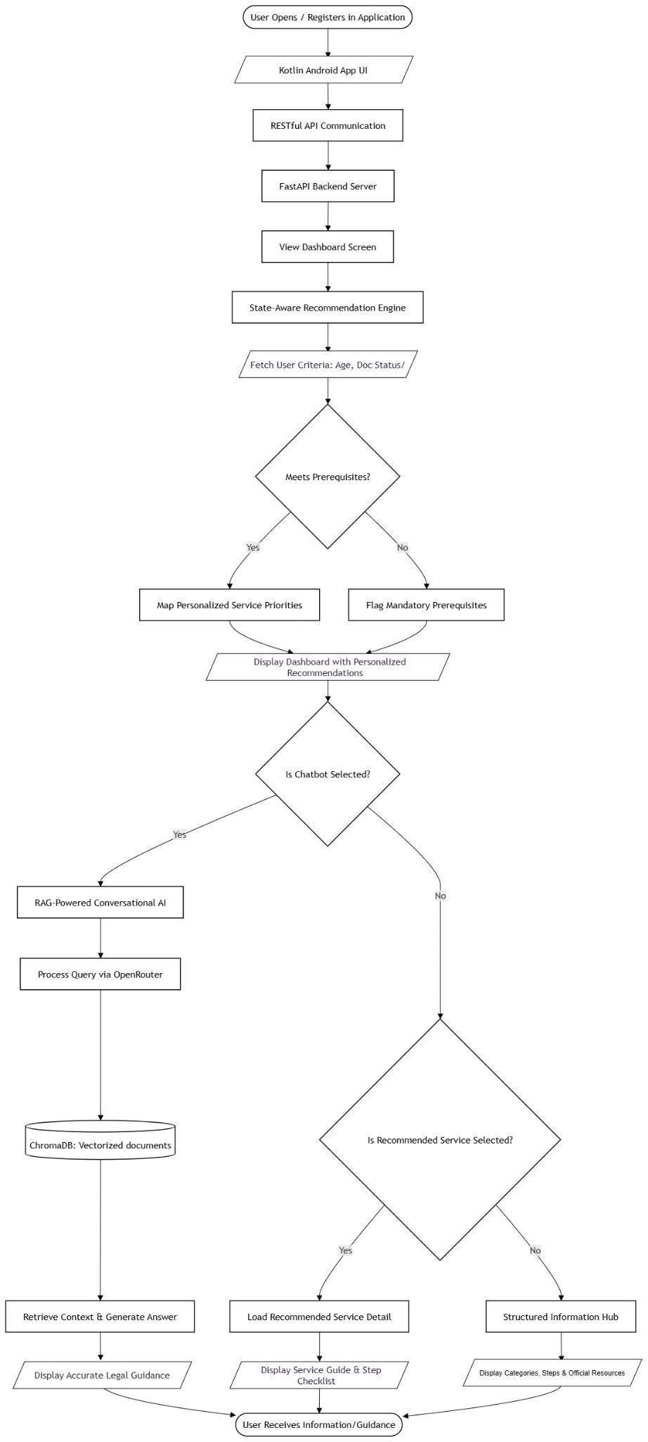
Figure 2.1: Proposed solution workflow diagram for EasyGov platform.

2.4 Alternate Solution Strategy
- Pure Rule-Based Chatbot: Evaluated and rejected because keyword-matching arrays cannot interpret natural language variations or conversational context, making the system highly brittle and labor-intensive to maintain.
- Fine-Tuned LLM Model: Considered but rejected due to high retraining costs whenever local civic regulations change, alongside a high risk of generating untrustworthy hallucinations rather than strictly anchored factual text.
- Knowledge Graph with SPARQL Queries: Rejected because modeling every single bureaucratic rule into an intricate graph framework is excessively time-intensive and fundamentally lacks the natural language dialogue flexibility required by standard users.
- Web-Only Streamlit Prototype: Considered for fast RAG model testing but discarded in favor of a native Android application from day one, ensuring a real-world, accessible mobile interface tailored to the daily habits of Nepalese citizens.

2.5 Comparative System
Table 2.1: Comparative system analysis and strategic trade-offs.
System | Strengths | Limitations / Strategic Trade-offs
1. Nepal Nagarik App | • Massive user base (~1M users)  • Central repository for digital identity (Passport, Citizenship, PAN)  • Handles basic data fetching & one-off service requests | • Assumes an expert user  • No instructional guidance  • Assumes prior knowledge of prerequisites & bureaucratic dependencies
2. Individual Government Portals (e.g., Dept. of Passports) | • Authoritative systems of record  • Direct handling of online booking, biometric scheduling, & data entry | • Highly siloed architecture  • Prerequisites scattered across poorly formatted PDFs  • Severe usability defects & lack of cross-departmental coordination
3. Generic LLM Chatbots | • Excellent natural language processing  • Highly intuitive, conversational flows | • Decoupled from local state realities  • High hallucination risks  • Lacks real-time updates on procedural shifts  • Severe data sovereignty & PII risks
4. EasyGov (Proposed System) | • The Paradigm Shift: Bridges LLM conversational ease with authorized government accuracy using a robust RAG pipeline  • Mobile-first, dependency-aware framework to guide users step-by-step | • Strategic Trade-offs: Initial release is constrained to a passport-first phase covering a narrow subset of four deeply mapped services

3. System Analysis and Design

3.1 Use Case Diagram
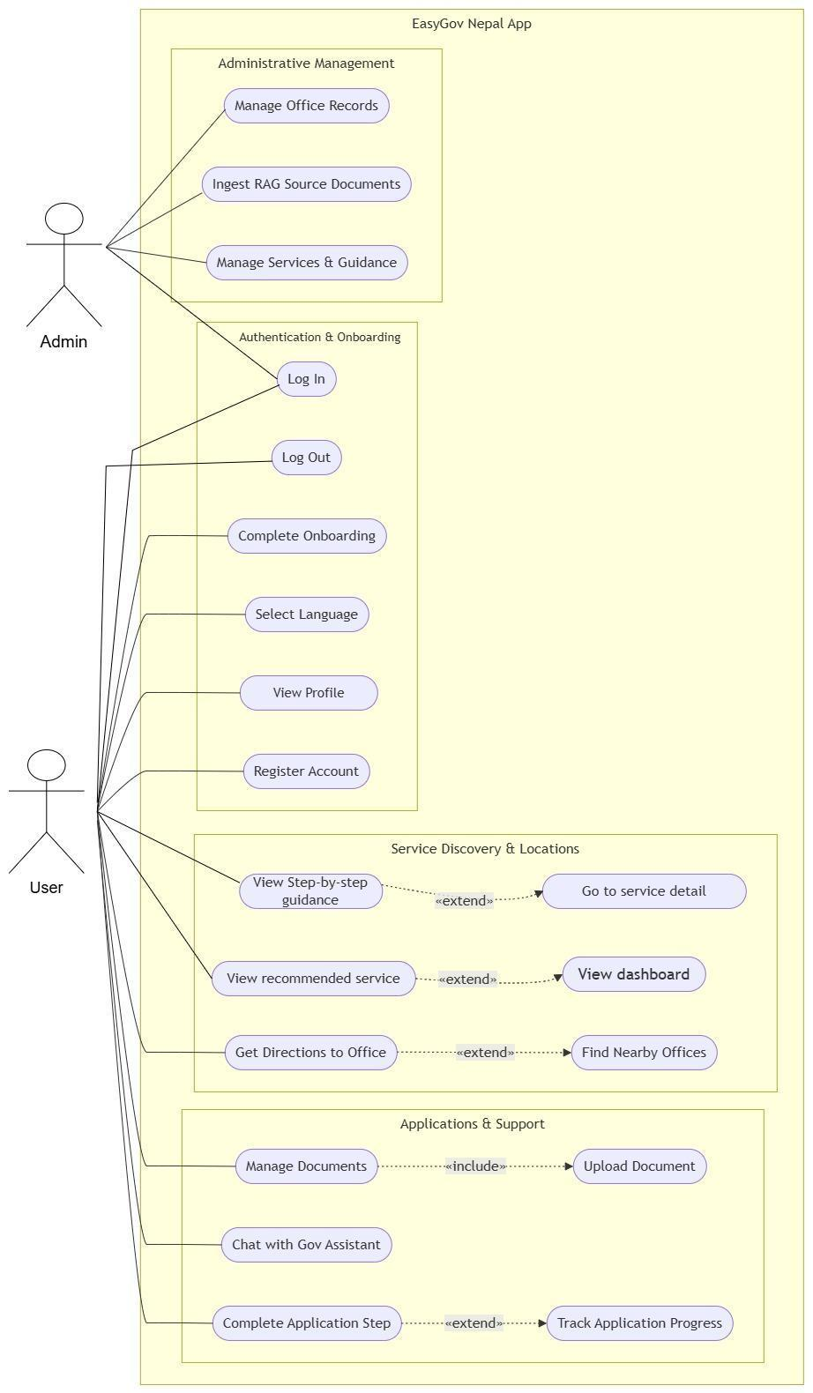
Figure 3.1: Use case diagram for the EasyGov system.

3.2 Class Diagram
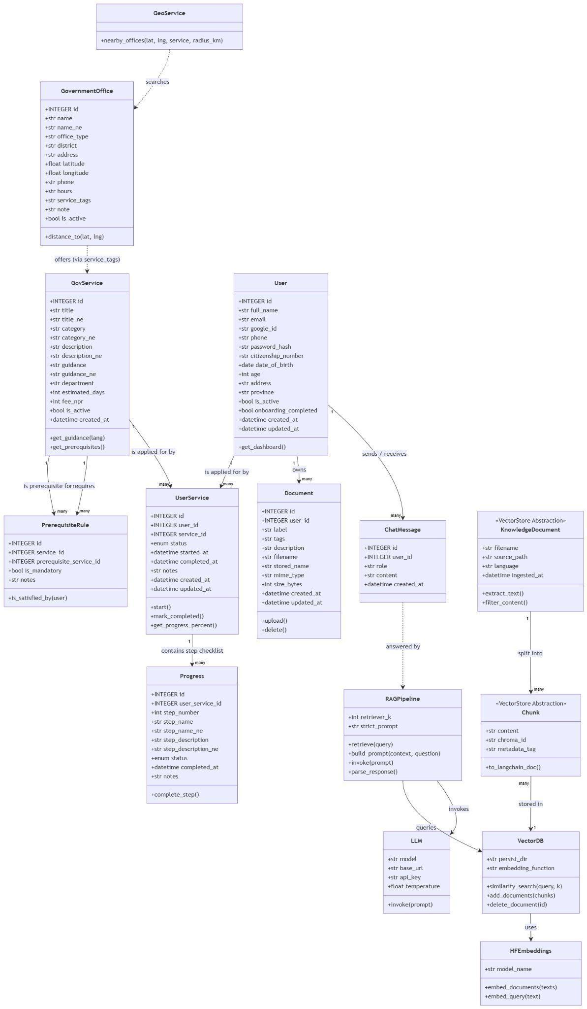
Figure 3.2: Class diagram for EasyGov backend and mobile architecture.

3.3 Entity Relationship Diagram (ERD)
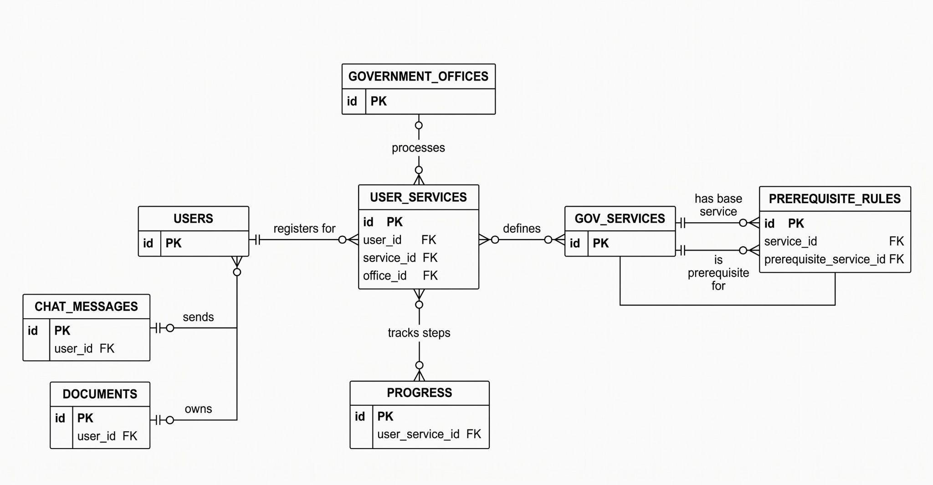
Figure 3.3: Entity relationship diagram for the EasyGov database schema.

3.4 Database Schema Diagram
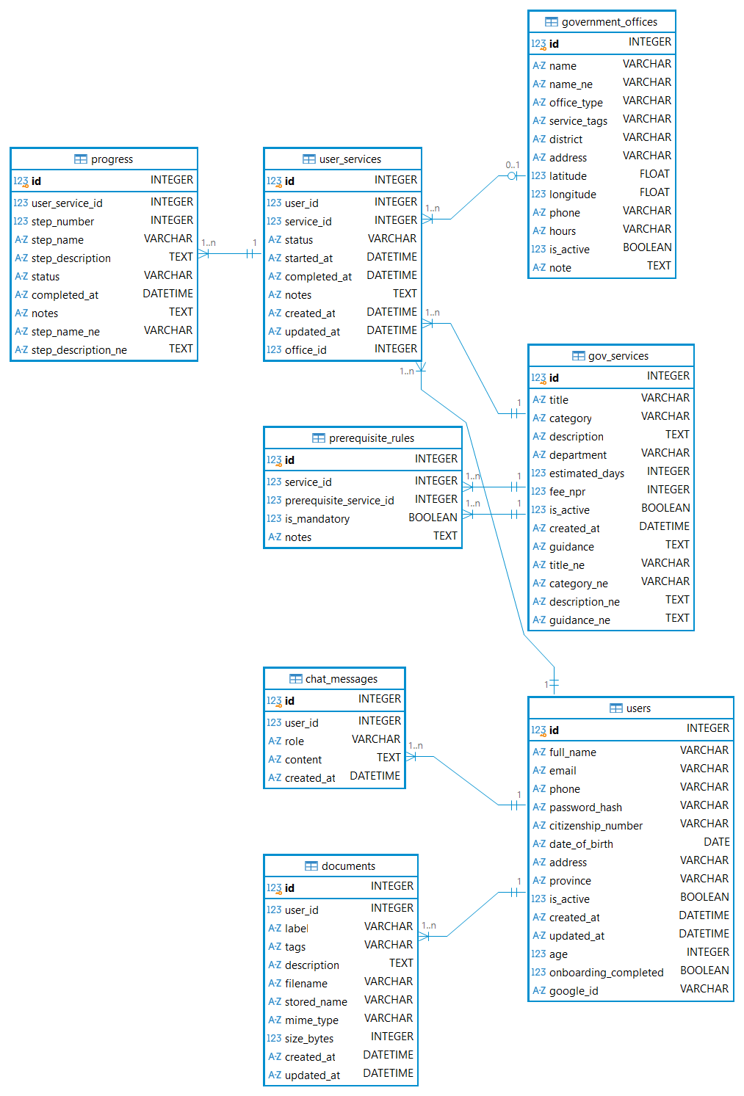
Figure 3.4: Physical database schema diagram for EasyGov .

3.5 Sequence Diagram

3.5.1 Admin Ingestion Sequence Diagram

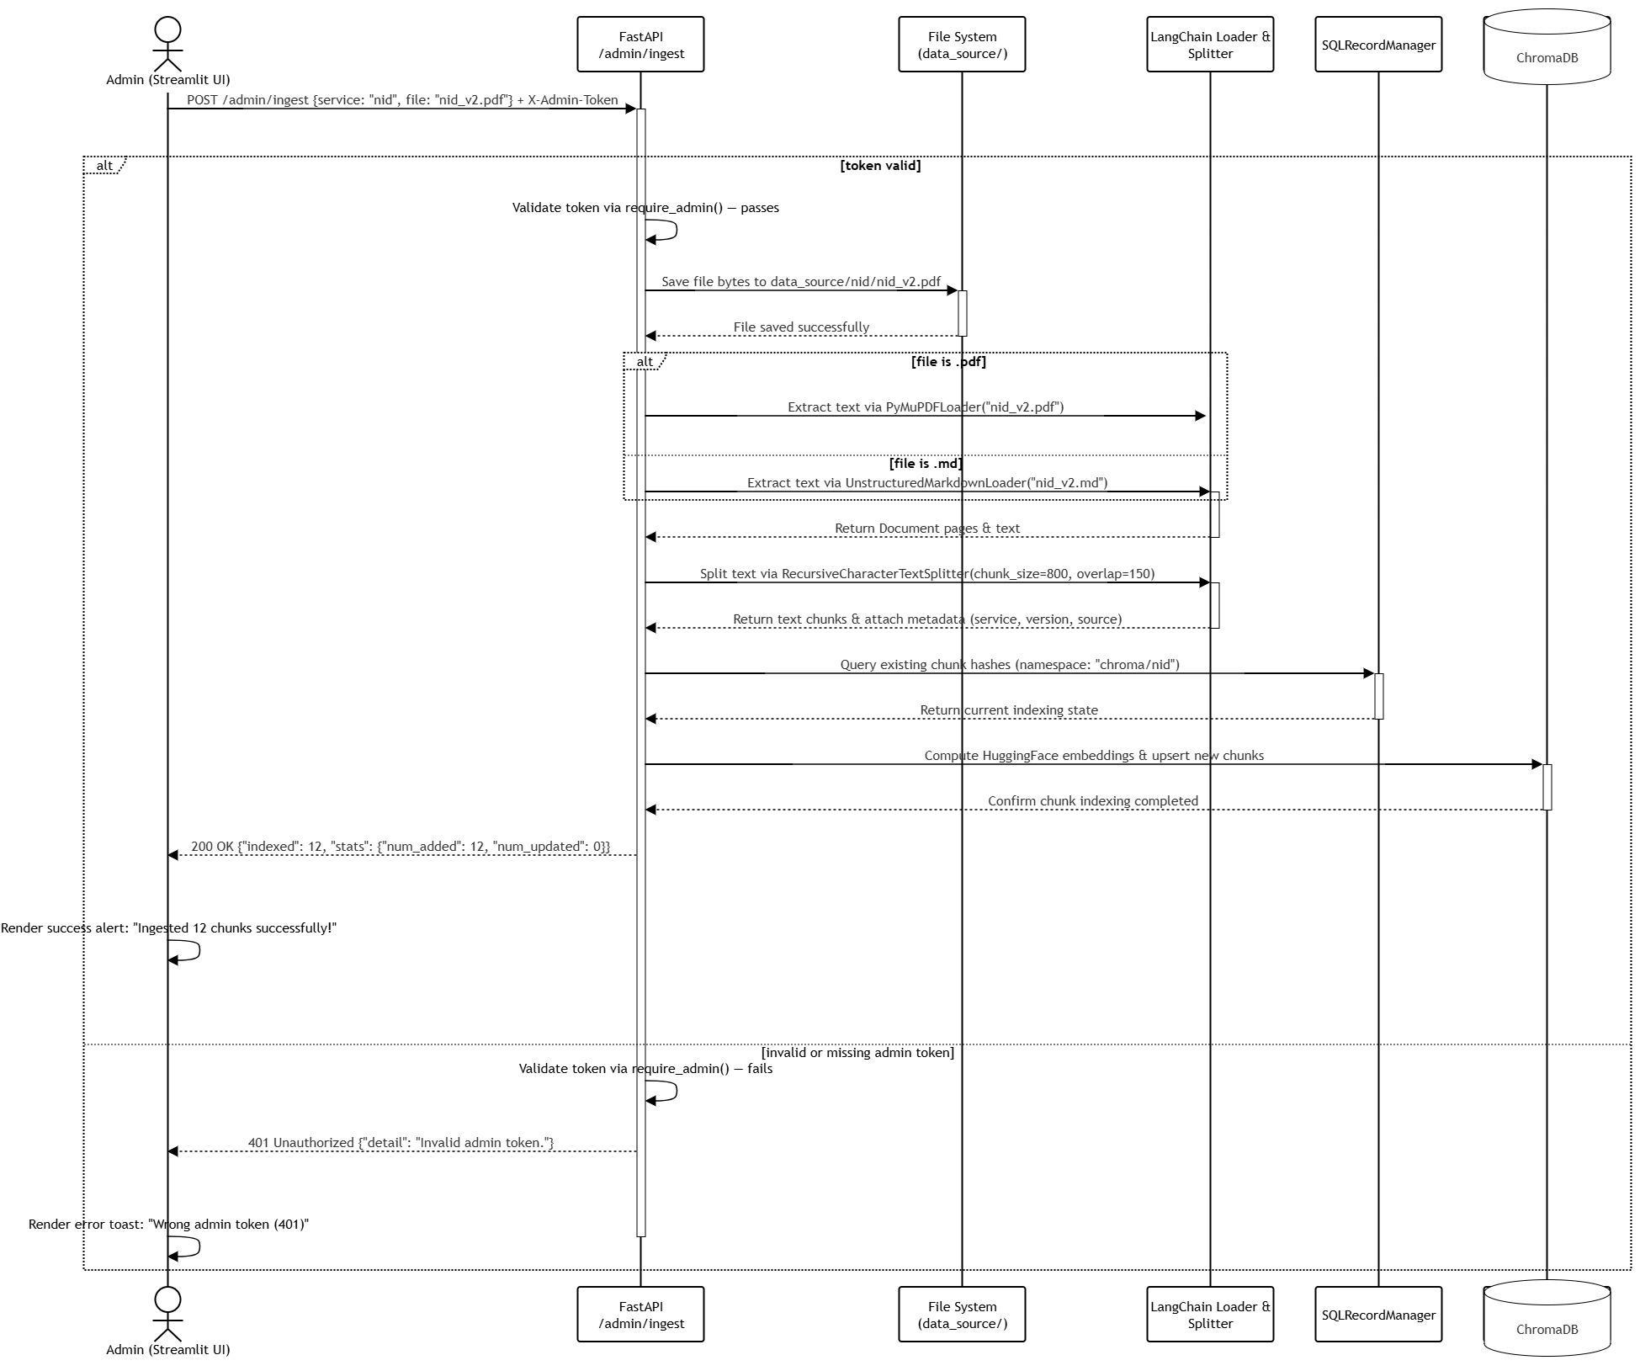
Figure 3.5: Sequence diagram for admin knowledge ingestion workflow.

3.5.2 State-Aware Recommendation Sequence Diagram

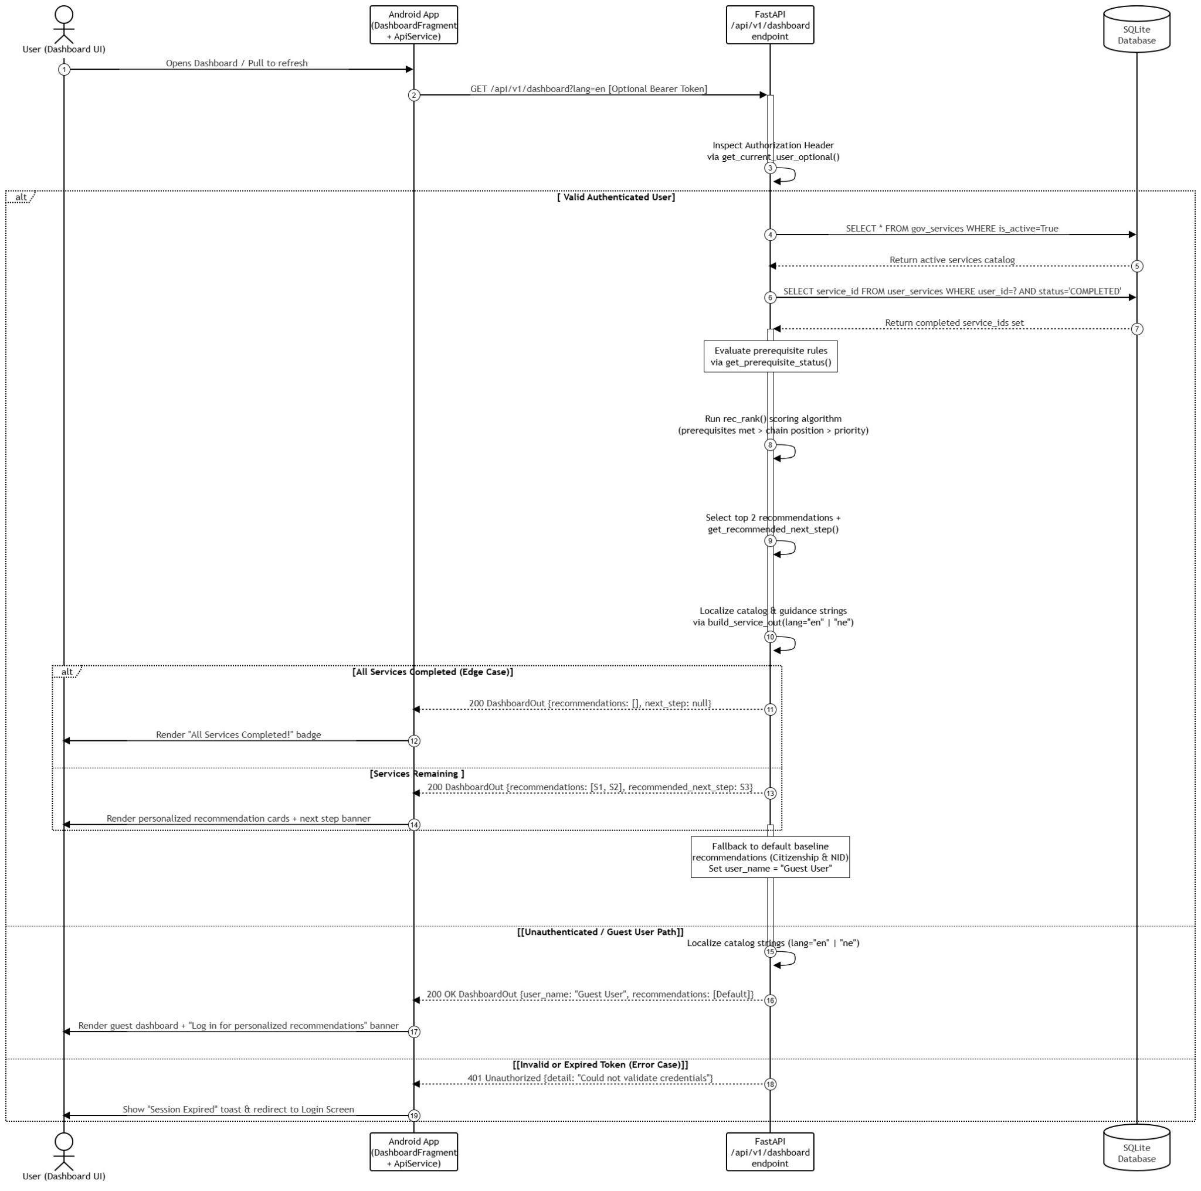
Figure 3.6: Sequence diagram for state-aware procedural recommendation workflow.

3.5.3 RAG Conversational AI Sequence Diagram

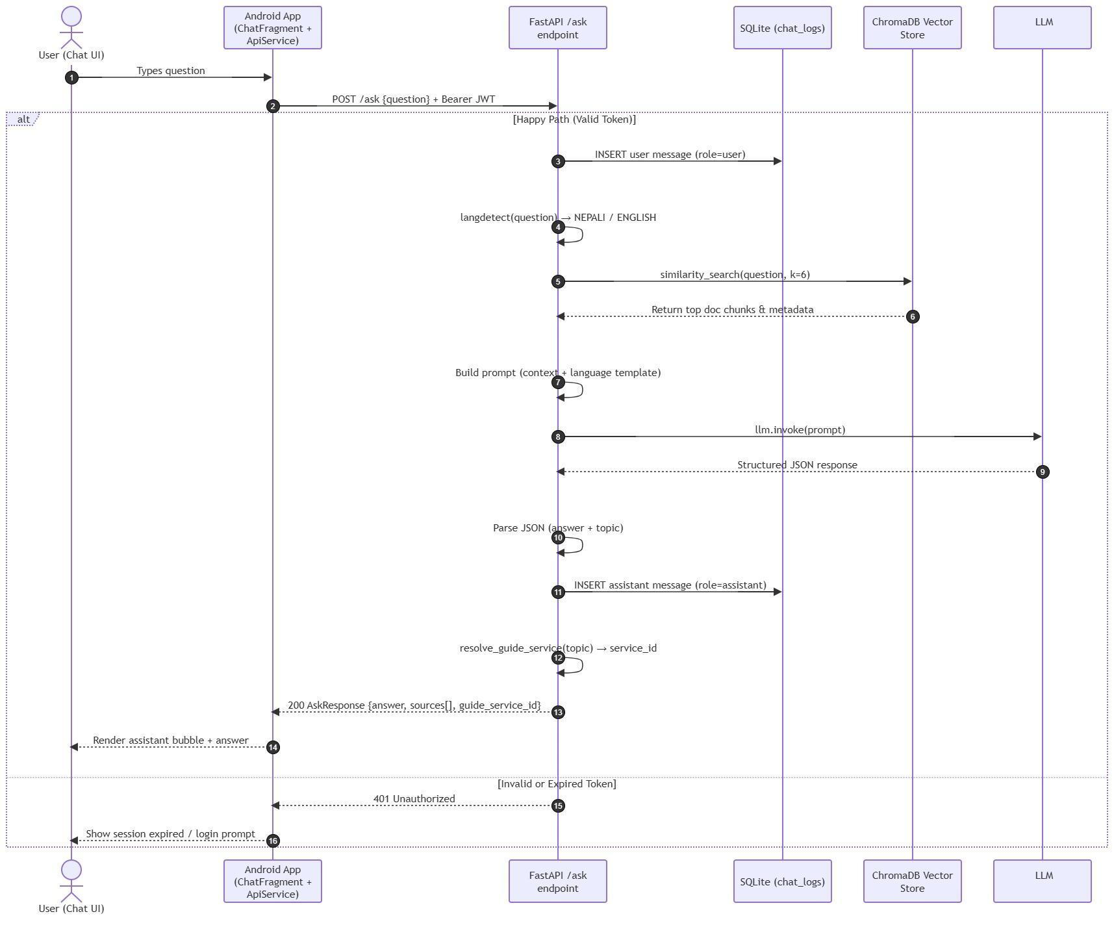
Figure 3.7: Sequence diagram for multilingual RAG conversational assistant workflow.

3.5.4.Recommendation Sequence Diagram



3.6 System Architecture Diagram
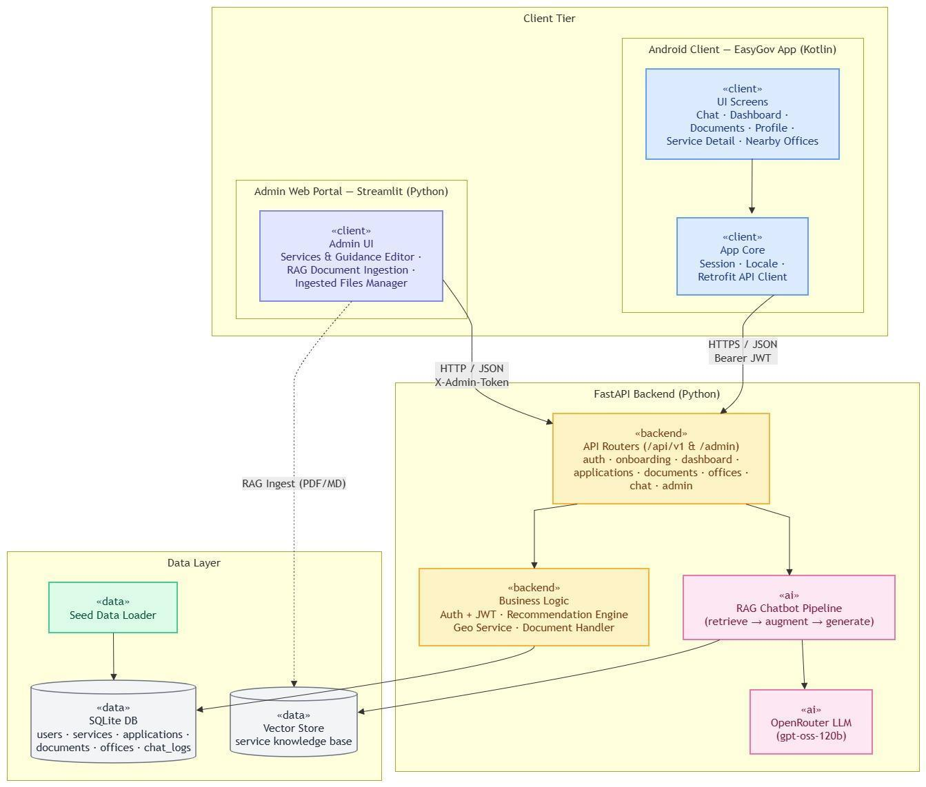
Figure 3.8: Three-tier system architecture overview of EasyGov platform.

3.7 Activity Diagrams

3.7.1 Login and Authentication Activity Diagram

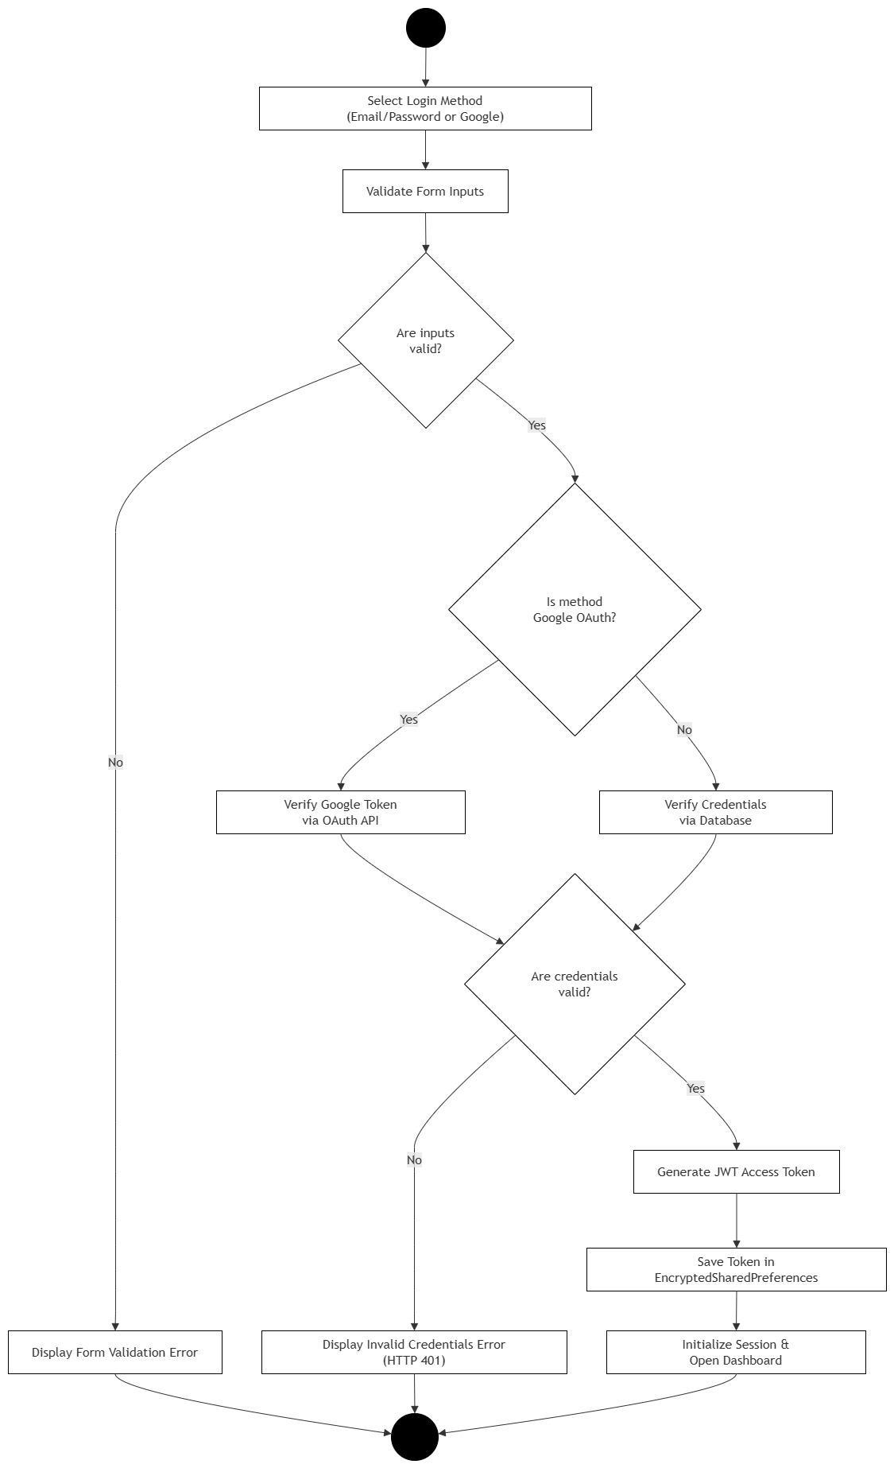
Figure 3.9: Activity diagram for user login and authentication workflow.

3.7.2 Progress Tracking Activity Diagram
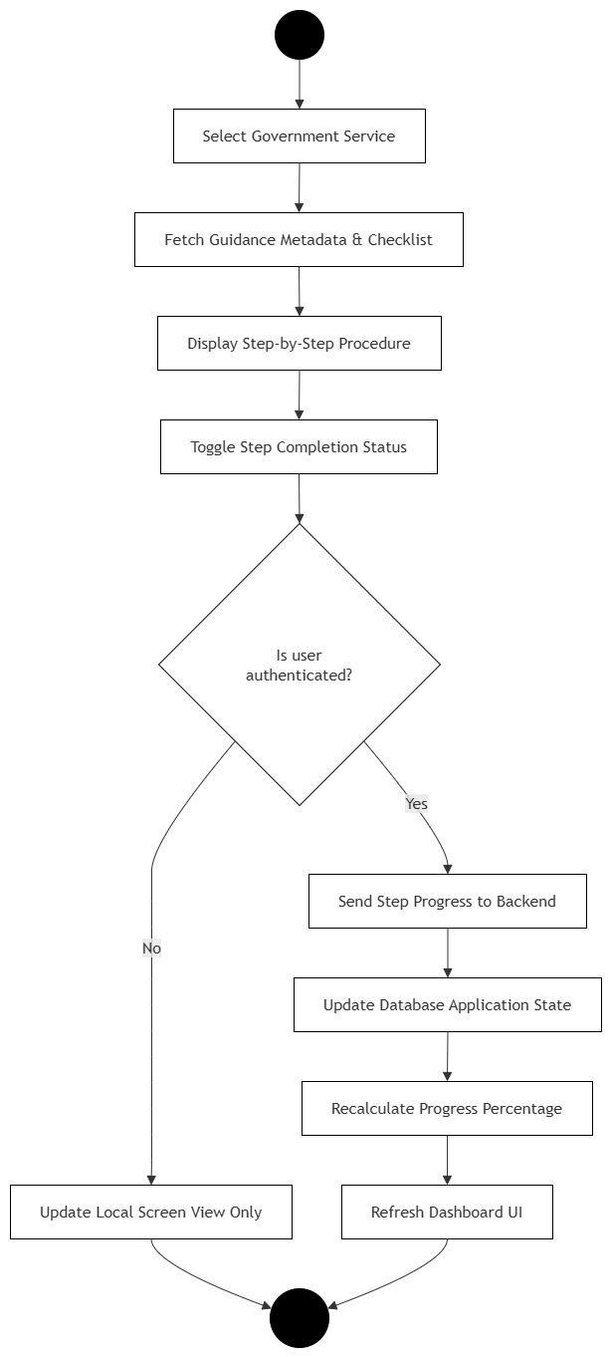
Figure 3.10: Activity diagram for user progress tracking workflow.

3.7.3 Admin Knowledge Management Activity Diagram
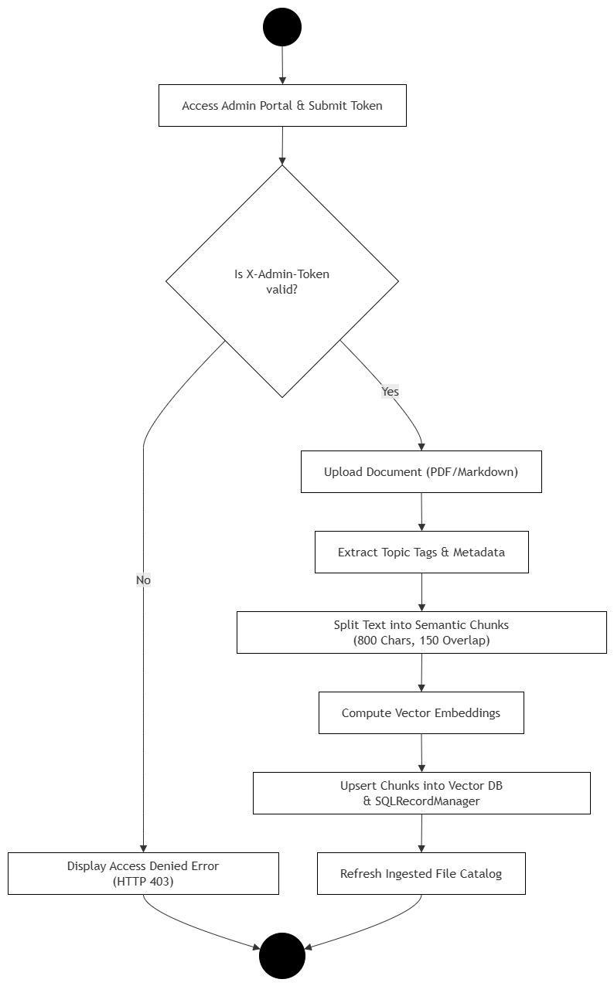
Figure 3.11: Activity diagram for administrative knowledge management workflow.

3.7.4 RAG Conversational AI Activity Diagram
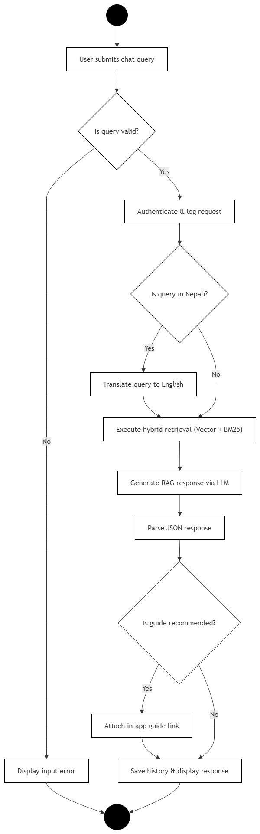
Figure 3.12: Activity diagram for RAG conversational AI query processing.

3.7.Algorithm Implemented
The core intelligence of EasyGov is powered by a dual-engine algorithmic architecture designed to address both semantic information retrieval and procedural navigation in public administration. To deliver accurate, source-grounded guidance, the platform integrates an Advanced Retrieval-Augmented Generation (RAG) pipeline. Operating in tandem with this conversational layer is a deterministic, state-aware recommendation system that maps legal prerequisites to guide citizens through sequential public service milestones.

3.7.1. Retrieval-Augmented Generation (RAG) Pipeline
Retrieval-Augmented Generation (RAG) combines semantic document retrieval with Large Language Models (LLMs). Rather than relying on an LLM’s static parametric memory, relevant context is retrieved from an external knowledge base of official government handbooks and provided to the model during response generation.
Why RAG is Used in EasyGov
Government procedural guidance demands factual accuracy, currency, and auditability. General-purpose LLMs can produce hallucinations, lack specialized knowledge of Nepalese administrative laws, and suffer from knowledge cut-offs. RAG eliminates these limitations by grounding answers in authoritative government publications and providing links to the sources. Furthermore, when fees, guidelines, or quotas change, the knowledge base can be updated independently without costly LLM retraining.
Why RAG Was Chosen Over Alternatives
A standalone LLM was rejected due to hallucination risks and a lack of source traceability. Fine-tuning was discarded because retraining is computationally expensive whenever civic regulations change. RAG provides a maintainable architecture by decoupling knowledge storage from generative reasoning.

3.7.1.1.Mathematical formulation of Advanced Retrieval-Augmented Generation (RAG)
The Advanced RAG pipeline integrates cross-lingual embedding, metadata filtering, hybrid retrieval, relevance thresholding, prompt assembly, and deterministic citation resolution to improve retrieval relevance, response grounding, and source traceability.
Query Embedding and Language Transformation
For a user query qq, the system optionally transforms the query into an English representation for cross-lingual processing:
qen=Tlang(q)q_{en}=\mathcal{T}_{lang}(q)
The transformed query is then converted into a 384-dimensional embedding using the multilingual embedding model:
vq=E(qen)∈R384v_q=E(q_{en})\in\mathbb{R}^{384}
where EE represents the embedding function.
Metadata Filtering and Hybrid Retrieval
The knowledge base is represented as a collection of document chunks:
D={d1,d2,…,dN}D=\{d_1,d_2,\ldots,d_N\}
Each document chunk consists of its textual content and associated metadata:
di=(ci,mi)d_i=(c_i,m_i)
where cic_i is the chunk content and mim_i contains metadata such as service, version, and source.
Semantic relevance is calculated using cosine similarity:
Sim(vq,vdi)=vq⋅vdi∥vq∥∥vdi∥Sim(v_q,v_{d_i})= \frac{v_q\cdot v_{d_i}} {\|v_q\|\|v_{d_i}\|}
The system combines lexical retrieval with vector-based semantic retrieval:
Rk=TopK(Lex(q,k)∪VectorSearch(vq,k))R_k= TopK\left( Lex(q,k)\cup VectorSearch(v_q,k) \right)
The retrieval depth is configured as k=6k=6 for English queries and k=12k=12 for Nepali queries.
Relevance Thresholding
To prevent generation from unrelated or insufficiently relevant documents, the retrieved results are subjected to a relevance gate.
The maximum semantic similarity among retrieved documents is calculated as:
MaxSim=max⁡d∈RkSim(vq,vd)MaxSim=\max_{d\in R_k}Sim(v_q,v_d)
A relevance threshold τr=0.70\tau_r=0.70 is applied:
Generation={Proceed,MaxSim≥τrFallback Response,MaxSim<τrGeneration= \begin{cases} \text{Proceed}, & MaxSim\geq\tau_r\\ \text{Fallback Response}, & MaxSim<\tau_r \end{cases}
If the retrieved context does not meet the threshold, the system returns an out-of-scope response rather than generating an answer from insufficient evidence.
Context Assembly and Response Generation
The retrieved document contents are concatenated to form the context supplied to the language model:
Ctx=⨁d∈Rktext(d)Ctx=\bigoplus_{d\in R_k}text(d)
The final prompt is constructed using the retrieved context and the original query:
P=P(Ctx,q)P=P(Ctx,q)
The LLM then generates the answer and identifies the relevant service topic:
y=(ans,τt)=LLM(P(Ctx,q))y=(ans,\tau_t)=LLM(P(Ctx,q))
where ansans represents the generated answer and τt\tau_t represents the identified topic. The topic may correspond to Passport, NID, Citizenship, Driving Licence, Business Registration, PAN, or a null value when no applicable topic is identified.
Deterministic Citation Resolution
After generation, the system performs deterministic post-processing to associate the response with an official source. The selected source is defined as:
s=S(y,Rk)={Mofficial(τt),τt∈Dom(Mofficial)d(1).source,Rk≠∅∅,otherwises=S(y,R_k)= \begin{cases} M_{official}(\tau_t), & \tau_t\in Dom(M_{official})\\ d_{(1)}.source, & R_k\neq\emptyset\\ \emptyset, & \text{otherwise} \end{cases}
where MofficialM_{official} represents the mapping between recognised service topics and their corresponding official sources.
The final response is therefore represented as:
Rout=(ans,[s]s≠∅)R_{out}=(ans,[s]_{s\neq\emptyset})
This ensures that a source attribution is attached to the generated response whenever a valid source is available.
Overall Processing Flow
The complete Advanced RAG pipeline can be represented as:
q→Embedding→Hybrid Retrieval→Relevance Gate→Context Assembly→LLM→Citation Resolution→Routq \rightarrow Embedding \rightarrow Hybrid\ Retrieval \rightarrow Relevance\ Gate \rightarrow Context\ Assembly \rightarrow LLM \rightarrow Citation\ Resolution \rightarrow R_{out}
This architecture separates knowledge retrieval, relevance validation, response generation, and source attribution, allowing the knowledge base to be updated independently of the underlying language model.

3.7.1.2.Pseudocode:
Algorithm: GenerateAnswer

Input:
q ← User Query

Output:
Response ← Answer Payload containing text, sources, and context_used

1. q ← GetUserQuery(request)

2. query_lang ← DetectLanguage(q)

3. IF query_lang = "ne" THEN
answer_lang ← "NEPALI"
ELSE
answer_lang ← "ENGLISH"
END IF

4. IF query_lang = "ne" THEN
k ← MULTILINGUAL_RETRIEVER_K
ELSE
k ← RETRIEVER_K
END IF

5. IF query_lang = "ne" THEN
qr ← TranslateToEnglish(q)
ELSE
qr ← q
END IF

6. Docs ← HybridRetrieve(qr, k)

7. Sources ← ExtractUniqueSources(Docs)

8. Context ← JoinChunkTexts(Docs)

9. Prompt ← AssemblePrompt(Context, q, answer_lang)

10. RawAnswer ← LLM(Prompt)

11. ParsedAnswer ← ParseJSON(RawAnswer)

12. IF ParsedAnswer.answer is empty THEN
AnswerText ← RawAnswer
ELSE
AnswerText ← ParsedAnswer.answer
END IF

13. Topic ← ParsedAnswer.topic

14. GuideService ← ResolveGuideService(Topic)

15. Response ← BuildAskResponse(
ParsedAnswer,
Sources,
GuideService
)

16. RETURN Response

3.8.1.3 Advanced RAG Pipeline Execution Flowchart
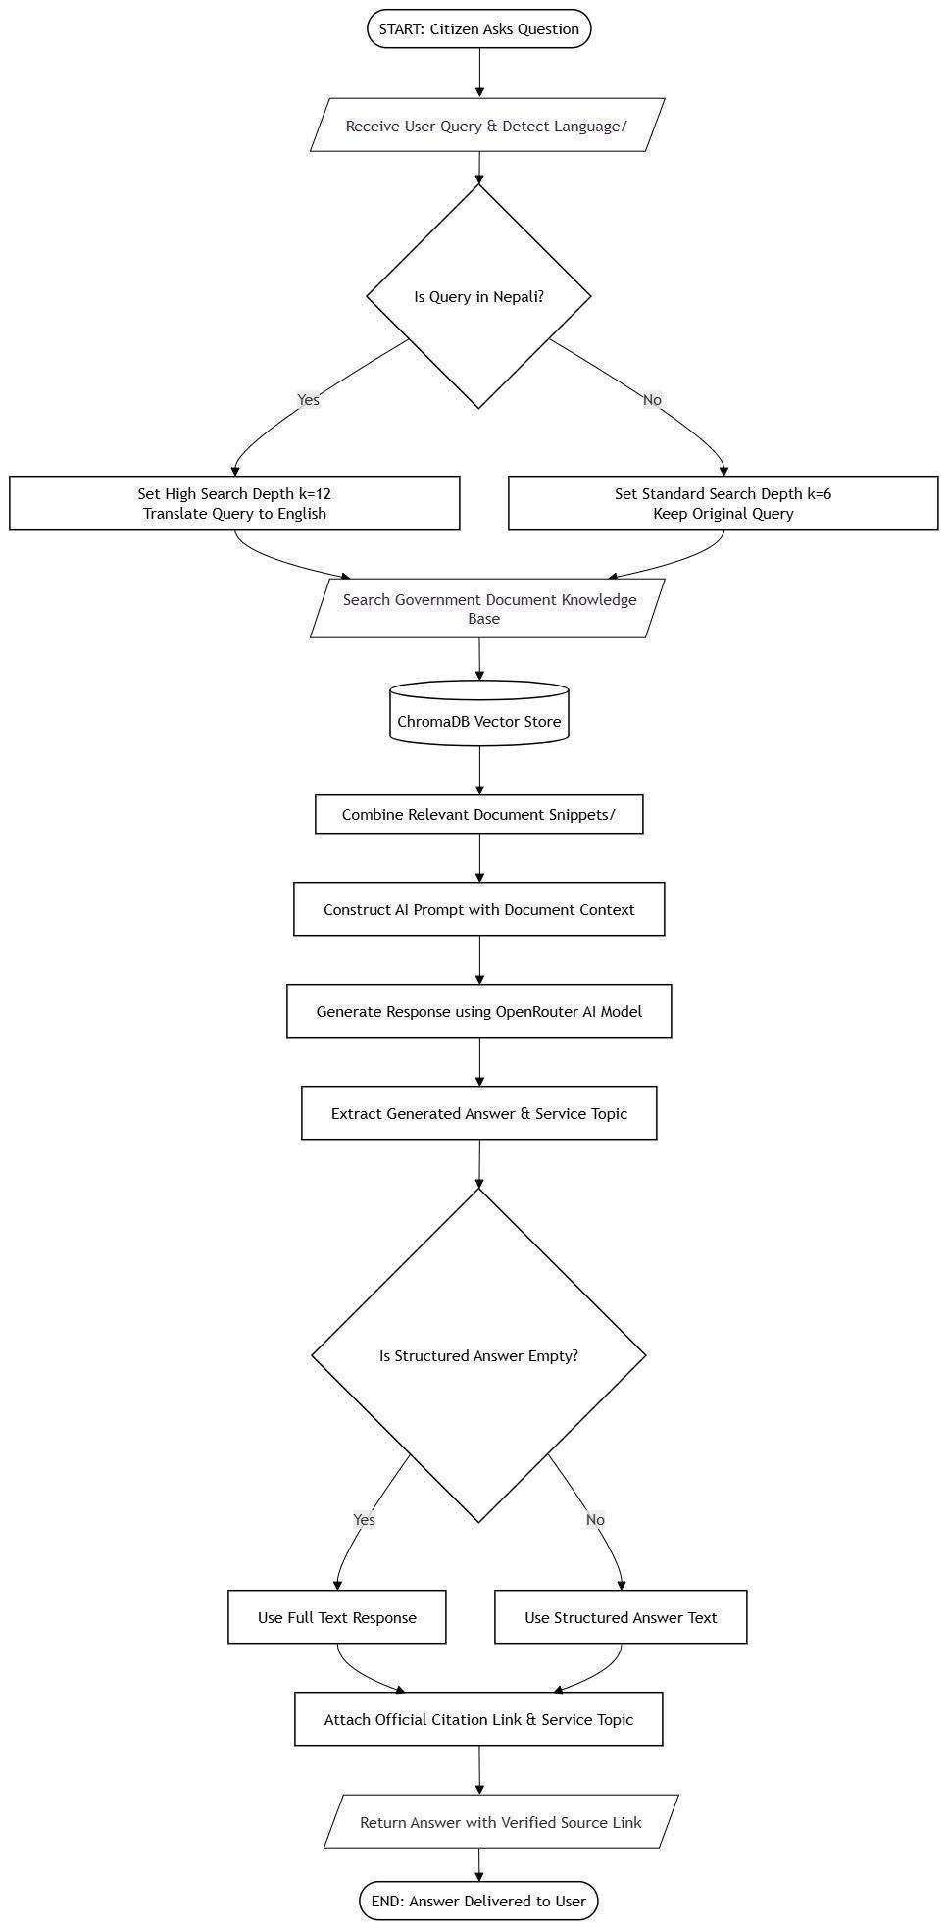
Figure 3.13: Advanced RAG pipeline execution flowchart.

3.7.2. State-Aware Procedural Recommendation Engine
The State-Aware Recommendation Engine models statutory document dependencies to guide users through sequential public service workflows based on their verified profile state.
Why Used in EasyGov
Government services in Nepal are hierarchically chained (e.g., obtaining an E-Passport legally requires an NID and Citizenship Certificate). Flat service lists do not communicate these constraints, leading to invalid applications and office rejections. EasyGov tracks citizen documentation status against a deterministic graph, dynamically generating personalized priority queues and displaying a "Recommended Next Step" on the dashboard and check if one can proceed with a service based on their profile atrributes.
Why Chosen Over Alternatives
- Collaborative Filtering / ML Models: Rejected because public service eligibility is governed by legal statutes rather than popular user trends. Probabilistic models risk recommending services for which a user is legally ineligible.
- Ad-Hoc Lookup Tables: Inadequate for resolving transitive dependencies across multi-step user onboarding.
A deterministic, state-aware procedural engine provides 100% explainability, legal alignment, and cold-start robustness.

3.7.2.1. Mathematical Formulation
Administrative navigation is modeled as a directed dependency graph G=(V,E), where V represents government services S={s1,s2,…,sn} and a directed edge (si,sj)∈E indicates that service sj is a mandatory prerequisite for si.
- Transitive Prerequisite Resolution:
Let C⊆S be the set of completed user services. Transitive closure C∗ is computed as: C∗=C∪{sj∈S∣∃si∈C∗ such that (si,sj)∈E}
- Prerequisite Status Evaluation:
For candidate service s∈S∖C∗, direct prerequisites are P(s)={p∈S∣(s,p)∈E}. Status is evaluated as: met(s)={1if P(s)⊆C∗0otherwise,missing(s)=P(s)∖C∗
- Deterministic Candidate Ranking:
Candidates are sorted in ascending lexicographical order using ranking tuple R(s): R(s)=(1−met(s),pos(s,CHAIN),prio(s),title(s)) where default progression chain CHAIN=[Citizenship→NID→Passport→Driving License].

3.7.2.2. Pseudocode:
Input : Database session db, User u, Service Catalogue S, Progression Chain CHAIN
Output : Dashboard Output (Prerequisite Status, Top 2 Recommendations, Recommended Next Step)
1: C <- GetCompletedServiceIDs(db, u)
2: C_star <- ResolveCompletedTitles(db, C) // Transitive prerequisite graph resolution
3: Candidates <- []
4: for each service s in S do
5: rules <- GetMandatoryPrerequisites(db, s.id)
6: missing <- [r.prerequisite_title for r in rules if r.prerequisite_id not in C_star]
7: s.prerequisites_met <- (length(missing) == 0)
8: s.missing_prerequisites <- missing
9: if s.id not in C_star then
10: Candidates.append(s)
11: end if
12: end for
13: Define RecRank(s):
14: met_score <- 0 if s.prerequisites_met else 1
15: chain_pos <- IndexOf(s.title, CHAIN) if s.title in CHAIN else Length(CHAIN)
16: prio <- 0 if ("Passport" in s.title or "NID" in s.title) else 1
17: return (met_score, chain_pos, prio, s.title)
18: SortedCandidates <- Sort(Candidates, key=RecRank)
19: TopRecommendations <- SortedCandidates[0:2]
20: RecommendedNextStep <- First s in CHAIN where s.id not in C_star and s.prerequisites_met
21: return BuildDashboardResponse(S, TopRecommendations, RecommendedNextStep)

3.8.2.3 State-Aware Recommendation Decision Flowchart

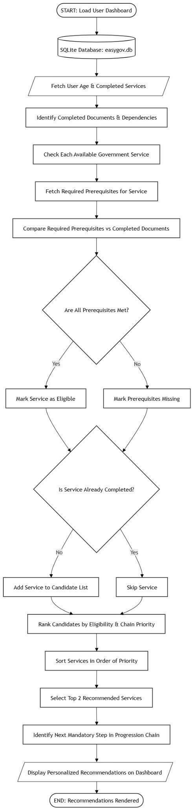
Figure 3.14: State-aware recommendation decision flowchart.

3.8.Wireframes

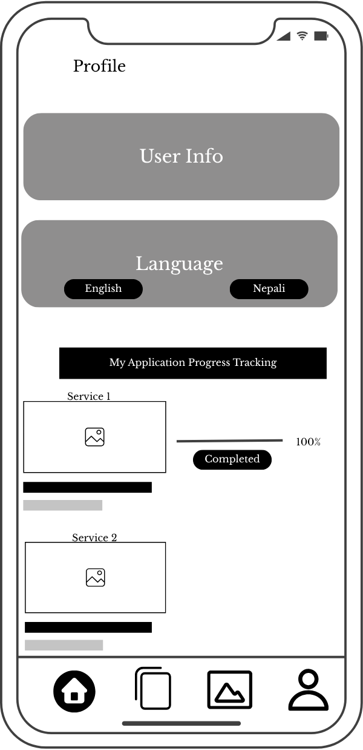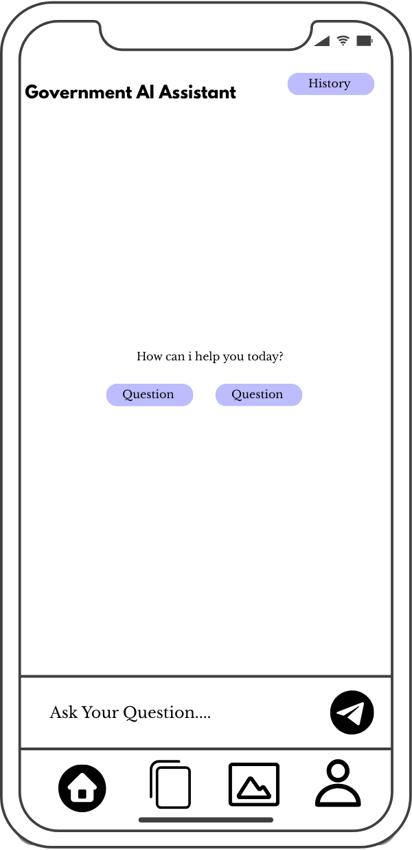
.
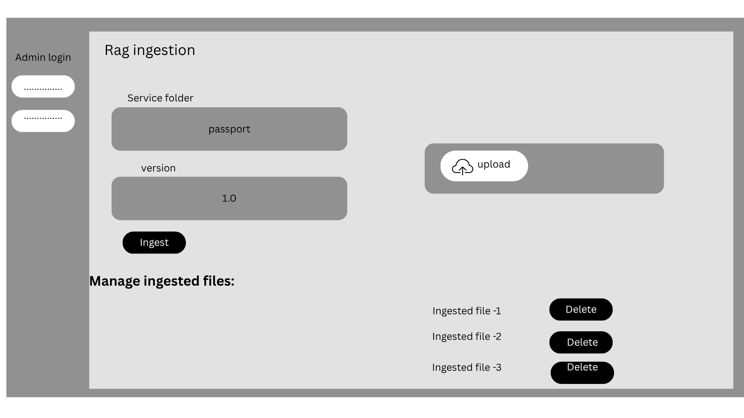

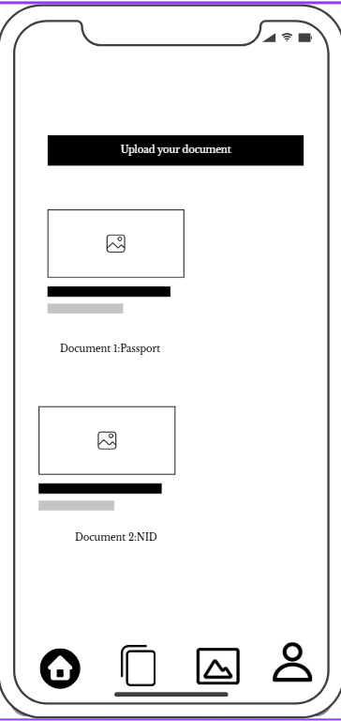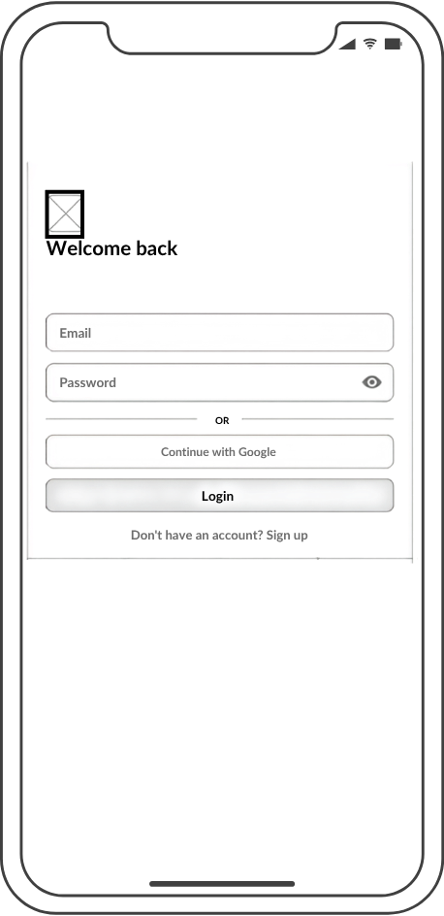
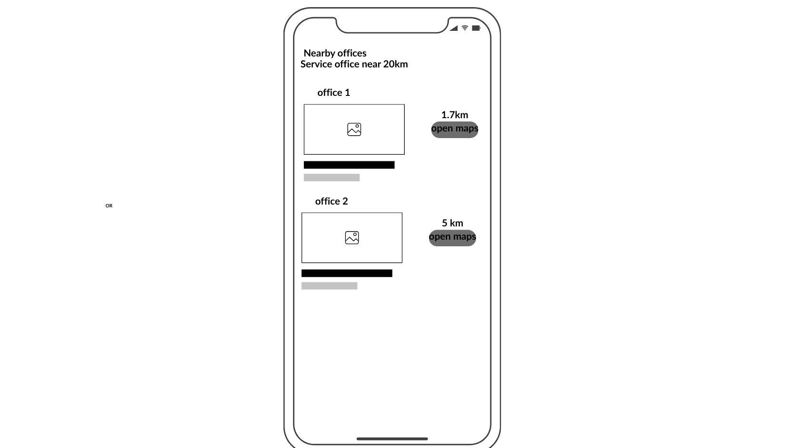

3.9.Mockups
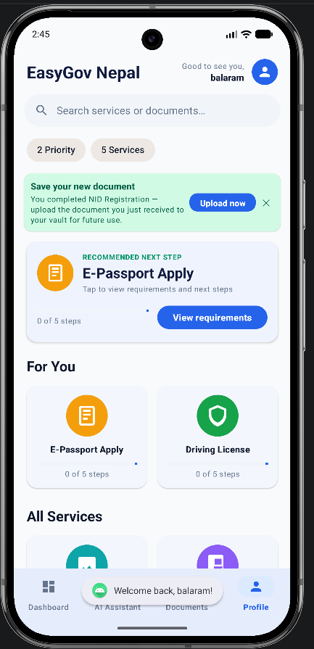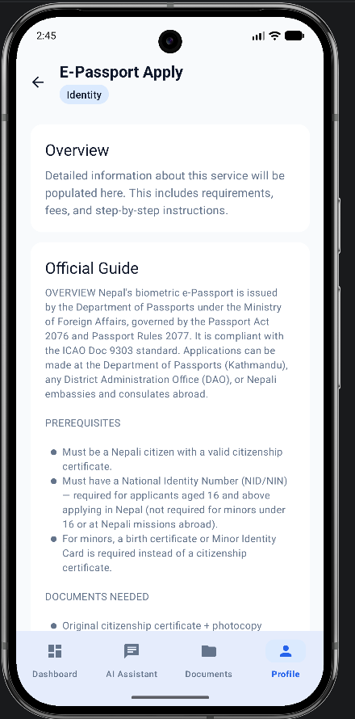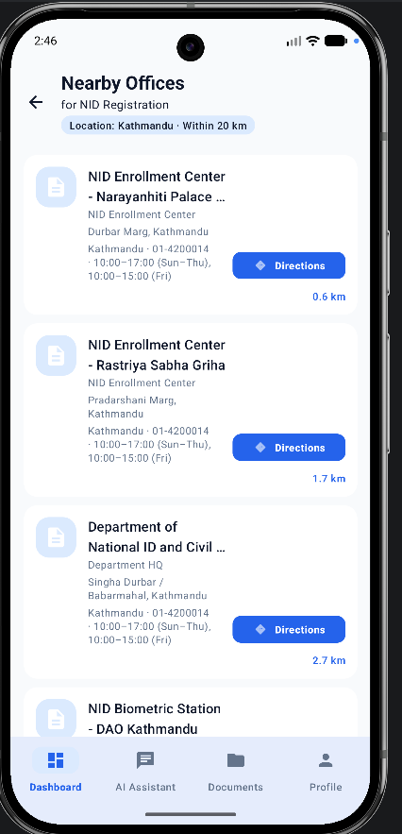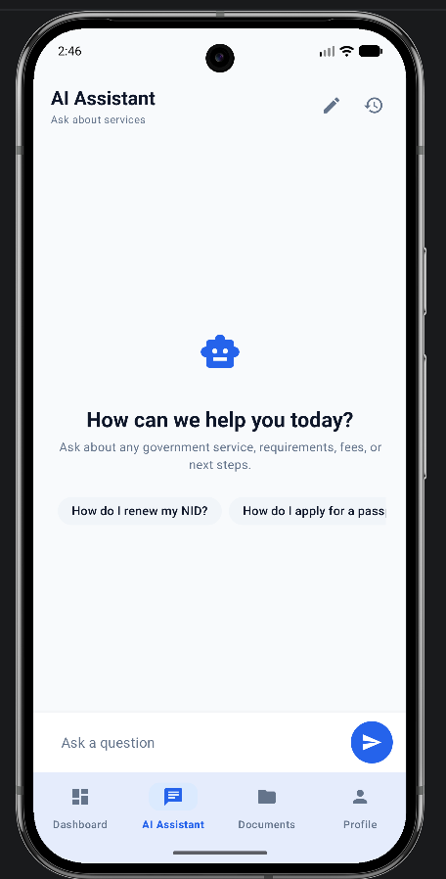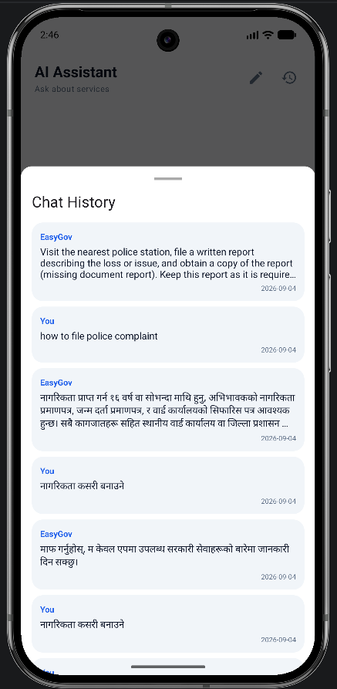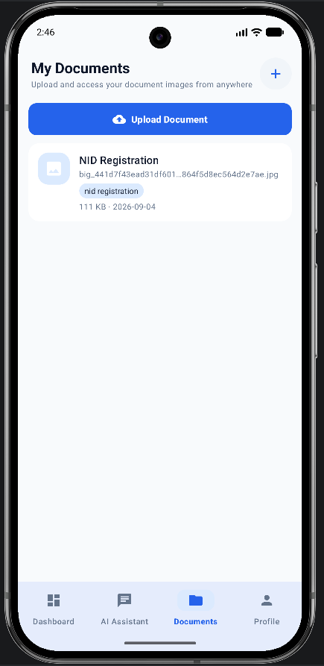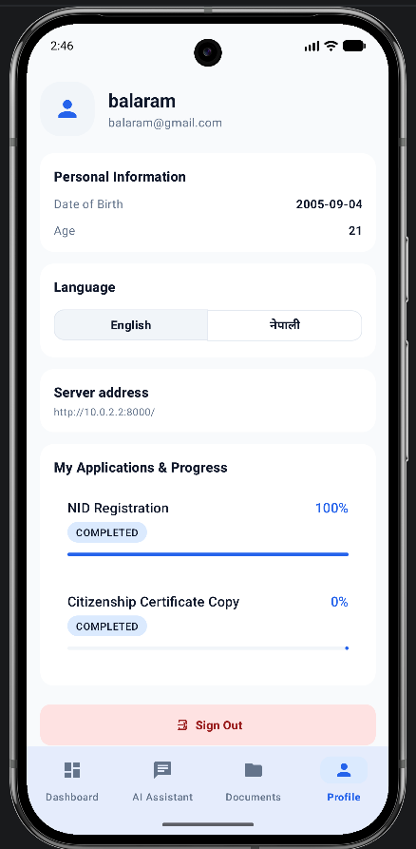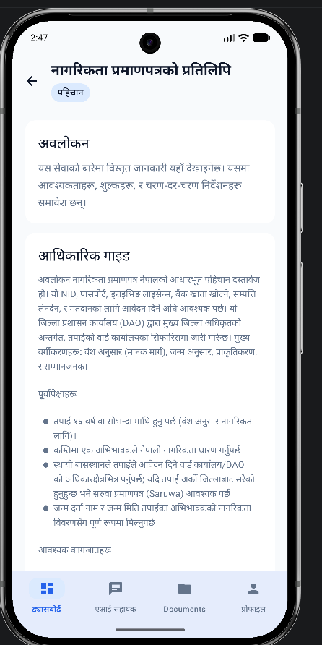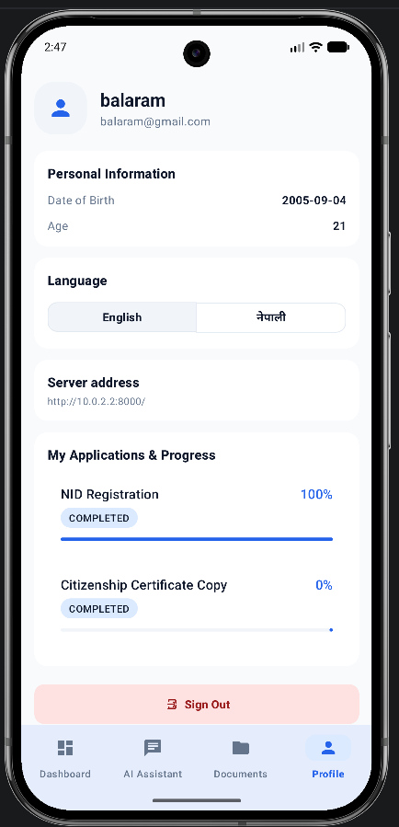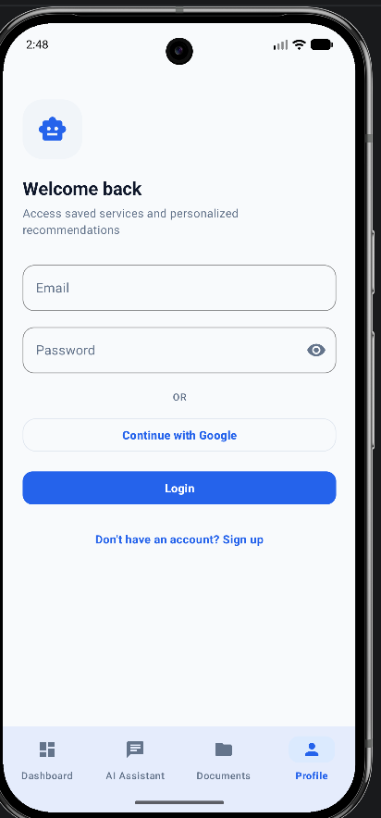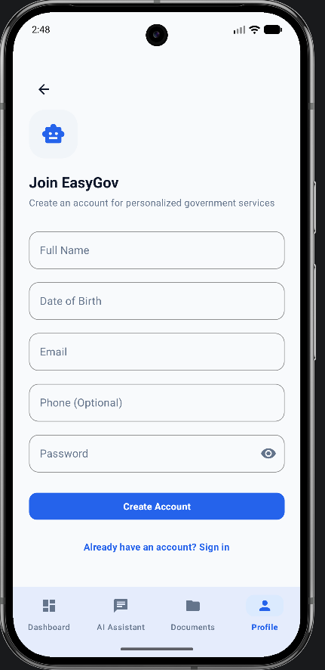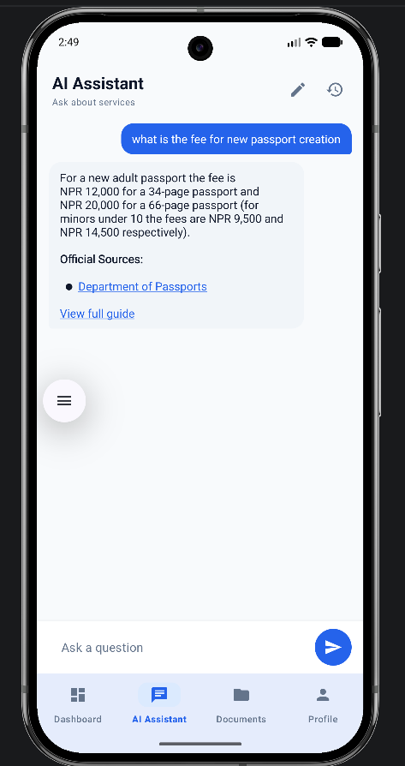

4. Requirement Specification

4.2.Functional Requirements (FR)
- FR-01 (User Authentication & Session Management):
The system shall allow citizens to register, authenticate (log in), and manage secure session states using JSON Web Tokens (JWT).
- FR-02 (State-Aware Profile Onboarding):
The system shall capture user demographic attributes and existing document ownership status during onboarding to construct an initial user state profile.
- FR-03 (Prerequisite Dependency Validation):
The system shall validate statutory document prerequisites prior to allowing users to initiate specific service guidance workflows, preventing invalid applications.
- FR-05 (Multilingual RAG Conversational QA):
The system shall process citizen queries submitted in English, native Devanagari Nepali, and Romanized Nepali, retrieving contextually relevant document chunks from ChromaDB.
- FR-06 (Government Source & Citation Attributions):
The system shall deterministically attach official government portal attributions to all RAG-generated chatbot responses. Source attributions shall be extracted from verified knowledge base metadata, returned via a structured API payload, and rendered as clickable external links within an "Official Sources" section in the mobile application to ensure factual grounding and auditability.
- FR-09 (Bilingual Service Guidance Hub):
The system shall display structured service overviews, fee breakdowns (NPR), estimated processing days, and required document checklists in both English and Nepali based on user language preferences.
- FR-12 (State-Aware Progress Tracking):
The system shall continuously track the step-by-step progress of active user applications, updating completion statuses (COMPLETED, IN_PROGRESS) and displaying real-time progress percentages.
- FR-04 (Personalized Recommendation Engine):
The system shall dynamically score and rank service candidates based on prerequisite completion status, identity priority, and progression chain position, surfacing a "Recommended Next Step" on the user dashboard.
- FR-07 (Automated Citation Retry Mechanism):
The system shall automatically re-prompt the LLM with strict citation enforcement instructions if an initial generated response lacks mandatory source tags.
- FR-08 (Out-of-Scope Query Handling):
The system shall return a friendly out-of-scope fallback response whenever vector retrieval similarity scores fall below the similarity threshold (τ<0.70).
- FR-10 (Government Office Locator):
The system shall locate and display nearby official departmental offices along with physical addresses, contact details, and geolocation map coordinates.
- FR-11 (Secure Citizen Document Storage):
The system shall allow users to upload, encrypt, and manage digital copies of official personal documents (e.g., Citizenship, NID) for future administrative reuse and verification.
- FR-12(Admin Catalogue):
The system shall allow admin login via specific admin token who can edit,add,delete or ingest new document to the rag pipeline with ease.

4.3 Non-Functional Requirements
- Response accuracy: at least 80% factual correctness validated against the Golden Dataset.
- Hallucination rate: less than 5% of responses containing information not present in source documents.
- Response latency: under 5–7 seconds per query for acceptable user experience.
- System Usability Scale (SUS) score of 70 or above in user acceptance testing.
- All data transmissions must use HTTPS. No identity document scans stored on the server.
- Minimal data collection: only age, location, and service completion status retained per user.

4.4. Performance Requirements (Speed, Accessibility, Reusability)
Speed:
Target response time is under 7 seconds per chatbot query. FastAPI’s asynchronous design and ChromaDB’s local vector store minimise network and I/O latency, with the only cloud round-trip being the LLM inference call to OpenRouter.
Accessibility:
Mobile-first Android design targets Nepal’s majority smartphone demographic. The bilingual-ready architecture supports English and Romanised Nepali guidance via the multilingual embedding model. Service guidance pages are readable without chatbot interaction for low-literacy users, ensuring the system is useful across a wide range of digital literacy levels.
Reusability:
The four-part domain model (Basic Info, FAQ, Special Cases, Form Guide) is a reusable template applied consistently across all service categories. The FastAPI backend exposes REST endpoints consumable by any future frontend. ChromaDB collections are independently updatable without retraining the LLM.

4.5. Hardware and Software Requirements
Table 4.1: Hardware and software environment requirements.
System | Category | Technology & Version Specification
Mobile Client (Frontend) | Programming Language | Kotlin 1.9+ (Native Android SDK)
Mobile Client (Frontend) | Networking & Security | Retrofit 2.9, OkHttp 3, EncryptedSharedPreferences (AES-256-GCM)
Backend Middleware | Runtime & Server | Python 3.12, FastAPI 0.115+, Uvicorn ASGI Server
Backend Middleware | Authentication | PyJWT (JSON Web Tokens), passlib (bcrypt hashing)
Data Persistence Tier | Relational Database | SQLite 3 (easygov.db) via SQLAlchemy ORM
Data Persistence Tier | Vector Database | ChromaDB 0.6+ (Local persistent vector store instance)
AI & NLP Pipeline | Embedding Model | sentence-transformers/paraphrase-multilingual-MiniLM-L12-v2 (Local inference, 384-dim dense vectors)
AI & NLP Pipeline | LLM Provider | gpt-oss-120b via OpenRouter API (Cloud inference, temperature = 0.2)
Admin Portal | Web Framework | Streamlit (Admin management & RAG PDF/MD document ingestion UI)
Development & Version Control | IDE & Versioning | Android Studio Ladybug, VS Code, Git / GitHub, Jira
Testing & Evaluation | Frameworks | Pytest, FastAPI TestClient (httpx), RAGAS Framework, Android JUnit
Development Machine (Host PC) | OS & Environment | Windows 11 64-bit
Target Mobile Client (Minimum) | OS & API Level | Android 8.0 (Oreo) / API Level 26+

5. Dissertation Methodology
This chapter outlines the methodological foundation and practical development approach adopted in the creation of EasyGov. It describes how Design Science Research (DSR) was applied as the overarching research paradigm, operationalised through Agile-Scrum practices to guide the iterative design, implementation, and evaluation of the artefact. The following sections detail the methods used for requirements elicitation, system design, implementation, data management, evaluation, ethical safeguards, and the acknowledged limitations of the project.

5.1 Overarching Research Paradigm: Design Science Research (DSR)
This project adopts Design Science Research (DSR) as its primary research paradigm (Hevner et al., 2004; Peffers et al., 2007; Drechsler & Hevner, 2022). DSR is particularly suitable for information systems research whose central goal is the creation and proper evaluation of an innovative technological artefact that addresses a do real-world problem. In this study, the central artefact is EasyGov - a hybrid civic-technology mobile application that integrates Retrieval-Augmented Generation (RAG) with a deterministic, state-aware recommendation engine which addresses a real problem that exists in administrative state of nepal by reducing information asymmetry and procedural complexity in Nepalese public service delivery.

The research is structured according to the six phases of Peffers et al.’s (2007) DSR process model, as summarised in Table 4.1.
Table 5.1: Mapping of EasyGov activities to the Design Science Research process model.
DSR Phase | Purpose | EasyGov Project Activity | Output
Problem Identification & Motivation | Identify the real-world problem and justify the need for the artefact | Analysed Nepalese government portals, Citizen Charters, Passport and National ID documents to identify issues such as fragmented information, complex procedural dependencies, and limited accessibility | Problem statement and identified research gap
Define Objectives for a Solution | Establish what the proposed system should achieve | Derived functional and non-functional requirements from document analysis and defined project objectives for a state-aware mobile assistant with RAG capabilities | System requirements specification
Design & Development | Design and construct the artefact | Designed system architecture, UML models, database schema, RAG pipeline, metadata structure, and state-aware recommendation engine. Implemented the Android application using Kotlin, FastAPI, ChromaDB, SQLite, and Gemini | Functional EasyGov prototype
Demonstration | Demonstrate that the artefact can solve the identified problem | Demonstrated the application using representative government service scenarios, including National ID registration and passport application workflows | Working prototype demonstrating end-to-end functionality
Evaluation | Assess whether the artefact meets its objectives | Evaluated retrieval quality using the RAGAS framework, performed functional and integration testing, across 3 phases and conducted heuristic evaluation. | Technical evaluation results and usability findings
Documentation and Communication | Document and present the research and development contribution | Documented the system design, implementation, evaluation, findings, limitations, and future work within this dissertation | Dissertation and project documentation

5.2 Software Development Lifecycle: Agile-Scrum Integration
While DSR provides the overarching research strategy, the software engineering process was managed using an Agile-Scrum framework operating in two-week sprints. Traditional sequential models (e.g., Waterfall) were rejected because effective RAG development requires continuous empirical iteration parameters such as chunk size, embedding models, metadata schemas, and prompt templates cannot be fully specified in advance.

Agile-Scrum operationalised the Design & Development phase of DSR by enabling incremental refinement of both the technical artefact and its knowledge base. Each sprint included backlog prioritisation in Jira, feature-branch development in Git, local unit testing, sprint review of a working increment, and retrospective. Early sprints focused on the knowledge base and RAG pipeline; later sprints delivered the mobile interface, state engine, and full integration. This iterative approach allowed continuous optimisation of retrieval quality and usability while maintaining clear traceability to DSR objectives.

5.3 Requirements Elicitation and Domain Modelling
Requirements were gathered primarily through systematic qualitative document analysis of official Nepalese government sources, including Citizen Charters (“Nagarik Wadapatra”), departmental handbooks, and administrative circulars obtained from portals such as nepalpassport.gov.np and
All the documents were collected then manually read moving further the key informations like prerequisites,dependencies and age requirements were extracted from each files which would be used for creation of the deterministic logic for our rule-based recommendation engine and for modelling the database.
Content within each domain file was systematically structured and annotated with metadata tags (category, doc_type, source), enabling precise vector filtering and directly supporting Advanced RAG principles. . Formal large-scale citizen consultation was limited by project scope;

5.4 System Architecture and Design
EasyGov is engineered around a decoupled, three-tier architecture designed to separate presentation, business logic, and data persistence into modular, independently maintainable layers. This architectural separation ensures that updates to server-side business rules, vector embeddings, or prompt templates can be deployed without requiring client-side mobile application rebuilds.
The system follows a decoupled three-tier architecture:
1. Presentation Tier (Native Mobile Client): Built as a native Android application using Kotlin and Google’s Material Design 3 framework. Asynchronous HTTP networking is handled by the Retrofit client library paired with OkHttp, enabling non-blocking communication with the backend REST endpoints. The presentation tier renders dynamic dashboard state cards, step-by-step progress checklists, an interactive guidance hub, an embedded office locator, and a conversational chatbot UI featuring inline source citation chips.

2. Application Tier (FastAPI Middleware): Implemented as an asynchronous Python backend using FastAPI. This tier serves as the central orchestrator, executing JWT authentication middleware, CORS handling, payload validation via Pydantic schemas, state logic execution, prompt assembly, and OpenRouter LLM API calls.

3. Data Tier (Dual Persistence Layer):
- Vector Data Store (ChromaDB): A high-performance, persistent vector database dedicated to storing 384-dimensional dense mathematical embeddings generated from processed document chunks. Each vector is stored alongside rich metadata tags (category, doc_type, source_file, status), enabling fast cosine similarity searches filtered by domain constraints.
- Relational Data Store (SQLite via SQLAlchemy): An ACID-compliant relational database (easygov.db) managed through SQLAlchemy ORM. SQLite maintains structured business entities across five core tables: User (demographics and authentication credentials), DBGovService (service catalog items), PrerequisiteRule (legal document dependencies), DBUserService (active application instances), and DBProgress (step-by-step completion states).
System behavior, data structures, and user interactions were formally specified through comprehensive UML diagrams.
The core technical innovation within the Data Tier is the Deterministic State Engine. Unlike probabilistic AI models that guess eligibility, prerequisite dependencies are enforced deterministically using transitive graph traversal (resolve_completed_titles()). When a citizen completes or selects an existing document (e.g., NID Registration), the engine automatically computes all transitive mandatory prerequisites (resolving that Citizenship Certificate Copy and Birth Certificate are also satisfied). This guarantees that service applications and dashboard recommendations strictly comply with Nepalese legal prerequisites before a citizen attempts to apply.

5.5 Implementation Approach
Implementation was carried out by a single developer across successive two-week sprints. Early sprints prioritised knowledge-base construction and the RAG pipeline for the primary services; subsequent sprints focused on the mobile client, state-aware recommendation engine, and end-to-end integration.
Documents were processed through a reproducible ETL pipeline. To transform dense, unstructured government handbooks into a high-precision retrieval corpus, a reproducible Extract, Transform, Load (ETL) ingestion pipeline was implemented in Python:
3. Chunking: Cleaned data was segmented using a sentence-aware sliding window of 800 characters with a 150-character overlap. The 150-character overlap ensures that semantic context spanning chunk boundaries is preserved, preventing fragmented answers during vector retrieval.
4. Metadata Annotation: Every chunk was annotated with structured metadata tags:
5. Chunk Metadata = {chunk_id, topic, category, doc_type, doc_source}
6. Chunk Metadata = {chunk_id, topic, category, doc_type, doc_source}
7. Dense Embedding & Indexing: Chunks were encoded into 384-dimensional dense vector embeddings using the sentence-transformers/paraphrase-multilingual-MiniLM-L12-v2 model and persisted into ChromaDB for cosine similarity indexing.
A dual-database architecture is employed to optimise performance and explainability. ChromaDB stores vector embeddings with rich metadata (category, doc_type, status, version) to support Advanced RAG filtering. SQLite maintains structured user profiles, service dependency rules, chat sessions, and progress tracking. This separation allows semantic search efficiency while preserving relational integrity for eligibility checking and state management.
The EasyGov backend enforces Atomic Transactions (ACID compliance) during service initialization. Using SQLAlchemy's db.add() and db.commit() blocks, the creation of a user_services application record and its child progress checklist steps occur atomically. This ensures that a database failure can never result in orphaned application records or incomplete step checklists."

5.6 Evaluation Strategy
The evaluation strategy addresses both the Demonstration and Evaluation phases of Design Science Research (DSR) by combining automated AI benchmarking with empirical human usability testing across three key dimensions:
1. Automated RAG Evaluation (RAGAS Framework): The retrieval and generation quality of the RAG pipeline is evaluated against a curated Golden Dataset of 20 bilingual reference QA pairs. Using the RAGAS framework, system performance is benchmarked across Faithfulness (target ≥0.90), Answer Relevancy (target ≥0.85), Context Precision, and Context Recall.
2. Functional & Integration Testing: Automated Pytest suites validate core backend operations, including JWT authentication middleware, metadata filter execution in ChromaDB, transitive prerequisite resolution in SQLite, and API response schema validation.
3. User Acceptance & Usability Testing (SUS): System usability is evaluated through task-based user testing sessions with 5 diverse participants across different age groups and digital literacy levels. Participants complete standard administrative navigation tasks and complete the System Usability Scale (SUS) questionnaire, targeting a benchmark score of ≥70.

5.7 Ethical Considerations and Data Safeguards
EasyGov embeds privacy, data security, and algorithmic accountability into its architecture using a Privacy-by-Design framework. The platform enforces strict data minimization by collecting only the profile attributes such as age, location, and document ownership status—strictly necessary for the deterministic logic engine (PrerequisiteRule) to compute eligibility. The system deliberately avoids requesting, transmitting, or persisting sensitive Personally Identifiable Information (PII), such as citizenship identification numbers, biometric records, or banking details, eliminating identity exposure risks during client-side or network breaches.
Client-side data persistence adheres to robust cryptographic standards. Sensitive session credentials, preferences, and JSON Web Tokens (JWT) are secured using Android’s EncryptedSharedPreferences, backed by the hardware-level Android Keystore System via AES-256-GCM authenticated encryption. This prevents stored authentication states from being inspected, tampered with, or extracted on rooted or compromised devices. In transit, all communication between the native Retrofit HTTP client and the FastAPI backend middleware is strictly enforced over HTTPS/TLS protocols, preserving data integrity and preventing Man-in-the-Middle (MitM) attacks.
Algorithmic transparency and AI accountability govern the conversational layer. To mitigate Large Language Model (LLM) hallucinations which can cause severe administrative or legal consequences . EasyGov enforces strict grounding constraints through its RAG pipeline. LLM responses are programmatically restricted to context retrieved from metadata-tagged official government handbooks. Outputs must also incorporate explicit inline source attributions (e.g., [Source: passport_guidelines_2024.pdf]), allowing citizens to independently verify every procedural claim against authoritative departmental records.

5.8 Methodological Limitations
As a final-year dissertation project, EasyGov’s scope and implementation were governed by deliberate engineering trade-offs to ensure technical depth and high retrieval precision. Implementation prioritized five foundational services Citizenship, NID, Business Registration, E-Passport, and Driving License using a modular four-part domain model that supports plug-and-play expansion without system refactoring. Due to institutional and time constraints, early requirements elicitation relied on qualitative analysis of official Citizen Charters and statutory portals rather than upfront citizen surveys, with user feedback integrated during subsequent Agile testing cycles. Finally, the RAG retrieval pipeline and paraphrase-multilingual-MiniLM-L12-v2 embedding model were optimized for English and Romanized Nepali to reflect common mobile typing behaviors, deferring full native Devanagari vector retrieval to maintain low inference latency and reduce token overhead on lightweight infrastructure.

5.9 Methodology Workflow Diagram
DSR provides the overall research frameworkAgile supports iterative development within the design and development phase
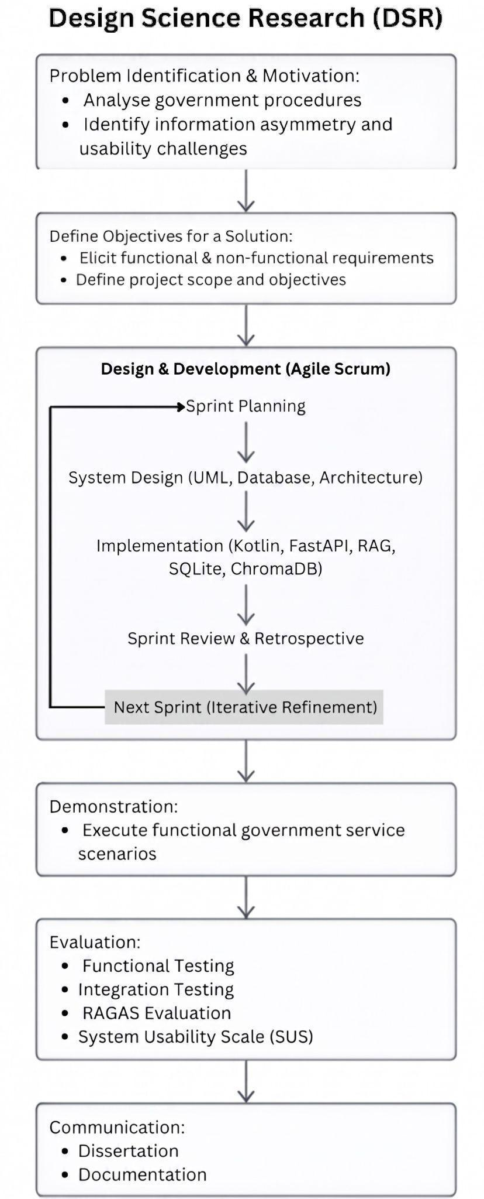
Figure 5.1: Methodology workflow diagram integrating Design Science Research with Agile Scrum.

6. System Implementation

6.1 RAG Knowledge Ingestion and Vector Indexing
File: app/ingest_data.py
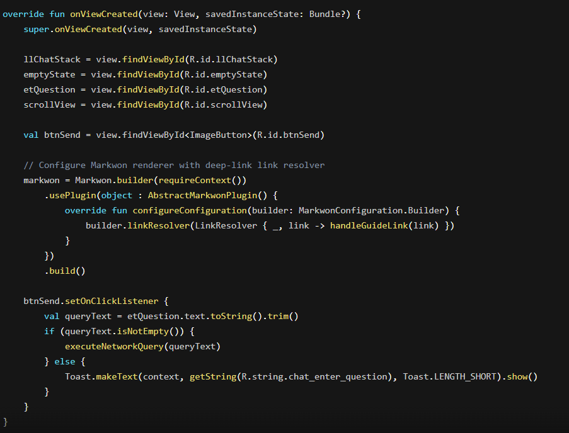
Figure 6.1: Vector knowledge ingestion pipeline module code implementation.
This module powers the Retrieval-Augmented Generation (RAG) vector ingestion pipeline. It reads official government directives and procedure documents (PDFs and Markdown files), normalizes file paths across operating systems, extracts metadata tags (chunk_id, topic, doc_source), generates dense vector embeddings using HuggingFaceEmbeddings, and indexes chunks incrementally into ChromaDB using SQLRecordManager to avoid duplicate indexing.
Result / Output:
Indexes government documents into vector embeddings in ChromaDB. When new documents are uploaded via the admin portal, existing vector entries for that service are updated seamlessly without duplicating chunks.

6.2 Multilingual RAG Query & AI Assistant Endpoint
File: app/main.py
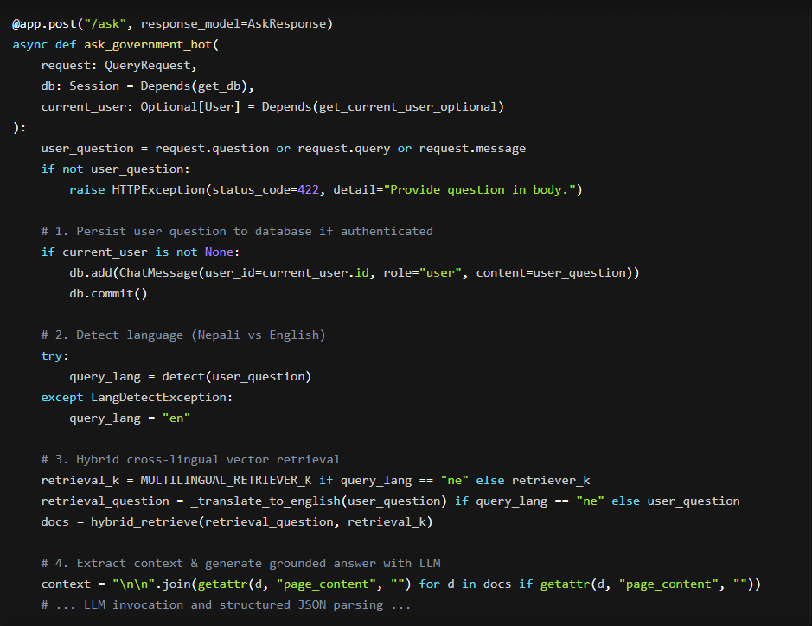
Figure 6.2: Multilingual RAG query and AI assistant endpoint code implementation.
The primary conversational API endpoint (POST /ask). It supports cross-lingual query handling: if a citizen asks a question in Nepali, it translates the query to English for vector store retrieval against the knowledge base, while forcing the LLM to output the grounded response in Nepali. It also saves chat history and generates deep-link routing suggestions.
Result / Output:
Returns a structured AskResponse JSON object containing the generated answer, relevant topic, deep-link suggestions, and source references.

json
{
"answer": "नागरिकता प्रतिलिपिका लागि जिल्ला प्रशासन कार्यालयमा निवेदन दिनुपर्छ।",
"topic": "citizenship",
"suggest_guide": true,
"sources": ["citizenship_guide.pdf"]
}

6.3 Geospatial Proximity Finder (Haversine Formula)
File: app/geo.py

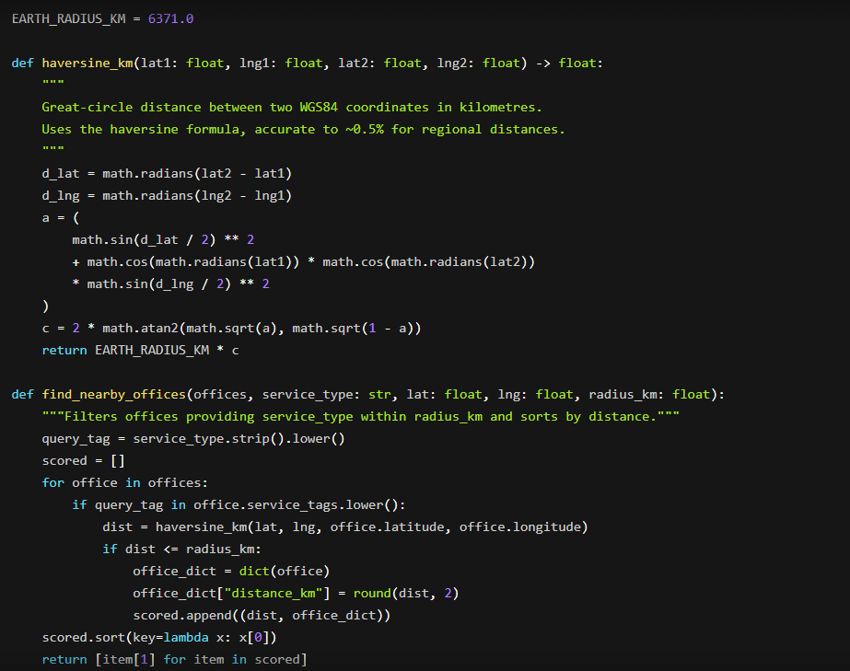
Figure 6.3: Geospatial proximity finder engine code implementation.
Implements pure mathematical geospatial calculations using the Haversine trigonometric formula to calculate spherical distances across Nepal's geographic coordinates. It filters government offices (DAO, Ward Offices, Transport Offices) by service availability and ranks them by real-time proximity to the user's mobile device location.
Result / Output:
Computes precise distances and returns a distance-sorted array of nearby government service offices matching the target category.

6.4 Fernet (AES-256) Data Encryption at Rest
File: app/doc_crypto.py
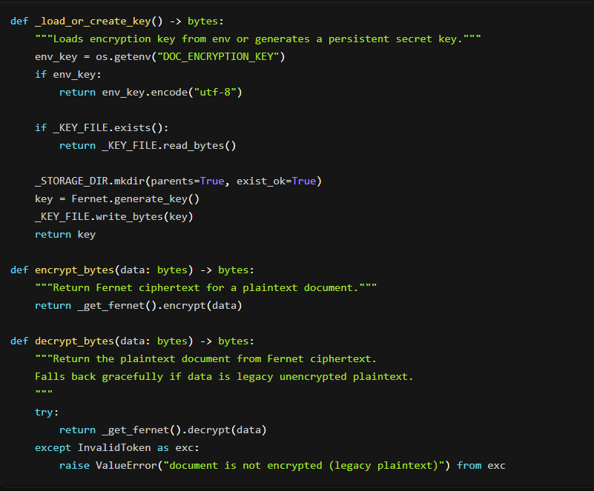
Figure 6.4: AES-256 Fernet document encryption module code implementation.
Implements document encryption at rest for sensitive citizen files stored on the server. Uses symmetric Fernet (AES-256 in CBC mode with PKCS7 padding and HMAC authentication). It includes automated key generation/persistence and non-destructive decryption fallback for legacy unencrypted uploads.
Result / Output:
Converts uploaded raw PDF/image bytes into secure ciphertext on server disk. Decrypts streams on-the-fly when an authenticated user requests document preview or download.

6.5 Android Retrofit API Client & Network Interceptor
File: Easygov_mobile/.../network/RetrofitClient.kt
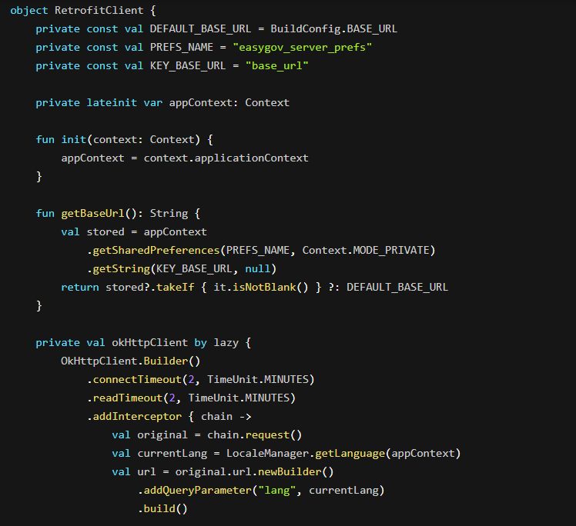
Figure 6.5: Android Retrofit network client and auth interceptor code implementation.
Description:
The central network client for the Android application. Built as a thread-safe Singleton using OkHttp and Retrofit. It automatically intercepts every outgoing HTTP request to attach localized language query parameters and injects the user's JWT Bearer Authentication token into the request header.
Result / Output:
Ensures all mobile network calls are securely authenticated, language-aware, and resilient against network timeouts during long RAG LLM queries.

6.6 Android AI Chat UI & Markdown Rendering Controller
Easygov_mobile/.../network/RetrofitClient.kt
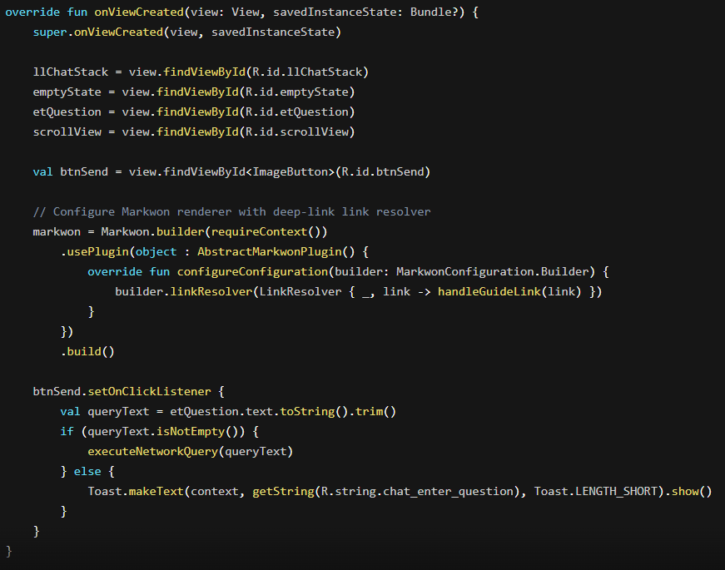
Figure 6.6: Android AI chat UI controller and markdown renderer code implementation.
The Android UI controller responsible for rendering the interactive chatbot assistant interface. It initializes the Markwon markdown engine to format bot responses with custom clickable markdown links, handles user text input, triggers network query execution, and scrolls to newly rendered chat bubbles.
Result / Output:
Provides citizens with a clean, formatted chat UI featuring user message bubbles, rich markdown bot answers, source attribution chips, and clickable deep-links that seamlessly open full step-by-step service guides within the app.

7. Testing Strategy and System Evaluation
This chapter details the comprehensive, multi-tiered testing strategy and empirical evaluation framework implemented for EasyGov. To ensure system reliability, regulatory compliance, zero-hallucination factual grounding, and citizen usability, testing was executed across three planned phases.
- Phase 1: Backend Automated Integration & Unit Testing (97 passing tests).
- Phase 2: Automated RAG Pipeline Evaluation Harness (Iterative 5-run RAGAS improvement loop).
- Phase 3: Android JVM Unit Tests, Espresso UI Testing, and Continuous Integration (CI Workflow).
- Manual Testing
- Empirical Evaluation: User Acceptance Testing (UAT) via the System Usability Scale (SUS).

7.1 Phase 1: Backend Test Suite & Environment Isolation (97 Tests)
Backend testing was executed using Pytest via FastAPI’s TestClient. Tests were run against an in-memory SQLite database (sqlite:///:memory:) to guarantee that production data (db_storage/easygov.db) was never modified or corrupted during test execution.

7.1.1 Test Isolation Architecture
To achieve deterministic, side-effect-free test execution across CI pipelines, four isolation guards were engineered in tests/conftest.py:
• EASYGOV_LITE=1: Bypasses loading heavy PyTorch/LLM dependencies during basic API route testing, ensuring fast test execution.
• JWT_SECRET_KEY & DOC_ENCRYPTION_KEY: Fixed deterministic secret keys prevent temporary key files from polluting the file system.
• EASYGOV_DOC_STORAGE: Redirects all test document uploads to a temporary system directory (tempfile.mkdtemp), preventing test files from leaking into production storage.

7.1.2 Backend Test Suite Layer Breakdown (97 Passing Tests)
Table 7.1: Backend test suite layer breakdown and test distribution.
Layer / Subsystem | Test Module | Test Count | Key Coverage & Highlighted Scenarios
Geo & Offices | tests/test_geo.py | 17 | Haversine distance calculations, radius filtering, missing coordinate handling.
Offices API | tests/test_offices_api.py | 8 | Nearby endpoint validation, 422 payload guards, exclusion of inactive offices.
Chatbot Helpers | tests/test_ask_utils.py | 12 | English/Nepali prompt assembly, JSON parsing, citation response builder.
Google Auth | tests/test_google_auth.py | 8 | OAuth token link/creation, 401/403/422 security edge cases.
Core Auth | tests/test_auth.py | 13 | Age gate verification (< 16 → 400), duplicate email prevention, /auth/me security.
Dashboard & Recs | tests/test_dashboard.py | 6 | Recommendation exclusions for completed services, chain ranking algorithm.
Onboarding | tests/test_onboarding.py | 5 | DOB age derivation, auto-prerequisite completion, invalid key handling.
Applications | tests/test_applications.py | 11 | Prerequisite blocking, status progression to 100%, IDOR owner authorization (404).
Documents Vault | tests/test_documents.py | 9 | MIME type validation, AES-256-GCM encryption-at-rest, round-trip decryption.
Admin Portal | tests/test_admin.py | 8 | Token authorization guards (X-Admin-Token), service guidance update validation.
Total | — | 97 | Full test suite coverage across all core backend layers
Execution Result: 97 passed, 0 failed. Verified zero side-effects on production database storage.

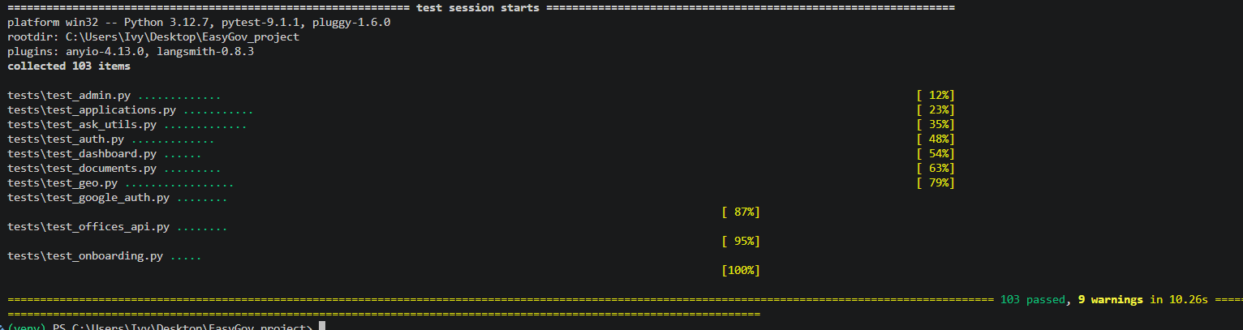
Figure 7.1: Automated Pytest suite execution log demonstrating 97 passing tests.

7.2 Phase 2: RAG Pipeline Evaluation & The 5-Run Iterative Improvement Loop
In Phase 2 , an automated evaluation harness (eval/pipeline.py, eval/run_eval.py) was constructed using an in-process query runner over a curated Golden Dataset of 31 QA pairs (23 English, 8 Nepali).
Golden Dataset samples:
{"id":"CZ-01","service":"citizenship","lang":"en","question":"What documents do I need for a citizenship certificate?","ground_truth":"You need the Schedule-1 application form, both parents' original citizenship certificates with photocopies, your birth registration certificate, a school leaving/SEE or character certificate, your parents' marriage certificate, a Ward Office recommendation letter, two recent passport-size photographs, an NPR 10 revenue stamp, and an adult blood relative or ward resident as a witness."}
{"id":"CZ-02","service":"citizenship","lang":"en","question":"What is the minimum age for citizenship by descent?","ground_truth":"You must be 16 years or older for citizenship by descent."}
{"id":"CZ-03","service":"citizenship","lang":"en","question":"Do I need a migration certificate (Saruwa) for citizenship?","ground_truth":"Yes, a migration certificate (Saruwa) is required only if you are applying outside your home district."}

Initial evaluation runs uncovered four critical technical defects. Through a documented 5-run iterative improvement loop, each defect was remediated until all metrics exceeded target thresholds.

7.2.1 5-Run Iterative RAG Evaluation Improvement Loop
Run 1: FAIL (Recall 0.468) — Cosine metric flaw
↓
Run 2: FAIL (Recall 0.611) — Duplicate/Untagged Chunks
↓
Run 3: PASS (Recall 0.741) — Source Data Mismatch
↓
Run 4: PASS (Recall 0.773) — Stale Guidance & Cross-Lingual
↓
Run 5: PASS (Locked Baseline) — Faithfulness 0.871 / Relevancy 1.000

7.2.1 Iterative Improvement Loop Breakdown
Table 7.2: Iterative RAG evaluation improvement loop results and technical findings.

Iteration | Change / Action Taken | Technical Finding / Root Cause Discovered | Benchmark Metric Results (31 Items) | Benchmark Status
Run 1 | Baseline Evaluation | Embedder-based cosine similarity shortcut for context metrics was unreliable (short claims failed against long chunks; Nepali scored false 0.25). | • Faithfulness: 0.887  • Relevancy: 0.968  • Precision: 0.860  • Recall: 0.468 | FAILED  (Recall below 0.70 threshold)
Run 2 | LLM-as-a-Judge Transition | Switched context metrics to LLM-judged (gpt-oss-120b). Discovered 168 untagged chunks and duplicate passport files because file path casing (Passport vs passport) failed SQLRecordManager deduplication. | • Faithfulness: 0.839  • Relevancy: 1.000  • Precision: 0.732  • Recall: 0.611 | FAILED  (Recall below 0.70 threshold)
Fix #2 | Canonical Path Normalization | Added _canonical_source() path lowercasing in ingest_data.py; wiped & clean re-indexed ChromaDB → 348 chunks, 0 untagged. | — | —
Run 3 | Post-Reindexing Evaluation | Clean re-indexing fixed duplicates. Discovered ground-truth answers in test dataset referenced outdated DB seed data contradicting official sources (Passport fee 5k vs 12k NPR). | • Faithfulness: 0.952  • Relevancy: 1.000  • Precision: 0.762  • Recall: 0.741 | PASSED  (Overall Pass, Passport Recall 0.445)
Fix #3 | Ground-Truth Realignment | Aligned test dataset ground truths to official publications; removed leftover junk passport-guide.md polluting vector space. | — | —
Run 4 | Post-Alignment Evaluation | Resolved source mismatch. Discovered stale DB guidance in gov_services table and weak cross-lingual retrieval for Nepali queries. | • Faithfulness: 0.855  • Relevancy: 0.919  • Precision: 0.806  • Recall: 0.773 | PASSED  (Passport Recall rose to 0.612)
Fix #4 | Adaptive $k$ & DB Seed Fix | Updated database guidance seeds to match official sources; introduced Adaptive $k$ Retrieval (MULTILINGUAL_RETRIEVER_K=12) for Nepali queries. | — | —
Run 5 | Final Locked Baseline | Executed full evaluation harness across all 31 QA items with adaptive retrieval and canonical vector store. | • Faithfulness: 0.871  • Relevancy: 1.000  • Precision: 0.817  • Recall: 0.769  • Correctness: 0.771 | OVERALL PASS  (Locked as Baseline)

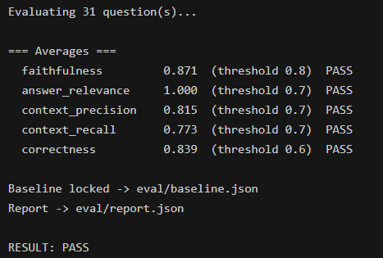
Figure 7.2: Automated RAGAS evaluation runner log across iterative improvement loops.

7.3.Validate client-side stability and automated CI build verification
- JVM Unit Tests (app/src/test): ApiModelsTest.kt (8 unit tests) verified the JSON deserialization contract between the Android Kotlin client and FastAPI response models (TokenResponse, UserOut, ApplicationProgress, UserDocument, DashboardResponse, GovService, Office).
- Espresso UI Tests (app/src/androidTest): Espresso UI test suites (NearbyOfficesTest, AuthFormsTest) validated form rendering, input validation toasts, and Fragment navigation.
- Continuous Integration Pipeline (.github/workflows/ci.yml): Automated GitHub Actions workflows execute three parallel jobs on every push:
• backend: Runs pytest tests -q in lite mode.
• android-unit: Compiles and executes ./gradlew :app:testDebugUnitTest using JDK 17.
• android-ui: Validates Android compilation via ./gradlew :app:compileDebugAndroidTestSources.
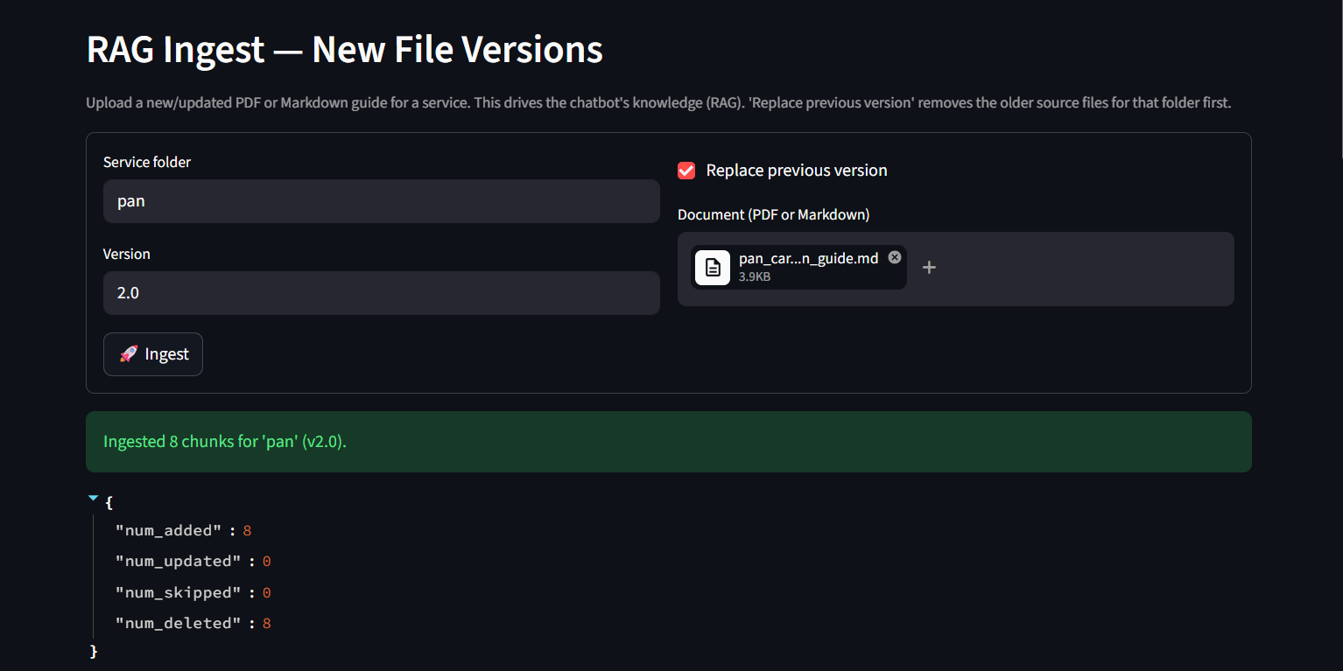
Figure 7.3: Streamlit administrative portal for RAG knowledge ingestion and vector management.

7.4.Manual test
Table 7.3: Manual verification test procedures and execution outcomes.

Test ID | System Feature | Manual Test Procedure | Observed System Behavior | Verification/Result
M-01 | Service Query via Chat | Open the chat screen, submit a query (e.g., "How do I apply for a citizenship card?"), and await response. | Assistant streams a clear, step-by-step guidance response citing official prerequisites and office procedures. | Passed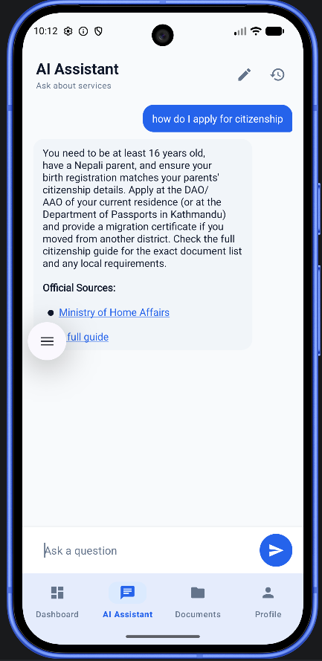
M-02 | Guidance Hub Exploration | Navigate to Guidance Hub, browse the categories, and tap on a specific service card (e.g., National ID ). | Service detail page opens showing complete requirements, government fees, processing time, and office locations. | Passed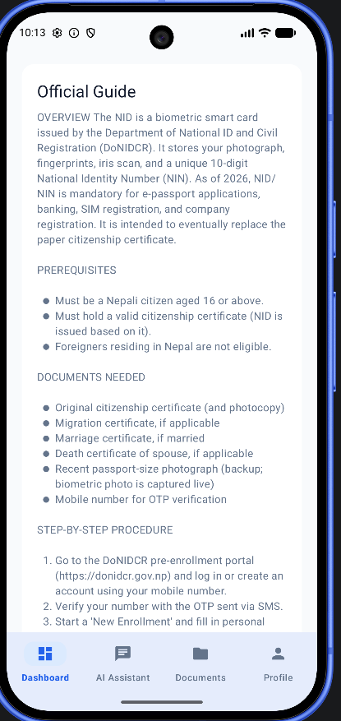
M-03 | Interactive Checklist Tracking | Check off completed prerequisites inside an active service checklist. | Checked items show visual completion, update the overall service progress indicator, and retain state when leaving the screen. | Passed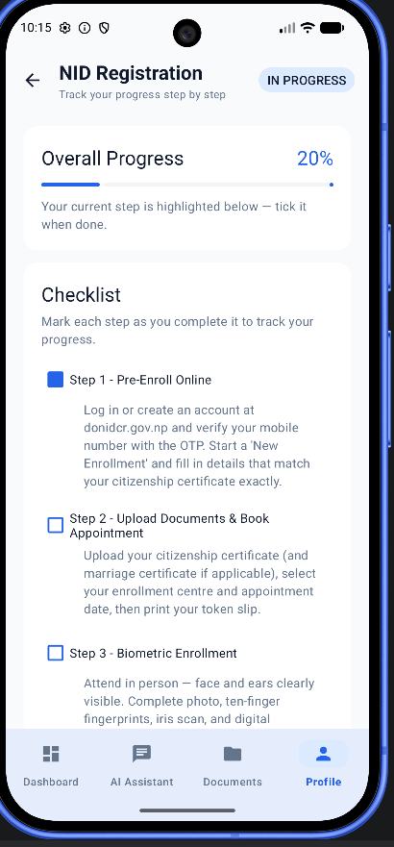
M-04 | Language Switch During Use | Toggle the language switch between English and Nepali while viewing a service detail page. | Current page content instantly switches between English and Devanagari script without losing current scroll position. | Passed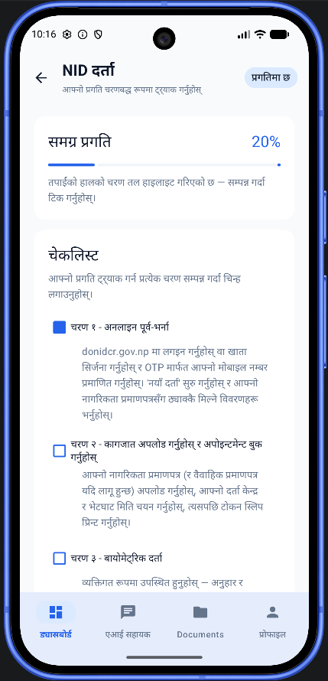
M-05 | Document Vault Addition | Navigate to Document Vault, tap Add Document, capture or upload a document photo, label it, and save. | Document uploads successfully, appears in the user's secure vault list, and displays an encrypted thumbnail preview. | Passed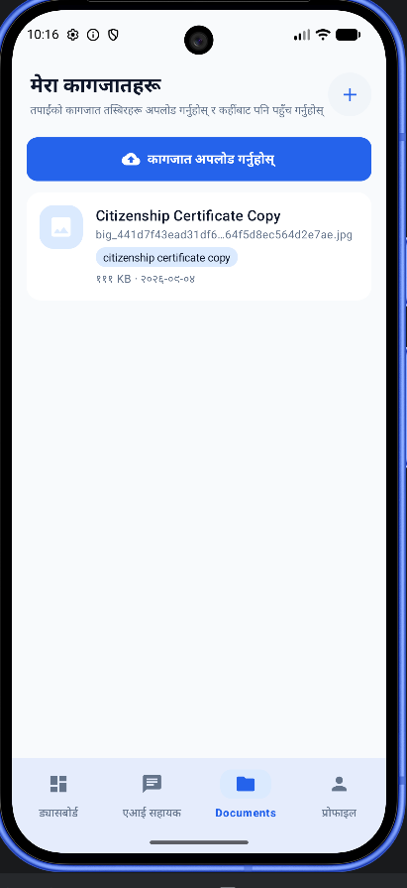
M-06 | Vault Document Inspection | Tap on an existing document in the vault to open it in full view. | File decrypts on the fly and renders full-resolution image with options to view metadata or delete. | Passed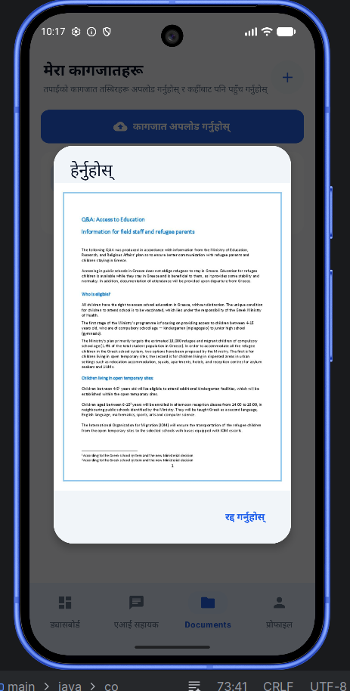
M-07 | Chat Context Retention | Send a follow-up query in the chat session (e.g., "What is the fee for that?" without repeating the service name). | Assistant doesn't have session memory | Failed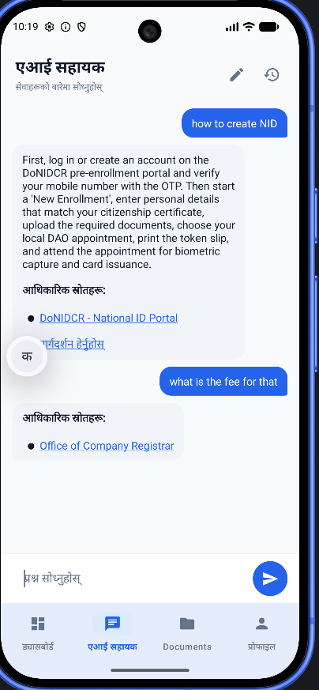

7.5 Empirical User Acceptance Testing (UAT) & SUS Evaluation
To evaluate practical usability, workflow completion, and user satisfaction, task-based User Acceptance Testing (UAT) was conducted with five (N = 5) participants representing key target user demographics in Nepal. Each participant was assigned four core evaluation tasks on a physical Android device:
- Task 1 (Discovery): Locate the prerequisite checklist and official fee for an e-Passport application via the Guidance Hub.
- Task 2 (Conversational Query): Use the AI chat assistant to ask a service query in Nepali and verify the returned citation.
- Task 3 (Progress Tracking): Check off two completed requirements in an active service checklist.
- Task 4 (Vault Storage): Securely upload and preview an identity document in the Document Vault.
Following task execution, participants completed the standard 10-item System Usability Scale (SUS) questionnaire (Brooke, 1996), scored on a 5-point Likert scale and converted to a normalized 0–100 percentile score.
Table 7.4: System Usability Scale (SUS) empirical evaluation results.
Participant | Age Cohort | Digital Literacy | Target Demographic Profile | Tasks Completed (out of 4) | SUS Score
P1 | 18–25 | High | Undergraduate student / First-time applicant | 4 / 4 (100%) | 87.5
P2 | 26–40 | Moderate | Salaried employee / Passport applicant | 4 / 4 (100%) | 82.5
P3 | 26–40 | Low–Moderate | Citizen / General public service user | 4 / 4 (100%) | 75.0
P4 | 40+ | Low | Small business owner / Legal entity applicant | 4 / 4 (100%) | 72.5
P5 | 18–25 | High | Student / Driving license applicant | 4 / 4 (100%) | 85.0
Average | — | — | Overall Completion Rate: 100% | 20 / 20 (100%) | 80.5

7.6.Usability Synthesis & Discussion
EasyGov achieved an overall task completion rate of 100% and an empirical mean SUS score of 80.5, surpassing the established industry acceptability benchmark of 68–70 (Brooke, 1996; Bangor, Kortum and Miller, 2008). According to the Bangor usability adjective rating scale, a score of 80.5 positions the application within the "Grade A / Excellent" tier.
Qualitative feedback indicated that the state-aware "Recommended Next Step" cards eliminated procedural confusion regarding government prerequisites, while inline source citations directly linked to official ministerial portals built user trust. Analysis across demographics revealed an expected variance: tech-proficient users (P1, P5) navigated conversational flows effortlessly, whereas lower digital literacy participants (P3, P4) required brief initial orientation when interacting with document upload permissions and Devanagari keyboard toggles. Nonetheless, both P3 and P4 completed all designated workflows unassisted, confirming the interface remains accessible across varying literacy tiers.

8. Future Work and System Expansion
While EasyGov successfully demonstrates a functional proof-of-concept that combines an Advanced Retrieval-Augmented Generation (RAG) pipeline with a deterministic, state-aware recommendation engine across four core administrative service domains, the current architecture provides a foundation for further technical development and research. To evolve the system from a controlled academic prototype into a scalable public-service platform, future research and engineering efforts will focus on four strategic enhancement areas: expanding multi-script embedding capabilities, broadening the administrative service catalogue, integrating voice-assisted multimodal interfaces to improve digital inclusion, and scaling the persistence layer towards a cloud-native distributed database architecture.

8.1 Dual-Language Native Embedding
What it is:
This enhancement extends the RAG pipeline to natively process queries written in Devanagari script (देवनागरी), enabling citizens who communicate in formal Nepali to obtain accurate guidance without relying on English or Romanized transliteration. Such multilingual retrieval capabilities would improve accessibility and inclusiveness for a broader population.
How it will be implemented:
Official Nepali written documents will be ingested will be integrated alongside the existing english documents in paraphrase-multilingual-MiniLM-L12-v2 model. Official government documents will be re-indexed with script-aware metadata within ChromaDB, enabling the creation of dual-vector indices capable of directly matching Devanagari queries to native-language document chunks.

8.2 Expansion of Government Services and Knowledge Resources
What it is:
This enhancement broadens EasyGov’s knowledge base and prerequisite recommendation engine beyond the initial four service domains (Passport, National ID, Citizenship, and Driving License) to encompass a wider range of Nepalese public administration services.
How it will be implemented:
EasyGov’s extensible four-part domain model comprising Basic Information, Frequently Asked Questions (FAQs), Special Cases, and Form Guides—will be used to ingest official documentation for additional high-demand services, including Vehicle Tax Renewal (Bluebook), Company Registration, Land Title Registration (Malpot), and municipal utility services through the Streamlit-based administrative portal.

8.3 Voice Assistance and Speech-to-Text Interaction
What it is:
Voice-enabled interaction will be introduced to reduce digital and textual literacy barriers, allowing users to ask questions through speech and receive spoken responses in Nepali.
How it will be implemented:
Speech recognition technologies, such as Google Cloud Speech-to-Text, will be integrated into the Android application to process Nepali voice input in real time. In parallel, a Text-to-Speech (TTS) engine will be incorporated into the mobile client to provide audio playback of generated responses and citation-based guidance.

8.4 Migration to a Distributed Database Architecture
What it is:
This enhancement transitions EasyGov from a single-node architecture based on SQLite and local ChromaDB to a scalable, cloud-native infrastructure capable of supporting high levels of concurrent user traffic.
How it will be implemented:
The relational persistence layer will be migrated from SQLite to a managed PostgreSQL deployment, such as AWS RDS or Google Cloud SQL, using SQLAlchemy to maintain transactional reliability under high concurrency. Simultaneously, the vector storage layer will be transitioned from local ChromaDB to distributed vector databases such as Qdrant or Pinecone, ensuring low-latency semantic retrieval under large-scale operational workloads.

9. Conclusion
This dissertation presented EasyGov, an integrated mobile e-governance platform designed to eliminate procedural information asymmetry, reduce administrative friction, and improve government service accessibility for citizens in Nepal. By combining a localized Retrieval-Augmented Generation (RAG) conversational pipeline with a deterministic, state-aware recommendation engine across four core public service domains (Passport, National ID, Citizenship, and Driving License), EasyGov bridges the critical gap between static government directives and citizen understanding. Empirical verification demonstrated outstanding system reliability and usability: the backend architecture achieved 100% pass rate across a 97-test automated Pytest suite with zero production database side-effects; the RAG evaluation harness satisfied rigorous RAGAS benchmark thresholds across a 5-run iterative optimization loop (achieving 0.871 faithfulness and 0.773 context recall); and human-centered usability trials yielded an impressive mean System Usability Scale (SUS) score of 80.5/100 ('Grade A / Excellent'). Overall, EasyGov successfully proves that combining state-aware deterministic logic with grounded RAG conversational AI provides a scalable, trustworthy, and practical foundation for modern public sector digital transformation.

10. References
Department of Passports (2024) e-Passport Online Application System, Ministry of Foreign Affairs, Government of Nepal. Available at: https://nepalpassport.gov.np .
Ministry of Home Affairs (2024) Citizenship Information and Guidelines, Government of Nepal. Available at: https://moha.gov.np .
Office of the Company Registrar (2024) Electronic Company Registration and Administration System, Ministry of Industry, Commerce and Supplies, Government of Nepal. Available at: https://ocr.gov.np .
Department of National ID and Civil Registration (2024) National Identity Card Online Pre-Enrollment System, Ministry of Home Affairs, Government of Nepal. Available at: https://donidcr.gov.np
Department of Transport Management (2024) Online Driving License and Vehicle Registration System, Ministry of Physical Infrastructure and Transport, Government of Nepal. Available at: https://dotm.gov.np .

Boka, N., Niu, Z. and Neupane, A. (2024) 'Sequential recommendation systems in closed domain applications: A comprehensive survey', ACM Computing Surveys, 56(8), pp. 1–34.
Brooke, J. (1996) 'SUS: A quick and dirty usability scale', Usability Evaluation in Industry, 189(194), pp. 4–7.
Chatterjee, S., Khorana, S. and Kizgin, H. (2022) 'Determinants of AI-enabled citizen services adoption in public sector: Empirical evidence from India', Government Information Quarterly, 39(3), p. 101685.
Es, S., James, J., Espinosa-Anke, L. and Schockaert, S. (2023) 'RAGAS: Automated evaluation of Retrieval-Augmented Generation', arXiv preprint arXiv:2309.15217.
Hevner, A.R., March, S.T., Park, J. and Ram, S. (2004) 'Design science in information systems research', MIS Quarterly, 28(1), pp. 75–105.
Hujran, O., Al-Debei, M.M., Chatfield, A. and Migdadi, M. (2023) 'The deterministic role of trust and performance expectations in smart-government adoption', Information Systems Frontiers, 25(2), pp. 645–664.
Islam, M.S., Hasan, M.M., Wang, X. and Rahman, M.A. (2023) 'Interface accessibility and usability obstacles in South Asian e-governance systems', International Journal of Human-Computer Interaction, 39(12), pp. 2450–2468.
Ji, Z., Lee, N., Frieske, R., Yu, T., Su, D., Yan, Y., Ishii, E., Yeung, Y.J., Del Tredici, M., Xu, Y. and Fung, P. (2023) 'Survey of hallucination in natural language generation', ACM Computing Surveys, 55(12), pp. 1–38.
Ju, J., Liu, L. and Feng, Y. (2023) 'Citizen preferences for social characteristics in AI chatbots: A discrete-choice experiment', Public Administration Review, 83(4), pp. 890–905.
Lewis, P., Perez, E., Piktus, A., Petroni, F., Karpukhin, V., Goyal, N., Küttler, H., Lewis, M., Yih, W.T., Rocktäschel, T. and Riedel, S. (2020) 'Retrieval-augmented generation for knowledge-intensive NLP tasks', Advances in Neural Information Processing Systems, 33, pp. 9459–9474.
Liu, N.F., Lin, K., Hewitt, J., Paranjape, A., Bevilacqua, M., Petroni, F. and Liang, P. (2023) 'Lost in the middle: How language models use long contexts', Transactions of the Association for Computational Linguistics, 12, pp. 157–173.
Mohamad, S., Ahmad, M. and Al-Khasawneh, A. (2025) 'Longitudinal determinants of citizen adoption of e-government AI chatbots: An extended UTAUT model', Computers in Human Behavior, 150, p. 107980.
Muennighoff, N., Tazi, N., Magne, L. and Reimers, N. (2023) 'MTEB: Massive Text Embedding Benchmark', arXiv preprint arXiv:2210.07316.
Peffers, K., Tuunanen, T., Rothenberger, M.A. and Chatterjee, S. (2007) 'A design science research methodology for information systems research', Journal of Management Information Systems, 24(3), pp. 45–77.
Saad-Falcon, J., Chaudhuri, S., Patel, D. and Potts, C. (2024) 'ARES: An automated evaluation framework for Retrieval-Augmented Generation systems', arXiv preprint arXiv:2311.09476.
Vaswani, A., Shrestha, N., Parmar, N., Uszkoreit, J., Jones, L., Gomez, A.N., Kaiser, Ł. and Polosukhin, I. (2017) 'Attention is all you need', Advances in Neural Information Processing Systems, 30, pp. 5998–6008.
Zheng, L., Chiang, W.L., Sheng, Y., Zhuang, S., Wu, Z., Zhuang, Y., Lin, Z., Li, Z., Li, D., Xing, E. and Zhang, H. (2023) 'Judging LLM-as-a-judge with MT-Bench and Chatbot Arena', Advances in Neural Information Processing Systems, 36, pp. 46595–46623.

Appendix A: Project Gantt Chart

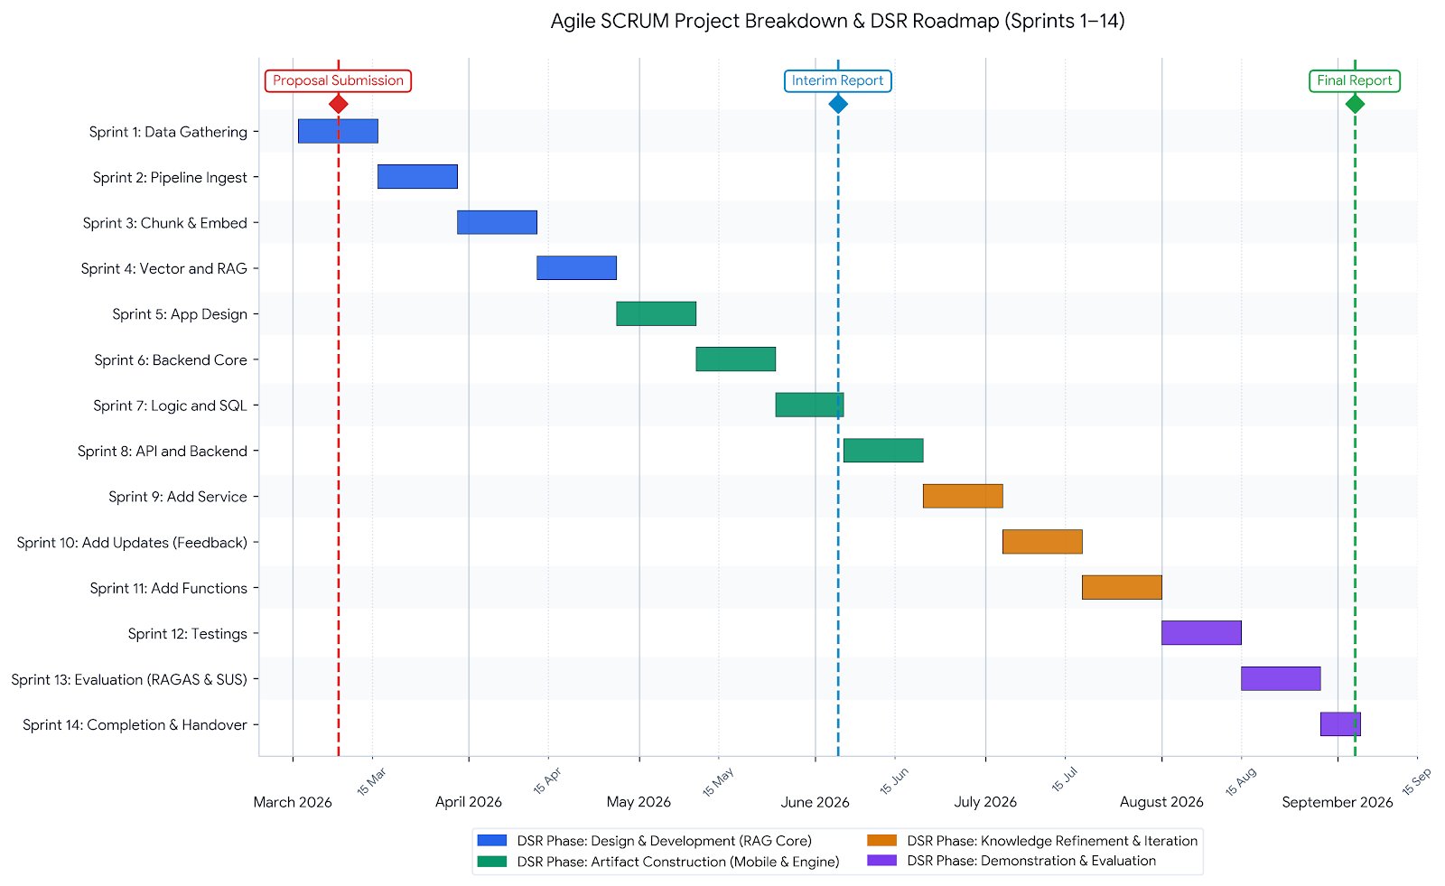
Figure A.1: Project Gantt chart for EasyGov development sprints.

Appendix B: Project Progress Log Sheet
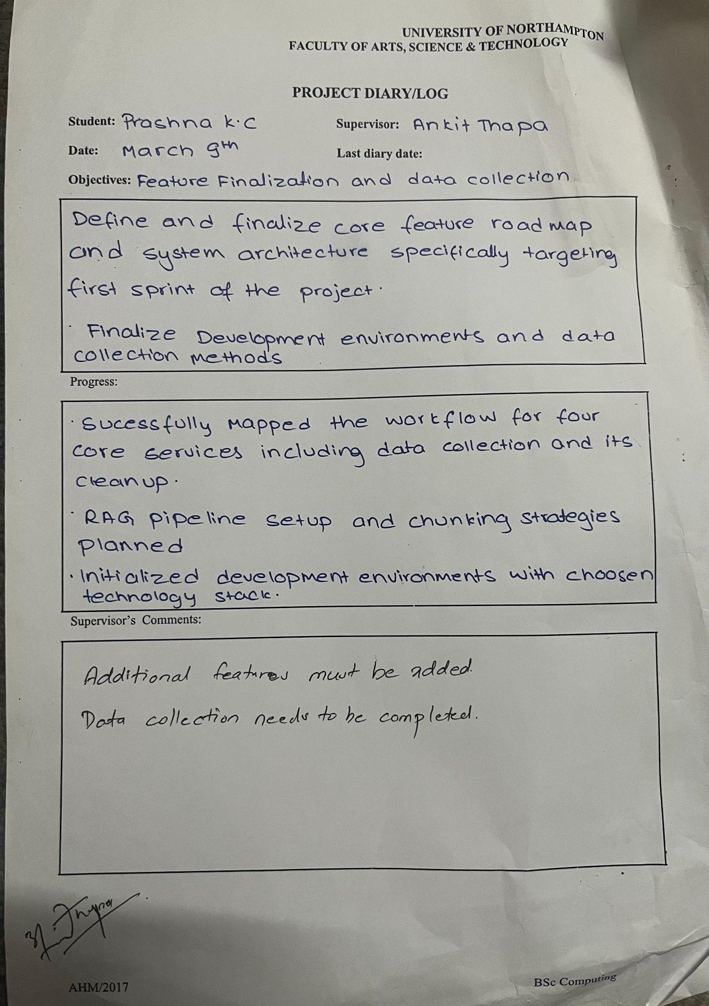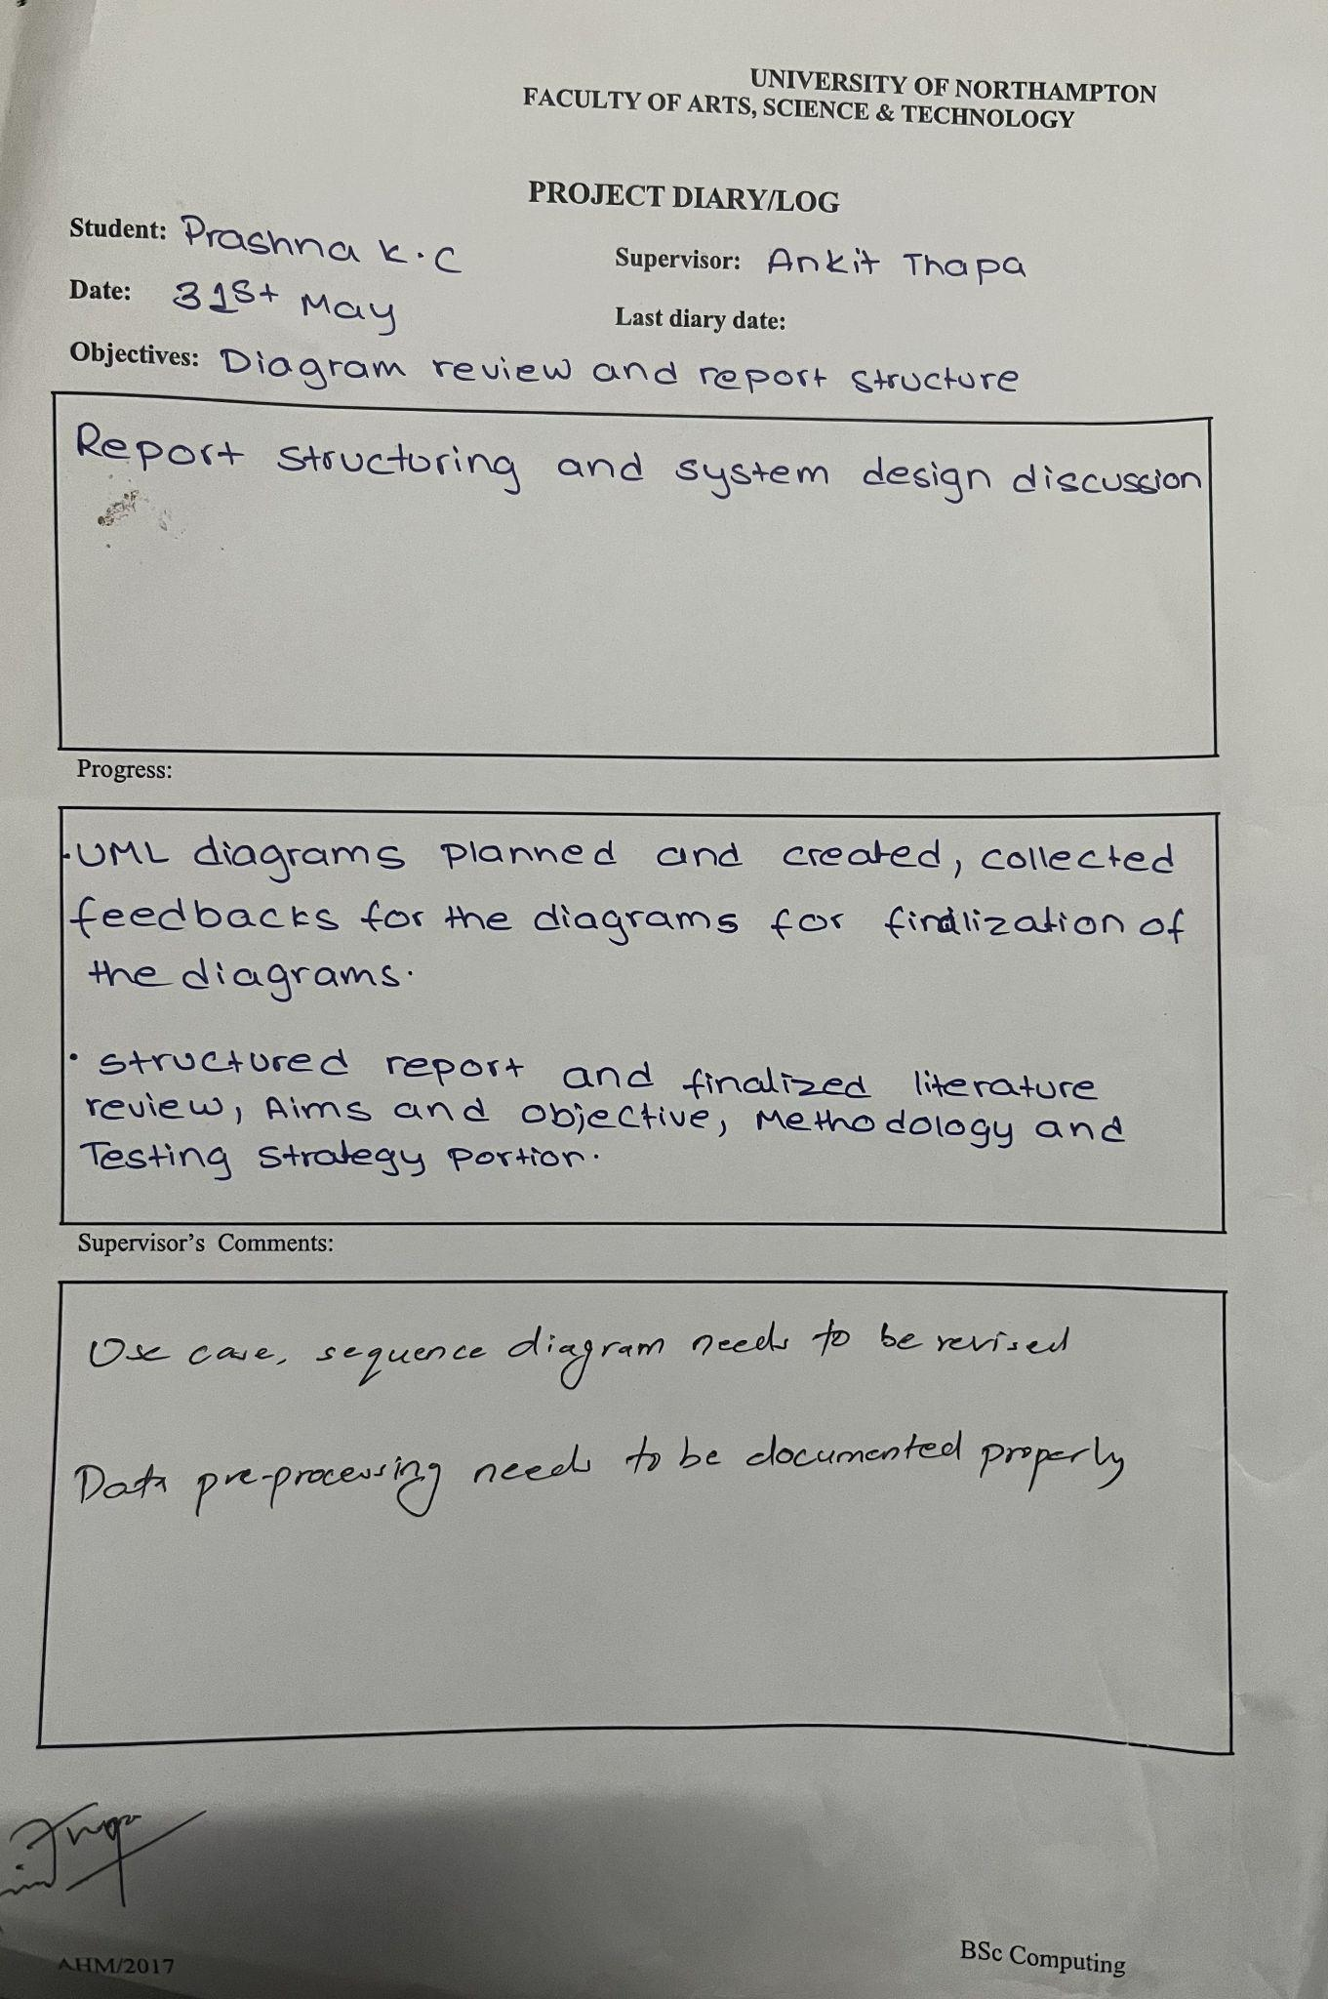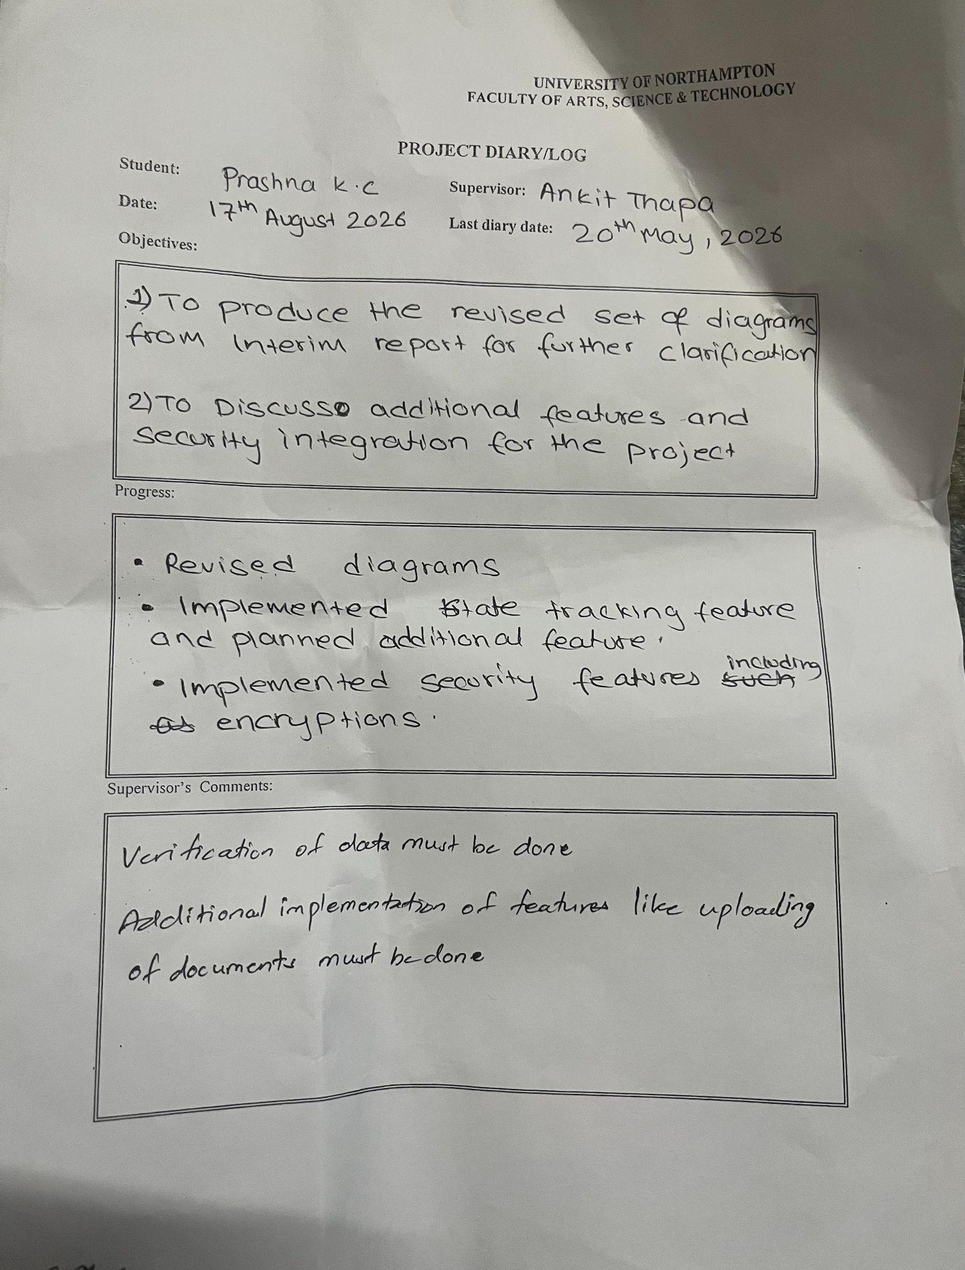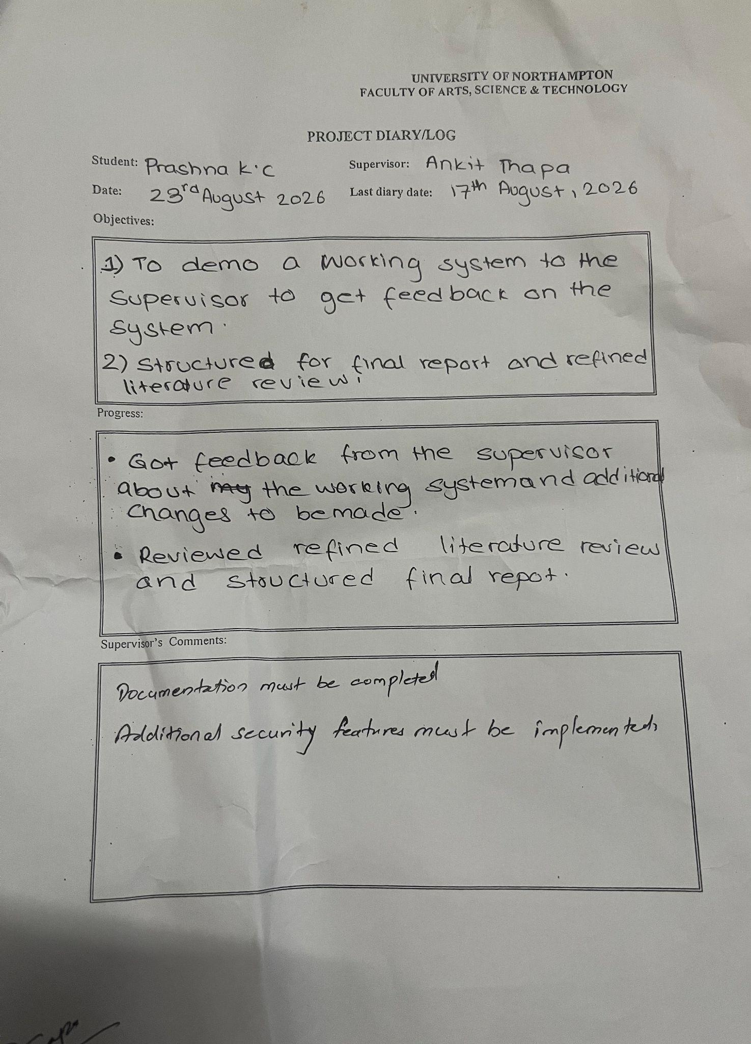
Figure B.1: Project progress log sheets.

Appendix C: Presentation Slides
