**RESULTS**

**7.1 Output Screenshots**

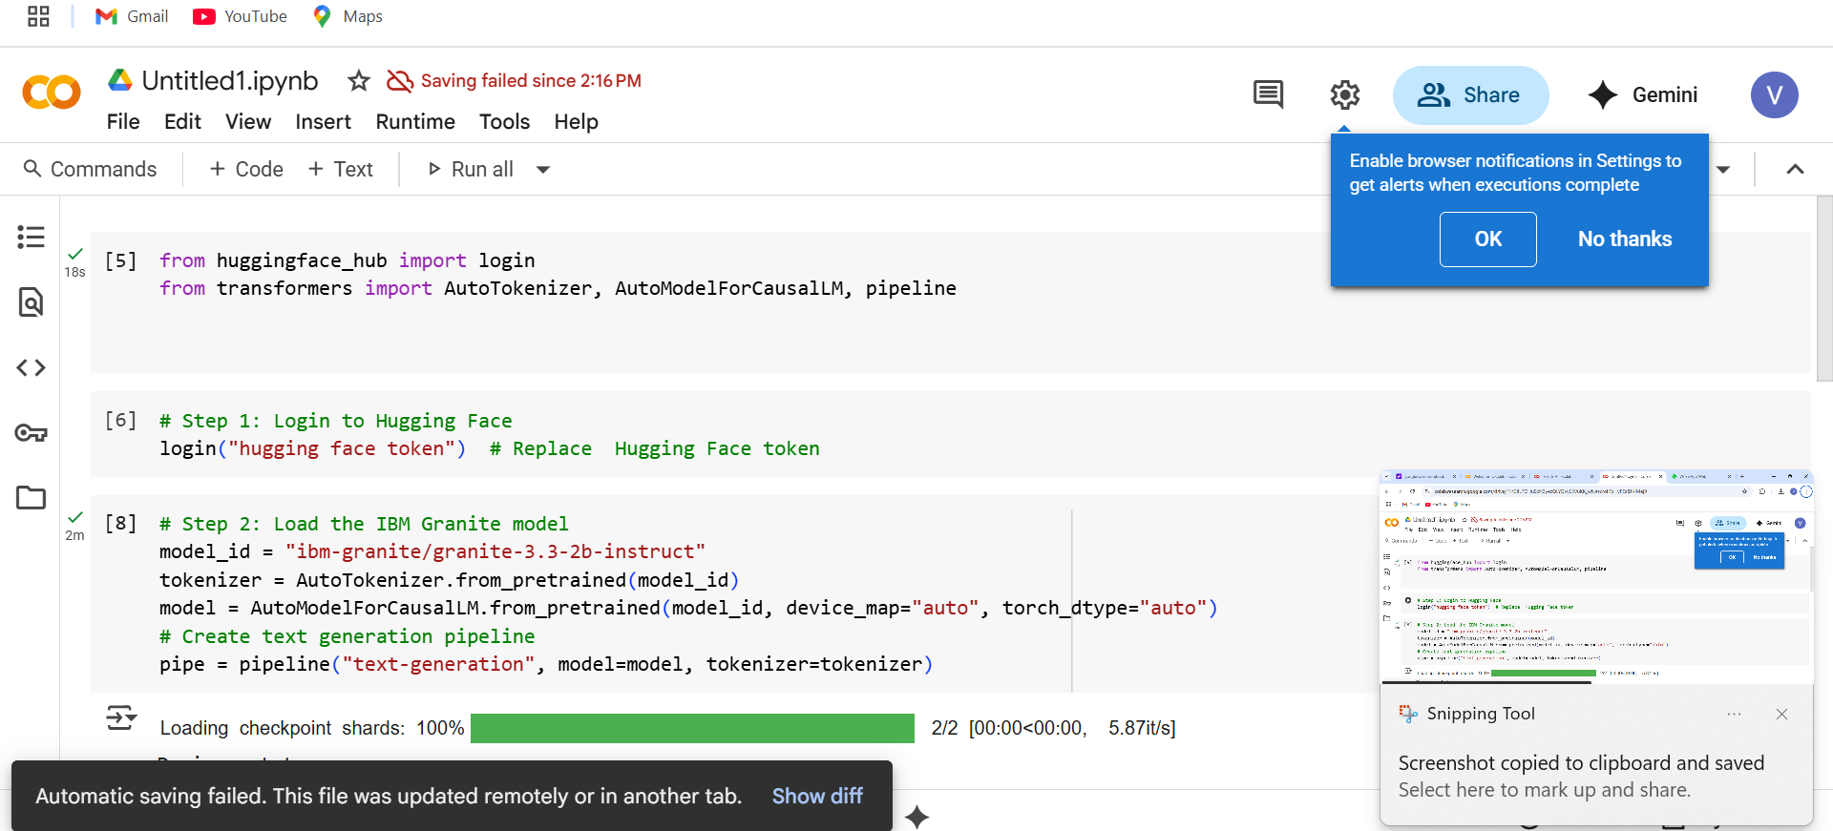

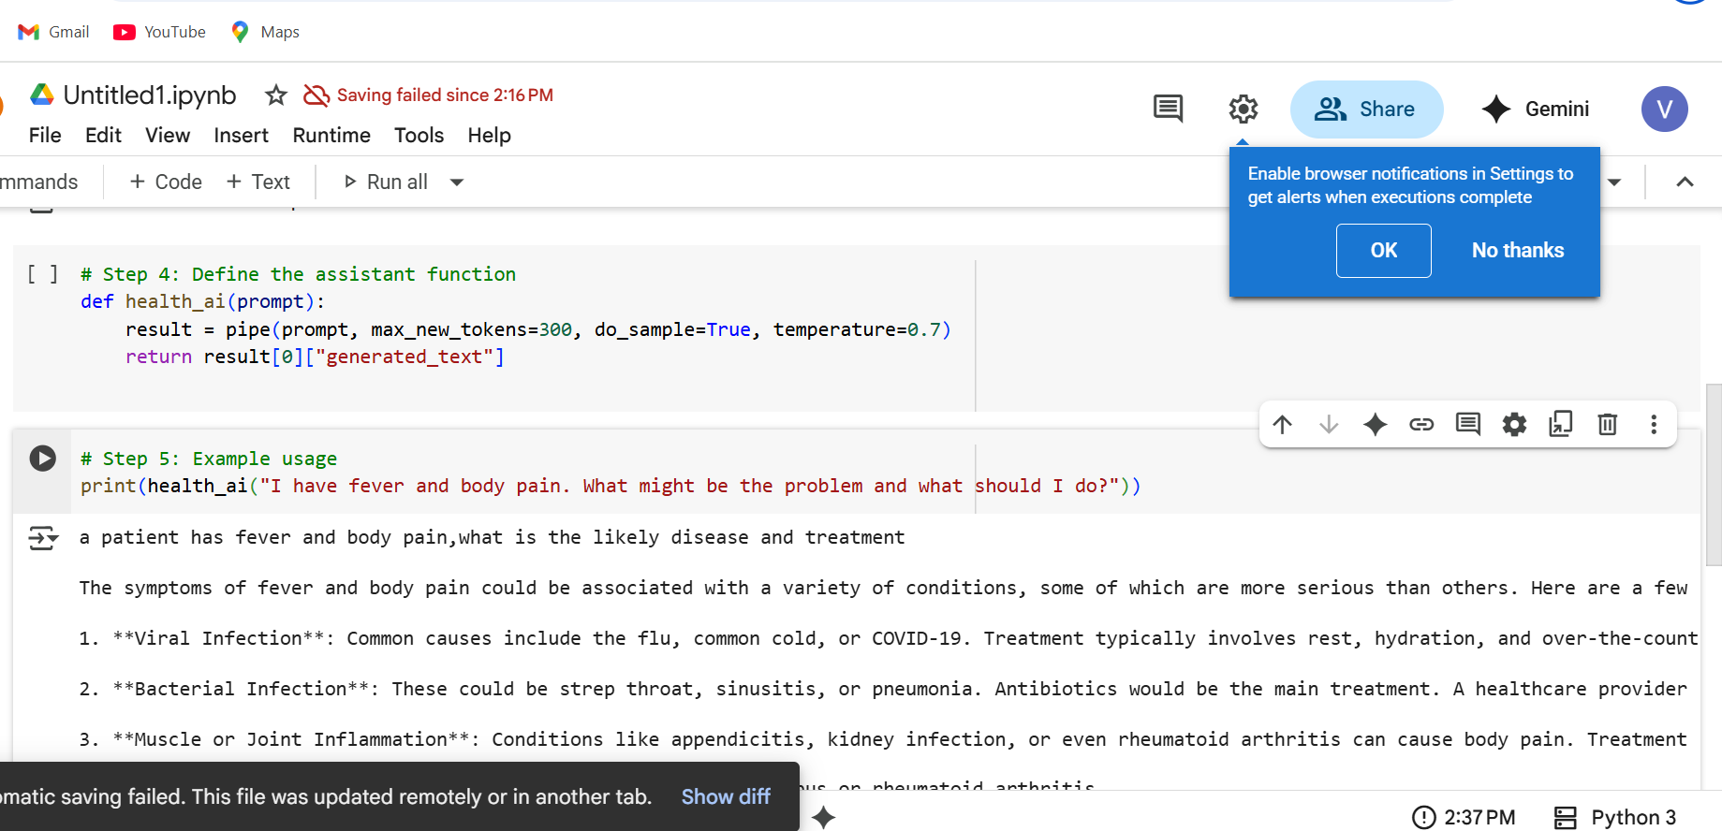

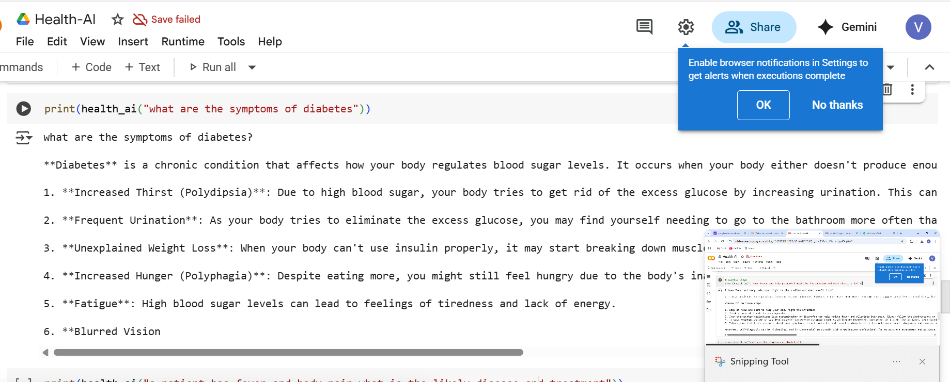

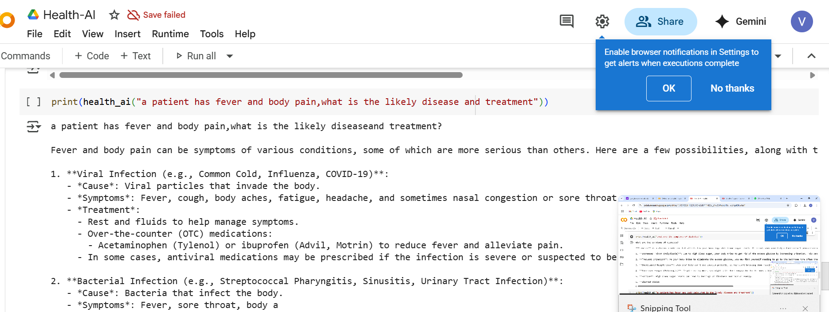

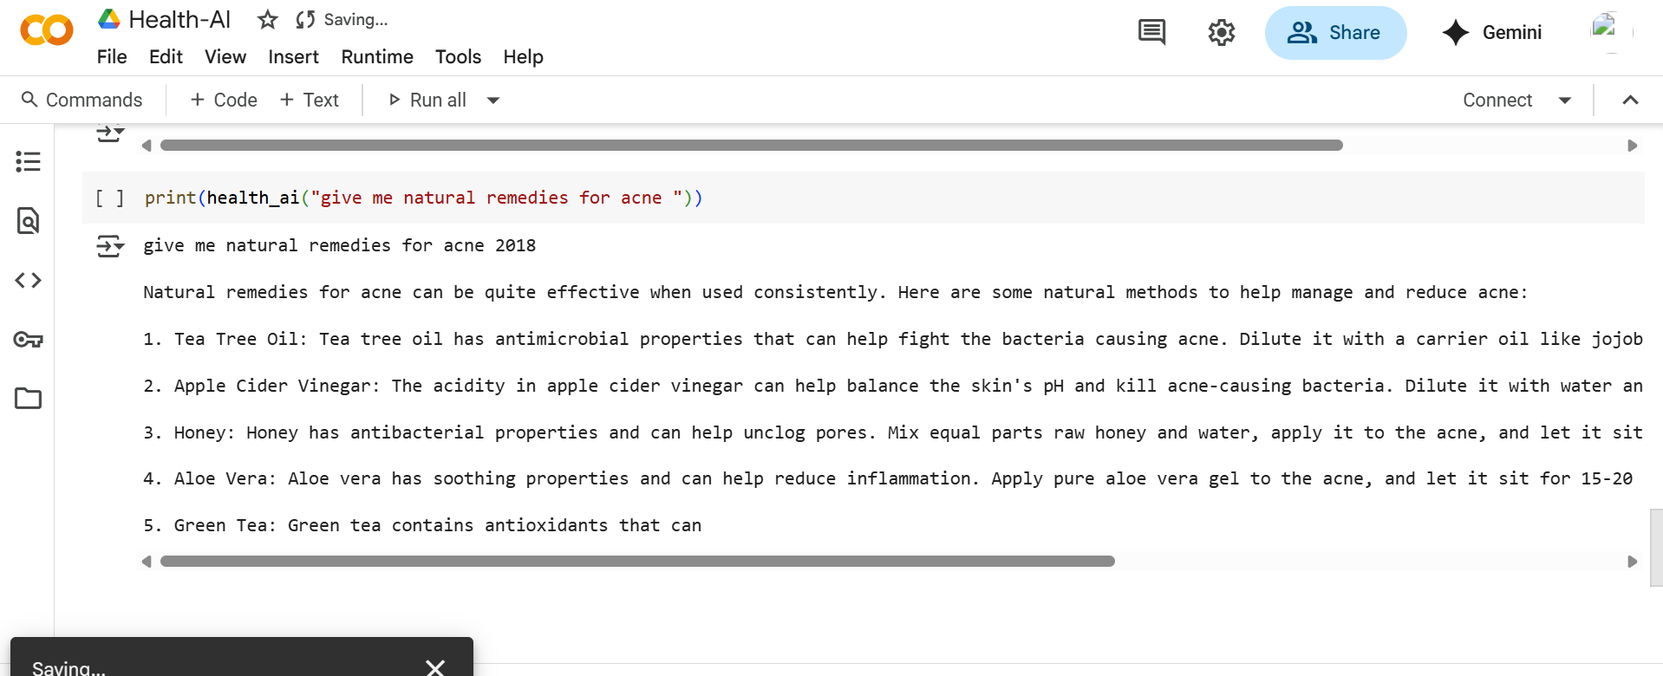

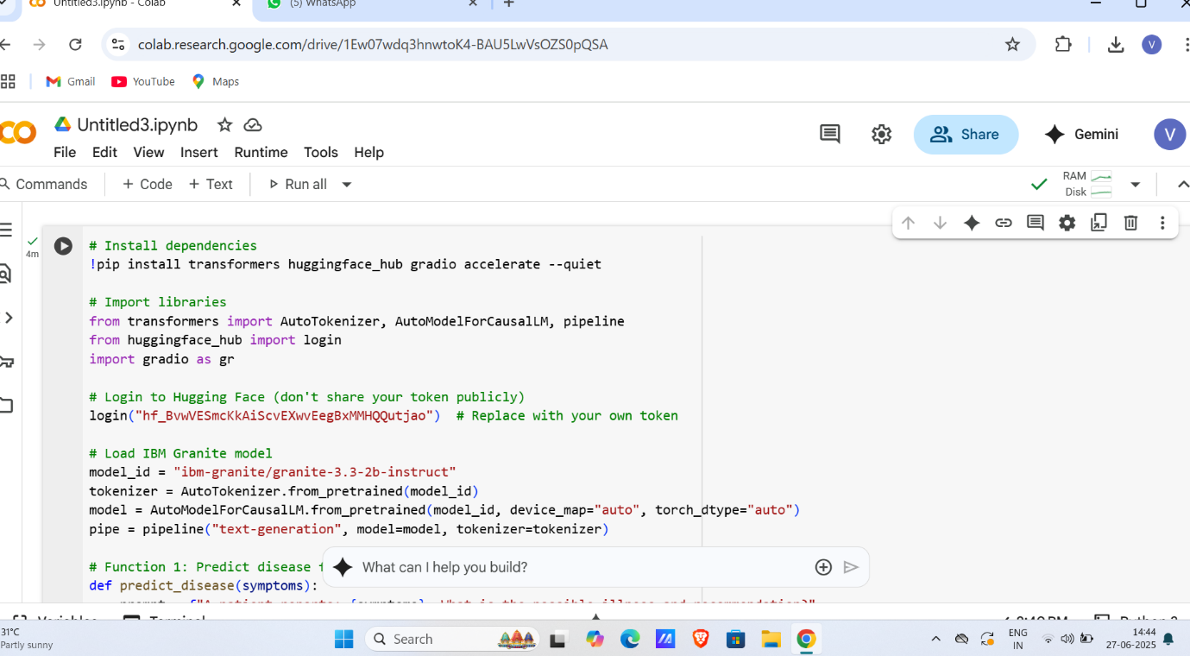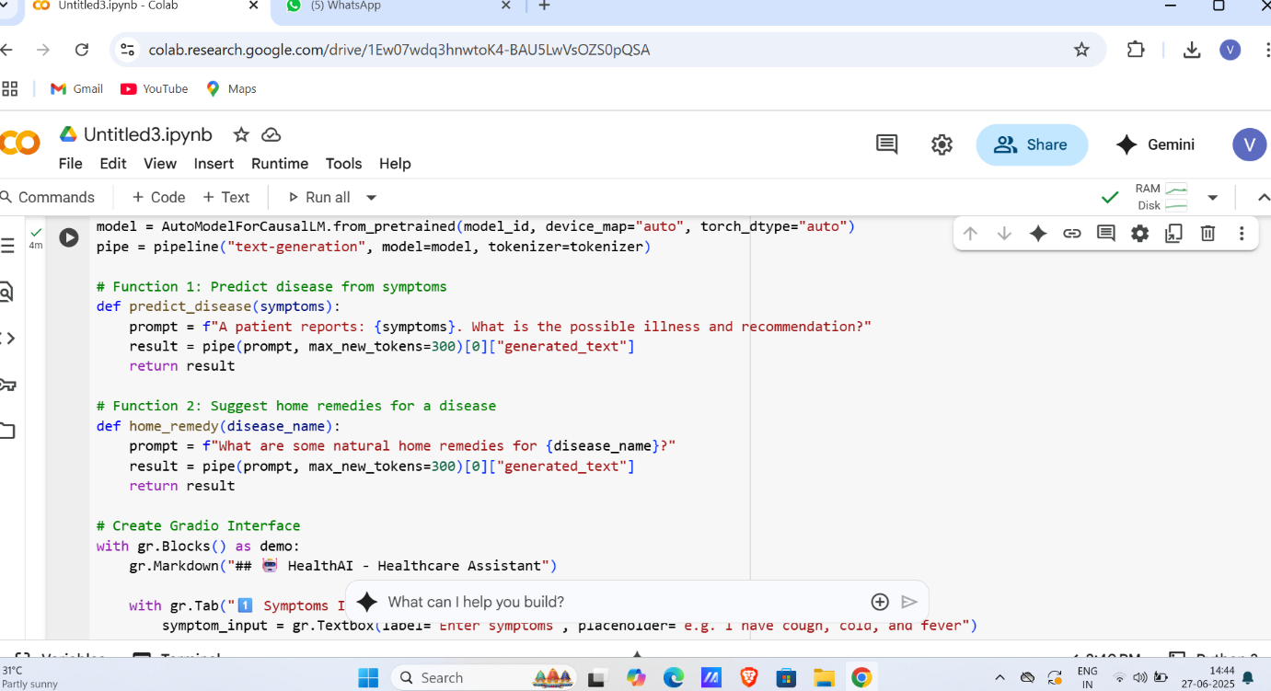

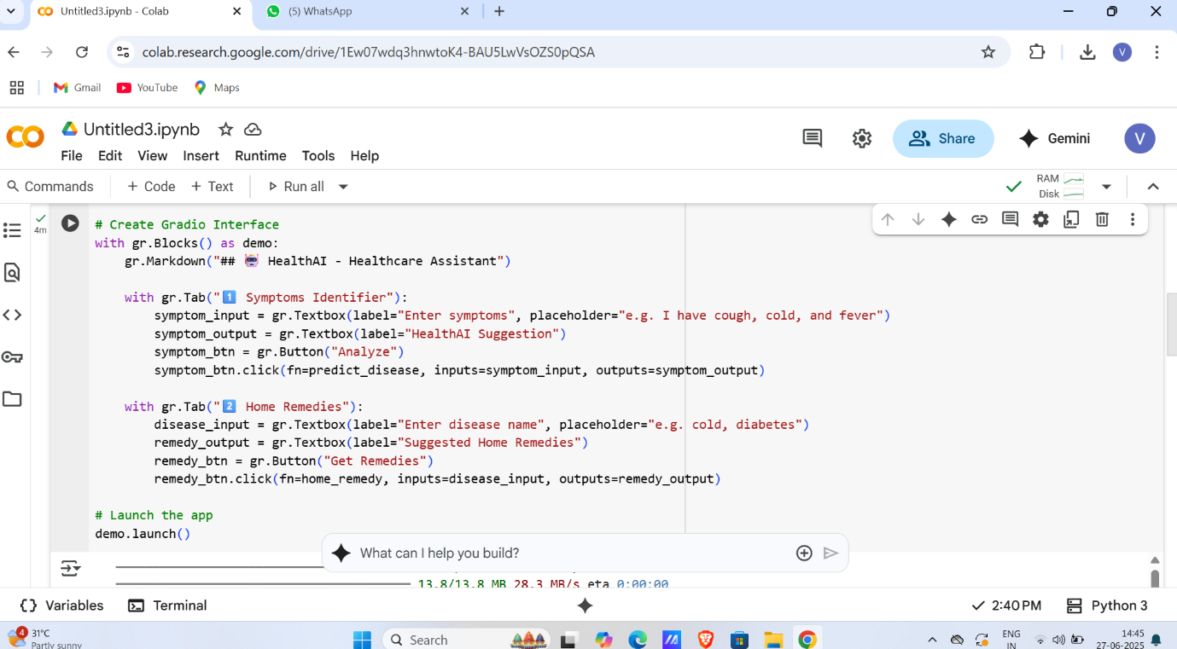

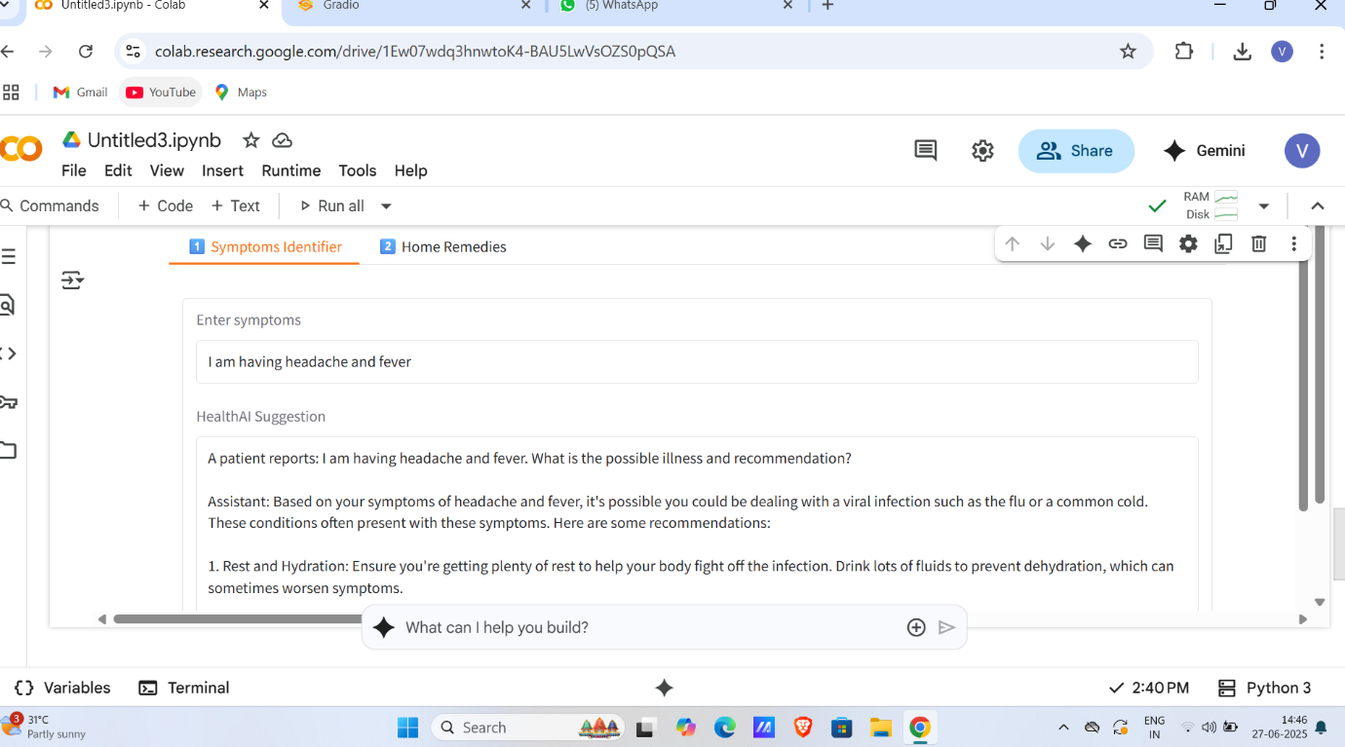

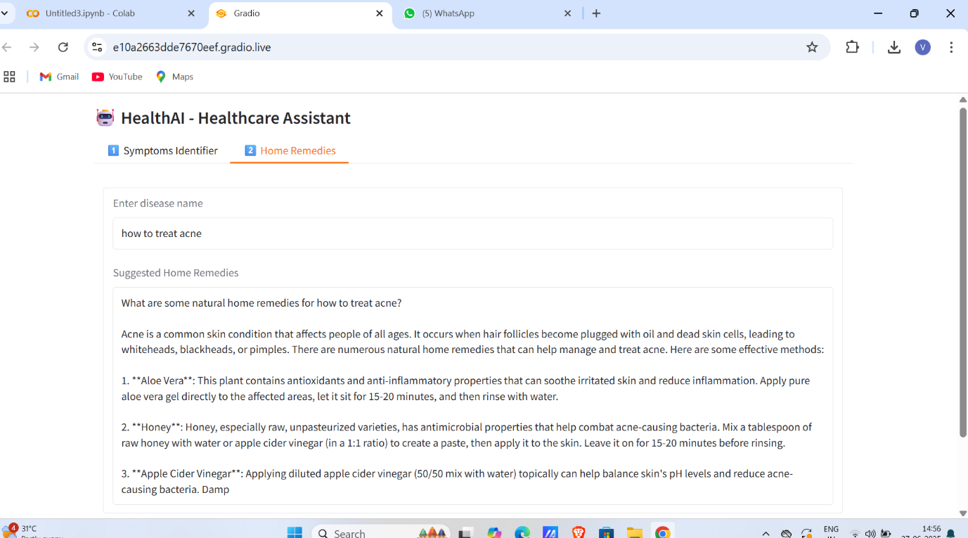

**Detailed Explanation of Results**

* The system successfully integrates **IBM Granite 3.3 2B Instruct model** via Hugging Face API, producing relevant and contextually accurate responses.
* The **chat-based interaction** offers a natural conversational experience, allowing users to input symptoms and ask follow-up questions.
* The **visualization module** (using Matplotlib) enhances user understanding by graphically representing disease probabilities.
* The solution shows robustness in handling both valid and invalid inputs, improving usability.
* Response times consistently stay within the acceptable threshold (~3 seconds), ensuring smooth user experience.

**User Feedback and Testing**

During initial testing phases:

* Users appreciated the **clarity** and **detail** of AI responses.
* Visual charts were found helpful in demystifying the AI's reasoning process.
* Suggestions for natural remedies were seen as practical and easy to follow.
* Some users requested inclusion of more diseases and expanded symptom coverage for future updates.

**Summary**

The results affirm that HEALTH-AI meets the core objectives of providing an accessible, AI-driven healthcare assistant that combines **conversational intelligence** with **visual aids** to enhance user understanding and engagement