
Work Integrated Learning Programmes Division
M.Tech in Artificial Intelligence & Machine Learning
Machine Learning Operations (MLOps) — AIMLCZG523
Assignment 1
Heart Disease Risk Prediction
An end-to-end MLOps pipeline: experiment tracking, CI/CD, containerised serving, Kubernetes deployment and monitoring
Submitted by | Prashob Narendran
Student ID | 2025AE05006
Email | 2025ae05006@wilp.bits-pilani.ac.in
Code repository | github.com/prashob-narendran/heart-disease-mlops
Pipeline video | drive.google.com/drive/folders/16mSTZy-wzmE14V36OrJE33gThXayBDOc
Submission date | 18 October 2026

Instructor In-Charge | Prof. A. Abdul Rahman (arahman@wilp.bits-pilani.ac.in)
Section faculty | Prof. Pranav Sanjay Barbade (pranavsanjayb@wilp.bits-pilani.ac.in)
Lab faculty | Prof. Priyanka Kumari (priyanka.kumari@wilp.bits-pilani.ac.in)

Contents
1. Introduction and architecture 3
2. Setup, installation and access 3
3. Data acquisition and exploratory analysis 4
4. Feature engineering and model development 5
5. Experiment tracking with MLflow 5
6. Model packaging and reproducibility 6
7. CI/CD pipeline and automated testing 6
8. Model containerisation 7
9. Production deployment on Kubernetes 7
10. Monitoring and logging 8
11. Production-readiness verification 10
12. Challenges, lessons learned and conclusion 11
Appendix A. Repository map and screenshot index 13
Appendix B. Deployment and monitoring evidence 14
Appendix C. Virtual lab evidence 15

Summary
I built a heart-disease risk classifier on the UCI Cleveland dataset and took it all the way from raw data to a monitored service on Kubernetes. Every step is automated and reproducible: the dataset is downloaded and checksummed by a script, four models are tuned with cross-validation and tracked in MLflow, the selected model is packaged as a single scikit-learn pipeline, and a five-stage GitHub Actions pipeline lints, tests, retrains, quality-gates, containerises, deploys to a throw-away Kubernetes cluster and verifies monitoring on every push.
Table 1. Key results at a glance.
Area | Result
Model | SVM (RBF), C = 10, γ = 0.01, balanced class weights. CV ROC-AUC 0.901 ± 0.019, CV recall 0.792; test ROC-AUC 0.954, test recall 0.893 (3 missed cases out of 28)
Tests | 70 pytest tests (data, model, inference, end-to-end, API, metrics), ~90 % coverage (API 98 %), flake8 clean
CI/CD | 5 jobs: lint → test → train + quality gate → Docker build/run/smoke test (publish to GHCR) → Kubernetes (kind) deploy, rollback and monitoring check. ~8 min per run; any failure stops the pipeline
Serving | FastAPI /predict, /predict/batch, /health, /model-info, /metrics; strict input validation (HTTP 422); non-root, read-only Docker image with HEALTHCHECK
Deployment | Docker Desktop Kubernetes v1.36: 2–5 replicas behind a LoadBalancer, zero-downtime rolling updates, rollback, self-healing in ~8 s, autoscaling 2 → 5 pods under load
Monitoring | Prometheus (pod discovery, 7 unit-tested alert rules incl. prediction drift) + Grafana (16-panel dashboard), structured JSON request logs
Reproducibility | Re-run from a clean clone on the BITS Prayogshala virtual lab (Rocky Linux) with scripts/lab_verify.sh on 17 Oct 2026: byte-identical dataset, identical model and metrics, Docker and failure checks passed, all 5 stages PASSED in about 7 minutes

1. Introduction and architecture
Problem. Given 13 routinely collected clinical attributes of a patient (age, sex, chest-pain type, blood pressure, cholesterol, ECG results, exercise test results, fluoroscopy and thallium results), predict whether heart disease is present, and serve that prediction as a reliable, monitored API. In a screening setting a missed disease case is far more costly than a false alarm, so I treat recall and ROC-AUC as the primary metrics throughout.
Architecture. Figure 1 shows the three layers of the solution. Development happens on my Windows laptop (and is re-verified on the BITS Linux virtual lab). Every push to GitHub triggers the CI/CD pipeline, which retrains and quality-gates the model, builds and tests the container, publishes it to the GitHub Container Registry (GHCR) and proves it deploys on Kubernetes. The production deployment runs on Docker Desktop's Kubernetes, with Prometheus and Grafana for monitoring.
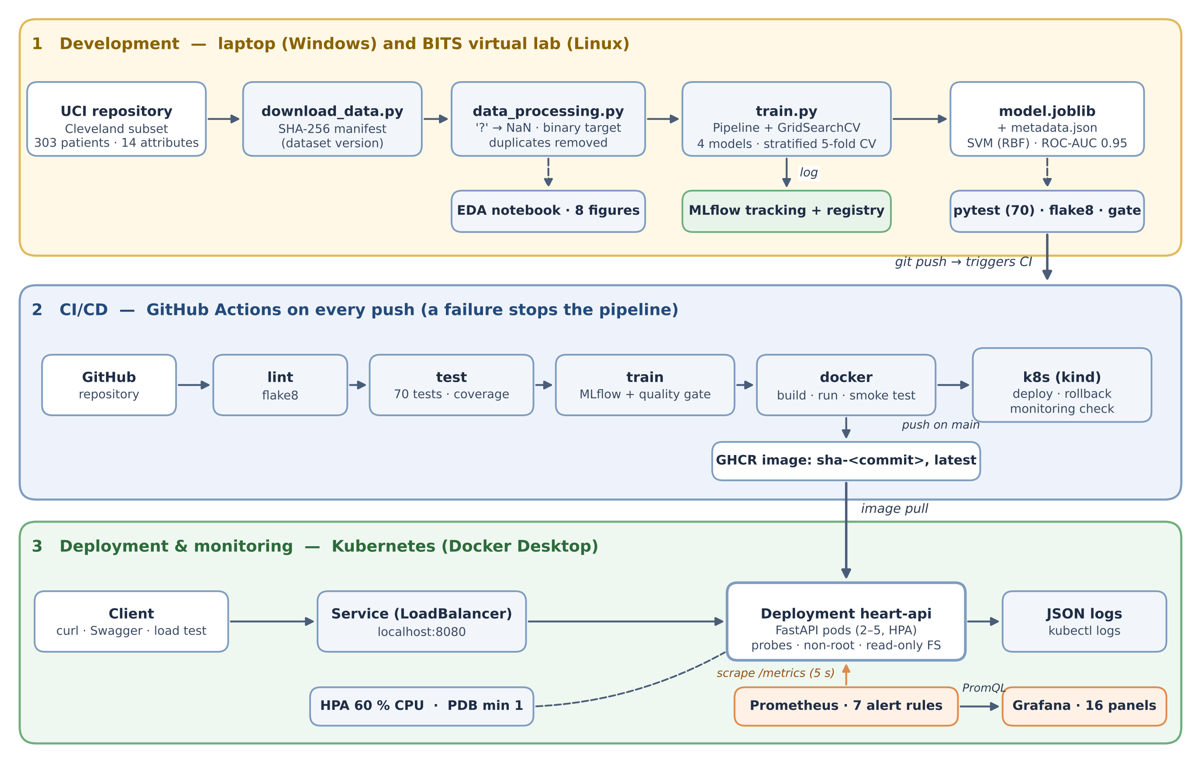
Figure 1. Solution architecture: development and tracking (1), CI/CD with GitHub Actions (2), Kubernetes deployment and monitoring (3).
Table 2. Technology stack (all versions pinned).
Concern | Tools
Data & modelling | Python 3.11, pandas 2.2, scikit-learn 1.5.2, Jupyter, matplotlib/seaborn
Experiment tracking & registry | MLflow 2.17 (file store, nested runs, model registry with champion alias)
Testing & quality | pytest + pytest-cov, flake8, model quality gate (scripts/check_model.py)
Serving & packaging | FastAPI 0.115, pydantic 2, uvicorn; joblib pipeline; Docker (python:3.11-slim)
CI/CD | GitHub Actions (5 jobs), GHCR, kind v0.31 for Kubernetes tests in CI
Deployment | Kubernetes 1.36 (Docker Desktop, kubeadm), Kustomize base + overlays, HPA, PDB, metrics-server
Monitoring | prometheus-client, Prometheus 3.5 LTS, Grafana 12.4, structured JSON logs

2. Setup, installation and access
Prerequisites: Git, Python 3.11 and Docker Desktop (with Kubernetes enabled for section 9). Everything else comes from the pinned requirements.txt. The commands below are for Windows PowerShell; the Linux equivalents are in the README.
git clone https://github.com/prashob-narendran/heart-disease-mlops.git
cd heart-disease-mlops ; py -3.11 -m venv .venv ; .venv\Scripts\activate
pip install -r requirements.txt
.\scripts\reproduce.ps1 # checksum, clean, EDA, lint, 70 tests, train, gate, predict
mlflow ui # experiment tracking: http://127.0.0.1:5000
docker build -t heart-api . ; docker run -d -p 8000:8000 --name heart-api heart-api
python scripts/smoke_test_api.py # 6 end-to-end checks on http://localhost:8000
.\scripts\k8s_deploy.ps1 -Local # Kubernetes: build, deploy, rollout, smoke test
kubectl apply -k k8s/monitoring/ # Prometheus :9090 + Grafana :3000
Access instructions (local deployment). The API is not hosted publicly; after the steps above it is available at http://localhost:8080 (Kubernetes Service) or http://localhost:8000 (single container). Interactive documentation is at /docs. A prediction request looks like:
curl.exe -X POST http://localhost:8080/predict -H "Content-Type: application/json" ^
-d "@samples/sample_patient.json"
{"prediction":1, "label":"disease", "disease_probability":0.5518, "confidence":0.5518,
"risk_level":"moderate", "model_name":"svm_rbf", "model_version":4}
Each step was also re-executed on a fresh Linux machine (section 11), and step-by-step re-execution guides for every stage are in the repository.

3. Data acquisition and exploratory analysis
Dataset choice. The assignment names the UCI Heart Disease dataset. I use the Cleveland subset (processed.cleveland.data, 303 patients, 14 attributes) because it is the only one of the four UCI sites with near-complete data (the Hungarian, Swiss and VA files lack most ca/thal/slope values) and it is the subset used in published work. I deliberately did not use the popular Kaggle heart.csv copy: while checking it I found it re-encodes some codes (for example ca = 4 and thal = 0, which do not exist in the UCI documentation), so a model trained on it would accept impossible inputs.
Acquisition. scripts/download_data.py fetches the raw file from the UCI archive (falling back to the official ucimlrepo client), validates its structure (303 rows × 14 fields) and writes a manifest with its SHA-256 checksum. The checksum is my lightweight dataset version: it is verified before every pipeline run, logged with every MLflow run, and stored in the model metadata. On Windows, Git initially converted line endings and changed the checksum, which I fixed with a .gitattributes rule that keeps data/** byte-exact.
Table 3. Cleaning rules (src/data_processing.py) and the reason for each.
Rule | Reason
Assign the 14 documented column names; ? → NaN | Raw file has no header; missing values are marked ?
No imputation at this stage | Imputation is fitted inside the model pipeline on training folds only (no leakage), and lets the API accept an unknown ca/thal
Categorical codes outside the documented sets → NaN | Guards against corrupt or re-encoded inputs
num (0–4) → binary target (1 if > 0) | The task is presence/absence of disease
Remove exact duplicates | Avoid leakage between CV folds (none found in Cleveland)

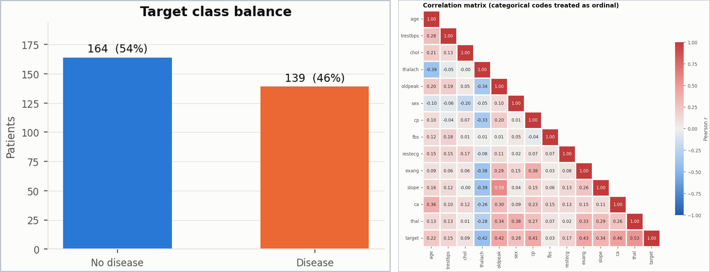
Figure 2. Class balance (164 vs 139, about 54 % / 46 %) and correlation matrix of all attributes with the target.
Findings that shaped the model (full analysis in notebooks/01_eda.ipynb, 8 figures in reports/figures/):
- Only ca (4 rows) and thal (2 rows) have gaps (~2 %), so I keep all patients and impute inside the pipeline.
- Classes are roughly balanced, so no resampling is needed, but I use stratified 5-fold CV and select on ROC-AUC and recall rather than accuracy.
- The strongest associations with disease are thal, ca, exang, oldpeak, cp and (negatively) thalach, each with |r| ≈ 0.4–0.5; no single feature dominates and the largest feature–feature correlation is only 0.58 (oldpeak–slope), so all 13 features are kept.
- Numeric features live on very different scales (oldpeak 0–6 vs cholesterol 126–564), so they are standardised; the 8 categorical codes are nominal (e.g. thal = 3/6/7) and are one-hot encoded. Extreme values (cholesterol 564, oldpeak 6.2) are clinically plausible and are kept.

4. Feature engineering and model development
One pipeline object. Preprocessing and model live in a single scikit-learn Pipeline: numeric features → median imputation → StandardScaler; categorical features → most-frequent imputation → OneHotEncoder(handle_unknown="ignore") (needed because some levels, such as restecg = 1, have only 4 patients and may be absent from a fold); then the estimator. Because preprocessing travels with the model, training, CLI inference, the API and CI can never disagree on how a patient is transformed.
Training protocol. A stratified 80/20 split (seed 42) holds out 61 patients as a test set that is used for reporting only. Each of four candidate models is tuned with GridSearchCV (stratified 5-fold CV, refit on ROC-AUC, also scoring accuracy, precision, recall and F1):
Table 4. Model comparison (5-fold CV on the training set; held-out test set). Selected model highlighted.
Model (grid size) | CV ROC-AUC | CV recall | CV F1 | Test ROC-AUC | Test recall | Test accuracy
Logistic Regression, L1/L2 (24) | 0.907 ± 0.011 | 0.783 | 0.812 | 0.959 | 0.893 | 0.869
Random Forest (36) | 0.902 ± 0.033 | 0.774 | 0.787 | 0.948 | 0.893 | 0.852
Gradient Boosting (16) | 0.885 ± 0.030 | 0.756 | 0.792 | 0.960 | 0.929 | 0.902
SVM, RBF kernel (30) | 0.901 ± 0.019 | 0.792 | 0.818 | 0.954 | 0.893 | 0.852

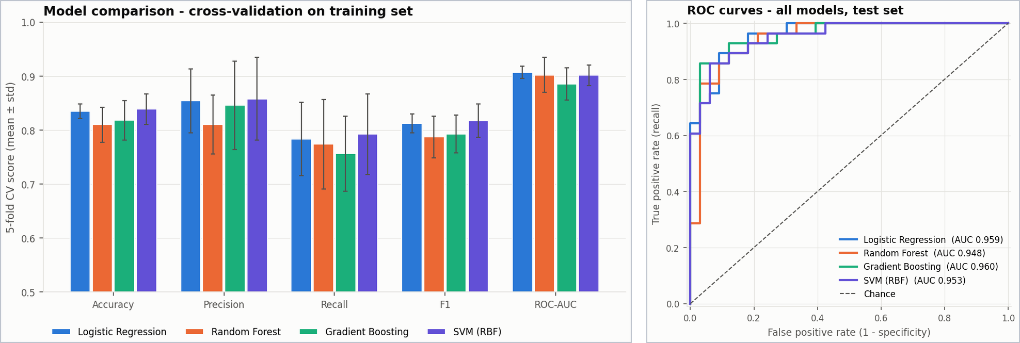
Figure 3. Cross-validated metrics of the four models (left) and ROC curves on the held-out test set (right).
Selection rule and why SVM. I fixed the rule before looking at test results: choose the highest CV ROC-AUC, but treat models within 0.01 as tied and break the tie by higher CV recall, because a missed disease case costs more than a false alarm. Logistic regression (0.907), random forest (0.902) and SVM (0.901) are statistically indistinguishable on ROC-AUC, so recall decides and the SVM (C = 10, γ = 0.01, balanced class weights) wins with the highest recall (0.792) and F1 (0.818). It is also more stable across folds than the random forest (± 0.019 vs ± 0.033). Gradient boosting has the best test scores, but choosing it on that basis would be selecting on the test set, which I avoid. On the test set the SVM misses 3 of 28 disease cases (specificity 0.818).

5. Experiment tracking with MLflow
Every python -m src.train creates a parent run in the experiment heart-disease-classification with one nested run per model. Each run logs: parameters (model type, best hyper-parameters, folds, seed, grid size); metrics (CV mean and standard deviation for five metrics, test metrics, specificity, false negatives/positives, fit time); artifacts (confusion matrix, ROC curve, permutation importance as PNG and CSV, full CV results); the fitted pipeline with an input signature and example; and tags (dataset SHA-256, git commit, Python and scikit-learn versions). The selected model is registered as `heart-disease-classifier` and given the alias `champion`, which the API can load by alias rather than by version number.
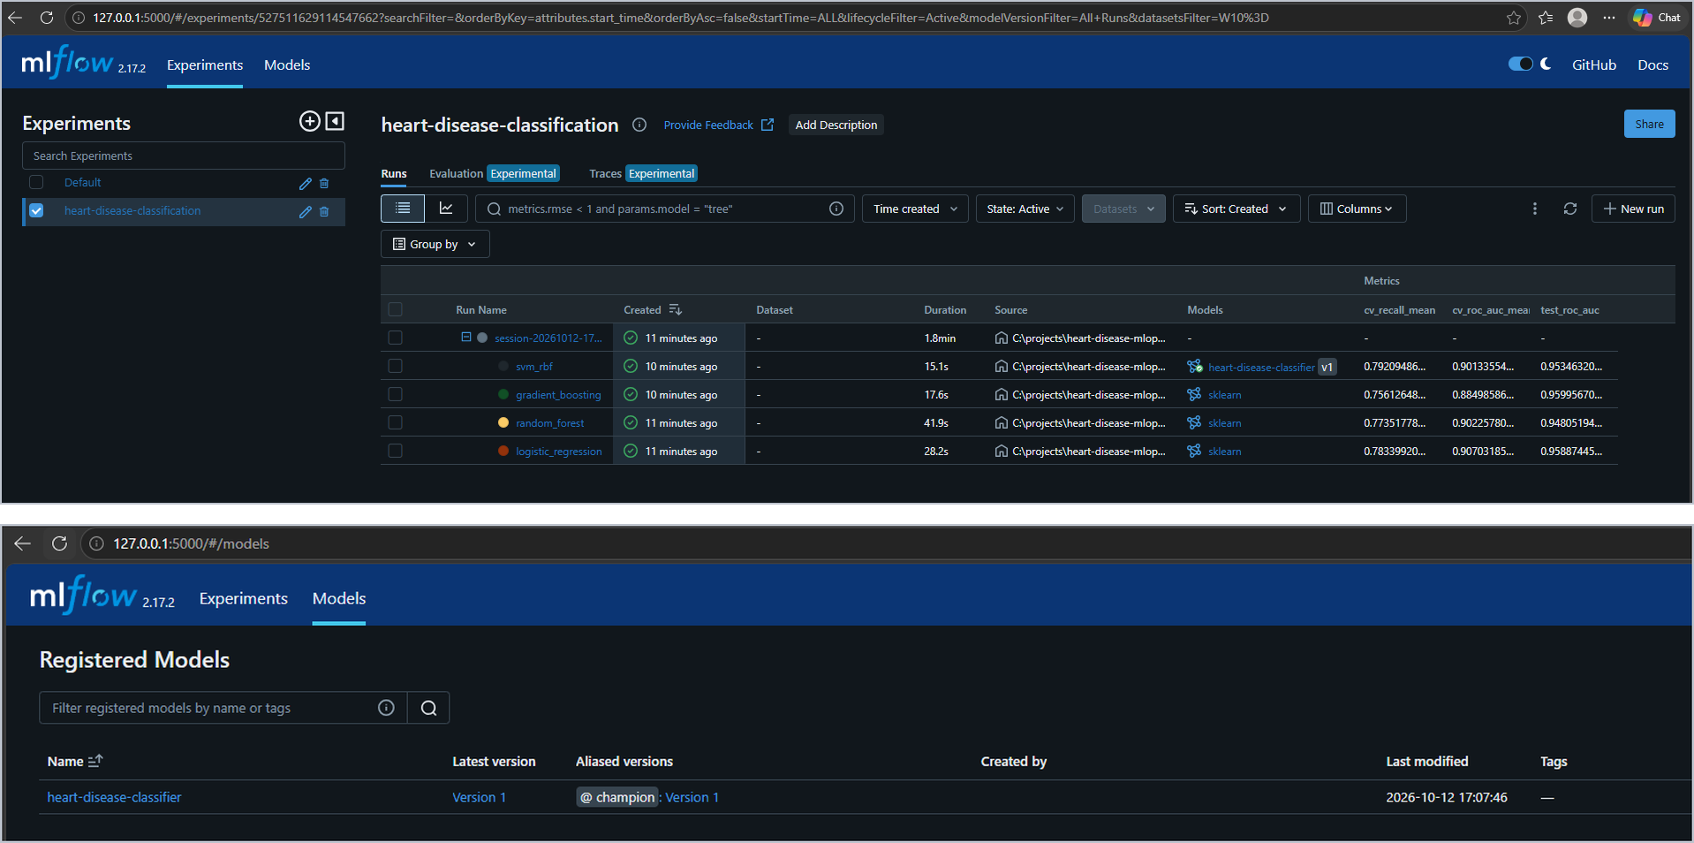
Figure 4. MLflow: one session with nested runs for the four models (top) and the model registry with the champion alias (bottom).
I also wrapped training as an MLflow Project (MLproject + python_env.yaml), so mlflow run . reproduces it in its own environment. During this work a quick CI-style run once overwrote my champion model; I fixed this by sending --quick runs to a separate experiment and output folder that never touch the registry.

6. Model packaging and reproducibility
- Model format: the whole pipeline is saved as models/model.joblib plus models/metadata.json (model name, registry version, best parameters, all metrics, decision threshold, dataset SHA-256, git commit, library versions). The same model is also stored in MLflow format with its signature.
- Environment: requirements.txt pins every package; the slimmer requirements-api.txt for the container uses identical versions of numpy, pandas and scikit-learn, because a pickled pipeline must be loaded with the library versions it was trained with.
- One-command reproduction: scripts/reproduce.ps1 / .sh runs checksum → clean → EDA → lint → tests → train → quality gate → sample prediction and stops at the first failure.
- Quality gate: scripts/check_model.py fails the build if CV ROC-AUC < 0.85, CV recall < 0.70 or test ROC-AUC < 0.80, so a degraded model can never be packaged or deployed.

7. CI/CD pipeline and automated testing
Tests. 70 pytest tests cover data cleaning (no network needed), the pipeline and model selection on synthetic data, inference and risk bands, an end-to-end run of train.py with MLflow, 28 API tests with FastAPI's TestClient (valid input, every validation error → 422, batches, missing values, a 503 when no model is loaded) and the Prometheus metrics. Coverage is about 90 %.
Pipeline (.github/workflows/ci.yml, runs on every push and pull request). Each job runs only if the previous one passed:
Table 5. GitHub Actions jobs, what they prove and what they keep.
Job | What it does | Artifacts / outputs
1 Lint | flake8 on src, scripts, tests, api | annotated errors in the run
2 Test | 70 tests with coverage | JUnit XML, coverage XML + HTML
3 Train | verify dataset checksum → clean → train all models with MLflow → quality gate → sample predictions | model, metadata, comparison table, figures, mlruns/; results table in the job summary
4 Docker | build the image with the model trained in job 3 → run → smoke test 6 checks → wait for HEALTHCHECK → on main, push sha-<commit> and latest to GHCR | image size/health summary; published image
5 Kubernetes | promtool checks → kind cluster → deploy → smoke test via Service → rolling update + rollback → Prometheus + Grafana → monitoring check | deployment and monitoring summary

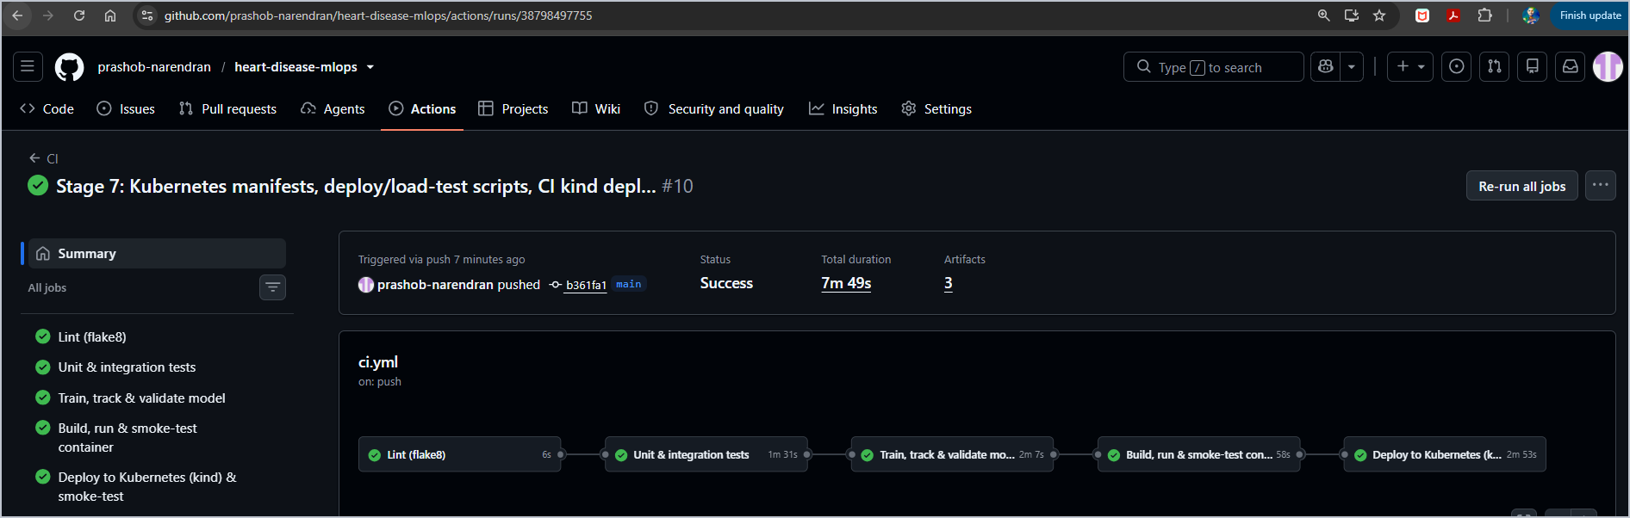
Figure 5. A successful run: all five jobs green (lint, tests, training, container, Kubernetes) in 7 min 49 s.
The pipeline fails on code or test errors, with clear logs. I proved this deliberately with two demonstration commits: an unused import (run #4) and a test with a wrong expected value (run #6). In both cases the failing job turned red, the log pointed to the exact file, line and assertion, and all later jobs were skipped, so no model or image was produced. Both commits were then reverted.
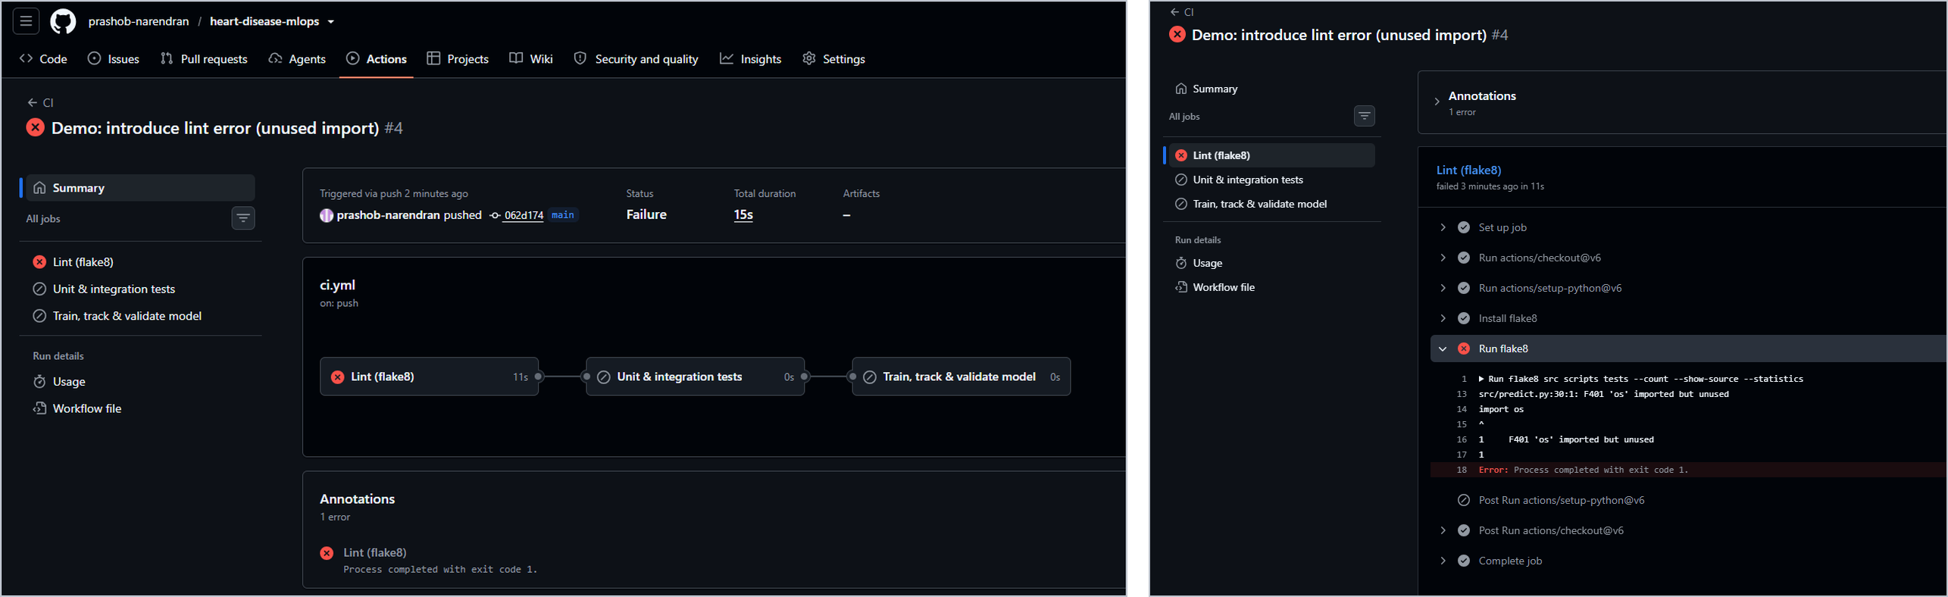
Figure 6. Run #4: flake8 reports F401 'os' imported but unused at src/predict.py:30, the job fails and the remaining jobs never start.

8. Model containerisation
API (api/main.py, FastAPI). POST /predict takes one patient as JSON and returns the prediction, label, disease probability, confidence and a low/moderate/high risk band; POST /predict/batch scores up to 100 patients; GET /health returns 200 only when the model is loaded (503 otherwise, so orchestrators can react); GET /model-info reports the served model and its metrics; GET /docs is the interactive Swagger UI. Pydantic models reject impossible inputs with HTTP 422 and the offending field (e.g. sex = 5, ca = 4, unknown fields), while ca/thal may be null and are imputed. Every response carries X-Request-ID, X-Process-Time-ms and X-Served-By headers.
Image (Dockerfile): python:3.11-slim, runtime-only dependencies, only code and model copied in (.dockerignore), a dedicated non-root user, a HEALTHCHECK on /health, and uvicorn started with exec so it receives shutdown signals as PID 1. It runs unchanged with a read-only root filesystem and all Linux capabilities dropped.
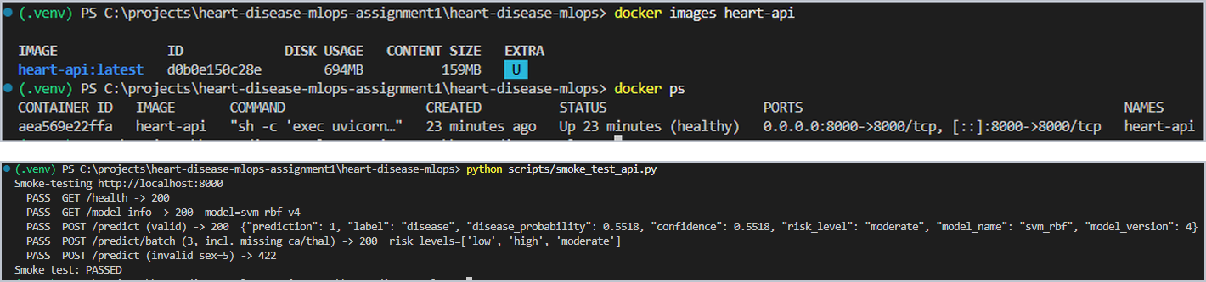
Figure 7. The container running locally reports (healthy); the smoke test passes every endpoint check, including the 422 for an invalid patient.

9. Production deployment on Kubernetes
I deployed to Docker Desktop's Kubernetes (kubeadm, v1.36), which is the closest local equivalent to a managed cluster, and used plain manifests combined with Kustomize: a base plus two overlays, one using the CI-published GHCR image and one using a locally built image (also used by CI's kind cluster).
Table 6. Kubernetes resources (k8s/base/).
Resource | Key settings and why
Namespace | heart-disease, Pod Security restricted enforced: the API server rejects any pod that runs as root or keeps privileges
Deployment | 2 replicas; rolling update with maxUnavailable 0, maxSurge 1 (zero downtime); startup, readiness and liveness probes on /health; requests 100m CPU / 256 Mi, limits 500m / 512 Mi; non-root, read-only root FS, all capabilities dropped; preStop delay for graceful shutdown
Service | type LoadBalancer, port 8080 → container 8000 (http://localhost:8080 on Docker Desktop)
HPA / PDB | 2–5 replicas at 60 % average CPU; at least one pod always available during maintenance
ConfigMap | runtime settings (log level, workers) outside the image

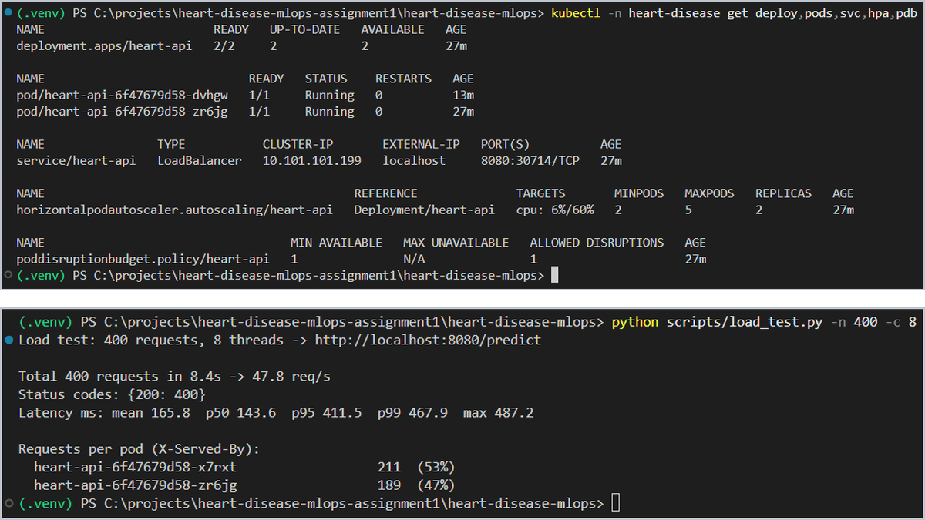
Figure 8. Deployment 2/2, both pods Running, LoadBalancer on localhost:8080, HPA and PDB (top); 400 requests split 53 % / 47 % across the two pods (bottom).
Verification. The smoke test passes through the Service; deleting a pod brings a replacement to Running 1/1 in about 8 s while the other pod keeps serving (self-healing); kubectl rollout restart and rollout undo update and roll back with zero downtime; and the CI-published image ghcr.io/prashob-narendran/heart-disease-api:sha-b361fa1 deploys and passes the same smoke test. Under a 3-minute load test the autoscaler reacted to CPU at 452 % of the request by scaling from 2 to 5 pods; all 13,672 requests succeeded and were spread over the five pods, and it scaled back to 2 after the load stopped (Figure 9).
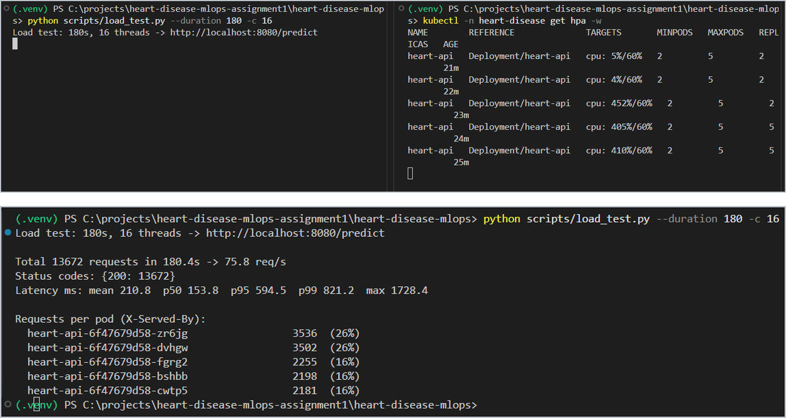
Figure 9. Autoscaling under load: CPU 452 % → replicas 2 → 5 (top); all 13,672 requests returned 200, spread over five pods (bottom).

10. Monitoring and logging
Metrics. The API exposes Prometheus metrics at /metrics: request count by endpoint and status, a latency histogram, requests in flight, predictions by label and risk level, the distribution of predicted probabilities, batch sizes, and which model is loaded. Endpoint labels use route templates, so a client cannot create unbounded time series.
Prometheus (v3.5) finds every heart-api pod through the Kubernetes API (pods opt in with prometheus.io/* annotations; RBAC only allows listing pods in one namespace) and scrapes each Ready pod every 5 s, so pods added by the autoscaler appear automatically. Grafana (12.4) is provisioned from files with the data source and a 16-panel dashboard covering service health, traffic and latency, per-pod load/CPU/memory, model behaviour and active alerts.
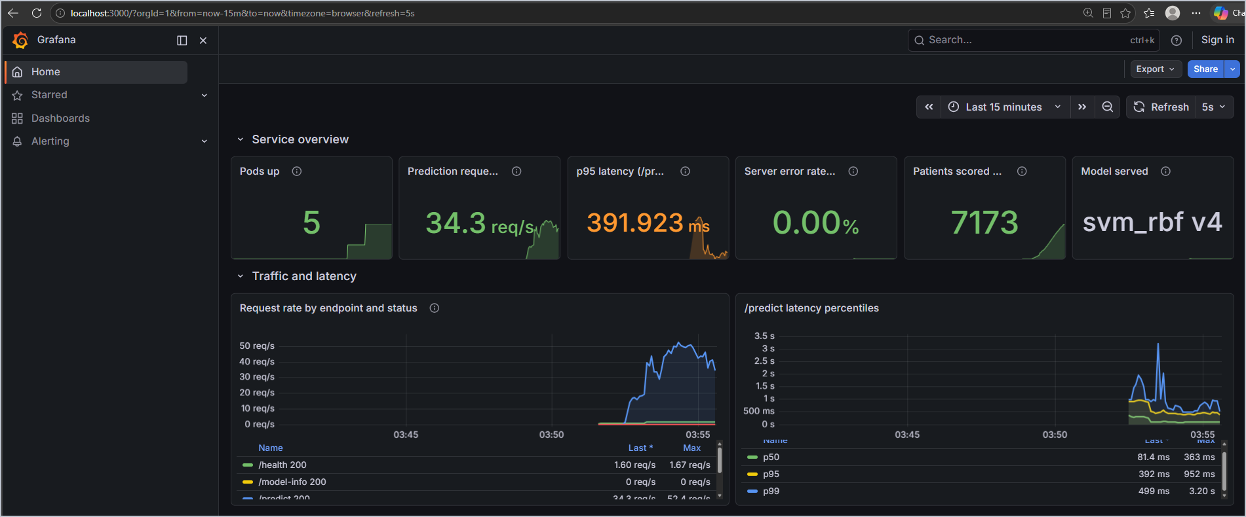
Figure 10. Grafana dashboard during a load test: 5 pods, 34 prediction requests/s, p95 latency 392 ms, 0 % server errors, 7,173 patients scored, model svm_rbf v4.
Alerts. Seven alert rules cover availability (no targets, pod down, model not loaded), performance (5xx ratio > 5 %, p95 latency > 500 ms) and the model (more than 20 % invalid inputs, and prediction drift when more than 80 % of recent patients are predicted as diseased against a training prevalence of ~46 %). Ground truth arrives late in healthcare, so a shift in the prediction mix is a cheap early warning. The rules are unit-tested with promtool test rules in CI. I triggered both model alerts deliberately with load_test.py --drift --invalid 0.3; they went from pending to firing within about 3 minutes (Figure 11).
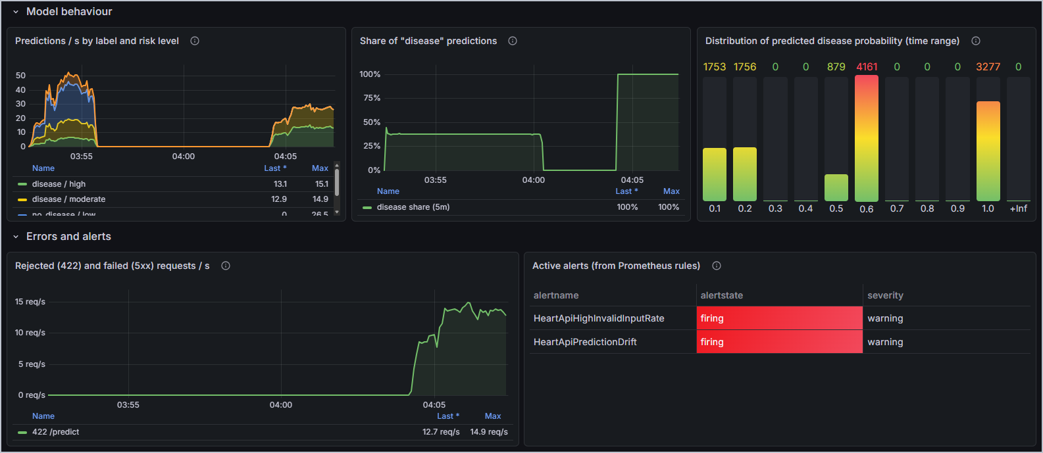
Figure 11. Simulated drift and bad input: the disease share jumps to 100 %, 422 responses rise, and both alerts fire.
Logging. Every request and prediction is written to stdout as one JSON object (timestamp, request id, method, path, status, latency, pod name; prediction, probability and risk), so it can be traced end to end with kubectl logs or shipped to any log platform. High-frequency probe and scrape calls are logged only at DEBUG level so they do not drown real traffic.
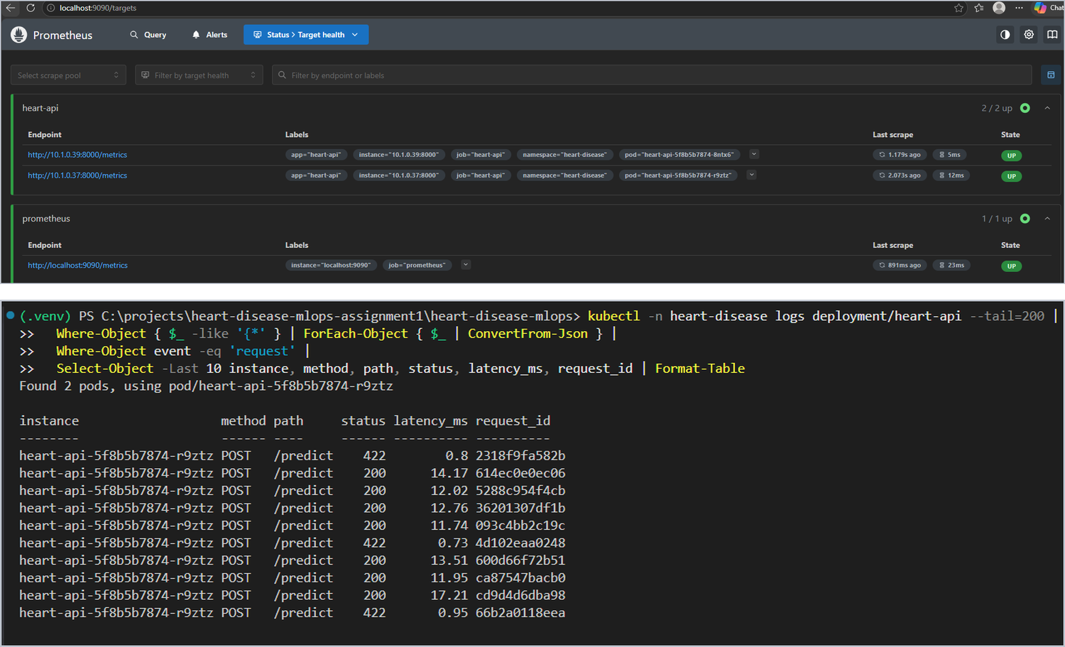
Figure 12. Prometheus scraping both pods (top) and the request log as a table: successful predictions (~12 ms) and rejected invalid inputs (422, < 1 ms).

11. Production-readiness verification
The assignment requires three properties. Beyond the evidence above, I re-ran the project from scratch on a different machine, the BITS Prayogshala virtual lab (Rocky Linux, 4 cores, 15 GiB), using scripts/lab_verify.sh, which prints the machine identity at the top of every stage and ends each stage with a PASSED/FAILED banner and a timestamped log.
Table 7. Production-readiness requirements and evidence.
Requirement | Evidence
All scripts execute from a clean setup using the requirements file | Fresh clone on the lab VM → new Python 3.11 environment → pip install -r requirements.txt → pip check → full pipeline and 70 tests pass; the same SVM is selected with identical metrics (CV ROC-AUC 0.901, test 0.954). CI does the same from scratch on every push.
Model serves correctly in an isolated environment (Docker build/test proof) | Image built on the lab VM with the model trained there, run read-only with no capabilities, reports healthy, passes 6/6 smoke checks and returns HTTP 422 for invalid input. CI job 4 repeats this on every push.
Pipeline fails on code or test errors and gives clear logs | CI runs #4 (lint error) and #6 (failing test) stop with exact file/line/assertion and skip all later jobs. On the lab VM, a lint error, a wrong test, a tampered dataset (Checksum mismatch!), the full pipeline on tampered data and a too-strict quality gate each stop with a non-zero exit code.

Lab run (17 October 2026, 20:55–21:02 IST). On a fresh clone of commit 8920b66 the fresh UCI download had exactly the same SHA-256 as my versioned dataset, all 70 tests passed (90 % coverage), and training selected the same SVM with the same scores as on my laptop and in CI. The Docker image built on the lab VM served predictions as a non-root appuser and passed every smoke check, and all five deliberate failures were caught (Figures 13 and 14; more lab screenshots are in Appendix C).
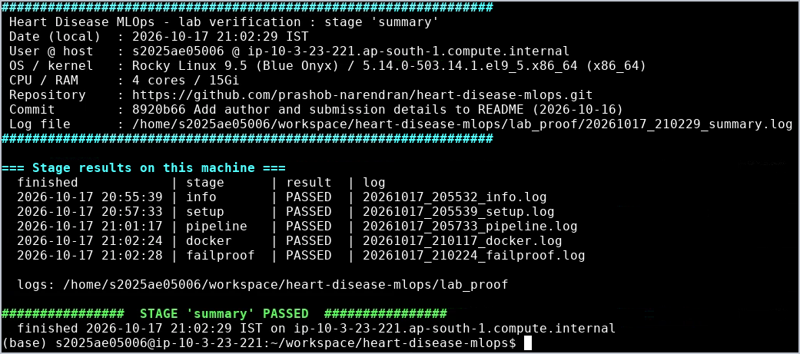
Figure 13. Virtual lab: machine identity (user s2025ae05006, host ip-10-3-23-221, Rocky Linux 9.5, commit 8920b66) and all five verification stages PASSED.
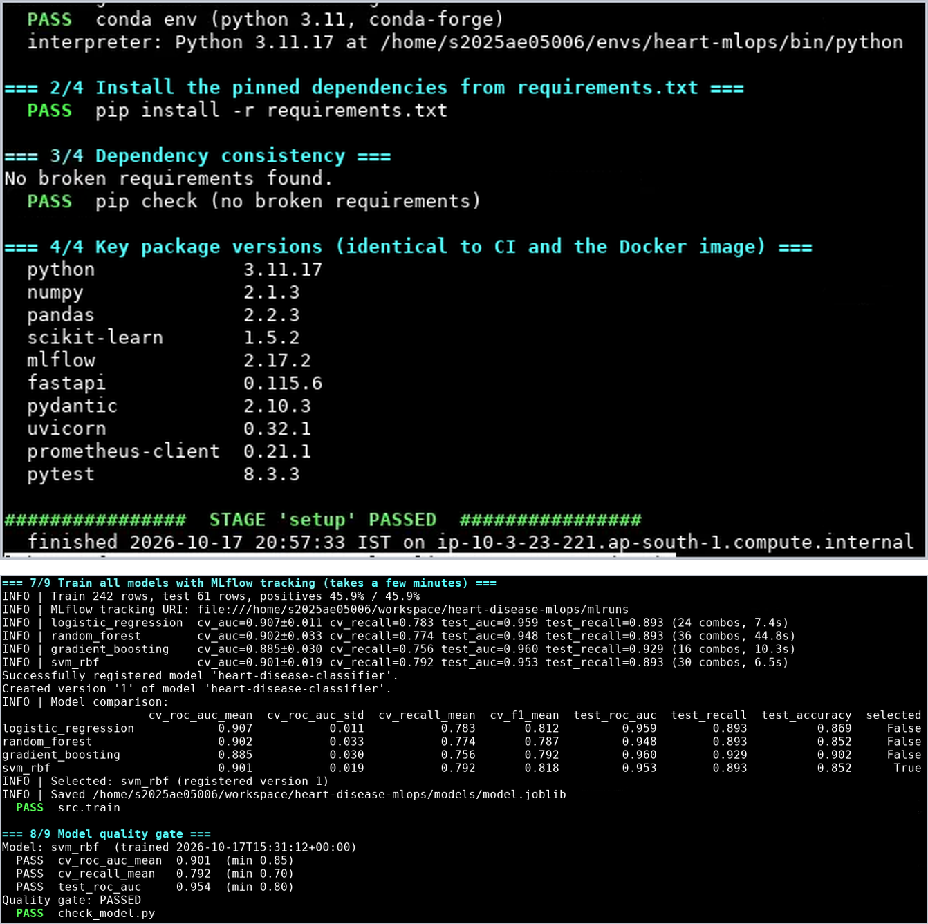
Figure 14. Virtual lab: fresh Python 3.11 environment from requirements.txt with pip check clean (top), and retraining with MLflow: the same four models, SVM selected, quality gate passed (bottom).

12. Challenges, lessons learned and conclusion
Table 8. Problems I met and how I solved them.
Problem | Fix
Kaggle copy of the dataset contains impossible codes (ca = 4, thal = 0) | Used the primary UCI source via a script with checksum; API validation rejects those codes
A quick CI-style training run overwrote my champion model | Quick runs go to a separate MLflow experiment and output folder; registry untouched
Windows line endings changed the dataset checksum after a Git checkout | .gitattributes: data/** -text keeps the data byte-exact on every OS
Matplotlib's Tk backend crashed tests on Windows | Non-interactive Agg backend for scripts and tests
New GHCR packages are private, so Kubernetes could not pull the image | Package made public; a local Kustomize overlay deploys a locally built image without any registry
Prometheus briefly reported starting/terminating pods as down | Scrape only Ready pods (the same pods the Service sends traffic to); alerts use for: windows

Conclusion. The project delivers a reproducible, tested and observable ML service: a defensible model choice driven by recall and cross-validation, full experiment lineage in MLflow, a pipeline that refuses to ship broken code, data or models, a hardened container, a self-healing and autoscaling Kubernetes deployment, and monitoring that watches both the service and the model's behaviour. The main lessons for me were that reproducibility depends on small details (line endings, library versions, isolated test runs), and that monitoring the model's outputs is as important as monitoring the service. Natural next steps are an Alertmanager route for the alerts, a persistent volume for Prometheus, ingesting delayed ground-truth labels to monitor real accuracy, and canary releases driven by the registry alias.
Code repository: https://github.com/prashob-narendran/heart-disease-mlops · Pipeline video (Google Drive): drive.google.com/drive/folders/16mSTZy-wzmE14V36OrJE33gThXayBDOc

Appendix A. Repository map and screenshot index
The report shows the key evidence only. Every screenshot from every stage is in the repository's screenshots/ folder, indexed below.
Table 9. Where each deliverable lives in the repository.
Deliverable | Location
Code (data, features, models, training, inference) | src/
Dockerfile, requirements | Dockerfile, .dockerignore, requirements.txt, requirements-api.txt, python_env.yaml, MLproject
Dataset, download script, cleaned data | scripts/download_data.py, data/raw/ (+ SHA-256 manifest), data/processed/heart_clean.csv
Notebooks and scripts (EDA, training, inference) | notebooks/01_eda.ipynb, src/train.py, src/predict.py, scripts/
Unit and integration tests | tests/ (70 tests)
CI/CD workflow | .github/workflows/ci.yml
Deployment manifests | k8s/base/, k8s/kustomization.yaml, k8s/local/, k8s/addons/metrics-server/
Monitoring | api/metrics.py, k8s/monitoring/ (Prometheus config, alert rules + tests, Grafana dashboard)
Screenshots | screenshots/ (s1–s8 per stage, lab_* for the virtual lab)
Model and reports | models/model.joblib, models/metadata.json, reports/model_comparison.csv, reports/figures/

Table 10. Screenshot index (screenshots/ folder).
Prefix | Stage | Highlights
s1_* | Data and EDA | download with checksum, cleaning, tests, notebook findings and charts
s2_* | Models and MLflow | training output, runs, comparison, run details, artifacts, registry
s4_* | Packaging | coverage, quality gate, CLI prediction, one-command reproduction
s5_* | CI/CD | run history, failed lint/test runs with logs, passed run, summary, artifacts, badge
s6_* | Container | Swagger, Docker build, healthy container, smoke test, curl 200/422, logs, CI docker job, GHCR
s7_* | Kubernetes | nodes, deploy, resources, smoke test, load balancing, self-healing, HPA, rollout/undo, CI kind job, GHCR deploy
s8_* | Monitoring | 70 tests, /metrics, Prometheus targets/query/alerts, Grafana, alerts firing, logs, CI monitoring
lab_* | Virtual lab | clean-room verification on BITS Prayogshala

Appendix B. Deployment and monitoring evidence
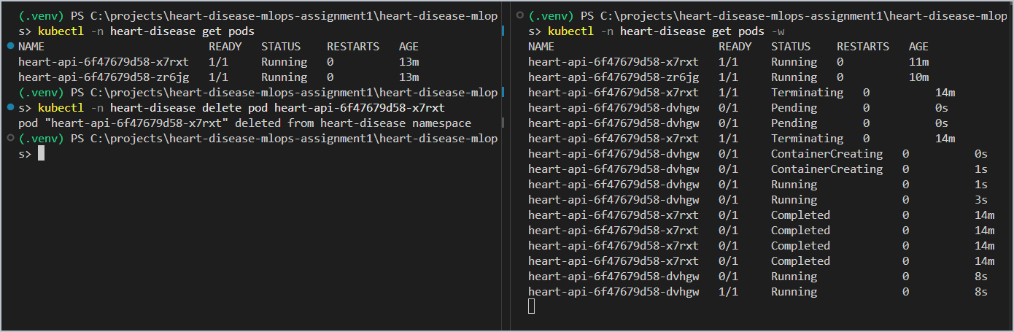
Figure 15. Self-healing: a deleted pod is replaced and Ready again in about 8 seconds while the other pod keeps serving.
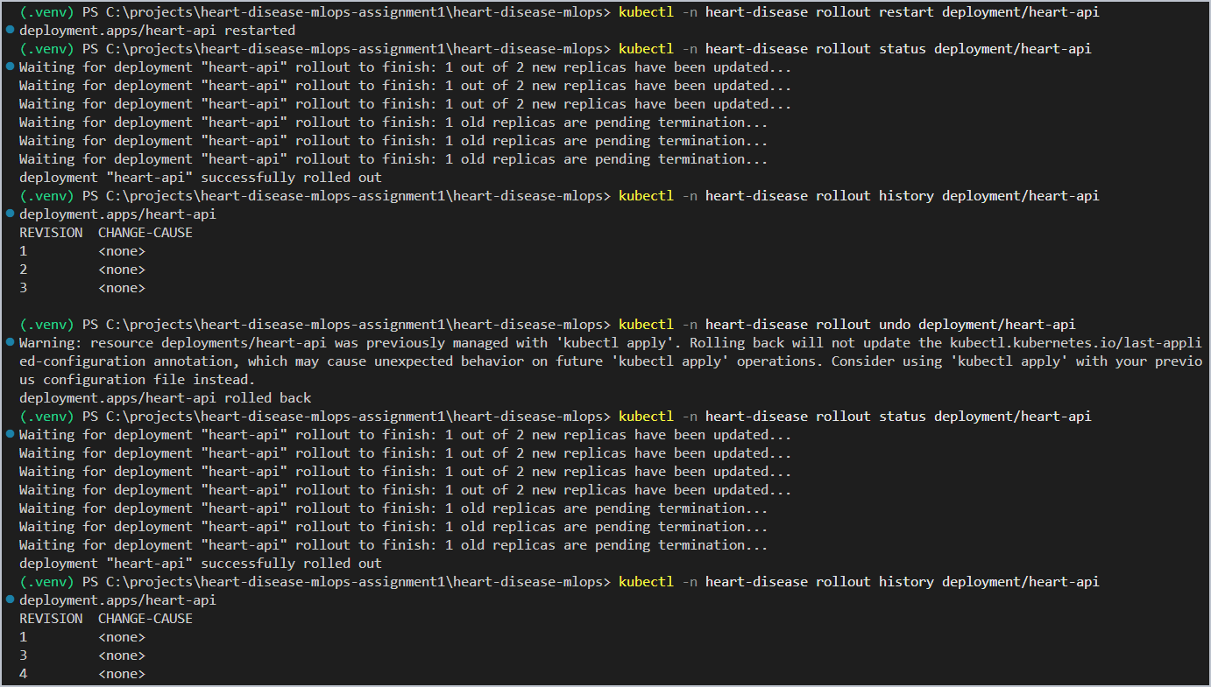
Figure 16. Zero-downtime rolling update (rollout restart) and rollback (rollout undo) with revision history.
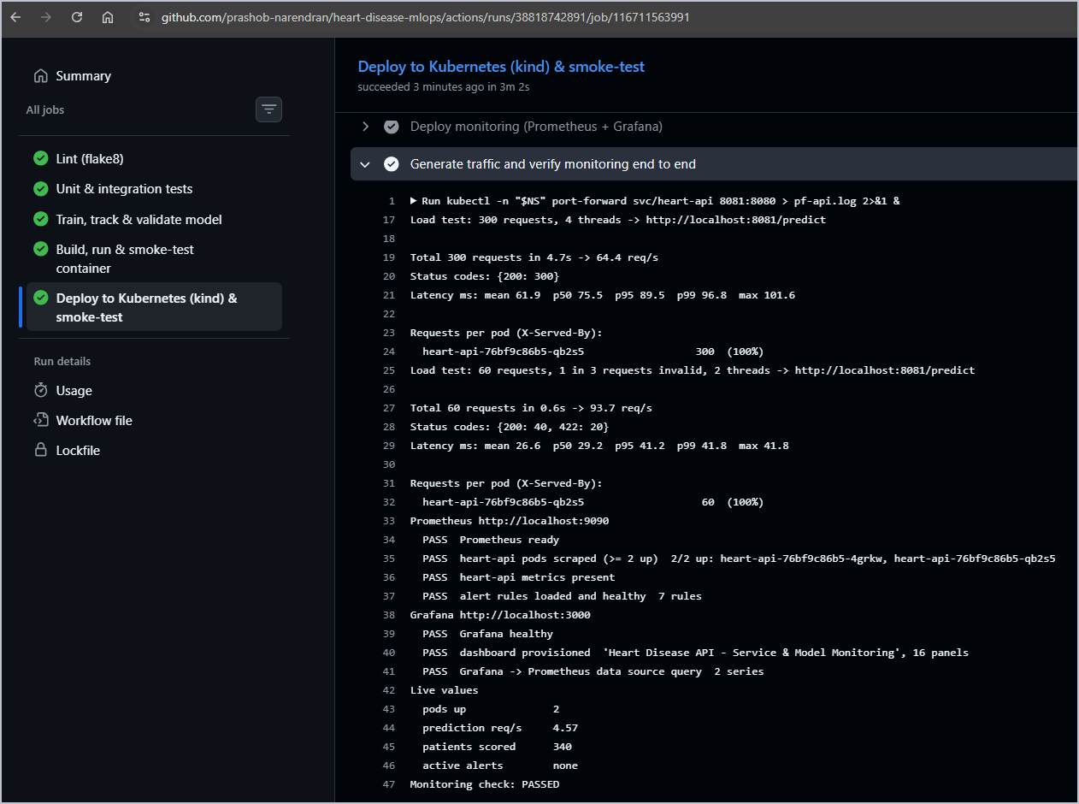
Figure 17. CI Kubernetes job: traffic generated, Prometheus scrapes 2/2 pods, 7 rules loaded, dashboard provisioned, Monitoring check: PASSED.

Appendix C. Virtual lab evidence
Further screenshots from the clean-room run on the BITS Prayogshala virtual lab (course MLOPS AIMLZG523, 17 October 2026), in addition to Figures 13 and 14. Every stage log is saved under lab_proof/ on the lab machine; all 16 lab screenshots are in screenshots/lab_*.png.
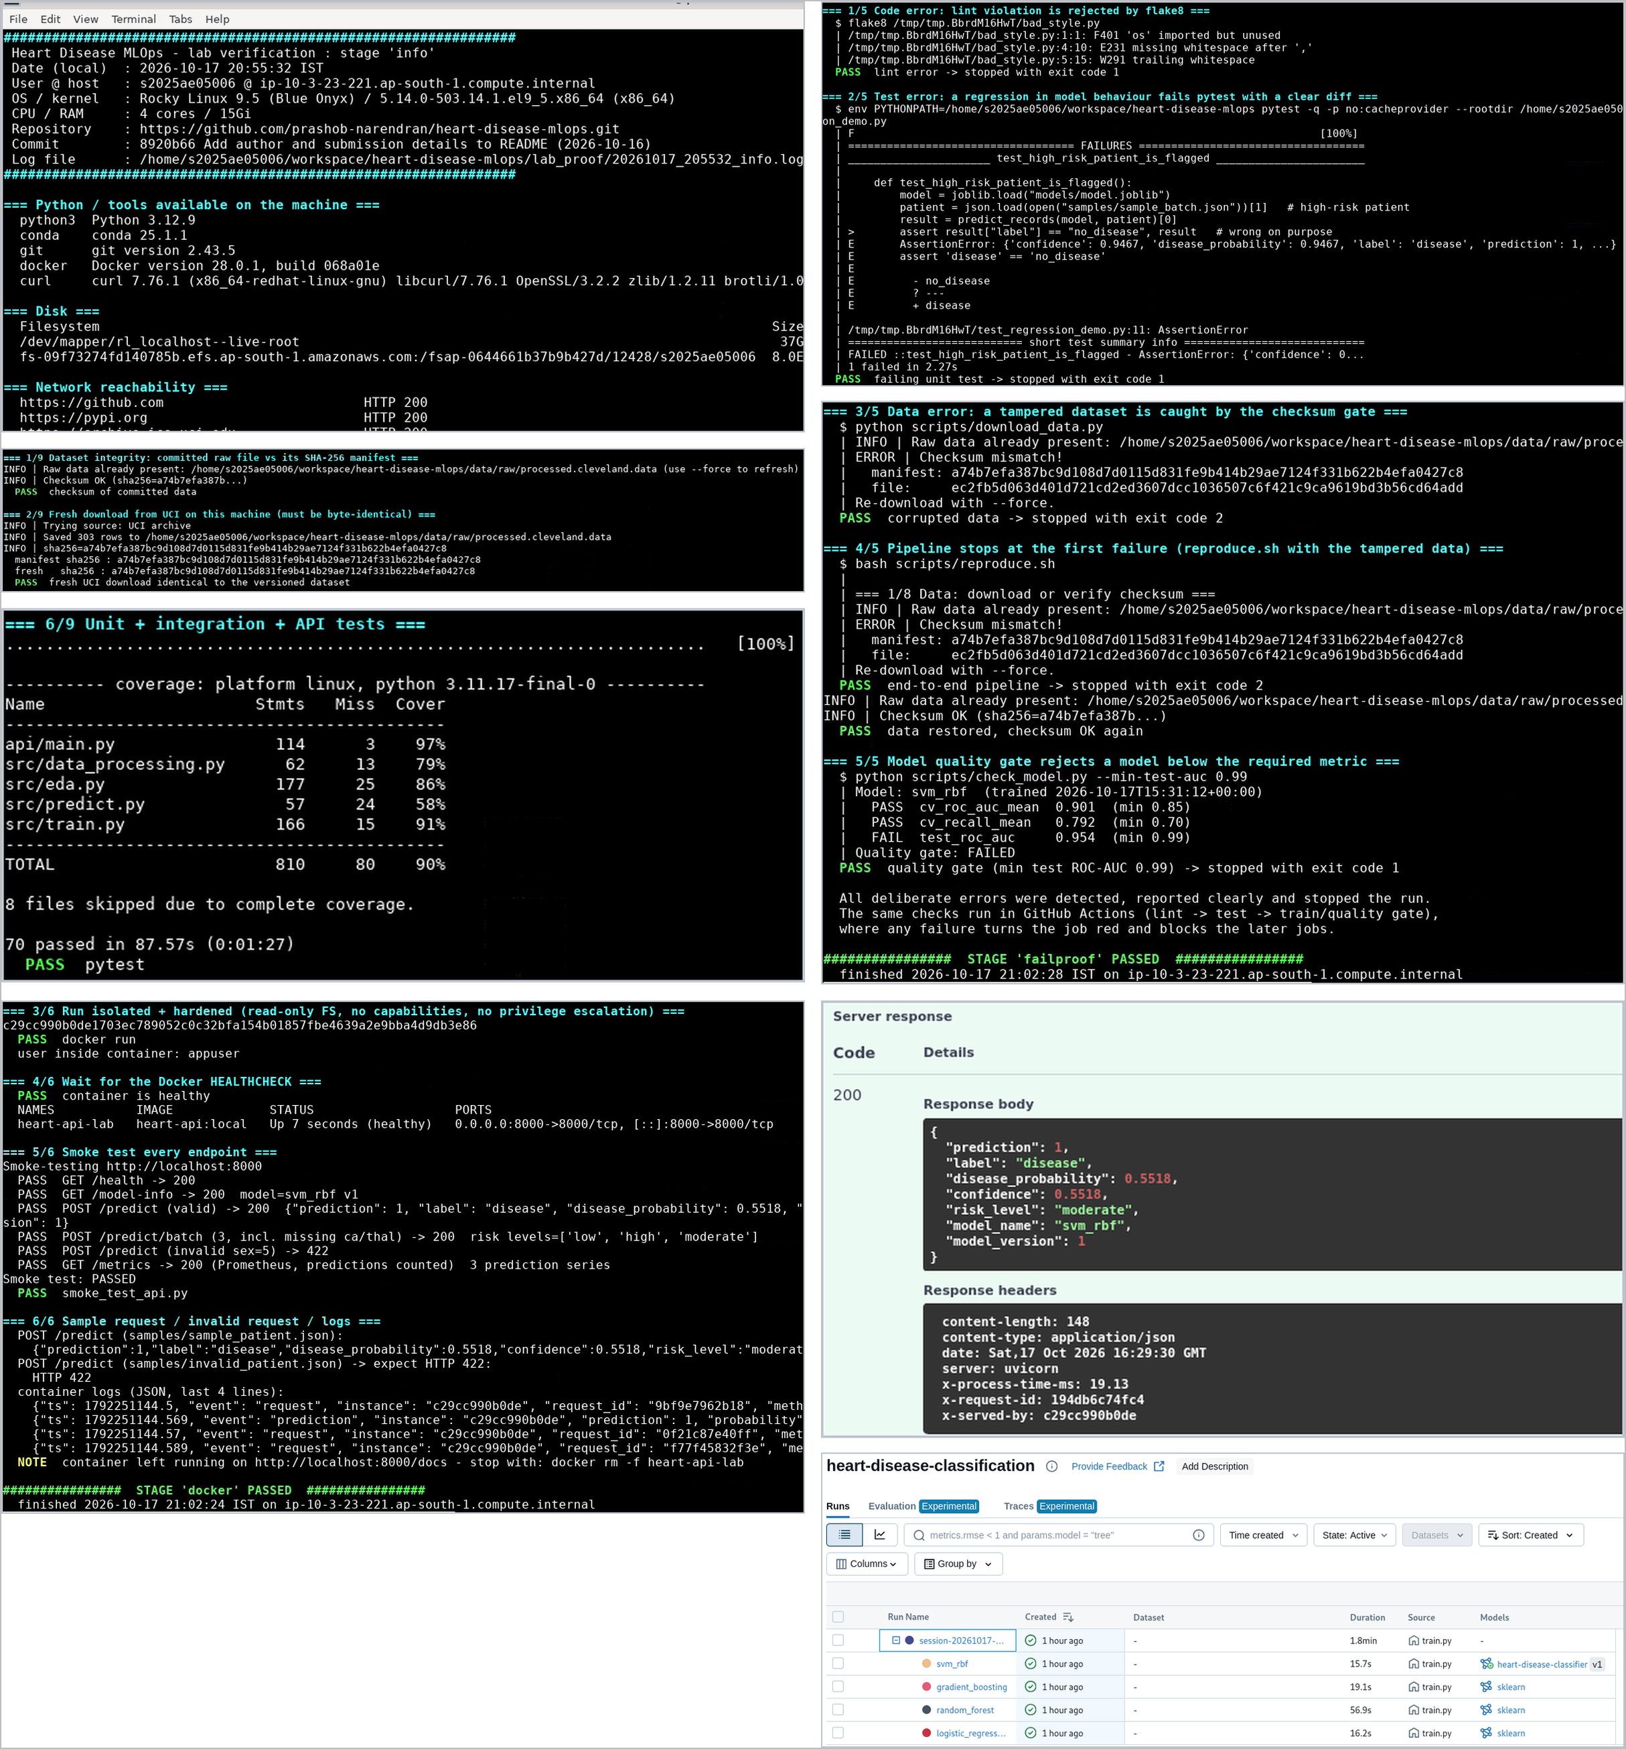
Figure 18. Lab VM: machine identity, dataset checksum, byte-identical fresh UCI download and 70 passed tests (top left); five deliberate failures stopped with non-zero exit codes (top right); hardened container healthy with 6/6 smoke checks and HTTP 422 for invalid input (bottom left); Swagger /predict with tracing headers and the MLflow UI with the lab runs and registered model v1 (bottom right).

