
AI CENTER OF EXCELLENCE
Knowledge Fabric
Enterprise Knowledge Intelligence

Answers your organisation can defend, drawn only from documents it has already approved.
Capability overview and platform walkthrough
A generic platform overview — no client-specific content

Prashobh Paul
AI Architect, QualiZeal · AI Center of Excellence

Contents

1. Overview 3
2. The problem it addresses 3
3. How an answer is produced 4
4. Clarify-back: ask, don’t refuse 5
5. Platform architecture 5
6. Functional coverage 8
7. What the platform covers 8
8. Value delivered 9
9. Deployment and portability 10
10. Delivery approach 10
11. What makes this different 11
12. Glossary 11

Exhibits

Figure 1 How an answer is produced 4
Figure 2 Reference architecture 6

1 Overview
Knowledge Fabric turns an organisation’s own approved documents — procedures, policies, specifications, manuals, records and correspondence — into a system that answers questions in plain language, cites the exact page it drew from, and states how confident it is in what it just said.
It is not a chatbot placed over a search box. Three properties separate it from a general-purpose assistant. Every sentence in an answer traces back to a source the organisation has already approved. The system measures the strength of its own evidence before it speaks, and when that evidence is thin it asks one clarifying question rather than guessing. And every question, answer, clarification and refusal is recorded, so the organisation learns which parts of its knowledge base are working and which are not.
The platform is delivered as one system in five zones: who may ask and what they are allowed to see; how approved content reaches the index; how an answer is assembled; how the organisation proves the answer was sound; and the security and operational foundation underneath. A feedback loop closes the system — questions the corpus cannot yet answer return to the content team as a ranked backlog, so the platform improves from real use rather than guesswork.
“Every sentence in an answer traces back to a source the organisation has already approved.”

2 The problem it addresses
In most large organisations the authoritative answer to an operational question already exists. It is simply unreachable in the time available. It sits three revisions deep in a controlled document, inside a system one team owns, in a language the person asking does not read, or in the memory of a colleague who has moved on.
The damage is rarely a wrong answer. It is a slow one — or worse, a confident one taken from a superseded revision. Work is redone, audits surface findings that were avoidable, and experienced people spend their day being a search index for everyone else.
Conventional search returns documents when people need answers. General-purpose assistants return fluent answers when regulated organisations need provenance. Knowledge Fabric is built for the space between the two: fluent answers that carry their evidence with them.

Where the time goes
• Answers are slow — The document exists; finding the right revision of it does not fit inside the decision window.
• Answers are inconsistent — Two sites, two teams or two languages give different answers to the same question.
• Answers are undefendable — When an auditor asks where an answer came from, nobody can reconstruct the trail.
• Knowledge leaves — Institutional memory walks out with the people who hold it, and nothing captures what was lost.
• Gaps stay invisible — Nobody knows which questions the organisation cannot currently answer until it matters.

3 How an answer is produced
An answer moves through six stages. The order matters: permissions are applied before searching, and evidence is scored before anything is written. Both of those sequencing decisions are what make the platform’s promises structural rather than behavioural.
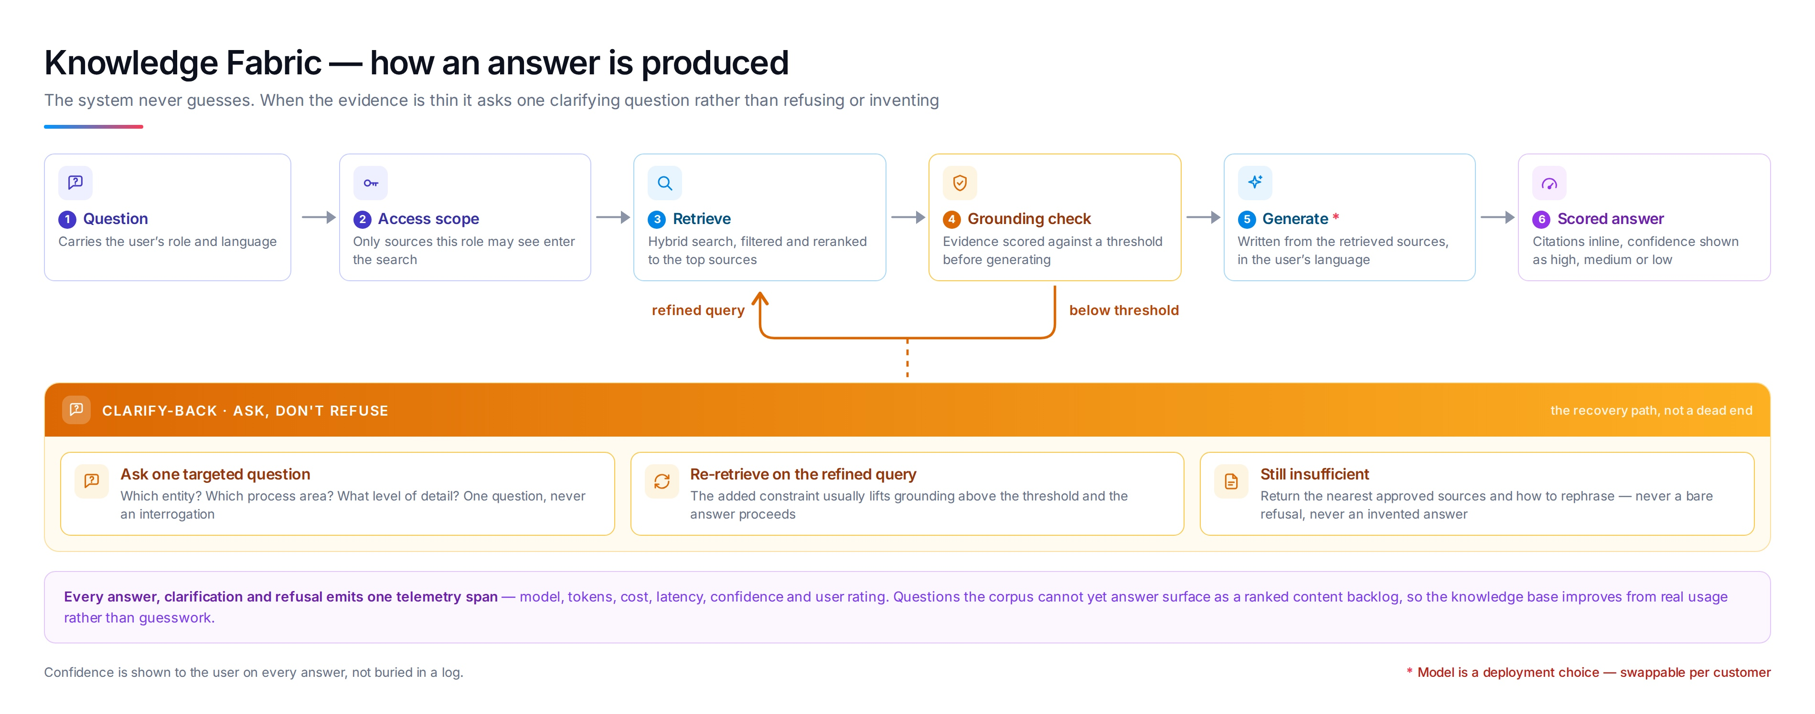
Figure 1 — How an answer is produced, with the clarify-back recovery loop

1. Question
A user asks in ordinary words — no query syntax, no document numbers. The request carries the person’s role and language with it, so both the search and the answer are shaped for who is asking.

2. Access scope
Permissions are applied before ranking, not after. Content the user is not entitled to never enters the candidate set, so it cannot influence the result or be inferred from it.

3. Retrieve
The platform runs a meaning-based search and an exact-term search at the same time, then merges the two ranked lists. Filters narrow by document status, entity, process area and language, so superseded and draft material stays out unless explicitly requested.

4. Grounding check
Before anything is generated, the retrieved evidence is scored against a threshold: how strongly the sources agree, how well they cover the question, how clearly the best result separates from the rest. Passing the threshold is what authorises generation.

5. Generate
The answer is composed from the retrieved passages and nothing else, in the language the question was asked in. Citations are attached inline as the answer is written, not appended afterwards, and translated material is labelled as such.

6. Scored answer
The user receives the answer, the sources behind each claim, and a plain confidence level — high, medium or low. Confidence is shown on screen, not buried in a log, so the reader can calibrate how much to lean on it.
Why the sequence matters
Permissions are applied before ranking, not after. Content a user may not see never enters the candidate set, so it cannot shape a result or be inferred from one.
Evidence is scored before generation, not after. Passing that check is what authorises the system to write — which is why citation is a property of the design rather than a promise about behaviour.

4 Clarify-back: ask, don’t refuse
The behaviour that most distinguishes Knowledge Fabric is what happens when the evidence is not strong enough. Most systems either refuse or invent. This one asks.
• Below threshold — One targeted question goes back to the user — which entity, which process area, what level of detail. One question, never an interrogation.
• Refined query — The added constraint is folded into a fresh retrieval. In most cases this lifts the evidence above the threshold and the answer proceeds normally.
• Still insufficient — The system returns the nearest approved sources and guidance on how to rephrase. Never a bare refusal, and never an invented answer.
• Every clarification logged — The questions the corpus cannot yet answer become a ranked content backlog for the people who own the documents.
This turns a dead end into a finding. A refusal tells you the system failed; a logged clarification tells you precisely which piece of knowledge is missing and how often somebody needed it.
“A refusal tells you the system failed. A logged clarification tells you which piece of knowledge is missing, and how often somebody needed it.”

5 Platform architecture
The platform is delivered as five zones. Three carry the flow of work — content in, answer out, proof recorded. Two are cross-cutting: who is allowed to ask, and the operational foundation everything runs on.
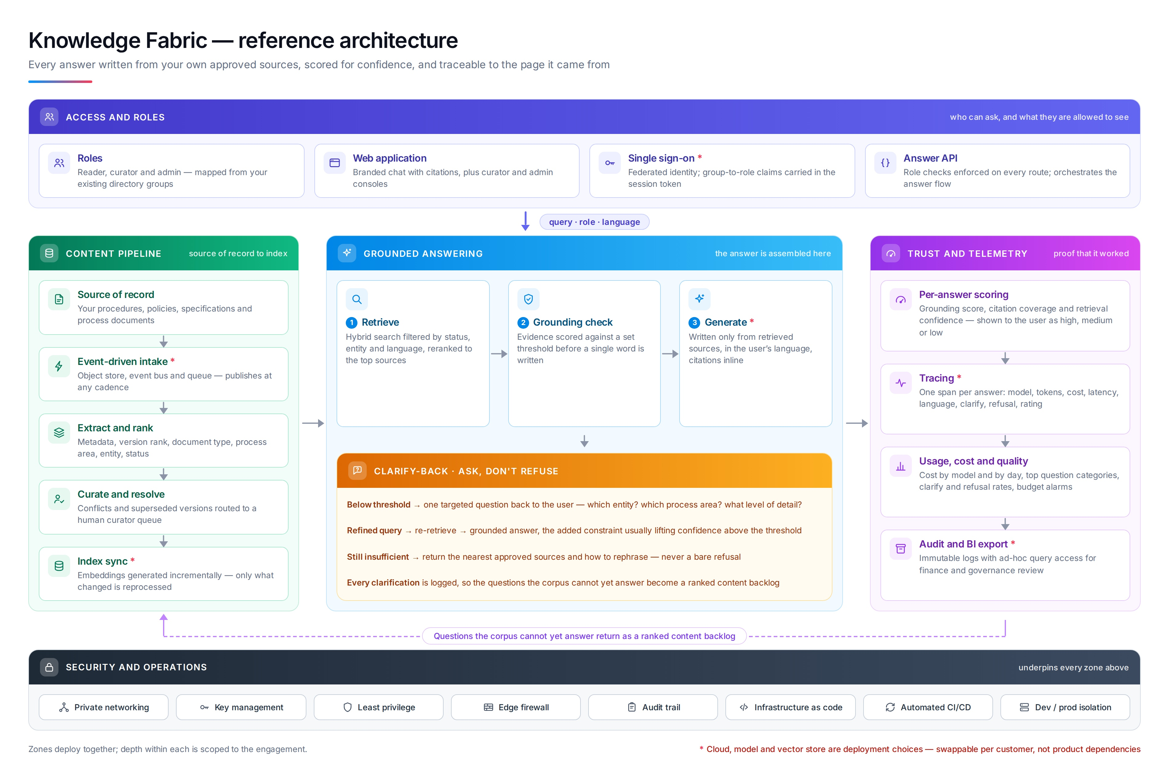
Figure 2 — Reference architecture — five zones, with the gap-backlog feedback loop

Access and roles
Users arrive through the organisation’s existing identity provider. Group membership becomes a role — reader, curator or administrator — and that role is enforced on every route, not just at the front door. The interface is a branded chat surface with citations, alongside curator and administrator consoles.
• Roles — Reader, curator and administrator, mapped from existing directory groups
• Web application — Branded chat with citations, plus curator and administrator consoles
• Single sign-on — Federated identity; group-to-role claims carried in the session token
• Answer API — Role checks on every route; orchestrates the answer flow for other systems

Content pipeline
Approved content flows from the systems that already own it. Publication is event-driven, so the index reflects the source of record at whatever cadence the organisation publishes. Metadata extraction establishes document type, process area, entity and status, and version ranking ensures the current revision outranks its predecessors. Conflicts and superseded material route to a human curator rather than being resolved silently.
• Source of record — Procedures, policies, specifications and process documents, owned where they already live
• Event-driven intake — Publishes at any cadence; the index follows the source rather than a fixed schedule
• Extract and rank — Metadata, version rank, document type, process area, entity and status
• Curate and resolve — Conflicts and superseded versions routed to a human curator queue
• Index sync — Built incrementally — only what changed is reprocessed

Grounded answering
The three-stage core: retrieve, check the grounding, then generate. Generation is gated on the grounding check, which is what makes the citation promise structural rather than aspirational. When the check fails, control passes to clarify-back instead of to the generator.
• Retrieve — Hybrid search filtered by status, entity and language, reranked to the strongest sources
• Grounding check — Evidence scored against a set threshold before a single word is written
• Generate — Written only from retrieved sources, in the user’s language, citations inline
• Clarify-back — The recovery path when evidence falls short — ask, refine, re-retrieve

Trust and telemetry
Every answer is scored and every interaction is instrumented. This zone serves three different audiences at once: the user sees a confidence level, the content owner sees which questions are failing, and the sponsor sees consumption and quality trends over time.
• Per-answer scoring — Grounding score, citation coverage and retrieval confidence, shown as high, medium or low
• Tracing — One record per answer: model, tokens, cost, latency, language, clarification, refusal, rating
• Usage, cost and quality — Consumption by day, top question categories, clarification and refusal rates, alerting
• Audit and export — Immutable logs with ad-hoc query access for governance and finance review

Security and operations
The platform is deployed as managed infrastructure inside the customer’s control environment, defined in code and promoted through environments. Nothing about the security posture is bespoke to Knowledge Fabric — it uses the controls the organisation already operates.
• Private networking — Service-to-service traffic stays inside the customer’s network boundary
• Key management — Encryption at rest and in transit under customer-controlled keys
• Least privilege — Every component holds the narrowest permission set that lets it function
• Edge protection — Application firewall and content delivery in front of the user interface
• Audit trail — Infrastructure and data-plane activity recorded independently of the application
• Infrastructure as code — Environments reproducible from version control, not from console changes
• Automated delivery — Build, test and release pipelines with promotion gates
• Environment isolation — Development and production separated by account and by credential

6 Functional coverage
The capabilities below are delivered as one platform rather than as separable modules; the list is a description of scope, not a menu.
Capability | What it does | Primary audience
Grounded answering | Plain-language answers assembled only from approved sources, never from general world knowledge. | Everyone
Verbatim citation and lineage | Each claim carries its source, down to document, page and paragraph. | Quality, audit, legal
Confidence scoring | A visible high / medium / low level on every answer, derived from evidence strength. | Everyone
Clarify-back | One targeted question when evidence is thin, instead of a refusal or a guess. | Everyone
Entity and relationship graph | Explore how products, processes, regulations and records connect to one another. | Engineering, quality
Knowledge health | Coverage, connectivity, provenance, extraction quality and freshness, with gaps ranked. | Content owners
Version and status awareness | Current revisions outrank superseded ones; draft material is excluded unless requested. | Quality, operations
Multilingual answering | Ask and answer in the user’s language; translated material is labelled as translated. | Global operations
Curator workbench | A human queue for conflicts, duplicates and superseded documents. | Content owners
Role-scoped access | Permissions applied before ranking, so unauthorised content never enters a result. | Security, IT
Usage and quality dashboards | Consumption, question categories, clarification and refusal rates over time. | Sponsors, IT
APIs and embedding | The answer flow exposed to other applications and portals through a governed interface. | IT, product teams

7 What the platform covers
Coverage is deliberately broad, because the questions an organisation actually asks do not respect system boundaries.
• Document formats — Text and scanned documents, office formats, presentations, spreadsheets, structured exports and web content. Scanned material is processed so its text becomes searchable and citable.
• Source systems — Document management and quality systems, engineering and product lifecycle systems, ticketing and service desks, wikis and intranets, shared drives, and regulatory or public registries.
• Content types — Standard operating procedures, work instructions, policies, specifications, manuals, validation and test records, audit findings, contracts, correspondence and training material.
• Business functions — Quality and compliance, engineering and manufacturing, service and support, operations, procurement, legal, and people functions.
• Languages — Multilingual corpora and multilingual users, with the answer returned in the language of the question and any translated passage labelled.
• Question shapes — Factual lookup, procedural how-to, comparison across documents, status and version checks, and relationship questions across entities.

8 Value delivered
Value shows up differently for each group of people who touch the platform. The following is what each group gets, stated without reference to commercial figures.

Frontline and operations
• The current, approved answer arrives in seconds instead of after a search through revisions.
• The same question gets the same answer across sites, shifts and languages.
• New joiners become productive without a colleague acting as their search index.

Quality, compliance and audit
• Every answer can be reconstructed to the document, page and paragraph it came from.
• Superseded revisions stop circulating as if they were current.
• The refusal and clarification record shows exactly where documented knowledge is thin.

Engineering and technical teams
• Relationships between products, processes, regulations and records become explorable rather than tribal.
• Prior work, decisions and test evidence surface at the moment they are relevant.
• Time spent reconstructing context is returned to engineering work.

Leadership and sponsors
• Institutional memory becomes an asset the organisation holds rather than one its people carry.
• Consumption and quality are visible, so the platform can be governed on evidence.
• Knowledge gaps arrive as a ranked backlog, turning content investment into a prioritised plan.

IT and security
• Identity, permissions and network controls are the ones the organisation already operates.
• Content stays inside the customer’s boundary; residency and retention follow existing policy.
• No component is a lock-in: model, vector store and cloud are all substitutable.

9 Deployment and portability
Knowledge Fabric is a platform pattern, not a bet on a single vendor. Four components are deliberately pluggable, and the reference implementation names one option for each without depending on it.

Pluggable components
Component | How it is chosen
Identity provider | Whatever the organisation already runs for single sign-on.
Embedding model | Commercial or self-hosted, selected for language coverage and residency.
Vector store | Managed or in-tenant, selected to match the existing data platform.
Language model | Commercial API, in-tenant deployment or self-hosted, per the control environment.

Deployment modes
• Managed service — Fastest to stand up. Suited to pilots and to content that is not restricted.
• In-tenant deployment — Runs inside the customer’s own cloud account and network boundary. The common production choice.
• Restricted or disconnected — Self-hosted models with no external calls, for the most tightly controlled environments.
The portability test
If a customer changes cloud provider, identity provider or language model, the platform pattern survives and the delivered work is not discarded. That is the difference between a platform and an integration.

10 Delivery approach
Delivery runs in four phases. Each ends with something the organisation can evaluate on its own terms, so the decision to continue is never taken on faith.
Phase | What happens | What the organisation gets
1. Discover | Corpus assessment and use-case selection. We inventory the candidate content, test how well it is structured, identify the questions that matter most, and agree what a good answer looks like. | Content readiness assessment, prioritised question set, target architecture.
2. Prove | A working pilot on one domain and one audience, with real content and real users. The ontology, filters and thresholds are tuned against the prioritised question set. | Working platform on live content, measured answer quality, curator workflow in use.
3. Harden | Production readiness: identity integration, permission mapping, security review, telemetry and dashboards, operational runbooks and release automation. | Production deployment inside the customer’s control environment, with governance in place.
4. Extend | Additional domains, languages and audiences, driven by the ranked gap backlog the platform itself produces. Continuous curation replaces one-off content projects. | Expanding coverage, improving health scores, a content plan grounded in real demand.

11 What makes this different
• Generation is gated, not trusted — The grounding check runs before anything is written. Citation is a property of the design, not a promise about behaviour.
• Clarification instead of refusal — Thin evidence produces a targeted question and a second attempt, recovering answers that a refusal would have discarded.
• Permissions applied before ranking — Unauthorised content never enters the candidate set, so it cannot shape a result or be inferred from one.
• The system reports its own gaps — Failed and clarified questions become a ranked content backlog, so the corpus improves from real demand.
• Portable by construction — Model, vector store, embedding and identity are all deployment choices; none of them is the product.

12 Glossary
Term | Meaning
Corpus | The full set of approved documents the platform has indexed.
Grounding | The strength of the link between an answer and the source passages behind it.
Citation coverage | The proportion of an answer’s claims that carry a traceable source.
Hybrid search | Running meaning-based and exact-term search together and merging the results.
Ontology | The customer-specific model of entity types and the relationships between them.
Clarify-back | The path taken when evidence is below threshold: ask one question, then retry.
Knowledge health | A standing measure of corpus coverage, connectivity, provenance, quality and freshness.
Curator | The role that resolves conflicts, duplicates and superseded versions in the pipeline.

