LnW

–

Potential Use Cases

–

Solution Architectures

Use Case Domains:
- Games QA
- Platform Servies QA
- Compliance
- QA Tools
- QIMA – Quality Incident Management

Use Cases By Domains:

Games QA:
- Visual Testing/Validation of base game scenarios (symbol/visual validation)
- Autonomous Gameplay Testing (simulated player input + visual testing)

Platform Services QA:
- Visual testing/validation:
  - Credit/Cash Meter display
  - History replay validation
  - Game switching banner
  - Order of display changes
  - Protocol testing visual cases (additional, currently manual)
- Agentic AI Orchestration:
  - AITF Test Script generation
  - Conversion of Manual Test Scripts to AITF compatible scripts
- Test Case Consolidation
- Protocol Testing (ASP,G2S,SAS,etc.)
  - Request/Response Pairs
    - Class Specific Commands/Set/Get/Parameters/Events
  - Meters/Counters Validation

Compliance
TBD

QA Tools:
TBD – probably not immediately

QIMA – Quality Incident Management
- QIR Ticket Handling – Non-SME flow
- TBD

Use Cases & High Level Architectures
One of the “Nice-to-Have” characteristics for the solution(s) is reusability of the architecture. The following architecture has been developed with this in mind.

Games QA:
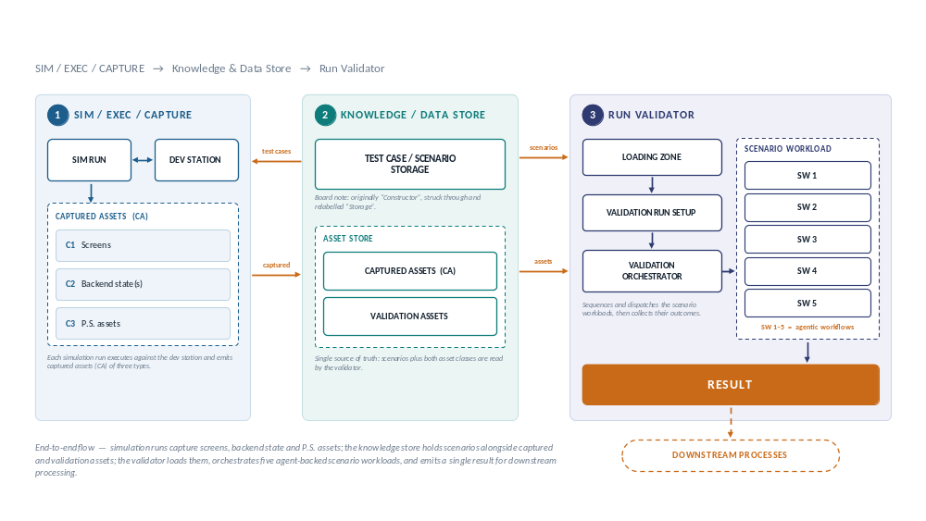

Visual Testing/Validation of base game scenarios

Autonomous Gameplay Testing

