Case Study Submission Template

1. Name: Prashant Bagewadi
2. Employee Id: 546961
3. Email Id: [bagewadi.prashant@tcs.com](mailto:bagewadi.prashant@tcs.com)
4. Git Repo URL: <https://github.com/prashpb/batch10.git>
5. DockerFile: <https://github.com/prashpb/batch10/blob/master/Dockerfile>  
   
6. Jenkinsfile: <https://github.com/prashpb/batch10/blob/master/Jenkinsfile>  
   
7. Complete Jenkins log file : <https://github.com/prashpb/batch10/blob/master/546961_bootcamp_jenkins_logs.docx>  
   
8. Screenshot of Jenkins job status:  
   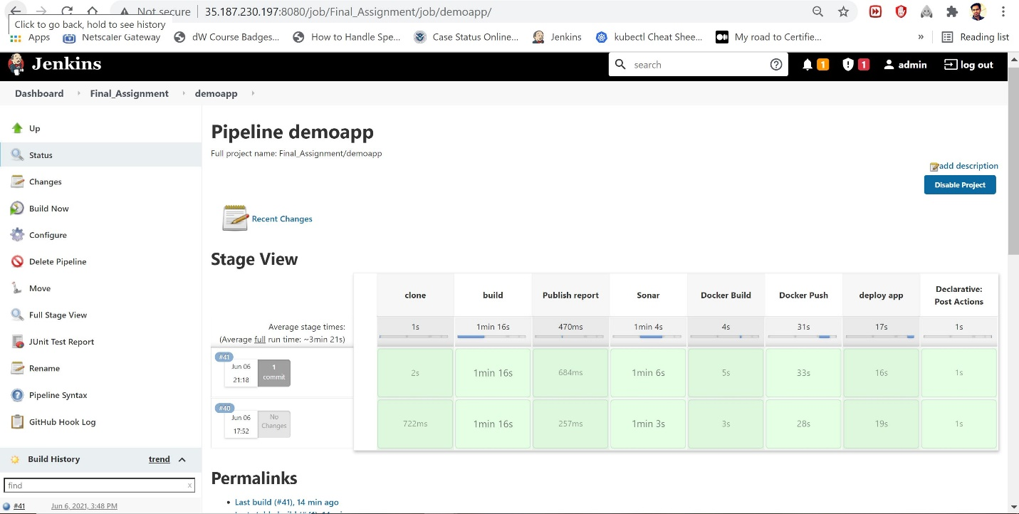
9. Screenshot of email notification for Jenkins build:  
   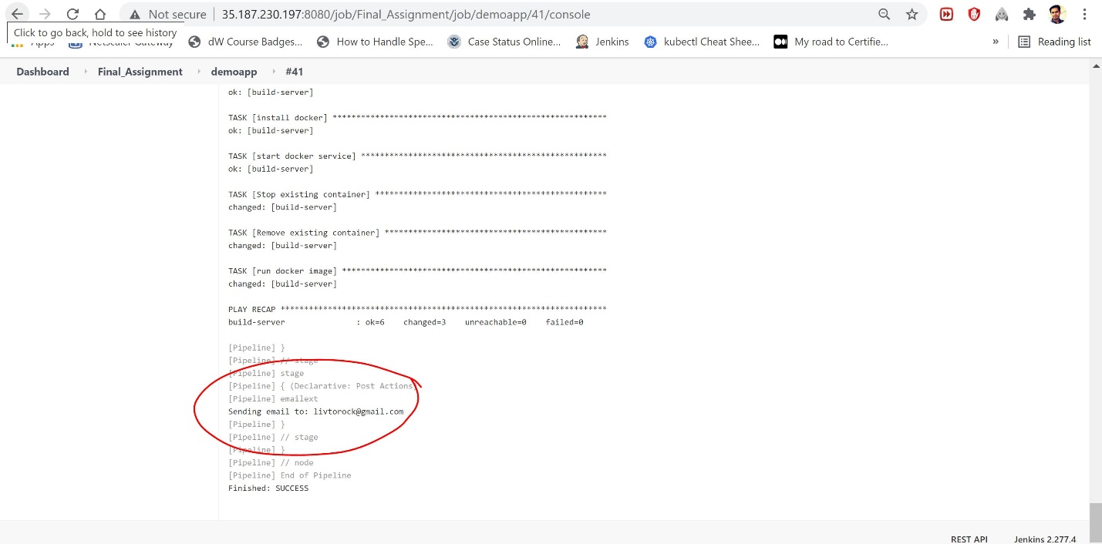
10. Screenshot of SonarQube Report:  
    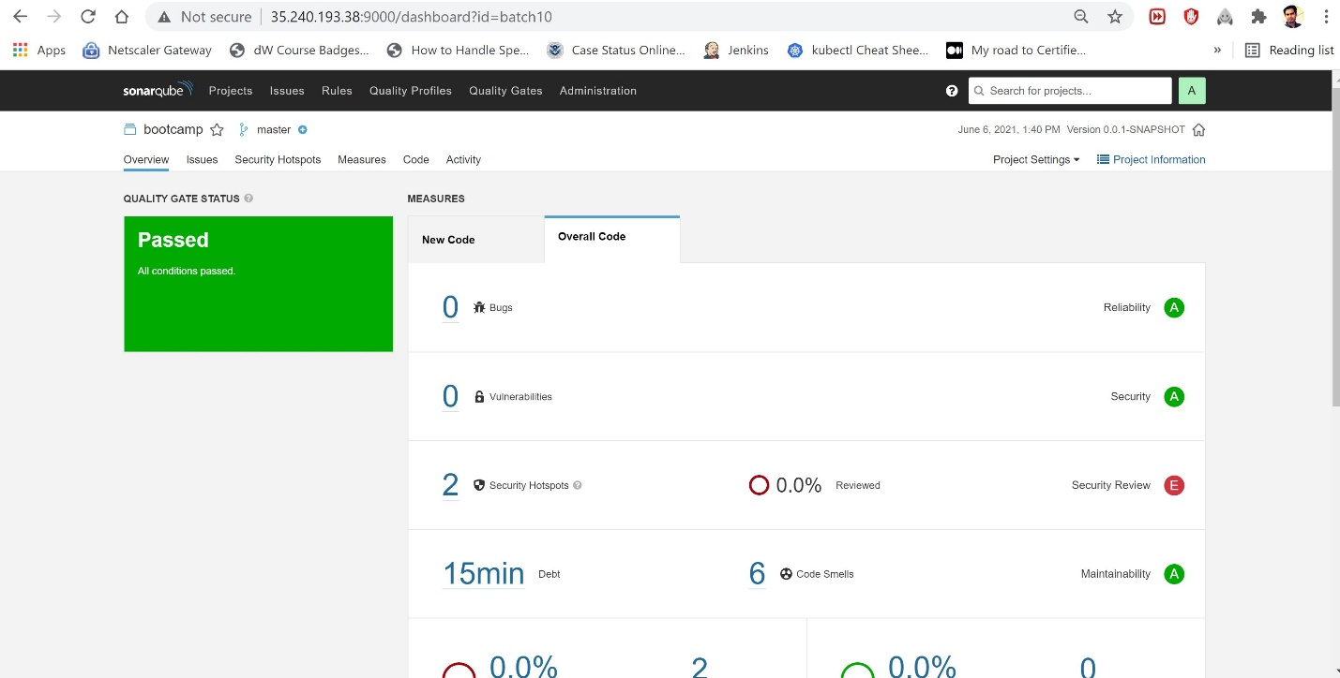
11. Screenshot of ansible playbook execution:  
    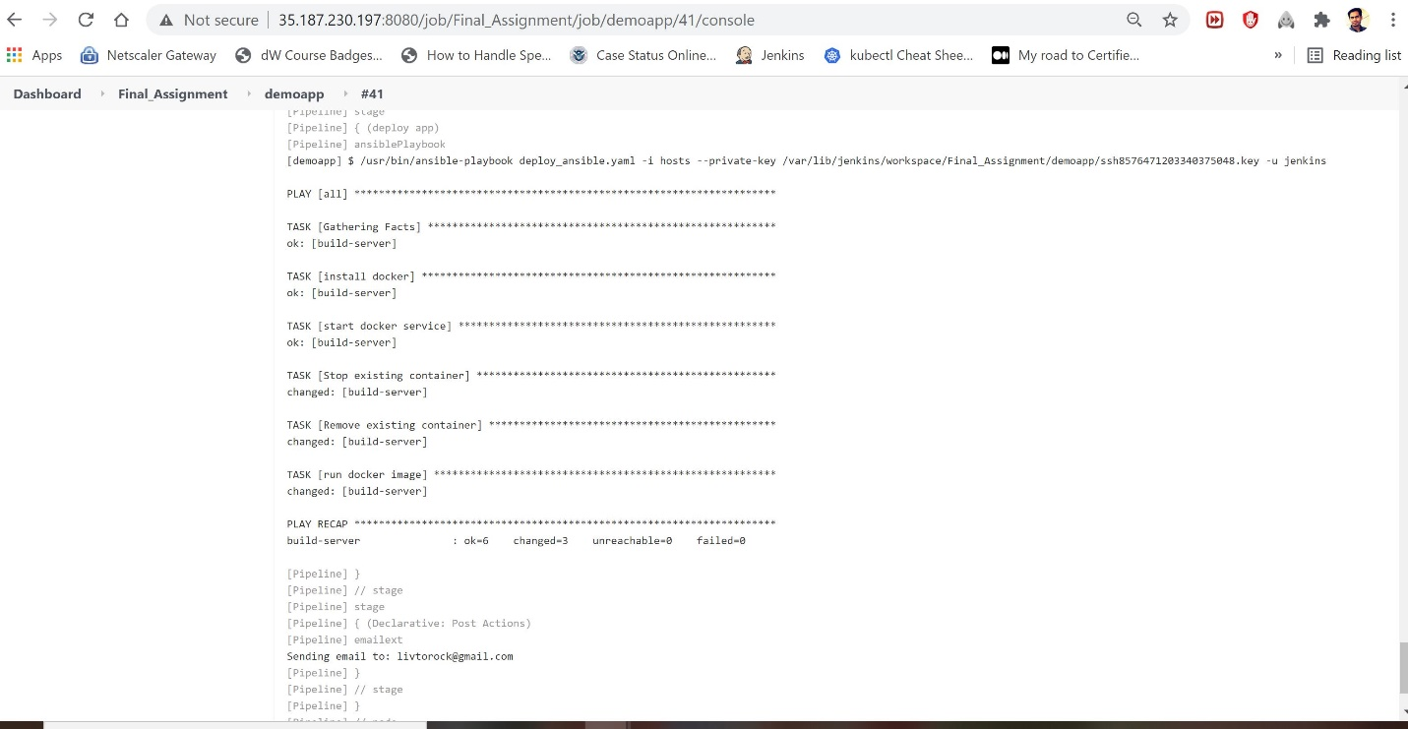
12. Screenshot of working app:  
    