1. Local git repository and created 3 files.

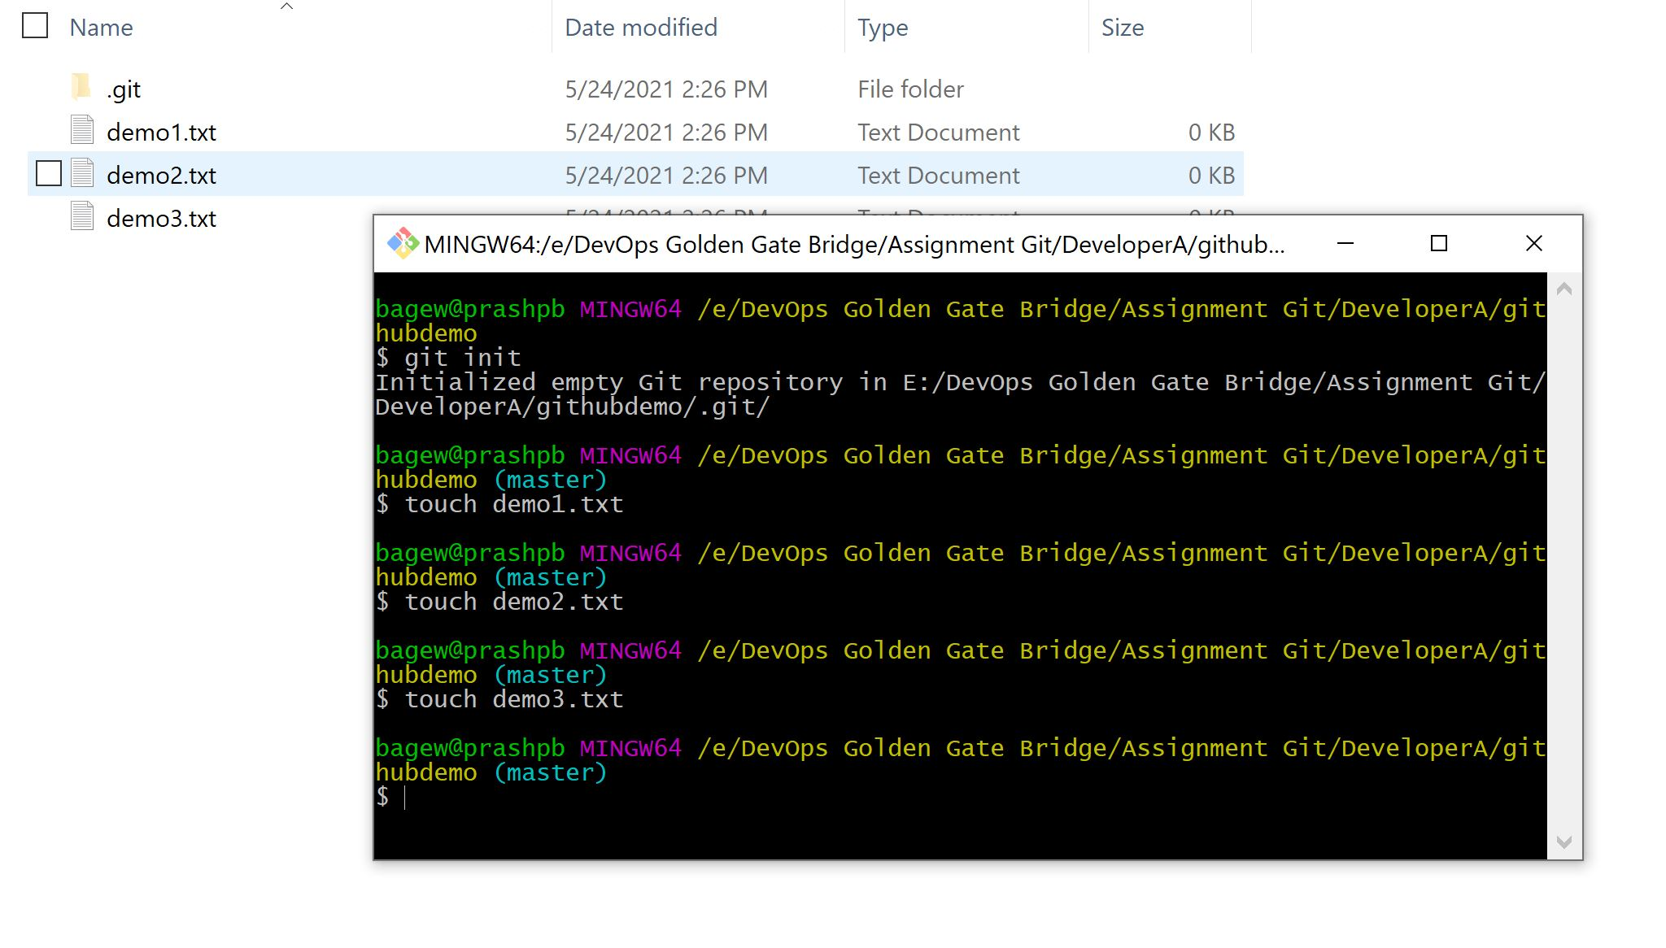

1. Add files to staging area and commit.

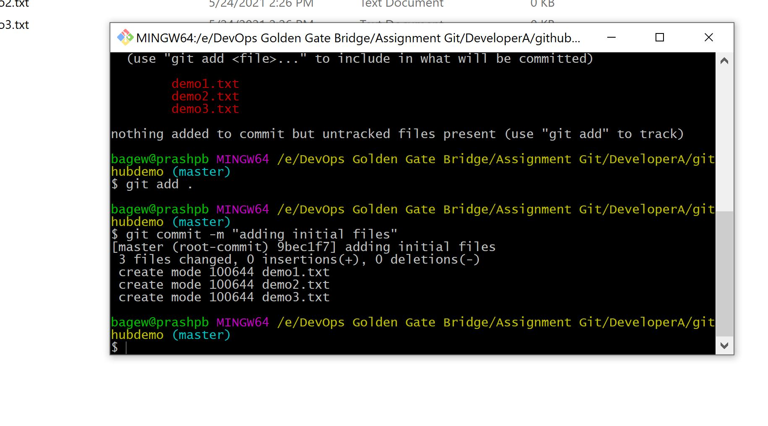

1. Create github repo and add remote repo to local repo.

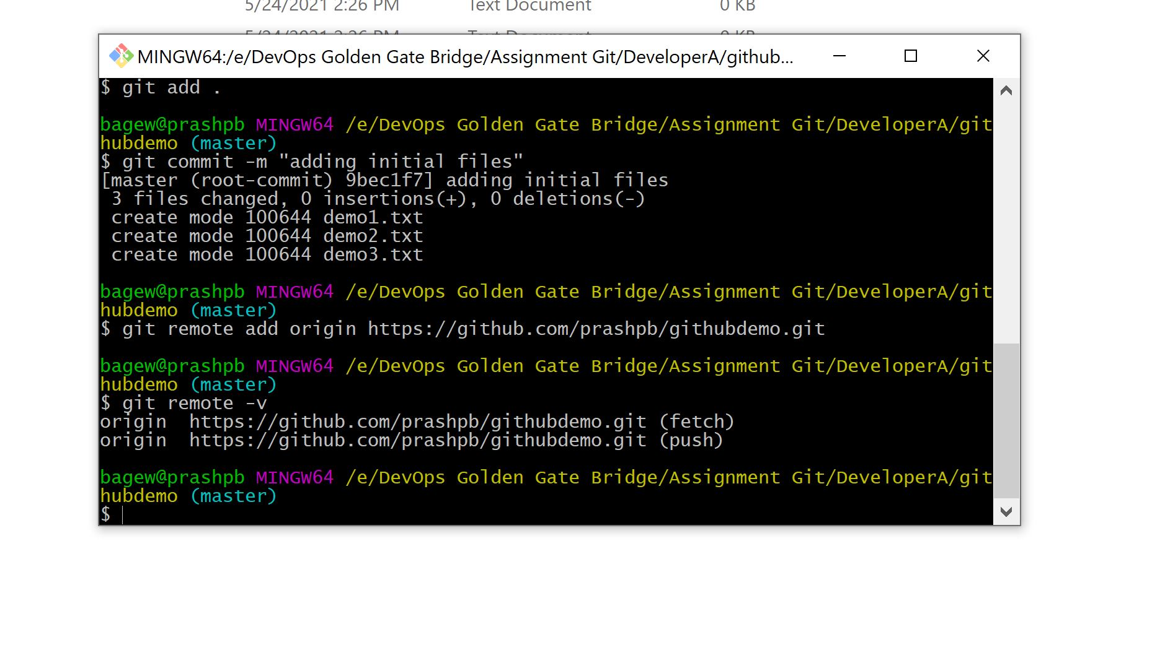

1. push to remote git repo.

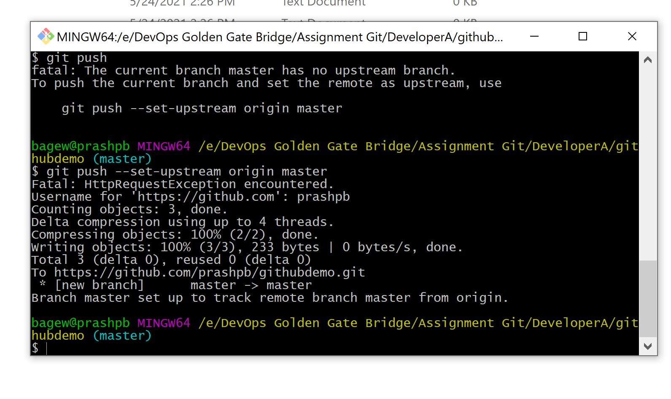

1. Clone the repo into developer folder.

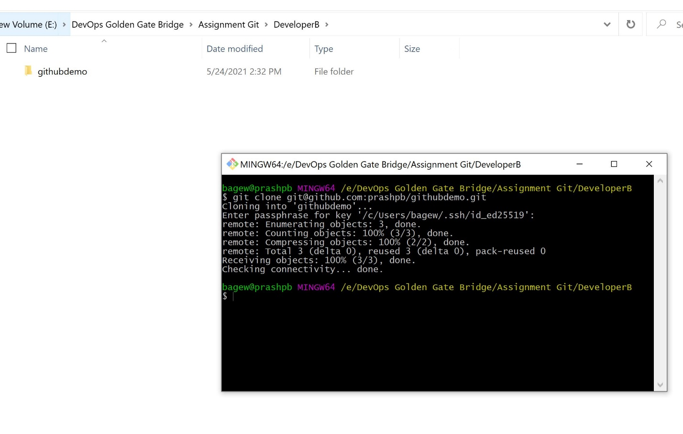

1. Edit file and commit/push in developerB folder.

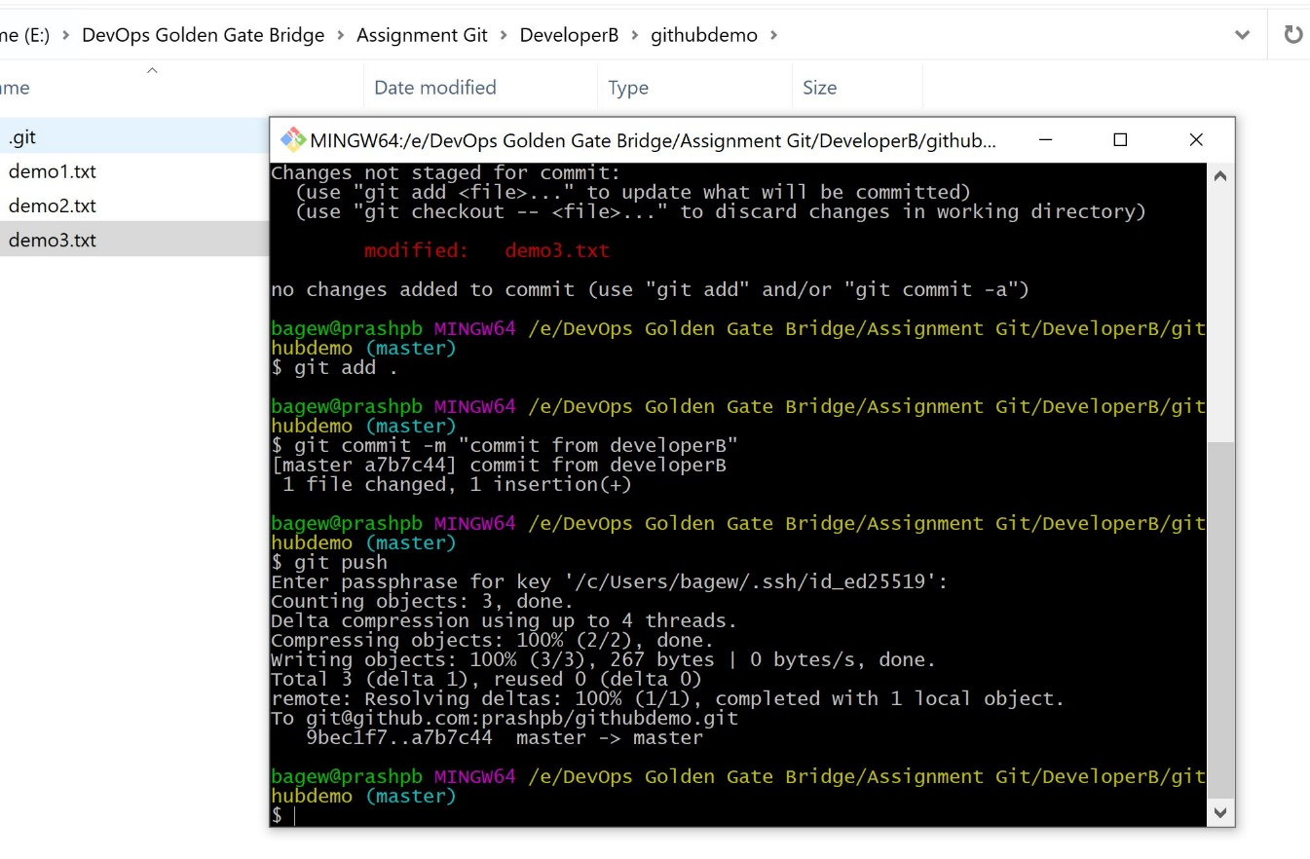

1. Sync the files in developerA folder

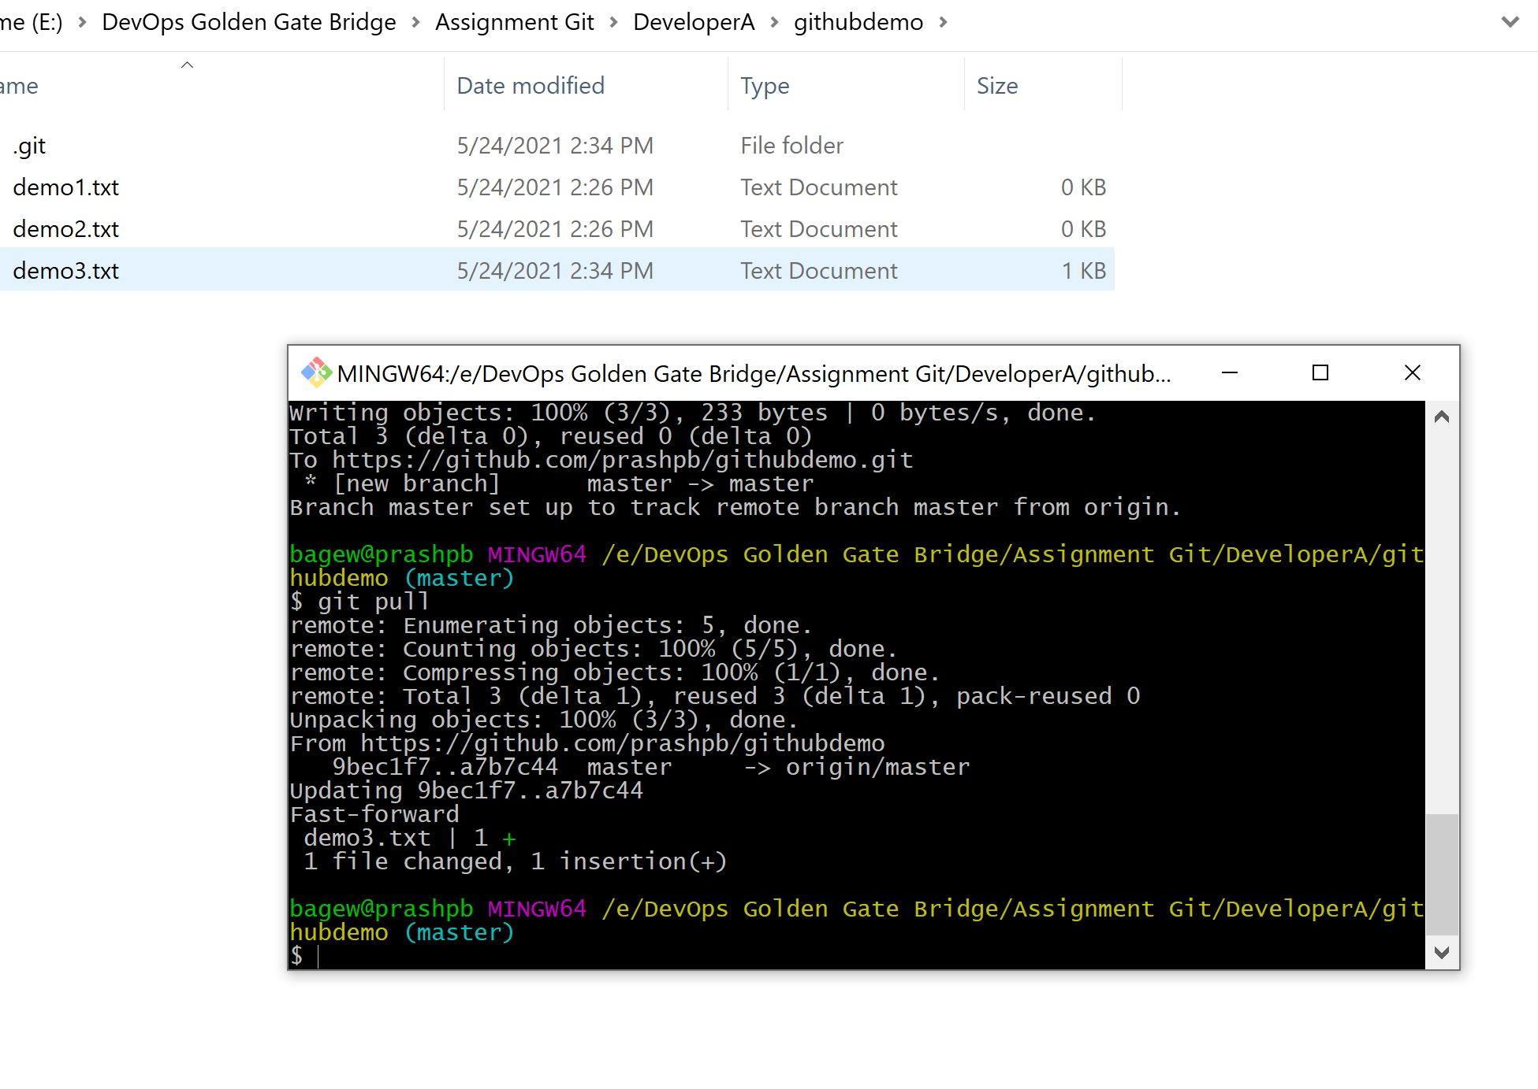

1. Create feaure1 branch.

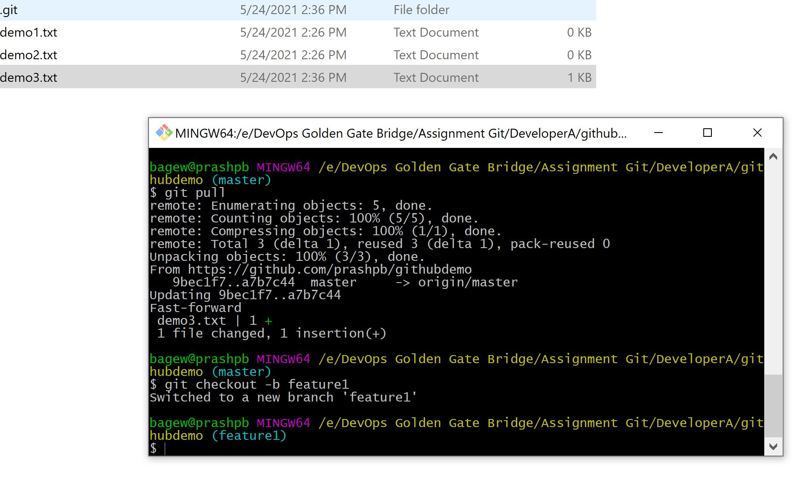

1. Update file in feature1 branch and commit.

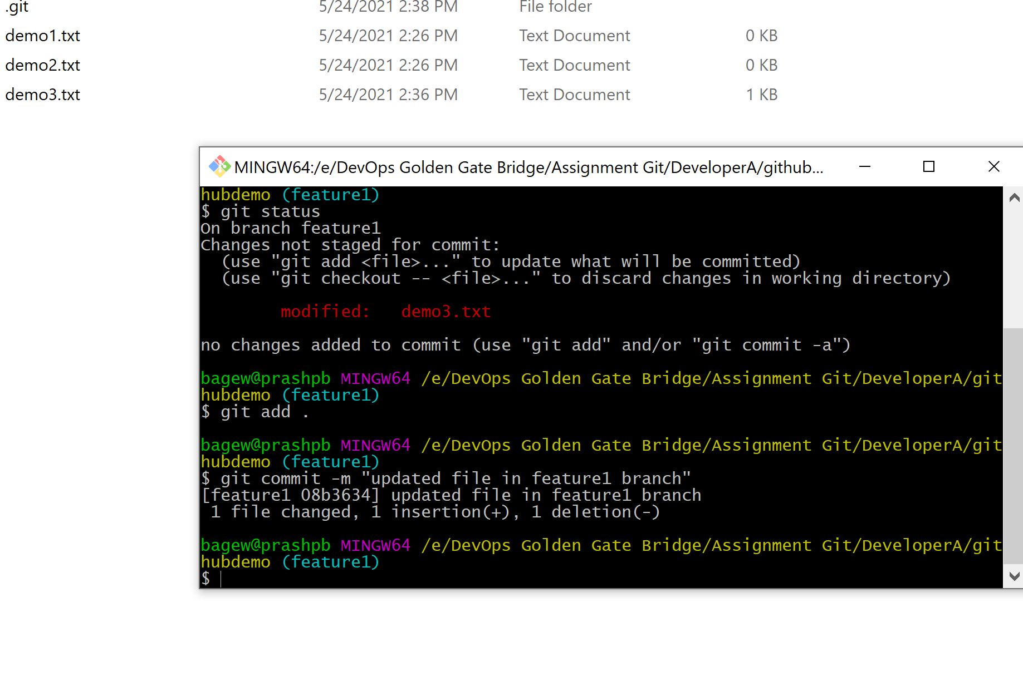

1. Merge the feature1 to master.

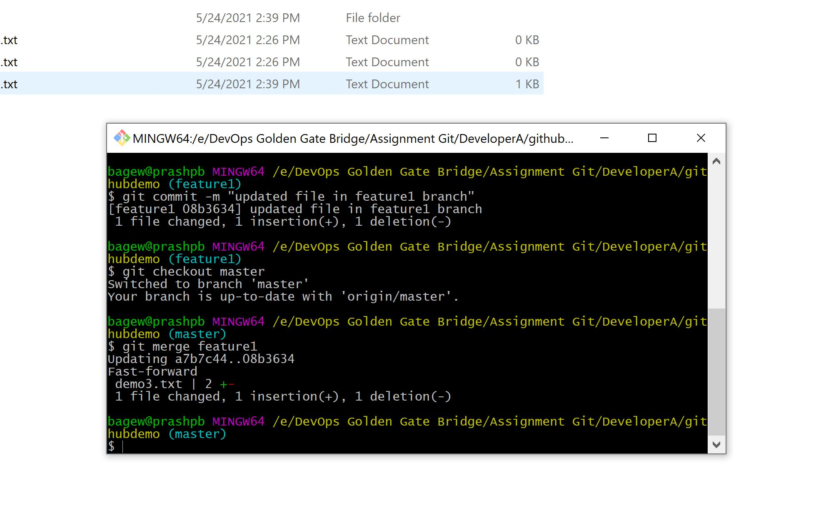

1. Delete the feature1 branch.

