1. Feature1 branch file edit and push. 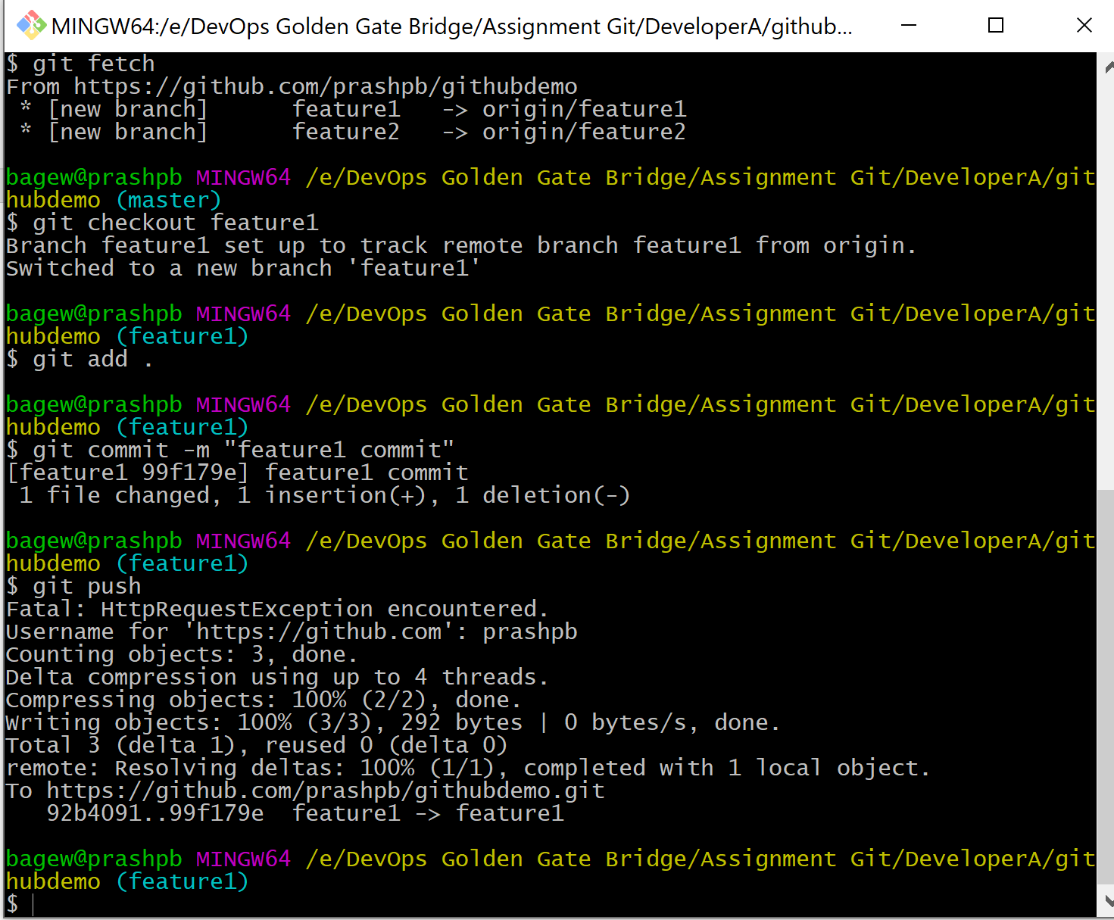
2. Merge feature1 to master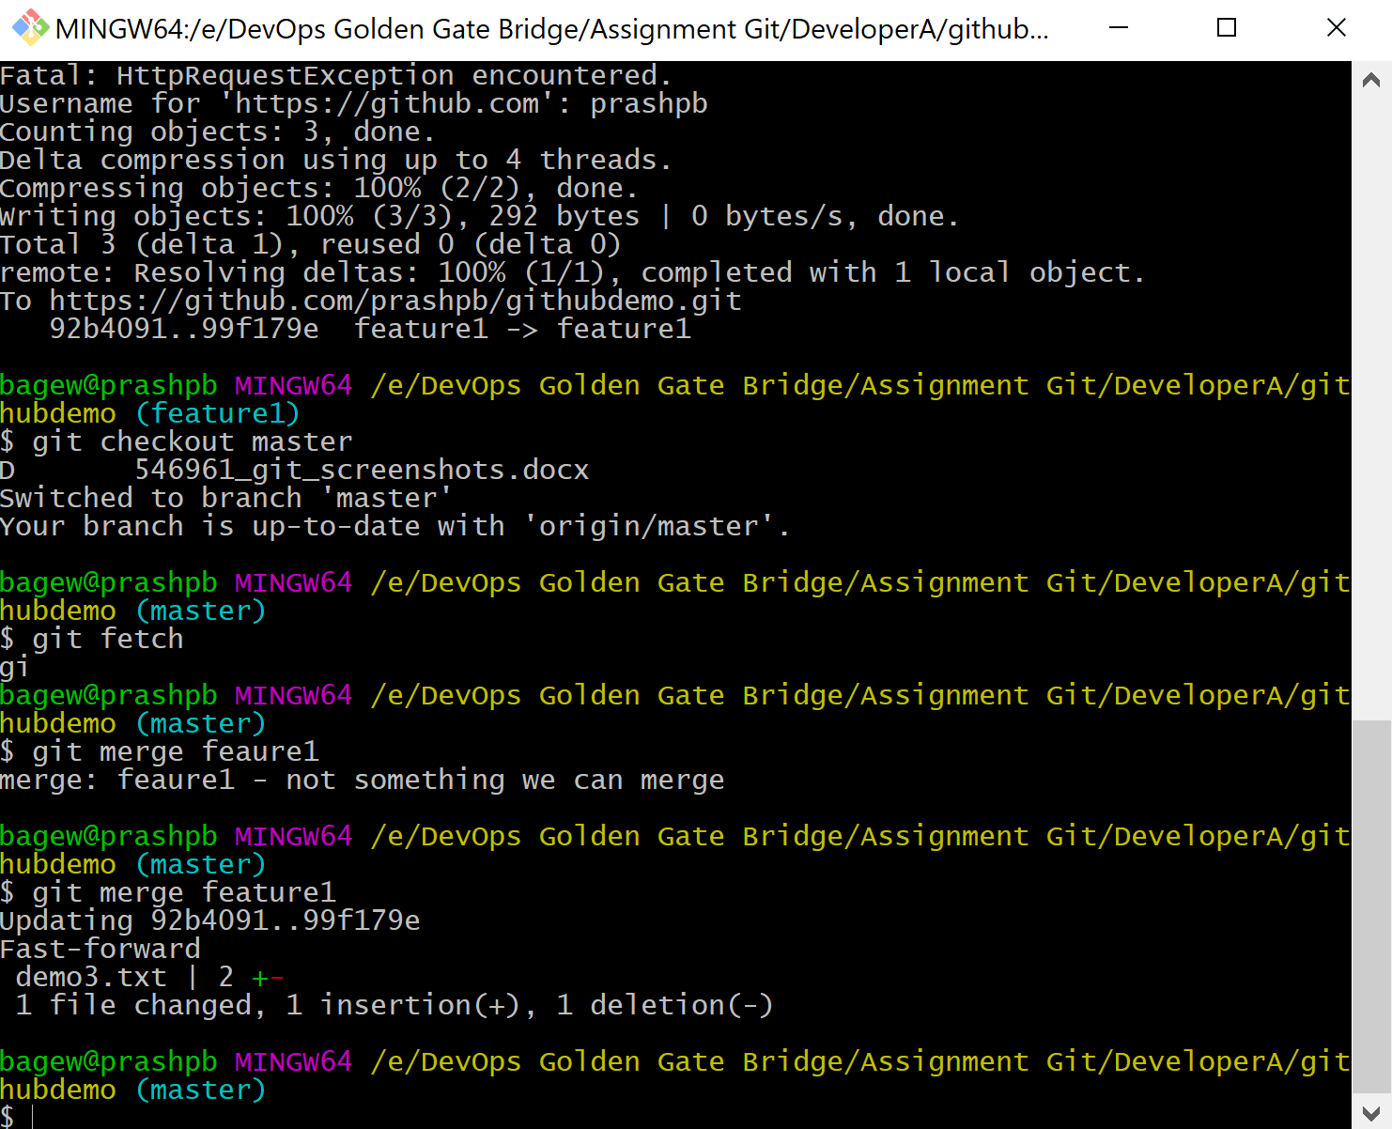
3. Feature2 branch file edit and push. 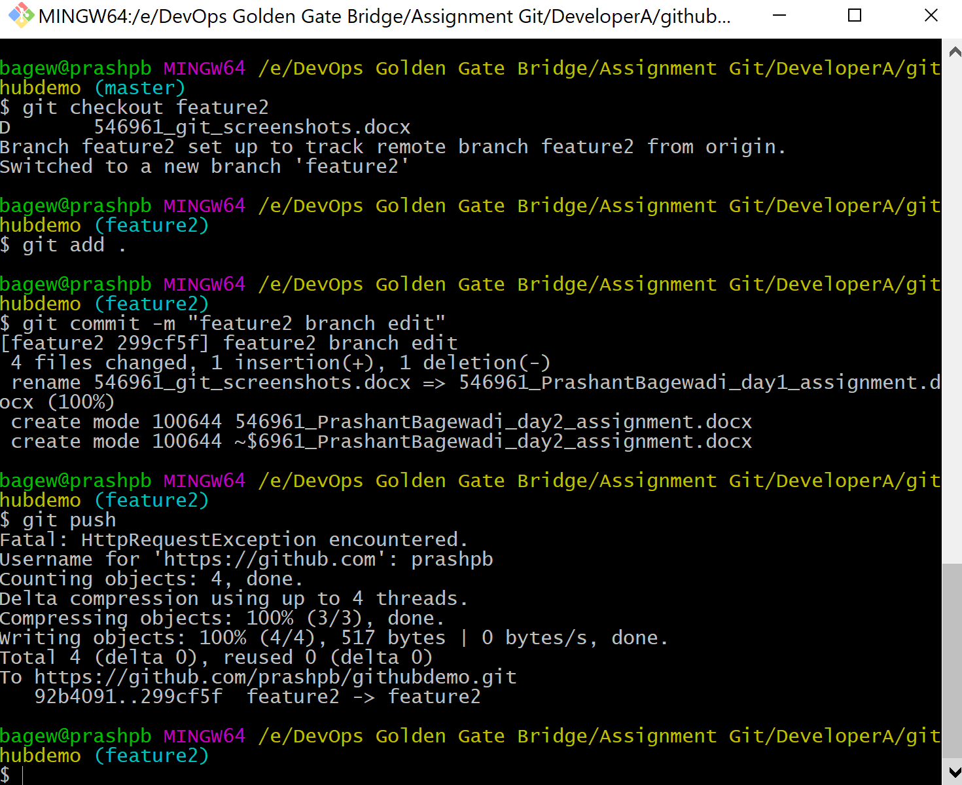
4. MERGE CONFLICT when merging feature2 to master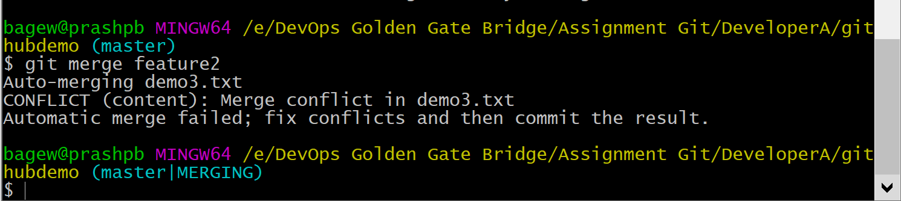
5. Resolve conflict in vscode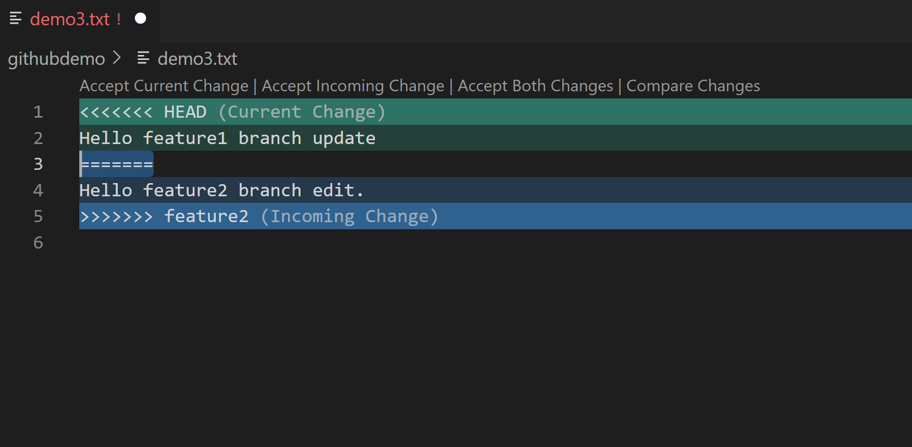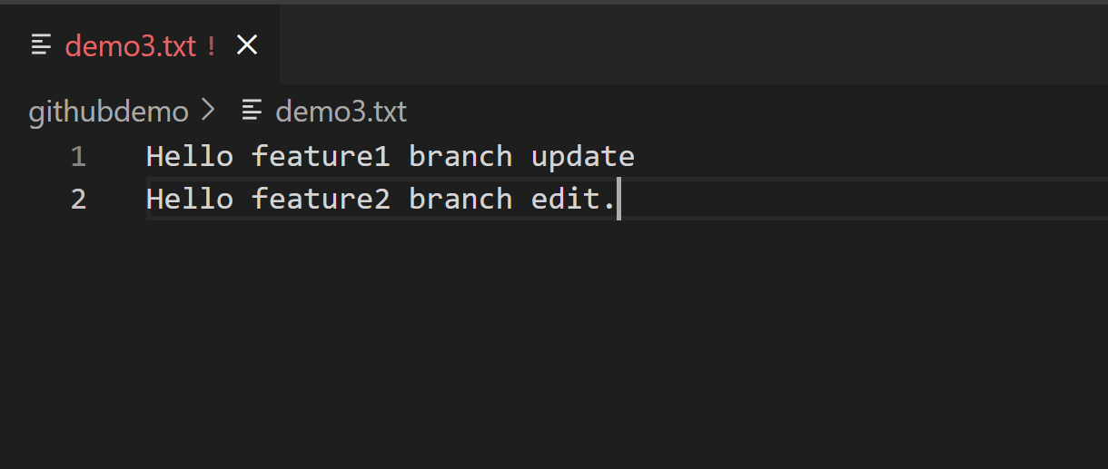
6. Resolved and commit/push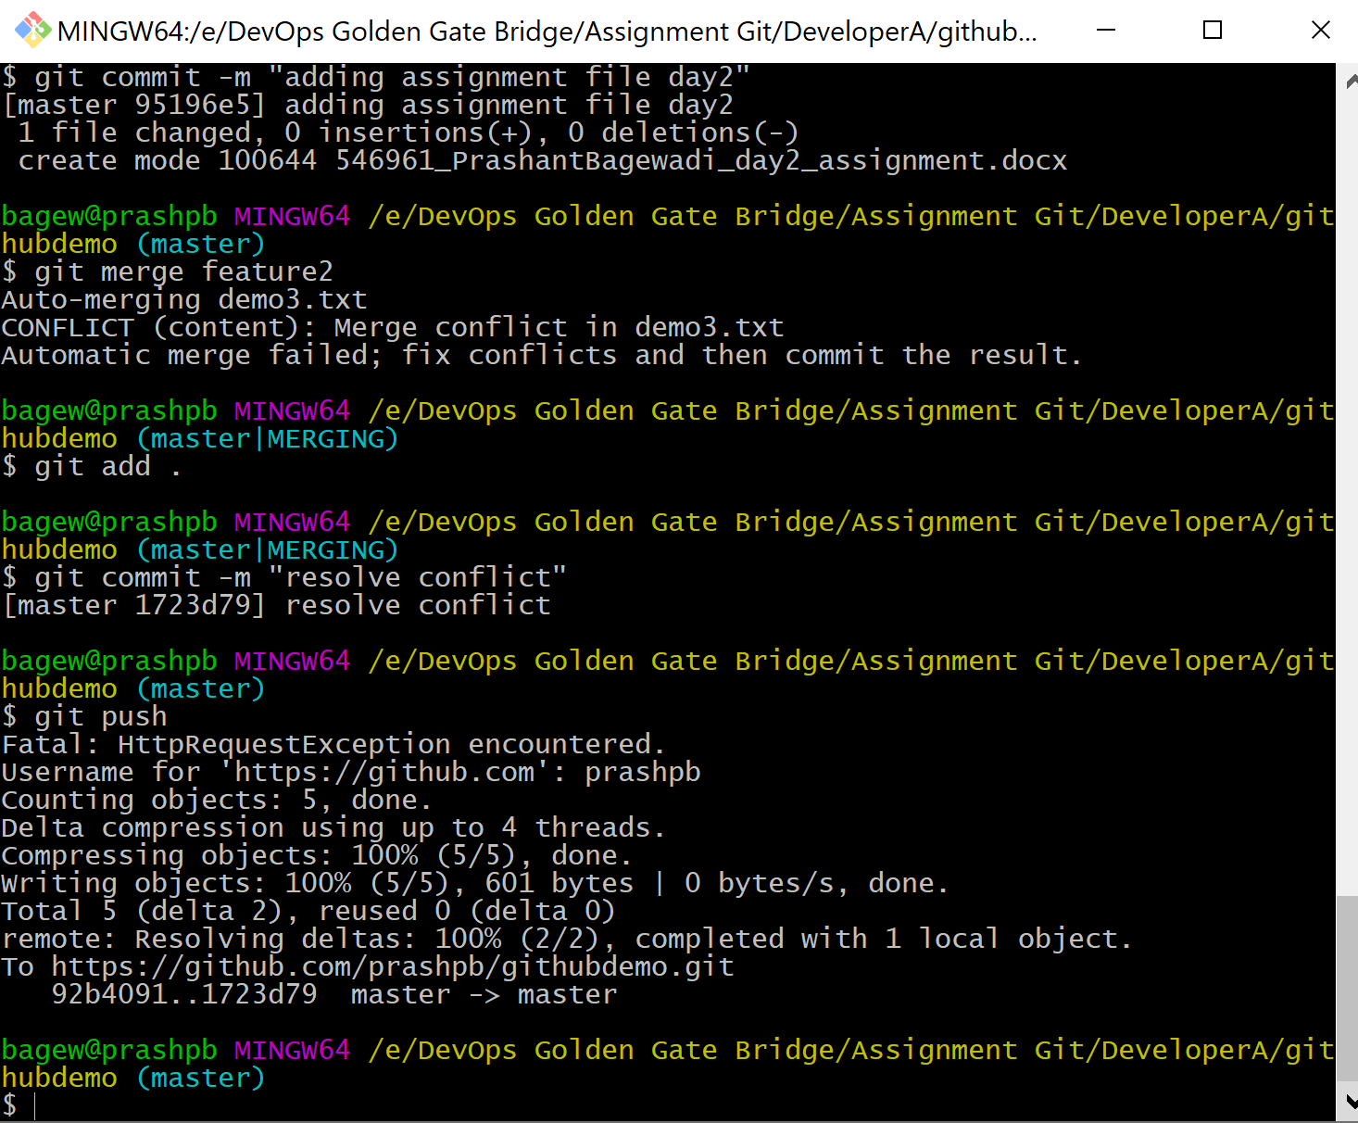

JENKINS :

1. Build console logs