1. Create docker image and tag prashpb/nginx:1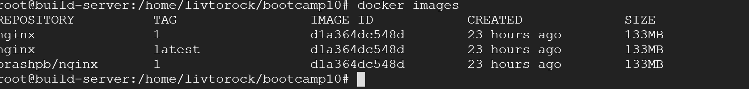
2. Docker login and push the image to dockerhub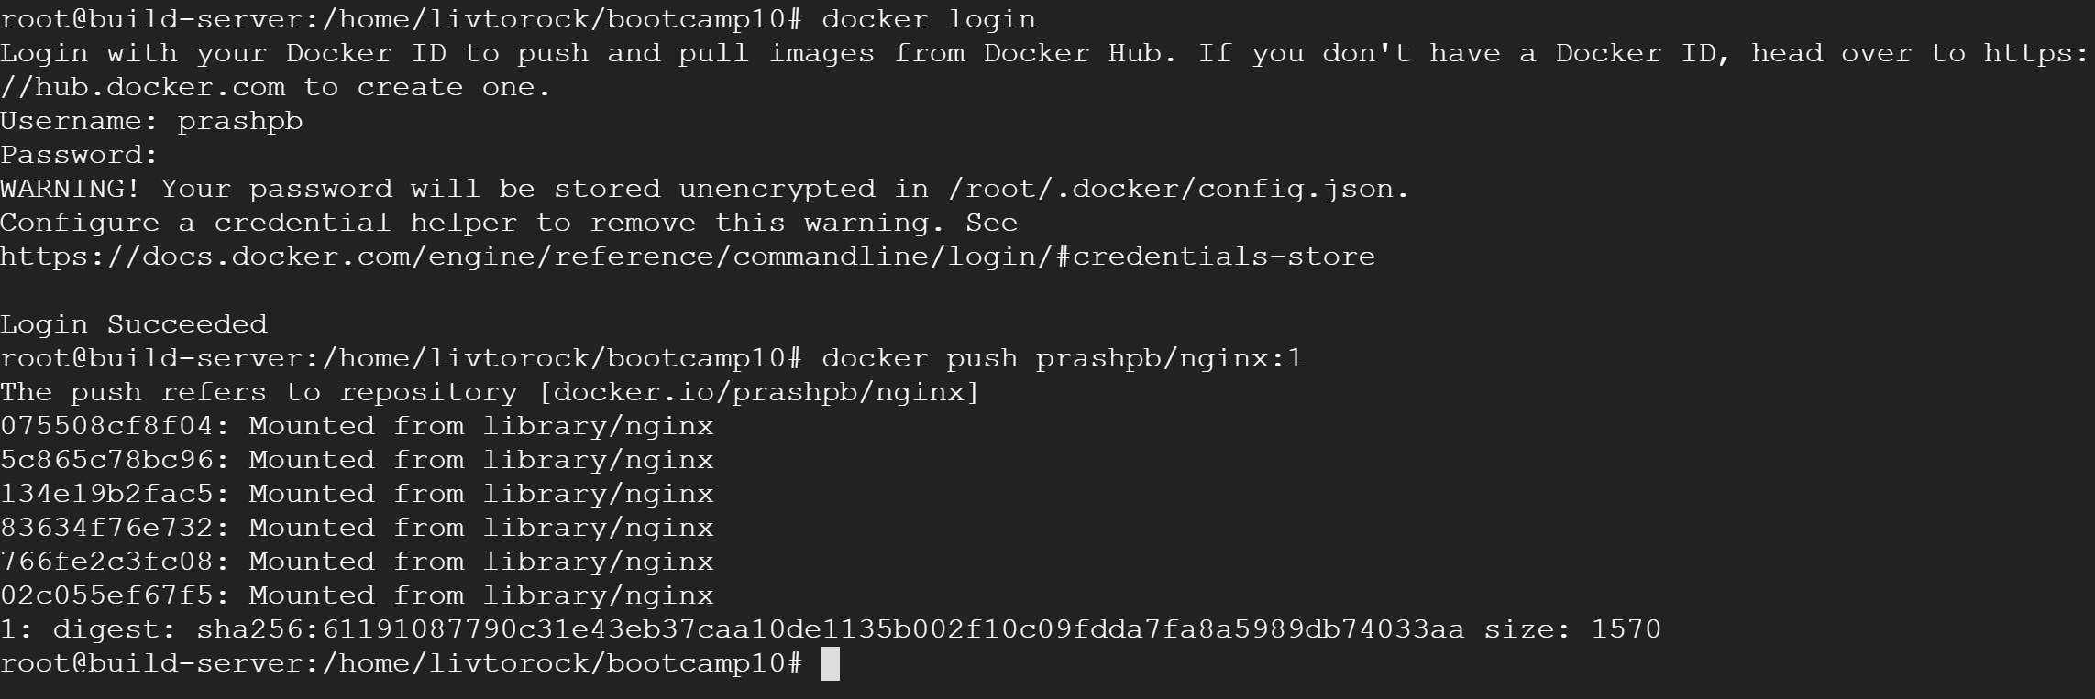
3. Pull and run prashpb/nginx image on port 8012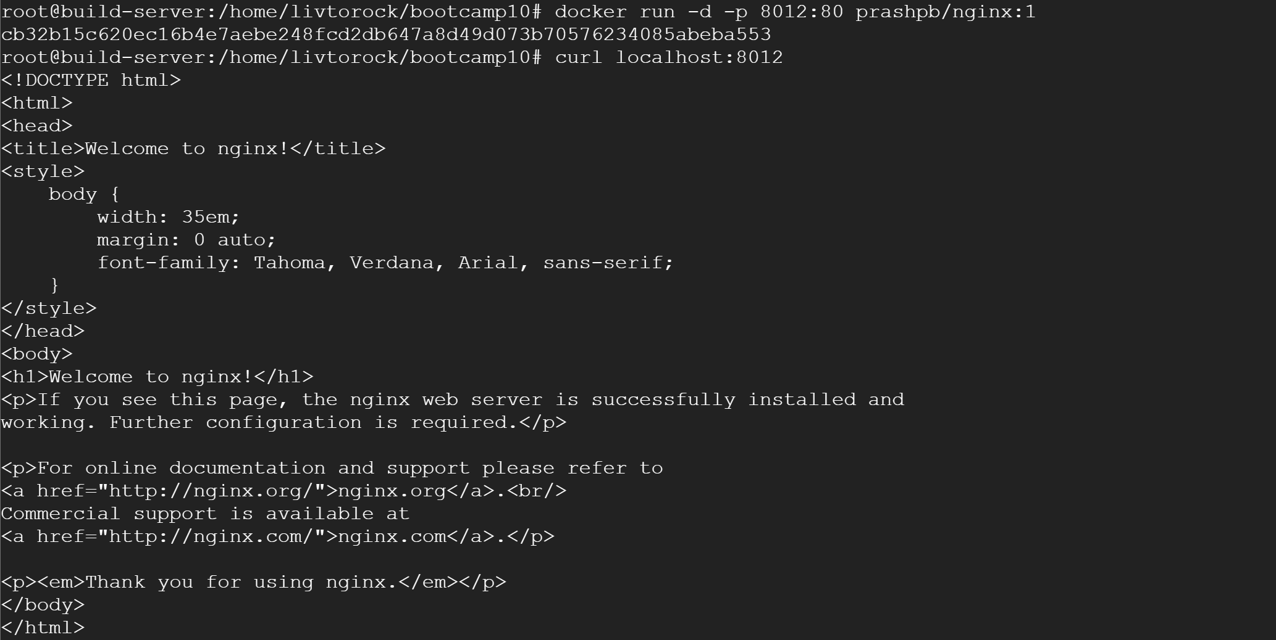
4. Able to access the nginx from local computer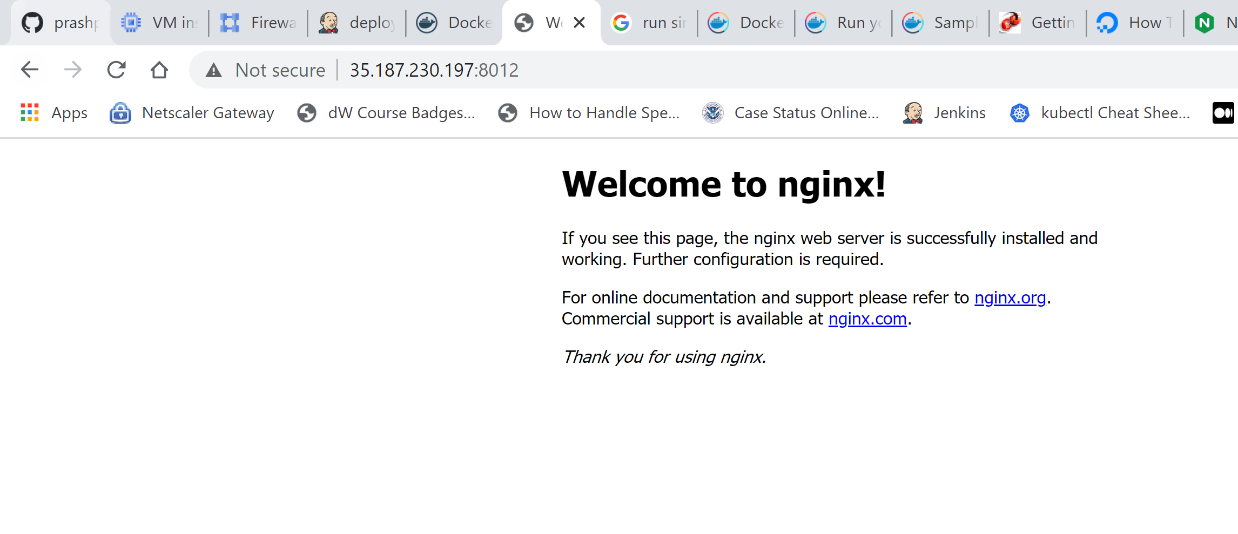

Docker Compose

1. Make changes to docker compose yml and run docker-compose up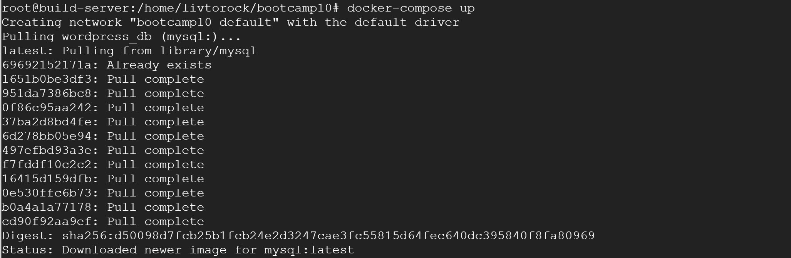
2. Create database and create table