1. Playbook yml 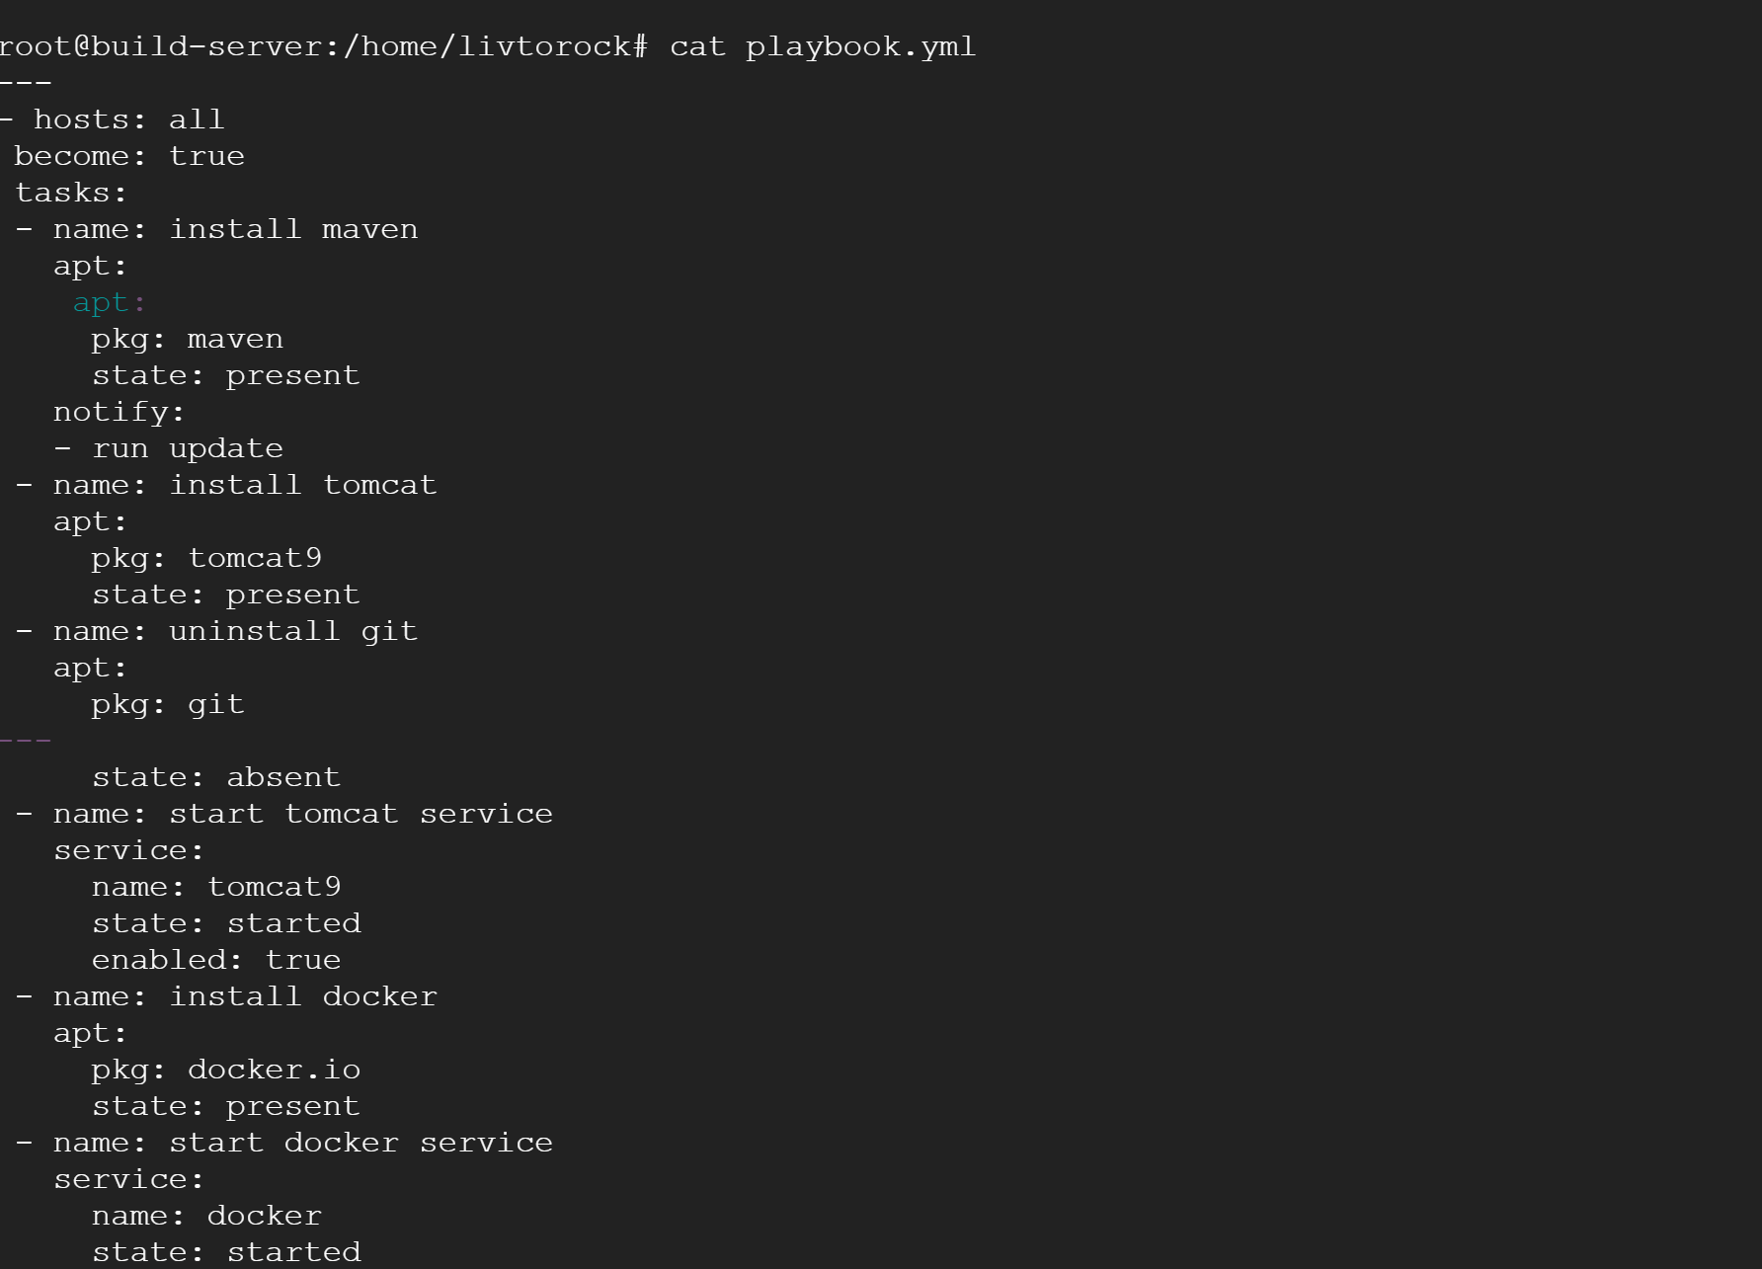
2. having issues with google cloud vm connection so executed ansible in same server. 