**Summer Training Report**

**On**

**ANALYSIS AND ANALYTICS OF PHOTODIODES**

**At**



**Solid State Physics Laboratory**

**Defence Research and Development Organization Timarpur, Lucknow Road, Delhi-110008**

***in partial fulfillment of the degree***

**Bachelor of Technology**

**Submitted By:**

**ASHISH RANA**

**2K17/CO/080**

**ABHISHEK DUNGRIYAL**

**00114807717**

**NAVEEN LAKHCHAURA**

**00814807717**

**PRASHUN CHAKRABORTY**

**41916412817**

**Under the Guidance of**

**Dr. RAGHVENDRA SAHAI SAXENA (SCIENTIST F)**

# DECLARATION

This is to certify that Summer Training Report entitled ANALYSIS AND ANALYTICS OF PHOTODIODE which is submitted by Ashish Rana, Abhishek Dungriyal, Naveen Lakhchaura, Prashun Chakraborty in partial fulfillment of the requirement for the award of degree B.Tech., It is a record of the candidates own work carried out by them under my/our supervision. The matter embodied in this report is original and has not been submitted for the award of any other degree. I hereby declare that this submission was their own work and that, to the best of his knowledge and belief, it contains no material previously published or written by another person nor material which to a substantial extent has been accepted for the award of any other degree or diploma of the university or other institute of higher learning, except where due acknowledgment has been made in the text.

**SIGNATURE**

**Dr. RAGHVENDRA SAHAI SAXENA (SCIENTIST F)**

# ACKNOWLEDGEMENT

We record our sincere thanks to the Dr. Raghvendra Sahai Saxena, Solid State Physics Laboratory, Defence Research and Development Organisation for providing us an excellent opportunity to undergo training in his esteemed organization through which we could gain an exposure to the Research and Development environment and getting acquainted with the HgCdTe photodiode technologies.

We wish to express my deep sense of gratitude and obligation to, Dr. Raghvendra Sahai Saxena, Scientist ‘F’ for his guidance. We would also like to thank, Dr. Pratap Singh Rana, Scientist ‘C’ for their valuable guidance in making report and helping us in other works.

# ORGANISATION PROFILE



**Defence Research & Development Organisation (DRDO)** works under Department of Defence Research and Development of Ministry of Defence. DRDO dedicatedly working towards enhancing self-reliance in Defence Systems and undertakes design & development leading to production of world class weapon systems and equipment in accordance with the expressed needs and the qualitative requirements laid down by the three services.

DRDO is working in various areas of military technology which include aeronautics, armaments, combat vehicles, electronics, instrumentation engineering systems, missiles, materials, naval systems, advanced computing, simulation and life sciences. DRDO while striving to meet the Cuttingedge weapons technology requirements provides ample spinoff benefits to the society at large thereby contributing to the nation building.

**Vision**

Make India prosperous by establishing world-class science and technology base and provide our Defence Services decisive edge by equipping them with internationally competitive systems and solutions.

DRDO have many research and development labs spread across the country. The different R&D labs are meant to work on different projects.one of the lab of DRDO is SSPL (solid state physics laboratory), which is located in Timarpur, Delhi.

Solid State Physics Laboratory (SSPL), one of the establishments under the Defence R&D Organization (DRDO), Ministry of Defence, was established in 1962 with the broad objective of developing an R&D base in the field of Solid State Materials, Devices and Sub-systems.The Laboratory has a vision to be the centre of excellence in the development of Solid State Materials, Devices and has a Mission to develop and characterize high purity materials and solid state devices and to enhance infrastructure, technology for meeting the futuristic challenges.

The major activities at SSPL include development of semi-conductor materials, Solid-state devices, Electronic components and investigation of Solid-state materials/devices. One of the thrust areas is the development of semiconductor Laser diodes. Recently development includes the fabrication of the Pulsed Laser Diode, CW Laser Diode, Laser Diode Array at SSPL.

# CONTENTS

1. List of figures …………7
2. Analysis and Analytics………8
3. Machine Leaning………10
   1. Type of machine learning problems...........10
   2. Machine Learning works in such ways…...…13
   3. Machine learning Application ………13
   4. Linear Regression ………14
      1. Type of Linear Regression………14
4. Photodiode………16
   1. Working of photodiode ………17
   2. Modes of Operation ………17
   3. Types of Photodiode ………18
   4. Applications of Photodiode ………19
   5. V-I Characteristics……….19
5. Mercury cadmium telluride……….20
6. Electrical characteristic signature for non-uniformity analysis in HgCdTe photodiode arrays…….…21
   1. Introduction ………21
   2. Electrical characteristics of HgCdTe photodiode ………21
7. Code (Data analysis of photodiodes data) ……...23
   1. Visualization ………28
   2. Visualization using Tableu ………….29
   3. GUI ………….32

Conclusion…………………………………………………………………………….36

References……………………………………………………………………………..37

## LIST OF FIGURES

1. Figure 1.1 block diagram
2. Figure 1.2 supervised learning
3. Figure 1.3unsupervised learning
4. Figure 1.4 classification and regression
5. Figure 1.5 linear regression graph
6. Figure 2.1 photodiode symbol
7. Figure 2.2 PN Junction diode
8. Figure 2.3 V-I Characteristics
9. Figure 3.1 voltage vs dynamic resistance
10. Figure 3.2 current vs dynamic resistance
11. Figure 3.3 voltage vs dynamic resistance (test set)
12. Figure 3.4 current vs dynamic resistance (test set)
13. Figure 4data visualization graphs

**CHAPTER-1**

**DATA ANALYSIS AND DATA ANALYTICS**

Data analysis and data analytics are sounds similar and often treated as interchangeable terms, but both the words have different meanings. Data Analysis is a process of getting useful decisions out of data. Data Analysis is also extracting useful information, meaningful information from observations. Whereas Data Analytics is a process of examining the data sets so that you can draw a conclusion, predict about the information they contain, with the help of software and specialized systems.

Data Analysis is all about what happened with the dataset so far or what happened with the dataset in the past. If you want to be a data analyst you have a good knowledge of database and some programming language like C, C++, Python, Java etc.

Data Analytics is all about what is going to happen or what is going to happen next. Data analytics is also known as Predictive analytics or Data Science. If you want to be a data analytics or data scientist you have to be very strong in mathematics, then you have to be good in data structure and algorithm and some programming language like C, C++, Python, Java etc.

Data analysis is a broader term that refers to the process of compiling and analysing data in order to present findings to management to help inform business decision making. Data analytics is a subcomponent of data analysis that involves the use of technical tools and data analysis techniques.

Data analysis is the process of examining, transforming, and arranging raw data in a specific way to generate useful information from it. In essence, data analysis allows for the evaluation of data through analytical and logical reasoning to lead to some sort of outcome or conclusion in some context. It is a multi-faceted process that involves a number of steps, approaches, and diverse techniques. The approach you take to data analysis depends largely on the type of data available for analysis and the purpose of the analysis.

The difference between data analysis and data analytics is that data analytics is a broader term of which data analysis forms a subcomponent. Data analysis refers to the process of compiling and analysing data to support decision making, whereas data analytics also includes the tools and techniques use to do so.

Whenever someone wants to find that what will happen next or what is going to be next then we go with data analytics because data analytics helps to predict the future value. Whereas In data analysis, analysis performs on past dataset to understand what happened so far from data. Data analytics and data analysis both are necessary to understand the data one can be useful for estimating future demands and other is important for performing some analysis on data to look into past.

**CHAPTER-2**

**Machine Learning**

**MachineLearning** is a branch of computer science. Machine Learning is closely related to data mining. Machine Leaning is a method of teaching computer to make predictions based on some dataset. As it is clear from the name, it gives the computer that which makes it more similar to humans: The ability to learn.

Machine Learning works as:

The huge number of dataset being given to a classifier and based on that data set it just do some processing and tries to predict some result.

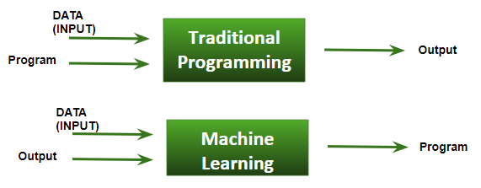

**Figure 1.1 block diagram of traditional programming and machine learning**

**Basic Difference in ML and Traditional Programming?**

* **Traditional Programming:**We feed in DATA (Input) + PROGRAM (logic), run it on machine and get the output.
* **Machine Learning:**We feed in DATA(Input) + Output, run it on machine during training and the machine creates its own program(logic), which can be evaluated while testing.

**3.1Types of machine learning problems**

1. **On basis of the nature of the learning “signal” or “feedback” available to a learning system.**

* **Supervised learning**: Supervised Learning uses labelled data to train the model. We can also tell that this is a “teacher oriented learning”. Some real-life examples are:
  + **Image Classification:**You train with images/labels. Then in the future you give a new image expecting that the computer will recognize the new object.
  + **Market Prediction/Regression:**You train the computer with historical market data and ask the computer to predict the new price in the future.
* **Unsupervised learning**: Unsupervised Learning uses no labelled data or you can say No labels are given to the learning algorithm, leaving it on its own to find structure in its input.Unsupervised learning can be a goal in itself (discovering hidden patterns in data).
  + - **Clustering:** You ask the computer to separate similar data into clusters, this is essential in research and science.
    - **High Dimension Visualization:** Use the computer to help us visualize high dimension data.
    - **Generative Models:** After a model captures the probability distribution of your input data, it will be able to generate more data. This can be very useful to make your classifier more robust.

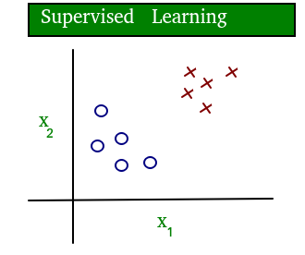

**Figure 1.2 Supervised Learning**

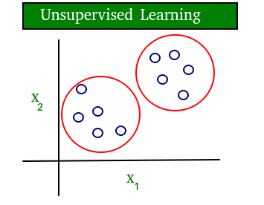

**Figure 1.3 Unsupervised Learning**

1. **On thebasis of “output” desired from a machine learned system.**

* **Classification**: Inputs are divided into two or more classes, and the learner must produce a model that assigns unseen inputs to one or more (multi-label classification) of these classes. This is typically tackled in a supervised way. Spam filtering is an example of classification, where the inputs are email (or

other) messages and the classes are “spam” and “not spam”.

* **Regression**: Regression is basically relationship between the variables. These variables are of two types:

Dependent and Independent. It is also a supervised learning problem, but the outputs are continuous rather than discrete. For example, predicting the stock prices using historical data.

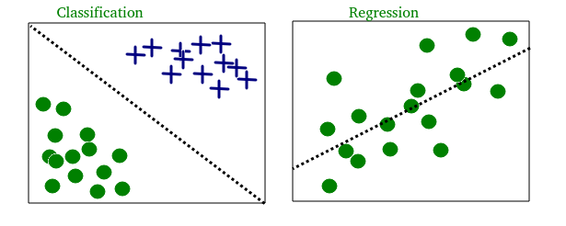

**Figure 1.4 Classification And Regression**

**3.2Machine Learning works in such aways:-**

* Collect or gather the data. Collect past data in any form suitable for processing.The better the quality of data, the more suitable it will be for modelling.
* Data Processing – Sometimes, the data collected is in the raw form and it needs to be pre-processed.
* Analysing the Input data.
* Train/Develop the algorithm.
* Divide the input data into training,cross-validation and test sets.
* Building models with suitable algorithms and techniques on the training set.
* Testing our conceptualized model with data which was not fed to the model at the time of training and evaluating its performance using metrics such as F1 score, precision and recall.

# 3.3Machine Learning Applications :-

* **Web Search Engine:** One of the reasons why search engines like Google, Bing etc work so well is because the system has learnt how to rank pages through a complex learning algorithm.
* **Photo tagging Applications:** Be it facebook or any other photo tagging application, the ability to tag friends makes it even more happening. It is all possible because of a face recognition algorithm that runs behind the application.
* **Spam Detector:** Our mail agent like Gmail or Hotmail does a lot of hard work for us in classifying the mails and moving the spam mails to spam folder. This is again achieved by a spam classifier running in the back end of mail application.

# 3.4 Linear Regression

**Linear Regression** is a machine learning algorithm based on **supervised learning**. Linear regression is a relationship between dependent and independent variable. It performs a **regression task**. Regression models a target prediction value based on independent variables. It is mostly used for finding out the relationship between variables and forecasting. Different regression models differ based on – the kind of relationship between dependent and independent variables, they are considering and the number of independent variables being used.

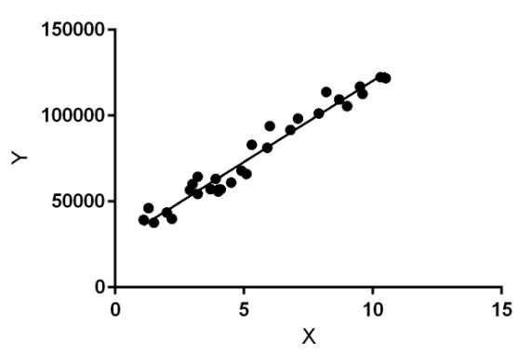

**Figure 1.5 Linear Regression Graph**

Linear regression performs the task to predict a dependent variable value (y) based on a given independent variable (x). So, this regression technique finds out a linear relationship between x (input) and y(output). Hence, the name is Linear Regression.  
In the figure above, X (input) is the work experience and Y (output) is the salary of a person. The regression line is the best fit line for our model.

**Hypothesis function for Linear Regression:**  
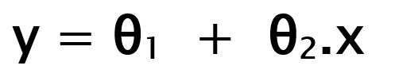

While training the model we are given:

**x:** input training data (univariate – one input variable(parameter))  
**y:** labels to data (supervised learning)

When training the model – it fits the best line to predict the value of y for a given value of x. The model gets the best regression fit line by finding the best θ1 and θ2 values.  
**θ1:** intercept  
**θ2:** coefficient of x

**3.4.1 Types of Linear Regression:**

**These are of two types:**

1. Simple linear Regression.
2. Multiple Linear Regression.

* **Multiple Linear Regression**

A regression model that contains more than one regressor variable is called Multiple Regression Model. Many applications of regression analysis involve situations in which there are more than one regressor variable.

Multiple Linear Regression attempts to model the Relationship between two or more features and a response by fitting a linear equation to observed data. The steps to perform multiple linear regression are almost similar to that of simple linear Regression. The Difference Lies in the evaluation. We can use it to find out which factor has the highest impact on the predicted output and now different variable relate to each other.[1]

Here:

**Y= b0 + b1*x1 + b2*x2 + b3*x3 +…… bn*xn**

Y = Dependent variable and x1, x2, x3, …… xn = multiple independent variables

**CHAPTER-3**

## PHOTODIODE

A photodiode is a P-N Junction or pin semiconductor device that consumes light energy and converts it into electric current or electrical energy. It is sometimes referred as photodetector, photo-sensor, or light detector.

These diodes are designed to work in reverse bias mode/condition(false connection), it means that the P-sideof the photodiode is associated with the negative terminal of the battery and n-side is connected to the positive terminal of the battery. The reverse saturation current will flow through in it which is knowns as “dark current”.

This diode is very complex to light so when light falls on the diode it easily changes light into electric current.

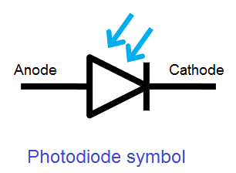

**Figure2.1 Photodiode symbol**

Some photodiodes will look like a light emitting diode. They have two terminals coming from the end. The smaller end of the diode is the cathode terminal (-ve), while the longer end of the diode is the anode terminal (+ve). See the following schematic diagram for the anode and cathode side. Under forward bias condition, conventional current will flow from the anode to the cathode, following the arrow in the diode symbol. Photocurrent flows in the reverse direction.

## 4.1 WORKING OF PHOTODIODE

The working principle of a photodiode is, when a photon of ample energy strikes on the diode, it makes a couple of an electron-hole. When photons of energy higher than 1.1eV hit the diode, electron-hole pairs are generated. When photon enters the depletion region of diode, it hits the atom with high energy. The absorption of photons depends on the energy of photons, the energy of photons is directly proportion to the intensity of photons absorption. When the energy of photons is high, the absorption of photons is less and when the energy of photons is less, the absorption of photons is more. Thiswhole process is known as inner photoelectric effect.

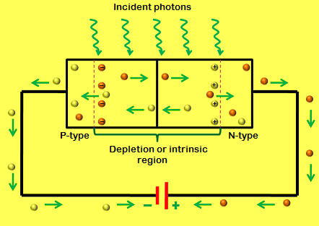

**Figure 2.2 PN Junction Diode**

The electron has a negative charge and the hole will have a positive charge. The depletion region will have built in electric field, so electron hole pairs moves away from the junction. After this the holes move towards anode and electrons move towards cathode to produce photo current.

#### **4.2 Modes of Operation**

The operating modes of the photodiode include three modes, namely Photovoltaic mode, Photoconductive mode and avalanche diode mode.

**Photovoltaic Mode**

 This mode is also known as zero bias mode, in which a voltage is produced by the lightened photodiode. It gives a very small dynamic range & non-linear necessity of the voltage formed.

**Photoconductive Mode**

The photodiode used in this photoconductive mode is more usually reverse biased. The reverse voltage application will increase the depletion layer’s width, which in turn decreases the response time & the junction capacitance. This mode is too fast and displays electronic noise.

**Avalanche Diode Mode**

 Avalanche diodes operate in a high reverse bias condition, which permits multiplication of an avalanche breakdown to each photo-produced electron-hole pair. This outcome in an internal gain in the photodiode, which slowly increases the device response.

## 4.3 Types of Photodiode

Although there are numerous types of photodiode available in the market and they all work on the same basic principles, though some are improved by other effects. The working of different types of photodiodes work in a slightly different way, but the basic operation of these diodes remains the same. The types of the photodiodes can be classified based on its construction and functions as follows.

* PN Photodiode
* Schottky Photo Diode
* Avalanche Photodiode

These diodes are widely used in the applications where the detection of the presence of light, color, position, intensity is required.

### **4.4Applications of Photodiode**

* Photodiode are applied in safety electronics like fire and smoke detectors. It is also used in TV units.
* The applications of photodiodes involve in similar applications of photodetectors like charge-coupled devices, photoconductors, and photomultiplier tubes.
* In other consumer devices like clock radios, camera light meters, and street lights, photoconductors are more frequently used rather than photodiodes.
* Photodiodes are also widely used in numerous medical applicationslike instruments to analyze samples.

#### **4.5 V-I Characteristics of Photodiode**

A photodiode continually operates in a reverse bias mode. The characteristics of the photodiode are shown clearly in the following figure, that the photocurrent is nearly independent of reverse bias voltage which is applied. For zero luminance, the photocurrent is almost zero excluding for small dark current. It is of the order of nano amperes. As optical power rises the photo current also rises linearly. The max photocurrent is incomplete by the power dissipation of the photo diode.[2]

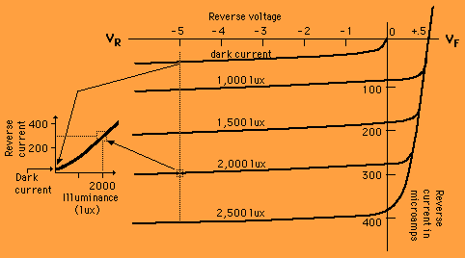

**Figure 2.3 V-I Characteristics**

**CHAPTER-4**

**Mercury Cadmium Telluride**

Mercury Cadmium Telluride (HgCdTe) is dominant in case of IR detection.It has tunable bandgap and high sensitivity. It is fragile and defect prone material.

The paper proposes a method to quickly analyse the performance, non-uniformity using signature of dynamic resistance voltage characteristics.Discription is done for Mid Wave Infrered Region (3-5 µm IR wavelength)

Mercury Cadmium Telluride or HgCdTe (also cadmium mercury telluride, MCT, MerCad Telluride, MerCadTel, MerCat or CMT)is an alloy of cadmium telluride(CdTe) and mercury telluride (HgTe) with a tunable bandgap spanning the shortwave infrared to the very long wave infrared regions. The amount of cadmium (Cd) in the alloy can be chosen so as to tune the optical absorption of the material to the desired infraredwavelength. CdTe is a semiconductor with a bandgapof approximately 1.5 electrons volts (eV) at room temperature. HgTe is a semimetal, which means that its bandgap energy is zero. Mixing these two substances allows one to obtain any bandgap between 0 and 1.5 eV.[3]

**CHAPTER-5**

**Electrical characteristic signatures for non-unifomity analysis in HgCdTe photodiode arrays**

**6.1 Introduction**

* Mercury Cadmium Telluride (HgCdTe) is dominant in case of IR detection.
* It has tunable band-gap and high sensitivity.
* Fragile and defect prone material
* The paper proposes a method to quickly analyse the performance, non-uniformity using signature of dynamic resistance voltage characteristics.
* Discription is done for Mid Wave Infrered Region (3-5 µm IR wavelength)

**6.2 Electrical Characteristics Of HgCdTe photodiode**

1. Dark Current Mechanisms are as follows:

* Thermal Diffusion current.
* Generation - Recombination in space charge region (G-R).
* Trap AssisstedTunneling(TAT).
* Band to Band Tunneling.
* Surface Leakage through ohmic shunt.

1. In case of MWIR HgCdTe, effort of BTB current is negligibly small.
2. Total current and overall dynamic resistance depends on parameters governing current mechanisms.
3. In typical HgCdTe, the forward biased region is dominated by G-R till certain voltage.
4. Diffusion current becomes dominant until series resistance starts limiting the current flow.
5. At reverse bias, TAT becomes the only dominant mechanism.[4]

**CHAPTER-6**

**Data analysis of Photodiodes data**

**Code:**

**#importing libraries**

import numpy as np

import matplotlib.pyplot as plt

import pandas as pd

**#importing dataset**

dataset = pd.read_csv('Diode Data.csv')

X = dataset.iloc[:, [3, 4]].values

y = dataset.iloc[:, [2]].values

# Splitting the dataset into the Training set and Test set

from sklearn.model_selection import train_test_split

X_train, X_test, y_train, y_test = train_test_split(X, y, test_size = 0.25, random_state = 0)

**# Fitting Multiple Linear Regression to the Training set**

from sklearn.linear_model import LinearRegression

regressor = LinearRegression()

regressor.fit(X_train, y_train)

# Predicting the Test set results

y_pred = regressor.predict(X_test)

**# Visualising Actual Set**

# Visualising Actual Set

plt.scatter(dataset['V'], np.log(dataset['RD']), color='red')

plt.title('Voltage Vs Dynamic Resistance(Actual Set)')

plt.xlabel('Voltage')

plt.ylabel('Dynamic Resistance(logarithmic Scale)')

plt.grid(True)

plt.show()

plt.scatter(dataset['I'], np.log(dataset['RD']), color='red')

plt.title('Current Vs Dynamic Resistance(Actual Set)')

plt.xlabel('Current')

plt.ylabel('Dynamic Resistance(logarithmic Scale)')

plt.grid(True)

plt.show()

**# Visualising Test Set**

plt.scatter(X_test[:,1],np.log(y_test), color='red')

plt.title('Current Vs Dynamic Resistance(Test Set)')

plt.xlabel('Current')

plt.ylabel('Dynamic Resistance(logarithmic Scale)')

plt.grid(True)

plt.show()

plt.scatter(X_test[:,0], np.log(y_test), color='red')

plt.title('Voltage Vs Dynamic Resistance(Test Set)')

plt.xlabel('Voltage')

plt.ylabel('Dynamic Resistance(logarithmic Scale)')

plt.grid(True)

plt.show()

# **Showing the difference in Prediction Vs Test Results**

plt.scatter(y_test, np.log(y_pred), color='green')

plt.title('Prediction Vs Test Results')

plt.xlabel('Test Results')

plt.ylabel('Prediction Results(logarithmic Scale)')

plt.grid(True)

plt.show()

# Output

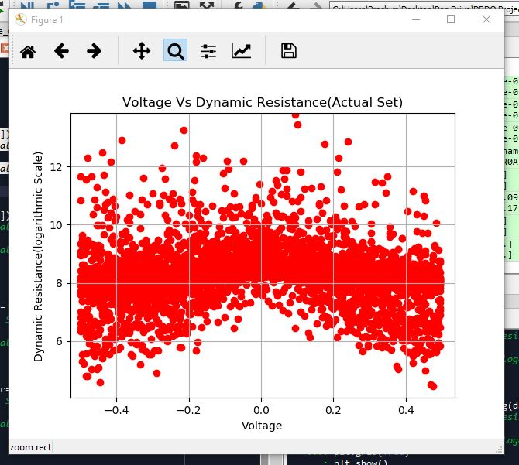

**Figure 3.1 voltage Vs dynamic resistance**

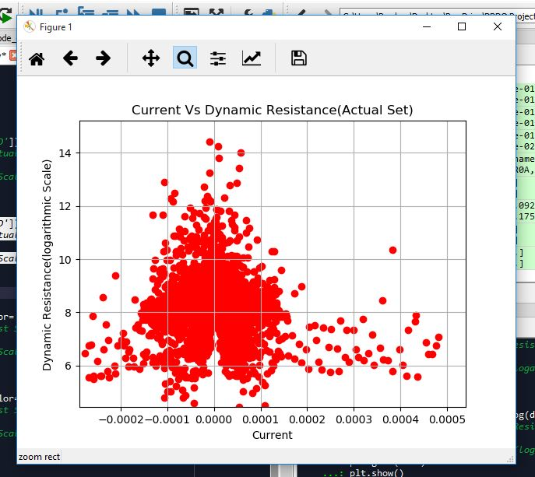

**Figure 3.2 Current Vs dynamic resistance**

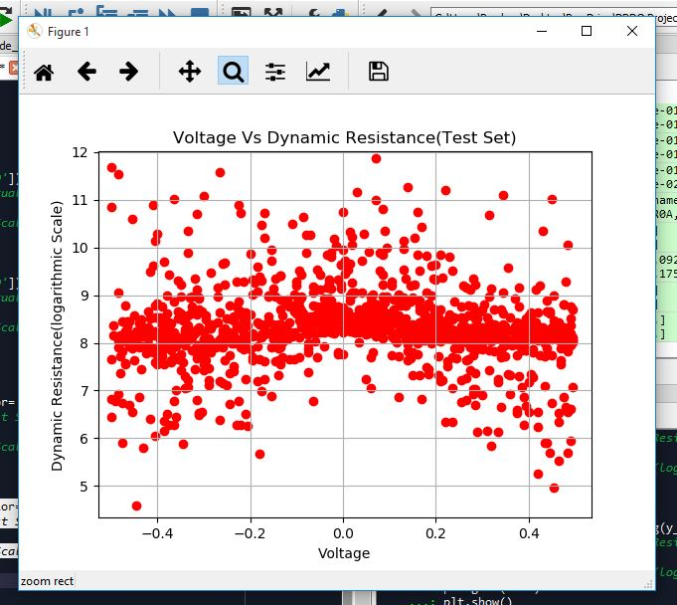

**Figure 3.3 Voltage Vs dynamic resistance (Test set)**

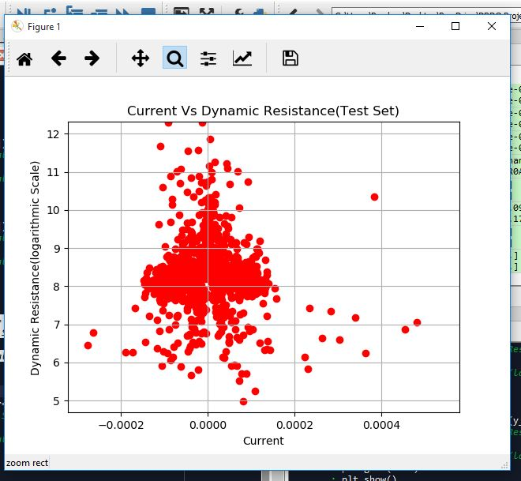

**Figure 3.4 Current Vs dynamic resistance (test set)**

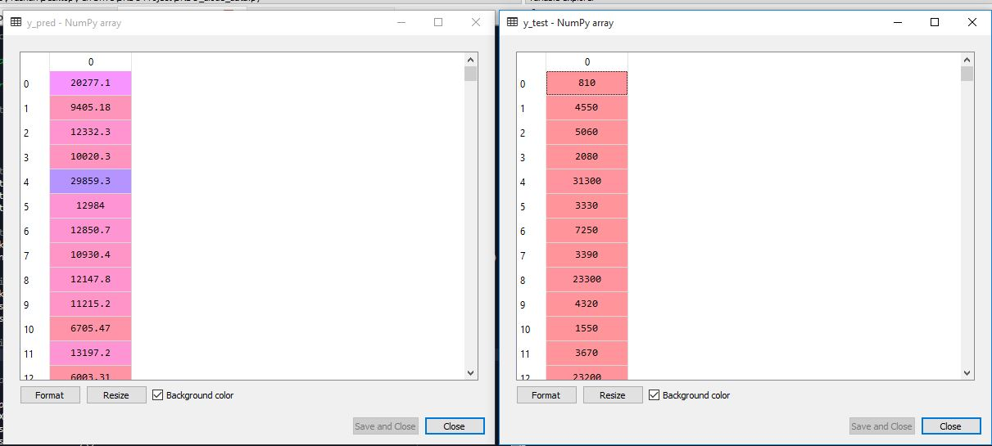

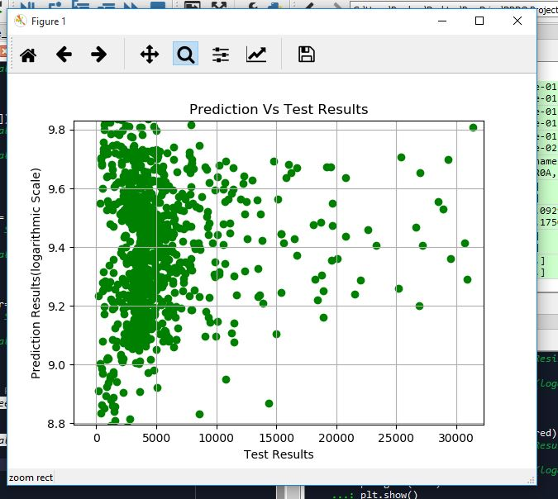

**Figure 3.6 Predict and Test (Plot)**

**Visualization of Data**

**Data visualization** is viewed by many disciplines as a modern equivalent of visual communication. It involves the creation and study of the visual representation of data.

To communicate information clearly and efficiently, data visualization uses statistical graphics, plots, information graphics and other tools. Numerical data may be encoded using dots, lines, or bars, to visually communicate a quantitative message. Effective visualization helps users analyze and reason about data and evidence. It makes complex data more accessible, understandable and usable.

Data visualization is the graphical representation of information and data. By using visual elements like charts, graphs, and maps, data visualization tools provide an accessible way to see and understand trends, outliers, and patterns in data.

In the world of Big Data, data visualization tools and technologies are essential to analyse massive amounts of information and make data-driven decisions.

**Common general types of data visualization:**

* Charts
* Tables
* Graphs
* Maps
* Infographics
* Dashboards

**Visualization made by data analytics using Tableu**

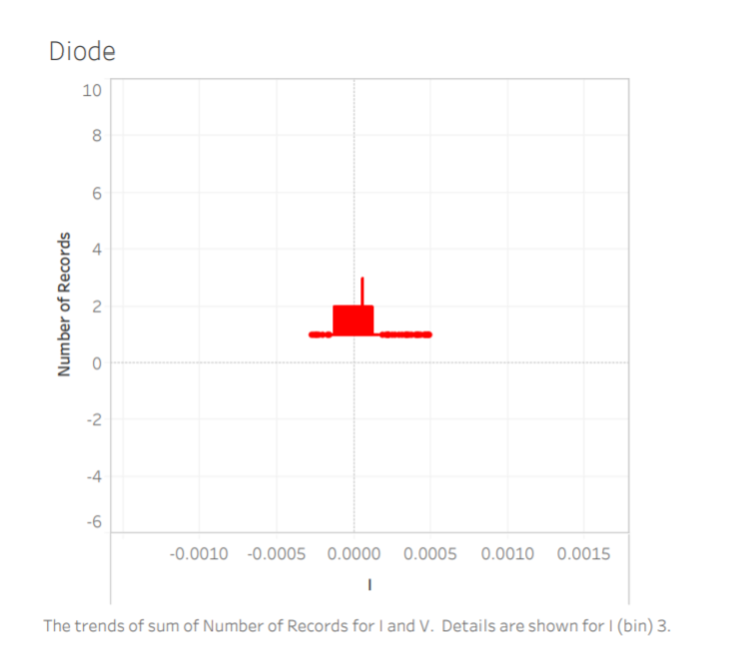

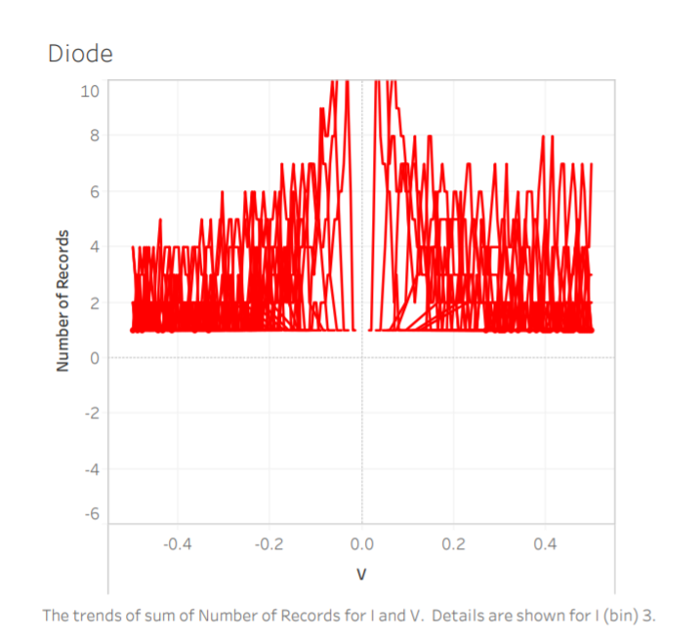

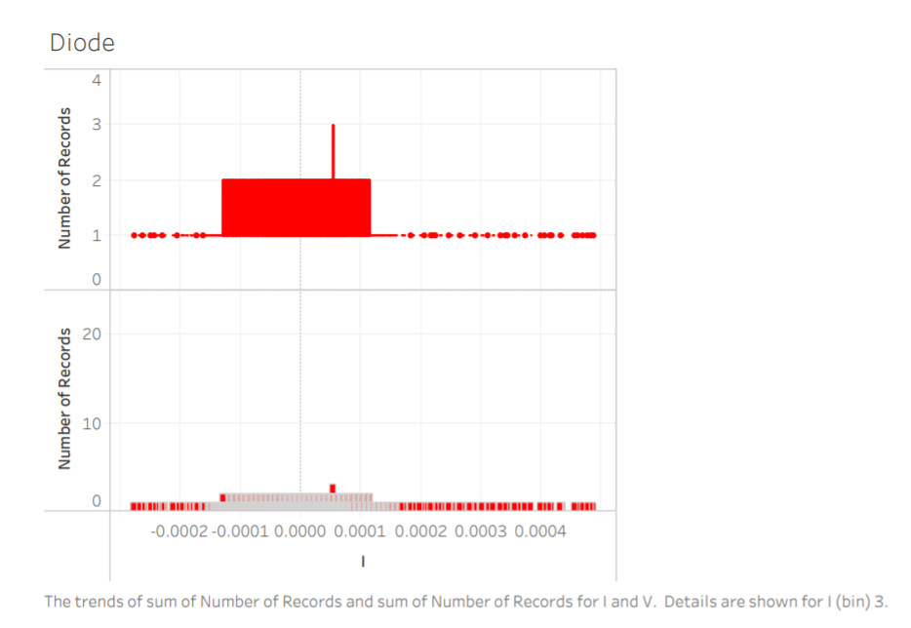

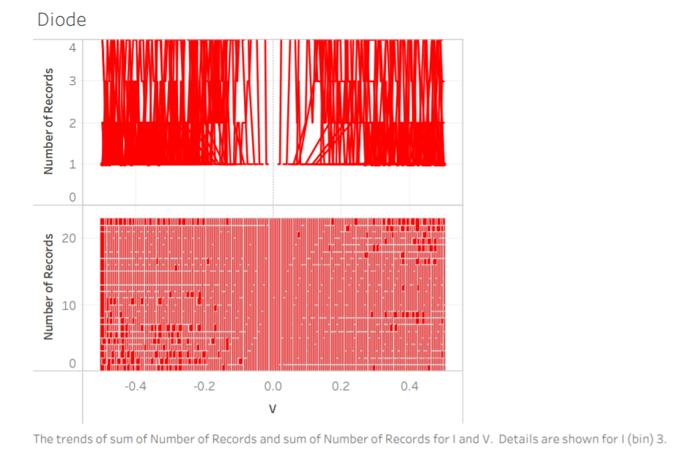

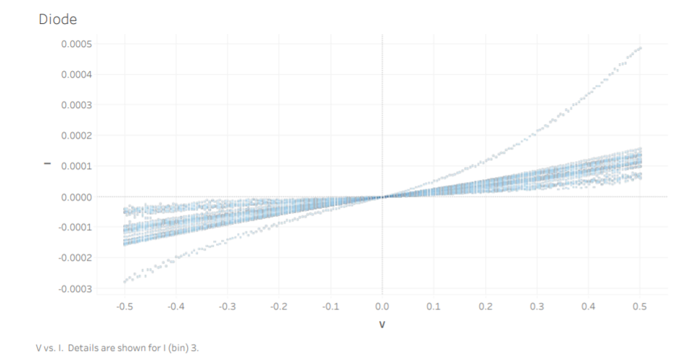

**GUI used for the Multiple Linear Regression in Python**

This is where the real fun begins!

Why not create a GUI that will allow users input the independent variables in order to get the predicted result?

It may be that some of the users may not know much about inputting the data in the Python code itself, so it makes sense to create them a simple interface where they can manage the data in a simplified manner.

import pandas as pd

from sklearn import linear_model

import tkinter as tk

import statsmodels.api as sm

Diode = pd.read_excel(r'C:\Users\mrash\Downloads\Diode.xlsx')

df = pd.DataFrame(Diode, columns= ['AnodeI', 'AnodeV','RD','V','I','RDA','ISM','RDSM','RDASM'])

print(df)

X = df[['V','I']] # here we have 2 input variables for multiple regression. If you just want to use one variable for simple linear regression, then use X = df['Interest_Rate'] for example.Alternatively, you may add additional variables within the brackets

Y = df['RD'] # output variable (what we are trying to predict)

# with sklearn

regr = linear_model.LinearRegression()

regr.fit(X, Y)

print('Intercept: \n', regr.intercept_)

print('Coefficients: \n', regr.coef_)

# with statsmodels

X = sm.add_constant(X) # adding a constant

model = sm.OLS(Y, X).fit()

predictions = model.predict(X)

# tkinter GUI

root= tk.Tk()

canvas1 = tk.Canvas(root, width = 1200, height = 450)

canvas1.pack()

# with sklearn

Intercept_result = ('Intercept: ', regr.intercept_)

label_Intercept = tk.Label(root, text=Intercept_result, justify = 'center')

canvas1.create_window(260, 220, window=label_Intercept)

# with sklearn

Coefficients_result = ('Coefficients: ', regr.coef_)

label_Coefficients = tk.Label(root, text=Coefficients_result, justify = 'center')

canvas1.createwindow(260, 240, window=label_Coefficients)

# with statsmodels

print_model = model.summary()

label_model = tk.Label(root, text=print_model, justify = 'center', relief = 'solid', bg='LightSkyBlue1')

canvas1.create_window(800, 220, window=label_model)

# New_V label and input box

label1 = tk.Label(root, text='Type V:')

canvas1.create_window(100, 100, window=label1)

entry1 = tk.Entry (root) # create 1st entry box

canvas1.create_window(270, 100, window=entry1)

# New_I label and input box

label2 = tk.Label(root, text=' Type I:')

canvas1.create_window(120, 120, window=label2)

entry2 = tk.Entry (root) # create 2nd entry box

canvas1.create_window(270, 120, window=entry2)

def values():

global New_V #our 1st input variable

New_V = float(entry1.get())

global New_I #our 2nd input variable

New_I = float(entry2.get())

Prediction_result = ('Predicted RD: ', regr.predict([[New_V ,New_I]]))

label_Prediction = tk.Label(root, text= Prediction_result, bg='orange')

canvas1.create_window(260, 280, window=label_Prediction)

button1 = tk.Button (root, text='Predict RD',command=values, bg='orange') # button to call the 'values' command above

canvas1.create_window(270, 150, window=button1)

root.mainloop()

OUTPUT:

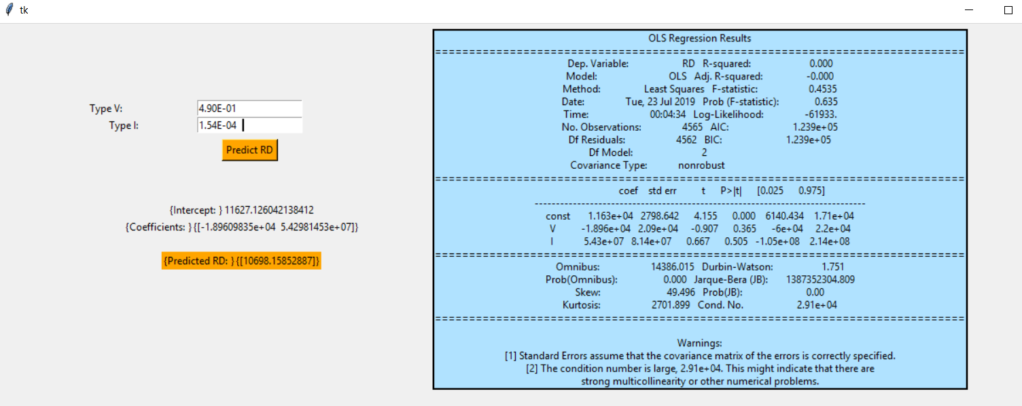

**CONCULSION**

In this project, we have dealt with a data of over 4000 records. In data analysis, we study the patterns of the data provided and using data analytics we create a model through understanding the data provided properly. Data analytics requires knowledge of machine learning and algorithms. Through the concepts of machine learning, we check which algorithm fits the data the best which was Multiple Linear Regression in our case.

Here in this model, we predicted the values of dynamic resistance through the provided values of voltage and current of the given diode. Once the model is created, the visualisation of results is done so as to check the variation in predicted and actual sets. Here, multiple linear regression model predicts the values of dynamic resistance the best.

# REFERENCES

1. <https://www.geeksforgeeks.org/ml-multiple-linear-regression-using-python/>
2. [https://www.elprocus.com](https://www.elprocus.com/)
3. <https://en.wikipedia.org/wiki/Mercury_cadmium_telluride>
4. Electrical characteristics signature for non-uniformity analysis in HgCdTe photodiode arrays. – Dr.RaghvendraSahai Saxena.