**Instruction to run the code**

1. The code has been split into different functions and all of it is inside the same .py file.
2. Running the code is a pretty simple process here.In order to run it from the terminal, we have to type the following:

“python3 machinelearning.py”

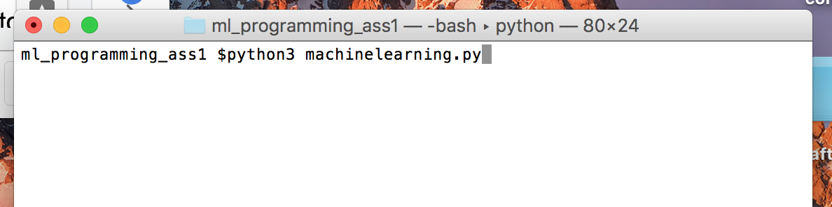

3)Next it will ask you for the filename of the text file that you want to

input and we have to enter the name along with the extension.

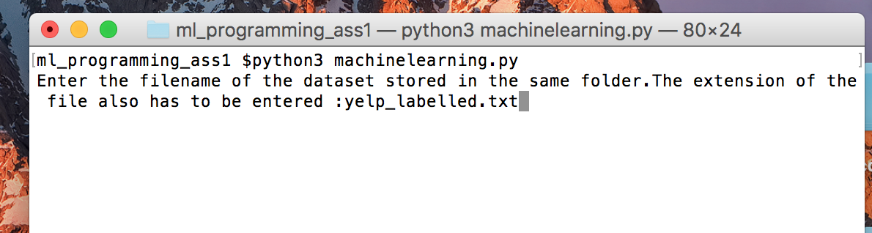

4)Now, the code should start running.It will keep on prompting on the

terminal when its done with experiment-1 and as it runs experiment-2

on different values of m as follows.

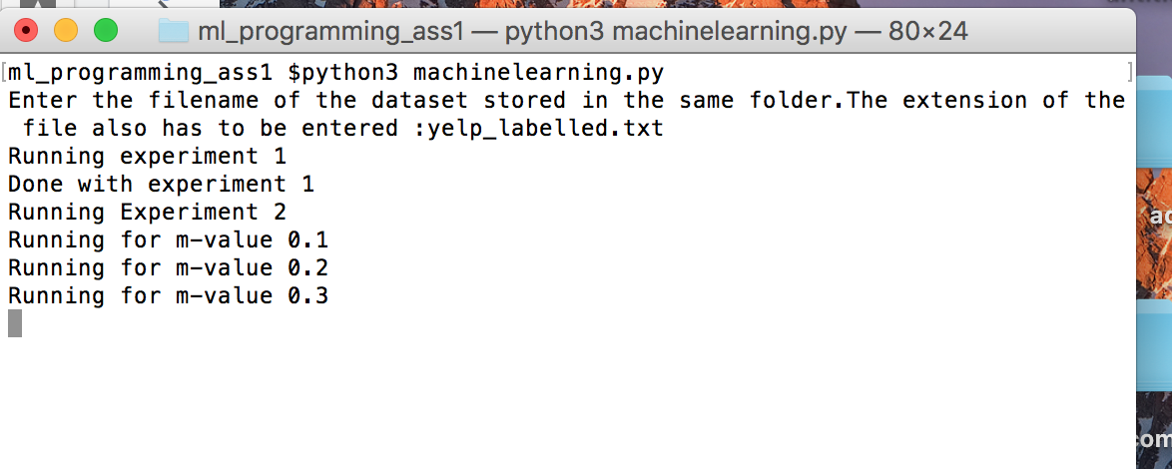

5)The program will take a little over a minute to run for each dataset

and then it shall terminate with 4 different graphs as output.