# Introduction to java

(If they already have basic information about java then they can directly go for quiz and exercise to advance through next lesson. If enough points are not gained then they have to take the lesson)

## What is java?

* Java is a widely adopted programming language that was initially developed in 1995.
* Owned by Oracle, Java has gained immense popularity, running on over 3 billion devices worldwide.
* Java finds application in various domains, including mobile apps (especially Android), desktop software, web development, server-side applications, gaming, and database connectivity.

**Do you know?**

Popular apps like Instagram, WhatsApp, and many games on the Google Play Store are built using Java.

( [Top 11 Applications of Java with Real-world Examples - TechVidvan](https://techvidvan.com/tutorials/applications-of-java/))

## Why java?

* Java being a popular object oriented language its value in the market never fades away. So it’s never waste of time to learn java and make career out of it.
* Due to its widespread usage, there is a high demand for Java developers in the job market.

Did you know?

* A Java developer’s median salary is $83, 975.00. It pays to be a Java developer.(geeks for geeks)
  + Java's object-oriented approach (which will be discussed later on the lesson) allows beginners to think in terms of real-world objects and relationships, making it easier to solve real-life problems and develop applications that simulate real-world scenarios.
  + Java is platform independence meaning it can be written and run in any devices like mac, windows, linux etc.
  + Simplicity and Learning Curve: Java's intuitive syntax and comprehensive documentation make it relatively easy to learn and use.
  + Open-Source and Cost-effective: Java is an open-source language, freely available for developers, making it cost-effective for businesses.
  + Security and Performance: Java incorporates robust security features and offers excellent performance in terms of speed and efficiency.
  + Code Reusability and Structure: Java's object-oriented nature promotes code reusability, modularity, and maintainability, resulting in lower development costs.
  + Smooth Transition: Java's similarity to languages like C++ and C# facilitates an easier transition for programmers.

### Mid-session quiz (only 1 and let them continue if wrong then ask another question. Do it three time if all three answer are wrong recommend them to start over or skip and continue)

Approximately how many devices worldwide run Java?

a) 500 million

b) 1 billion

c) 3 billion

d) 5 billion

In which year was Java initially developed?

a) 1985

b) 1990

c) 1995

d) 2000

Which of the following is NOT a reason why Java is popular in the job market?

a) High salary prospects for Java developers

b) Strong demand for Java skills in the industry

c) Java's simplicity and ease of learning

d) Limited career growth opportunities for Java developers

## Application of java (chat gpt)

Mobile Apps: Java is used to make apps for smartphones and tablets, like the ones you use on Android devices. It helps developers create apps that can do different things, like social media apps or games.

Desktop Software: Java can also be used to make programs that you use on your computer. It allows developers to create software that works on different operating systems, such as Windows, Mac, or Linux.

Web Development: Java is used to create websites and web applications. Developers use Java to build interactive and dynamic web pages that can do things like take user input or store information.

Server-Side Applications: Java is used to create programs that run on servers. These programs handle tasks like managing user accounts, processing transactions, or serving web pages to users.

Gaming: Java can be used to create simple games that you can play on your computer or mobile device. While it may not be used for complex and high-graphic games, Java is great for creating smaller games with basic graphics.

Database Connectivity: Java allows developers to connect their programs to databases, which are used to store and retrieve data. With Java, developers can interact with databases to store information or retrieve data when needed.

## Getting started with java

Now let’s get started with java programing. For the first task lets install an ide that allows us to run the java program. For this you can use any editor tools like vs code, intellij eclipse etc. For our course we will continue with eclipse.

* 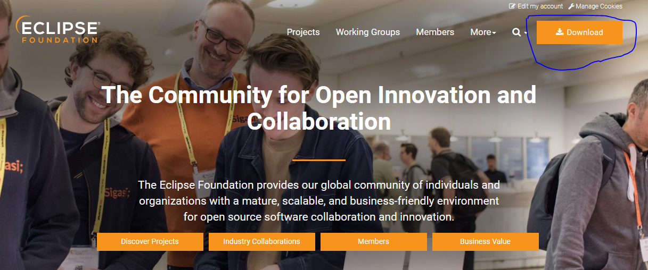Visit the official Eclipse website at https://www.eclipse.org/ and navigate to the Downloads page.
* After getting here, click on the download tab on the right top bar.

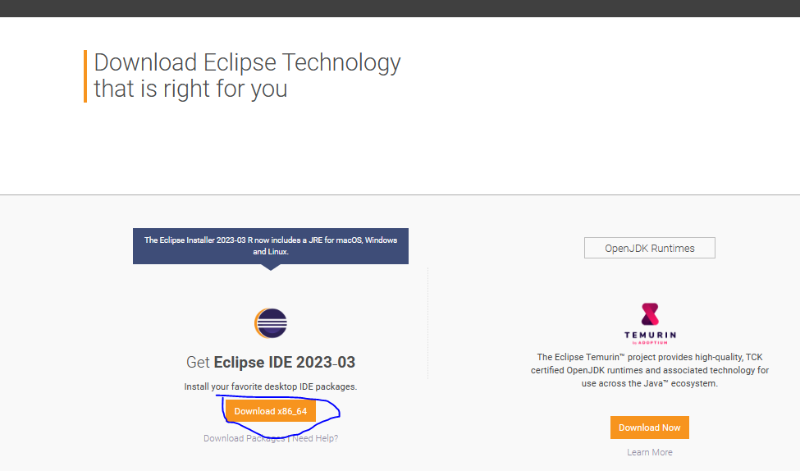

You will get to this page click on download *86_64

* Choose the appropriate version of Eclipse for your operating system (Windows, Mac, or Linux) and click on the download link.
* Once the download is complete, locate the downloaded file and run the installer.
* Follow the installation wizard instructions to complete the installation process. You can choose the default settings unless you have specific preferences.
* After the installation is finished, launch Eclipse.
* On the first startup, Eclipse will prompt you to choose a workspace. A workspace is a directory where your Java projects and files will be stored. You can choose the default workspace or select a custom location on your computer.
* Once you've selected the workspace, click "Launch" to open Eclipse.

## Writing the first program

Once you have editor, we can now write first java program for testing. The code is given below. Copy and paste the code for testing.

public class FirstProgram {

public static void main(String[] args) {

System.out.println("Hello, world!");

}

}

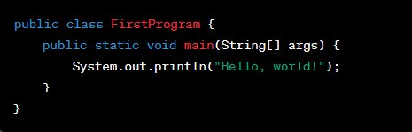

We will discuss about how the program is running in the next lesson. This program prints "Hello, world!" to the console when executed. It serves as a common starting point for learning any programming language.

To run the program in Eclipse, follow these steps:

* Open Eclipse and make sure you are in the Java perspective.
* Create a new Java project by going to File > New > Java Project. Give your project a name and click "Finish".
* Inside your project, create a new Java class by right-clicking on the project folder, selecting New > Class. Enter the name "FirstProgram" and click "Finish".
* In the editor, delete the existing content and paste the code provided above.
* Save the file by pressing Ctrl + S (or Cmd + S on Mac).
* To run the program, right-click anywhere inside the code editor and select Run As > Java Application or simply click the green "Run" button in the toolbar.

### Congratulation on accumulating the basic insight of java.

Do you find the java programming interesting to run?

Yes

No

If yes (Continue to give choice on taking quiz or exercise)

If not (message:

* Its okey. You may find other programming language more interesting. Here are some other programming language to learn:
* (Give the list with link (our dinga vinga learning apps)
* Then at last give option. No, I want to continue furthermore and see what happens ))

On yes :

Message; Take the quiz and exercise to accumulate points or skip for now;

# Quiz

* What does it mean for Java to be platform-independent?
* Java can run on any operating system without any modifications.
* Java can only run on Windows operating systems.
* Java requires a specific platform to run its programs.
* Java is compatible with mobile devices but not desktop computers.
* Which of the following statements about Java's syntax is true?
* Java syntax is similar to natural language, making it easy for beginners to understand.
* Java syntax is highly complex and difficult to learn.
* Java syntax allows developers to write code without any rules or structure.
* Java syntax is strict and enforces specific rules for writing code
* What is the main advantage of using Java for web development?
* Java allows for faster website loading times.
* Java provides advanced graphics and animation capabilities.
* Java ensures better security and protection against cyber attacks.
* Java eliminates the need for web servers and hosting services.

# Exercise