

HYPERSPECTRAL SUPER - RESOLUTION
Report submitted for completion of training

(Satellite Meteorology and Oceanography Research and Training)
Programme of Space Applications Centre
Submitted by
PRASIT MAZUMDER
(Registration No. RS03680)
B.Tech + M.Tech. (Electronics & Electrical Communication)

Under the guidance of
Sri. Himanshu N Patel
SCI/ENG – G
Head, MSCED/MSDG/MRSA
Space Applications Centre, (ISRO) Ahmedabad
Institution
Indian Institute of Technology, Kharagpur
Kharagpur – 721302
West Bengal


SRTD-RTMG-MISA
Space Applications Centre (ISRO)
Ahmedabad, Guajrat
11 May 2026 to 20 July 2026

Abstract
This report describes how we built a runtime-reconfigurable embedded-FPGA (eFPGA) coprocessor for the CV32E40X RISC-V processor, from the first abandoned prototype to a hardened, measured silicon layout. A 30×32-tile FABulous eFPGA attaches to the core through the CORE-V eXtension Interface (XIF). Four custom instructions share the one fabric. When the processor issues an instruction whose accelerator is not loaded, the coprocessor wrapper streams that instruction's bitstream (29,702 32-bit words) from system memory into the fabric's configuration port and then completes the instruction, so hardware is swapped at run time without touching the processor. The flagship instruction is a Kalman-filter (KF) step that denoises radar-altimeter measurements. Its 14-stage single-token pipeline, running over a pool of ten 32×32 Booth–Wallace multipliers and a Newton–Raphson reciprocal, finishes one predict-plus-update step in 23 cycles where optimized software needs 661 — 28.7× fewer cycles, bit-exact in all 62 test samples. Everything runs on an open flow (FABulous, Yosys, nextpnr, LibreLane/OpenROAD) and the open IHP sg13g2 130 nm PDK: we hardened all seven tile types to signoff-clean macros and stitched them by abutment into a 6.88×12.60 mm GDS of 916 macros. To learn the real speed of the configured design we developed a config-static per-tile static-timing method, then drove the measured figure from an initial 12.44 MHz to 28.48 MHz at the typical corner (20.26 MHz slow) through a four-lever optimization campaign. The project also leaves behind two fixes that outlive it: a custom 1×4 multiplier supertile (QMUL), and an encoded frame index that lifts FABulous's 640-bit per-tile configuration ceiling to the hardware maximum of 1,024 bits.
Keywords: RISC-V, CV32E40X, CORE-V XIF, eFPGA, FABulous, runtime reconfiguration, Kalman filter, Booth–Wallace multiplier, Newton–Raphson reciprocal, open-source EDA, LibreLane, OpenROAD, IHP sg13g2, static timing analysis

Table of Contents
Abstract 2
1. Introduction 5
1.1 Motivation 5
1.2 Objectives 5
1.3 Contributions 5
1.4 Organization 6
2. Background 6
2.1 RISC-V custom opcodes 6
2.2 CV32E40X and the eXtension Interface 6
2.3 The FABulous eFPGA framework 6
2.4 Open physical design and the IHP PDK 7
2.5 The Kalman filter and the altimeter application 7
3. Phase 1 — CV32E40P and the ALU-Shadowing Dead End 7
4. Phase 2 — CV32E40X, XIF, and the First Coprocessor 8
5. Phase 3 — The Same Instruction, Now Inside an eFPGA 8
6. Phase 4 — Four Opcodes, One Fabric: Runtime Reconfiguration 9
6.1 The multiop architecture 9
6.2 The live-reconfiguration simulation wall 9
7. Phase 5 — The Kalman Filter: From Algorithm to Architecture 10
7.1 A real workload, as a soft coprocessor first 10
7.2 Scalar dataflow: why there is no matrix engine 10
7.3 The software baseline 11
7.4 The architecture ladder 11
8. Phase 6 — The QMUL Tile and the Pipelined Multiplier Pool 12
8.1 Booth–Wallace multiplication and the Newton–Raphson reciprocal 12
8.2 The QMUL custom tile: 96 wires into a FABulous tile 12
8.3 The 14-stage single-token pipeline and the pool of ten 13
9. Phase 7 — Lifting FABulous's 640-Bit Configuration Ceiling 13
9.1 The wall 13
9.2 Anatomy, and the fix 14
10. Phase 8 — Final System Integration on CV32E40X 15
10.1 The final opcode map 15
10.2 Bring-up lessons 15
10.3 The multiop system test: ALL TESTS PASSED 15
11. Phase 9 — Physical Implementation: From RTL to a Stitched GDS 17
11.1 From GF180 to IHP 17
11.2 Hardening the seven tile types 17
11.3 The timing-repair discovery 18
11.4 Stitching 916 macros by abutment 18
12. Phase 10 — Measuring the Truth: Config-Static Per-Tile STA 19
12.1 Why the obvious measurements are both wrong 19
12.2 The methodology 19
12.3 Keeping the delay model honest 20
13. Phase 11 — The Optimization Campaign: 12.44 to 28.48 MHz 20
13.1 Four levers, all measured 20
13.2 The seed sweep 21
14. Consolidated Results and Validation 22
14.1 Headline numbers 22
14.2 Functional validation 23
14.3 Reproducibility 23
14.4 Limitations 24
15. Challenges and Lessons Learned 24
16. Future Work 24
17. Conclusion 25
References 25
Appendix A — Instruction Encodings 26
Appendix B — Evidence Map 26
Appendix C — Toolchain 27

1. Introduction

1.1 Motivation
Domain workloads — filtering, bit manipulation, sensor fusion — serialize poorly through a general-purpose datapath, and a fixed-function accelerator gambles silicon on one workload frozen at design time. An embedded FPGA (eFPGA) resolves this: a region of programmable fabric on the processor die can implement any accelerator, and if its bitstream can be swapped at run time, one modest fabric can stand in for several. That is this project's central idea: one eFPGA, four custom RISC-V instructions, hot-swapped on demand by the coprocessor hardware itself.
The second motivation is openness. The project uses an entirely open stack — FABulous, Yosys, nextpnr, and LibreLane/OpenROAD — targeting IHP's open-source sg13g2 130 nm PDK. Every result is reproducible without a proprietary license (the sole exception being Questa, used only for gate-level system simulation).

1.2 Objectives
- Attach a runtime-reconfigurable FABulous eFPGA coprocessor to CV32E40X over the CORE-V eXtension Interface (XIF), without modifying the core.
- Support multiple custom instructions on one fabric, each bitstream streamed from system memory at run time by the coprocessor itself.
- Accelerate a real application — Kalman-filter denoising of radar-altimeter data — bit-exactly and with a large cycle advantage over software.
- Carry the fabric to a placed-and-routed GDS on the open IHP sg13g2 130 nm PDK using only open-source tools.
- Measure — not model — the post-layout frequency of the configured fabric, and drive it above 25 MHz at the typical corner.

1.3 Contributions
1. An XIF coprocessor architecture in which one eFPGA hosts four custom opcodes with autonomous runtime reconfiguration over an OBI bus master, made safe by an interchangeability discipline: equal-size bitstreams, identical physical pin map.
2. A Kalman-filter coprocessor for a small fabric: a scalar-dataflow analysis that eliminates matrix engines, a 32×32 Booth–Wallace multiplier tile, a Newton–Raphson reciprocal reusing the multiplier, and a 14-stage single-token pipeline over a pool of ten multipliers — 23 cycles per sample, 28.7×, bit-exact.
3. The QMUL supertile: a 1×4 vertical FABulous tile that carries a full-width 32×32 multiplier past the switch-matrix I/O limits of a single tile.
4. A fix for FABulous's silent 640-bit per-tile configuration ceiling: an encoded 5-bit frame index plus a one-line on-fabric decoder raises it to the hardware maximum of 1,024 bits.
5. A config-static per-tile STA methodology that measures the true routed critical path of a configured eFPGA, plus the finding that the stock tile-hardening flow silently disables timing repair.
6. A measured optimization campaign, 12.44 → 28.48 MHz typical, every step scored by the same signoff-grade method.

1.4 Organization
Chapters 3–10 follow the project's phases chronologically, including the failed approaches. Chapters 11–13 cover physical implementation, timing methodology, and the optimization campaign; Chapter 14 consolidates results and validation; Chapters 15–17 close with lessons, future work, and conclusions.

2. Background

2.1 RISC-V custom opcodes
RISC-V permanently reserves four major opcodes for non-standard extensions: custom-0 (0x0B), custom-1 (0x2B), custom-2 (0x5B) and custom-3 (0x7B). They can never collide with future standard extensions, and the GNU assembler emits them via the .insn directive with no toolchain changes. Each accelerator in this project owns one of these opcodes, so coprocessor decode is a match on bits [6:0].

2.2 CV32E40X and the eXtension Interface
CV32E40P and CV32E40X are OpenHW Group's industrial-grade 4-stage RV32IMC cores. CV32E40X adds the decisive feature: the CORE-V eXtension Interface (XIF), a standardized coprocessor port. XIF is a set of valid/ready channels: the core offers an unrecognized instruction (with source-register values) on the issue channel; the coprocessor accepts or rejects it; the commit channel confirms the instruction is non-speculative; the result channel returns the destination value. The core needs no knowledge of what the instruction does, so it is never modified — every accelerator change happens behind a stable interface.

2.3 The FABulous eFPGA framework
FABulous (University of Manchester) generates eFPGA fabrics from a spreadsheet-like description. A fabric is a grid of tiles; each tile holds BELs (e.g. eight LUT4s with flip-flops in the LUT4AB tile), a switch matrix of configurable routing muxes, and latch-based configuration memory. Inter-tile wires of graded reach (length 1, 2, 4, 6) terminate in neighboring switch matrices. FABulous emits synthesizable Verilog, a routing model for nextpnr-generic, and a bitstream specification. Configuration is frame-based — 32-bit data words addressed by column and frame — and the fabric configures itself through a SelfWrite port that any on-chip logic can drive: a boot ROM, an SPI slave, or (in the final system) an OBI bus master streaming from RAM. Tiles taller than one row (the stock DSP, this project's QMUL) are supertiles whose sub-tiles share internal wires.

2.4 Open physical design and the IHP PDK
Hardening RTL to layout uses LibreLane 3 (successor of OpenLane) orchestrating OpenROAD, Magic, KLayout and Netgen. The librelane_plugin_fabulous plugin adds two FABulous-aware flows: FABulousTile hardens one tile as a macro with pins legalized on its edges, and FABulousFabric places tile macros in a grid and stitches them by abutment — adjacent pins connect by touching, with no top-level routing. The target is IHP sg13g2, an open-source 130 nm BiCMOS PDK with signed timing corners and full DRC/LVS decks.

2.5 The Kalman filter and the altimeter application
A Kalman filter is the optimal recursive estimator for a linear system with Gaussian noise. Each sample it predicts (state through the model A, covariance inflated by process noise Q) and updates (prediction blended with measurement y in proportion to the gain K, computed from covariance and measurement noise R):
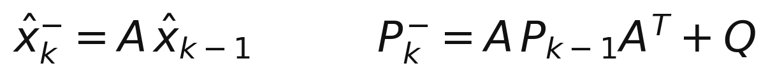
Figure 1: Predict: state and covariance extrapolation.
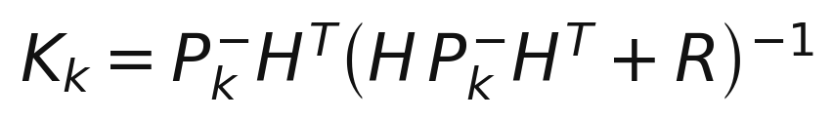
Figure 2: Kalman gain. With a scalar measurement the parenthesized term is a scalar — the inverse is one division.
Figure 3: Update: state and covariance correction.
The application follows A. Jha et al., “Kalman Filter for Precise Altitude Estimation in FMCW Radar” (IEEE MAPCON 2023): a wide-beam radar altimeter returns noisy altitude, and a 3-state constant-acceleration filter — x = [altitude, velocity, acceleration], H = [1 0 0] — cleans it at 50 Hz. This project's tuning, in Q16.16 fixed point: R = 8, Q = diag(0.05, 0.55, 0.001), P₀ = diag(200, 200, 200), dt = 0.02 s.

3. Phase 1 — CV32E40P and the ALU-Shadowing Dead End
The project began on CV32E40P with an ALU-shadowing concept: the eFPGA sits beside the ALU in the execute stage, sees the same operands, and a write-back multiplexer selects the fabric's result for our opcodes. The attraction is zero interface overhead; the cost is opening up the core. The decoder must learn the opcodes, the stall and forwarding logic must handle a second result source, and the write-back mux sits on a correctness-critical net — every edit inside a verified third-party core, re-opened with each core release. The approach was dropped before deep implementation.
Aspect | ALU shadowing (CV32E40P) | XIF coprocessor (CV32E40X)
Core modification | Decoder, EX stage, write-back mux, stalls | None
Verification | Core's verification re-opened | Interface-level only
Latency handling | Match the pipeline by hand | Valid/ready handshakes
Speculation/flush | Manual, inside the pipeline | Commit channel, by contract
Portability | Redo per core version | Any XIF-compliant core
Table 1: ALU shadowing versus a standard coprocessor interface
The lasting lesson is interface-first design: meet the host at a stable boundary, not inside it. From here on the processor was never modified again — through every fabric redesign and the entire physical campaign, CV32E40X remained a stock release.

4. Phase 2 — CV32E40X, XIF, and the First Coprocessor
Phase 2 stood up the XIF machinery, starting from the openly available example material on GitHub (the OpenHW XIF documentation and example coprocessor). The first coprocessor was deliberately trivial fixed RTL — no eFPGA yet — implementing BITREV: return the operand with its 32 bits reversed. It is meaningful (an FFT addressing primitive), not achievable in one RISC-V instruction, and trivially checkable. Encoding, emitted from C with no toolchain changes:
/* rd = bit-reverse(rs1); opcode custom-1 = 0x2B, funct3 = 7, funct7 = 2 */
.insn r 0x2B, 0x7, 0x02, %0, %1, x0 /* instruction word 0x0400F12B */
One XIF transaction: the core raises issue_valid with the instruction and rs1; the coprocessor answers issue_ready with an accept; the core pulses commit_valid; the coprocessor returns the result on result_valid/result_ready. Getting this four-beat handshake right on a trivial instruction — including back-to-back issues and results held across stalls — was the point: every later coprocessor, up to the Kalman filter, reuses this verified skeleton unchanged.

5. Phase 3 — The Same Instruction, Now Inside an eFPGA
Phase 3 moved BITREV into programmable logic. A small FABulous fabric was generated; the coprocessor datapath was synthesized (Yosys synth_fabulous), placed and routed (nextpnr-generic), and compiled to a 1,446-word bitstream (bit_gen). The fabric netlist replaced the fixed RTL inside the wrapper, and a boot-time loader streamed the bitstream from an on-chip ROM into the fabric's SelfWrite port. The same C program then produced the same results — but the logic computing them now existed only as a bitstream.
A second variant replaced the ROM with a runtime channel: an SPI slave assembling bytes into 32-bit SelfWrite words, a sticky mode bit selecting SPI over ROM, and a controller holding the coprocessor in reset (config_busy asserted) until 16 cycles after the last word. The full bitstream was pushed over SPI in simulation and all BITREV vectors passed (0x12345678 → 0x1E6A2C48, 0xDEADBEEF → 0xF77DB57B, and the palindrome 0xA5A5A5A5 → itself). Phase 3 thus proved both pillars of what follows: a fabric behind XIF can stand in for fixed RTL, and it can be configured through a runtime stream.

6. Phase 4 — Four Opcodes, One Fabric: Runtime Reconfiguration

6.1 The multiop architecture
Phase 4 delivered the defining capability: four custom opcodes share the fabric, and the wrapper reconfigures it on demand. The first-generation assignment was custom-0 = NOT, custom-1 = BITREV, custom-2 = BSWAP, custom-3 = XOR, with four 1,446-word bitstreams in RAM at a fixed base plus per-slot stride.
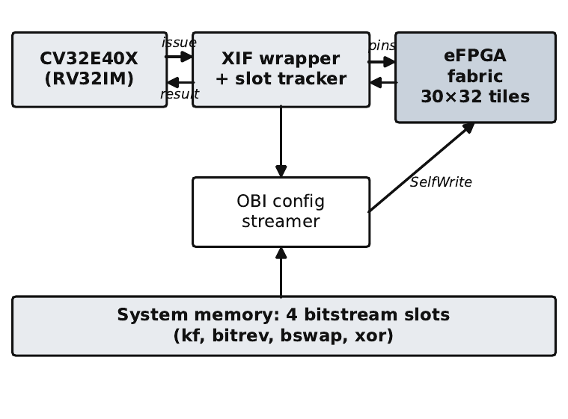
Figure 4: System architecture (final generation shown; identical structure from Phase 4 onward). The wrapper decodes four custom opcodes, tracks the loaded bitstream, and streams a new one from RAM through its OBI read master when the opcode changes.
The wrapper contains an OBI read master — the same bus protocol the core's data port uses. On an instruction whose opcode differs from the loaded one, the wrapper withholds issue-ready (the core simply waits), holds the fabric in reset, bursts the slot's bitstream from RAM into SelfWrite, releases the fabric, and completes the XIF handshake. Software is oblivious: an instruction whose hardware is not loaded just takes longer, once. Repeating the same opcode executes at full speed.
Hot-swapping is safe because of a discipline kept to the end of the project: every slot's bitstream is generated for the same fabric through the same top-level wrapper, hence identical size and identical physical pin map. The host wrapper needs no per-slot knowledge beyond a base address, and a new accelerator is just another conforming bitstream.

6.2 The live-reconfiguration simulation wall
The FABulous switch matrix contains combinational loops by construction; a valid configuration never closes one, but a live reconfiguration overwrites the old configuration frame by frame, and for a few frames a loop can transiently close. With zero-delay models this oscillates at zero sim-time and floods the event queue: Icarus Verilog's scheduler was corrupted outright (and Icarus cannot compile the core's SystemVerilog anyway). The fix: full-system simulation in ModelSim/Questa, plus a tiny simulation-only inertial delay (#0.1, `ifdef-guarded) in the loop-breaker cells so transient closures dissipate. On silicon, real gate delays do this for free.
The full-CPU demonstration ran all four instructions in one program with live reconfiguration between each — ALL OPS PASSED. The system architecture was now fixed; everything after this phase is about making the accelerator worth swapping in.

7. Phase 5 — The Kalman Filter: From Algorithm to Architecture

7.1 A real workload, as a soft coprocessor first
The chosen workload is the 3-state altimeter filter of Section 2.5. It was first built as fixed-RTL XIF coprocessor with two sub-functions on custom-0, selected by funct7:
kf_step: .insn r 0x0B, 0x0, 0x00, rd, rs1, x0 /* rs1 = raw altitude -> rd = denoised */
kf_cfg: .insn r 0x0B, 0x0, 0x01, rd, rs1, rs2 /* rs2 = coeff index, rs1 = new value */
kf_step runs one complete predict-plus-update on persistent internal state (the filter self-initializes from the first sample); kf_cfg re-tunes any coefficient — R, the Q diagonal, dt, initial covariance — at run time, so one bitstream serves any scalar-measurement tracking problem. The soft coprocessor reproduced the reference paper's ~30% RMS error reduction, and a live re-tune of R was demonstrated. All arithmetic is Q16.16 fixed point, used end-to-end from here on.

7.2 Scalar dataflow: why there is no matrix engine
The reflexive KF architecture — a matrix-multiply engine plus matrix inversion — is wrong for this filter class. With n = 3 every matrix is at most 3×3, so a GEMM array would idle; and with a scalar measurement, HP⁻Hᵀ + R is a scalar, so the gain's “inverse” is one division. Expanding the equations and exploiting the symmetry of P, one full step is exactly: 34 scalar multiplies, ~30 add/subtracts, one reciprocal. The right machine is a well-fed scalar multiplier array plus one reciprocal unit.
Figure 5: The observation that collapses the architecture.
A further collapse: all three Kalman gains divide by the same scalar S = P₀₀⁻ + R. Computing 1/S once and multiplying three times replaces three divisions with one reciprocal — the most profitable single optimization in the filter.

7.3 The software baseline
The same filter in optimized C, measured on CV32E40X via the cycle CSR (after clearing mcountinhibit, which otherwise freezes mcycle at zero), costs 661 cycles per sample, dominated by three 64-bit divisions (__divdi3) and 24 widening multiplies. Every speedup in this report uses 661 as its denominator.

7.4 The architecture ladder
Between the soft coprocessor and the final design lie four intermediate architectures, each built, verified bit-exact, and measured:
Generation | Multipliers | Cycles/sample | Speedup | Lesson
Pure software | core's own | 661 | 1× | divisions dominate
Combinational soft coproc | 25 spatial | ~10 | 66× | fast but never fits a small fabric
Time-shared engine | 1 shared | 74 | 8.8× | 56-step microprogram, one multiplier
RegFile variant | 1 shared | 90 | 7.3× | state in hard RegFile tiles; 2-cycle MACs
Whole-KF-in-fabric (16 MULADD) | 1 (time-shared) | 170 | 3.48× | entire coprocessor as a bitstream; time-sharing caps the win
Final: pipelined pool (Ch. 8) | 10 pooled | 23 | 28.7× | spatial arithmetic, time-multiplexed pool
Table 2: KF coprocessor generations
The whole-KF-in-fabric generation deserves a note. A deliberate re-architecture ruled that the entire coprocessor — datapath, state, control — must live in the fabric, with the CV-side wrapper reduced to the generic multiop shell; a hybrid with the algorithm in fixed RTL was rejected as making the reconfigurable accelerator a fiction. On stock tiles this meant a 32×32 multiplier assembled from sixteen 8×8 MULADD DSP tiles, a RegFile column for state, and a microprogrammed engine — the complete Kalman coprocessor as a single 32,664-byte bitstream, loaded into a fabric that moments before had been an AND gate, computing six golden filter steps bit-exactly on the CV32E40X.
But measured end-to-end it delivered 3.48×: a time-shared engine serializes 34 multiplies through one unit, structurally. The spatial alternative was sized honestly — ~510 MULADD tiles plus 21,000 LUTs, a ~3,700-tile fabric, ten times anything routable here. Conclusion, proven with data: spatial speed in a routable fabric requires the multiplier itself to become a dense custom tile.

8. Phase 6 — The QMUL Tile and the Pipelined Multiplier Pool

8.1 Booth–Wallace multiplication and the Newton–Raphson reciprocal
The arithmetic core is a signed 32×32→64 combinational multiplier. Radix-4 Booth recoding rewrites the multiplier operand as 17 digits in {−2,−1,0,+1,+2}, halving the partial products; a Wallace tree of 3:2 carry-save compressors sums them in six levels; only the final two vectors pass through a 64-bit carry-propagate adder. Hardened on sg13g2 the unit measures ~4.1 ns typical / 6.3 ns slow — never the critical path. It is deliberately not pipelined: every pipeline stage multiplies, so an internal register would add ≥12 cycles per sample and break the 28× floor. A Q16.16 wrapper was verified bit-exact over 200,000 vectors.
Figure 6: Radix-4 Booth recoding: 32 bits → 17 partial products.
The one reciprocal per step reuses the multiplier. Newton–Raphson iteration doubles the correct bits each step; four iterations from a good seed are exact for this format. The seed x₀ = 2^(31−MSB(d)) is computed without a priority encoder or barrel shifter: a prefix-OR isolates the MSB's power of two and a bit-reversal — pure wiring — places it. The result is bit-exact for every input including d = 0.
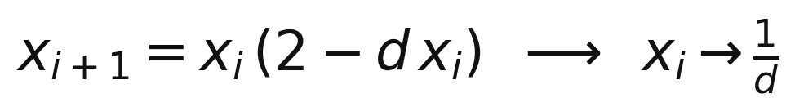
Figure 7: Newton–Raphson reciprocal iteration.

8.2 The QMUL custom tile: 96 wires into a FABulous tile
A full-width multiplier BEL needs 64 inputs and 32 outputs; FABulous's automatic switch-matrix generator caps a tile at 32 inputs / 8 outputs. The way through, found empirically:
1. Bypass the generator: a tile whose .csv names a hand-written matrix (MATRIX,./qmul_matrix.list) skips the 32/8 check. The list format is sink,source — BEG wires and BEL inputs as sinks, END wires and BEL outputs as sources.
2. Full through-routing is mandatory: every routing wire entering the tile must connect. The working matrix gives every BEG sink two END sources, every BEL input four END sources plus constants GND0/VCC0, every BEL output eight BEG sinks.
3. Spread output fan-out across all four directions — clustered fan-out made results unroutable; two wires each to N/E/S/W closed routing immediately.
Two FABulous rules emerged: a BEL must be one fully-unrolled Verilog module (the flow flattens and re-reads it), and the BEL module name must differ from the tile name. The multiplier BEL is a 102-line unrolled Booth–Wallace module named boothmult inside a tile named qmul, and the tile was proven end-to-end: placed, routed, bitstreamed, and gate-simulated computing 3.0 × 5.0 = 15.0 in Q16.16. In the production fabric it is packaged as a 1×4 vertical supertile — the BEL in the bottom sub-tile, operand/result routing above — and two QMUL columns in the 30×32 fabric provide 14 multiplier slots.

8.3 The 14-stage single-token pipeline and the pool of ten
Thirty-four spatial multipliers do not fit 14 slots. The final architecture is a time-multiplexed pool: the filter step is a 14-stage pipeline in which exactly one stage is alive per cycle — a one-hot token marches stage to stage, and each stage's registers capture only in its token cycle. A pipeline holding one token needs multipliers only for the live stage, so a pool of ten boothmult units (the busiest stage's need) serves all 34 multiplies through a token-selected operand crossbar, at zero added latency versus a fully spatial design.
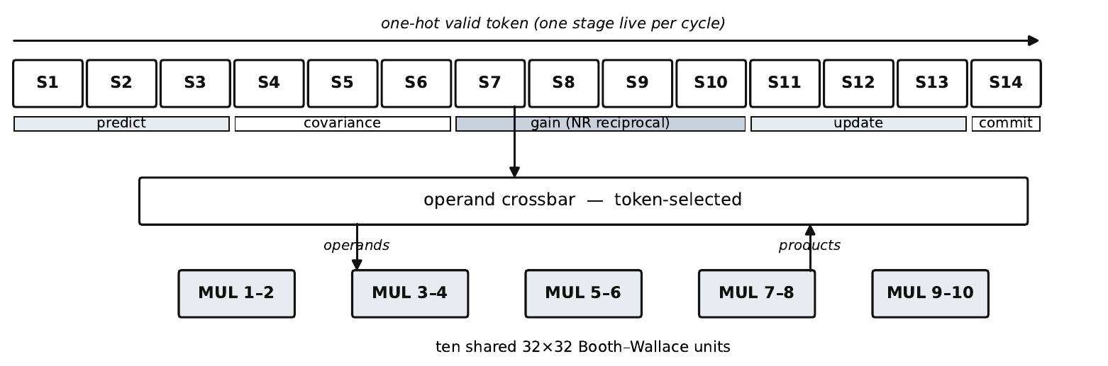
Figure 8: The 14-stage single-token pipeline over a pool of ten Booth–Wallace multipliers.
Two rules were learned the hard way: stage registers must never free-run (pool outputs change every cycle), and the crossbar's default arm must hold the final stage's operands so results stay stable during the commit wait. One kf_step costs 23 cycles: 661/23 = 28.7×. The pipeline is bit-exact against the 34-multiplier spatial reference on all 62 samples, which is itself bit-exact against the C model; cycle count and exactness were then held invariant through every later optimization.
One supporting fabric change: the stock west edge paired a general-I/O column with the wide user-I/O columns, congesting the west side. A merged custom edge tile (CIO_W) dropped the unused general I/O — external pins fell from 960 to 540 — moved user signals to the die edge, and more than halved router convergence time.

9. Phase 7 — Lifting FABulous's 640-Bit Configuration Ceiling

9.1 The wall
With the pooled pipeline routed, the timing model still reported ~4.4 MHz, and the critical arcs were transport: stock LUT4AB routing is sparse (each LUT input reachable from only 4 sources), and the worst measured arc spent 71 ns on a single adjacent-tile hop. Densification — widening the input muxes to 16 sources — is the fix, and it worked immediately on the QMUL tiles (multiply-stage probe 22.6 → 13.0 ns) because they had ~340 spare configuration bits. LUT4AB has 24: the tile already uses 616 of the 640-bit ceiling, and 16-input muxes need roughly 768 more. Everything within 640 bits was tried and measured; the ceiling itself had to move.

9.2 Anatomy, and the fix
The 640 comes from 20 frames × 32 bits. Investigation showed 20 is a default, not hardware: the frame-address register is a full 32-bit word, so the hardware maximum is 32 frames = 1,024 bits. It is pinned at 20 by the bitstream format — the frame strobe is packed one-hot into the frame-address word beside a 5-bit column field (bits [31:27]) and a desync flag (bit 20), colliding beyond 20 frames — and by a hardcoded 20-frame loop in the bitstream generator. Worse, the failure is silent: a tile declaring more than 640 bits simply never receives its upper frames and half-configures with no diagnostic (this exact failure surfaced during integration as “the KF never asserts ready”).
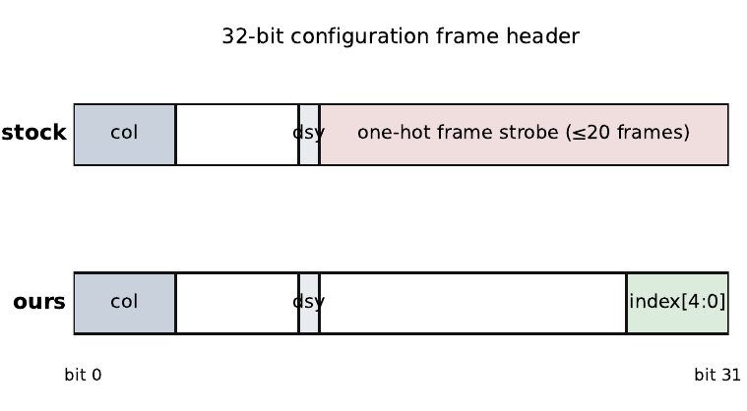
Figure 9: The frame-address word: one-hot strobe (top) collides beyond 20 frames; the encoded 5-bit index (bottom) addresses all 32.
The repair is two matched halves. The generator emits an encoded 5-bit frame index in bits [4:0] — previously unused, so column field and desync flag are untouched — and loops to the fabric's true maximum. On the fabric, one added line decodes it back: FrameStrobe = 1 << FrameAddr[4:0]. The configuration FSM is unchanged. The change is minimally invasive by design and suitable for upstreaming.
Quantity | Before | After
Addressable frames per tile | 20 (one-hot) | 32 (encoded index)
Config bits per tile (max) | 640 | 1,024
LUT4AB config bits | 616 | 874 (28 frames)
LUT-input mux richness | 4 sources | 16 sources
Bitstream size | 18,566 words (truncated) | 29,702 words — complete
Table 3: What the ceiling lift bought
One simulation consequence: with the complete bitstream every frame is written, so unconfigured latches during a live reconfiguration must model as X, not forced 0 — X propagates quietly through transient loop closures, while zeros let inversion rings oscillate.

10. Phase 8 — Final System Integration on CV32E40X

10.1 The final opcode map
Opcode | Encoding | Instruction | Fabric utilization
custom-0 | 0x0B | kf_step / kf_cfg — Kalman filter | 5,070/6,496 LCs (78%), 10 of 14 QMUL slots
custom-1 | 0x2B | bitrev | ≈65 LCs (≈1%)
custom-2 | 0x5B | bswap | ≈65 LCs (≈1%)
custom-3 | 0x7B | xor | ≈65 LCs (≈1%)
Table 4: Final instruction set
All four bitstreams are 118,808 bytes (29,702 words), produced through the identical wrapper — the interchangeability invariant carried by the encoded-frame generator. The simple ops stay deliberately. They cost ~1% of the fabric each, and swapping between a 78%-full fabric and a 1%-full one makes the runtime reconfiguration easy to see in a waveform.

10.2 Bring-up lessons
Six distinct bugs separated “compiles” from “works,” each a reusable lesson: (1) the top wrapper's fabric-I/O map must be regenerated by script from the fabric's own top-level file — a hand-edited wrapper was self-consistent standalone but wrong when embedded; (2) the bitstream word count existed as both a parameter default and an instantiation override, and updating one streams past the end; (3) the simulator compiles the manifest file list, not the Makefile wildcard — editing the Makefile alone left the old fabric compiled; (4) the `ifdef-guarded simulation-only fabric patches (loop-breaker delay, user-clock gate) are silently dropped by every fabric regeneration and must be re-applied by script; (5) the configuration-wipe polarity of Section 9; and (6) the silent 640-bit truncation of Chapter 9 itself.

10.3 The multiop system test: ALL TESTS PASSED
The system regression, in Questa on the full gate-level fabric inside the CV32E40X testbench, runs five phases in one program: KF over the 62-sample altimeter trace, then bitrev, bswap, xor (exact checks), then a KF reload — five live reconfigurations in total. Result: the three simple ops bit-exact with zero failures; the KF reduces measurement error from 11 to 7, identically before and after the reload. Final transcript line: ALL TESTS PASSED.
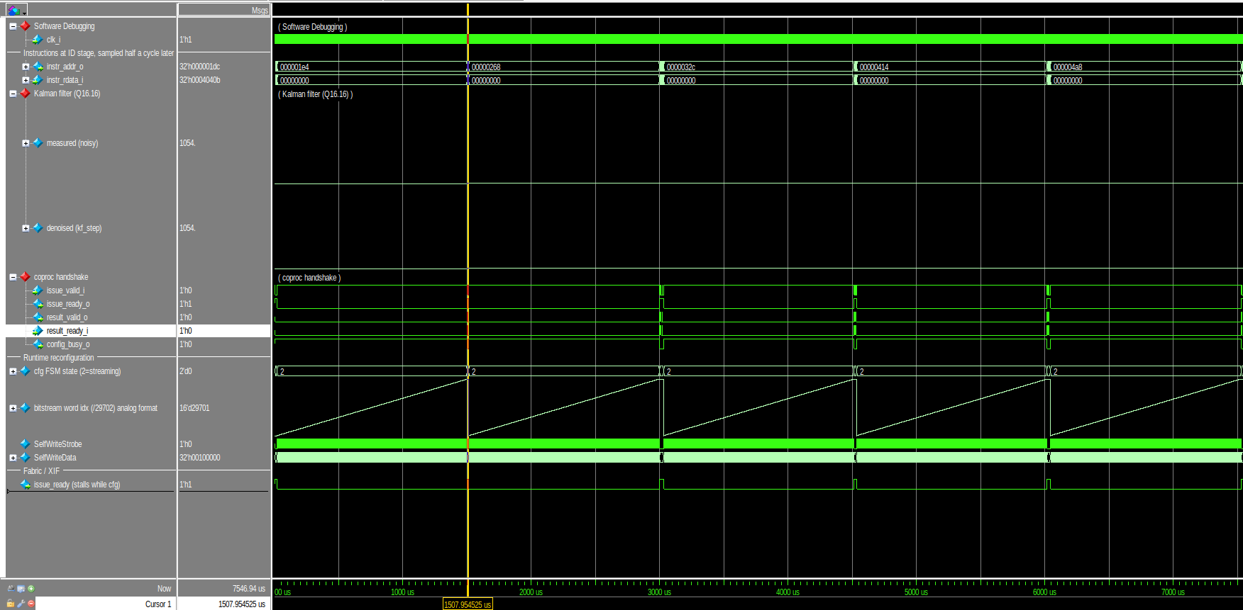
Figure 10: Questa overview of the multiop run: five bitstream-streaming ramps (29,702 words each), handshake pulses between them, issue_ready stalled during configuration.
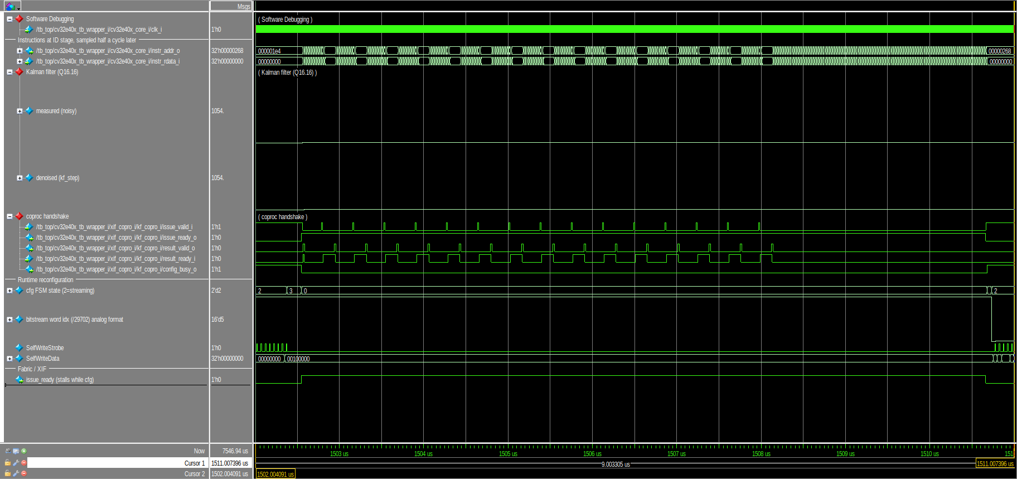
Figure 11: Two back-to-back reconfigurations in close-up: configuration FSM, SelfWrite strobes, fabric held quiet until release.
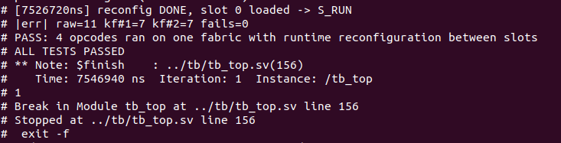
Figure 12: Console transcript of the runtime-reconfiguration system test.
Scope note: this transcript used the pre-champion (v2-era) KF bitstream. The champion v3 RTL is bit-exact with it (62/62 equivalence), so a re-run is expected-pass; functional validation and live reconfiguration are the claims here, and the timing numbers of Chapter 13 come from STA.

11. Phase 9 — Physical Implementation: From RTL to a Stitched GDS

11.1 From GF180 to IHP
The first physical campaign targeted the GF180MCU open PDK and got far — five tile types hardened to LVS-clean macros, the full chip top synthesized — but detailed-routing the stitched fabric as one flat design proved infeasible, and the flow offered no per-tile alternative. The project moved to IHP sg13g2, where librelane_plugin_fabulous provides exactly the right structure: tiles hardened independently, then stitched by abutment with no top-level routing at all. One upstream patch was needed — the plugin deleted the UserCLK spine (its author's tiles clock through routing wires), silently leaving flip-flops unclocked; the patched flow restores UserCLK with pins on the tile's north/south edges so the spine, like every other wire, connects by abutment.

11.2 Hardening the seven tile types
Each tile type is hardened as an independent macro — synthesis, placement, routing, and signoff inside the tile, every inter-tile wire legalized to an exact boundary pin. Abutment demands strict geometry: all full-width tiles share one width, and the QMUL supertile is exactly four LUT4AB heights. Tile heights were grown in legal 0.42 µm steps until the densified configuration placed and routed cleanly.
Tile | Size (µm) | Config bits | Notes
LUT4AB | 219.84 × 446.04 | 874 | 8 LUT4 + FFs; 16:1 muxes; 90% util
QMUL (1×4 supertile) | 219.84 × 1784.16 | ≈300/row | boothmult BEL in bottom row; 48% util
CIO_W | 68.64 × 446.04 | 122 | merged west-edge I/O
N/S terminators (×4) | 219.84 × 56.70 | — | column caps
Table 5: Hardened tile macros (IHP sg13g2, per-tile signoff clean)
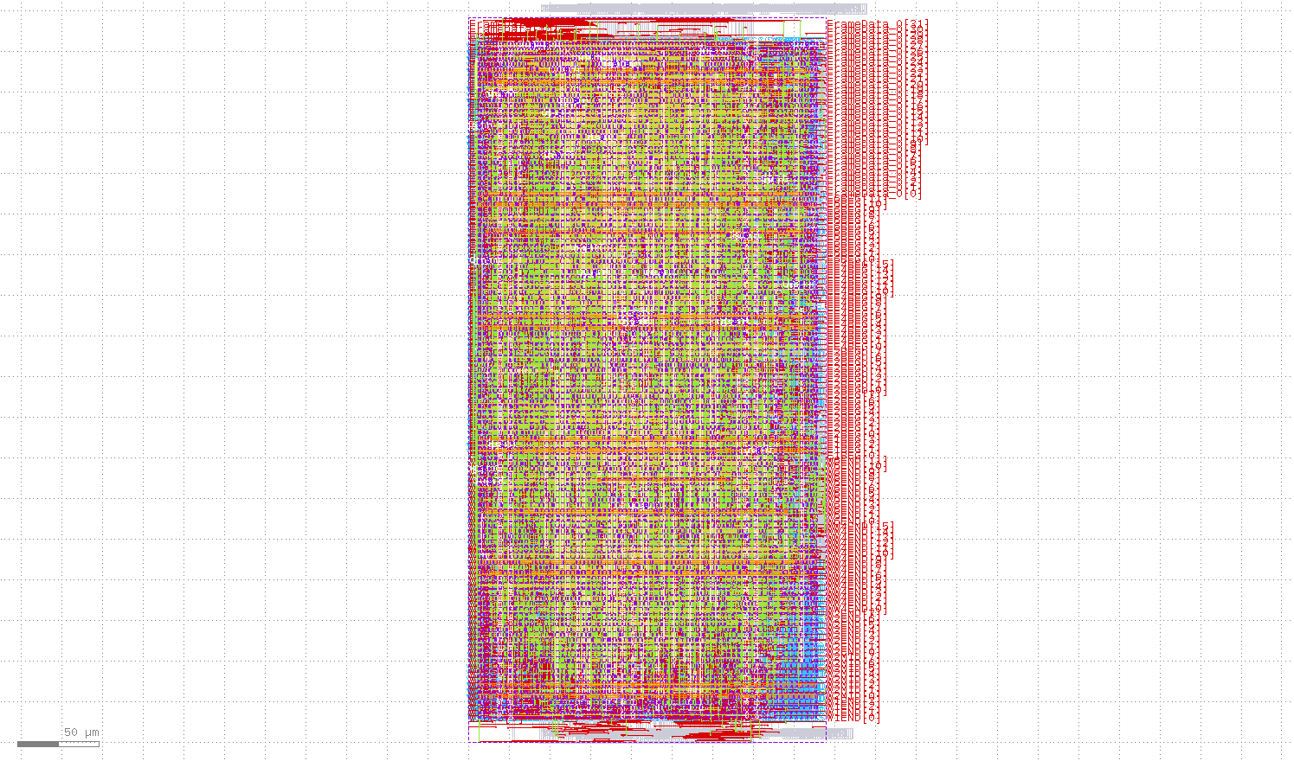
Figure 13: The hardened LUT4AB macro: 874 configuration bits, densified muxes, UserCLK spine pins on the horizontal edges.
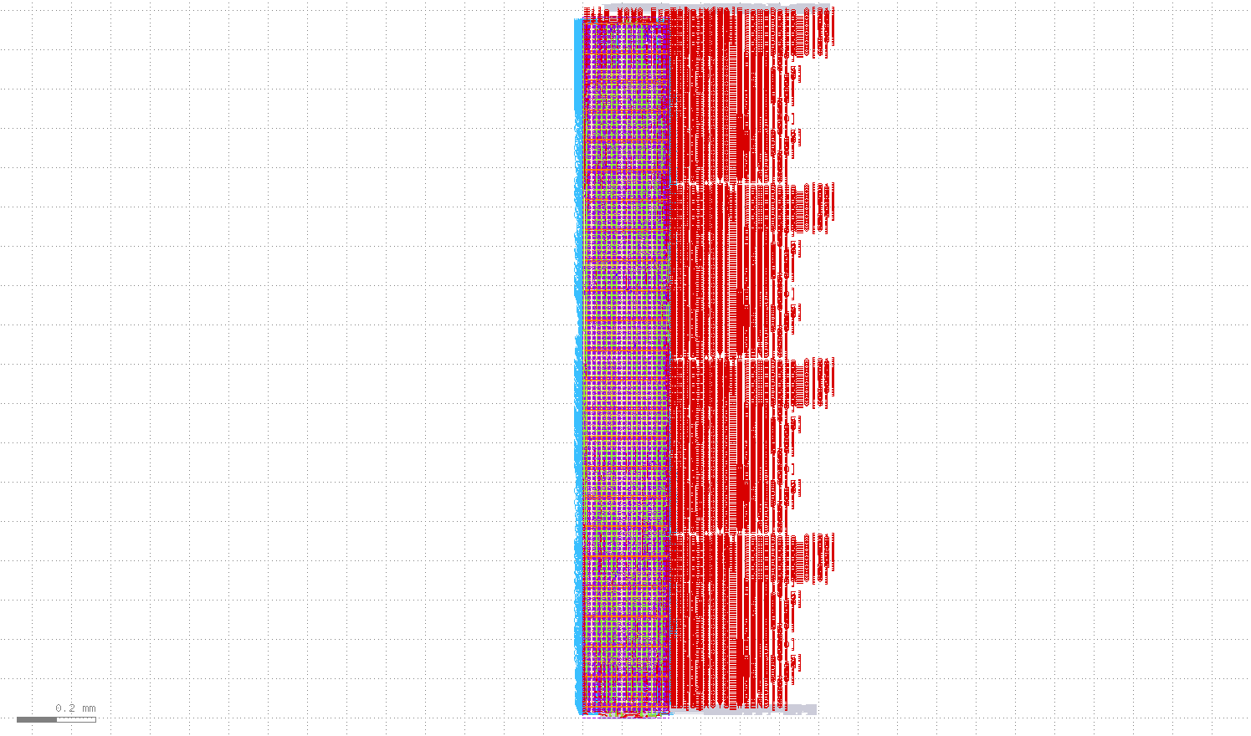
Figure 14: The QMUL 1×4 supertile macro: multiplier in the bottom sub-tile, operand/result routing above.

11.3 The timing-repair discovery
The most consequential physical finding hides in a flow default: the stock FABulousTile flow disables all of OpenROAD's timing repair (no resizing, buffering, or cloning). Sparse stock tiles never notice; densified tiles are punished — 16:1 muxes land on minimum-drive cells, and one under-driven high-fanout gate measured 3.2 ns. Re-enabling repair via a plugin shim, plus a real per-tile clock constraint, raised the measured full-fabric figure from 12.44 to 15.73 MHz with no design change (Chapter 13, lever L1). Timing repair is not optional for dense tiles.

11.4 Stitching 916 macros by abutment
The fabric flow places all 916 tile-macro instances on the computed grid, builds the power network, runs global routing (verifying abutting pins align — there is no top-level detailed routing), inserts fill, and streams out the merged GDS via KLayout and Magic: 6.88 × 12.60 mm. Per-tile signoff (DRC/LVS/antenna) is clean on all seven macros; full-fabric signoff was not run to completion (the remaining stages are verification-only, and the flow's antenna checker crashes on a checker bug after assembly). This report is precise on the claim: a complete, assembled fabric GDS with per-tile signoff clean — not a signoff-clean fabric GDS.
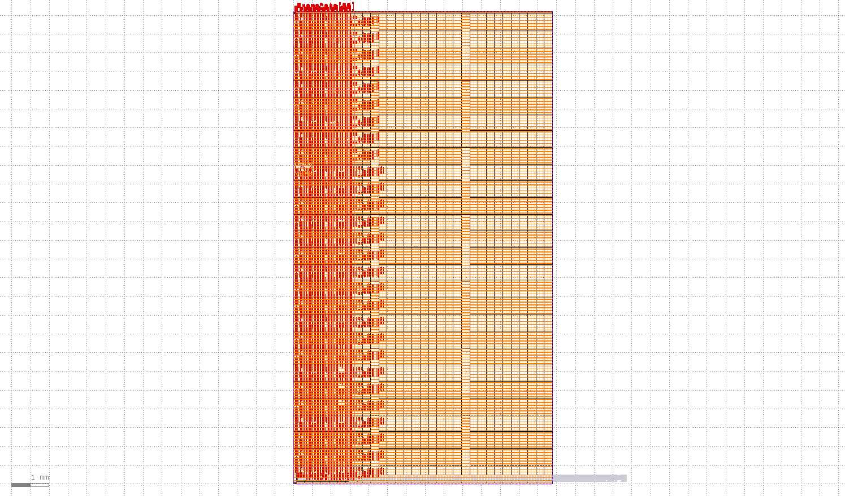
Figure 15: The stitched eFPGA fabric GDS: 916 abutted macros, 6.88 × 12.60 mm. The two tall QMUL columns stand against the LUT4AB field; CIO_W lines the west edge.

12. Phase 10 — Measuring the Truth: Config-Static Per-Tile STA

12.1 Why the obvious measurements are both wrong
How fast is the configured fabric? Neither available answer survives scrutiny. Whole-fabric STA on the stitched netlist is meaningless: an unconfigured eFPGA contains millions of structural paths no configuration ever sensitizes, and the reported worst path is always one of these false paths. The place-and-route model, meanwhile, is not silicon — nextpnr-generic's fixed per-element delays proved ~10× pessimistic on logic and optimistic in places on routing. A publishable claim needs the actual routed path, under the actual configuration, at signed corners.

12.2 The methodology
1. Trace. A script walks the routing switches the bitstream actually enables, backward from capture to launch register, yielding the exact ordered tile crossings of the critical path — 42 crossings across 4 nets for the champion.
2. Per-tile STA under the real configuration. For each crossing, OpenSTA runs on that tile's placed-and-routed netlist with extracted parasitics (SPEF), with the tile instance's actual bitstream bits applied as case-analysis constants on its configuration latches — identified structurally by frame-data/frame-strobe connectivity, honoring inverter parity. Both signed corners are run: typical (1.20 V, 25 °C) and slow.
3. Compose. Per-crossing delays, endpoint setup, and clock latencies sum to a minimum clock period per corner — the true period of the real routed path.
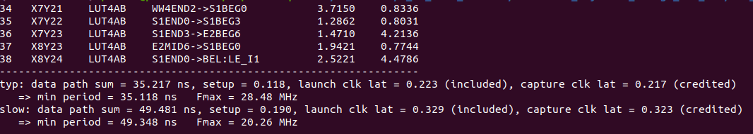
Figure 16: The champion summary: 42 crossings composed into 35.118 ns (28.48 MHz) typical and 49.348 ns (20.26 MHz) slow.

12.3 Keeping the delay model honest
The nextpnr model still steers placement and seed selection, so it was recalibrated against measured crossings (LUT 3.0 → 1.6 ns, 0.65 ns/tile, per-class pip delays). One bright line preserves integrity: the model only chooses candidates; every claimed number is scored by the config-static STA. Across the five measured placements the model under-predicts by 0.4–6.5 MHz — a conservative lower bound, so model-ranked, measurement-confirmed results cannot overstate. A calibration tool was also built that derives each pip-class delay directly from the PDK liberty files and hardened netlists, reproducing five of seven hand-tuned classes exactly.

13. Phase 11 — The Optimization Campaign: 12.44 to 28.48 MHz

13.1 Four levers, all measured
With a measurement we could trust, we set ourselves a hard target of 25 MHz at the typical corner and pulled four levers to reach it. Every row below is a full config-static STA of a real placed, routed, bitstreamed design; nothing is extrapolated.
Lever | Change | Typ (MHz) | Slow (MHz)
— | Baseline: stock flow, stock model, RTL v1 | 12.44 | 7.81
L1 | Re-enable tile timing repair (Section 11.3) | 15.73 | 9.87
L2 | Recalibrated nextpnr model + RTL v2 token replicas | 20.94 | 13.12
L3+L4 | Drop redundant valid-gate (v3) + seed search | 28.48 | 20.26
Table 6: The optimization campaign (config-static per-tile STA, both corners)
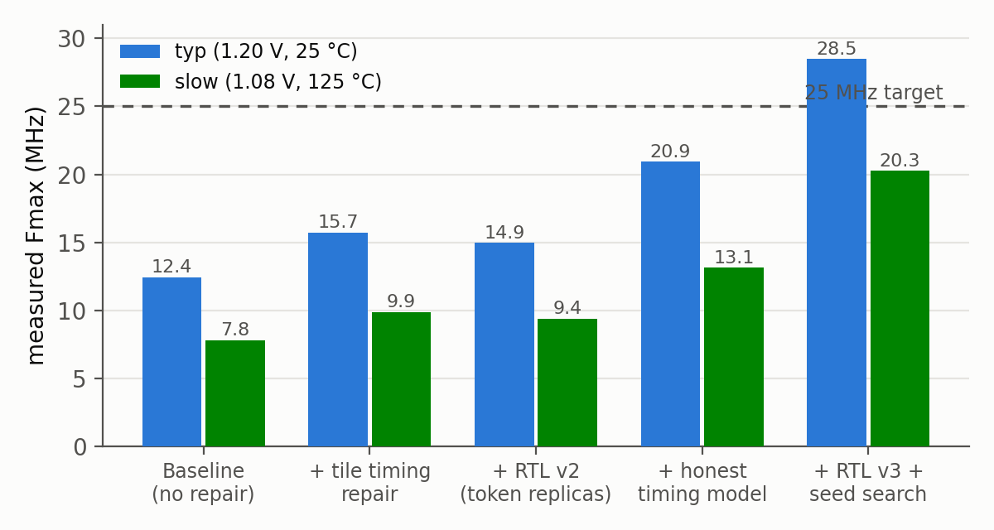
Figure 17: The campaign: measured typical- and slow-corner frequency after each lever.
The RTL levers attack transport. L2's token replicas: in v1 the one-hot pipeline token was computed centrally and distributed to all 14 stages, crossing the whole fabric every cycle; in v2 each stage computes its own token copy locally, and only two signals cross the fabric. L3 removed a fabric-wide OR of all token bits that gated every stage's capture — redundant by construction (each one-hot bit implies it), but synthesis cannot prove one-hotness across registers, so it kept the reduce-and-broadcast that measurement showed was the critical path at both 20.9 and 24.7 MHz. Both revisions were re-verified bit-exact (62/62) — only the paths changed, never the cycle count or results.

13.2 The seed sweep
Seed | Model (MHz) | Measured typ (MHz) | Measured slow (MHz)
1 | 21.98 | 24.72 | 15.50
2 (champion) | 21.95 | 28.48 | 20.26
5 | 24.39 | 25.24 | 15.82
7 | 25.48 | 25.85 | 18.58
Table 7: Seed sweep on the final RTL (v3); model steers, measurement decides
Three of four measured seeds clear 25 MHz typical — the target is a property of the design, not a lottery ticket. The champion was in fact the model's lowest-ranked candidate (+6.5 MHz under-prediction) — exactly why every candidate gets measured. The champion path crosses 42 tiles over 4 nets in 35.118 ns.
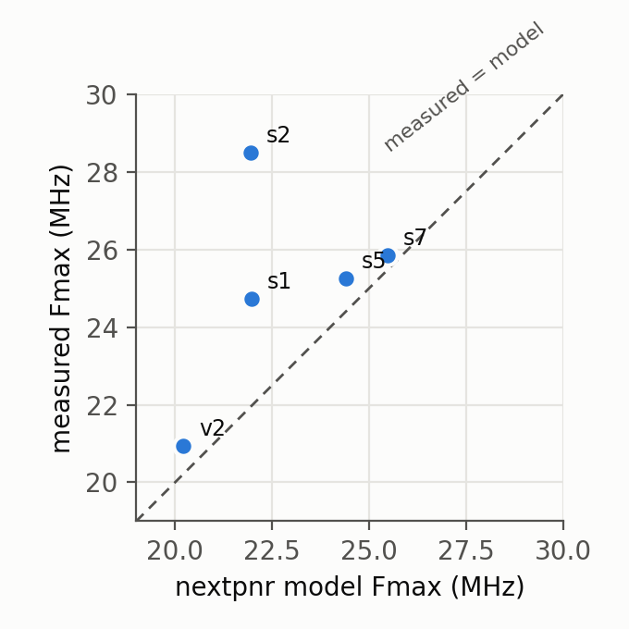
Figure 18: Model versus measured frequency for the five measured placements: the model under-predicts throughout.

14. Consolidated Results and Validation

14.1 Headline numbers
Metric | Value
Cycle reduction, KF step | 23 vs 661 cycles/sample = 28.7×
Bit-exactness | 62/62 samples identical to software reference
Post-layout Fmax, typical | 28.48 MHz (35.118 ns)
Post-layout Fmax, slow corner | 20.26 MHz (49.348 ns)
Critical path | 42 tile crossings, 4 nets
KF throughput at Fmax | 1.24 Msample/s typ (application needs 50/s)
Fabric | 30×32 tiles, 6,496 LCs, 14 QMUL slots; KF uses 78%
Bitstream (each of 4 slots) | 29,702 words = 118,808 bytes
Fabric GDS | 916 abutted macros, 6.88 × 12.60 mm, IHP sg13g2
Runtime reconfiguration | 4 opcodes hot-swapped live; ALL TESTS PASSED
Table 8: Headline results (all measured; evidence in Appendix B)
The throughput headroom — nearly 25,000× the application's 50 Hz — is the point: it lets one modest fabric serve as the substrate for whatever instruction is needed next, at frequencies compatible with a microcontroller-class SoC clock.

14.2 Functional validation
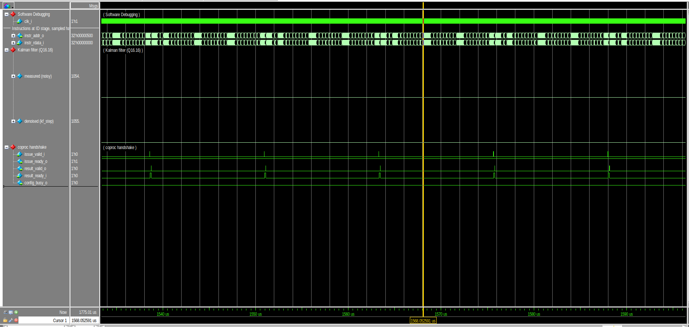
Figure 19: The KF coprocessor over the altimeter trace: raw measurement and denoised estimate track through the descent; one XIF handshake per sample.
Figure 20: The bit-exactness check: 62 of 62 outputs identical to the software reference.
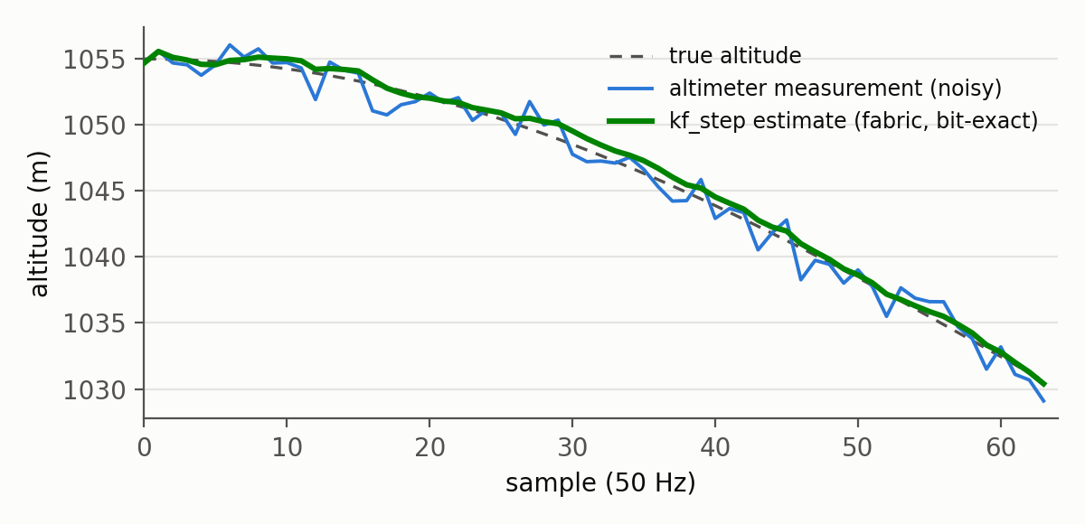
Figure 21: Application-level result: raw measurement, true altitude, and the fabric's Kalman estimate over the 62-sample descent.

14.3 Reproducibility
Near the project's end the entire fabric flow was re-executed from scratch in a fresh directory — fabric generation, custom tiles, densification, the 32-frame generator, v3 RTL with its equivalence check, and the champion-seed place-and-route. The rebuilt FASM and bitstream came out byte-identical to the originals. Two build documents (DOC1: the FABulous flow; DOC2: the CV32E40X integration) record every command and failure mode, and a traceability file maps every quantitative claim to its evidence artifact (Appendix B).

14.4 Limitations
- Full-fabric signoff was not run to completion; per-tile signoff is clean on all seven macros, and the remaining stages are verification-only.
- The archived system transcript used the pre-champion bitstream; the champion RTL is formally bit-exact, and a confirmation re-run is planned.
- UserCLK spine skew across the fabric is not modeled in the composed period.
- The measured frequency is the configured KF design's; other bitstreams have their own critical paths, measurable the same way.

15. Challenges and Lessons Learned
- Meet the host at a standard interface: abandoning core modification for XIF (Chapter 3) is the decision that most shaped the project's velocity.
- Analyze the algorithm before choosing the engine: the scalar-dataflow census (34 multiplies, one reciprocal) eliminated whole architectures before any RTL.
- Time-sharing has a hard ceiling and spatial has a hard area cost; the pooled pipeline holds exactly as much hardware as the busiest cycle needs.
- Impose invariants early: the equal-size/equal-pinmap bitstream discipline and the 28× speedup floor were cheap to keep and expensive to retrofit.
- Silent truncation is the worst failure mode: a tile exceeding 640 config bits half-configures with no diagnostic. Budget configuration bits like any resource, and check generated totals.
- Custom tiles demand full through-routing, directional fan-out spread, single-module unrolled BELs, and BEL names distinct from tile names.
- Regeneration hygiene: stale generated files shadow fresh ones, and simulation-only patches are silently dropped by every regeneration — re-apply by script, never by memory.
- Configurable fabrics contain legitimate combinational loops; live reconfiguration transiently closes them. Simulate with inertial delays on the loop breakers, and model unwritten latches as X, not 0.
- Flow defaults are design decisions someone else made: the disabled timing repair cost 3.3 MHz until found by reading the flow, not the logs.
- Never let the steering model score the claim: the champion seed was the model's lowest-ranked candidate.
- State limitations in the artifact record as you go — precision about what was not done is what makes the rest credible.

16. Future Work
- Complete full-fabric signoff, and re-run the system regression with the champion bitstream so the functional transcript and timing claim share one artifact.
- Tape out: the fabric GDS plus CV32E40X are the two halves of an MPW candidate on IHP's open shuttle program.
- Upstream the encoded-frame configuration path and the timing-repair shim to FABulous and the LibreLane plugin.
- Widen the instruction library — FIR/IIR stages, CRC, AES rounds — each new accelerator costs one bitstream, not one tape-out.
- Partial reconfiguration: the frame-addressed path naturally supports column-granular updates, cutting the ~30k-word swap cost.

17. Conclusion
We set out to make a RISC-V processor's instruction set soft — extendable at run time by hardware the processor itself loads from memory — and to prove it down to measured silicon layout on an open flow. The project ends with that proof in hand: a stock CV32E40X issues four custom instructions to one 30×32-tile FABulous fabric; the wrapper hot-swaps 118.8 kB bitstreams between them; the Kalman-filter instruction denoises a radar altimeter bit-exactly at 28.7× fewer cycles than software; and the fabric exists as a stitched 6.88 × 12.60 mm GDS whose configured critical path measures 28.48 MHz typical / 20.26 MHz slow — more than double the starting point of the optimization campaign.
The dead ends taught us as much as the result did. The ALU-shadowing attempt pushed us to interface-first design; the time-sharing ceiling justified a custom tile; the silent 640-bit truncation hid for a day and fell to a two-line fix; the timing repair a flow default had quietly disabled cost 3.3 MHz until we read the flow itself; the false paths of whole-fabric STA forced a better measurement. Each of these is now written down, with its fix, where the next project can find it. That, together with a fabric that can become whatever instruction is needed next, is what this project leaves behind.

References
1. A. Jha et al., “Kalman Filter for Precise Altitude Estimation in FMCW Radar,” IEEE MAPCON 2023, doi:10.1109/MAPCON58678.2023.10463967.
2. D. Koch, N. Dao, B. Healey, J. Yu, and A. Attwood, “FABulous: An Embedded FPGA Framework,” Proc. ACM/SIGDA FPGA, 2021.
3. OpenHW Group, “CV32E40X RISC-V core” and “CORE-V eXtension Interface (CV-X-IF) specification,” github.com/openhwgroup.
4. D. Shah, E. Hung, C. Wolf, S. Bazanski, D. Gisselquist, and M. Milanović, “Yosys+nextpnr: An Open Source Framework from Verilog to Bitstream,” Proc. IEEE FCCM, 2019.
5. T. Ajayi et al., “Toward an Open-Source Digital Flow: First Learnings from the OpenROAD Project,” Proc. DAC, 2019.
6. M. Shalan and T. Edwards, “Building OpenLANE: A 130nm OpenROAD-based Tapeout-Proven Flow,” Proc. ICCAD, 2020 (LibreLane is its successor).
7. IHP Microelectronics, “IHP Open Source PDK — SG13G2 130 nm SiGe BiCMOS,” github.com/IHP-GmbH/IHP-Open-PDK.
8. X. Tang, E. Giacomin, B. Chauviere, A. Alacchi, and P.-E. Gaillardon, “OpenFPGA: An Open-Source Framework for FPGA Prototyping,” IEEE Micro, 2020.
9. A. D. Booth, “A Signed Binary Multiplication Technique,” Q. J. Mechanics and Applied Mathematics, 1951.
10. C. S. Wallace, “A Suggestion for a Fast Multiplier,” IEEE Trans. Electronic Computers, 1964.
11. R. E. Kalman, “A New Approach to Linear Filtering and Prediction Problems,” J. Basic Engineering, 1960.
12. librelane_plugin_fabulous — FABulous tile/fabric flows for LibreLane 3, github.com/mole99/librelane_plugin_fabulous.

Appendix A — Instruction Encodings
Instruction | Opcode | funct3 | funct7 | Operands | Semantics
kf_step | 0x0B | 0x0 | 0x00 | rd, rs1 | rs1 = raw altitude (Q16.16); rd = denoised; advances persistent state
kf_cfg | 0x0B | 0x0 | 0x01 | rd, rs1, rs2 | rs2 = coefficient index (R, Q00..Q22, P0*, DT, REINIT); rs1 = value
bitrev | 0x2B | 0x7 | 0x02 | rd, rs1 | rd = bit-reversed rs1
bswap | 0x5B | — | — | rd, rs1 | rd = byte-swapped rs1
xor | 0x7B | — | — | rd, rs1, rs2 | rd = rs1 ^ rs2
Table 9: Custom-instruction encodings (R-type, emitted via .insn)
Bitstreams reside in RAM at base + slot × stride; the OBI master fetches 29,702 words per swap. The format is FABulous's with the Chapter 9 header: column in bits [31:27], desync at bit 20, frame index in bits [4:0].

Appendix B — Evidence Map
Claim | Evidence artifact
28.48 / 20.26 MHz champion | sta_fmax/out/summary_v3s2.txt
Critical-path trace | sta_fmax/out/trace_v3s2.txt, segments.csv
Seed sweep | summary_v3.txt / _v3s5 / _v3s7 + P&R logs
78% utilization; model 21.95 MHz | build/pnr_v3_s2.log
Champion bitstream (118,808 B) | build/kf_v3.bin (+ FASM)
62/62 bit-exactness | tb_kf_equiv testbench (DOC1 §8)
661 cycles/sample baseline | kfperf measurement on CV32E40X (mcycle CSR)
ALL TESTS PASSED multiop | sw/transcript_kfmulti
Fabric GDS | runs/wide874_stitch_r/37-klayout-streamout/eFPGA.gds
Tile macro metrics | tiles/<TILE>/macro/ihp-sg13g2/metrics.json
Byte-identical rebuild | efpga_kf_final_self (independent tree)
Table 10: Claim-to-evidence map (paths abbreviated to project-internal names)
Honesty guards: (1) “3 of 4” measured final seeds clear 25 MHz — four, not five, have measured summaries; (2) the fabric GDS is assembled with per-tile signoff clean — full-fabric signoff was not completed; (3) the archived multiop transcript predates the champion bitstream (bit-exact RTL; re-run planned).

Appendix C — Toolchain
Tool | Role | Notes
FABulous | fabric generation, bitstream spec | 2.0 line, pinned
Yosys (synth_fabulous) | user-design synthesis | oss-cad-suite build
nextpnr-generic (FABulous uarch) | place & route | rebuilt with recalibrated delay constants
bit_gen (encoded) | bitstream generation | project copy with 32-frame encoded-index emitter
LibreLane 3 + FABulous plugin | tile hardening & fabric stitch | 3.0.0 + plugin 1.2.0 (UserCLK and timing-repair patches)
OpenROAD / Magic / KLayout / Netgen | P&R, DRC/extraction, streamout, LVS | pinned Nix environment
OpenSTA | config-static per-tile timing | via LibreLane environment
IHP-Open-PDK sg13g2 | target process (130 nm) | open PDK, signed corners
Questa | gate-level system simulation | the one non-open tool, simulation only
Icarus Verilog | unit/equivalence testbenches | oss-cad-suite build
RISC-V GCC (xPack) | bare-metal C for CV32E40X | riscv-none-elf 15.2
Table 11: Tools used

